A Review of the Challenges in the Theory of Planned behavior and Integrative Framework Presentation in Social Behavior Related to Ecotourism and Wildlife Management

Marjan Jafarpour, M1, M.Manohar. 2*

1,2Faculty of Forestry, University Putra Malaysia, 43400 Serdang, Selangor, Malaysia
1. Marjan.jafarpoor@gmail.com
*2. Corresponding author: mano@upm.edu.my

Abstract: The Theory of Planned Behaviour (TBP) is one of the most widely used models for social behaviour. Applied studies have examined whether the TBP is a true general social behavior model through, for example, the selection of samples from diverse populations or the use of this model to develop effective strategies for behavior change. Several interfering factors can affect control intended behavior. In this review, the motivational and cognitive factors are considered in the final integrated model which can be applied in the field of conservation and wildlife management.
[Marjan Jafarpour, M, M.Manohar. A Review of the Challenges in the Theory of Planned behavior and Integrative Framework Presentation in Social Behavior Related to Ecotourism and Wildlife Management
.N Y Sci J 2021;14(4):57-76]. ISSN 1554-0200 (print); ISSN 2375-723X (online). http://www.lifesciencesite.com. 7. doi:10.7537/marsnys140421.07.

Key words: TPB(Theory of Planned Behaviour), Integrated Framework, Cognitive hierarchy, Self-determination theory (SDT), Motivation Model.

Introduction
1. Summary of Planned behavior and its main concepts
The Theory of Planned Behaviour (TPB), as the extended version of the Theory of Reasoned Action (TRA), is one of the most widely used models, among several other models developed to describe general and environmental behavior. This planned behavior theory is affected by the value expectancy tradition; however, it includes two factors, namely subjective norms and behavioural control which, in addition to attitudes and beliefs, are predicted to influence our behavior. According to Branstrom et al. (2004) the attitudes of relevant others toward a behavior as well as the motivation to meet relevant others’ expectations are included in the subjective norms, while behavioural control refers to the perception of control over behavior performance and is closely associated with self-efficacy. According to the TPB, three different beliefs determine our behavior: behavioural beleifes, which are beliefs about behavior and thoughts about its consequences, normative beliefs, which include beliefs about others’ normative expectations and motivation for compliance with the norms, and control beliefs, which are perceptions about the existing factors which can facilitate or impede behavior performance as well as the power of these factors. These factors or constructs of behavioural beliefs, i.e. attitudes about the behavior, subjective norms and perceived control over behaviour, result in behaviour intention. This intention, with sufficient actual control, can lead to overt behavior (Branstrom et al. 2004). The TPB has been supported by a meta-analysis including 185 previous studies, which showed that 27-39 percent of variance in the behaviour and behavioural intention seemed to be explained by the theory (Armitage & Conner, 2001; Branstrom et al. 2004). The diagrams of TRA and TRB are shown in Fig1 and Fig2.
Figure 1. Reasoned Action Model (Fishben and Azjen, 1967).

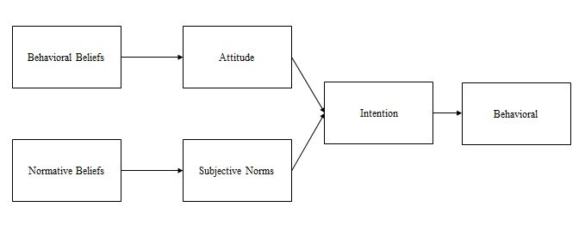
Figure 2. Planned Behavior Theory (Ajzen and Maddlen, 1986)

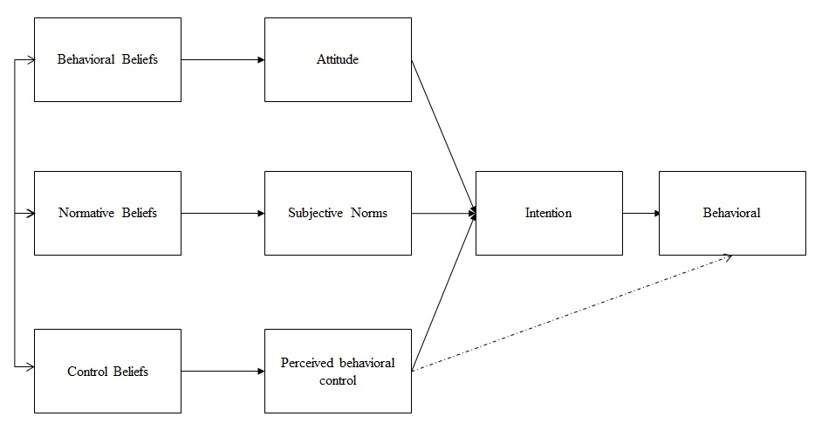

2. Problem and Solution
Applied studies have examined whether the TPB is a true general social behavior model through, for example, the selection of samples from diverse populations or the use of this model to develop effective strategies for behavior change. On the other hand, more basic-oriented studies have attempted to develop the TPB by, for instance, examining factors potentially moderating component relationships and the validity of additional variables in prediction (Conner & Armitage, 1998). Regarding the second example, investigating additional variables has been encouraged by some researchers (e.g. Ajzen, 1991), who regard TPB as, “open to the inclusion of additional predictors if it can be shown that they capture a significant proportion of the variance in intention or behaviour after the theory's current variables have been taken into account” (Armitage & Christian, 2003).

Body of Research
1. Development from Reasoned Action to the Theory of Planned Behaviour
1.1 Reasoned Action Theory
Fishbein and Ajzen (1967) introduced the Theory of Reasoned Action aiming to explain the relationships between attitudes, beliefs, intentions and behaviour (Madden et al. 1992). The theory has been widely applied by researchers in social psychology studies to predict and understand the effects of motivation on behaviour (Fig. 1). Also, the TRA model has been extensively used to predict behavioural intentions and behaviour. In their theory, Fishbein and Azjen (1967) classified the beliefs which precede behavioural intentions into two distinct categories, namely behaviour and normative (Madden et al. 1992). It is assumed that behavioural beliefs have the main influence on one’s attitude towards the performance of the behaviour, while the individual’s subjective norm related to behaviour performance is affected by the normative type beliefs. Thus, the intentions and subsequent behaviour are affected by information and salient beliefs either by attitude or by subjective norms. Later, Azjen extended the theory and added perceptions of behavioural control as a predictor of intentions and behaviour to the original theory (Madden et al. 1992).
In social psychology research, the two most commonly used models to understand human behaviour are reasoned action theory (Ajzen & Fishbein, 1980; Fishbein & Ajzen, 1975; Fishbein & Manfredo, 1992; Montano & Kasprzyk, 2008) and the extended theory of planned behaviour (Ajzen, 1985, 1991; Ajzen & Driver, 1992; Montano & Kasprzyk, 2008). These theories have been employed in numerous studies aimed at understanding and influencing individuals’ behaviour, such as condom use, illegal drug use, and speeding behaviour among drivers.The underlying assumption in all these studies is that understanding the behaviour predictors makes it possible to better design interventions intended to change individuals’ behaviour (Elliott & Armitage, 2009; Parker, 2002). A review of the studies which used interventions designed based on findings from planned-behaviour-theory research revealed that the intervention produced some desired behavioural change in two thirds of the cases (Elliott & Armitage, 2009; Hardeman et al., 2002). According to Azjen and Fishbein (1980) two main assumptions underlie the TRA and the TPB: 1) individuals make an evaluation of (weigh) the possible implications and consequences of performing a behaviour prior to making a decision whether or not to engage in that behaviour, and 2) an individual makes sensible decisions according to a systematic evaluation of the available information, regardless of the correctness or reliability of the information. Similar assumptions to these assumptions are also made in economic models (St John, Edwards-Jones, & Jones, 2011) with the only difference that quite different predictors of behaviour are used in social psychological models. According to the TRA, the individual’s attitude toward certain behaviour as well as his/her subjective norms affect the likelihood of performing that behaviour by the individual (Ajzen & Madden, 1986).

1.2 Volitional Control
Although the theory of reasoned action has been successful thus far, there remain fundamental unresolved problems with this theory, which are mainly related to the boundary conditions of the theory. The boundary conditions deal primarily with the verbal response to actual behaviour transition. There are three prerequisites to a strong intention-behaviour association. First, there must be a correspondence between the measure of general level of intention and the behavioural criterion (Ajzen & Madden, 1986). Therefore, in order to predict certian behaviour, like regular attendance in class lectures, intentions that are equally specific, i.e. attending intentions in the given lectures regularly, must be assessed. Second, there should be no change in intention during the interval between the time of its assessment and the time of behaviour observation. If the interval lasts longer, the likelihood of unexpected events which might change the intention will also increase. It is argued that variations in the time interval between measuring intention and observing the behaviour usually lead to inverse variations in the accuracy of prediction (Ajzen & Madden, 1986).
The third requirement for a strong intention-behaviour relationship is the volitional control of a given behaviour, which is also the focus of this section (Fishbein & Ajzen, 1975). If a person can willingly decide to perform a specific behaviour or not, we may say that the behaviour is totally under the individual’s control. Contrary to this, the more the dependence of behaviour performance upon the existence of good opportunities or access to sufficient resources, such as time and skills, the less volitional control will be over the behaviour (Ajzen & Madden, 1986).
The issue of control may, at first glance, seem to apply to a small range of behaviours. However, in-depth examination reveals that even some mundane activities which can be performed or not performed at will, can also be affected by factors beyond the individual’s control. For example, a simple activity such as driving to work can be disrupted by mechanical failure of the car. Therefore, we can view behavioural control as a continuum, including behaviours which encounter few or no control problems on one extreme, and behaviours with our fairly little control over them on the other. Obviously, the majority of behaviours are placed between these extremes. Few control problems are usually encountered in attending a lecture or reading a book, however, control problems become more obvious in trying to abandon powerful habits such as drinking or smoking or when attempting to achieve a difficult goal such as becoming a famous actor. In light of the argument above, strictly speaking, most of the intended behaviours can be best viewed as goals whose achievement involves some uncertainty. Hence, we can talk about units of behaviour-goal and regard intentions as action plans to pursue goals of behaviour (Ajzen, 1985).

2. Theory of Planned Behaviour
The previous argument implies that the dependence of the TRA upon intention as the mere factor predicting behaviour is not sufficient in cases where there is incomplete control over the behavioural goal. Many internal factors such as knowledge, skills, and abilities, along with external factors such as time, money, and opportunity can interfere with control over the individual’s intended behaviour. According to Ajzen and Madden (1986), in order to ensure the accuracy of behaviour prediction in cases where people have little control over their behaviour, not only the intention must be assessed but also the extent to which an individual can have control over a given behaviour must be estimated.
The theory of planned behaviour was proposed by Ajzen and Madden (1986), with the aim of moving beyond solely volitional action. The TPB is an extended version of the theory of reasoned action by adding the concept of behavioural control. Nowadays, the role of control over intended behaviour is increasingly attracting interested psychologists’ attention. The fact that the probability of behavioural achievement must be to some extent dictated by the available opportunities and resources makes the significance of actual control self-evident. Therefore, researchers have proposed examining the opportunity context, presence of facilitating factors, resources and action control to be able to make accurate behaviour predictions when individuals have little control over their behaviour. The importance of behaviour control has also been emphasized by clinical psychologists who attempt to assist individuals give up undesirable habits, fears, and inhibitions (Ajzen & Madden, 1986; Kanfer & Hagerman, 1981).
The adequate assessment of actual control prior to behaviour observation is often difficult, if not impossible. There are many accidental factors which can prevent the performance of an action and, by definition, cannot be anticipated. Moreover, we have a quite limited ability to identify required skills or other internal factors and make a valid assessment of these factors. In a nutshell, we cannot be certain that people have the required resources and that suitable opportunities will not be available unless one attempts to perform a specific behaviour.

However, it is possible to assess perceived behavioural control or the person’s belief about the extent of probable easiness or difficulty of performing certain behaviour. According to the theory of planned behaviour, a group of beliefs that are concerned with the presence or absence of required opportunities and resources is among the ultimate determinants of intention and action. The perceived behaviour control should increase with increasing opportunities and resources people think they have and decreasing impediments or barriers they anticipate. It is possible, as it is regarding behavioural and normative beliefs, to treat these control beliefs separately as to some extent independent behaviour determinants. Since beliefs about behaviour consequences are considered as determinants of attitudes, and normative beliefs are regarded as subjective norms, thus we may view beliefs concerning resources and opportunities as the main perceived control over behaviour. The beliefs about behavioural control can be partly based on past behavioural experience; however, these beliefs will usually be under the influence of second hand information on the behaviour, friends and acquaintances’ experiences, and factors increasing or decreasing the perceived performance difficulty of a specific behaviour (Ajzen, 1985).
Furthermore, acoording to Ajzen (1985) the impact of perceived behaviour control on human behaviour and judgment has been of interest to many researchers (Averill, 1973; Janis & Rodin, 1979; Langer, 1983; Rothbaum, Weisz, & Snyder, 1982; Steiner, 1970). The study by Rotter (1966), whose internal-external center of control scale or a variant of it, has been continuously employed for the predictip of various behaviours, partly stimulated the interest in this matter (Ajzen, 1985). However, self-efficacy beliefs concept is mostly similar to the present usage of perceived behavioural control(Ajzen, 1985). Bandura, Adams, and Beyer (1977) and Bandura, Adams, Hardy, and Howells (1980) showed by evidence that individuals’ behaviour is largely affected by their level of confidence in their behaviour performance ability, i.e. by perceived control over behaviour(Ajzen, 1985). This construct is placed within a more general framework of belief, attitude, intention, and behaviour relations in the theory of planned behaviour (Ajzen, 1985).
Figure 2 illustrates two versions of the TPB schematically. The basis for the first version that does not include the broken connection between perceived control over behaviour and behaviour is that perceived control over behaviour is assumed to have motivational effects on intention. The individual who thinks that s/he does not have sources or opportunities needed to do a specific behaviour will not develop strong intentions to perform a specific behaviour even if s/he has a positive attitude about that behaviour and is convinced about important others’ approval of his/her behaviour performance. Therefore, a relationship between perceived control over behaviour and intention which is not mediated by subjective norm and attitude would be expected. According to Ajzen (1985) there is a correlation between perceived control over behaviour and subjective norm and attitude, as shown in Figure 2, and behavioural control influences intention independently.
The mentioned model of the TPB holds that intention completely mediates the impact of perceived behavioural control on behaviour, and that intention immediately precedes goal oriented behaviours. However, the second model assumes that there is possibly a direct connection between perceived control over behaviour and behaviour. In many cases, performing a specific behaviour depends on motivation as well as on enough control over that certain behaviour. It can be said that perceived behavioural control can contribute to the prediction of goal achievement, regardless of the intention to the extent of reflecting the actual control with a level of accuracy. That is to say that, in the second version, perceived control over behaviour can have an indirect effect on behaviour through intentions. Perceived behavioural control can be employed for the direct prediction of behaviour since it might be regarded as a partial replacement for actual control. A direct perceived behavioural control-behaviour relationship is shown in Figure 2 by a broken arrow. Obviously, the strict expectation is that actual control directly affects behaviour and not the perceived control. Nevertheless, perceived behavioural control may often be an accurate reflection of the resources and opportunities at hand, i.e. perceived control and behaviour can be both affected by actual control. Thus, it is necessary to understand the relationship between perceived control over behaviour and behaviour regarding the determining role of actual control in human behaviour (Ajzen, 1985).

3. Conceptual Framework of TPB
The diagram above illustrates theoretical constructs which are in fact hypothetised variables that are not directly observable; rather we should infer them from responses that are observable. This applies to actual behaviour as well as other constructs.

Behaviour
According to Francis (2004), we should define the target behaviour considering its target, action, context, and time (TACT). The model can be used to study more general behaviours, however, the observation of the compatibility principle is important .The TACT elements will be discussed in the Criticism section of this article in more detail.

Attitude towards Behaviour
Albarracin et al. (2001) have defined attitude as “the psychological tendency of an individual to evaluate an entity (person, place, behaviour or thing) with a degree of favour or disfavour.” So, it is an individual’s general evaluation of certain behaviour. Attitude about behaviour consists of two components working together, i.e. beliefs about behaviour consequences and related judgments, either positive or negative, about these behaviour features (Francis et al. 2004).
With regard to wildlife conservation, the general perception has been that positive attitudes about a preserved area or positive attitudes towards conservation may be related to pro-conservation behaviours; thus, attitudes toward conservation among people have been investigated by a number of researchers (see Holmes, 2003 for a review).
In order to identify the determining variables of positive attitudes researchers have examined the relationship between general conservation attitudes and socio-demographic and livelihood variables (Arjunan et al. 2006; Mehta & Heinen, 2001; Nepal & Weber, 1995).
In a study conducted by Arjunan et al. (2006) near a Tiger Reserve in India, local people’s conservation attitudes were investigated and it was shown that women’s attitudes about tiger and forest protection were more positive than attitudes held by men. Moreover, richer farmers whose crops were threatened by the animals whose hunting was prohibited, had more negative attitudes about the conservation of tigers compared to the poorer locals who were not concerned about such a loss.
Nevertheless, having knowledge about the distribution pattern of general attitudes will not be necessarily helpful in designing interventions with the aim of changing a certain behaviour since an individual may hold a positive attitude toward conservation, but perform contradictory behaviours such as poaching protected species (Ajzen, 1985).
Studies exploring attitudes about protected species discovered that people have positive conservation attitudes; however, they either do not perform conversation behaviours or engage in behaviours with negative conservational consequences. Such findings are mainly due to the mismatch that exists between gathered data and individuals’ behaviour (see St John et al., 2011 for a review). The usefulness of the information in designing conservation interventions to change behaviour can be limited by this kind of mismatch, e.g. assessing conservation attitudes, yet linking them to contradictory behaviours. For instance, if we know that crop-raiding animals cause negative attitudes about conservation, this knowledge can lead to the initiation of projects aimed at deterring that group of animals (De Boer & Baquete, 1998).
Such interventions, however, may not be effective if negative attitudes never lead to negative behaviours toward the protected species or areas. Similarly, positive attitude about a protected areas resulted from perceived profits and good relationship with staff does not necessarily mean that people follow all the rules of that area (Natura, 1995). Although increase in benefit flows from a protected area to locals is important, it alone might not be the suitable way to resolve the illegal extraction of resources, if the promise of these benefits only leads to improvement in the local people’s attitudes rather than increasing their obedience of the rules.
Findings of a study by Infield and Namara (2001) showed that despite their more positive attitudes about wildlife and Lake Mburo National Park, the behaviour of local people who were involved in a long conservation programme of the park in Uganda did not change and they continued illegal grazing and poaching. These researchers concluded that attitude alone cannot be a sufficient predictor of behaviour. Several wildlife and conservation studies have investigated attitudes towards the species (Bruskotter, Schmidt, & Teel, 2007; Kaczensky, Blazic, & Gossow, 2004; Lindsey, Du Toit, & Mills, 2005; Marchini & Macdonald, 2012).
In another study on attitudes about endangered species, Waylen et al. (2009) also showed that conservation attitudes were not necessarily predictors of behaviour. According to this study, even the respondents who held positive attitudes about conservation and believed that hunting was a threat to conservation, continued to do hunting as a pastime.
However, a setback with these two studies is the studied attitude-behaviour mismatch. In Waylen et al. (2009), the general conservation attitudes were assessed and not the particular behaviour being studied, i.e. hunting. Ajzen (1991) argues that studying general attitudes about a subject might have little use in the identification of particular behaviour predictors. Thus, if the purpose is to affect certain behaviour like poaching in a protected area, the focus of the attitude studies should be on people’s attitudes about poaching, rather than what people generally think of conservation or other issues.
As suggested by Conner and Sparks (1996), the target, action, context, and time of specific behaviour need to be taken into account (Ajzen, 2005; Huang & Hsu, 2009). Marchini and MacDonald (2012) argue that based on the theory of planned behaviour, attitudes will predict behaviours, only if they are assessed specifically related to the behaviours under investigation. Examples of the mentioned four attitude objects are: killing (action), killing a jaguar (action + target), killing a jaguar on own property (action + target + context), and killing the next jaguar that appears on own property (action + target + context + time) (Prokop et al., 2008).

Subjective Norms
An individual’s personal estimation of the social pressure on performing or not performing certain behaviour is referred to as subjective norms. Two interacting components are assumed for subjective norms: normative beliefs which refer to beliefs about how the important others would like the individual to behave, and outcome evaluations which are the positive and negative judgements on the beliefs (Francis et al., 2004).
According to social psychology, the individual’s behaviour is affected by the subjective norms, i.e. the expectations of other people who are important (Fishbein & Ajzen, 1975). The common understanding of acceptable, obligatory, or forbidden actions is generally termed as social norms (Ostrom, 2000). These norms include general behavioural expectations of the society (Cialdini et al., 1990) and standards developed from the observation of others’ behaviour.
The enforcement of social norms is done by informal institutions, which are independent from judicial laws of the government (North, 1994). People who break social norms will face shame and rejection from the society (Posner & Rasmusen, 1999). According to Fortes (1966), some particularly unacceptable behaviours which may cause community as well as religious entities’ displeasure can be categorized as taboo.
Traditional natural resource management systems existing in non-industrial countries can be governed with the help of social norms and taboos (Berkes et al. 2000). Managing natural resources traditionally has been of importance for centuries around the world. For instance, since the 16th century, Indonesians have used a set of traditional rules known as sasi to control fishing and forest product harvesting patterns in Maluku (Harkes & Novaczek, 2002). Similarly, Norwegian Sami reindeer herders have controlled stocking density on communal lands through traditional institutions (Bjørklund, 1990).
Social norms can have a great contribution to managing common-pool resources successfully. The examples of these resources are irrigation schemes managed by farmers (Bjørklund, 1990), nomadic-managed pastures (Fernandez-Gimenez, 2000), and near-shore fisheries in tropical Pacific islands (Johannes, 1978). In Mongolia, the time and place herders can graze their herds are controlled by temporal grazing norms, and neighbouring herders can access each other’s pasture in case of climatic disaster through a reciprocity norm (Fernandez-Gimenez, 2000).
Chen et al. (2009) have recently shown that social norms are significant in the prediction of re-enrolment to an ecosystem services payment scheme. In a study of investigating the significance of social norms and payment for conservation using stated-choice methods, Chen et al. (2009) found that social norms were the most important with intermediate conservation payment, while they were the least important with the lowest and highest conservation payment levels, i.e. none or all participants would re-enrol.
According to Chen et al. (2009), respondents made decisions based on what other farmers did, when they were offered intermediate conservation payment.
Colding and Folke (2001) have identified six types of taboo (resource and habitat taboos) held by traditional societies which impact on conservation. According to these authors, taboos developed for reasons other than managing natural resources can greatly influence conservation. This type of taboos have played a role in the conservation of endangered species in Madagascar, such as lemurs (Indiridae family), which were believed to represent the ancestors, and the carnivorous fosa, thought to feed from the ancestors’ bodies buried in the forest (Jones et al., 2008). The taboos mentioned above originate from respect for ancestors and are not related to natural resources management, yet they contribute greatly to the conservation of certain species. Another example of taboos is the sacred groves, where the conservation of …… is a result of taboo, and not a will to protect biodiversity (Gadgil & Vartak, 1976). Sacred groves, which were originally protected for cultural or religious reasons, play an important role in conservation of biodiversity and ecosystem services, e.g. pollination and seed dispersal today (Bodin et al., 2006). However, some taboos may negatively influence conservation, such as the aye-aye (Simons & Meyers, 2001) and spotted eagle owls (Kideghesho, 2008) which are thought of negatively in Madagascar and Tanzania. These negative beliefs can lead to the persecution of these species.
Conservation interventions can lead to the erosion of the taboos or social norms and their enforcing institutions (Anoliefo et al., 2003; Jones, et al., 2008). For instance, Jones et al. (2008) showed that the traditional management of Pandans (a plant used for weaving) broke down as a result of designating Ranomafana national Park in Madagascar. The reason for this breakdown was that as the resource became park property, the prevailing norm to keep the tip undamaged while harvesting was greatly ignored. Modernization and religions introduce recently are the other contributing factors that erode local social norms which protected sacred groves and streams in Nigeria and Tanzania (Anoliefo et al., 2003; Kideghesho, 2008). In case of low enforcement capacity, there is a need for conservationists to take care in introducing new rules which might adversely lead to the collapse of social norms which contribute to a level of effective management (Jones et al. 2008).
Descriptive beliefs, on the other hand, determine one’s beliefs about other individuals’ behaviour. Unlike subjective norms, descriptive norms describe what is done rather than what should be done. These norms also represent something that is viewed as normal, whether it is morally correct or not (Deutsch & Gerard, 1955).
The influence of descriptive norms would be also acknowledged by the TPB, as the subjective and descriptive norms are combined in the later versions of the theory (Ajzen & Fishbein, 2005). Nevertheless, several studies could not support the effectiveness of the combination and they showed that there is a distinction between these two norms (see Rivis et al., 2006). The descriptive norms have been shown to better predict intention than subjective norms at times (Rivis et al., 2006).
Rivis and Sheeran (2003), based on the meta-analysis of 14 studies, showed that descriptive norms were overall successful, increasing the variance 5% above the already existing variables in the model. However, they reported some conflicting results about the predicting ability of descriptive norms in their analysis as well. The reasons provided to explain the conflicting findings are different. One reason is the behaviour itself which can be more important when examining the behaviours that are considered risky behaviours. Forward (2009) argues that behaviours with risk factor are more salient and individuals are more affected by others in these situations.

Perceived Behavioural Control
The extent to which an individual feels s/he can enact the behaviour is referred to as perceived behavioural control, which includes two dimensions: the amount of control over the behaviour, and the confidence an individual has about his/her ability to perform the behaviour or not. The control beliefs about the power of situational and internal factors to prevent or facilitate behaviour performance are the determinants of the perceived control over behaviour (Francis et al. 2004).
According to Ajzen (1991) there seem to be no studies conducted on the quantification of the effect of the presence or absence of factors facilitating decision making similar to how perceived control acts in the TPB. In measuring perceived behaviour control, psychologists quantify the extent to which individuals think that they are able to perform a given behaviour. They measure the perceived presence of requisite resources, skills and other requirements, as well as the amount of power that individuals perceive these requirements have in making behaviour performance easier or harder (Ajzen, 1991). These factors influence decision making since, as argued by Conner and Sparks (1996), individuals who feel that they possess the required resources and believe that there is an opportunity for behaviour performance (with little barriers), will more probably perform the behaviour. Even though these terms are not used in the conservation literature, some studies have examined the factors that impact on the positive effectiveness of interventions such as the production of essential oils from wild plants and the establishment of ecotourism projects (Salafsky et al. 2001), as well as factors (e.g. product stability) which can affect uptake of intervention projects (Wallmo & Jacobson, 1998). Moreover, perceived behavioural control was shown not to increase variance in hunting, which suggests that hunting-related behaviours are mainly affected by volitional control (Hrubes et al. 2001).

Intention
Behavioural intentions refer to a summary of motivations needed for behaviout performance, which reflect a person’s decision to perform an action, and also an index of the extent to which individuals try hard to perform certain behaviour (Ajzen & Fishbein, 1980; Fishbein & Ajzen, 1975). According to Francis (2004) despite the imperfect intention-actual behaviour relationship, intention can be used to approximately measure the behaviour.

Attitude-Intention
- A meta-analysis by Forward (2009) results showed that attitude and subjective norms accounted for 33-50% of the variance. In order to understand how attitudes predict behaviour, on approach is to examine the potential moderators of the relationship between attitude and behaviour. Moderators are variables that “partition a focal independent variable into subgroups that establish its domains of maximal effectiveness in regard to a given dependent variable" (Baron & Kenny, 1986). With regard to the relationship between attitude and behaviour, the strength of attitude is considered as an important moderator: stronger attitudes tend to be better predictors of behaviour than weak attitudes. Over a dozen aspects of attitude power have been examined in recent years. Several of these facets have been shown to moderate the relationship between attitude and behaviour. For instance, Conner and Sparks (1996) showed that univalent attitudes are more predictive than ambivalent attitudes, Kokkinaki and Lunt (1997) showed that attitudes can predict behaviour more provided that they are accessible in memory.The moderating effect of measurement on the relationship between attitude and behaviour has been examined in a related area, most notable of which is the research by Fishbein and Ajzen (1975) and the correspondence principle (Ajzen & Fishbein, 1977). Corey (1937) attempted to resolve the measurement reliability issue using a reliable attitude scale, but found a correlation of only r =.02. As noted by Fishbein and Ajzen (1975), measurement unreliability was just one explanation of the small difference between intention prediction and behaviour prediction.

Fishbein and Ajzen (1975) particularly argued that global attitudes such as attitude about religion were often used for the prediction of specific actions such as attending church. They argue that there should be a match between measures of attitude and behaviour, wherever possible, regarding target, action, time and context. For example, a person’s attitude about workout (action), for fitness (target), at a gym (context), every day (time), should be more associated with a measure of beahviour intended to tap working out at the gym to get fit every day, than for example, a fitness index.
In line with this, many studies show that the attitude-behaviour correspondence results in greater correlation between them. Davidson and Jaccard (1997) showed general attitudes towards contraception to be weaker predictors of the use of birth control pills than a particular attitude measure. Furthermore, Kraus (1995), in a meta-analysis of studies in which correspondence level was manipulated, showed that "specific attitudes were significantly better predictors of specific behaviours than were general attitudes (Armitage & Christian, 2003) .
Overall, various moderators of the relationship between attitude and behaviour have been examined so far. The extent of attitude-behaviour relationship seems to be affected by the strength of the attitude and the method of attitude and behaviour measurement. Nevertheless, one issue in studying attitude strength is the variety of attitude strength measures that seem to work independent from each other. For instance, Krosnick, Boninger, Chuang, Berent, and Carnot (1993) examined thirteen different attitude strength indexes, with the aim to determine a coherent structure. Their conclusion was that "we were unable to detect any stable structure underlying these correlations. Exploratory factor analyses did not produce reliable evidence of a relational framework underlying these dimensions"(Armitage & Christian, 2003). This implies that understanding the impact of attitude on attitude-behaviour relationship is possible in some way or another and there is a need for additional research to deepen this understanding. One could also argue that for a better understanding of the relationship between attitude and behaviour, we need to take into consideration the factors which may mediate this relationship. This issue will be addressed in the following section.

Subjective Norm-Intention
As reported by a meta-analysis by Forward (2009), attitude and subjective norms accounted for 33-35% of the variance. Nonetheless, some other studies have shown that non-contribution seems to be more related to subjective norms than attitude, thus perceived behavioural control being the weakest link. Individual differences are one of the explanations presented for this. According to Terry and colleague (1999) the effectiveness of subjective norms is dependent on whether or not the individual identifies themselves with the target group. It has also been suggested that individuals are controlled by norms or attitudes (Forward, 2009).The other explanation for the weak impact of subjective norms can be the extreme narrowness of the normative measure and the need to include other norms, such as moral, personal, and descriptive norms as well (Forward, 2009).
However, Hrubes, Ajzen, and Daigle (2001) found that subjective norms significantly contributed to predicting hunting intention. Their findings support the informational bases of subjective norms, attitude and perceived control as well.

Perceived Behavioural Control-Intention
Studies have shown that the variance further improved 5-12% when perceived behavioural control was added to the model (Armitage & Conner, 2001; Hrubes et al., 2001). The findings of the study by Hrubes, Ajzen, and Daigle (2001), mentioned earlier provides a strong supporting evidence for the effects of TPB as a conceptual framework to predict and understand activities related to wildlife, e.g. hunting.

Intention-Behavior
Despite its well known complexity, the social behaviour of humans can often be easily predicted. A great variance in actual behaviour can be accounted for by a simple and direct measure of intention. High correlations of .90 (King, 1975) and .96 (Smetana & Adler, 1980) between intention and behaviour have been shown by studies, although the accuracy of prediction in most cases is less than these measures (Ajzen, Czasch, & Flood, 2009). Armitage and Conner (2001) meta-analytically reviewed 180 studies which used the TPB framework and found that behavioural intentions accounted for an average of 27% of behaviour variance (Ajzen et al. 2009). Interestingly, low correlation between intention and behaviour often indicates the overestimation of readiness for social bahviour performance by intentions (Ajzen, Brown, & Carvajal, 2004; Ajzen et al., 2009; Sheeran, 2002).
Various factors can account for this self-regulation failure; however, a simple intervention can be very effective in reducing the gap between intention and actual behaviour. According to Sheeran (2002), the intention-behaviour correspondence increases when respondents are required to formulate an implementation intention including the time, place and the manner in which they will perform the intended action.
Gollwitzer and his colleagues have investigated the motivational and cognitive processes accounting for the success of implementation intentions. Although it is said that particular behavioural pans on time, place and manner of performing an intended behaviour generates a sense of commitment for the production of response in specific conditions, commitment is assigned a small role in Gollwitzer’s theory. Rather, it is assumed that intentions to implementation are helpful since they enable individuals to direct their control over goal directed behaviours to stimulus situations (Ajzen et al. 2009).

3. Criticisms against Theory of Planned Behavior
According to the TPB, human social behaviour is reasonable (Artimage, 2003). Even though individuals’ beliefs might be biased or baseless, their attitudes, subjective norms and perceived control over behaviour result from these beliefs, create a corresponding behavioural intention, and eventually lead to behaviour consistent with the beliefs. Some theorists have challenged this view arguing that human behaviour can be performed automatically or out of habit. This view has been tested through measures of past behaviour. It is argued that, if human behaviour is reasoned, the past behaviour frequency should only be indirectly related to later behaviour and intention and perceived control should mediate the effects of that behaviour. Nevertheless, when past behaviour is included in the regression equation, it usually increases the prediction of later behaviour significantly, far beyond the impacts of intention and perceived behavioural control. Such findings generally mean that that certain behaviour, not being totally reasonable, is partially controlled by the stimulus situation directly, i.e. it turns into a habit if performed repeatedly. Based on this view, past behaviour frequency indicates habit strength and can be used to independently predict later action (Bamberg et al., 2003).

a. Target, Action, Context and Time (TACT)
A certain behaviour is defined with regard to its elements of target, action, context, and time (TACT). Let’s consider the example of jogging on a track in the park every morning during the next month. The TACT elements are defined quite arbitrarily. In this example jogging is considered the action part of the behaviour, but every morning can also be included in this element. The track in this example can be considered as the target element and the park could be viewed as the context. The next month refers to the time of performing the behaviour in this example.

Compatibility
Regardless of how we define the TACT elements, the observation of compatibility principle is very important that requires defining all other constructs including subjective norm, attitude, perceived control, and intention in terms of similar elements. Therefore, the compatible attitude for this behaviour will be the attitude towards jogging on a track in the park every morning during the next month, the subjective norm will be the social pressure to perform the behaviour, perceived control is the control over behaviour performance and the intention to perform this certain behaviour needs to be measured as well (Ajzen, 2002).

Specificity and Generality
Although the TACT elements in the case above are specific, the generality of some elements can be increased by aggregation. The time element ‘during the next month’ has been define more generally than, for example, ‘tomorrow at 3:00 pm.’ In order to measure the behaviour in our case, we should aggregate the observations over a whole month. The observation of behaviour only once has too limited practical value. In the same way, we might not be interested in a particular context. So, we might attempt to predict the behaviour of jogging on a track, regardless of the context where it happens. The context element can be generalised by recording the frequency of behaviour performance in all possible contexts. A similar argument is possible to make with regard to the action element. Our focus can be on exercising in general, rather than jogging in the park, so that we should be able to generalise to include other types of exercise such as walking, swimming, and running. In doing so, an explicit description of the behaviour is necessary. Asking the respondents simply about exercising would be ambiguous and their attitudes about exercise can be influenced by their recent experiences which makes it possible for them to access one or other form of exercise temporarily (Ajzen, 2002).

Norms
A person’s beliefs about other individuals’ behaviour are measured by descriptive norms. These norms are the things that are done, rather than the things that should be done which is the case with subjective norms.
Rivis and Sheeran (2003) conducted a meta-analytic study to examine the effect of descriptive norms in the TPB. They argue that subjective norms are responsible for the influences of injunctive norms, rather than the descriptive norms on people. They found that the inclusion of descriptive norms may be useful in the TPB (Armitage & Christian, 2003).
According to Fishbein and Ajzen (2005), the theory of planned behaviour confirms the impact of descriptive norms as the recent versions of this model has combined subjective norms with descriptive norms. Nevertheless, some studies have not supported the combination and showed a distinction between these two variables and that, sometimes, descriptive norms can predict intention better than subjective norms (Rivis et al., 2009). Rivis et al. (2009) showed in a meta-analytic study of 14 studies that descriptive norms were overall effective and raised the variance by 5% over the other variables included in the model. However, they reported some contradictory findings in their study as well. For example, descriptive norms successfully predicted intention of behaviours such as diet, while they could not predict intentions to perform behaviours such as using a condom. Different reasons have been provided for the conflicting results. One reason is related to the behaviour itself and that it becomes more important in examining the behaviours which are somehow risky. It is argued that risky behaviours are more salient and individuals are more affected by others in these situations (Forward, 2009).

Past Behaviour
Different meta-analyses of the theory of planned behaviour have shown that the predictive validity of the theory increases with including past behaviour (Kaplanidou, 2006). Including past behaviour variable in the TPB for improving the predictive validity of the model has been stressed by Hagger, Chatzisarantis and Biddle (2002).
In the TPB model, past behaviour is related with intention, yet it has an indirect effect and other variables in the model mediate this effect. However, the influence of habit and the possibility of its interference with intention-behaviour relationship has been recognized (Fishbein and Ajzen, 1975), even though the automatic responses like habits are not interesting for social scientists from this perspective (Forward, 2009).

4. Development of theory of planned behavior
a. Cognitive Hierarchy
The cognitive hierarchy model has been highlighted by Fulton, Manfredo & Lipscomb (1996) who studied consistency and connectivity of beliefs. From a non-scientific point of view, we usually expect the individuals’ beliefs to be uniform and predictable. The structures of cognitive hierarchy include values, value orientations, attitudes, behavioural intentions, normative beliefs, and behaviours, which form an inverted pyramid structure in which these components are built upon another and few values make the foundation and act as principles to guide individual behaviours (Manohar et al. 2012). The cognitive hierarchy model is shown in fig3.

Value
Values are fundamental concepts that form the foundation of cognitive hierarchy. According to Vaske and Donelly (2001) values are essential to the beliefs which can be shared by cultural community members as well. In Schwartz’s (1192) description, values are abstract and conceptual ideas such as respect, honesty, and obedience which can be either means or aims of deciding to perform certain behaviour (Manohar et al. 2012).

Basic Beliefs
Basic beliefs are second order cognitions constructed from values. These beliefs form patterns that build value orientations for people (Homer & Kahle 1988; Fulton et al. 1996) as ideas that affect decisions related to wildlife. For instance, consider the belief that ‘conservation of endangered species is very important.’ In this example, ‘endangered species’ is the object of belief and we can imagine it as a beam; ‘conservation is very important’ is the attribute which can be taken as a rivet. They can be used with a different object or attribute logically, but if the attribute does not have an object, it is not a belief. A beam with no rivets or vice versa cannot be a bridge. They can be used together and joined to other attitudes, beliefs, and norms to help individuals in decision making to perform specific behaviour (Manohar et al., 2012).

Value Orientation
According to Homer and Kahle (1988), clusters of basic beliefs that are interrelated within a specific domain are theorized as value orientations. These orientations which act as intermediate between fundamental values and more specific beliefs, strengthen more general values and give meaning t them (Manohar et al., 2012).
Vaske et al. (2011) refer to cognitions as the mental processes and dispositions such as values and attitudes used by individuals to think about and understand situations. We can best understand them as part of a general to specific hierarchy. The relationship between general values and specific norms/attitudes are examined by cognitive hierarchy to understand the way they affect individual or agency behaviour such as management actions. An increasing number of empirical studies have used this theory to evaluate wildlife related behaviour (Manfredo, 2008; Vaske, et al., 2011). The values are differentiated from value orientations by the hierarchy. Values generally refer to desirable end states or qualities of life held individually or collectively dear such as honesty, freedom, and equality (Vaske et al., 2011). These general mental constructs are not related to particular objects or situations. Therefore, an individual who has the ‘honesty’ value is probably honest in doing business or interaction with people. Values are the reflection of one’s basic desires and goals and they define what is important to people. They are highly resistant to change since they are mostly formed earlier in life, constructed culturally, and are linked with the individual’s identity (Vaske et al., 2011). Values may not be responsible for much variation in particular behaviours, since they are usually shared by all community members. However, our thoughts about general object categories or issues are reflected in our basic beliefs, which provide meaning for more global cognitions which are represented in values. Networks of these basic beliefs are referred to as value orientations which organise based on values which give contextual meaning to these values related to a certain domain, e.g. wildlife (Manfredo, Teel, & Henry, 2009; Teel & Manfredo, 2010; Vaske, Jacobs, & Sijtsma, 2011). According to Schwartz (2006), value orientations are the reflection of the effect of ideology on the cognitive hierarchy. Ideology refers to a group of commonly held beliefs which enable individuals to define themselves, understand meaning, and relate to each other (Pratto, 1999). Vaske et al. (2011) believe that the strength of an ideology and thus value orientations, differ from person to person and attitude and behaviour differences originate from this difference.

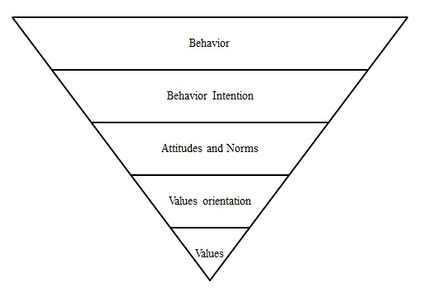
Figure 3. Cognitive Hierachy Model (Fluten, Manfredo and Lipscomb, 1996)

b. Developing an Integrated Theoretical Model (SDT and TPB)
In this section, first a brief outline of the main SDT and TPB concepts as well as theoretical integration will be provided. Then, a review of 36 integrated studies which provided 45 tests examining the effects of TPB and SDT variables is presented.
Hagger et al. (2009) argued that TPB and SDT theories have some drawbacks. Before explaining the rationale behind theoretical integration, the hypotheses related to each theory will be explained here. As you can see in figure 4, according to the TPB, the most proximal predictor of target behaviour is the person’s intention which is the mediator of the effect of three belief-based behaviour perceptions, i.e. attitudes, subjective norms, and perceived behavioural control. A person’s general positive or negative assessment of the behaviour is referred to as attitude. Subjective norms are the expectation of important others from a person to perform the target behaviour. The perceived behavioural control refers to the individual’s overall judgment about their ability and available resources to perform the behaviour.
The focus of self-determination theory (SDT) is on one’s motivation quality in a particular context as well as the environmental factors influencing motivation in the given context (Deci & Ryan, 1985; Hagger & Chatzisarantis, 2009). The distinction between self-determined and controlled motivation is an essential feature of this theory (Ryan & Deci, 2000). People with self-determined motivation feel that they have autonomy and personal choice and that what they do is a reflection of their true self. On the other hand, individuals with controlled motivation feel to be under pressure to behave by external forces. Research on SDT shows that self-determined motivation has positive effects on engagement in behaviour (Chatzisarantis, Hagger, Biddle, Smith, & Wang, 2003) and this type of motivation can be enhanced by environmental factors, such as significant others (Hagger & Chatzisarantis, 2007; Reeve et al., 1999).
The shortcomings of the theories explained above have been highlighted by Hagger and colleagues. First, self-determination theory does not explain how proximal factors, such as beliefs, planning and commitment affect the actual behaviour performance (Hagger & Chatzisarantis, 2009; Hagger, Chatzisarantis, & Biddle, 2002). Second, the theory of planned behaviour does not provide details related to the origins of attitudes, subjective norms, and perceived behavioural control. Also, the TPB does not clearly explain how information sources, e.g. general motives might affect intention through the mediation of proximal variables included in the theory. Therefore, the integration of TPB and SDT may tackle the shortcomings of both theories and lead to a more thorough analysis of the cognitive and motivational processes affecting intention and behaviour. In the integrated model, autonomous and controlled motivation have been found to be distal predictors of behaviour (Hagger & Chatzisarantis, 2009; Hagger, et al., 2002), whereas attitude, subjective norms and perceived control are considered the proximal predictors of behaviour (Hagger & Chatzisarantis, 2009). See figure 4 for better understanding.

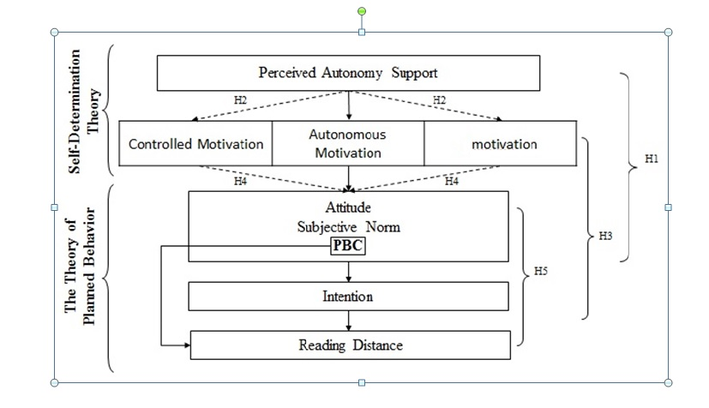
Figure 4. Integrated model SDT and TBP (Hagger & Chatzisarantis, 2009).

The Motivation Model
Research on motivation attempts to explain the reasons for individuals’ choice of certain activities. One of the widely used motivation theories in the field of recreation is the expectancy value theory. This theory presents two reasons for behaviour: expecting specific behaviours to result in desirable events and the probability of the events leading to valued psychological results (Decker, Riley, & Siemer, 2012). Applying this to recreation, we can say that individuals choose and engage in recreation activities to achieve goals or satisfy certain needs. According to Manning (1999), these activities are means to an end rather than ends. A framework has been provided by the expectancy value theory, using the recreation experience preferences (REP) scales in more than 35 studies (Driver, Tinsley, & Manfredo, 1991).
Motivation is usually considered to be an internal condition; however, external factors in the social context can impact on the individual’s decision to engage in recreational activities. Mannel and Kleiber (1997) argued that, “at first glance, the focus of motivational explanation appears to be internal to the person. However, on closer scrutiny, the motivational answers to these “why questions” have both personal and situational components, and require an inter actionist perspective to be understood”. A four-stage motivation model developed by Mannel and Kleiber (1997) describes the process of decision making for the participation in a recreational activity by an individual. The motivation model consists of four components, namely motives or needs, activity or behaviour, satisfaction or goals, and feedback. Their hypothesis was that arousal of motivation or need emergence leads to disequilibrium. An individual, in an attempt to reduce disequilibrium by goal achievement, participates in an activity expected to satisfy the need. Feedback will reinforce future behaviour/activity, if engaging in an activity leads to need satisfaction. If the activity does not result in satisfaction of need, then future participation will be discouraged by the negative feedback. The definitions of motivation vary in outdoor recreation. Generally, the reason one wants to engage in a
recreational activity is regarded as the motive for the behaviour(Stankey & Schreyer, 1987). A motive is regarded as a predisposition to satisfy a particular kind of need. Driver, Tinsley, and (Manfredo & Bright, 1991) refer to participation reasons in outdoor recreation also as recreation experience preferences. Motivations have been defined by Decker et al., (2012) as cognitive forces driving individuals to the achievement of certain goals. The potential of motivations to affect satisfaction by fulfilling individual needs, preferences, and goals makes studying motivations in recreation very important. The Expectency Value Model is shown in Figure 5.

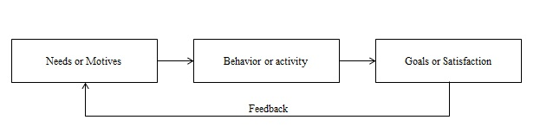
Figure 5. Model of Motivation , Expectancy Value Model (Decker et al., 2012).

D. Responsible/Pro Environmental Behavior
Hines and his coleagues (1987) conducted an important meta-analysis study on responsible environmental behaviour, including 128 studies. A large number of these studies investigated the relationship between pro-environmental behaviour and socio-cultural variables. Nevertheless, a limited share of analyzed studies focused on the relationship between the four psychological variables, namely attitude, self-efficacy/locus of control, behavioural intention, and moral responsibility and pro-environmental behaviour (Bamberg & Möser, 2007).
In the environmental behaviour model proposed by Hines et al. (1987), the intention to act and objective situational factor directly determine the pro-environmental behaviour. In this model, intention is considered as a summary of the interaction of cognitive variables such as action skills and knowledge of action strategies and issues and personality variables such as attitude, locus of control, and personal responsibility; see Figure 6 for further understanding.
We may best view pro-environmental behaviour as a mix of self-interest, concern for others, the next generation, other species, or ecosystems, e.g. air pollution prevention. The mentioned mixture has also been stressed by the most frequently used models to explain pro-environmental behaviour.
In the studies that focus on the view that environmental behaviour is mainly motivated by pro-social factors, researchers employ the norm activation model (Liere & Dunlap, 1978) as theoretical framework, while those regarding self-interest as the main reason, focus on models of rational choice, such as the TPB (Ajzen, 1991). The main principle of norm activation model is that pro-social behaviour is directly determined by moral or personal norms. According to Schwartz (1977), moral norms are a sense of strong moral obligations experienced by individuals themselves to perform social behaviour (Ajzen, 1991). Consistent with this model, a number of studies showed the contribution of moral norms to explaining pro-environmental behaviours such as energy conservation, recycling, travel mode choice, and pro-environmental buying. A correlation between moral obligation towards environment preservation and pro-environmental behaviour has been found by Hines et al. (1987). A moral norm seems to be formed and activated as a result of the interaction of cognitive, emotional, and social factors . The important cognitive prerequisites for the development of moral norms in pro-environmental behaviour are probably the awareness and knowledge about environmental issues(Bamberg & Möser, 2007). According to Weiner (2005) when a harmful behaviour is attributed internally, it causes emotional reactions called guilt feelings. Guilt refers to ‘‘a painful feeling of regret that is aroused when the actor actually causes, anticipates causing, or is associated with an aversive event.’’ (Ferguson, 2005). It is considered as a significant pro-social emotion since it leads to a feeling of obligation to make up for the damaged caused (Baumeister, Vohs, & Tice, 2007). Guilty feelings are associated with social norms as well. According to Baumeister (1998), feeling guilty is a consequence of a mismatch perceived between an individual’s behaviour and norms of the society (Figure 7). In addition to their effects on feelings of guilt, social norms have a direct contribution to the social norms development. These norms provide the standard for the appropriateness of behaviour in the eyes of a social reference group in a particular context. The content of an individual’s personal moral norms results from the internalization of these standards by the individual.
Ajzen’s theory of planned behaviour as the second theoretical framework is based on a hedonistic view of individuals. The assumption in this model is the individuals’ motivation to avoid punishment and look for rewards. The model holds that making decisions is based on rational evaluation of the consequences of behaviour. The overall attitude towards a behavioural option is determined by a combination of perceived positive and negative consequences of that behaviour. There is no direct relationship between attitude and behaviour, rather attitude influences behaviour through intention indirectly.
The significance of situational limitations is also emphasized by the TPB. In forming intentions, individuals consider not only their behavioural attitudes but also their norm performance ability. The assumption here, consistent with Sherif’s (1936) research on the informational effects of social norms, is that rather than following social norms for fear of social pressure, people follow them to use social norms as information about the appropriateness of certain behaviours. Hence, social norms can not only determine the moral appropriateness of specific behaviour, but also they can determine if the behaviour is easy or beneficial to perform.
Regarding the statement discussed earlier that pro-environmental behaviour can be a combination of self- interest and social motives, combining the above mentioned theories has been suggested as well. Therefore, moral norm has been proposed to be considered as an additional predictor for intention in addition to attitude, social norms and perceived behavioural control (Manstead, 2000). In a study on the determining factors of some pro-environmental intentions, Harland, Staats, & Wilke (1999) showed that adding moral norm to the determinants increased the intention variance by 1-10%.
Additionally, as shown in Figure 7, feelings of guilt, internal attribution, social norm, and problem awareness are important predictors of moral norm. They account for 58% of the moral norm variance altogether. The assumption that in addition to a direct and indirect relationship between social norm and moral norm, social norm has a direct influence on perceived behavioural control and attitude, has been confirmed. Also, feelings of guilt and attitude are directly associated. Internal attribution is assumed to be a major predictor of moral norm, social norm, feelings of guilt, and attitude(Bamberg & Möser, 2007).
Nevertheless, these associations should be taken with caution since they are based on a single study, rather than pooled correlations. Results by MASEM supported indirect, yet significant, role of problem awareness, which has a direct association with guilt, moral norm, social norm, and internal attribution (Bamberg & Möser, 2007).

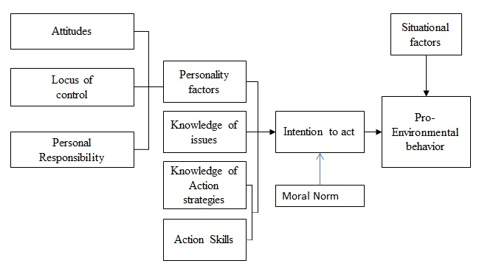
Figure 6. Pre-environmental Behaviore Model (Hines et al., 1987)

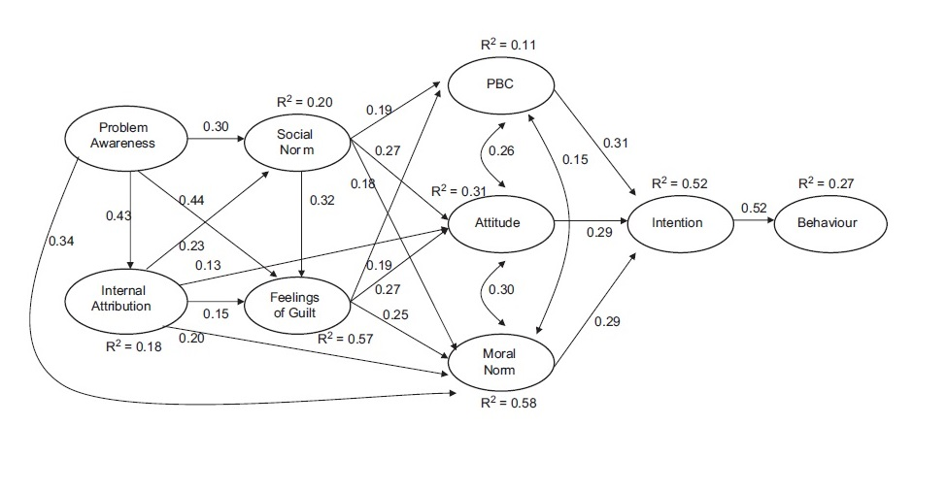
Figure 7. : Results of the MASEM based on pooled random-effect correlations, PBC: perceived behavioral control, single-headed arrows, standardized path-coefficients; double-headed arrows, correlations, R²: explained variance (Bamberg & Möser, 2007).

G. Final Integration
The final aim of this article is the presentation of an integrated model. The central model in this integration is the TPB, which has been used as the theoretical framework in 185 studies. The basic constructs of this theory are attitude, perceived behavioural control, and social norm. The motivational combination of these variables creates behavioural intention. According to the literature, adding PBC to the reasoned action model, as a major factor, increases target behaviour performance variance.
Additionally, other variables such as past behavior, self-efficacy, knowledge, etc. can be acceptable depending on the situation and even can increase the power of behavior prediction. Moreover, the responsible environmental behavior model includes personal responsibility which mediated trough personal factors, domain of knowledge (knowledge of action strategy and knowledge of issue) and action skills and can be a response to the lack of clarity about which variables were most effective on motivating individuals to engage in a responsible environmental behaviour.
On the other hand, it is said that implementation intentions transfer goal-directed behaviour control to situational cues, thus behaviour initiation becomes automated. Instead, implementation intentions can be influential since they lead to commitment to the target behaviour. In line with the commitment hypothesis, the specific and general implementation intentions similarly raised task performance level significantly by requiring an overt commitment to task performance. In addition, highly conscious individuals were more likely to enact their intentions compared to less conscious ones (Ajzen, 2009).
Also, the integrated model of cognitive hierarchy and TPB is recommended. The former consists of values, value orientations, attitudes, normative beliefs, behavioural intentions, and behaviours, which are built upon another in the form of an inverted pyramid structure with relatively few values as the foundation and functioning as the guiding principles for individual behaviours. Furthermore, combining the SDT and TPB can almost compensate for the deficiencies of the two models and raise the prediction power of target behaviour.
Furthermore, including motivation model and expectancy value model will provide a framework for perceived autonomy support to fulfil end satisfaction and goals. The four stage general motivation model provides a description of the process of decision making by an individual to engage in a leisure activity. The motivation model consists of four components, namely needs or motives, behaviour or activity, goals or satisfaction, and feedback.
The results of meta-analysis studies also support the view that pro-environmental behaviour is a mix of self-interest and pro-social motives (Bamberg, 2007). The results of MASEM study by Bamberg & Möser (2007) confirm the assumption that with regard to pro-environmental behaviour, a moral norm is formed and activated as a result of an interplay of cognitive, emotional, and social variables. Problem awareness, internal attribution, feelings of guilt, and social norms are all significant predictors of moral norm. These predictors are responsible for 58% of moral norm variance.
Moreover, intention is believed to be a summary of cognitive (action skills, knowledge of action strategies and issues) and personality variables (attitudes, locus of control, and personal responsibility). Finally, this advanced model of TPB can be applied in most scientific regions in the field of wildlife and ecotourism management. The final integrated model and subgroup models can also be applied in research in other fields, where TBP can be used. Further studies need to confirm the domain of using integrated models. The final integrated model is shown in Figure 8.

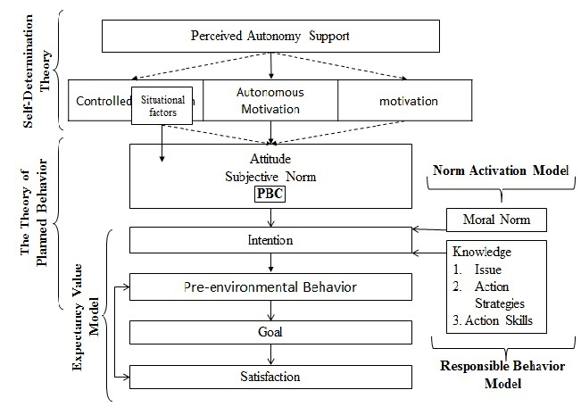
Figure 8. Final Integration (Integrated Model of TBP, EVM, SDT, PBM).

ACKNOWLEDGEMENT
The authors would like to express their gratitude and appreciation from Universiti Putra Malaysia for supporting the fees for publish.

Corresponding Author:
Dr. Manohar.M
Department of Ecotourist and Recreation
Universiti Putra Malaysia
43400 Serdang, Selangor, Malaysia
E-mail: mano@upm.edu.my

Reference

- Ajzen, Icek. (1991). The theory of planned behavior. Organizational behavior and human decision processes, 50(2), 179-211.
- Ajzen, Icek. (2002). Constructing a TPB questionnaire: Conceptual and methodological considerations.
- Ajzen, Icek, Brown, Thomas C, & Carvajal, Franklin. (2004). Explaining the discrepancy between intentions and actions: The case of hypothetical bias in contingent valuation. Personality and social psychology bulletin, 30(9), 1108-1121.
- Ajzen, Icek, Czasch, Cornelia, & Flood, Michael G. (2009). From Intentions to Behavior: Implementation Intention, Commitment, and Conscientiousness1. Journal of Applied Social Psychology, 39(6), 1356-1372.
- Ajzen, Icek, & Fishbein, Martin. (1977). Attitude-behavior relations: A theoretical analysis and review of empirical research. Psychological bulletin, 84(5), 888.
- Armitage, Christopher J, & Christian, Julie. (2003). From attitudes to behaviour: Basic and applied research on the theory of planned behaviour. Current Psychology, 22(3), 187-195.
- Armitage, Christopher J, & Conner, Mark. (2001). Efficacy of the theory of planned behaviour: A meta‐analytic review. British journal of social psychology, 40(4), 471-499.
- Bamberg, Sebastian, & Möser, Guido. (2007). Twenty years after Hines, Hungerford, and Tomera: A new meta-analysis of psycho-social determinants of pro-environmental behaviour. Journal of environmental psychology, 27(1), 14-25.
- Baron, Reuben M, & Kenny, David A. (1986). The moderator–mediator variable distinction in social psychological research: Conceptual, strategic, and statistical considerations. Journal of personality and social psychology, 51(6), 1173.
- Baumeister, Roy F, Vohs, Kathleen D, & Tice, Dianne M. (2007). The strength model of self-control. Current directions in psychological science, 16(6), 351-355.
- Bruskotter, Jeremy T, Schmidt, Robert H, & Teel, Tara L. (2007). Are attitudes toward wolves changing? A case study in Utah. Biological Conservation, 139(1), 211-218.
- Chatzisarantis, Nikos LD, Hagger, Martin S, Biddle, Stuart JH, Smith, Brett, & Wang, John CK. (2003). A meta-analysis of perceived locus of causality in exercise, sport, and physical education contexts. Journal of Sport and Exercise Psychology, 25(3), 284-306.
- Corey, Stephen M. (1937). Professed attitudes and actual behavior. Journal of educational psychology, 28(4), 271.
- Decker, Daniel J, Riley, Shawn J, & Siemer, William F. (2012). Human dimensions of wildlife management: JHU Press.
- Deutsch, Morton, & Gerard, Harold B. (1955). A study of normative and informational social influences upon individual judgment. The journal of abnormal and social psychology, 51(3), 629.
- Driver, BL, Tinsley, E, & Manfredo, MJ. (1991). The paragraphs about leisure and recreation experience preference scales: Two inventories designed to assess the breadth of perceived psychological benefits of leisure. Benefits of leisure, 263-286.
- Elliott, Mark A, & Armitage, Christopher J. (2009). Promoting drivers' compliance with speed limits: Testing an intervention based on the theory of planned behaviour. British journal of psychology, 100(1), 111-132.
- Ferguson, Tamara J. (2005). Mapping shame and its functions in relationships. Child maltreatment, 10(4), 377-386.
- Forward, Sonja E. (2009). The theory of planned behaviour: The role of descriptive norms and past behaviour in the prediction of drivers’ intentions to violate. Transportation Research Part F: Traffic Psychology and Behaviour, 12(3), 198-207.
- Hagger, Martin S, & Chatzisarantis, Nikos LD. (2009). Integrating the theory of planned behaviour and self‐determination theory in health behaviour: A meta‐analysis. British journal of health psychology, 14(2), 275-302.
- Hagger, Martin S, Chatzisarantis, Nikos LD, & Biddle, Stuart JH. (2002). A meta-analytic review of the theories of reasoned action and planned behavior in physical activity: Predictive validity and the contribution of additional variables. Journal of sport & exercise psychology.
- Hardeman, Wendy, Johnston, Marie, Johnston, Derek, Bonetti, Debbie, Wareham, Nicholas, & Kinmonth, Ann Louise. (2002). Application of the theory of planned behaviour in behaviour change interventions: A systematic review. Psychology and health, 17(2), 123-158.
- Harland, Paul, Staats, Henk, & Wilke, Henk AM. (1999). Explaining proenvironmental intention and behavior by personal norms and the theory of planned behavior1. Journal of applied social psychology, 29(12), 2505-2528.
- Hines, Jody M, Hungerford, Harold R, & Tomera, Audrey N. (1987). Analysis and synthesis of research on responsible environmental behavior: A meta-analysis. The Journal of environmental education, 18(2), 1-8.
- Hrubes, Daniel, Ajzen, Icek, & Daigle, John. (2001). Predicting hunting intentions and behavior: An application of the theory of planned behavior. Leisure Sciences, 23(3), 165-178.
- J. Vaske, Maureen P. Donnelly, Daniel R. Williams, Sandra Jonker, Jerry. (2001). Demographic influences on environmental value orientations and normative beliefs about national forest management. Society &Natural Resources, 14(9), 761-776.
- Kaczensky, Petra, Blazic, Mateja, & Gossow, Hartmut. (2004). Public attitudes towards brown bears (< i> Ursus arctos</i>) in Slovenia. Biological Conservation, 118(5), 661-674.
- Kokkinaki, Flora, & Lunt, Peter. (1997). The relationship between involvement, attitude accessibility and attitude–behaviour consistency. British Journal of Social Psychology, 36(4), 497-509.
- Liere, Kent D, & Dunlap, Riley E. (1978). Moral Norms and Environmental Behavior: An Application of Schwartz's Norm‐Activation Model to Yard Burning1. Journal of Applied Social Psychology, 8(2), 174-188.
- Lindsey, Peter A, Du Toit, Johan T, & Mills, MGL. (2005). Attitudes of ranchers towards African wild dogs< i> Lycaon pictus</i>: Conservation implications on private land. Biological Conservation, 125(1), 113-121.
- Manfredo, Michael J, & Bright, Alan D. (1991). A model for assessing the effects of communication on recreationists. Journal of Leisure Research.
- Manfredo, Michael J, Teel, Tara L, & Henry, Kimberly L. (2009). Linking Society and Environment: A Multilevel Model of Shifting Wildlife Value Orientations in the Western United States*. Social Science Quarterly, 90(2), 407-427.
- Mannell, Roger C, & Kleiber, Douglas A. (1997). A social psychology of leisure: Venture Publishing Inc.
- Manstead, Antony SR. (2000). The role of moral norm in the attitude–behavior relation.
- Marchini, Silvio, & Macdonald, David W. (2012). Predicting ranchers’ intention to kill jaguars: case studies in Amazonia and Pantanal. Biological Conservation, 147(1), 213-221.
- Parker, Dianne. (2002). Changing drivers' attitudes to speeding: Using the Theory of Planned Behaviour.
- Rivis, Amanda, & Sheeran, Paschal. (2003). Descriptive norms as an additional predictor in the theory of planned behaviour: A meta-analysis. Current Psychology, 22(3), 218-233.
- Ryan, Richard M, & Deci, Edward L. (2000). Self-determination theory and the facilitation of intrinsic motivation, social development, and well-being. American psychologist, 55(1), 68.
- Schwartz, Stephen P. (1977). Naming, necessity, and natural kinds.
- Sheeran, Paschal. (2002). Intention—behavior relations: A conceptual and empirical review. European review of social psychology, 12(1), 1-36.
- Sherif, Muzafer. (1936). The psychology of social norms.
- St John, Freya AV, Edwards-Jones, Gareth, & Jones, Julia PG. (2011). Conservation and human behaviour: lessons from social psychology. Wildlife Research, 37(8), 658-667.
- Stankey, George H, & Schreyer, Richard. (1987). Attitudes toward wilderness and factors affecting visitor behaviour: a state-of-knowledge review. General Technical Report, Intermountain Research Station, USDA Forest Service(INT-220), 246-293.
- Teel, Tara L, & Manfredo, MICHAEL J. (2010). Understanding the diversity of public interests in wildlife conservation. Conservation Biology, 24(1), 128-139.
- Terry, Deborah J, Hogg, Michael A, & White, Katherine M. (1999). The theory of planned behaviour: self‐identity, social identity and group norms. British Journal of Social Psychology, 38(3), 225-244.
- Vaske, Jerry J, Jacobs, Maarten H, & Sijtsma, Mette TJ. (2011). Wildlife value orientations and demographics in The Netherlands. European Journal of Wildlife Research, 57(6), 1179-1187.
- Wallmo, Kristy, & Jacobson, Susan K. (1998). A social and environmental evaluation of fuel-efficient cook-stoves and conservation in Uganda. Environmental Conservation, 25(02), 99-108.
- Weiner, Bernard. (2005). Motivation from an attribution perspective and the social psychology of perceived competence. Handbook of competence and motivation, 73-84.

2/20/2021

