Karachi is an important Growth Pole of Pakistan and CPEC: Recent Study of Pakistan

Mohsin Rasheed¹, Liu Jinhua¹
¹ Department of Management Engineering, Zhengzhou University, Zhengzhou 450001, China
contactmohsinz@zzu.edu.cn, Ljh@zzu.edu.cn

Abstract: This study investigate the economic development in Pakistan with the help of growth poles theory. Karachi rank 7th biggest city, where people are willing to see major development such as economic and social. It has 27.5 million people and has a GDP over $164 billion and is the most populous and biggest growth pole, by the side of the major urban poles of Pakistan: Gwadar, Lahore, Islamabad and Peshawar. The budget of CPEC has increased from $46 billion to $64 billion after addition some energy and infrastructure projects. Major industrial import and export govern from Karachi sea routes, as china 60% oil is also governed by sea route. Karachi has become the symbol of innovation and increase the power in Pakistan after launching a China Pakistan Economic Corridor (CPEC) project which is an essential part of Belt and Road Initiative (BRI). This article attempts to focus on the implication of Special Economic Zones (SEZSs) and growth poles in CPEC projects.
[Mohsin Rasheed. Karachi is an important Growth Pole of Pakistan and CPEC: Recent Study of Pakistan. N Y Sci J 2021; 14(3):32-37]. ISSN 1554-0200 (print); ISSN 2375-723X (online). http://www.sciencepub.net/newyork 8. doi:10.7537/marsnys140321.08.

Keywords: CPEC, SEZS, Growth pole, BRI, China, and Pakistan.

- INTRODUCTION
The concept of growth pole was started in the 1950s, within the structuralized policy of regional development. Growth pole basically linked with economic growth in the area or clustering. Ramona Camelia Bere (2020). The concept is differ in term, it’s usually refer to urban areas or firms where growth was focused by (F. Perroux). In this article we define growth pole in Pakistan and how it become more innovate CPEC projects.
Karachi is the main industrial hub of Pakistan, where population is 27 million. It is a 7th biggest city in the globe. Karachi has become the symbol of innovation and increase of power in Pakistan after launching a CPEC. There are nine economic zones and other export zones which is directly related to CPEC development. In this research we take Karachi city as a growth pole, with the help of we analyze the industrial development and overall economic development.
China-Pakistan Economic Corridor has launched various projects related to energy, infrastructure and railroads. The budget of CPEC has increased from $46 billion to $62 billion which is a huge amount for development. On the other hand India is trying to start a corridor of its own named “The North South corridor”. The success of such Projects is yet to be seen. Another growth pole Gwadar will become the gateway to China, it will become a huge business hub after completion of the CPEC project. Right now the major growth pole Karachi is going to take advantage in terms of economic development.
CPEC is a win mega project which aim to connect Gwadar Port of Pakistan to China Xinjiang, through network of highways, railways, and pipelines. The economic corridor is considered significant to China Pakistan relations and will run about 2700 km from Gwadar to Kashgar. CPEC and its connectivity with Middle East, Central Asia and Africa will help to boost economy and global opportunities. Overall construction costs are estimated at around $64 billion, lot of energy, infrastructure and Gwadar projects which will complete in several years.

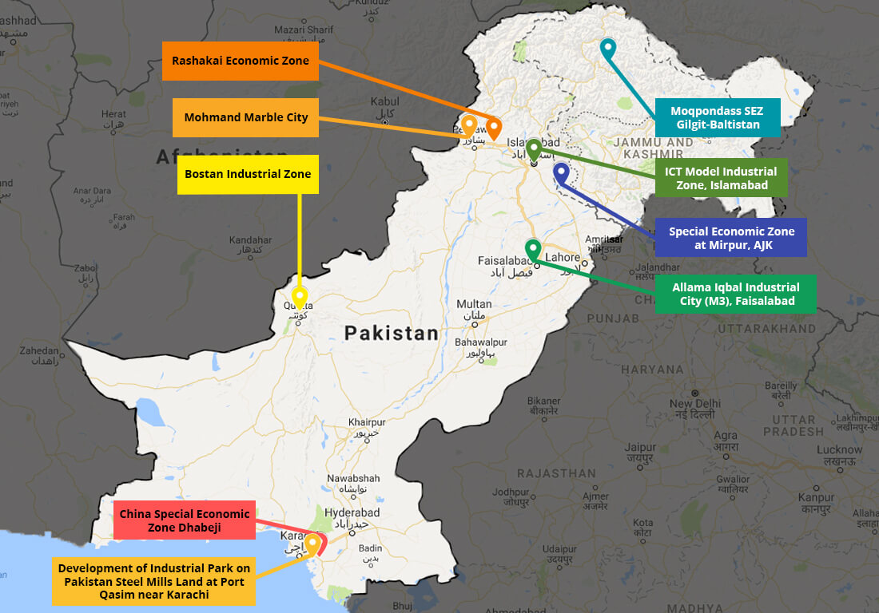

Source: Cpec.gov.pk

1.1 MAIN COMPONENTS OF CORRIDOR:
- Gwadar Projects
- Infrastructure Projects
- Energy Projects

Table 1: shows the CPEC major projects in Pakistan along with their values.
No | Project | No of Projects | Cost in (Million $)
1 | Energy | 21 | 33,794
2 | Infrastructure | 4 | 9,783
3 | Gwadar | 8 | 700

- LITRATURE REVIEW
After analysis of some reviews Khalida Mehmood (2016) told that Pakistan has experienced very deliberate development ranging from 0.8% in 2012-2013 to 4.24 in 2014 to 2015. She used urban development and industrial clustering in Pakistan. However, due to assured strategic and economic developments that include the construction of China-Pakistan Economic Corridor (CPEC), the country's economy boosted up towards positive trends and major sectors of the economy during 2014-2020. Therefore, the GDP growth rate stood at 5.5 % in 2020.
Pakistan due to fundamental .governmental limitations, is still acting to overcome economic goals which is about 8% annual growth. In addition, in the late 2018-19 the GDP growth rate has dropped from 5.2.to 3.8 percent. In another review Abdul Samad (2020) says importantly, after covid-19 Pakistan growth rate is growing negatively due to shortage of labor and lockdown but now Prime Minister Imran khan allows development in CPEC projects.
Khan D K (2016) says in his research, in Pakistan there are the special economic zones created by the government for better economic growth and number of challenges as well therefore, the main project CPEC was organized. By Chinese leader Li Keqiang in May 2013 during his visit to Pakistan. At the same time, an official memorandum was signed in Beijing in the presence of Prime Minister Nawaz Sharif. Then, on April 10, 2015, Chinese President Xi Jimping, together with Prime Minister Nawaz Sharif, launched CPEC.signing 51 memorandums of understanding and agreements totaling $ 46 billion, but after a while the cost increased to $ 62 billion, adding some more projects.
In another study of Emilian M. Dobresc (2014) shows Shanghai is a major growth pole in china where GDP is over 300 billion dollar. He said shanghai is the first terminal of export goods and also a gateway of workshop. Shanghai is one the highest volume of export goods containers. It has become the biggest trade hub and a region that extents west axis of Yangtze River and other link cities with industrial functions.

- METHODOLOGY
The article was written by using official sites of CPEC, Pakistan government, documents, reports and other published summaries as a primary source of information. It uses data and reports in the literature that were analyzed, compared and processed in order to shape the conclusions on the influence of growth pole industries, Challenges and special economic zones in Pakistan.
The following economic and competitiveness indicators were calculated and analyzed:
- Number of enterprises in the industry in growth poles
- Number of industrial parks
- Number of Special economic zones
The data use from these major official sites in Pakistan
- Statistical data sources
- Pakistan Statistical Directory
- Pakistan board of investment
- World Bank
- Pakistan China Pakistan corridor organization

- RESULTS AND DISCUSSION
4.1 GROWTH POLE IN PAKISTAN
In Pakistan there are 8 special economic zones and export processing zones. Karachi by contrast is extremely well connected, is highly industrialized, with all skill sets available and hosts two thriving ports. Karachi is moreover expanding at such a hectic pace, particularly along the National Highway and the Super Highway that the planned port of Keti Bandar, the planned city of Zulfiqarabad and the planned economic zone at Dhabeji.

Table 1: Existing SEZSs in Pakistan
No. | Type | Location
1 | Karachi Export Processing Zone | Karachi (Sindh)
2 | Risalpur Export Processing Zone | Risalpur (KP)
3 | Sialkot Export Processing Zone | Sialkot (Punjab)
4 | Gujranwala Export Processing Zone | Gujranwala (Punjab)
5 | Khairpur Special Economic Zone | Khairpur (Sindh)
6 | Rashkai Economic Zone | Rashakai (KP)
7 | Gadoon Economic Zone | Swabi (KP)
8 | Hattar Economic Zone | Haripur (KP)

In Table 1 shows IEs and EPZs Pakistan under Statutory Regulatory Orders (SROs) issued by the Ministry of Industries and Production (MOIP). The Pakistan government identify approximately 45 SEZS for development of CPEC. Due to these SEZS, Pakistan economy is growing rapidly. In 2012, a dedicated Act was promulgated; promising special incentives to enterprises at notified SEZSs, and by 2020, eight SEZSs were formally launched. Currently, several of these SEZSs are ready to be operational, while a few are under develop.

  - KARACHI INDISTRIAL PARKS
Karachi is now Pakistan's premier industrial and financial growth pole. The city has a formal economy estimated to be worth $165 billion as of 2020 which is the largest in Pakistan. Karachi collects more than a third of Pakistan's tax revenue, and generates approximately 21 % of Pakistan's GDP.

Table 2. Industrial parks in Karachi, Source: Board of Investment
No. | Industrial Parks Karachi | Total Number of Industries
1 | District Malir | 648
2 | F.B Area | 111
3 | Korangi | 559
4 | North Karachi | 95
5 | District West (S.I.T.E) | 1998
6 | District South | 6
 | Total | 3417

In this Table No 2 shows there are 6 industrial parks and a number of industries in the growth pole. Karachi is now Pakistan's premier industrial and financial growth pole. The city has a formal economy estimated to be worth $165 billion as of 2020 which is the largest in Pakistan. Karachi collects more than a third of Pakistan's tax revenue, and generates approximately 21 % of Pakistan's GDP.
In Figure 2 shows the industrial growth pole in Karachi. There are large number of industries linkages for economic development in Pakistan. It is directly and indirectly benefit for CPEC project as well as economic benefit. Karachi is a major business hub in Pakistan and a number of special economic zones exist in the area. Growth pole help to attain FDI, level of production, employment opportunities and research and development. According to the Karachi Chamber of Commerce, 77% of successful entrepreneurs in the past 15 years in Karachi are between the ages of 30 and 44, as long as the people are sincere and willing to contribute to progress. Karachi will be able to meet all the challenges and opportunities that will come and thus contribute to the success of CPEC in future.
Source: Romania growth pole and regional development

SECTORIAL SEZS IN KARACHI
Although the initial round of CPEC investments mainly focused on energy projects and infrastructure projects with the help of SEZS and growth poles. A number of industrial park in Karachi under CPEC which attract investor, who want to invest in Pakistan industry and the booming export markets of Middle East and North Africa. In return, Pakistan would get investments and jobs, ushering in a new era of industrialization. In Table No. 3 shows SEZs in Sindh, two of them are located in Karachi and rest of the one is located in khairpur Sindh. After construction of these zones it has a major role in boosting Pakistan economy and also betterment for CPEC growth.

Table 3. Sectorial SEZs in Karachi under CPEC
SEZS | Project cost | Unit under production | Unit under construction | Area
Korangi | 2.8Bn approx. | 19 | 25 | 250 acres
Bin Qasim | 9.8Bn approx. | 7 | 3 | 950 acres
Khairpur | 1.9Bn approx. | 6 | 6 | 140 acres

In Sindh area there are three main economic zones which is operating in Pakistan under CPEC projects. In this Figure 3 shows the cumulative data of three economic zones, which is specifically related to firms operation in SEZs. However it is said that the industrial sector contribution in Pakistan GDP is positive and this strategy is improving economy and attract foreign investors. It is proven that Karachi is one of the growth pole in Pakistan who generate revenue and economic growth.

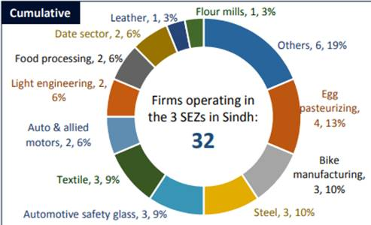
Figure 3 source: My own finding

- CONCLUSION
The establishment of industrial parks and growth poles will boost economic development in Pakistan. The study reveals that Karachi, the major business hub in Pakistan, significantly provide several opportunities for a large number of population in term of economic development and socio development. After an industrial analysis, we have investigated that industrial park help to generate more revenue and positively work for economic growth. CPEC is the most important project for China and Pakistan. Both the countries are expecting multiple advantages once the project is completed. After going through this complete study of industrial parks, growth pole and CPEC it can be said that Pakistan is on the roadway to socio-economic development. Growth pole is very beneficial for industrial sector of Pakistan.

- REFERENCE

- “The Role of the Sectorial Composition of Foreign Direct Investment on Economic Growth: A Policy Proposal for CPEC and Regional Partners”. (2016). “China-Pakistan Economic Corridor and Regional Integration” (pp. 1-18). Islamabad: Mr. Haider Ali.
- Khalida Mahmood1, R. A.-J. (2016). Urban Development and (growth pole) Industrial Clustering in Pakistan: A Study Based on Geographical Perspective. Journal of Basic & Applied, 32-40.
- Khan, D. K. (2016). Special Economic Zones (SEZs) and CPEC: Background, Challenges and Strategies. Journal of economics, 5-30.
- AYESHA and HANS DITRECH (2020). Implication for economic zones in Pakistan under CPEC. Journal of regional science inquiry, 179-194.
- Ramona Camelia Bere (2020). On Growth Poles from EU Countries in The Framework of Europe 2020, Procedia of economic and finance, 920-925 www.sciencedirect.com.

3/25/2021

