Response Of The Groundwater Regime Of The South Fergana River Basins To Global Warming

Mirzahmedov Ismoiljon Karimjon ugli

Department of Geography, Namangan State University, Uychi street 160136, Uzbekistan
Telephone: +998943462922, E-mail: mirzahmedovismoil@mail.ru

Abstract: The article presents the results of assessing the response of the groundwater regime in the river basins of South Fergana to global warming and covers the use and protection of natural resources of the Fergana. It also covers the issues of population growth in the Fergana and changes in the soils of the oasis as a result of various natural processes, reduced productivity and their protection.
[Mirzahmedov I.K. Taxonomic Response Of The Groundwater Regime Of The South Fergana River Basins To Global Warming. N Y Sci J 2021;14(3):1-4]. ISSN 1554-0200 (print); ISSN 2375-723X (online). http://www.sciencepub.net/newyork. 1. doi:10.7537/marsnys140321.01.

Key words: global warming, groundwater, groundwater level, fan, river basin, trend.

1. Introduction
In Central Asia, especially in Uzbekistan, the growing shortage of water resources from year to year creates many geoecological problems. The situation is complicated by the fact that here surface water resources are fully developed. If the first cause of complication is the consumers of water resources, then the second is their natural changes. The Fergana Valley is richer in inland water resources than other regions of Central Asia and Uzbekistan. That is why the valley has been one of the main centers of subsistence farming since ancient times [6]. The regime of surface waters is mainly determined by the regime of precipitation, their distribution over the territory and within the year, and changes in temperature. According to the change in global temperature, the 20th century is divided into 3 periods:
- Warming in 1910-1945;
- Somewhat cool period in 1946-1975;
- Warming since 1976, continuing to the present
In recent studies, an increase in the runoff of glacier-fed rivers flowing from the northern slopes of the Turkestan and Alai ridges has been established due to the increased melting of glaciers during the warming period [1]. This increase in the flow of glacial rivers should have led to changes in the regime of groundwater. As is known, the infiltration theory of groundwater formation is currently dominant. The volume of accumulation of infiltration waters mainly depends on the amount of atmospheric precipitation, porosity of rocks, the structure of the earth's surface, its absolute height above sea level, etc. Also, surface waters of rivers, canals, lakes, swamps, and reservoirs are involved in the formation of groundwater. Infiltration of water from these sources can form a new underground runoff in the underground layers or significantly increase the volume of groundwater and raise the level of groundwater [2].

2. Material and Methods

Table 1 Average values of the annual runoff of the Sokh and Isfayram rivers (m3 / s) and the level of groundwater in their basin
River names and well numbers | 1934-2015 | 1934-1945 | 1946-1975 | 1976-2015 | 1934-2015 | 1934-1945 | 1946-1975 | 1976-2015
 | Average values |  |  |  | Trend
Sokh | 44,14 | 41,36 | 41,08 | 47,71 | 0,02 | 0,14 | -0,01 | 0,04
21 | -2,44 | -2,07 | -2,30 | -2,67 | -0,02 | 0,05 | -0,06 | 0,04
28 | -1,62 | -1,40 | -1,49 | -1,80 | -0,02 | 0,22 | -0,10 | 0,03
56 | -0,94 | -0,69 | -0,96 | -0,97 | 0,00 | 0,24 | -0,05 | 0,06
Isfayram | 22,85 | 22,12 | 21,83 | 24,21 | 0,01 | 0,05 | -0,03 | 0,04
1 | -8,05 | -8,52 | -7,42 | -8,46 | -0,01 | 0,24 | -0,06 | 0,02
3 | -1,68 | -0,33 | -1,17 | -2,33 | -0,03 | 0,29 | -0,09 | 0,07

All this shows the essential role of surface runoff in the formation of groundwater. Therefore, the changes observed in the surface runoff as a result of global warming should also affect the groundwater regime. This article is devoted to the study of this issue on the example of the rivers of the southern part of the Fergana Valley - Sokh and Isfayram, flowing from the northern slopes of the Alay ridge. The Sokh River is fed mainly by glaciers and snow from the highlands. Therefore, it is most abundant in July-September due to increased thawing in summer at high temperatures. During the warming period, noticeable changes took place in the flow of the Sokh and Isfayram rivers (Table 1).

.

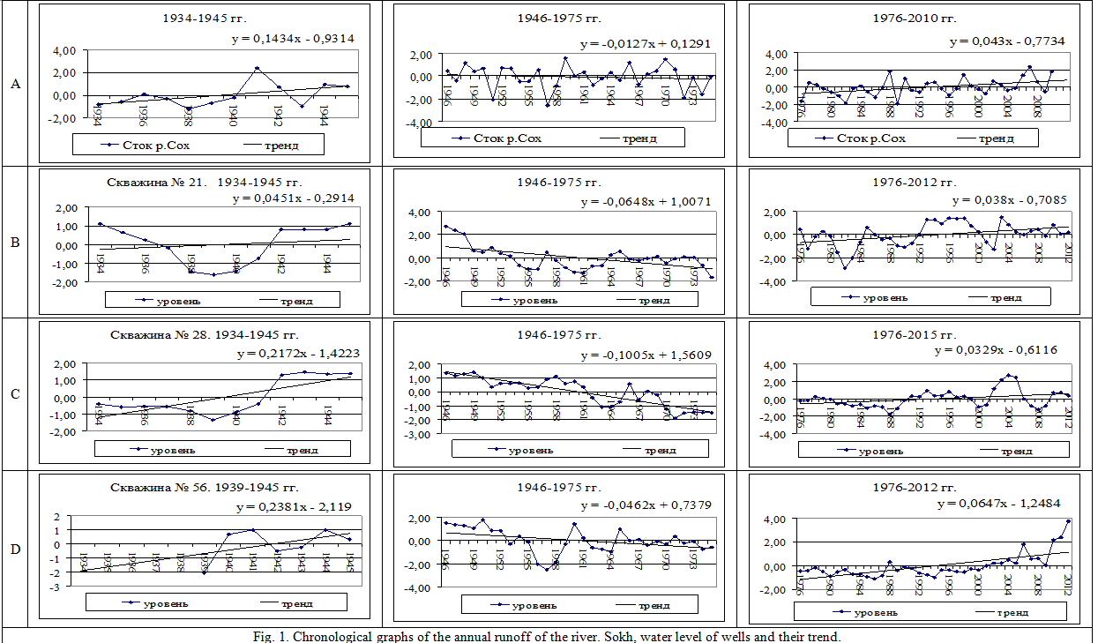
Fig. 1. Chronological graphs of the annual runoff of the river. Sokh, water level of wells and their trend.

3. Results
As you can see, the flow of rivers during the warming period up to 1945. was less than the average annual for 1934-2015, in 1946-1975 even less, and during the warming period after 1976 - much more. The groundwater level in these periods, in most cases, decreased from period to period. This does not correspond to the change in the flow of the rivers supplying groundwater. And along well 1 in the basin of the river. Isfayram, where in the period 1946-1975. there was a rise in the level of groundwater; we observe the opposite picture; during the period of no warming in 1946-1975. The history of irrigation of the Kokand Oasis has a long period, as a result of this process, significant changes occurred in the soil cover, the process of soil formation has passed from the automatic mode to the side of half-gomorph soil formation. The biological productivity of oasis soils is higher than the reserve sandy soils. For example, onshore plant biomass in cotton fields in Fergana valley is 5-8 tonnes per hectare and root biomass is estimated 0.5 tonnes [5]. The relative humidity is much lower, the temperature is relatively hot and dry, and the air pressure decreases as a result of warming up the temperature in spring and autumn. the groundwater level was higher than during the warming periods. However, chronological charts and the trend of annual river flow and water table give more consistent results among themselves. In fig. 1a shows the chronological graphs and the trend of the annual runoff of the Sokh River, corresponding to the three periods noted above. In these graphs, for ease of comparison, the average annual runoff is presented in a normalized form (q-qo) / σ, where q is the average annual runoff, m3, qo is the average annual runoff, σ is the standard deviation of the annual runoff. As can be seen from the figure, changes in the river flow. Sokh occurs in accordance with changes in air temperature. The trend of changes in the river flow. Sokh before 1945 had a positive value, in 1976-1975 it was negative, after 1976 it was negative. again positive. It should be noted that the increased flow of the river. Sokh during a warming period may be temporary, since such an increase occurs not due to an increase in precipitation in the river catchment, but as a result of increased melting of glaciers, whose areas are rapidly decreasing (Table 2) [3]. And this can subsequently lead to large changes in the river flow regime.

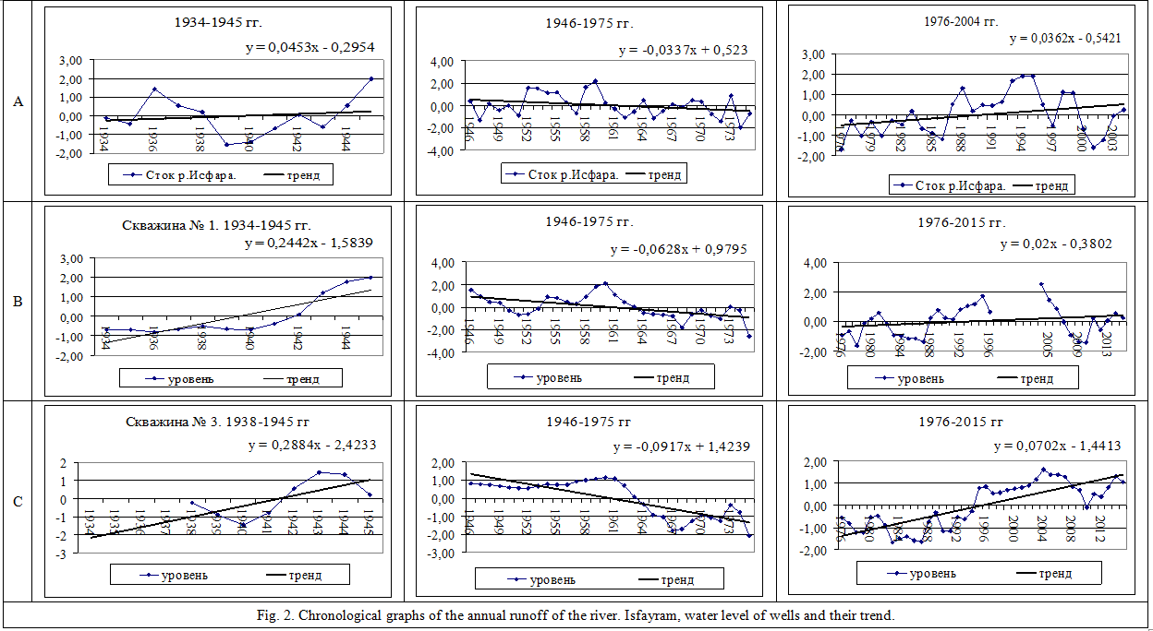
Fig. 2. Chronological graphs of the annual runoff of the river. Isfayram, water level of wells and their trend.
The table was compiled by the author using the data of the Fergana regional statistical department.

4. Discussions
Changes in the groundwater level in the river basin. Sokh has been recorded since 1934. to facilitate comparison of data on the river runoff. Sokh and about the groundwater level, the latter are also given in the normalized form (h-ho) / σ, where h is the average annual groundwater level in a given year, ho is its mean annual value, σ is the standard deviation of the annual values of the groundwater level.

Table 2 Glacier areas in the Sokh river basin
Years | Glacier area, km2 | Difference, km2 | Annual change in glacier area, km2 / year
1948 | 170
1968 | 258,7 | +88,7 | 4,44
1975 | 282,7 | +24,0 | 3,43
1980 | 244,1 | -38,6 | -6,44
2001 | 198,3 | -45,8 | -2,20

Such normalized values ​​of the groundwater table for the above-mentioned periods of warming are shown in Fig. 1b-d. Comparison of these graphs shows the correspondence of the trend of the groundwater level for all three observation points to the trend of the river flow. Sokh. However, there are big differences in the chronological course. Especially striking is the presence of a deep dip in the middle of the period in the chronological course of the groundwater level during the warming period before 1945. To determine the prevalence of these changes, such graphs were drawn for other river basins. Figure 2 shows similar graphs for the neighboring river Isfayram, It is also a river of glacier-snow supply. As can be seen from Fig. 2, the indicators of the runoff trend of the Isfayram and the groundwater level in the wells in its basin resemble what is observed in the Sokh river basin.
Acknowledgements:
Grounds: The authors are grateful to the Department of Science and Technology of the Republic of Uzbekistan for financial support for this work.

Corresponding Author:
Dr. Ismoiljon Mirzahmedov
Department of Geography
Samarkand state University
Samarkand 140104, Uzbekistan
Telephone: +998943462922
E-mail: mirzahmedovismoil@mail.ru

References:
- Soliev E.A. Abstract of dissertation for the degree of Candidate of Geographical Sciences "Assessment of water discharge in the rivers of the Fergana Valley in the context of climate change":.T - 2008. 32 pages.
- Mirzahmedov I.K. Use And Protection Of Natural Resources Of Kokand Oasis. Nature and Science. №12 (18), 2020. USA. –P. 49-52.
- Mirzahmedov I.K. Mathematical modeling and ecological optimization of the use of Fergana valley landscapes. Geography: nature and society journal. №1. ISSN: 2181-0834. DOI: http//dx.doi.org/10.26739/ 2181-0843-2020-1-3. Vol 1: Issue 1. Тashkent.
- Boymirzayev K.M., Mirzahmedov I.K. Geoecological Problems and their Prevention in Kokand Oasis Landscapes. Electronic Research Journal of Social Sciences and Humanities. ISSN: 2706 – 8242. Vol 1: Issue III www.eresearchjournal.com Pakistan.
- Boymirzayev K.M., Mirzahmedov I.K. Specific features of formation and development of oasis soils in fergana valley. Science and education scientific journal. ISSN 2181-0842. Volume 1, Issue 2. 2020. [Google scholar]
- Boymirzaev K.M., Mirzahmedov I.K. Oakh Landscapes And Their Creator Factors Study. The American Journal of Applied Sciences. ISSN 2689-0992. Volume 02, Issue 09. 2020. [Google scholar]

2/28/2021

