Subatomic particle structures and unified filed theory based on bipolar particle

Ebrahim Kefayati

Department of Engineering, Technical Campus, Tehran University, Tehran, Iran
z.kefayati0@gmail.com

Abstract: In this theory, all subatomic particles are formed from a magnetic bipolar particle. In fact, this particle is the smallest magnet in the universe. In this article, we describe the structure of quarks, anti-quarks, leptons, photons… and dark matter. This small magnetic particle is called particle “KFA”. We even describe the place where antimatter exists and why matter and antimatter do not destroy each other.
[Ebrahim Kefayati. Subatomic particle structures and unified filed theory based on bipolar particle. N Y Sci J 2021;14(2):30-34]. ISSN 1554-0200 (print); ISSN 2375-723X (online). http://www.sciencepub.net/newyork. 5. doi:10.7537/marsnys140221.05.

Keywords: KFA particle; Unified field theory; Big Bang

1. Introduction
In Physics, subatomic particles are smaller than atoms (Lewis, 1967). They can be composite particles, such as the neutron and proton or elementary particles which according to the standard model are not made of other particles (Oerter, 2006).
The elementary particles of the standard model are six types of quarks (Seez, 2017) and six types of leptons (Ozansoy, 2020) twelve gauge bosons (force carriers) (Riad, 2014). The photon of electro magnetism, the three w and z bosons (Tenchini & Verzegnassi, 2003).
Quark is one of the basic particles that combine to form composite particle’s called hadrons (Ullah et al, 2018). The most stable hadrons, protons and neutrons are the components of the atomic nucleus. Quarks are never found alone, and are not directly visible (Fox, 2009). There are six types of quarks the up and down quarks have the lowest mass (Nave, 2009). Heavier quarks quickly turn in to up and down quarks during a particle decay process. Because of this, up and down quarks are generally stable and one of the most abundant quarks in the world. Other quarks are produced in energetic collisions (Echenard, 2018).
Leptons are a group of elementary particles with spin are semi- correct and follow the Pauli principle (Krolikowski, 2005). leptons have two categories; electrically charged (Electron) and non- electrically charged (Neutrinos) (Martin et al, 1997).
There are six types of leptons that are classified in the three different types (Andre and Petr, 2013).
Electron (e) electron neutrino (υ_{e})
Muon (µ) muon neutrino (υ_{µ})
Tau (τ) tau neutrino (υ_{τ)}
Electrons have the lowest mass among charged leptons. leptons heavier muons and tau are rapidly converted to electrons in a particle decay process. Electron are the most abundant charged leptons in the world, while muon and tau occur in high – energy collisions (Frits et al, 1985).
Spin is an intrinsic property of elementary particles and its direction is an important degree of freedom (Richard and Milner, 2013).
The motion vector and the magnetic field vector make a 90 degree angle with each other and apply force to the magnetic particle (Prisiazhniuk and Flecken, 2017).

2. Material and Methods
Properties of KFA particle
It is the smallest magnetic particle in the universe that has no mass when it is not moving. The motion in these particles was created by big bang explosion (Lane and smith, 1993) and magnetism is the massless essence of this particle therefore, according to Flemings rule (Tuli, 2020), a force was applied to the particle. by applying force to one and at most two particles KFA rotation in a circuit begins. This is similar to the state of an atom where gravity is applied to the electron from the nucleus (Fore, 2020), but the electron is not absorbed by the nucleus due to Heisenberg’s uncertainty principle (Hilgevoord, 2001). This rule also applies to KFA particle, The orbit in which one KFA particle rotates is equal to the diameter of the electron and the orbit in which the two particles rotate is equal to the diameter of the quark. The motion of a particle in orbit is due to a change in the direction of motion of an accelerated motion
(Fiscaletti and sorli, 2006) and according to newton’s rule this particle has mass without mass.
After the big bang, the KFA particles began to move away from the center of the explosion very quickly.
If we pass a hypothetical axis through the center of the explosion, we will see that the particles have started moving from the center of the explosion in two opposite directions. By rotating the hypothetical axis around the center of the explosion at any angle, we this state exists on all hypothetical axes. We examine two modes A and B.
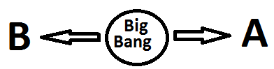
Fig.1 two particles moving on an axis in two opposite directions

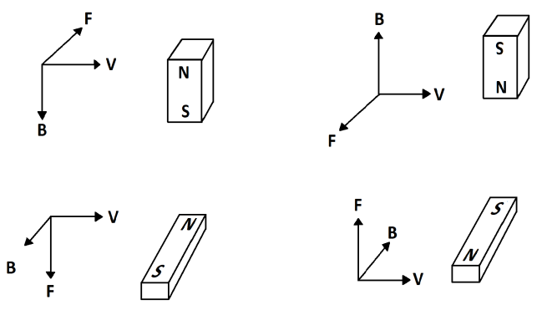

Fig.2 different states of particle motion in the direction of A

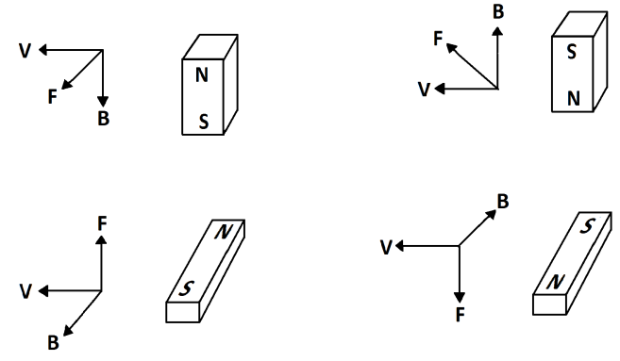
Fig.3 different states of particle motion in the direction of B

Considering that the angle between the magnetic field which is the intrinsic property of this particle and the motion caused by the big bang must be 90 degrees (Lane and smith, 1993), The force on the particle is plotted in two directions A and B, In order to be able to express the subject we have drawn a magnetic particle in the form of a permanent magnet in the image. B indicates the magnetic field, V indicates the direction of motion of the particle, and F indicates the direction of the force on the particle.
One or at most two particles can be placed in one circuit. According to Flemings rule the direction of magnetic field and the direction of motion of the particle must be perpendicular to each other and the two cannot be in the same direction. (Lane and smith, 1993) Therefore it is not possible to place the particle as shown in the fig4.
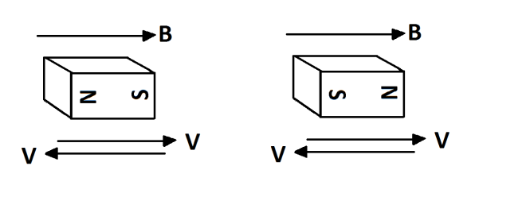
Fig.4 this kind of particle motion is impossible

The structure of leptons
Leptons have various intrinsic properties, including electric charge (+1e, 0e,-1e), spin1/2 and mass (Martin et al, 1997).
Particles KFA in orbit can rotate around their magnetic axis clock wise or counter clock wise or without rotation.
Considering the motion of the particle around its magnetic axis and the motion in the direction A of the forced applied to the particle of the big bang we will have six states drawn in figure 5. We have used Flemings rule to determine the direction of the force on the particle.

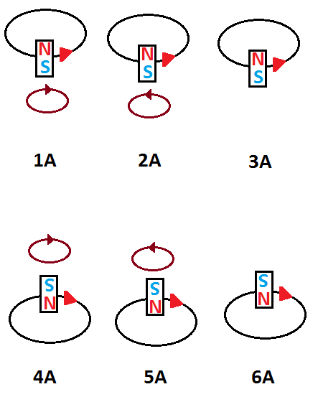
Fig.5 six modes of particle motion in the direction of A

3A and 6A can be states of lepton with zero electric charge.
We have the same six states for the motion of particle KFA in region B, with the difference that the direction of motion of the particle is completely opposite to the motion of the same particle in region A.
We have drawn the six states of motion of this particle in region B in figure 6.

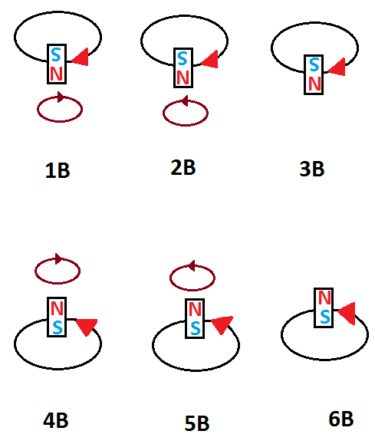
Fig.6 six states of particles motion in the direction of B

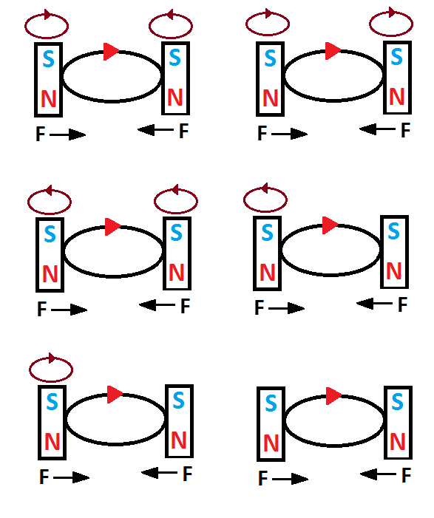
Fig.7 These six modes can be six quarks structure in the direction of A

The states shown in figures 5 and 6 can be six lepton forms and six anti-lepton forms.
This article states that particles and anti-particles exist in the universe but are moving away from the center of the big bang in the opposite direction.
The structure of quarks and anti - quarks.
Two KFA particles rotate in a circuit if they are to apply the force of rotation to the center of the circuit.
Otherwise, two particles will not remain in the circuit and no orbit will be formed. There are six modes for placing two particles in a circuit, which are plotted to move the particles in direction A shown in figure 1.
Which form belongs to which quark? needs further research. We also have six states of two particles in a circuit with a direction of motion of B shown in figure 1, which is drawn below that actually change the direction of the magnet field and also change the direction of movement of the particles in the orbit in order for the force to be inward.

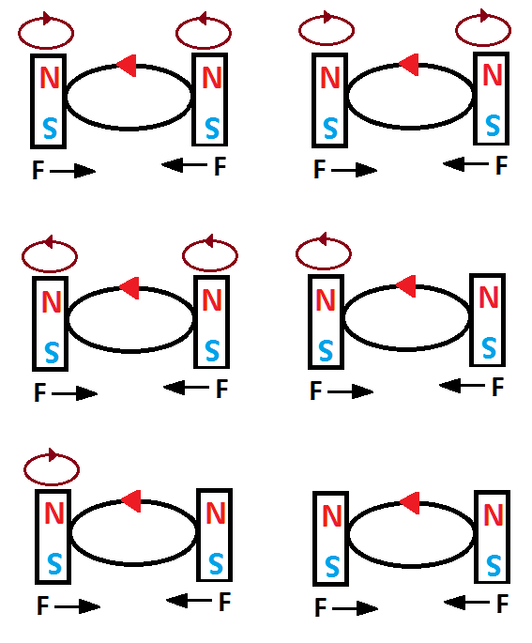
Fig.8 six states that can be six anti-quark structures in the direction of B

Apart from the drawn states, there is no other state for placing two magnetic particles in a circuit.
Due to the fact that the magnetic particle has only two poles, then in each hypothetical axis around the center of the big bang there is matter in one direction and anti-matter in the other.
particle motion in states where the velocity vector and the magnetic field vector are on a horizontal plane
These states are plotted in figures2 and 3 considering the particle motions, we will have twelve states. In total there are twelve gauge bosons (Ozansoy, 2020) and these twelve shapes can be the structure of twelve boson gauges, in these twelve cases, because the direction of the force vector is perpendicular to the plane formed by the velocities and the magnetic field vectors,

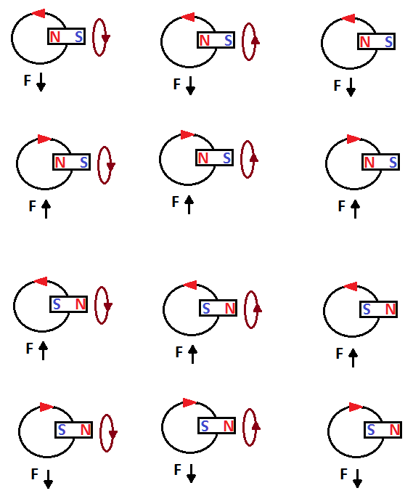
Fig.9 Twelve modes of gauge bosons

These particles move in paths similar to springs. in this state, infinite magnetic particles can move in the same direction. so that we will have the motion of these particles due to their infinity as an electromagnetic wave. to better understand, we have not drawn the trajectory of these particles springy. Suppose the observer looks at this spring from above.
Interestingly, this theory states that boson gauges are the same in terms of matter and antimatter world, and that they are no different. and if the particles are placed in the orbit in such a way that the two poles of the same name are in the direction of the center of the orbit, due to the repulsive force between the poles the direction of the magnetic field it changes the structure to quark or anti- quark structure based on movement in A or B. we have shown these two modes in two images.
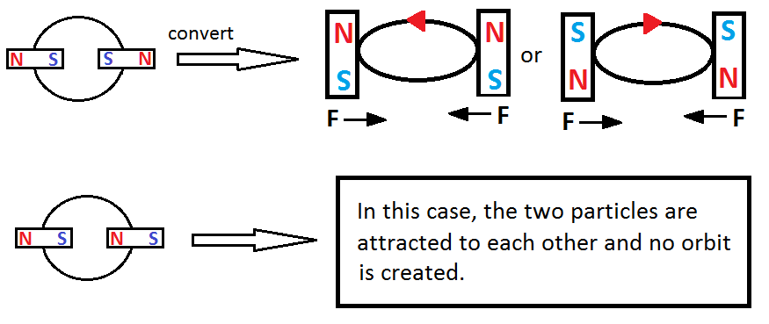
Fig.10 placing two magnetic particles in a circuit so that the velocity vector and the magnetic field are on a horizontal plane

However, changing the states of the particles causes the formation of quarks and anti – quarks twice the formation of leptons.
Dark matter
We have studied the types of collisions of KFA particles, but a state that occurred one hundred percent after the big bang and we do not know the result remains. What happens when two particles of KFA collide with poles of not the same name? This article tells us that when two magnetic particles with poles of not the same name collide with each other at the speed caused by the big bang, it is like a particle from region A collides with a particle from region B at the same speed. Due to the inverse direction of the particles moving in these two regions, the velocity vector becomes zero and then the force vector becomes zero and the two particles become massless again.

3. Results
This article explains well the existence of anti-quarks and anti-leptons and their differences with quarks and leptons and the reason why anti- quarks and anti- leptons do not destroy quarks and leptons. It also states that bosons have the same structure in the matter and antimatter world. With the help of this paper the structure of each subatomic particle of charge and its properties can be determined. Also a new window has been opened on dark matter, allowing more work for researches.

Corresponding Author:
Ebrahim Kefayati
Department of Engnireeng
Technical Campus, Tehran University
Tehran, Iran
Telephone: 09125589835
E-mail: z.kefayati0@gmail.com

References
- Andre, De., Gouvea, A., and Vogel, P. 2013. Lepton flavor and number conservation, and physics beyond the standard model. Progress in particle and nuclear physics. 71:75-92.
- Echenard, B. (2018). Search for a stable Six-Quark State at BABAR.
- Fiscaletti, D., Sorli, A. 2006. Toward a new interpretation of subatomic particles and their motion inside a temporal physical space.
- Fox, T. (2009). Why Quarks Are Unobservable.
- Frits, A., Berends, PH., Kleiss, R. 1985. Complete lowest order calculations for four-lepton final states in electron-positron collisions. Nuclear physics B. 253: 441-463.
- Hilgevoord, J. 2001. Heisenberg and the uncertainty principle stanford encyclopedia.
- Krolikowski, W. 2005. Intrinsically acting pauli principle as the origin of three standard model generations of leptons and quarks. High Energy Physics-Phenomenology.
- Lane, W., Smith, Q. 1993. Theism atheism and big bang cosmology.
- Lewis, D. 1967. Relationships between the masses of Subatomic Particles. Nature. 216: 784-786.
- Martin, L., Peri, A., and Eric, R. 1997. The search for elementary particles with fractional electric charge and the philosophy of speculative experiments. American Journal of Physics. 65.698.
- Meredith, F. 2020. Bohr Model Definition and Development.
- Nave, R. 2008. Quarks. Hyperphysics. Georgia State University, Department of physics and Astronomy.
- Oerter, R. 2006. The Theory of Almost Everything: The Standard Model, the Unsung Triumph of Modern Physics. Publisher: Pi Press.
- Ozansoy, A. (2020). Doubly charged Lepton Search Potential of the FCC. Hindawi.
- Prisiazhniuk, D., Flecken, A. K. 2017. Magnetic field pitch angle and perpendicular velocity measurements frommulti- point time delay estimation of poloidal correlation reflectometry.
- Riad, S. 2014. Studies of effective theories beyond the Standard Model DiVA.
- Richard, G., Milner, A. (2013). A short history of spin Arxiv preprint arxiv:1311-5016.
- Seez, D. 2017. Difference between top quark and antiquark in pp collisions at roots. Journal Physletb.
- Tenchini, R., Verzegnassi, C. (2007). The Physics of the Z and W Bosons.
- Tuli, N. (2020). Experience Flemings rule in Electromagnetism. Science Direct.
- Ullah, S., Ajaz, M., and Ali, Y. (2019). Hadron production models prediction for PT distribution of charged hadrons in pp interactions at 7 TeV.

2/25/2021

