**Variation in Morphological and Physical Properties and Land Use Potential along a toposequence in Ekwusigo Area of Anambra State.**

Kamalu O. J., Amadi-Rapheal K.A.S. Anozie H. I*. And Aronu, O. B.

Department Of Crop And Soil Science, Faculty Of Agriculture, University Of Port Harcourt

[*henry.anozie@uniport.edu.ng](mailto:*henry.anozie@uniport.edu.ng) (corresponding author)

**Abstract:** Spatial variability in soils is inherent and dependent on several environmental factors. The degree of variability also impacts great on effectiveness of the use and management of agricultural fields. The morphological and physical properties of soils in Ekwusigo area of Anambra State were assessed in ten minipedons sampled at four predetermined depths of 0 cm – 20 cm, 20 cm – 40 cm, 40 cm – 60 cm and 60 cm – 80 cm and three representative profiles sampled according to genetic horizons. Both undisturbed core samples as well as disturbed bulk samples were collected from the minipedons and soil profiles and taken to the laboratory for physical analysis. K.sat with a range of (23.01 cm/hr – 98.91 cm/hr) was the most variable soil property in the area with CV value of 294.8 (minipedon 2) while sand content (77.20 % – 95.20 %) was the least variable with CV value of 1.8 (minipedon 9). The order of degree of variability of the various soil properties in the area was K.sat > clay > silt > bulk density > porosity > Sand, while the graduation in variability of the minipedons was in the order MP 2 > MP 10 > MP 8 > MP 3 > MP 9 > MP 4 > MP 6 > MP7 > MP 1 > MP 5. Most soil nutrients significantly increased down the slope due to translocation of materials and its deposition at the foot slope.

[Kamalu O. J., Amadi-Rapheal K.A.S. Anozie H. I. And Aronu, O. B. **Variation in Morphological and Physical Properties and Land Use Potential along a toposequence in Ekwusigo Area of Anambra State.** *N Y Sci J* 2021;14(2):17-26]. ISSN 1554-0200 (print); ISSN 2375-723X (online). <http://www.sciencepub.net/newyork>. 3. doi:[10.7537/marsnys140221.03](http://www.dx.doi.org/10.7537/marsnys140221.03).

**Key Words:** minipedons, land use potential, soil variability ranking, catena.

**Introduction**

In order to adequately address the challenge of food insecurity and a rapidly growing population attention must be paid to soil management. Undoubtedly one of the ways to improve food security is to increase agricultural production in unit land areas and to utilize the land with respect to its potentiality in an appropriate manner. Land use should be based on the understanding of the suitability of each land for the intended use in order to achieve environmental sustainability (Nuga, 2009). Soil properties vary in space and time. Variation in soil properties occurs in differing degrees along geographic and geologic scales. The variations in soil forming processes operating on different parent materials, under different climatic, topographic, and biological conditions over time contribute to the nature and properties of soils found along a catena (Soil Survey Staff, 1993). Soil properties vary from the summit of a hill down to the bottom slope. Soils differ in their behaviour due to differences in morphological, physical, chemical and mineralogical properties.

Soil properties are strongly influenced by soil management systems and changes in land use (Hulugalle, *et al*., 1997. The variation of soil properties should be monitored and quantified to understand the effects of land use and management systems on soils (Kilic K. *et al*., 2012). Different studies had shown that soil physical properties such as clay content distribution with depth, sand content and pH are highly correlated with landscape position.

Soil catena -specific management is the process of managing soils based on localized conditions within catena which affect crop yield. To be effective, management schemes must address both soil variability and soil properties limiting yield (Musa, 2015). Land use potential is the potential of a soil and land to sustain a specific crop type. According to FAO (1979) and Rowland *et. al.,* (2016) land use potential is concerned with the assessment of land performance when used for a specified purpose. It is likely to be the prediction of land potential for productive land use types, and then generally a comparison or match of the requirements of each potential land use with the characteristics of each kind of soil (Can, *et al*., 2015).

In the area under study, the soils are predominantly sedimentary soils and as result, vulnerable to erosion. Topsoil removal has become a major threat to livelihood of Ekwusigo residents. Clearly, land use development is lacking in the area.

Moreso, no systematic assessment and land use planning has been carried out in the area. The determination of the use potential of land is a necessary condition for land use planning (Kilic, *et al*., 2002), thus it became eminent to determine soil morphological and physical properties and land use potential of soils along a catena in the study area. The objectives of the research were to: characterize the morphological and physical properties of the soils of Ekusigo area, determine the extent of variability in soil characteristics within the catena and assess land use patterns and potentials of the soil at the various topographical positions.

**Materials And Methods**

**Study area**

Field studies and sampling took place in four communities: Ozubulu, Ihembosi, Oraifite and Ichi all located within 5˚58′24′′ N, 6˚49′43′′E in Anambra State of Nigeria. The annual rainfall area ranges from 1,500 mm to 1,800 mm. The maximum temperature ranges from 29 ˚C to 33 ˚C while the minimum temperature ranges from 20.80 ˚C to 22.80 ˚C. The major land use/cover classes include: natural forest, grassland, small scale cultivation and large scale agriculture. The upper slope is used for sole cropping such as cassava and maize crops. The middle slope soils are under fallow while the foot slope is used for mixed cropping of crops such as cassava, maize, yam.

**Soil Sampling and Laboratory Analysis**

Ten (10) minipeds (80cm deep) were dug along the transect, core samples and disturbed samples were collected at predetermined depth of 0 cm – 20 cm, 20 cm – 40 cm and 60 cm – 80 cm adding up to a total of 40 samples each of the core and disturbed samples. Proper labelling and descriptions of the morphological properties following the guidelines outlined in USDA-SCS (I974) and the munsell colour chart were carried out as well as identification of the different land use along the catena. The soil samples were air dried, crushed and passed through a 2mm mesh for determination of physical property in the laboratory using standard procedures. The particle size distribution was determined using hydrometer method as described by Gee and Or (2002).

**Table 1: Variability Class**

|  |  |
| --- | --- |
| Coefficient of Variability (%) | Variability Class |
| ≤ 20 % | Little Variability |
| 20 – 50 % | Moderately Variability |
| ≥ 50 % | High Variability |

**Source: Aweto, 1982**

Statistical Analysis: Descriptive statistics (sum, mean, standard error of mean, standard deviation, variance, and coefficient of variation were computed for each soil property in the various minipedons for variability studies using the scale described by Aweto (1982).

**Results And Discussion**

**Morphological Properties of the Area**

The morphological properties of the minipedons are shown in Table 2. Generally, the soils ranged in colour from 2.5YR3/3 to 7.5YR5/2 with a consistency that varied between loose to slightly hard and a texture of sand to sandy loam.

**Minipedon 1 (MP 1):** varies slightly in colour from brown (5YR5/3) moist to reddish brown (5YR5/2) moist. Structure ranges from weak crumbic to sub angular blocky. Texture was dominated by sand fraction varying with depth from sand to loamy sand. Consistency ranges from loose to slightly hard with clear boundary at the first layer and gradual wavy boundary at other layers. Presence of fine roots at the top soil which decreases with depth. Absent of mottles showing that soil is well drained.

**Minipedon 2 (MP 2):** In this minipedon, colour varies with from dark brown (5YR3/3) moist to 2.5YR3/6 (weak red) moist. Structure ranges from weak crumbic to sub angular blocky. Texture varies from sand to sandy loam. Consistency ranges from loose to slightly hard with smooth boundary. Presence of fine roots. Soil is well drained.

**Minipedon 3 (MP 3):** In this minipedon, soil colour varies with depth from brownish red (5YR5/1) to red (2.5YR6/4). Structure ranges from weak crumbic to sub angular blocky. Texture ranges from loamy sand to sandy-loam. Consistency ranges from loose to slightly hard with smooth boundary between the layers. Presence of fine roots at the top soil which decreases with depth and shows moderate to poor drainage condition.

**Minipedon 4 (MP 4):** Minipedon 4 as shown in Table 2 below had colour variation with depth from brown (5YR5/2) to reddish brown (2.5YR5/4). Structure ranges from weak crumbic to sub angular blocky. Texture was also dominated by sand fraction varying with depth from sand to sandy loam. Consistency ranges from loose to slightly hard. The soil is well drained with smooth boundary between layers. Presence of roots only at the top soil (0 cm – 20 cm) and (20 cm – 40 cm) showing shallow soil depth. The soil is well drained without mottles.

**Minipedon 5 (MP 5):** Soil colour varies with depth from 2.5YR5/3 to 2.5YR5/4. Structure ranges from weak crumbic to sub angular blocky. Texture ranged from loamy sand to sandy loam. Consistency ranges from loose to slightly hard with clear boundary at the first layer and gradual wavy boundary at other layers. Presence of fine roots at the top soil which decreases in density with depth. Absent of mottles showing proper drainage.

**Minipedon 6 (MP 6):** In this minipedon, colour varies with from 2.5YR4/2 to 2.5YR4/4. Structure ranges from weak crumbic to sub angular blocky. Texture ranged from sand to sandy loam. Consistency ranges from loose to slightly hard with clear boundary at the first layer and gradual wavy boundary at other layers. Presence of fine roots at the top soil which decreases with depth.

**Minipedon 7 (MP 7):** In this minipedon, as shown in Table 2, colour varies with depth from 5YR5/3 to 2.5YR3/4. Structure ranges from weak crumbic to sub angular blocky. Texture was dominated by sand fraction varying with depth from sand to loamy sand. Consistency ranges from loose to slightly hard with clear boundary at the first layer and gradual wavy boundary at other layers. Presence of fine roots at the top soil which decreases with depth. Mottling was not observed owing to good drainage condition.

**Minipedon 8 (MP 8):** Soil colour varies with depth from 5YR5/2 to 2.5YR4/4. Structure ranges from weak crumbic to sub angular blocky. Texture was dominated by sand fraction varying with depth from sand to loamy sand. Consistency ranges from loose to slightly hard with clear boundary at the first layer and gradual wavy boundary at other layers. Presence of fine roots at the top soil which decreases with depth and good drainage condition.

**Minipedon 9 (MP 9):** In this minipedon, soil colour varies with depth from reddish brown (7.5YR5/2) to red (2.5YR5/4). Structure ranges from weak crumbic to sub angular blocky. Soil texture ranges from sand to loamy sand. Consistency ranges from loose to slightly hard with clear boundary at the first layer and gradual wavy boundary at other layers. Presence of fine roots at the top soil which decreases with depth. No mottling was observed.

**Minipedon 10 (MP 10):** Soil colour varies from brownish red (7.5YR3/3) to dark red (2.5YR4/4). Structure ranges from weak crumbic to sub angular blocky. Texture was dominated by sand fraction throughout the 0 cm – 80 cm depth. Consistency ranges from loose to slightly hard with smooth boundary. Presence of fine roots at the top soil which terminates at the 40 cm – 60 cm layer. Soil is generally well drained.

**Variability in Soil Physical Properties along the Catena**

The spatial variability of soil occurs due to pedogenetic factors and their use and management (Rodenburg *et al.,* 2003), and is expressed in physical and chemical properties (Cerri *et al*., 2004).

**Particle Size Distribution**

The percentage sand, silt and clay for the ten minipeds are presented in Table 3. The sand fraction decreases with increase in the soil depth across the different horizons (Ap – Bt3) for all the minipeds. The eluviation of silty materials through erosive action from the Ap horizon and subsequent illuviation down the Bt3 could be the reason for the trend. This observation was in agreement with the findings of Voncir *et al*., (2008) who worked on profile distribution of some physicochemical properties of soil along a toposequence. However, the sand fraction dominates the entire soil which ranged from 77.5 % (MP5) to 95.5 % (MP9).

No particular trend was observed for the silt content. However, the silt content ranged from 2.0 % (Mp8 and MP9 respectively) to 8.0 % (MP3). This observation agrees with the findings of Kamalu et al, 2018 who worked on Morphological Characterization and Soil Quality Assessment along a Toposequence.

The clay content down the profile ranged from 2.4 % (MP9) to 1.8 % (MP2). Clay content increases down the profile, indicating the existence of definite clay bulge. This observation suggests the occurrence of argillic horizon which conforms to a similar work reported by Esu *et al.,* (2015). However, the regular clay increase with depth was in agreement with Eshett (1996), that soils of the region are friable and underlain by clay enriched sub-soil (argillic horizon).

**Table 2: Soil morphological properties of the minipedons along the catena of the study area**

| **Pedon ID** | **Depth (cm)** | **Colour (moist)** | **Structure** | **Consistency** | **Texture** | **Roots** | **Mottles** | **Boundary** |
| --- | --- | --- | --- | --- | --- | --- | --- | --- |
| MP 1 | 0-20 | 5YR 5/3 | 1,cr | L | S | Fr | - | - |
|  | 20-40 | 2.5YR 4/3 | 1,cr | L | S | Ffr | - | Sb |
|  | 40-60 | 5YR 4/3 | 2,cr | S | LS | Vf | - | Sb |
|  | 60-80 | 5YR 5/2 | Sbk | Sh | LS | - | - | Cl |
| MP 2 | 0-20 | 5YR 3/3 | 1,cr | L | S | Fr | - | - |
|  | 20-40 | 2.5YR ¾ | 2,cr | L | LS | Ffr | - | Sb |
|  | 40-60 | 2.5YR 4/3 | Sbk | S | SL | Vf | - | Sb |
|  | 60-80 | 2.5YR 3/6 | Sbk | Sh | SL | - | - | Sb |
| MP 3 | 0-20 | 5YR 5/1 | 1,cr | L | LS | Ffr | - | - |
|  | 20-40 | 5YR 3/3 | 2,cr | L | LS | Vf | - | Sb |
|  | 40-60 | 5YR 4/4 | Sbk | L | LS | - | - | Sb |
|  | 60-80 | 2.5YR 6/4 | Abk | Sh | SL | - | - | Cl |
| MP 4 | 0-20 | 5YR 5/2 | 1,cr | L | S | Fr | - | - |
|  | 20-40 | 5YR 5/3 | 1,cr | L | S | Vf | - | Sb |
|  | 40-60 | 2.5YR 4/3 | 2,cr | Sh | LS | - | - | Sb |
|  | 60-80 | 2.5YR 4/6 | Sbk | Sh | SL | - | - | Cl |
| MP 5 | 0-20 | 2.5YR 5/3 | 1,cr | L | LS | Fr | - | - |
|  | 20-40 | 2.5YR 4/3 | 2,cr | L | SL | Ffr | - | Cl |
|  | 40-60 | 2.5YR 4/4 | Sbk | S | SL | Vf | - | Sb |
|  | 60-80 | 2.5YR 5/4 | Sbk | S | SL | - | - | Sb |
| MP 6 | 0-20 | 7.5YR 4/3 | 1,cr | L | S | Fr | - | - |
|  | 20-40 | 2.5YR 4/2 | 2,cr | L | LS | Ffr | - | Sm |
|  | 40-60 | 2.5YR 4/6 | Sbk | S | SL | Vf | - | Sm |
|  | 60-80 | 2.5YR 4/4 | Sbk | Sh | SL | - | - | Sm |
| MP 7 | 0-20 | 5YR 5/3 | 1,cr | L | S | Fr | - | - |
|  | 20-40 | 2.5YR 4/6 | 2,cr | L | LS | Vf | - | Sm |
|  | 40-60 | 2.5YR 4/4 | 2,cr | S | LS | - | - | Sm |
|  | 60-80 | 2.5 YR3/4 | Sbk | S | LS | - | - | Sm |
| MP 8 | 0-20 | 5YR 5/2 | 1,cr | L | S | Fr | - | - |
|  | 20-40 | 2.5YR ¾ | 1,cr | L | S | Ffr | - | Cl |
|  | 40-60 | 2.5YR 4/4 | 2,cr | S | LS | Vf | - | Sm |
|  | 60-80 | 2.5YR 4/4 | Sbk | S | LS | - | - | Sm |
| MP 9 | 0-20 | 7.5YR 5/2 | 1,cr | L | S | Fr | - | - |
|  | 20-40 | 2.5YR ¾ | 1,cr | L | S | Ffr | - | Sb |
|  | 40-60 | 2.5YR 4/3 | 2,cr | S | S | Vf | - | Sb |
|  | 60-80 | 2.5YR 5/4 | Sbk | S | LS | Vf | - | Cl |
| MP 10 | 0-20 | 7.5YR 3/3 | 1,cr | L | S | Fr | - | - |
|  | 20-40 | 5YR 5/2 | 1,cr | L | S | Ffr | - | Sm |
|  | 40-60 | 2.5YR 4/4 | 2,cr | L | S | Vf | - | Sm |
|  | 60-80 | 2.5YR 5/4 | Sbk | S | S | - | - | Sm |

Structure; 1 = weak, 2 = moderate, 3 = strong, g = granular, cr = crumb, abk = angular blocky, sbk = sub-angular blocky. Textural class, S=sand SL=sandy loam, SCL = sandy clay loam, SC = sandy clay, Boundary (GW = gradual wavy; structure. Consistency ( l= loose, s=slightly hard); Pores = ( f = fine roots, vf=very fine roots, vfr = very few roots)

**Bulk Density (BD**

Bulk density in the study area ranged from 0.97 g/cm3 (MP4) – 1.54 g/cm3 (MP2) without no definite trend in most of the minipedons. However, Reynolds *et al*., (2007) reported that the optimal bulk density for crop production ranges from 0.9 g/cm3 to 1.3 g/cm3 for fine-textured soils. It was recorded that 87 % of the sampled soils fell within the optimal BD range for crop production as aforementioned. Hence, such soils have very good physical property and as such are of high soil quality. So, such soils would not restrict plant root within 65 cm depth as reported by Arshad *et al*. (1996) that bulk density between 1.60 gcm-3 and 1.75 gcm-3 affected root growth of most cultivated crops in sandy clay loam soils.

**Saturated Hydraulic Conductivity (Ksat)**

The average C.V for the soils was 71.10 % indicating there was a wide variability in saturated hydraulic conductivity across the 10 micropeds along the catena as shown in Table 3. The soils of the study area showed high values of Ksat with range; 23.01 – 98.91 cm/hr (Table 3), indicating that the soil are highly porous due to high percentage sand fraction, Brady (1999). It was observed that Ksat decreased with increased in soil depth due to a reduction in pore size distribution from sandy fraction to clay/silt fraction since sand contains large pore spaces (though fewer in number) when compared to clay or silt with smaller pore size thus holds water longer than sandy fractions of soil (USDA, 2008)

**Porosity**

The total porosity of the soils across all the 10 minipeds ranged from 42 % to 63 % as shown in Table 3. It was observed that 90 % of soil samples recorded values above the ideal porosity for healthy soils (>50 %) as proposed by Lawrence (1977). Soils that fall below the ideal porosity were probably due to high bulk density and this is similar to the report of Alemayahu (2014). High amount of total porosity (50 % to 64 %) could be attributed to fine-textured and loamy fine-sand texture of the soils as well as reported by Robinson et al., (2012). These observed high porosity values imply that the soil cannot retain water for a long period of time. It also indicates that the tendency of the soil to flooding, crusting and cracking is high in this area. Similar observation has been reported by Sharma and Bhagat (1993) on studies on both water storage and residual porosity of soil under intensive agricultural land use. The soils of the study area would be easily flooded and eroded under heavy rainfall. However, with adequate soil management and tillage practises at appropriate soil moisture content, the soil quality can be improved to sustain agricultural production.

**Table 3: Selected Physical Properties of the Study area**

|  |  |  |  |  |  |  |
| --- | --- | --- | --- | --- | --- | --- |
| Pedon/Depth (cm) | K.Sat (cm/hr) | B.D (g/cm3) | Sand | Silt | Clay | Porosity |
| % | | | |
| MP1 (0-20) | 91.64 | 1.10 | 90.60 | 6.00 | 3.40 | 58.00 |
| (20-40) | 68.42 | 1.19 | 92.20 | 3.00 | 4.80 | 55.00 |
| (40-60) | 55.60 | 1.21 | 85.20 | 3.40 | 11.40 | 54.00 |
| (60-80) | 58.35 | 1.16 | 84.60 | 6.00 | 9.40 | 56.00 |
| CV | 23.91 | 4.12 | 4.33 | 35.32 | 52.02 | 3.06 |
| MP2 (0-20) | 98.91 | 1.14 | 91.20 | 2.00 | 6.80 | 57.00 |
| (20-40) | 96.69 | 1.09 | 87.20 | 2.40 | 10.40 | 59.00 |
| (40-60) | 56.01 | 1.54 | 79.20 | 5.40 | 15.40 | 42.00 |
| (60-80) | 43.24 | 1.28 | 77.20 | 4.00 | 18.80 | 52.00 |
| CV | 294.80 | 15.98 | 7.89 | 45.25 | 41.30 | 14.46 |
| MP3 (0-20) | 67.20 | 1.30 | 87.20 | 8.00 | 4.80 | 51.00 |
| (20-40) | 58.04 | 1.19 | 84.60 | 3.00 | 12.40 | 56.00 |
| (40-60) | 23.82 | 1.48 | 84.40 | 2.20 | 13.40 | 44.00 |
| (60-80) | 23.01 | 1.26 | 82.20 | 4.00 | 13.80 | 52.00 |
| CV | 53.34 | 9.46 | 2.42 | 59.87 | 38.21 | 9.84 |
| MP4 (0-20) | 80.68 | 0.97 | 93.20 | 3.40 | 3.40 | 63.00 |
| (20-40) | 48.87 | 1.2 | 89.2 | 4.00 | 6.80 | 54.00 |
| (40-60) | 81.25 | 1.34 | 83.2 | 6.00 | 10.80 | 49.00 |
| (60-80) | 44.31 | 1.22 | 81.2 | 6.40 | 12.40 | 54.00 |
| CV | 31.26 | 13.07 | 6.35 | 29.76 | 48.55 | 10.60 |
| MP5 (0-20) | 76.37 | 1.08 | 82.60 | 6.00 | 11.40 | 59.00 |
| (20-40) | 47.04 | 1.16 | 82.60 | 4.00 | 13.40 | 56.00 |
| (40-60) | 73.31 | 1.21 | 78.60 | 6.00 | 15.40 | 54.00 |
| (60-80) | 45.21 | 1.17 | 77.20 | 6.00 | 14.80 | 56.00 |
| CV | 27.52 | 4.72 | 3.46 | 18.18 | 12.92 | 3.66 |
| MP6 (0-20) | 28.10 | 1.27 | 91.20 | 4.00 | 4.80 | 52.00 |
| (20-40) | 51.31 | 1.12 | 84.60 | 4.00 | 11.40 | 58.00 |
| (40-60) | 74.53 | 1.18 | 79.20 | 5.40 | 15.40 | 55.00 |
| (60-80) | 42.15 | 1.20 | 79.20 | 6.00 | 14.80 | 55.00 |
| CV | 39.74 | 5.17 | 6.82 | 20.86 | 41.93 | 4.45 |
| MP7 (0-20) | 82.48 | 1.20 | 88.60 | 7.00 | 4.40 | 55.00 |
| (20-40) | 90.41 | 1.32 | 85.20 | 4.00 | 10.80 | 50.00 |
| (40-60) | 82.41 | 1.20 | 89.20 | 2.00 | 8.80 | 55.00 |
| (60-80) | 93.95 | 1.04 | 86.60 | 6.00 | 7.40 | 61.00 |
| CV | 6.65 | 9.66 | 2.11 | 46.68 | 34.27 | 8.14 |
| MP8 (0-20) | 29.32 | 1.18 | 86.60 | 8.00 | 5.40 | 56.00 |
| (20-40) | 82.48 | 1.13 | 90.60 | 6.00 | 3.40 | 57.00 |
| (40-60) | 67.20 | 1.04 | 85.20 | 2.40 | 12.40 | 61.00 |
| (60-80) | 27.49 | 1.13 | 85.20 | 2.00 | 12.80 | 57.00 |
| CV | 53.30 | 5.21 | 2.94 | 62.906 | 56.55 | 3.84 |
| MP9 (0-20) | 96.53 | 1.16 | 95.20 | 2.40 | 2.40 | 56.00 |
| (20-40) | 98.39 | 1.05 | 91.20 | 6.00 | 2.80 | 60.00 |
| (40-60) | 92.53 | 1.28 | 92.60 | 2.00 | 5.40 | 52.00 |
| (60-80) | 82.34 | 1.11 | 92.60 | 2.00 | 8.80 | 58.00 |
| CV | 7.75 | 8.49 | 1.80 | 62.66 | 60.83 | 6.05 |
| MP10 (0-20) | 97.75 | 1.02 | 92.60 | 4.00 | 3.40 | 62.00 |
| (20-40) | 81.25 | 1.49 | 92.60 | 3.00 | 4.40 | 44.00 |
| (40-60) | 70.26 | 1.29 | 90.60 | 4.00 | 5.40 | 51.00 |
| (60-80) | 69.65 | 1.26 | 89.20 | 3.40 | 7.40 | 52.00 |
| CV | 172.77 | 15.23 | 1.82 | 13.61 | 33.16 | 14.18 |

CV = Coefficient of variability

**Land Use Characteristics and Potentials along the Catena**

**Soils of the Upper Slope**

The terrain characteristics show undulations with slope being between 70 and 90. The soil is generally red coloured showing presence of iron oxides and low organic matter status. The soils are dominated by sand fraction with texture ranging from fine sand to sandy loam. The soils are massive with poor tilth leading to high bulk density. They are characterized low water holding capacity he coarse texture also means low cation exchange capacity but with high base saturation greater than 50%. It has a hyperthemic temperature regime with mean annual soil temperature greater than 22 0C. The moisture regime is Ustic where moisture is limited but is present during growing season. The soils of the upper slope have been classified as Typic Psammentic ferrustalf (Plate 1)

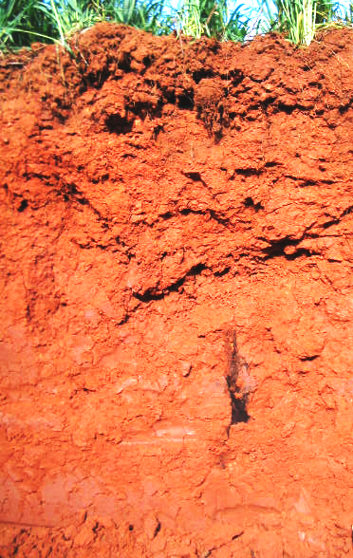

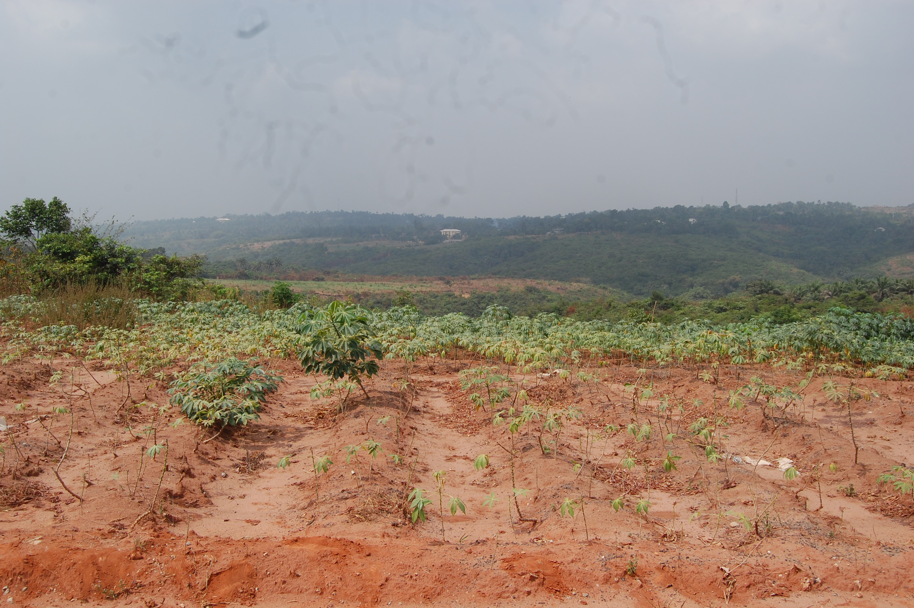

Plate 1 (Left): Land use Features of the upper slope (exposed / bare ground susceptible to erosion) (Right): Reddish soil (lateritic) due to loss of top soil to erosion

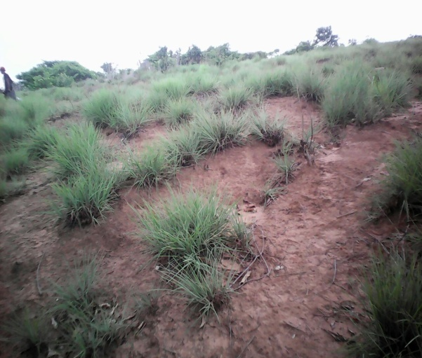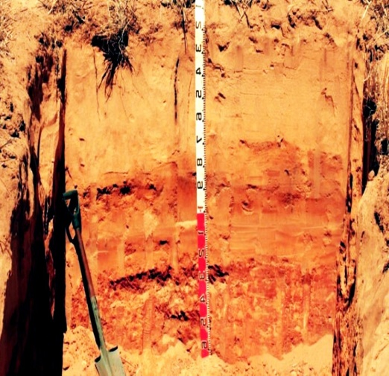

Plate 2 (Left): Middle slope soils under fallow (Dominantly left as grazing ground) (Right): Representative Pedon of the Middle Slope with features of unstable Morphology and limited soil development

The relatively higher bulk density, low organic matter status and predominantly sandy texture collectively render the use and management of these soils unsuitable for agriculture. Moreover, sheet erosion is prominent and low inherent soil fertility prevails. Use of the soils of the upper slope would entail the incorporation of organic residues into the soil to improve fertility, structure and water retention as well as reduce soil bulk density. The choice of suitable agronomic practices like strip cropping and use of cover crops to check surface run off and improve infiltration capacity of the soils would be necessary.

**Soils of the Middle Slope**

It is also dominated by sand fraction and texture ranges from very fine sand to loamy fine sand with some weak indication of argillic horizon, it has a redder hue at the subsoil. The soil showing presence of iron oxides under- going weathering with high base saturation greater than 50 %. A typical pedon of the Middle Slope has features of unstable soil morphology and limited soil development. The soils are more developed than those of the upper slope position and as such are characterized by deep, well drained soils. Gullies are present though with less demands when compared with the soils on the upper slope position. It has a hyperthemic temperature regime with mean annual soil temperature greater than 22 0C. The moisture regime is Ustic where moisture is limited but is present during growing season. The soil of the middle slope has been classified as Typic Psammentic cambustalf (Plate 2).

**Soils of the Foot Slope**

The soils of the Foot Slope have follistic epipedon with high amounts of organic carbon and low bulk density. These are dark coloured soils characterized by imperfectly to poorly drained conditions (Plate 3). If properly drained, these soils support a wide variety of crops. There is difficulty in horizon differentiation due to lack of mature profile development. This might be due to frequent and recent deposit or the cold condition of the environment slowing down soil genesis (profile development processes). The soils are characterized by udic moisture regime and are sometimes saturated with water for hour or few days after heavy rains. They have high porosity with fine textures on the surface and underlined by a coarse textured sub surface soils. The best way to utilize the soil on this foot slope position is practice dry season farming with early maturing crops. These soils have been classified as Typic psammentic haplustepts.

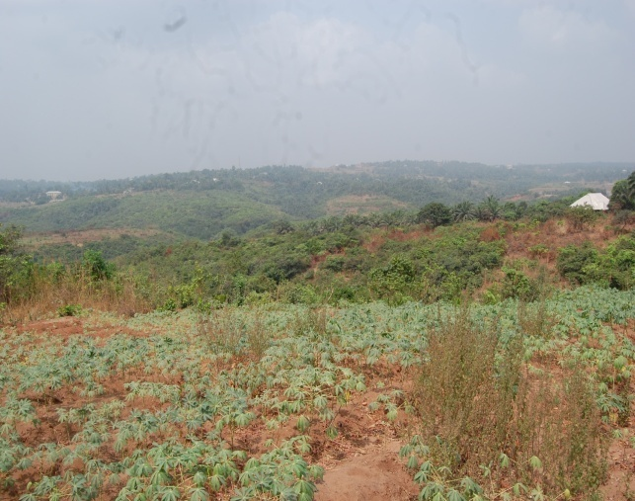

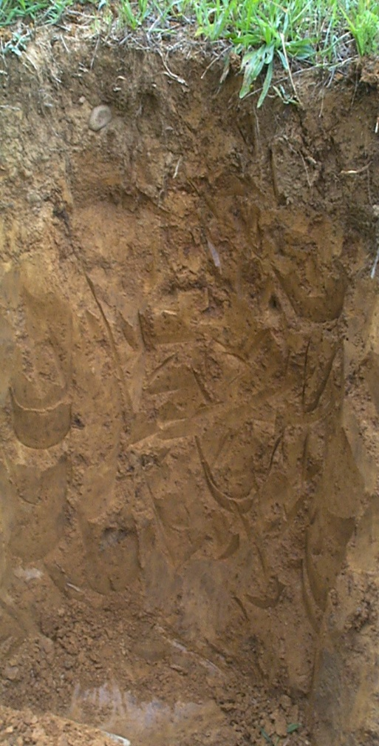

**Plate 3**: (left): Land use Features of the foot slope (Cassava farm) (Right): Typical Profile of the Foot slope with dark soil

**Conclusion**

This study revealed that there was variation in soil properties along the soil catena in the study area as shown in the ten minipedons located at designated topographic locations. However, some soil properties varied more than others. Generally K.sat is the most variable (MP2) with CV value of 294.8 and sand the least variable (MP9) with CV value of 1.8.

Morphologically, the soil properties such as color showed high variability with depth. These changes in soil properties across the slope positions had influence on land use and management such that each slope position has different crop types and management strategy.

Both field and analytical properties showed that variations or changes occurred along the catena and the changes are inter-related with the land use potential. Based on these study results, most of soil nutrients significantly increased down the slope due to translocation of materials and its deposition at the foot slope.

**Authors:**

Kamalu O. J., Amadi-Rapheal K.A.S. Anozie H. I*. And Aronu, O. B.

Department Of Crop And Soil Science, Faculty Of Agriculture, University Of Port Harcourt

[*henry.anozie@uniport.edu.ng](mailto:*henry.anozie@uniport.edu.ng) (corresponding author)

**References**

1. Alemayahu et al., (2014) Pedological characteristics and classification of soils along landscapes at Abobo, southwestern lowlands of Ethiopia. Vol. 5(6), pp. 72-82, September, 2014 DOI 10.5897/JSSEM13.0432. Journal of Soil Science and Environmental Management.
2. Arshad, M.A., Lowery, B., Grossman, B., (1996). Physical tests for monitoring soil quality. In: Doran, J.W., Jones, A.J. (Eds.), Methods for Assessing Soil Quality. SSSA Special Publication No. 49. SSSA, Madison,WI.pp.123–141. https://acsess.onlinelibrary.wiley.com/doi/abs/10.2136/sssaspecpub49.c7 19. Brady, N.C. and Weil, R.R. (1999). The Nature and Properties of Soils. 12th Edition, Prentice Hall Publishers, London,1-9,453-536,727,739-740. https://www.scirp.org/(S (351jmbntvnsjt1aadkposzje))/reference/ReferencesPapers.aspx?ReferenceID=1705491.
3. Can Bü lent Karakus Orhan Cerit, Kaan Sevki Kavak (2015) determination of land use/land cover changes and land use potentials of sivas and its surrounding using geographical Information system (GIS) and remote sensing (RS) / Procedia Earth and Planetary Science 15 (2015) 454 – 461. https://doi.org/10.1016/j.proeps.2015.08.040.
4. Cerri, C.C.; Bernoux, M.; Cerri, C.E.P., Feller, C. (2006). Carbon cycling and sequestration opportunities in South America: the case of Brazil. Soil Use and Management 20: 248-254. https://www.researchgate.net/publication/229700092_Carbon_cycling_and_sequestration_opportunities_in_South_America_The_case_ of_Brazil
5. Eshett, E. T. (1996). Characteristics and Management Problem of Humid and Sub-humid Tropical Soils with Special Reference to Southeastern Nigeria, Agronomie Africaine VIII (1): 21-35.
6. Esu, I.E., U. Uko and E.E. Aki, 2014. Morphological, physiochemical and mineralogical properties of soils developed from basalt at Ikom, cross river state, Nigeria. Proceeding of the 38th Annual Conference of Soil Science Society of Nigeria, March 10-14, 2014, Uyo, Nigeria, pp: 89-100.
7. Hulugalle NR, Entwistle P (1997) Soil properties, nutrient uptake and crop growth in an irrigated Vertisol after nine years of minimum tillage. Soil & Tillage Research 42, 15–32. doi:10.1016/S0167-1987 (96)01104-X
8. Kamalu, O.J, Anozie, H.I and Ovat N (2018) Morphological Characterization and Soil Quality Assessment along a Toposequence in Obubra Cross Rivers State, Nigeria. New York Science Journal 2018; 11(6) http://www.sciencepub.net/newyork/ny110618/01_33612nys110618_1_12.pdf.
9. Kılıç, K., K. Saltalı and A.K. Sürücü. 2002. Effects of tobacco powder application on the physical and chemical properties of alkaline soils Turk J. Agric. For. 26: 87-91. http://journals.tubitak.gov.tr/agriculture/issues/tar-02-26-2/tar-26-2-4-0006-22.pdf.
10. Kilic, K., Kilic. S. and Kocyigit R. (2012). Assessment of spatial variability of soil properties in areas under different land use. Bulgarian Journal of Agriculture Science, 18: 722-732. https://www.agrojournal.org/18/05-12-12.pdf.
11. Lawrence, G.P. 1977. Measurement of pore size in fine textured soil: a review of existing techniques. Journal of Soil Science, 28: 527- 540. https://doi.org/10.1111/j.1365-2389.1977.tb02261.x.
12. Nuga, B.O. (2009). Classification and Evaluation of the Soils of Ikwuano Local Government Area, Abia State, Nigeria. PhD thesis. Dept. of Agronomy. University of Ibadan.191pp.
13. Reynolds JF, Stafford Smith DM, Lambin EF, et al. (2007). Global desertification: building a science for dryland development. Science 316: 847–51. DOI: 10.1126/science.1131634.
14. Robinson, D.A., N. Hockley, E. Dominati, I. Lebron, K.M. Scow, B. Reynolds, B.A. Emmett, A.M. Keith, L.W. de Jonge, P. Schjonning, P. Moldrup, S.B. Jones, and M. Tuller. 2012. Natural capital, ecosystem services, and soil change: Why soil science must embrace an ecosystems approach. Vadose Zone J. 11. doi:10.2136/vzj2011.0051.
15. Rodenburg, J.; Stein, A.; Noordwijk, M.; Ketterings, Q. M. (2003). Spatial variability of soil pH and phosphorus in relation to soil runoff following slash-and-burn land clearing in Sumatra, Indonesia. Soil and Tillage Research, v. 71, n. 1, p. 1-14. http://www.worldagroforestry.org/publication/spatial-variability-soil-ph-and-phosphorus-relation-soil-run-following-slash-and-burn.
16. Rowland J, Maschmedt D & Liddicoat C (2016). Land use potential for agricultural crops in southern South Australia: Summary of assessment and mapping methodology. DEWNR Technical note 2016/29, Government of South Australia, Department of Environment, Water and Natural Resources, Adelaide. Science 2(3): 218-223.
17. Sharma, P.K. and Bhagat, R.M. (1993). Puddling and compaction effects on water permeability of texturally different soils. J. Indian soc. Soil Sci. 41: 1-6. Available at https://www.sciencedirect.com/science/article/pii/0167198795005048.
18. Soil Survey Staff (1993). Soil Survey Manual. Soil Conservation Service, United State Department of Agriculture. Agricultural. Handbook 18. (Online). Available at: http://soils.usda.govt/technical/manual/ contents/index.html (Accessed 17 July 2011).
19. Udoh, B.T., Harold, K.O. and Adiole, C.U (2010). Variation in soil types and characteristics as influenced by topography within an agricultural management nit in Southern Eastern Nigeria. Journal of Applied Agricultural Research, 2: 10 – 111.
20. USDA 2008 Agricultural Prices, http://usda.mannlib.cornell edu/usda/nass/AgriPric//2000s/2008/AgriPric-04-30-2008. pdf (Washington, DC: United States Department of Agriculture).
21. USDA-SCS, 1974. US Department of Agriculture, Soil Conservation Service. National Engineering Handbook. Section 15. Border Irrigation. National Technical Information Service, Washington, DC,Chapter4.https://www.nrcs.usda.gov/wps/portal/nrcs/detailfull/national/water/?cid=stelprdb1043063 Commented [WU5]: Author is requested to provide DOI or URL of highlighted references. DOI is mandatory, without DOI your article will not be able for further processing.
22. Van Wambeke, A.R., 1962. Criteria for classifying tropical soils by age. J. Soil Sci., 13: 124-132. https://doi.org/10.1111/j.1365- 2389.1962.tb00689.x.
23. Voncir, N., S. Mustapha, V.A. Tenebe, A.L. Kumo and S. Kushwaha, (2008). Content and profile distribution of extractable zinc (Zn) and some physicochemical properties of soil along a toposequence at Bauchi, Northern Guinea Savanna of Nigeria. Int. J. Soil Sci., 3: 62-68. https://scialert.net/fulltext/?doi=ijss.2008.62.68.

2/20/2021