Banana Fiber Reinforced Concrete: A Review

Mohammed Mahmoud Mohammed Attia¹, Shymaa M. M. Shawky²

¹Civil & Architecture Construction Department, Faculty of Technology & Education, Suez University, Egypt
²The High Technological Institute, Ramadan 10th City, Egypt
Email: ¹mohammed.mahmoudattia@suezuni.edu.eg; ²shymaa.mukhtar@hti.edu.eg

Abstract: Banana fibers (BFs) are utilized as reinforcement to compensate for concrete's inherent weaknesses. Nowadays, there is a focus on incorporating BFs into concrete, depending on them to develop alternative building materials. Numerous advantages associated with the usage of BFs reinforced concrete include higher bending strength, enhanced post-crack load-bearing capability, and others. This context provides an overview of the physical, chemical, and biological pretreatments applied to BFs, their consequences, and the resulting fibrous concrete. This section concludes with conclusions, and recommendations for more in-depth research on the issue.
[Mohammed Mahmoud Mohammed Attia, and Shymaa M. M. Shawky, Banana Fiber Reinforced Concrete: A Review. N Y Sci J 2021;14(1):48-57]. ISSN 1554-0200 (print); ISSN 2375-723X (online). http://www.sciencepub.net/newyork

Keywords: Banana fiber; Compressive strength; Chemical treatment; fiber reinforced concrete; Microstructure.

- Introduction
Fibrous concrete is a sort of reinforced concrete that contains aggregate, hydraulic cement, water, and discrete, discontinuous fibers [1:3]. Portland cement concrete is robust in compression but feeble in tension and therefore it is brittle [4]. The tension feebleness can be solved by including standard steel bar reinforcement and a sufficient volume of fibers [1]. Fibers are widely classed as synthetic and natural (NFs). Artificial fibers are composed of synthetic materials such as steel and synthetic polymers, whereas NFs are obtained from animals, plants, and minerals [3,4]. The usage of NFs throwback to centuries-old cultures. For example, in Egypt 3000 years ago, buildings were constructed by strengthening clay with straw [5]. On the other hand, NFs have been widely used as an appropriate reinforcement in a wide variety of industries since the second part of the 20th century [6].
Lately, a surge in public awareness has prompted the scientific community to seek environmentally friendly solutions and ways to slow the depletion of petroleum supplies [5]. Thus, NFs are chosen over artificial fibers in matrix because of their multiple advantages, including lightweight, high specific strength, corrosion resistance, and biodegradability, low cost, and broad availability [4:10]. On the other hand, NFs provide resistance to abruptly applied stresses and significantly reduce shrinkage cracking [9].
Furthermore, the use of NFs in different building components of bearing and non-bearing structures has increased in both interior and exterior purposes [6]. The global annual usage of fibers in concrete is 300,000 tons, even though the market for fibrous concrete is relatively modest in comparison to total concrete output [1]. When compared to synthetic fibers, the cost of NFs is extremely low; for instance, the cost of glass fibers is from $1200 to $1800 per ton, but NFs cost from $200 to $1,000 per ton [11,12].
Not only does the banana plant yield delectable fruit, but it also produces textile fiber [9,13]. BFs offer superior mechanical and physical qualities, allowing for increased productivity [1,13]. Numerous engineering parameters of the concrete were greatly improved by adding BFs, especially regarding tensile strength, compressive strength, and flexural strength. Additionally, the resistance to spalling and cracking was improved [1,14]. Concrete becomes more isotropic, homogeneous, and transforming from brittle to ductile failure by adding BFs [2]. While reinforcing concrete with BFs retards crack propagation and thus improves its strength and impact characteristics, it also reduces workability; the inclusion of a superplasticizer helps with the possible issue of fiber tangling or balling [2].

- Vegetable Fibers (VFs)
1.2 General
Animal, mineral fibers, and VFs mainly are used to classify NFs. The VFs, likewise known as lignocellulosic fibers, based on their primary structural elements of cellulose, hemicellulose, and lignin, are classed chemically as wood and non-wood fibers. When compared to non-wood fibers, wood fibers have a greater quantity of lignin and are classified as softwood or hardwood fibers. Pines, firs, and other conifers contain softwood fibers, while beech, eucalyptus, and birch, among other conifers, contain hardwood fibers. Non-wood fibers are categorized into four broad sorts based on their location on the plant (e.g., leaf, stalk, bast, seed, and reed fibers) [3,12]. NFs and their categorization are depicted in (Fig. 1) [15].
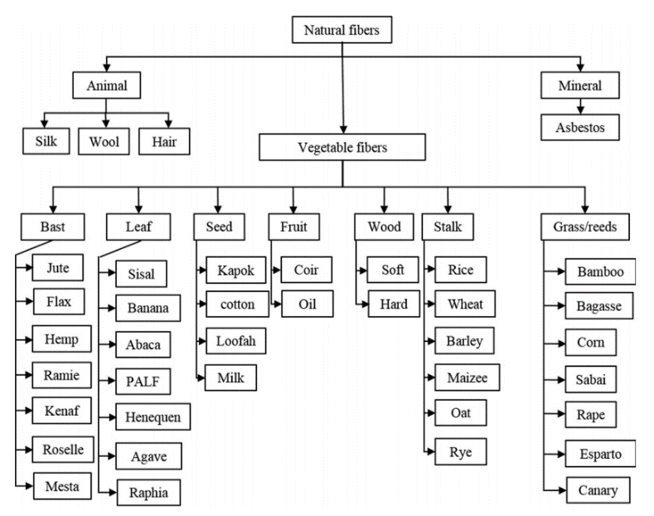

Fig 1: - Classification of NFs [15]

Plant fibers have a structure like a stack of composite folds, as illustrated in (Fig. 2) [16,17]. The fiber has a primary and secondary wall, with the secondary wall being composed of the three layers S1, S2, and S3. The S2 layer is the thickest and is responsible for the overall action of the fiber. The material gains anisotropy because of this multilayer structure. In a plant, the fibers are typically bundled together, which results in their polygonal shapes. The primary and secondary walls are framed by cellulose microfibrils and are ringed by a hemicellulose and lignin matrix [17].
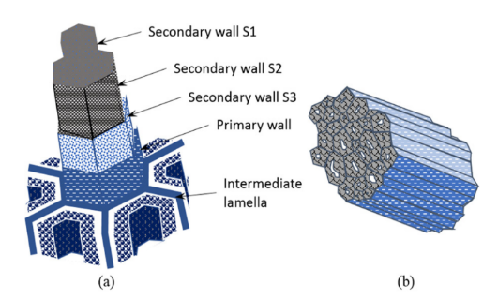

Fig. 2: - The structure of plant fiber [17]

2-2 Main components of VFs
1-2-2 The cellulose
Cellulose is the prevalent biopolymer on the globe due to its natural occurrence. It is used in a range of sectors, notably packaging, textiles, and paper, in addition to serving as a food additive. Cellulose is a polymer made up of long chains of glucose anhydride unit molecules that can reach up to 15,000 molecules in length. Beta bonds are responsible for the cohesion of the glucose anhydride particles [1,4]. As illustrated in (Fig. 3), this bonding configuration results in the cellulose molecule exhibiting a linear shape [17].
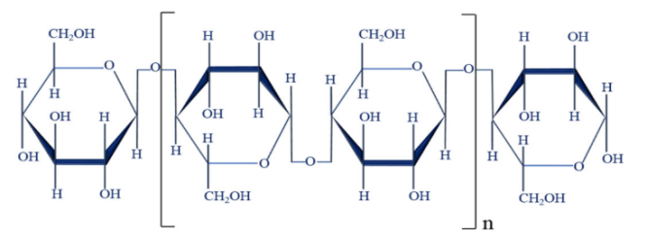

Fig. 3: - Cellulose molecule [17]

2-2-2 The hemicellulose
Hemicellulose, like cellulose, is a natural polymer composed of carbohydrate monomers. Hemicellulose is composed of glucose, arabinose, mannose, galactose, and xylose monomers [17]. A typical hemicellulose molecule is depicted in (Fig. 4) [17].

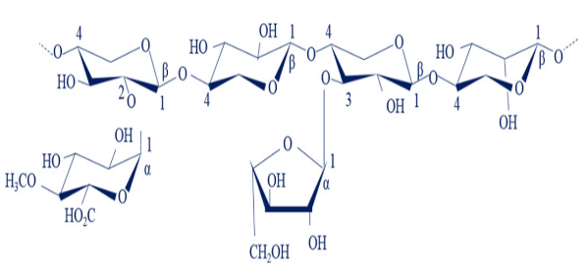

Fig. 4: - Structure of hemicellulose [17]

3-2-2 The lignin
Lignin is a large and diversified macromolecule that makes up around thirty percent of the organic carbon in the biosphere. Lignin is completely amorphous, and unlike the other carbohydrate-based cellulose and hemicellulose, it participates in the stability of the cell wall by functioning as the paste that holds the cells together. Lignin's aromatic structure is defined by three predecessors, as illustrated in (Fig. 5) [5,17].
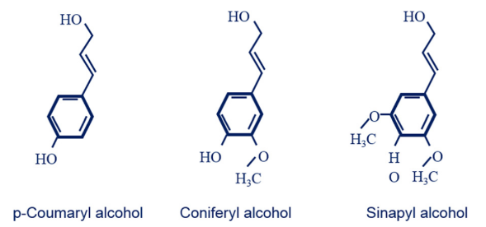

Fig. 5: - Structure of lignin precursors. [17]

3-2 Mechanical Properties of VFs
The major elements of VFs are cellulose, hemicelluloses, and lignin. Unlike the other elements of the fiber, cellulose has a predominantly crystalline structure, which results in a modulus of elasticity of roughly 136 GPa, compared to 75 GPa for glass fibers. The cellulose fibrils, in contrast, are helically arranged at an angle entitled the "microfibrillar angle." This angle exists between the fibrils and the fiber's axis. The frequency of the microfibrillar angle has an effect on the fiber's stiffness [5,17].
The qualities of VFs are frequently disputed due to the wide variety of processes used to cultivate, harvest, and separate the fibers, which can dramatically alter their behavior. For instance, the wide range, culture conditions (climate, soil, treatment), maturity, degree of readiness (combing, retting, scutching), moisture content, crystalline structure (crystallinity degree, polymerization degree, cellulose form), and morphological characteristics (cell diameter, microfibrillar angle) all have an effect on the characteristics of natural fiber. Generally, the reinforcing content and orientation of the fibers in a composite material dictate the material's elastic and rupture characteristics [18,16].

4-2 Chemical Properties of VFs
VFs are mostly composed of cellulose, hemicelluloses, and lignin. Proteins, pectin, starch, and inorganic ions are also found in trace levels [19]. The chemical makeup of VFs varies according to their origin, but cellulose is always present in significant amounts, varying from 22% to 85% by weight [18,20]. Lignin concentrations range from 7% to 24% by weight, while hemicellulose concentrations range from 12% to 27% by weight. These are heteropolymers with a wide range of chemical compositions depending on their origin. [17,19,21].

5-2 Physical Properties of VFs
The physical and chemical characteristics of VFs are primarily defined by their chemical and physical composition, structure, the percentage of cellulose, the microfibrillar angle, the aspect ratio L/d (length/diameter: a critical parameter enabling charge transfer between the fibers and matrix), the cross section, and the polymerization degree [18].

6-2 Hygroscopic properties of VFs
The moisture content at the fiber saturation point varies considerably by sorts but is typically from 25 to 35 percent of the total moisture content for most sorts of fibers. Generally, a value of 30% is more appropriate, as this agrees to the behavior of most sorts. Fig 6 depicted the moisture content of several different sorts of VFs [22].

- Banana Fibers (BFs)
1-3 General
BFs are widely obtainable across the world as waste of agricultural from banana farming. Environmentally friendly, BFs offer significant advantages such as low density, lightweight, low cost, resistance to water and fire and, excellent tensile strength [23]. BFs are demonstrated in Fig.7 [24].
BFs are lignocellulosic materials composed of cellulose microfibrils embedded in an amorphous matrix of hemicelluloses and lignin. Both the cellulose content and the micro fibril-angle of fibers influence their mechanical characteristics. With a high cellulose concentration and a low microfibril angle, banana fiber can achieve the required mechanical characteristics. In contrast, lignin's are associated with hemicelluloses and contribute significantly to the lignocellulosic material's natural degradation resistance [23, 13].
BFs are extracted by the water retting technique. Banana stems were purchased from a farm and entirely immersed in clean, drinkable water for six weeks. The stems were then retrieved from the water, slackened, and washed in a clean water tank. Thus, the fibers were sun-dried and then manually combed to unwind them further. The isolated fibers were then cut to the appropriate lengths [7].
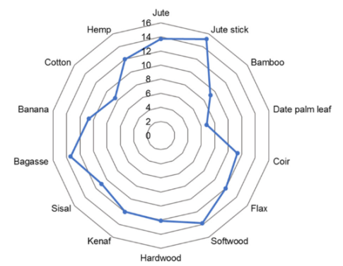

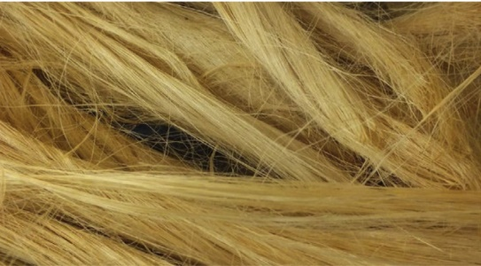
Fig 6: - Moisture content of some sorts VFs [22]

Fig. 7: - Banana fibers [24]

2.3 Mechanical and Physical Characteristics
of BFs
Table 1 shows the mechanical and physical characteristics of BFs that were reported by K. Chandra Mouli et al. [25].

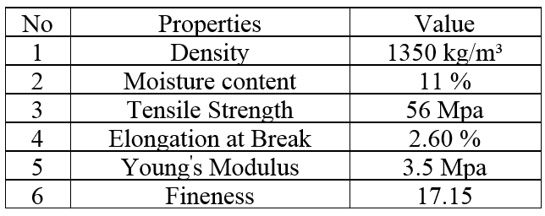
Table 1: - Mechanical and Physical Characteristics of BFs [25]

3.3 Chemical Properties of BFs
The structures of NFs contain botanical components [26]. Table 2 shows the chemical properties of BFs [23].

Table 2: - Elements of BFs [23]
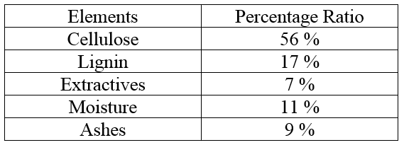

4-3 Chemical Treatments of BFs
Strength of BFs increased by Chemical treatments, eliminate impurities from the fiber, and improve wettability. There are a variety of chemical medications available to strengthen and purify natural fibers. Among these treatments, alkali therapy has the best outcomes. BFs have a proclivity for absorbing water, particularly in the first few hours following water immersion. Alkali treatment raises the surface roughness of fibers, which improves mechanical bonding and decreases water absorption. On the other hand, alkali treatment altered the botanical components [26, 27].
Elbehiry and Mostafa [28] demonstrated that two hours at room temperature were spent studying sodium hydroxide at a concentration of 6%. Following that, they are thoroughly rinsed in a water tank to eliminate any inactive reactions and ensure that the fibers are alkali-free. They are then dried for 24 hours at 80 °C.
Nor Azwin bt Ahad et al. [26] investigated the effect of BF therapy. For 3 hours at room temperature, the fibers were submerged in NaOH solutions with concentrations from 5 to 15 percent. After treatment, the fibers were rinsed under tab water and left to dry for two days at room temperature. It was found that the NaOH treatment removes contaminants from banana and coconut husk fiber, as pollutants were detected on the surface of the untreated fiber. Additionally, alkaline treatment influences on increased the quantity of cellulose exposed on the surface and roughening the surface of fibers. Additionally, this can aid in the interlocking of fibers and matrix.

5-3 Water Absorption of BFs
Raw BFs absorb significantly more water than treated BFs. Impurities and waste particles on raw fiber increase fiber absorption. It should be highlighted that the BFs' moisture absorption is a significant issue when preparing them as composites. The percentages of absorbed moisture were determined prior to and the following immersion in water in accordance with ASTM DS70 [27,29].

6-3 Scanning Electron Microscopy
As illustrated in Figure 8, the scanning electron microscope exposes the morphology of surface, transverse-sectional view, fracture behavior, and bonding between the fiber and resin matrix. Scanning electron microscopy is used to characterize the contaminants, wax, and ash content of raw fibers as well as their removal from treated fibers. On the other hand, micropores on treated fiber were exposed. BFs have elliptical cross-sectional structures with hoses of elliptical shape. SEM guarantees that the diametric transverse -section of the BFs increases their tensile strength [27].

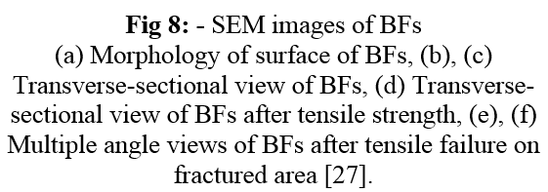
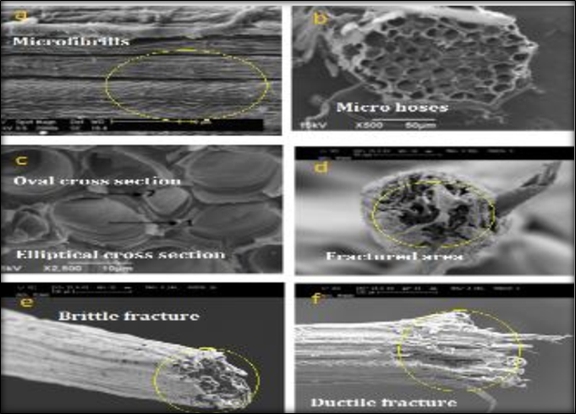

- Properties of BFs Reinforced Concrete
1.4 Fresh properties of BFs reinforced concrete
The addition of VFs significantly reduces workability. This is because the VFs absorb water. However, the mixture must be sufficiently flowable to enable the casting process to take place. An overly dry mixture may result in an insufficiently compacted product that will likely have more voids. On the other hand, an overly wet mixture will result in a loss of mechanical strength [5]. The other critical component of workability is creating fiber pellets, sometimes referred to as fiber agglomeration during the mixing process. Agglomeration is determined by the sort and fibers length utilized, the fiber volume fraction, and the aggregate size in the cementitious matrix [30].
Agglomeration of fibers should be avoided as it degrades mechanical strength. To limit the influence of agglomeration can be made specific arrangements during the mixing process. Typically, incremental addition of fibers towards the conclusion of the mixing process, after all, other contents have been thoroughly mixed, mitigates this effect of agglomeration. Additionally, the addition of a plasticizer admixture enables a significant increase in workability without impairing the composite's mechanical performance [31]. Another factor that considerably impacts the workability of new properties is the methodology used to homogeneously mix the VFs in the concrete matrix [5].
Workability loss can be mitigated by pretreatment of fibers to remove chemical components that absorb water. Pre-wetting the VFs prior to adding them to the mixture is an option. Alternatively, when producing fiber-reinforced mortar mixtures, the absorption rate of fibers can be considered by adding a set amount of additional water [32]. S. Kesavraman [2] examined the influence of high-reactivity metakaolin HRM on the characteristics of BFs-reinforced concrete. BFs were utilized at concentrations of 0.5 percent, 1%, 1.5 percent, and 2% by volume of concrete in this investigation. It was discovered that as the banana fiber level increased, the workability dropped.

2-4 Mechanical Properties of BFs reinforced concrete
Stokke, D.D. et al; [17] demonstrated that numerous factors influence the mechanical characteristics of VFs reinforced cementitious materials, as with other fibrous concrete. These factors are as follows: Sort of fibers included jute, sisal, hemp, coir, and banana, as well as the date palm. Fiber morphology is length, diameter, and transverse section. Fiber type Included single fibers, bundles, and strands. Fiber surface characteristics include smoothness, roughness, and coating agent. Matrix characteristics: cement sort, aggregate size, and admixtures. Percentage of the various constituents: W/C ratio, fiber content, and aggregate content. The mixing process includes the mixer type, the order in which constituents are added, the manner of fiber incorporation, the mixing period, and the mixing speed. Methods of implementation: vibration standard, extrusion. Air and water are the Curing conditions.
Al-Oraimi and Seibi [33] investigated the mechanical characteristics of VFs, and synthetic fibrous concrete and concluded that employing a low proportion of VFs develop the mechanical characteristics of concrete while maintaining a comparable performance to synthetic fibrous concrete.
Razak et al. [34] concluded that the addition of tiny amounts (0.6–0.8 percent) of VFs to cement-based composites increases their toughness.

1-2-4 Compressive Strength
According to numerous investigations [35:42], VFs have a detrimental effect on the compressive strength of concrete. For example, Kriker et al. [38] reported in their investigation that increasing both the length of fibers and their number lowered compressive strength. The scientists ascribed this reduction to an increase in the frequency of faults and the non-uniform distribution of fibers. On the other hand, several investigations indicated that the inclusion of trace amounts of VFs might result in good compressive strength results [39,43, and 45].
Ozerkan et al. [39] observed that a 0.5 percent concentration of VFs has the required influence on compressive strength. This result was obtained owing to the high degree of compaction between the fibers and the matrix, that resulted in a mix with a high degree of homogeneity.
Andiç-akir et al. [43], evaluated the cement mortar composites, including VFs at concentrations of 0.4 percent, 0.6 percent, and 0.75 percent by weight of mixing. According to the researchers, increasing VFs resulted in an increase in compressive strength from 3.64 percent to 14.25 percent for reinforced samples with untreated VFs. Additionally; a rise from 9% to 17.94% was seen for samples containing alkali-treated VFs. A similar finding was achieved in a laboratory study conducted by Omak et al. [45], where the researchers stated that VFs might have a beneficial influence on the compressive strength of cementitious materials. The purpose of this study was to explore a cement-based mortar integrating VFs with fiber content ratios of 1%, 2%, and 3% and lengths of 6, 12, and 18 mm. The authors saw a 30% increase in compressive strength. The scientists concluded that the long fibers ' alignment to the specimen's length was superior, resulting in a significantly greater elevation in compressive strength.
K. Chandramouli et al. [9] studied the influence of six various percentages of with a 40mm length on compressive strength: 1%, 2%, 3%, 4%, 5%, and 6%. It was discovered that the compressive strength of concrete increased progressively up to a 3 percent addition of BFs and after that gradually decreased. At 28 and 90 days, the addition of 3% BFs increased compressive strength by up to 35.04 and 40.83 percent, respectively, when compared to reference concrete. The compressive strength of the BFs reinforced concrete is increased by 34.62 percent as compared to conventional concrete after 56 days of curing.
S. Kesavraman [2] found that the compressive strength of BFs reinforced concrete increased significantly when compared to reference concrete, up to 0.5 percent of fibers by volume of concrete, at which point the strength diminishes. Compressive strength of 58.6 N/mm² is reached at fiber content of 0.5 percent, which is 18.62 percent greater than the reference concrete strength. Compressive strength at 1.5 percent fiber content is 51.9 N/mm², which is 5% greater than the compressive strength of reference concrete.
R. Kiruthigasri et al. [45] reported the characteristics of concrete with the addition of BFs and coconut fiber. Fiber percentages were 0%, 0.50%, 1.50%, 2.0%, and 2.50%, respectively, by weight of cement. Compressive strength was shown to be significantly greater for 1.5 percent fibers than for 0%, 0.5%, 2%, and 2.5 percent fibers.
Mir Firasath et al. [46] investigated the strength properties of concrete when BFs were added. Various percentages of BFs 0%, 0.5%, 1%, and 1.5 percent by volume of concrete with a 50 mm length were employed in this context. Compressive strength at 0.5 percent fiber content was determined to be 58.5 N/mm², which is 18.18 percent greater than the standard concrete strength at 0% fiber content.
Solomon Ikechukwu et al. [7] investigated the effects of partially substituting fly ash for cement on several characteristics of BFs reinforced concrete. Samples containing 0%, 10%, 20%, 30%, and 40 percent fly ash were strengthened with that have BFs of a volume fraction of 0.5 percent, 30 mm long. It was discovered that the introduction of BFs resulted in minor reductions in the compressive strengths of concrete.
Pannirselvam N et al. [25, 47], reported that the greatest compressive strength increment is 35.2 percent for seven days and 41.25 percent for 28 days when using 3 percent BFs and 3 percent nano-silica. On the other side, BFs significantly improved the compressive strength of Nano-silica concrete.
Chacko et al. [1] investigated various proportions of BFs with a 40mm length. At 28 days, it was discovered that adding BFs enhances compressive strength by up to 32.33 percent when contrasted to reference concrete.

2-2-4 Tensile Strength
Normal concretes were found to be weaker than those reinforced with BFs and kenaf fiber [49]. Chacko et al. [1], investigated that increasing the number of BFs in concrete improves the tensile strength when compared to a control mixture. K. Chandramouli et al. [9], reported that the tensile strength of concrete increased gradually up to a 4 percent addition of BFs and then gradually decreased. Tensile strength increased by 47.39 percent with the addition of 4% BFs as compared to reference concrete after 28 days. At 56 and 90 days, the addition of 4% BFs increased tensile strength by up to 46.91 and 46.14 percent, respectively, as compared to reference concrete.
S. Kesavraman [2], observed that a split tensile strength of BFs reinforced concrete is similarly greatest at 0.5 percent fiber content in comparison to other fiber contents. At 0.5 percent fiber content, the maximum split tensile strength is 4.93 N/mm², which is 15.18 percent greater than the standard concrete strength. R. Kiruthigasri and Sathishkumar [45] reported that the split tensile strength of 1% fibers is significantly higher than that of 0%, 0.50%, 1.50%, 2%, and 2.50% fibers. Ali et al. At 0.5 percent fiber content, the maximum split tensile strength is 4.65 N/mm², which is 9.1 percent greater than the standard concrete strength at 0% fiber content.
Anowai and Fredrick [7], discovered that adding 0.5 percent banana fiber increased tensile strength by 18% when compared to the control mix. Pannirselvam et al. [47] showed that the largest increase in split tensile strength is 26.9 percent for seven days and 43.03 percent for 28 days when using banana fiber and 3% nano-silica. M. Dilipan et al. [49], studied the different ratios of banana and jute composite fibers, such as 0.5 percent, 1%, and 1.5 percent by weight of fine aggregate. By the addition of 0.5 percent composite fiber, the tensile strength of concrete is increased to 5.7 percent.

3-2-4 Flexural strength
The flexural characteristics of VFs reinforced cementitious composites, as with other fibrous concrete, was highlighted in the investigations. The ordinary matrix of cementitious composite exhibited a brittle linear behavior in flexural characteristics. In contrast, the bio-composite specimens did not exhibit brittle behavior and retained a load after reaching the peak load [50]. Sedan et al. [50] identifies three phases in the cementitious composite's bending behavior:

- Phase I: Near-linear behavior comparable to that of a cement paste sample. During phase I, the matrix provides the primary support for the activities.

- Phase II: The first crack appears in the matrix just prior to achieving the maximum load. The stress is then transferred to the fibers, which bear the stress and, in turn, boundary the crack's progression via their bridging effect.
- Phase III: After the maximum load (post-peak phase), the stress reduces gradually, in contrast to the cement paste, which breaks abruptly. This phase, according to the author, is characterized by gradual rupture of the fiber/matrix contacts, followed by fiber pull-out.
All authors emphasize the shift from a brittle to a ductile pattern with controlled post-peak behavior. Nevertheless, this behavior change is not necessarily associated with an elevation in flexural strength [38]. The researchers discovered that the flexural characteristic of cementitious materials reinforced with VFs, is dependent on the dimensions (aspect ratio) and nature of the fibers, the sort of cementitious matrix, the spread of fibers within the matrix, and the making process used to make the VFs (raw, treated, and wet) [5].
Flexural strength was observed to be increased up to 8% of fibers were used. This because of fiber's making operations, including the pulping and Kraft processes, also the specimen's casting operation, which utilizes a method of dewatering to remove excess water. Although the dose of the fibers had a substantial effect on the flexural characteristics of the cementitious composites, the length of fiber was also a factor [51]. Tung et al. [52] said that the composite's flexural properties are directly proportional to the length of the VFs. At first, the lengthening of the fibers lead to an elevation in flexural characteristics. Nevertheless, after a length of 3 cm, that is regarded as a crucial length, the strength ceases to increase and starts to decline. However, it is higher than the reference mixtures.
As per Al-Mulali et al. [13], BFs contribute to the increase of concrete's flexural strength due to its high mechanical strength. S. Kesavraman, et al. [2], demonstrated that the Flexural characteristics of BFs reinforced concrete is similarly greatest at 0.5 percent fiber content when contrasted to other fiber contents. At a fiber concentration of 0.5 percent, the highest flexural strength is 6.4 N/mm², which is 17.64 percent greater than the reference concrete strength. R. Kiruthigasri and T. Sathishkumar [45] established that the flexural strength of 1 percent fibers is greater than that of 0 %, 0.5 %, 1 %, 2 %, and 2.5 percent fibers.
Mir Firasath et al. [46], indicated that the highest flexural strength attained at 0.5 percent fiber content is 6.3 N/mm², which is 16.64 percent greater than the strength of reference concrete at 0% fiber content.
Anowai and Fredrick [7], Flexural strength data indicated that specimens with 0.5 % of BFs, and 0 percent fly ash improved by 25 and 25.5 percent over the reference sample after 28 and 90 days of curing, respectively. On the other hand, it was seen during testing that reference concrete specimens (with and without fly ash) failed abruptly without warning, whereas BFs reinforced concrete samples (with and without fly ash) failed in a ductile way with enough notice.

4-2-4 Impact Strength
S. Kesavraman, [2], reported that the impact characteristics of BFs reinforced concrete improves as the fiber content increases (from 0% to 2% at a fiber length of 20mm) and the fiber length is considered. This phenomenon could be explained by BFs' capacity to absorb the energy required to cause failure. The addition of fiber results in more closely spaced cracks with a smaller fracture width, which results in the absorption of significant energy. At 2% fiber content, the maximum impact energy is (energy per blow), which is 36.9 percent greater than the reference concrete. This demonstrates the importance of BFs in resisting concrete cracking.

5-2-4 Cracks Resistance
Mir Firasath et al. [46] noted that the concrete specimens' cracking resistance improved significantly and that the specimens remained intact with one another even after specimen failure under stress, indicating a non-brittle failure.
Pannirselvam N et al. [47], indicated that the concrete's cracking resistance has also dramatically improved.

3-4 Physical Properties of BFs reinforced concrete
1-3-4 Water Absorption
Anowai and Fredrick [7] discovered that BFs reinforced concrete that is not reinforced with fly ash retains more water than traditional concrete. At 28 days, adding a 0.5 percent of BFs to the concrete led to a water absorption rate of 6.77 percent, compared to 5.61 percent for the control concrete.

- Conclusion
Refer to the above result and discussion, it can be reported that: -
Agriculture waste can be incorporated into the structure of the building, so resolving the issue of limited space for dumped agriculture waste. Additionally, it can help impair air pollution if agricultural waste is burned.
The qualities of BFs are highly dependent on the processes employed to develop, remove, and separate the fibers, which can dramatically alter their behavior.
Alkali treatment raises the surface roughness of fibers, which improves mechanical bonding and decreases water absorption.
The incorporation of BFs results in a significant loss in workability, which can be mitigated by pretreatment of fibers or pre-wetting them prior to inclusion in the mixture, or by considering the fibers ' absorption rate when producing it by adding additional water. On the other hand, the addition of a water-reducing plasticizer improves the workability of the matrix without impairing its mechanical performance.
The inclusion of BFs increased the number of the concrete's technical qualities, the most notable compression, and tensile characteristics. Additionally, the resistance to spalling and cracking was increased.
When compared to synthetic fiber reinforced concrete, a low amount of BFs enhanced the mechanical characteristics of concrete and provided similar results.
Despite its superior qualities, banana fiber as a concrete reinforcement material is unlikely to replace steel in many constructions completely.

References
1. | Raphael Chacko, et al, "Experimental studies on coconut fiber and banana fiber reinforced concrete", International journal of Earth sciences and Engineering, Vol.9, No. 3, 2016.
2. | S. Kesavraman, "Studies on metakaolin based banana fiber reinforced concrete", International Journal of Civil Engineering and Technology, Volume 8, Issue 1, pp. 532–543, January 2017.
3. | Hakeem, K.R., Jawaid, M., Rashid, U., "Biomass and bioenergy: Processing and properties. Biomass and Bioenergy: Processing and Properties", PP.1–367, doi:10.1007/978- 3-319-07641-6, 2014
4. | Ayman H. H. Khalil, Ashraf M. A. Heniegal and, Mohammed Mahmoud Attia, Behavior of post-tensioned fibrous lightweight concrete beams made of natural pumice”, 2nd International Conference, "Sustainable Construction and Project Management-Sustainable Infrastructure and Transportation for Future Cities”, December 16-18, Aswan, Egypt,2018
5. | Oussama Benaimeche et al, "The utilization of vegetable fibers in cementitious materials", Encyclopedia of Renewable and Sustainable Materials, Vol.2 , pp. 649-662, 2020.
6. | R.D.S.G. Campilho et al, "Natural Fiber Composites", Taylor & Francis Group, LLC, 2016.
7. | Solomon Ikechukwu Anowai and Olorunmeye Fredrick Job, " Properties of banana fiber reinforced fly ash concrete", International Journal of Modern Trends in Engineering and research, Vol.4, Issue 10, October– 2017.
8. | Rai, A and Jha, C.N., "Natural Fiber Composites and its Potential as Building Materials", http://besharp.archidev.org/IMG/doc. Retrieved on 10th April 2014.
9. | K. Chandramouli, et al, "Experimental investigation on banana fiber reinforced concrete with conventional concrete", International Journal of Recent Technology and Engineering, Vol. 7, Issue-6S, March 2019.
10. | Rewi, K.H.A, and Khafagy, M.A.S.A "Effects of adding Sisal Fiber and Iraqi Bauxite on Some Properties of Concrete", AL-TAQANI, Vol. 24, pp 58-73, 2009.
11. | Satyanarayana, K.G., Arizaga, G.G.C., Wypych, F., "Biodegradable composites based on lignocellulosic fibers – An overview", Progress in Polymer Science, Vol. 34, pp. 982–1021. doi: 10.1016/j.progpolymsci.2008.
12. | Ardanuy, M., Claramunt, J., Toledo Filho, R.D., " Cellulosic fiber reinforced cement-based composites: A review of recent research", Construction and Building Materials, Vol. 79, pp 115–128. doi: 10.1016/j.conbuildmat. 2015
13. | Mukhopadhyay S, et al, "Banana fibers – variability and fracture behavior", J Eng. Fiber, 2008
14. | Awwad E., Mabsout M., Hamad B., & Khatib K. "Preliminary studies on the use of natural fibres in sustainable concrete" Lebanese Science Journal, Vol.12, pp.106-117, 2011.
15.  16. | Jawaid, M., Abdul Khalil, H.P.S., "Cellulosic/synthetic fiber reinforced polymer hybrid composites: A review", Carbohydrate Polymers, Vol. 86, pp. 1–18. doi:10.1016/j. carbpol.2011.04.043.  Chabert, B., "Fibres de renfort pour matériaux composites, Initiation à la chimie et à la physico-chimie macromoléculaires", Physico-chimie des polymers, Vol. 7. Techniques Ingénieur, 1988
17. | Stokke, D.D., Wu, Q., Han, G., "Introduction to Wood and Natural Fiber Composites", John Wiley & Sons, 2013.
18. | Väisänen, T., Haapala, A., Lappalainen, R., Tomppo, L., "Utilization of agricultural and forest industry waste and residues in natural fiber-polymer composites: A review", Waste Management, Vol. 54, pp. 62–73.doi:10.1016/j.wasman.2016.04.037
19. | Rowell, R., "A new generation of composite materials from agro-based fiber. In: Polymers and Other Advanced Materials" SE - 68. Springer, pp. 659–665. doi:10.1007/ 978-1-4899-0502-4_68 1995.
20. | Al-Oqla, F.M., Salit, M.S, "Materials Selection for Natural Fiber Composites", Amsterdam: Elsevier, pp. 107–168, 2017.
21. | Sbiai, A., "Matériaux composites à matrice époxyde chargée par des fibres de palmier dattier: Effet de l’oxydation au tempo sur les fibres (PhD disscussion), Lyon: INSA, 2011
22. | Ahmad, F., Choi, H.S., Park, M.K., "A review: Natural fiber composites selection in view of mechanical', Light Weight, and Economic Properties, 10–24. doi:10.1002/ mame.201400089, 2015.
23. | Marwan Mostafa and Nasim Uddin, "Effect of Banana Fibers on the Compressive and Flexural Strength of Compressed Earth Blocks", Buildings, Vol.5, PP 282-296, 2015
24. | Manickam Ramesh et al, "Mechanical and Water Intake Properties of Banana-Carbon Hybrid Fiber Reinforced Polymer Composites", Materials Research, Vol.20, pp. 365-376, 2017.
25. | K. Chandra Mouli, "Strength studies on banana fiber concrete with metakaolin", International Journal of Civil Engineering and Technology, Vol.10, pp. 684–689, Issue 2, February 2019.
26. | Nor azwin bt ahad, "Effect of chemical treatment on the surface of natural fiber", journal of nuclear and related technologies, vol. 6, special edition, 2009.
27. | D. Jagadeesh et al, "Characterization of Banana Fiber - A Review", J. Environ. Nanotechnol, Vol. 4, pp. 23-26, ,2015.
28. | Amgad Elbehiry and Marwan Mostafa, "Finite Element Analysis of Beams Reinforced with Banana Fiber Bars (BFB)", fibers, https://doi.org/10.3390/fib8080052, 2020.
29. | Boopalan, M., Niranjanaa, M. and Umapathy, M.J., "Study on the mechanical properties and thermal properties of jute and banana fiber reinforced epoxy hybrid composites", Composites, Vol.51, pp. 54-57, doi:10.1016/j.compositesb.2013.02.033, 2013
30 | Arnon Bentur‏، Sidney Mindess,"Fibre reinforced cementitious composites", CRC Press, Taylor & Francis Group, 2nd Edition 2006.
31 | Sawsen, C., Fouzia, K., Mohamed, B., Moussa, G., "Effect of flax fibers treatments on the rheological and the mechanical behavior of a cement composite", Construction and Building Materials, Vol. 79, pp.229–235, 2015.
32. | Onuaguluchi, O., Banthia, N., "Plant-based natural fibre reinforced cement composites: A review", Cement and Concrete Composites, Vol. 68, pp. 96–108, 2016
33. | Aloraimi SK, Seibi AC. "Mechanical characterization and impact behavior of  concrete reinforced with natural fibers", Compos Struct 1995, Vol.32, pp. 165–71
34. | Razak HA, Ferdiansyah T. "Toughness characteristics of Arenga pinnata fiber  concrete", J Nat Fibers, Vol. 2, pp. 89–103, 2005.
35. | Al-Rifaie, W.N., Al-Niami, M., "Mechanical performance of date palm fiber-reinforced gypsums", Innovative Infrastructure Solutions, Vol. 1, doi:10.1007/s41062-016-0022-y, 2016.
36. | Belakroum, R., Gherfi, A., Kadja, M., et al., "Design and properties of a new sustainable construction material based on date palm fibers and lime", Construction and Building Materials, Vol.184, pp. 330–343. doi: 10.1016/j.conbuildmat, 2018
37. | Hamzaoui, R., Guessasma, S., Mecheri, B., et al., "Microstructure and mechanical performance of modified mortar using hemp fibers and carbon nanotubes", Materials and Design, Vol. 56, pp. 60–68. doi:10.1016/j.matdes.2013.10.084, 2014.
38. | Kriker, A., Debicki, G., Bali, A., et al., "Mechanical properties of date palm fibers and concrete reinforced with date palm fibers in hot-dry climate", Cement and Concrete Composites, Vol. 27, pp. 554–564. doi: 10.1016/j.cemconcomp.2004.09.015, 2005
39. | Ozerkan, N.G., Ahsan, B., Mansour, S., Iyengar, S.R., "Mechanical performance and durability of treated palm fiber reinforced mortars", International Journal of Sustainable Built Environment, Vol. 2, pp. 131–142, doi:10.1016/j.ijsbe.2014.04.002, 2013.
40. | Tian, H., Zhang, Y.X., Yang, C., Ding, Y., "Recent advances in experimental studies of the mechanical behavior of natural fiber-reinforced cementitious composites", Structural Concrete, Vol. 17, pp. 564–575, doi:10.1002/suco.201500177, 2016.
41. | Tioua, T., Kriker, A., Barluenga, G., Palomar, I., "Influence of date palm fiber and shrinkage reducing admixture on self-compacting concrete performance at early age in hot-dry environment", Construction and Building Materials, Vol. 154, pp. 721–733. doi:10.1016/j.conbuildmat.2017.07.229, 2017
42. | Lima, P.R.L., Toledo Filho, R.D., Melo Filho, J.A., "Compressive stress-strain behavior of cement mortar-composites reinforced with short sisal fiber", Materials Research, Vol. 17, pp. 38–46. doi:10.1590/S1516-14392013005000181, 2014
43. | Andiç-Çakir, Ö., Sarikanat, M., Tüfekçi, H.B., et al., "Physical and mechanical properties of randomly oriented coir fiber-cementitious composites", Composites Part B: Engineering, Vol. 61, pp. 49–54. doi:10.1016/j.compositesb.2014.01.029, 2014.
44. | Çomak, B., Bideci, A., Salli Bideci, Ö., "Effects of hemp fibers on characteristics of cement-based mortar", Construction and Building Materials, Vol. 169, pp. 794–799. doi:10.1016/J.Conbuildmat.2018.03.029, 2018
45. | R. Kiruthigasri, T. Sathishkumar,"Strengthening the Properties of Concrete using Banana Fiber and Coconut Fiber", International Journal of Trend in Scientific Research and Development, Vol. 4, Issue 4, June 2020.
46. | Mir Firasath Ali et al, "Study on Strength Parameters of Concrete by adding Banana Fibers", International Research Journal of Engineering and Technology, Vol. 7 Issue 3, Mar 2020.
47. | Pannirselvam N et al, "Pulse velocity test on banana fiber concrete with nano silica", Vol. 9, Issue 11, pp. 2853–2858, November 2018.
48. | Nurul Akmam Naaamandadin, et al, "Mechanical Behavior of Banana Fiber Reinforced Concrete with Kenaf Fiber as an Additive", Symposium on Intelligent Manufacturing & Mechatronics, 2019.
49. | M.Dilipan et al, "Experimental Investigation based on Natural Fibers Banana and Jute in Concrete ", International Journal for Scientific Research & Development, Vol. 5, Issue 2, 2017.
50. | Sedan, D., "Etude des interactions physico-chimiques aux interfaces fibres de chanvre/ciment. Influence sur les propriétés mécaniques du composite (Thesis)", Limoges, pp. 1–139. doi:10.3917/reru.071.0139, 2007.
51. | Coutts, R.S.P., Warden, P.G., "Sisal pulp reinforced cement mortar", Cement and Concrete Composites, Vol. 14, pp. 17–21, doi:10.1016/0958-9465(92)90035-T, 1992
52. | Tung, L.H., Boutouil, M., Khadraoui, F.,  January 25, 2021  Moussa, G., "Mechanical and microstructural characterization of flax fibre-reinforced cement composite", In: Proceedings of the 11th Japan-Korea-France-Canada Joint Seminar on Geoenvironmental Engineering, pp. 131–136, 2012.

