**The Usage of interactive teaching methods in formation of communicative competencies of students**

Mingboyev Ulug’bek Xujayevich

Jizzakh Regional Center for retraining and advanced training of Public Education Staff, Uzbekistan

Emails: [m_ulugbek1977@mail.ru](mailto:m_ulugbek1977@mail.ru)

**Abstract.** This article addresses the issue of shaping the communicative competencies of vocational school students through interactive methods.

[Mingboyev Ulug’bek Xujayevich. **The Usage of interactive teaching methods in formation of communicative competencies of students.** *N Y Sci J* 2021;14(1):14-17]. ISSN 1554-0200 (print); ISSN 2375-723X (online). <http://www.sciencepub.net/newyork>. 3. doi:[10.7537/marsnys140121.03](http://www.dx.doi.org/10.7537/marsnys140121.03).

**Key Words:** Integration, integration trinity, reproductive, heuristic, interaction, interactive, communicative, competence.

Decree of the President of the Republic of Uzbekistan PF-5812 dated September 6, 2019 "On additional measures to further improve the system of vocational education" through the introduction of primary, secondary and specialized vocational education The task is to train qualified and competitive personnel. This, in turn, requires the formation of basic competencies in learners.

The formation of basic competencies in students of vocational schools depends mainly on the interaction of students, the presence of a real professional environment of cooperation in solving problems, the use of educational technologies and teaching methods that stimulate activities based on professional self-determination.

I. Ya. Lerner figuratively called teaching methods "methodological tools". The mastery of the content of vocational education, the accumulation of social and professional experiences in students depends in many respects on them. Teaching methods are the most dynamic and dynamic element of the educational process, and are closely related to other aspects of education, ie goals, content, principles of teaching organization, individual characteristics of students.

Based on the work of A.A. Verbitsky and A.P. Panfilova, we believe that active teaching methods can be a modernization of traditional teaching methods. For example, the conversational method of teaching can be in reproductive and heuristic forms. Describing interactive methods, it should be noted that interactive methods ("inter" - interaction, "act" - actions) imply a mode of interaction, conversation, two-way exchange of information. Moreover, if active teaching methods are related to the organization of a wide range of interaction between teacher and students, for example, interactive methods focus on the interaction of students not only with teachers but also with each other, computer, interactive textbook, textbook. Thus, interactive teaching methods can be considered as the most modern form of methods based on student communication. Interactive teaching methods (discussions, games, situation analysis, etc.) are based on student interaction, organizing independent work in groups and in pairs.

Understanding the essence of interactive teaching methods is related to the concept of "interaction" as communication, the organization of the process of interaction between communicators, the exchange of knowledge, ideas, actions. In this case, the interaction is based on a feedback loop, the specificity of which depends on the ability of the receiver to choose the content and form of mastery.

An analysis of the psychological and pedagogical literature implies a multifaceted understanding of the conceptual field associated with interactive teaching methods. In particular, M.V. Clarin defines the concept of “interactive teaching” as teaching based on direct interaction in the learning environment for students to gain new experiences.

However, although these concepts have different interpretations, their following main characteristics can be distinguished: they describe the ways in which the teacher forms a pedagogical dialogue between the student and the learning environment, performing leadership, organizational and corrective functions.

In our study, we see the “interactive teaching method” as a way to ensure interaction, create a common state of interpersonal relationships between students and teachers as subjects of the learning process, and implement common goals, values, and activities as an image of the future. As a result, a positional professional community is formed, which

solves the educational (professional) task. In describing interactive teaching methods, we look at it as interactive teaching, i.e. “teaching, teaching communication”. It is characterized by the organization of cognitive activities through dialogue, in which each student contributes individually to the solution of the problem by sharing knowledge, ideas and methods of activity. It is known that communication can take place in traditional teaching in the areas of "teacher - student", "teacher - student group". Communication for interactive learning expands in the context of "student-student" (pair work), "student-group", "student-audience", "student-computer" and others.

The use of interactive teaching methods in the formation of communicative competencies transforms students into able to independently search for and assimilate the necessary information from the ready recipient. The role of the teacher in the application of interactive teaching methods becomes the communication facilitator, counselor and expert.

The analysis shows that the choice of interactive teaching methods in the formation of communicative competence in the educational process depends on: personal relationships, the organization of group interactions in the classroom, taking into account academic achievement; the content of the educational material includes the problem, has different points of view, the disproportion of positions, is of an incidental nature for students; The process of completing the tasks is based on the exchange of ideas, valuable perspectives of students, scientific approaches to problem solving. All of this implies interaction and collaboration between students who are active subjects of teaching.

One of the main features of interactive teaching methods is that they are mainly used in a goal-oriented educational process that develops in the preparation of vocational school students for professional activities.

The strategy of choosing interactive teaching methods in teaching students, in our opinion, is carried out taking into account the following actions in the formation of communicative competencies: determine the role of the studied science in the formation of communicative competencies; identify specific skills that need to be developed through these science tools; identify topics in which communicative competencies are formed; identification of opportunities for interactive teaching methods for the formation of communicative competencies in students.

Thus, taking into account the research and justification of interactive teaching methods that provide the formation of communicative competence in students of vocational schools, we express the features identified by us as follows: - The presence of an active (subjective) position of the student in the learning process; - activation of active knowledge, which provides students with the skills, algorithms and methods of activity that are universal for the acquisition of communicative competence, providing readiness for solving educational and professional problems according to V. Zinchenko "vital knowledge"; -interactive methods are circular in nature and include: problem - task - dialogic interaction - independent activity of students - reflection.

Interactive teaching methods allow them to model communicative situations, find clear communicative problem solutions and understand the consequences of decisions made, process interpersonal communication skills, provide feedback, edit feedback, and find alternative ways to solve communicative problems.

Each method has its own area of ​​application and limitations. If interactive teaching methods are properly selected and combined, then communicative competencies can be formed more effectively.

Below we consider the method of "Integration Trinity" developed by us, which is based on the integration of methods "Working in small groups", "Small lecture" and "Student teaches student, teacher teaches student", which is effective in the organization of lessons "Computer Science and Information Technology". (Figure 1).

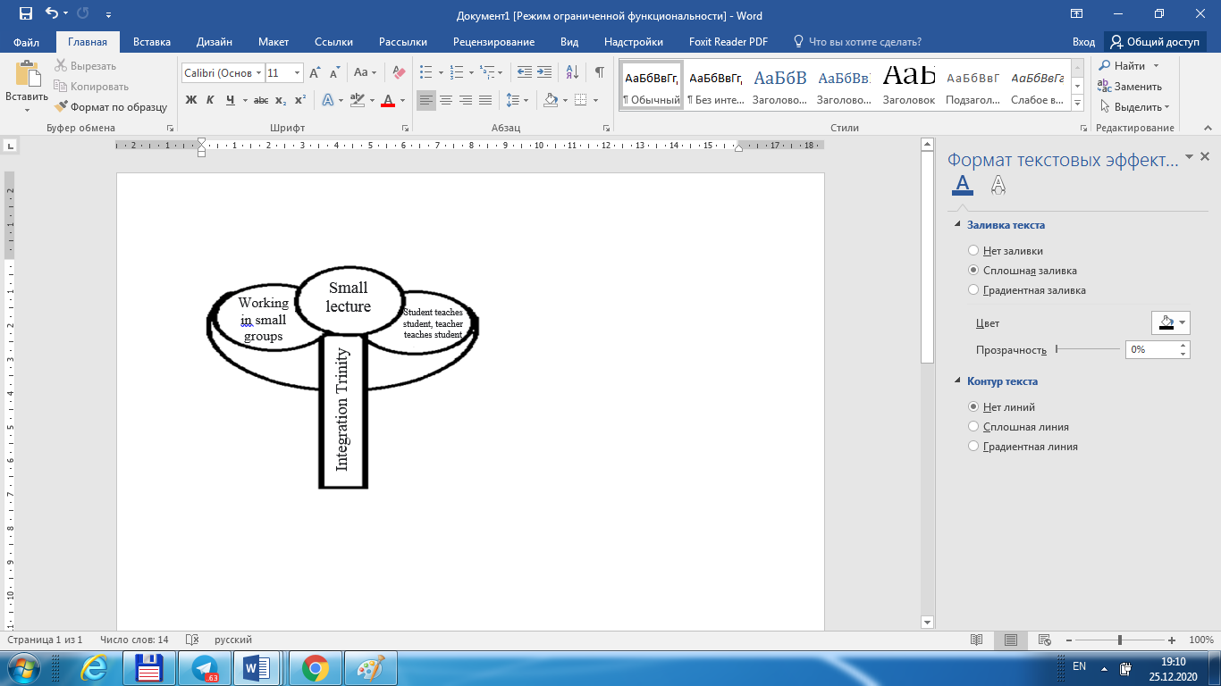

Figure 1. Integration triple method.

The method helps students to work in small groups and collaboratively, to develop a sense of personal responsibility and communicative competencies at the same time. Ensures 80-90 percent mastering of educational material by all pupils at high efficiency.

The “Integral Trinity” method involves dividing the guaranteed material into modules of 4-5 minutes of small lectures. The lecture should be fluent, simple, understandable and contain the most important information, which determines the criteria of the teacher's skill.

**Sequence of application of the method.**

Students are divided into small groups of 5-6 people. Groups can name themselves and elect a leader. The tasks of the groups are to listen carefully to the teacher’s lecture and to put it into practice. Be able to complete a given task in a given time Prepare for the presentation. The teacher emphasizes that the group members have the right to choose which student to present. A teacher-selected member of the group is given 5 points if the text is completely correct, 4 points if there are minor shortcomings, 3 points if there are shortcomings, 2 points if the presentation is not given (1 point is given based on the general work of the group, although at the time the group is active, there are hand lifts in the sense that I can speak, 6 people could not master the material at all was not observed in the experiment. However, no member of the group other than the one present at the presentation will be given the opportunity to speak or complete.

After the teacher introduces the first module to the students in a small lecture method, based on the number of modules, the students are given 3-4 minutes to prepare.

The teacher closely monitors the work of the groups. It can also help some groups. He notes the shortcomings he felt in the work of the groups. At the end of the allotted time, the teacher asks a student to make a presentation based on the observation. The rest of the groups should listen carefully, the teacher can also stop the presentation at any time and ask the other group member to continue. The work of the groups will be evaluated and recorded on an electronic slide.

In this order, the second and remaining modules are also presented and evaluated. In subsequent stages, the teacher may also ask the same student again which group participant had difficulty answering in the first stage. In this way, group members are involved in helping this student more. The teacher attaches great importance to the mutual respect of the members of the group. If all the other members object to one participant, it will have a negative effect on his psyche. Therefore, the teacher must first create the right psychological environment.

At the end of the lesson, the winning group is determined by the total number of points. The most active students in the remaining groups will also be assessed. The student does not have to make a presentation in order to be recognized and evaluated as active. Students who actively participate in group activities and helping their friends should also be evaluated during the lesson based on teacher observation.

**Advantages of the method of "integration trinity":**

1. A 4-5 minute lecture can be listened to with high attention by the reader;

2. The essence of the lecture text is understood and understood;

3. The lecture or practical assignment is immediately reinforced;

4. Even if you don't tell the students, they take pens and notebooks and start writing;

5. Team members help each other and teach each other;

6. Students control each other;

7. They will have to repeat the text or practical task again during the control;

8. Allows assessment of a large number of students at a high level; 9. In a well-organized lesson, 100 percent of students are assessed and 100 percent effective, all students master the material for 4 or 5 grades;

10. The effect on students 'mastery is immediately felt, at the same time students' communicative competencies are formed and their interest in science increases;

11. Active participation of all students in the group is ensured.

The student listens to the teacher, writes, listens to his friends, expresses his opinion, completes practical assignments, prepares for the presentation, goes to the presentation, listens attentively to the presentation of others. Corrects errors. One piece of information is repeated 7-8 times by the reader. This process is done with a very high level of attention, interest and passion. In each student, responsibility is maintained throughout the lesson.

In conclusion, it should be noted that the use of the method of "Integration Trinity" in the lessons of computer science and information technology in vocational schools allows students to effectively form communicative competencies.

**References**

1. Decree of the President of the Republic of Uzbekistan dated September 6, 2019 No PF-5812 "On additional measures to further improve the system of vocational education." www.lex.uz.
2. Verbitskiy A.A. Personal and competent approach to education: problems of integration. -M.: Logos, 2009. -336 p.
3. Ivanov D.A. Competence and competence approach in modern education -M.: Chistye prudy. -2007. -32 s.
4. Clarin M.V. Interaktivnoe obuchenie - instrument osvoeniya novogo opyta - Pedagogika. -2000. -№7. -S.12-18.
5. Kolesnikova I.A. Pedagogical reality: experience of mezhparadigmalnoy reflex. Course of lectures on pedagogical philosophy -SPb: Detstvo-Press, 2001. -288 p.
6. Lerner I.Ya. Показатели системы учебно-poznavatelnyx заданий - Новые иследования в педагогических иследованиях. Vyp.2 (67). - М. Pedagogy, 1990. -80 p.
7. Mingboev U.X. Formation of communicative competencies in students through exercises in computer science classes // Vocational education. -Tashkent, 2018. - №2. - B. 50-55.

1/14/2021