Flowering And Fruiting Phenology Of False African Nutmeg

Bello O. A.* ¹ and Akinyele A.O. ²

¹Department of Biology, Osun State College of Education, Ila-Orangun, Osun State, Nigeria
²Department of Forest Productions and Products, University of Ibadan, Nigeria
*Corresponding author (Phone number: +234 8066557071 Email: nikebello73@gmail.com)

Abstract: Matured trees of Pycnanthus angolensis (20.0±5.0years) were purposively selected from Oyo (Idito ID, Adewumi AD), Osun (Gbongan GB, Ajaba AJ), and Ekiti (Otun OT, Ayetoro AY) States, based on availability. Onset and duration of flowering and fruiting (months) and period of fruit colour change (days) were monitored for 24 months. Flower initiation ranged from September-November in which GB initiated flower in October, AJ (September), OT (November), AY (November), ID (November) and AD (November). However, OT, AY, ID and AD initiated flower at the same time. Flower formation also occurred between October-January. In GB, it occurred between Nov – December for (30days), AJ October 3rd–November. 30th for (58days), OT November 8th– December 8th (30days), AY November 8th–December 8th (30days), ID and AD formed flower between December 8th–January8th (30days). Flowering period/ duration also varied, in GB, between October 1st-April 30th (7mths/ 211days), AJ between September 1st – January 31st (5mths/ 153 days), OT between November 1st – March 31st (5mths/ 151days), AY (April), ID and AD (June). Flowering period ranged from 5-8 months. It fruits from middle of July–June. However, Osun fruits (July-April), Ekiti (July-May) and Oyo (November-June). Fruiting initiation (FrI) ranged from July-November, GB: September, AJ: July, OT: July, AY: August, ID and AD: November. However, OT and AJ, ID and AD initiated fruit at the same time. Fruit formation (FF) occurred between September-November. Fruit maturation starts with brown colouration (FrM₁), brown-Green (FrM2), Green-Yellow (FrM3) and Yellow (FrM4). FrM₁ in GB {September 1st – September 30 (30)}, AJ: July 1st–November (150days), OT: July1st–August 30th (62), AY: August1st–October 30th (90), ID: November-December (61) and AD November1st-30th (30); FrM2 in GB ranged from October 1st-December 15th (105), AJ November1st-30th (30), OT (91days), AY October (60 days), ID (61) and AD (61); FrM3: ranged from (30 to 89days), and FrM4 ranged from (90days/3months) to 202 days. Fruiting occurred between middle of September–June. Osun began (September-January), Ekiti (November-April) and Oyo (November-June).
[Bello O. A. and Akinyele A.O. Flowering And Fruiting Phenology Of False African Nutmeg. N Y Sci J 2020;13(12):73-78]. ISSN 1554-0200 (print); ISSN 2375-723X (online). http://www.sciencepub.net/newyork. 5. doi:10.7537/marsnys131220.05.

Keywords: Phenology, Fruiting, nutmeg, and Timing

- Introduction
Pycnanthus angolensis, an evergreen tree from the family Myristicaceae mainly grows in the West and Central African countries like; Ghana, Sierra Leone, and Cameroon. This plant is generally known as \False African nutmeg with a large, small crown of branches at right angles to the bole. Pycnanthus angolensis has some common names aside of False African nutmeg such as; Akomu in Yoruba, Walele in Ivory Coast, Eteng in Cameroon, Calabo in Spanish (Wikipedia, 2015), and Lolako in Zaire (Forest Products Laboratory. Forest Service, USDA. 2015). A relative number of studies on phonological studies of tropical species from natural forest ecosystem have been reported by some authors. In plants, phenology mainly focuses on flowering phenology, floral biology, and pollen-pollinator interaction, breeding systems and gene flow through pollen and seeds. Fruiting studies in humid forest species aid to give fundamental information for regeneration of accessible stands and for the establishment of plantations. There is need to study on flowering and fruiting of local tree species to make possible the propagation of fresh trees.

2 Materials and Methods
2.1. Mother tree selection.
Matured trees of Pycnanthus angolensis (20.0±5.0years) were purposively selected from Oyo (Idito ID, Adewumi AD), Osun (Gbongan GB, Ajaba AJ), and Ekiti (Otun OT, Ayetoro AY) States, based on availability. Matured trees of Pycnanthus angolensis (20.0±5.0years) were purposively selected from Osun (Gbongan: GB, Ajaba: AJ), Ekiti (Otun: OT, Ayetoro: AY) and Oyo (Idito: ID, Adewumi: AD)
States, based on availability. Onset and duration of flowering and fruiting (months) and period (days) of fruit colour change (days) were monitored for 24 months. Phenological characteristics such as Fruit onset (FRI), Fruit formation (FF), Fruit maturation: brown colouration (FrM₁), brown-Green (FrM2), Green-Yellow (FrM3) and Yellow were observed. Data collected were analysed using descriptive statistics. The global positioning system was used to record their GPS of each stand of tree used in each state. This formed the location for the selected trees (Table 1).

Table 1: Selected Locations of P. angolensis in states of South West Nigeria
Locations | Latitude | Longitude | Altitude (m) | Accuracy (m) | State
Gbongan | 7°29'17.616"N | 4°20'37.092"E | 244.40 | 3.50 | Osun
Ajaba | 7°59'33.894"N | 4°53'52.596"E | 485.40 | 2.90 | Osun
Otun | 7°58'47.661"N | 5°7'59.874"E | 594.70 | 3.40 | Ekiti
Ayetoro | 7°55'59.090"N | 5°81'43.182"E | 569.90 | 3.30 | Ekiti
Adewumi | 7°26'57.792"N | 4°2'3.381"E | 207.10 | 2.80 | Oyo
Idito | 7°27'14.676"N | 4°3'9.504"E | 215.20 | 4.00 | Oyo

3. Results
3.1 Flower timing
The flowers are arranged in dense, rusty inflorescence (panicles) in which the entity flowers are not easy to see in the rigid panicle until the stamens expand, the flowers are hairy and fragrant (Plate 1a). Flowers are unisexual (male and female flower separately), normal, very small, and stalkless, with 3-lobed enclosed with dim chocolate hairs (Plate1a) and changes occurred from the bottom to the top of the inflorescence (basipetal) (Plate 1b) Male flowers with stamens merged together into a synandrium with no distinctive filaments and connectives (Plate1c) that are in clusters of inflorescence flowers.

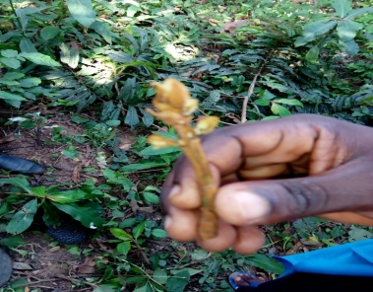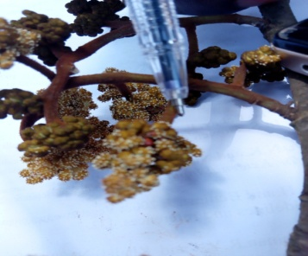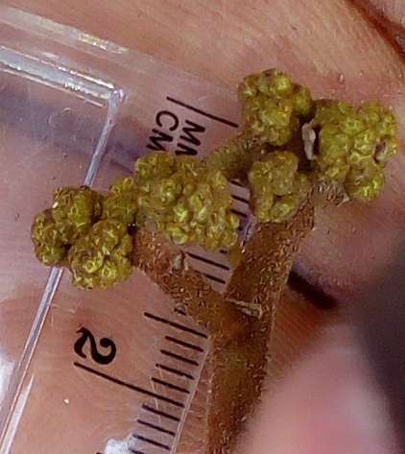
a b c
Plates 1a: Inflorescence flower with 3 lobed perianth. b: Inflorescence changes start from the bottom to the top (Basipetal) c: Male inflorescence of P. angolensis
c
a

Flowering occurred at different times between middle of September, 2017 to June, 2018. However, Osun began flowering from September, 2017 to January, 2018, Ekiti began flowering between November, 2017 to April, 2018 and Oyo began flowering from November, 2017 to June, 2018. From Table 1, flower initiation ranged from September to November, 2017 in which GB initiated flower in October, 2017 AJ initiated flower in September, OT initiated flower in November, 2017, AY initiated flower in November, 2017, ID initiated flower in November, 2017 and AD initiated flower in November, 2017. However, OT, AY, ID and AD initiated flower at the same time. Flower formation also occurred at different times from October, 2017 to January, 2018 between 30-58 days. In GB, it occurred between Nov-December, 2017 for 30days, AJ flower formation occurred from October 3rd to November. 30^{th,} 2017 for 58days, in OT, it occurred from November 8th to December 8th 2017 for 30days, in AY, it occurred between November 8th to December 8th, 2017 for 30days, ID and AD formed flowers at the same time between December 8th 2017 to January 8th 2018 for 30days. Flowering period ranged from 5-8 months, in GB, it lasted for seven months, started from October 1st 2017 to April 30th 2018for 7mths/ 211days, AJ flowering lasted for five months, started from September, 1st 2017to January 31st 2018 for 5mths/ 153 days, OT between November 1^{st 2018} to March 31st 2018 for 5mths/ 151days, AY flowering lasted for eight months (8mths/ 242days), between November 1st 2017 to June 30th 2018. In ID, flowering lasted for eight months (8mths/ 242days), started from November 1st 2017 to June 30th 2018 and AD flowering lasted for eight months (8mths/ 242days), started from November 1st 2017 to June 30th 2018. The opening of cream coloured flowers is situated from early December to early January during the dry season Inflorescence dropping varied within and among the locations and it occurred between January and June 2018, GB dropped inflorescence in April, AJ dropped inflorescence in January, OT dropped inflorescence in March, AY dropped inflorescence in April, ID and AD dropped inflorescence in June. Dropping of inflorescent could be as a result of disease condition which has caused premature dropping at Otun Ekiti and environmental conditions. Flowering initiation (FI) ranged between 30 to 58 days and FF ranged between151 to 282 days (Table 2)

Table 2: Floral duration of P. angolensis
Location | Flower initiation FI (Month) | Flower formation FF (DAYS) | Flowering period (M/D) | Inflorescence dropping
Gbongan (GB) | October, 2017 | Nov – Dec 2017 (30days) | Oct 1, 2017 – April 30, 2018 (7mths/ 211days) | April, 2018
Ajaba (AJ) | September, 2017 | Oct 3 – Nov. 30 2017 (58days) | Sept 1, 2017 – Jan. 31,2018 (5mths/ 153 days) | January, 2018
Otun (OT) | November, 2017 | Nov 8 – Dec 8 2017 (30days) | Nov1, 2017– March31, 2018 (5mths/ 151days) | March, 2018
Ayetoro (AY) | November, 2017 | Nov 8 – Dec 8 2017(30days) | Nov 12017 – April 30, 2018 (6mths/ 181 days) | April, 2018
Idito (ID) | November, 2017 | Dec 8, 2017 – Jan 8, 2018 (30days) | Nov 1, 2017 – June 30, 2018 (8mths/ 242days) | June, 2018
Adewumi (AD) | November, 2017 | Dec 8, 2017 – Jan8,2018(30days) | Nov 1, 2017 – June 30, 2018 (8mths/ 242days) | June, 2018

3.2. Fruiting Duration/timing
P. angolensis fruits at different times between middle of July, 2017–June, 2018. However, Osun fruits between July, 2017and April, 2018. Ekiti fruits between July, 2017 to May, 2018 and Oyo fruits from November, 2017 to June, 2018. It was observed that the developing phases were alike crosswise all chosen locations but the moment in time varies with a little overlapping in some areas Fruiting initiation/ onset of fruiting (FrI) ranged from July-November, 2017 in which GB initiated fruit in September, 2017. Fruiting initiation / onset of fruiting (FrI) in AJ was July, 2017, OT initiated fruit July, 2017, AY initiated fruit in August, 2017, ID initiated fruit in November, 2017 and AD initiated fruit in November, 2017. However, OT and AJ, ID and AD initiated fruit at the same time. Fruit formation / Fruiting Timing (FF) also occurred at different times between September-November, 2017. Early fruit initiation /onset occurred in Gbongan and late in Ajaba (Osun state) (Table 3).
3.3. Fruit maturation
Fruit ripening occurred during the rainy season and fruit maturation starts with initial brown colouration (FrM₁) changing from brown to Green at the second stage (FrM₂), followed by Green changing to Yellow at the third stage of fruit maturation (FrM₃) and Yellow as the last fruit maturation colour (FrM₄₎. It took 30 to 150 days for fruit of P. angolensis to mature. Fruit initiation colour (FrM₁) occured in GB from September 1st to September 30, 2017 for 30days, AJ initiated fruit between July 1st to November, 2017 for 150days, OT initiated fruit between July1st to August 30th 2017 for 62 days, AY initiated fruit from August1st to October 30th, 2017 for 90days, ID initiated fruit from November to December, 2017 for 61days and AD initiated fruit from November1st to 30th 2017for 30days. At second stage of fruit maturation (FrM₂) fruit colour changed from Brown to Green. In GB, FrM₂ ranged between October 1st to December 15th 2017 for 105 days, AJ fruit changed from Brown to Green from November1st to 30th 2017 for 30days, OT fruit changed from Brown to Green from September 1st to November 30th, 2017 for 91days, in AY, fruit changed from Brown to Green from October 1st to November 30th 2017for 60 days, ID fruit changed from Brown to Green from November to December, 2017for 61days and AD November1st-December 31st, 2017 for 61days. At third stage of fruit maturation (FrM₃), fruit colour changed from Green to Yellow. In GB, FrM₃ ranged between December 15th 2017 to January15th 2018for 30 days, in AJ, FrM₃ ranged between November 15th to December 15th 2017 for 30days, in OT, FrM3 ranged between November1st to 30th for 30days, in AY FrM₃ ranged between November1st to December 31st, 2017 for 61days, in ID, FrM₃ ranged between December1st, 2017 to January 31st, 2018 for 61 days, and in AD, FrM₃ ranged between December1st to February 29th 2018 for 89 days. At forth stage of fruit maturation (FrM₄), fruit colour changed to Yellow. In GB, fruit colour changed between 1st January to April 30th 2018 for 120days/4months, in AJ, fruit colour changed between December1st, 2017 to February 29th, 2018 for 90days/3months, in OT, fruit colour changed between December1st, 2017-March 31st, 2018 for 121days/4months, in AY, fruit colour changed between December 13th, 2017 to May 5th 2018 for 161 days, in ID, fruit colour changed between January 5th to June 16th 2018 for 202days and in AD, fruit colour changed between Feburary1st-June 16th 2018 for 135 days (Table 3).
3.4 Fruiting period
From table 3, fruiting period ranged from 8-10 months and occurred for a very long period, in GB it lasted for eight month (8mths/ 241days), started between September 1st, 2017 to April 30th, 2018. Fruiting period in AJ lasted for eight months (8mths/ 243 days), started from July 1st, 2017 to February 29th, 2018, OT lasted for nine months (9mths/ 274 days), started from July 1st, 2017 to March 30th, 2018. Fruiting period in AY lasted for ten month (10mths/304 days), which started from August 1st, 2017 to May 30th, 2018, fruiting period in ID and AD lasted for eight months (8mths/ 242days), between November 1st, 2017 to June 30th, 2018. However, the longest fruiting period occurred in Ayetoro for10 months/ 304 days followed by Otun in 9months/ 274days while the other four locations: AJ, GB, ID and AD had fruiting period lasted for 8months with distinctions in days. ID and AD had similar fruiting period of 242 days, AJ had 243 days while late fruiting period occurred in GB at 241days.
3.5 Fruit Dehiscence
Fruit Dehiscence varied within and among the locations (Table 3 and Plate 2), in GB Fruit Dehiscence lasted for 30 days started in April1st to April 30th, 2018. In AJ, it lasted for two months, started in March, 2018 to April 30th, 2018. Fruit Dehiscence in OT lasted for three months (121 days) started in December15th, 2017 to 31st March, 2018. In AY, it lasted for two months, started in March, 2018 to April 30th, 2018; ID lasted for six months (181 days), started in January 25th, 2018 to June 30th 2018. Fruit Dehiscence lasted for three months (91days) in AD started in April, 2018 to1st June, 2018.

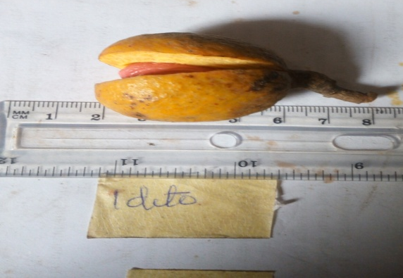
Plate 2: Fruit dehiscence of P. angolensis

Table 2: Fruiting and maturation timing of P. angolensis
Locations | Fruit initiation /Onset (FrI) | Fruit formation (FrF) | Fruit Maturation/ colour |  |  | Fruiting Period | Fruit Dehiscent
 |  |  | Fr₁ | Fr₂ | Fr₃
 |  |  | Brown-Green (days) (BG) | Green-Yellow (GY) | Yellow (Y)
Gbongan (GB) | Sept. | Sept1 – Sept30, 2017 (30 days) | Sept 1 – Dec 15, 2017 (105 days) | Dec 15, 2017 – Jan 15, 2018 (30days) | Jan – April, 2018 (120 days) | Sept – April (8 months) 241 days | April (1 – 30, 2018) 30days
Ajaba (AJ) | July | July, 2017-Nov. 2017 (150days) | Nov 1 – Nov 30, 2017 30days | Nov15 – Dec15, 2017 (30days) | Dec., 2017– Feb., 2018 (90days) | July, 2017 – Feb., 2018 8months (243 days) | Dec, 2017 – Feb, 2018 3months (90days)
Otun (OT) | July | July – Aug.,2017 (62days) | Sept – Nov, 2017 (91days) | Nov1-30,2017 (30days) | Dec, 2017–March, 2018 (121days) | July, 2017– March, 2018 9 months (274 days) | Dec 1, 2017 – March 30,2018 3 months (121days)
Ayetoro (AY) | Aug. | Aug1 – Oct 30, 2017 (90 days) | Oct – Nov, 2017 (60days) | Nov 1 – Dec 30, 2017 61days | Dec13, 2017 – May5, 2018 (161days) | Aug,2017 – May, 2018 10months (304days) | March15-April, 15,2018 (30days)
Idito (ID) | Nov | Nov 1 – Nov30, 2017 (30days) | Nov 1 – Dec 30, 2017 (61days) | Dec 1, 2017– Jan 31, 2018 (61days) | Jan 5 –June16, 2018 (202 days) | Nov, 2017– June,2018 8 months (242days) | Jan – June, 2018 6 months (181days)
Adewumi (AD) | Nov | Nov 1 – Nov30, 2017 (30days) | Nov 1 – Dec 30, 2017 (61days) | Dec 1, 2017 – Feb 28,2018 (89days) | Feb 1 – June 16,2018 (135days) | Nov 1 – June 30 8months (242days) | April – June, 2018 3months (91days)

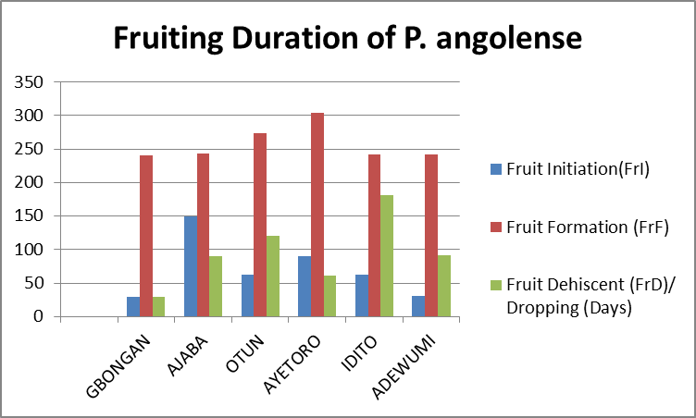
Figure 1. Fruit Phenology of P. angolensis in selected locations

4. Discussion
Phenology is the study of relationships between climatic variables and periodic phenomena in organisms (Yadav and Yadav 2008). Some of the periodic phenomena in plants include germination, leafing, flowering, fruiting and growth. Among the most important phenological events in flowering, for example, is the timing, and duration. In southwestern Nigeria, flowering occurred at different times between middle of September–june. However, Osun began (September-January), Ekiti (November-April) and Oyo (November-June). Some researchers reported that Flowering phenologies vary in the tropics and trees can potentially flower at any time of the year. It was also occurred that plants belonging to the same population like GB and AJ did not have the same phenological pattern. The same was also reported by Gomez (1993) that plants belonging to the same population do not always have the same phenological pattern. The variation in the flowering phenological events ranged from a few days to the whole year. There are many periodic phenomena in plants which include germination, leafing, flowering, fruiting and growth. Among the most important phenological events in flowering, for example, is the timing, and duration. The flowers are set in dark, corroded inflorescence (panicles) in which the character flowers are not easy to spot, the flowers are hairy and fragrant. This agrees with Onocha and Otunla (2010). Flowers are unisexual, normal, very small, and stalkless. This agrees with the report of Mapongmetsem (2007). No distinct filaments and connectives and this result is same with other scientists. In southwestern Nigeria, the flowering times /timing which refers to the length of the blooming period was observed to be long to allow the gathering of hereditary materials for enhancement and hybridization within and between the locations (Ujor, 1984). It depends on location which occurred at different times between middle of September-June of another year. This agrees with Lok (1983). This period of flowering observed in this species is long like those of Irvingia species (22-80 days) (Ujor, 1984); Terminalia ivorensis A. Chev. (40-110 days) in Oni et al. (1991) and 40-90 sdays in Triplochiton scleroxylon (Oni, 1985). However, Osun began flowering between September-January, Ekiti began flowering between November-April and Oyo began flowering between November-June. This is consonant with Bawa et al. (2003) that flowering phenologies vary in the tropics. It was also occurred that plants belonging to the same community like GB and AJ did not have the same phenological pattern. The same was also reported by Gomez (1993) that plants belonging to the same community do not always have the same phenological pattern. The differences in the flowering phenological events range from little days to the entire year (Opler et al., 1980). The flowering timing of P. angolensis is seasonal and in southwestern Nigeria, flowering occurred at different times between middle of September–June. However, Osun began (September-January), Ekiti (November-April) and Oyo (November-June). This result is related to Bawa et al. (2003) who accounted that flowering phenologies differ in the tropics. It also occurred that plants belonging to the same community like GB and AJ did not have the same phenological pattern. The same was also reported by Gomez (1993) that plants belonging to the same community do not always have the same phenological pattern. Flowers were formed between October and January and seen mostly in December in clusters as small flowers which occurred in rust coloured (Mapongmetsem (2007) but individual flowers are difficult to see and this agrees with Mapongmetsem (2007). Dropping of inflorescent occurred earlier in Ajaba and this could be traced to the effect of global position of the tree on latitude while late dropping of inflorescent could be as a result of their position on latitude, longitude, and altitude. The observed changes of peaks from one month to another (Table 2) together with the differences in flowering during monitoring periods, indicates seasonality in patterns of flowering and fruiting phenologies in P. angolensis (Tables 2) and also in locations.

5. Conclusion
Flowering of Pycnanthus angolensis occurred at different times between middle of September–june. However, Osun began (September-January), Ekiti (November-April) and Oyo (November-June). Flowering period of Pycnanthus angolensis ranged from 5-8 months. The plant did not flower at the same time among six locations. Fruiting period ranged from 8-10 months and Fruit maturation starts with brown colouration, brown-Green, Green-Yellow and Yellow. P. angolensis fruits at different times between middle of July–June. However, Osun fruits (July-April), Ekiti (July-May) and Oyo (November-June). It was observed that the developing stages were similar across all selected locations but the time interval varies with some overlapping in some areas. Fruit formation (FF) also occurred at different times between September-November. Fruit Dehiscence varied within and among the locations, it ranged from 30 to 181 days (from April one year to June of another year). Fruiting occurred at different times between middle of September to June. Osun began (September-January), Ekiti (November-April) and Oyo (November-June).

References
- Bawa, K.S., Kang, H., and Grayum, M.H. (2003). Relationships among time, frequency, and duration of flowering in tropical rain forest trees. American Journal of Botany, 90:877-887. http://dx.doi.org/10.2307/2443526
- Gopalakrishnan, K.K. and Thomas, T.D. (2014). Reproductive Biology of Pittosporum dasycaulon Miq., (Family Pittosporaceae) a Rare Medicinal Tree Endemic to Western Ghats. Botanical Studies, 55, 15. http://dx.doi.org/10.1186/1999-3110-55-15
- Lok, C. M. (1983). Kombic acid, a hydroquinone polyisoprenoic carboxylic acid from Pycnanthus kombo seed fat. Phytochemistry 22(9): 19, 73-76.
- Mapongmetsem, P.M. 2007. Pycnanthus angolensis (Welw.) Warb. in Vossen HAMvd, Mkamilo GS (eds): PROTA 14: Vegetable oils/Oléagineux. Wageningen, Netherlands: [CD-Rom].
- Oni, O. (1985) Patterns of Flowering and Pollen Viability Studies in Obeche Triplochiton scleroxylon K. Schum. M.Sc Thesis, University of Ibadan, Ibadan, 98.
- Oni, O., Fasehun, F.E., and Ladipo, D.O. (1991). Flowering in the West African Hardwood (Terminalia ivorensis A. Chev.). The Nigerian Journal of Forestry 21(1 & 2):42-46.
- Onocha, P.A., and Otunla, E.O. (2010). Biological activities of ‘Extracts of Pycnanthus angolensis (Welw.) warb. Achieves of Applied science research. Also available at http://scholarsresearch library.com/archive.html. 2.4: 186 – 190.
- Stevenson, P. R., M. C. Castellanos, A. I. Cortés & A. Link. (2008). Flowering pattern in a seasonal tropical lowland forest in western Amazonia. Biotropica 40: 559-567.
- Ujor, G.C, (1994). Reproductive biology of Irvingia gabonensis (O’ Rorke) Baill. In Southern Nigeria Phenology, Flower Biology, and Varietal qualities. Unpublihed Ph.D. Thesis University of Ibadan 355pp.
- Van Schaik, C., W. Terborgh & J. Wright. (1993). The phenology of tropical forests: adaptive significance and consequences for primary consumers. Annual Review of Ecology and Systematics 24: 353-377.
- Wikipedia. (2015).
- Yadav, R. K. & A. S. Yadav. (2008). Phenology of selected woody species in a tropical dry deciduous forest in Rajasthan, India. Tropical Ecology 49: 25-34.

12/13/2020

