Spore Morphology of Some Bryophyta in Egypt

Gamal M. A. Lashin, Usama Y. Abo-Salama*, Ekram M. Abd El Haliem
and Gehad A. A. Hamouda

Department of Botany and Microbiology, Faculty of Science, Zagazig University, Egypt.
*Department of Botany, Faculty of Science, Ain-Shams University, Egypt.
Corresponding Author: gamalsabaa@yahoo.com

Abstract: In this work, spore morphology of eight species, Tortula muralis, Tortula brevissima, Aloina brevirostris, Syntrichia leavipila, Microbryum clavallianum (Pottiaceae); Funaria hygrometrica, Entosthodon muhlenbergii, Entosthodon attenuates (Funariaceae); were examined by Light microscopy (LM) and Scanning electron microscopy (SEM). All spores are small; the length of polar axis is between 7.5 μm and 18.5 μm, equatorial diameter is between 10.5 μm and 27 μm. The smallest spores of them are Tortula brevissima and the biggest spores of them are Entosthodon attenuates. The shapes of the spores are determined as suboblate for Tortula muralis, Aloina brevirostris, Syntrichia leavipila, and oblate for Tortula brevissima, Funaria muhlenbergii, Funaria hygrometrica, Entosthodon attenuates. The ornamentation observed can be regulate, verrucate- regulate, baculate, verrucate, clavate- foveolate, clavate, foveolate- psilate on the distal pole, spore ornamentation of the proximal face is different or less complex than the distal face. We can concluded that the spore ultrastructure give important role for identification and taxonomic significant.
[Gamal M. A. Lashin, Usama Y. Abo-Salama, Ekram M. Abd El Haliem. Spore Morphology of Some Bryophyta in Egypt. N Y Sci J 2020;13(12):44-56]. ISSN 1554-0200 (print); ISSN 2375-723X (online). http://www.sciencepub.net/newyork. 3. doi:10.7537/marsnys131220.03.

Key words: Bryophyta, spore, LM, SEM, Egypt.

Introduction
Studies of bryophytes spores have increased during the last years (Savaroglu et al., 2007) studied spore morphology of some Bryaceae from Turkey; (Savaroglu and Potoglu Erkara, 2008) studied spore morphology of some Pottiaceae from Turkey; (Savaroglu, 2015) studied spore morphology of some Orthotrichaceae Arn. Species (Bryophyta) from Turkey; (Estebanez et al., 2006) studied the ultra-structure of spores in four species of Ptychomitrium from Japan; (Lashin, 2011) studied spore ultra-structure of some mosses belonging to some families like Funariaceae, Pottiaceae, Bryaceae and Hypnaceae from Saudi Arabia.
Bryophytes disperse by small unicellular spores between 7 μm in some species of Grimmia to as much as 250 μm in some species of Archidium (Flower, 1973). Size and weight of spores suggest that they must easily disperse. The spore wall is double, it consists of an outer thicker layer (the exine) and the thin inner membrane (the intine), the exine may be smooth wrinkled or finely to coarsely papillose, sometimes spinulose, and in some genera reticulate (Flower, 1973).
The study include two families; Pottiaceae and Funariaceae, these families are from the dominate flora in Egypt (El-Saadawi et al., 2015).
This study is a part of bryophytes spores from Egypt. The work aims to provide palynological data as acomplement to the general knowledge of the species.

Material And Methods
Spores were obtained from herbarium specimens of CAIA (Herbarium of the Faculty of Science, Ain-Shams University), where examples of the specimens have been stored, also ripe spores were collected from different localities of Daqahlia province, mature sporophytes, were examined ( table 1).
The external surface was observed with LM & SEM. For LM the spores were treated with hot 3% sodium carbonate for 2 min and acetolyzed according to the method of Erdtman (1960). For SEM the material was treated with hot 3% sodium carbonate, washed, dehydrated, suspended in 96% ethanol and then transferred to acetate plates. After drying by using CO₂ critical point drier (Tousimis- Audosamdri-815) they were coated by gold sputter coater (SPI-Module). Finally they were examined by (JEOL-JSM-5500 LV) microscope by using high vaccum mode at the Regional Center of Mycology and Biotechnology, Cairo, Egypt.

Table 1: The studied species, Localities and Habitats.
No. | Species | Family | Locality | Habitats
 | Aloina brevirostris | Pottiaceae | Khashm El-Aish plateau in Omayed Protected Area- Mediterranean Coast | Inside rock crevices, on coarse soil where water flows, on the floor of small cave, semi-shaded area
 | Microbryum davallianum | Pottiaceae | At road-mark, Gebal Maghara, Isthmic Desert | On fine sediments between rocks in runnels
 | Syntrichia leavipila | Pottiaceae | Khashm El-Aish plateau in Omayed Protected Area- Mediterranean Coast | Inside calcareous rock crevices
 | Tortula muralis | Pottiaceae | El-shawamy village, belqas center, el-daqahliah province | On red break wall of house, semi-shaded area
 | Tortula brevissima | Pottiaceae | Khashm El-Aish plateau in Omayed Protected Area- Mediterranean Coast | Between calcareous rock surfaces and on them
 | Entosthodon muhlenbergii | Funariaceae | El-gamasy village, el-sinbillaween center, el-daqahliah province | Cement on red break wall of water way, semi-shaded area.
 | Entosthodon attenuateus | Funariaceae | El godirate mountains, Northern Sinai | Inside rock crevices
 | Funaria hygrometrica | Funariaceae | El-hawawsha village, el-mansoura city, el-daqahliah province | Cement on red break wall of water basin from inside, shaded area.

Results
The maximum mean diameter, not exceeding 25 μm, places the spores in all the species within in the "small" type category of spores (Erdtman, 1969). The spores were unicellular. The outer most layer of spore wall is the exine which provides the sculpturing pattern.
Aloina brevirostris (Hook. & Grev.) Kindb.
Plate I (1-5)
Spores are monad or dyad, small; their shape is concave-angular in the equatorial view and semi-spherical to angular in polar view, suboblate, heteropolar, bilaterally symmetrical to asymmetrical. The equatorial diameter is 10.5-11 μm, the polar diameter is 8-8.5 μm. Analyzed with SEM, the proximal face is piloid. The apertural region consists of concave angular leptoma. The distal face is piloid, the ornamentation of the surface is dense, short and irregular piloid.
Microbryum davallianum (Sm.) R.H. Zander
Plate II (1-4)
Spores are monad, small; their shape is concave-hemispherical in the equatorial view and semi-spherical in polar view, heteropolar, bilaterally symmetrical to asymmetrical. The equatorial diameter is 20-21 μm. Analyzed with SEM, the proximal face is foveolate. The apertural region consists of triangular leptoma, the surface near the leptoma is psilate. The distal face is rugulate- foveolate, the foveolae are dense in the distal face and scattered in the proximal face. A few small globules can be observed on the proximal face of the spore.
Syntrichia laevipila Brid.
Plate III (1-5)
Spores are monad, small, their shape is concave-hemispherical in the equatorial view and semi-spherical in polar view, oblate, heteropolar, bilaterally symmetrical. The equatorial diameter is 11-12 μm, the polar diameter is 8-9 μm. Analyzed with SEM, the proximal face is verrucate to rugulate. The apertural region consists of elliptic leptoma, the surface near the leptoma is psilate, the ornamentation on the leptoma is granulate. The distal face is verrucate to rugulate, the elements are irregular in size. The ornamentation is dense in the distal face, diluted in the proximal face.
Tortula muralis Hedw.
Plate IV (1-5)
Spores are monad, small; their shape is concave-hemispherical in the equatorial view and spherical in polar view, oblate, heteropolar, bilaterally symmetrical. The equatorial diameter is 11-12 μm, the polar diameter is 8-9 μm. Analyzed with SEM, the proximal face is rugulate, composed by small low ridges which are irregular in size and orientation. The apertural region consists of sub-triangular to rounded leptoma, the ornamentation on the leptoma is granulate. The distal face is rugulate, with elongated, irregular and fused ridges.
Tortula brevissima Schiffn.
Plate V (1-5)
Spores are monad, small; their shape is concave-hemispherical in the equatorial view and elliptic in polar view, oblate, heteropolar, bilaterally symmetrical. The equatorial diameter is 10.5-11 μm, the polar diameter is 7.5-8 μm. Analyzed with SEM, the proximal face is verrucate, the surface between the verrucae elements is granulate, the surface of the verrucae elements is granulated. The apertural region consists of circular to sub-triangular leptoma. The distal face is verrucate- regulate, with elongated and irregular ridges, also the surface of the verrucae elements is granulated.
Entosthodon muhlenbergii (Turner) Fife
Plate VI (1-5)
Spores are monad, small; their shape is concave-hemispherical in the equatorial view and elliptic in polar view, oblate, heteropolar, bilaterally symmetrical. The equatorial diameter is 23-24 μm, the polar diameter is 15-16 μm. Analyzed with SEM, the proximal face is baculate. The apertural region consists of elliptic to longitudinal leptoma. The distal face is baculate, the bacula elements are long, tapering and condensed distributed. The tips of the elements are granulated.
Entosthodon attenuatus (Dicks.) Bryhn
Plate VII (1-5)
Spores are monad, small; their shape is concave-hemispherical in the equatorial view and spherical in polar view, oblate, heteropolar, bilaterally symmetrical. The equatorial diameter is 27 μm, the polar diameter is 18.5 μm. Analyzed with SEM, the proximal face is clavate- foveolate. The apertural region consists of concave semi-circular leptoma. The distal face is clavate- foveolate, the ornamentation of the surface is clavate intermediated with foveolae, clavae elements are irregular in size, the tip of the clavae elements is granulated. The ornamentation is dense in the distal face, diluted in the proximal face.
Funaria hygrometrica Hedw.
Plate VIII (1-5)
Spores are monad, small; their shape is convex-hemispherical in the equatorial view and semi-spherical in polar view, oblate, heteropolar, bilaterally symmetrical. The equatorial diameter is 11.8 μm, the polar diameter is 8.5 μm. Analyzed with SEM, the proximal face is verrucate to gemmate. The apertural region consists of quadrangular to longitudinal leptoma. The ornamentation on the leptoma is granulate, and near the equator, the ornamentation is observed psilate. The distal face is clavate; the tip of the clavae elements is granulated.

Table 2: the spore morphological parameters (values in μm); (P: polar axis in equatorial view, E: equatorial diameter in equatorial view)
No. | Species | Spore size |  | P/E ratio | Shape | Ornamentation | Aperture region (leptoma)
 |  | P | E
 | Aloina brevirostris | 8.5 | 11 | 0.77 | suboblate | Piloid | concave angular
 | Microbryum davallianum | - | 21 | - | - | foveolate- psilate | Triangular
 | Syntrichia leavipila | 9 | 12 | 0.75 | Oblate | Verrucate | Elliptic
 | Tortula muralis | 9 | 12 | 0.75 | Oblate | Rugulate | sub-triangular
 | Tortula brevissima | 8 | 11 | 0.73 | Oblate | verrucate- granulate | circular to sub-triangular
 | Entosthodon muhlenbergii | 16 | 24 | 0.67 | Oblate | Baculate | Longitudinal
 | Entosthodon attenuateus | 18.5 | 27 | 0.68 | Oblate | clavate- foveolate | concave semi-circular
 | Funaria hygrometrica | 8.5 | 11.5 | 0.74 | Oblate | Clavate- granulate to gemmate | Quadrangular

Key to the families according to the spore morphology
1-Polar diameter of spores more than 15 μm Funariaceae (in part)
1-Polar diameter of spores less than 10 μm ottiaceae
2-Leptoma of spores quadrangular Funariaceae (in part)
Key to the genera of Pottiaceae according to the spore morphology
1-Leptoma of spores sub triangular Tortula
1-Leptoma of spores otherwise 2
2-Equatorial shape of spores suboblate Aloina
2-Equatorial shape of spores oblate 3
3-Ornamentation of spores foveolate Microbryum
3-Ornamentation of spores verrucate Syntrichia
Key to the species of Tortula according to the spore morphology
1- Ornamentation of spores rugulate Tortula muralis
2- Ornamentation of spores verrucate-granulate Tortula brevissima
Key to the genera of Funariaceae according to the spore morphology
1- Polar diameter of spores more than 15 μm Entothodon
2- Polar diameter of spores less than 10 μm Funaria
Key to species of Entothodon according to the spore morphology
1- Ornamentation of spores baculate Entothodon muhlenbergii
2- Ornamentation of spores clavate Entothodon attenuates

Discussion
The spores of eight species of mosses are studied from Egypt using LM and SEM. Sex types of spores are determined. Spores are different in shape from oblate to suboblate. Free spores or monads are most frequently radio symmetric and spheroids in shape (Boros and Járai-Komlòdi, 1975). The average size of spores in mosses in many families not exceed 20 μm, the reason for such limit is related to the peristome which optimize spore release (Polevova, 2015). The ornamentation pattern of the spores is of taxonomic importance, as is evident from the distribution of the different spore’s types among the families (Brotherus, 1924; Müller & Frahm, 1987; Savaroğlu and Potoğlu Erkarai, 2008). All spores are small, the length of the polar axis is between 8 μm and 18.5 μm, equatorial diameter is between 11 μm and 27 μm. The smallest spores of them are Aloina brevirostris and the biggest spores of them are Entosthodon attenuates. All spores are heteropolar. Apertures are concave leptoma on proximal pole. Spore wall is thick on distal pole, tapers to proximal pole and forms leptoma. Ornamentation is differing on leptoma, near leptoma and on distal pole (Ceter, 2018). The sclerine surface ornamentation of Funaria muhlenbergii is baculates, this agree with (Lashin, 2011); the ornamentation of Funaria hygrometrica is gemmate, this agree with ( Khashravesh and Kazempour, 2007). Observing the figures presented in the referred papers, we can see that the same ornamentation pattern is sometimes described by those different authors using distinct terms; this may cause some difficulties and misunderstanding for those who are not familiarized with palynological terms (Luizi-Ponzo & Barth, 1999). In conclusion, we can say that, SEM observations are useful for the study of spore characters and permit a clear distinction of the taxa examined.

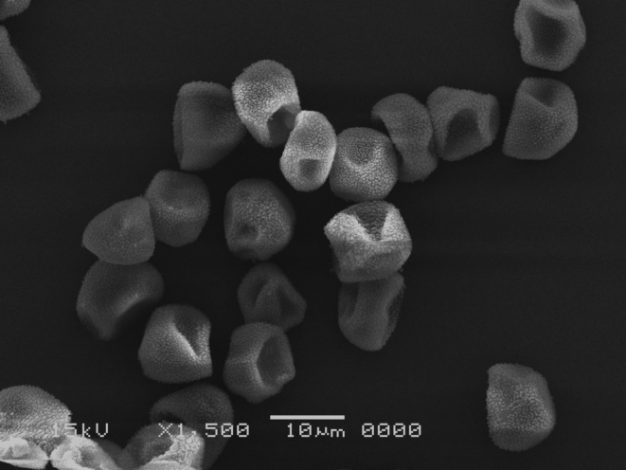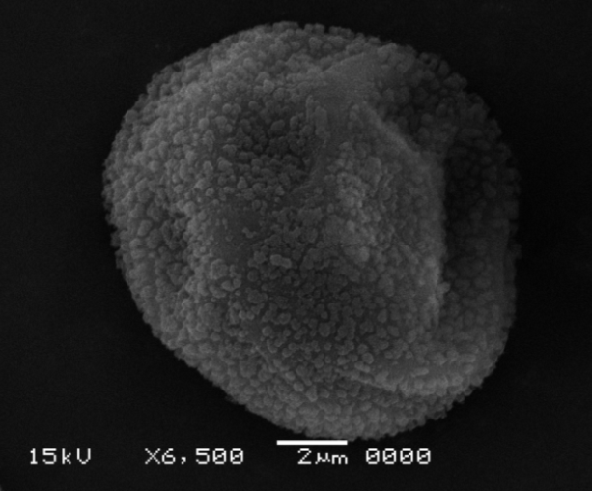
5
1
3
2
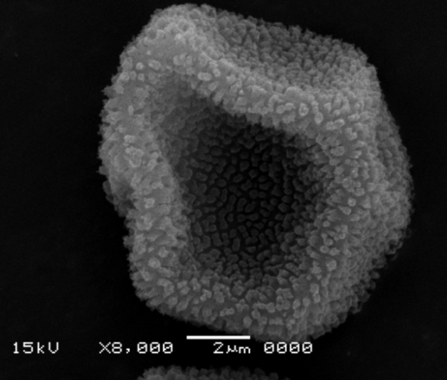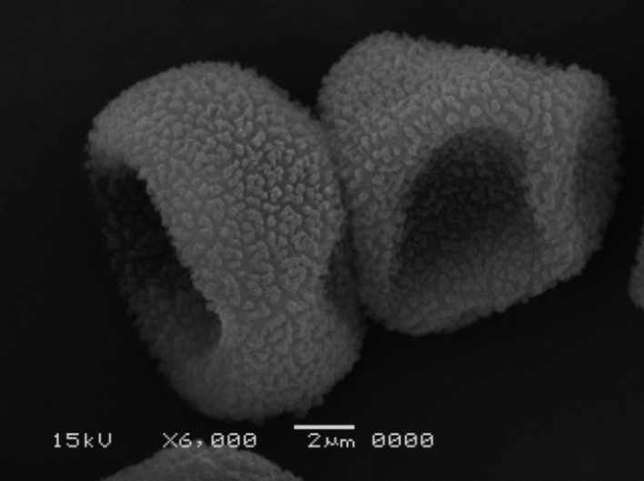
4
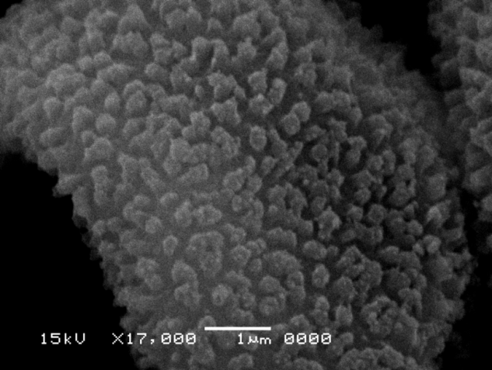
5
Plate I. Spores of Aloina brevirostris with SEM. 1–5, 1-Group of quinquangular spores, leptoma is triangular, elliptic, 2-Distal view of semi-spherical spore, The ornamentation is piloid, 3-Proximal view of a spore with pentagonal leptoma. The ornamentation is piloid, 4Equatorial view of elliptic spore, 5-Detail of the piloid distal surface.

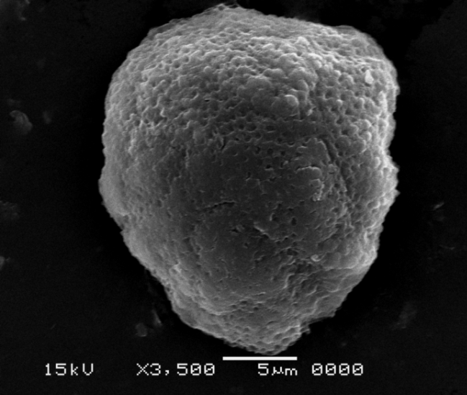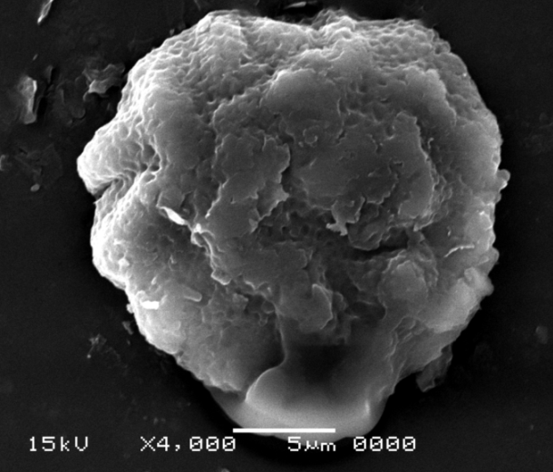
1
2
3
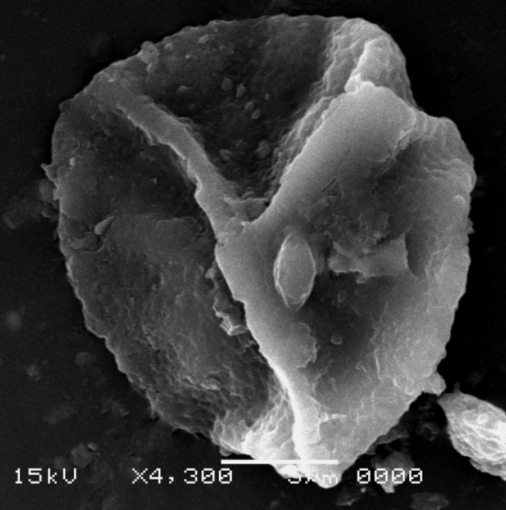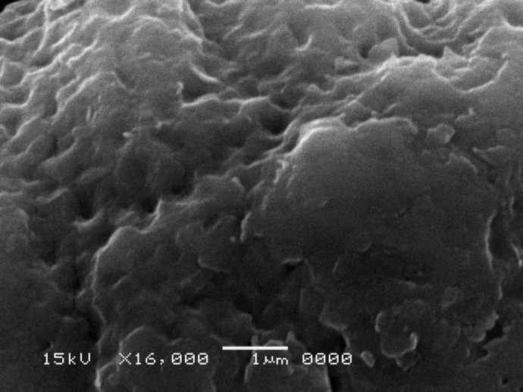
4
Plate II. Spores of Microbryum davallianum with SEM. 1–4, 1-Distal view of semi-spherical spore, The ornamentation is foveolate- psilate, 2-Distal view of semi-spherical spore, The ornamentation is rugulate with foveolae, 3-Proximal view of a spore with triangular leptoma, the surface near the leptoma is psilate. A globule located on a foveola can be observed (arrow), 4- Detail of the rugulate- foveolate distal surface.

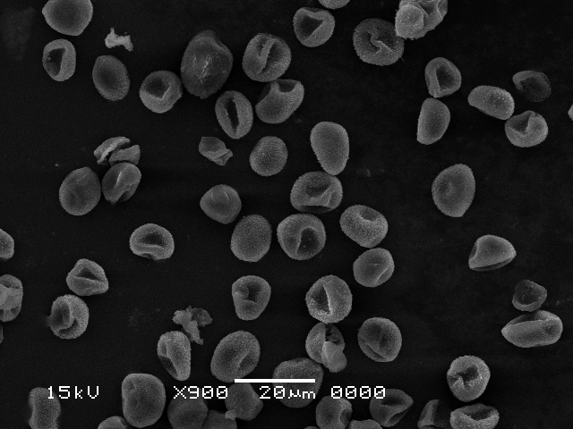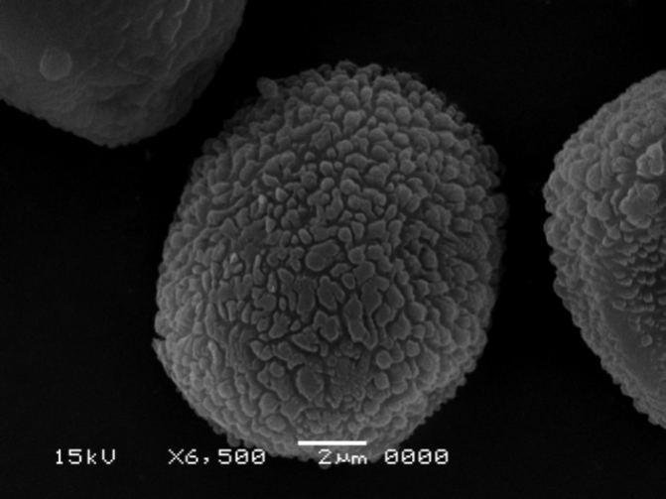
2
1

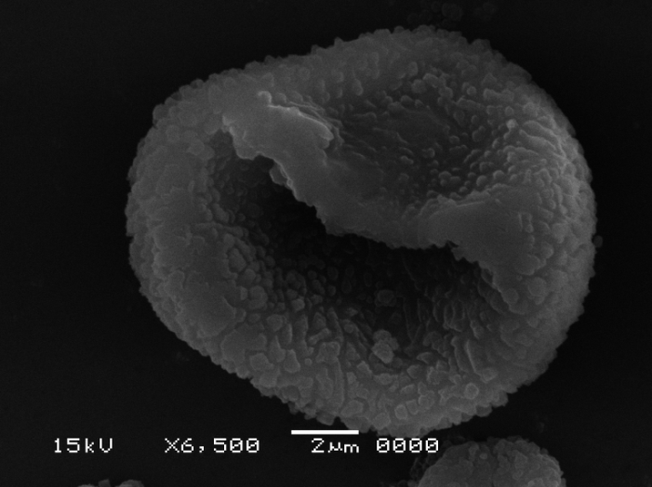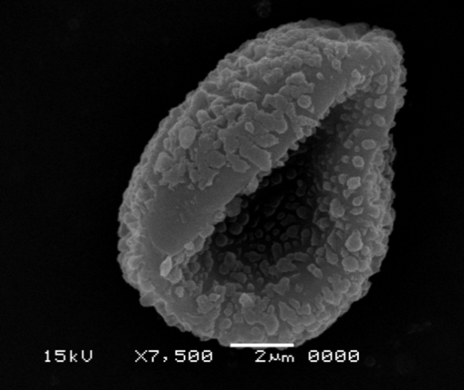
4
3

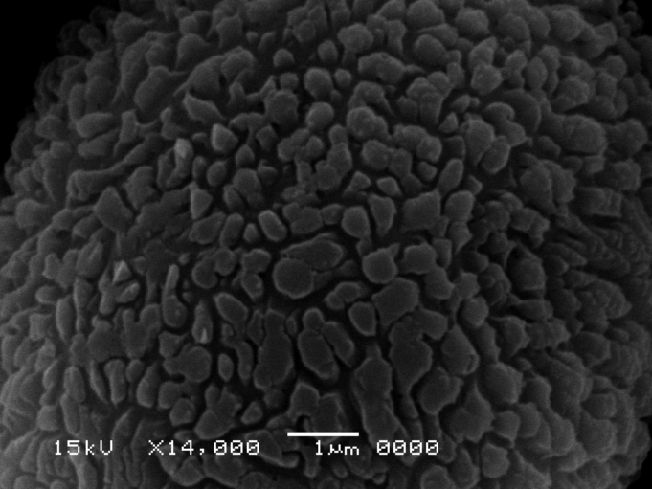
5
Plate III. Spores of Syntrichia laevipila with SEM. 1–5, 1-Group of spores, leptoma is elliptic, 2- Distal view of subprolate spore, The ornamentation is verrucate- regulate, 3-Proximal view of a spore with elliptic leptoma, The ornamentation is granulate, 4-Equatorial view of a concave-hemispheric spore, the surface near the leptoma is psilate, 5-Detail of the verrucate- rugulate distal surface. The muri are irregular in thickness

1
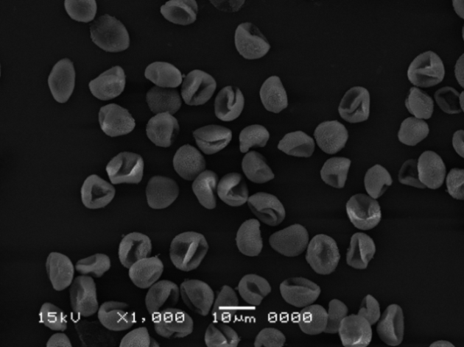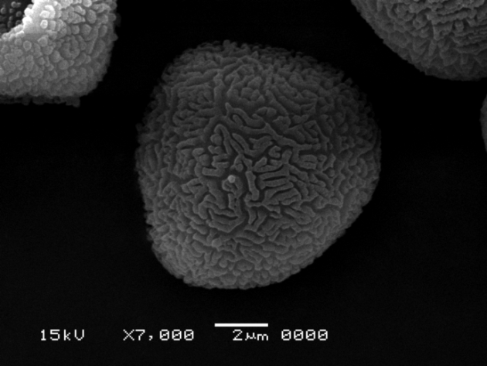
2
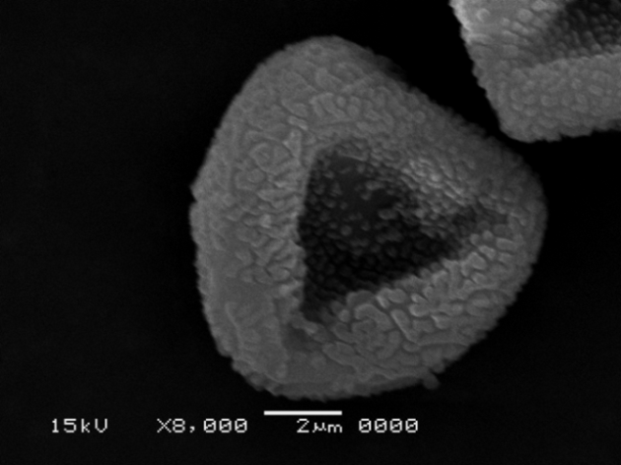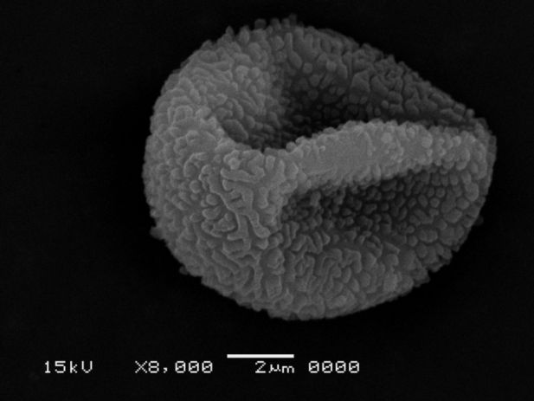
5
4
3

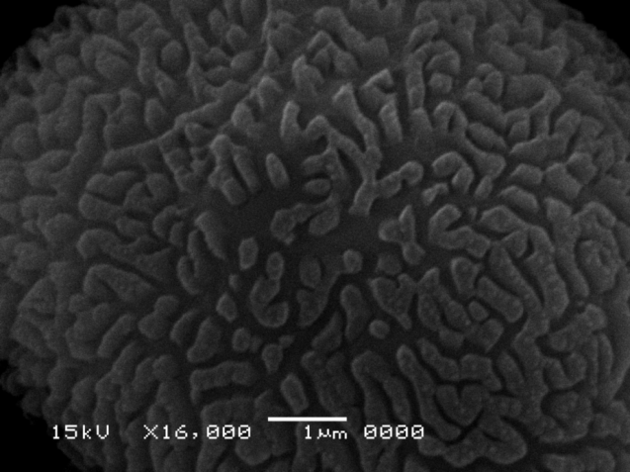
Plate IV. Spores of Tortula mularis with SEM. 1–5.1-Group of spores, leptoma is triangular, 2- Distal view of semi-spherical spore. The ornamentation is regulate, 3-Proximal view of a spore with a triangular leptoma, The ornamentation is regulate, 4-Equatorial view of a concave-hemispheric spore, 5-Detail of the rugulate distal surface, The ridges are irregular and are fused to one another.

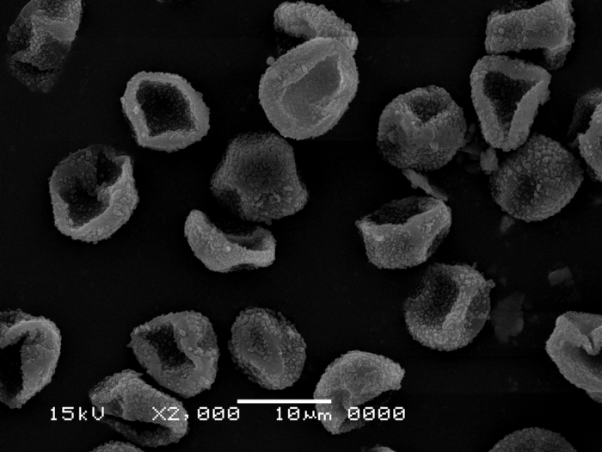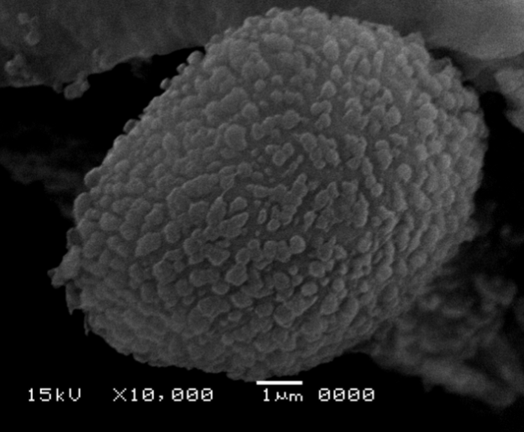
1
4
2
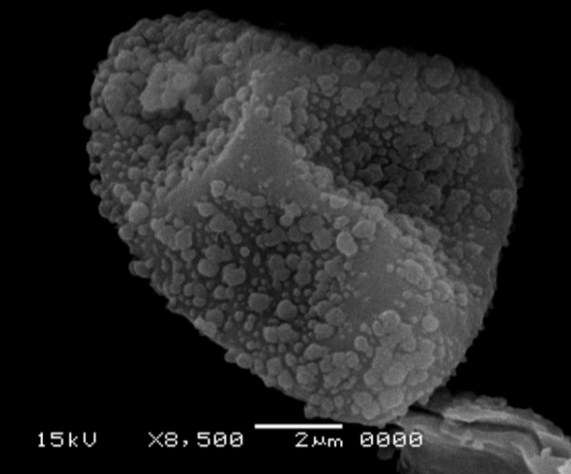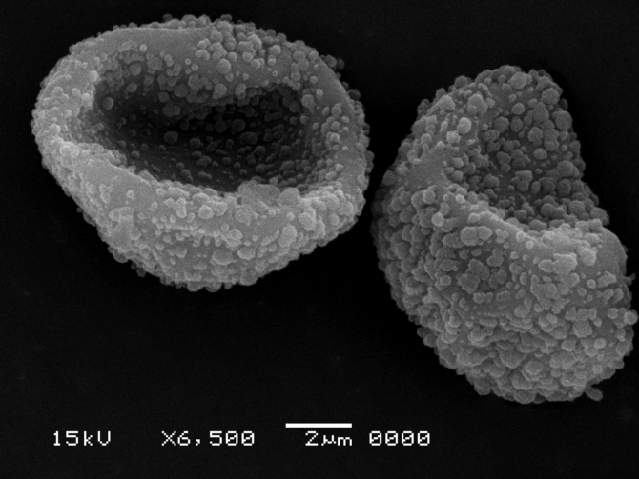
3

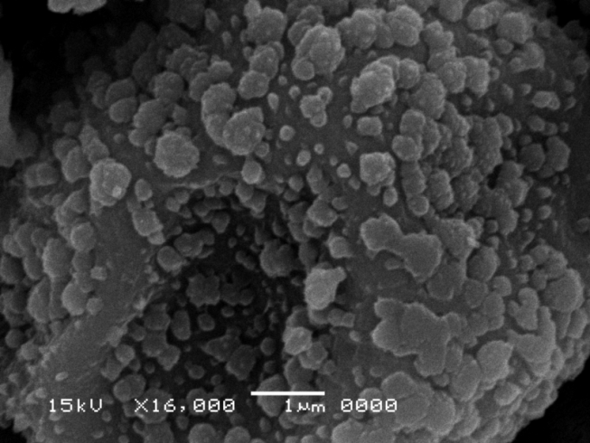
5
Plate V. Spores of Tortula brevissima with SEM. 1–5, 1-Group of spores, leptoma is rounded, triangular, 2-Distal view of semi-spherical spore, The ornamentation is verrucate- regulate, 3-Proximal view of a spore with rounded to triangular leptoma, The ornamentation is verrucate- granulate, 4-Equatorial view of a concave-hemispheric spore, the surface near the leptoma is psilate, 5-Detail of the verrucate- granulate proximal surface.

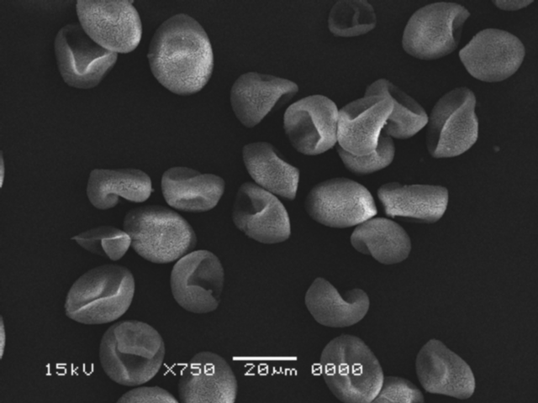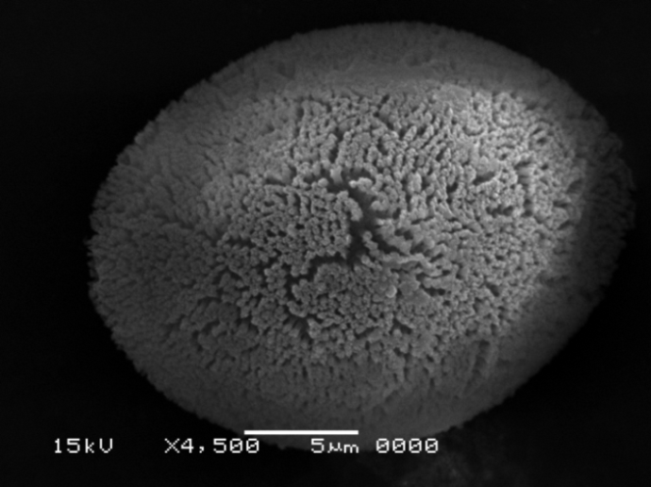
1
4
2
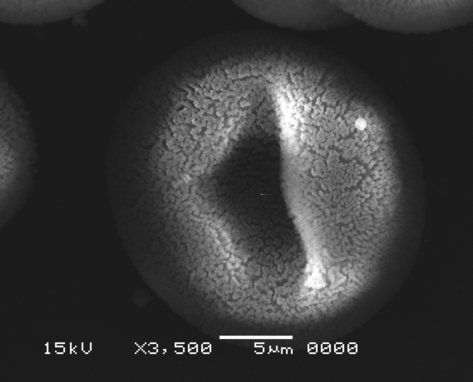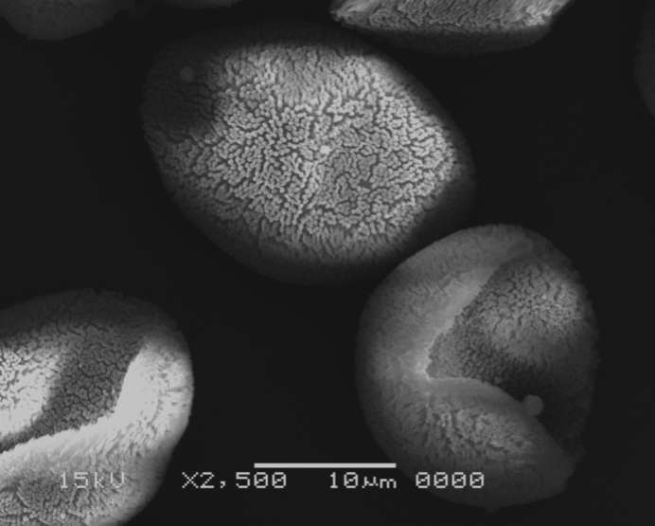
3
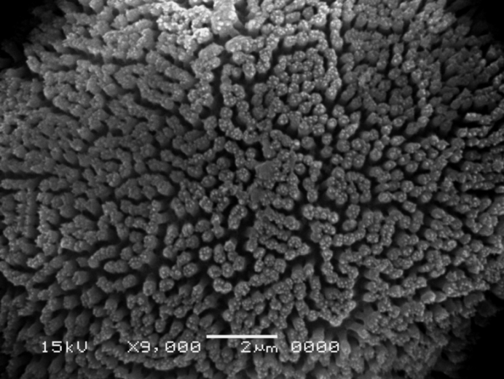
5
Plate VI. Spores of Entosthodon muhlenbergii with SEM. 1–5, 1-group of spores, leptoma is longitudinal, 2-Distal view of elliptic spore, The ornamentation is baculate, 3-Proximal view of a spore with longitudinal leptoma, The ornamentation is baculate, 4-Equatorial view of a concave-hemispheric spore, the surface near the leptoma is psilate, 5-Detail of the baculate distal surface, bacula are long, dense and tapering.

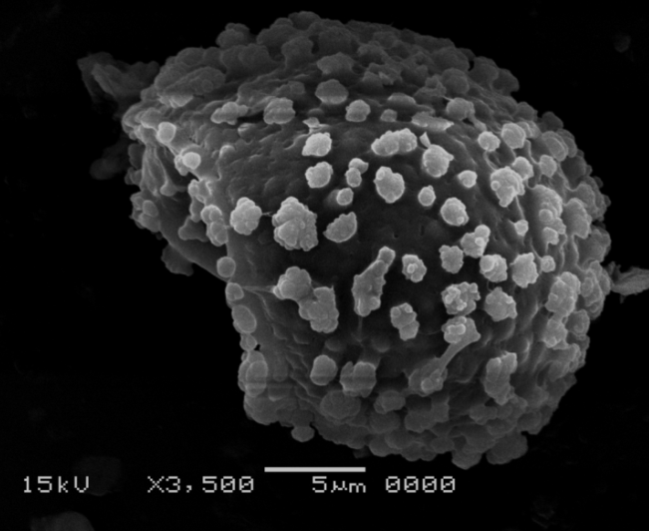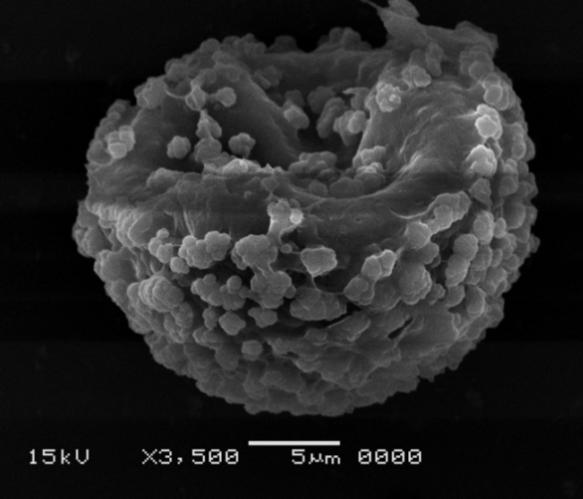
1
2
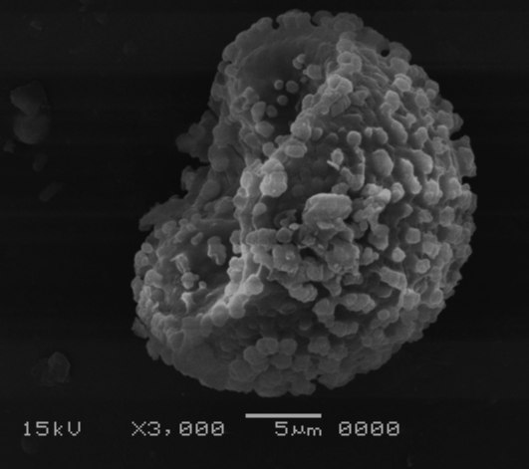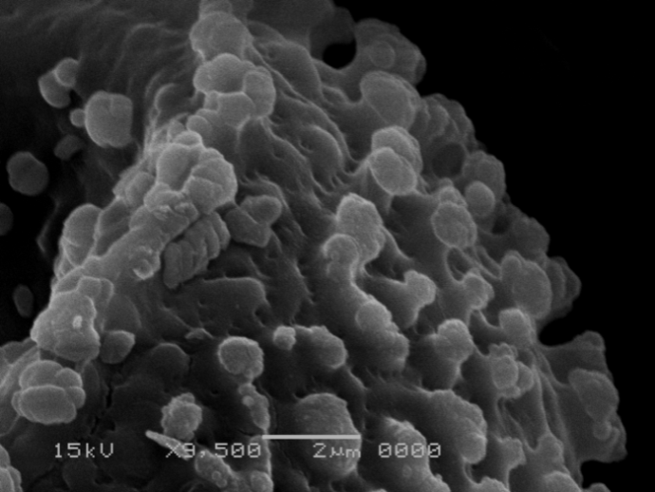
4
3

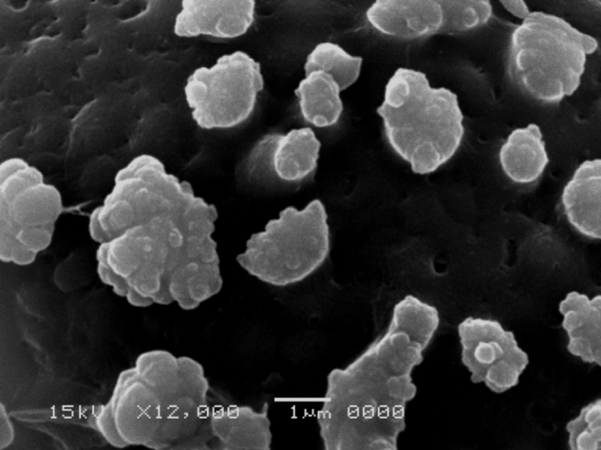
5
Plate VII. Spores of Entosthodon attenuatus with SEM. 1–5, 1-Distal to equatorial view of convex- hemispherical spore, The ornamentation is clavate- foveolate, 2-Proximal view of a spore with rounded leptoma, The ornamentation is clavate- foveolate, 3-Equatorial view of concave- hemispherical spore, 4-detail of equatorial view of spore, 5-Detail of the clavate- foveolate distal surface. Clavae elements are irregular in size.

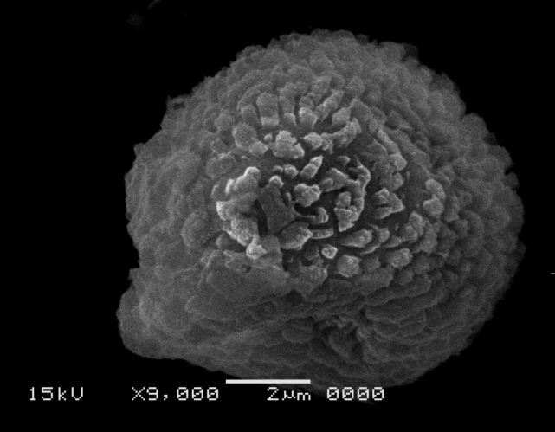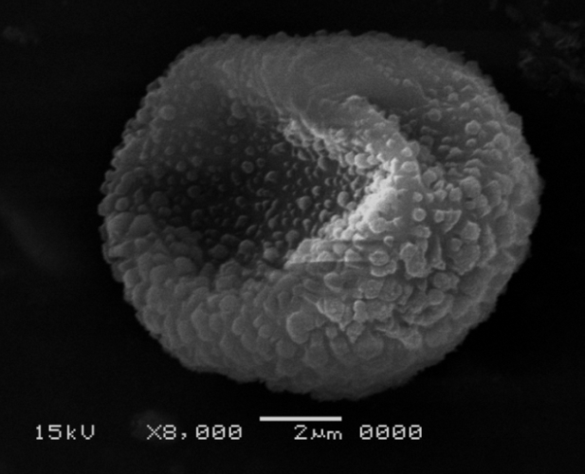
2
1
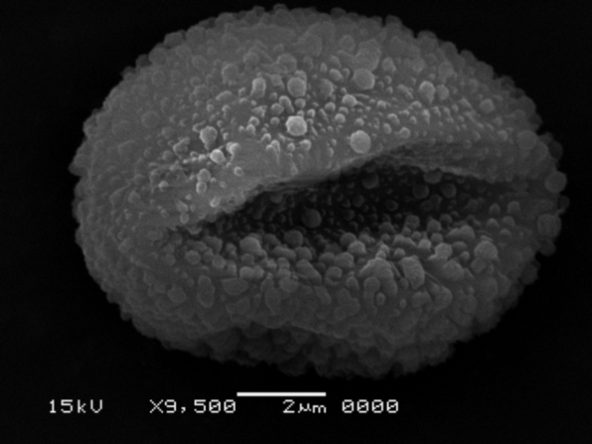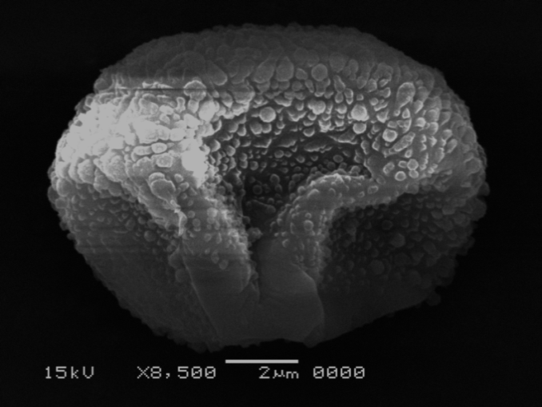
4
3

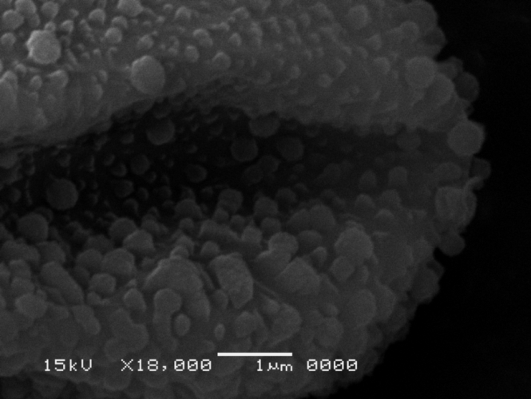
5
Plate VIII. Spores of Funaria hygrometrica with SEM. 1–5, 1-Distal view of semi-spherical spore, The ornamentation is clavate, 2-Proximal view of a spore with quadrangular leptoma, The ornamentation is verrucate, 3-Proximal view of a spore with longitudinal leptoma, The ornamentation is verrucate, 4-Equatorial view of a concave-hemispheric spore, 5-Detail of the verrucate-gemmate proximal surface. Verrucae are irregular in size.

a
b
c
d

h
e
f
g

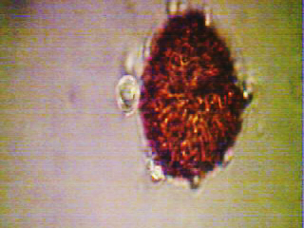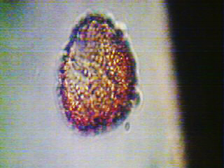
i
j
k
l
Plate IX. Spores by light microscope a-l (a,b: Aloina brevirostris; c,d: Tortula mularis; e,f: Tortula brevissima; g,h: Entosthodon muhlenbergii; i,j: Funaria hygrometrica; k,l: Entosthodon attenuates, all figs., X: 1000

References
- Boros, A. & Járai-Komlòdi, M., 1975. An Atlas of Recent European Moss Spores. Akademiai Kiadò, Budapest.
- Brotherus, V. F., 1924. Bryales. In: Die Natürlichen Pflanzenfamilien. Ser. 2, Vol. 10(1). (ed. A. Engler & K. Prantl). pp. 177-214. W. Engelmann, Leipzig.
- Ceter, T., 2018. Spore Morphology of some Bartramiaceae species (Bryophyte) in Turkey. Fac. Sci. Univ. Ank. 27(2): 253-262.
- Erdtman, G., 1960. The Acetolysis Method. A revised description. Sven. Bot. Tidskr. 54: 561-564.
- Erdtman, G., 1969. Handbook of Palynology. Munksgaard, Copenhagen.
- Estebanez, B., Yamaguch, T. & Duguchi, H., 2006. Ultrastructure of Spores in four Japanese Species of Ptychomitrium Fümr (Music). Grana 45: 61-70.
- El-Saadawi, W., Shabbara, H., Ibrahim, M. & Taha, M., 2015. An Annotated Checklist of Egyptian Mosses. Taeckholmia 35: 1-23.
- Flower, S., 1973. Mosses of Utah and the West. Brigham Young University Press.
- Khashravesh R. & Kazempour S. O., 2007. Spore Morphology of Certain Mosses of Northern Tehran. Taxonomical and Ecological Implications. Iran J. Bot. 13(2):150-159.
- Lashin, G., 2011. Fine Structure of Some Bryoflora Spores From Saudi Arabia. Egypt. J. Exp. Boil. (Bot.). 7(1): 35-41.
- Luizi-Ponzo, A. P. & Barth, O. M., 1999. Spore Morphology of Some Dicranaceae Species (Bryophyte) From Brazil. Grana 38(1): 42-49.
- Müller, P. & Frahm, J. P., 1987. A review of The Paraleucobryoideae (Dicranaceae). Nova Hedwigia 45 (3/4): 283-314.
- Polevova S.V., 2015. Sporodern ultrastructure of Oedipodium griffithianum (Oedipodiopsida, Bryophyta). Journal of Bryology. 24: 419-430.
- Savaroğlu, F. & Potoğlu Erkarai, I., 2008. Observation of Spore Morphology of Some Pottiaceae Schimp. Species (Bryophyte) In Turkey. Plant Syst. Evol. 271:93-99.
- Savaroğlu, F., Potoğlu Erkarai, I., Baycu, C. And Alkan, M., 2007. Observation of Spore Morphology of Some Bryaceae Schwägr. Species (Bryophyte) From Turkey. Int. J. Nat. Engin. Sci.1(2): 49-54.
- Savaroğlu, F., 2015. spore morphology of some Orthotrichaceae Arn. Species (Bryophyta) from Turkey. Bangladesh Journal of Botany. 44(4): 499-506.

11/25/2020

