**Design and Control of a Vertically Moving Base Inverted Pendulum using PI and PID Controllers**

Mustefa Jibril1, Messay Tadese2, Reta Degefa3

1 Msc, School of Electrical & Computer Engineering, Dire Dawa Institute of Technology, Dire Dawa, Ethiopia

2 Msc, School of Electrical & Computer Engineering, Dire Dawa Institute of Technology, Dire Dawa, Ethiopia

3 Msc, School of Electrical & Computer Engineering, Dire Dawa Institute of Technology, Dire Dawa, Ethiopia

[mustefa.jibril@ddu.edu.et](mailto:mustefa.jibril@ddu.edu.et)

**Abstract:** In this paper, a vertically moving base inverted pendulum control analysis has been done using Matlab/Simulink Toolbox. Because the vertically moving base inverted pendulum system is nonlinear and highly unstable, a feedback control system is used to make the system controlled and stable. A PI and PID controllers are used to improve the stability of the pendulum. Comparison of the vertically moving base inverted pendulum using PI and PID controllers for tracking a desired angular position of the system using a step and random input signals and a promising results have been obtained succesfully.

[Mustefa Jibril, Messay Tadese, Reta Degefa. **Design and Control of a Vertically Moving Base Inverted Pendulum using PI and PID Controllers.** *N Y Sci J* 2020;13(11):6-9]. ISSN 1554-0200 (print); ISSN 2375-723X (online). <http://www.sciencepub.net/newyork>. 2. doi:[10.7537/marsnys131120.02](http://www.dx.doi.org/10.7537/marsnys131120.02).

**Keywords:** Inverted pendulum, Proportional Integral Derivative controller, Proportional Integral controller

1. **Introduction**

An inverted pendulum is a oscillator which has its crowd above its pivot point. It is often implemented with the pivot pip mounted on a stock that tins move vertically. The inverted oscillator is a classic problem in control system design and is widely used as a extent for trying control algorithms. Variations on this funeral include multiple links, allowing the activity of the share to be commanded while arranging the pendulum, and evenness the cart-pendulum system on a see-saw. The inverted pendulum is related to missile guidance, where propulsion is actuated at the bottom of a tall vehicle. The understanding of a similar system is built in the technology of Segway, a self-balancing transportation device. The largest implemented utility are on huge lifting cranes on shipyards. Another appliances that an inverted pendulum may be stabilized, without any response or control mechanism, is by oscillating the support rapidly up and down. If the oscillation is sufficiently strong (in terms of its acceleration and amplitude) then the inverted pendulum tins recover from perturbations in a strikingly counterintuitive manner.

1. **System Discribtion of the Pendulum**

The vertically moving base inverted pendulum schematic diagram is shown in Figure 1. The rod is considered massless. The pointmass at the end of the rod is denoted by *m*. The rod has a length *l*.

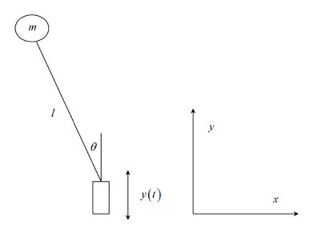

Figure 1 Vertically moving base inverted pendulum system

The equation of motion for a vertically moving base inverted pendulum is derived using the Lagrangian.

The position of the point mass is now given by:



and the velocity is found by taking the first derivative of the position:



The Lagrangian for this system can be written as:



and the equation of motion follows from:



resulting in:



For small angle approximation:, Equation (4) becomes



The system is nonlinear and the block diagram of the system is shown in Figure 2 below

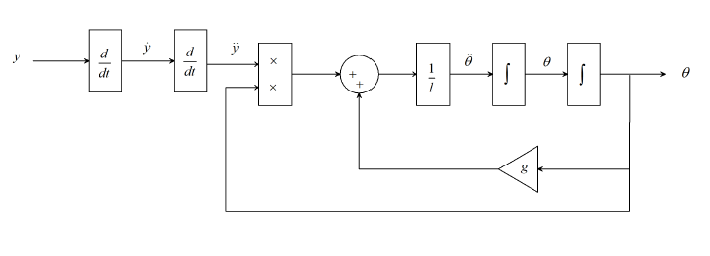

Figure 2 Block diagram of vertically moving base inverted pendulum

The system parameters are shown in Table 1 below.

Table 1 System parameter

|  |  |  |  |
| --- | --- | --- | --- |
| No | Parameter | Symbol | Value |
| 1 | Mass of the pendulum |  | 0.6 Kg |
| 2 | Pendulum rod length |  | 0.45 m |
| 3 | Acceleration due to gravity |  | 10 m/s^2 |

1. **Proposed Controllers Design**
   1. **PID Controller.**

A proportional-integral-derivative controller (PID) is a mechanism employing feedback that is widely used in industrial control organization and a variety of other implementation requiring continuously modulated control. A PID controller continuously calculates an inaccuracies values as the unlikeness between a desired set point (SP) and a measured process variable (PV) and applies a adjustment based on proportional, integral, and derivative terms (denoted P, I, and D respectively). In practical terms it automatically applies accurate and responsive change to a control function. The controller's PID algorithm restores the measured output to the desired input with minimal deferment and overshoot by increasing the ability of the system. The distinguishing feature of the PID controller is the skill to use the three control terms of proportional, integral and derivative pertinence on the controller output to apply accurate and optimal control.

The proportional, integral, and derivative terms are summed to calculate the output of the PID controller. Defining u (t) as the controller output, the final term of the PID controller is:



* 1. **PI Controller.**

The output of the system equals to the sum of proportion and integration coefficients. The higher the proportion coefficient, the less the output of the system at the same control error. The higher the integration coefficient, the slower the accumulated integration coefficient. PI controller provides zero control error and is insensitive to interference of the measurement channel.

The proportional and integral terms are summed to calculate the output of the PI controller. Defining u (t) as the controller output, the final term of the PI controller is:



* 1. **Tuning**

The part of these effects is achieved by loop tuning to whip the optimal control function. The tuning constants are denoted as "K" and must be derived for each control application, as they depend on the response wood of the complete loop external to the controller. These are dependent on the behavior of the final control element.

Using Chien, Hrones and Reswick (CHR) PID Tuning Algorithm method the value of the PID and PI controller are





1. **Result and Discussion**
   1. **Comparison of the Vertically Moving Base Inverted Pendulum using PI and PID Controllers for Step Input signal**

The simulink model of the vertically moving base inverted pendulum using PI and PID controllers for step input signal is shown in Figure 2 below.

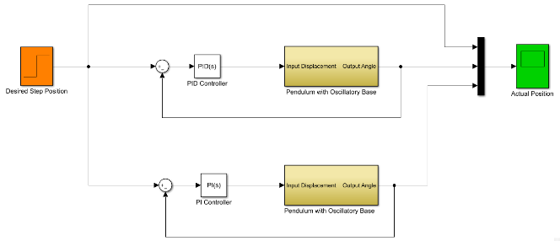

Figure 2 Simulink model of the vertically moving base inverted pendulum using PI and PID controllers for step input signal

The vertically moving base inverted pendulum subsystem and the simulation result are shown in Figure 3 and Figure 4 respectively.

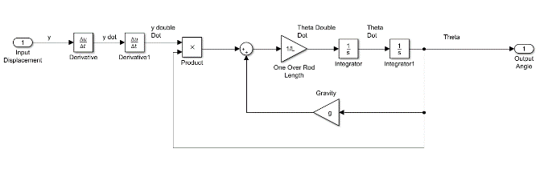

Figure 3 vertically moving base inverted pendulum subsystem

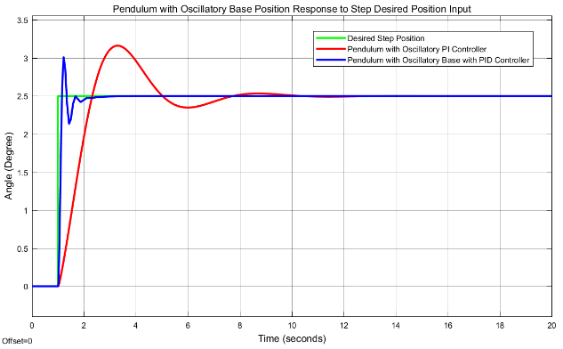

Figure 4 Step response simulation result

The data of the rise time, percentage overshoot, settling time and peak value is shown in Table 2.

Table 2 Step response data

|  |  |  |  |
| --- | --- | --- | --- |
| No | Performance Data | PID controller | PI controller |
| 1 | Rise time | 1.12 sec | 1.8 sec |
| 2 | Per. overshoot | 20 % | 40 % |
| 3 | Settling time | 2.3 sec | 10.5 sec |
| 4 | Peak value | 3 Degree | 3.5 Degree |

As Table 2 shows that the vertically moving base inverted pendulum using PID controller improves the performance of the system by minimizing the rise time, percentage overshoot and settling time.

* 1. **Comparison of the Vertically Moving Base Inverted Pendulum using PI and PID Controllers for Random Input signal**

The simulink model of the vertically moving base inverted pendulum base using PI and PID controller for random input signal is shown in Figure 5 below.

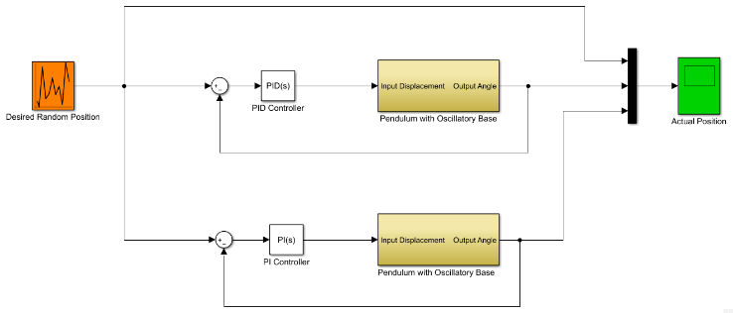

Figure 5 Simulink model of the vertically moving base inverted pendulum using PI and PID controllers for random input signal

The vertically moving base inverted pendulum system simulation result are shown in Figure 6 below.

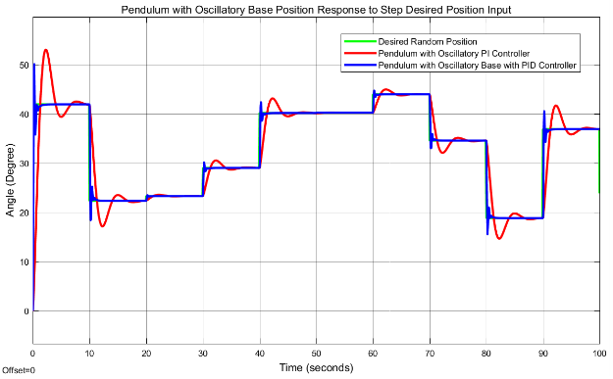

Figure 6 Random input signal simulation result

Figure 6 shows that the vertically moving base inverted pendulum using PID controller improves the performance of the system by minimizing the percentage overshoot and tracking the reference signal.

1. **Conclusion**

The design and control of a vertically moving base inverted pendulum using PI and PID controller have been analyzed. Comparison of the vertically moving base inverted pendulum using PI and PID controllers for tracking a desired angular position of the system using a step and random input signals have been done. The step response simulation result shows that the vertically moving base inverted pendulum using PID controller improves the performance of the system by minimizing the rise time, percentage overshoot and settling time while the random input response simulation result shows that the vertically moving base inverted pendulum base using PID controller improves the performance of the system by minimizing the percentage overshoot and tracking the reference signal.

**Acknowledgements:**

I am very grateful to the coauthors a for financial support to carry out this work. I would like to thanks to my families for supporting me to publish this work.

**Corresponding Author:**

Mr Mustefa Jibril

School of Electrical & Computer Engineering

DDIT, Dire Dawa University

Dire Dawa, Ethiopia

Telephone: +251967821842

E-mail: [mustefazinet1981@yahoo.com](mailto:mustefazinet1981@yahoo.com)

**Reference**

1. R. E. Grundy “The Kapitza Equation for the Inverted Pendulum” The Quarterly Journal of Mechanics and Applied Mathematics, Vol. 72, Issue 2, pp. 261-272, 2019.
2. Reetam Mondal et al. “Optimal Fractional Order Controller for Stabilization of Cart Inverted Pendulum System: Experimental Results” Asian Journal of Control, Vol. 22, Issue 3, 2019.



1. Amira Tiga et al. “Nonlinear/Linear Switched Control of Inverted Pendulum System: Stability Analysis and Real-Time Implementation” Journal of Mathematical Problems in Engineering, Vol. 2019, Article ID 2391587, 10 pages, 2019.
2. Morasso P. et al. “Quiet Standing: The Single Inverted Pendulum Model is Not So Bad After All” PLOS ONE, Vol. 14, Issue 3, 2019.
3. Mohammed Rabah et al. “Comparison of Position Control of a Gyroscopic Inverted Pendulum using PID, Fuzzy Logic and Fuzzy PID Controllers” International Journal of Fuzzy Logic and Intelligent Systems, Vol. 18, Issue 2, pp. 103-110, 2018.
4. Beata K. et al. “Inverted Pendulum Model Linear Quadratic Regulator (LQR)” Proc. SPIE 10808, Photonics Applications in Astronomy, Communications, Industry and High-Energy Physics Experiments, 2018.
5. Elisa Sara V. et al. “Optimal Control of Inverted Pendulum System using PID Controller, LQR and MPC” IOP Conference Series: Materials Science and Engineering, Vol. 263, Issue 5, 2018.

10/26/2020