Six-wheeled Demining Robot for crossing rough terrain and Obstacles

Vahid Ghane Ahary, Mahdi Abbasgholipour, Behzad Mohammadi Alasty

Department of Computer, Tehran, Iran
ghaneaharyvahid@yahoo.com

Abstract: Today, landmine detection and removal is a challenging issue for researchers. The advantages of a fully automated method to this challenge are clear, but there are many technical and economic problems to deal with. Many of commercially available mobile robots consist of largely custom made parts. The designing and manufacturing of these parts make the robots highly expensive. This problem reduces their attractiveness for humanitarian demining goals, as landmine affected countries, like Iran cannot support expensive high-tech solution. A demining robot should be cost effective in comparison with labor costs. To deal with these challenges a new 6 wheeled mobile robotic platform is suggested. Its geometry has been designed for rough terrain and obstacle crossing. The robot consists mainly of Commercial off-the-shelf (COTS) parts that can easily found at low costs. Using such parts significantly reduce the overall development time and costs while the reliance on proven-in-use components has increased.
[Vahid Ghane Ahary, Mahdi Abbasgholipour, Behzad Mohammadi Alasty. Six-wheeled Demining Robot for crossing rough terrain and Obstacles. N Y Sci J 2020;13(10):81-84]. ISSN 1554-0200 (print); ISSN 2375-723X (online). http://www.sciencepub.net/newyork. 10. doi:10.7537/marsnys131020.10.

Keywords: robotics, landmine detection in Iran, terrain locomotion, low cost robot

1. Introduction
According to estimations of the United Nations (UN) landmines still claim about 15.000 victims a year [United Nations, 2006]. As this number refers to the reported number of landmine incidents, the number of unreported cases may be much more. Apart from the human tragedy, the mutilation or killing of innocent people brings there arise devastating economic impacts for mine affected countries.
Humanitarian demining requires removal of all mines and unexploded ordnance from a specified area to a certain depth. The beneficiaries of such programs must be confident that, cleared land is safe for their use [United Nations Mine Action Service (UNMAS), 2003]. Therefore, it is not enough to argue that some or most landmines have been deactivated but it has to be proven that, all threats have been eliminated.
Until today, this level of confidence can only be obtained by manually proving the ground. This approach benefitting a metal detector, a probe and excavation tools is performed in heavy protective garment by an individual which is an exhausting and dangerous task. Since landmines are buried in war-torn countries, the soil is often polluted with a large amount of metallic debris like shells, ammunition belts, barbed wire, grenade fragments, scrap metal etc. The false alarm quote is as high as 1 to 2000 for a single landmine.
Therefore it is desirable to carry out this task by intelligent mobile robots in the near future. Such robots could work without symptoms of fatigue, twenty-four hours a day [P. Kopacek, 2002].
The working process can be divided into three steps:
- Detection of a landmine
- Excavation of the threat
- Transport to a safe place where the mines are piled up and destroyed.
The above-mentioned steps can be executed concurrently by a Multi Agent System (MAS) consisting of three specialized robot classes [P. Kopacek, 2002]. The benefit of such system can be presented in one sentence: More square kilometers of lands can be cleared in shorter time, at lesser cost and with lower risk.

2. Material and Methods
The results of the latest survey demonstrate that the main challenge of mobile robots is that, landmines are seldom laid on even, flat surfaces [C. King, 2004]. Most minefields are hard to access due to heavy vegetation, obstacles or slopes. Such terrain types pose high demands on locomotion system of the robot. The most important requirements for such a locomotion system are as following:

2. 1. Reliability and Robustness

To prevent costly periods where the robot is out of service, due to a failure, the locomotion system must operate very reliably. Spare parts are difficult to obtain in remote regions, thus a small set of expandable parts should be sufficient to maintain operation over a few months without the need for a major service. The robot should be capable of working in a wide range of temperatures and environmental conditions. Adequate protection of its internal components (e.g. water and dust tightness) is required.
2.2. Maneuverability and Crossing Obstacles
The robot should be able to navigate accurately through the minefield to avoid the triggering of mines. Since there is no typical minefield, it must cope with obstacles in the area of operation to prevent entrapment. Therefore, the robot should be able to cross most of the obstacles in its way while circumnavigating those which are impassable.
2. 3. Ground Pressure
The lower the ground pressure of the robot, the higher is the probability of avoid triggering a landmine. The robots weight divided by the area of the robot which has ground contact must not exceed the triggering weight of a landmine divided by the area of its spring plate.
2. 4. Endurance
Operation time should be at least 2 hours before re-charging and this work should not take more than 30 minutes [P. Kopacek, 2002].
2. 5. Cost Effectiveness
Since many mine affected countries belong to the poor countries, a demining robot has to be cost effective. One way is to reduce costs by using commercial off-the-shelf (COTS) components [http://ir-robot.com/ and P. Kopacek, M. Han, B. Putz, E. Schierer, M. Würzl, 2002]. Potential sources for such parts are R/C cars or trucks, automotive parts or parts diverted from consumer goods (Figure 1).

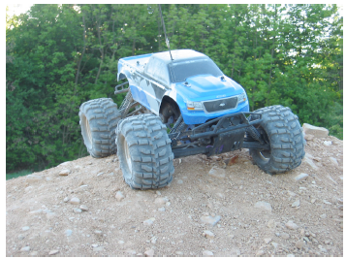
Figure 1: R/C Monster Truck: A cheap source of rugged COTS components

Another solution to achieve cost effectiveness would be diversification. It is imaginable to have a multipurpose robotic platform, produced at low costs in high quantities which are customized at a late stage during production for different usages. Such applications could be lawn mowing or hovering in the consumer industry, object and facility surveillance for other industries, and humanitarian demining. The initial development costs are equally shared by all different branches and because of economies of scope the marginal costs decrease considerably.
The customization of a product at a late stage in production requires a modular platform. This means that, different parts and attachments may be added and exchanged. Such a concept offers high flexibility at the price of increased development and marginal costs. However, the advantages of an easy exchange of worn out or defect modules is especially interesting in heavy duty applications like demining.

3. Results
Designing a new robot means having to face many different design alternatives. In order to evaluate each of them, different methodologies apply the following:
- Experiment with real world prototypes
- Use physical, mathematical or analytical models
- Simulation
Simulation has higher popularity among robot developers because of its relative simplicity: while it may be very extensive and even impossible to generate a complete and solvable mathematical description to a problem, the same problem might be easily solved by a simulation model [J. W. Schmidt, 1984]. Furthermore, simulation offers better flexibility and versatility: simulation parameters and functions are generally easier to change than analytical expressions which may require reconsidering the entire model.
In order to find an appropriate locomotion system for a demining robot, we have used a digital obstacle course [http://ir-robot.com/]. It contains objects like rocks, tree trunks and slopes of varying steepness. It is concluded that, if the robot is able to master these obstacles it will fulfill its rough terrain requirements.
After finding promising locomotion geometry by an iterative design/simulation method, we have built a prototype using mostly low-cost COTS components. Our demining robot is segmented into front and rear sections. These two sections are interconnected by a passive joint which allows the robot to adapt passively to the terrain. Four wheels are located in the front section and two wheels in the rear.

As the front section should carry the weight of the mine detector and its rotating mechanism, this asymmetric wheelbase enables an equal weight distribution among all of 6 wheels. Each wheel is driven by a high torque gear motor with integrated magnetic encoder. Six servo motors allow setting each wheel’s steering angle individually.

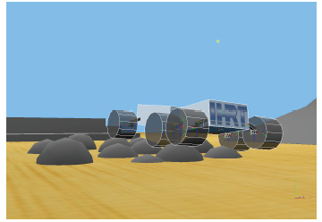
Figure 2: Virtual Robot passing over "Rocks" Obstacle

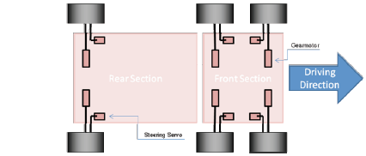
Figure 3: Architecture of Mechanical System

The chassis frame has been composed of lightweight 20 mm aluminum profiles. This method is state of the art for plant engineering and construction. The profiles are available at very low costs in a wide variety of shapes and sizes.
For the suspension mechanism, the parts were obtained from R/C monster trucks. These parts are designed to withstand high forces and vibration and are easily available and cheap in comparison with custom made solution. Figure 1 exhibits a HPI Savage 3.5 R/C monster truck. This truck drives at speeds up to 50 km/h, has a weight of almost 4.5 kg and an engine capable of delivering 2.3 HP / 1.71 kW. During field trials, the truck’s suspension proved to withstand jumps of over 3 meters length and 1.5 meters height with no sign of damage. Therefore, it is considered robust and reliable enough to be used on a slow moving demining robot. We refitted the dampers with stiffer springs to support the weight of the robot and the payload.
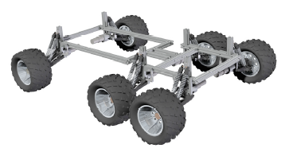
Figure 4: Chassis Frame, Monster Truck Suspension and Tires

Given the mentioned requirements, the electronic architecture has been developed to support highest extensibility while keeping the overall costs low. Several communication interfaces (RS-232, RS-485, USB, and Ethernet) allow the addition of modular components and thus the flexible adaption of the demining robot to future challenges.
The electronic hardware consists of the following core components:
- On-Board Computer: Mini-ITX mainboard, 1GHz CPU, 1 GB RAM, 30 GB automotive hard disk (shock resistant), 8 x USB, 4 x RS-232, 2 x Ethernet
- I/O board: connected over a serial link to the on-board computer, provides access to all sensors and actuators
- 3 x Motor Controllers: Driven by a 20 MHz microprocessor each custom made motor controller drives two wheels using a PID controller. Furthermore it sets two steering servos, implementing the well-known Ackermann steering geometry for the six wheeled vehicle
- Wireless Interface: A WLAN Access Point allows to establish a 54 MBit connection to the robot
- Mine Detector: A Schiebel AN-19/2 state-of-the-art landmine detection set is used to detect landmines
Additionally, multiple cameras allow a remote operator to navigate the vehicle through the field. This remote controlled operation, which lies in the center of our current examination, should discover existing flaws of the robot and pave the way for a potential future upgrade to full autonomous operation.
The demining robot is steered by a 4 axis joystick with 12 buttons and an 8-way coolie hat (point of view switch). While the first two axes define the movement of the robot, axis three and four operate the landmine detector (turn left/right, lift/lower detector head). In combination with a graphical user interface, the joystick provides an easy and intuitive instrument to control the robot.

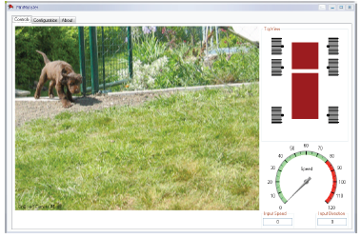
Figure 5: Graphical User Interface

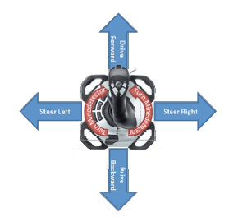
Figure 6: Joystick Usage

Although the prototype is not completely finished yet, the first test drives showed promising results. It was possible to navigate through narrow corridors in the laboratory into the courtyard of our main building. On the way we mastered various obstacles like small steps and ramps while circumnavigating moving pedestrians.
There was no direct line of sight to the vehicle during the entire mission - we were dependent on our on-board cameras for environmental perception and situational awareness. The current batteries allow journeys of about 50 minutes continuous driving so far which corresponds to a total mission time of about 90 minutes. More tests in rough terrain with fake landmines will follow.

4. Discussions
The imprudent use of landmines provides a meaningful field of activity for robot engineers and researchers. Demining robots face two main challenges: First, they must be able to traverse rough terrain and second, their costs have to be competitive to current manual demining procedures.
Our prototype has been developed in an iterative design process using computer based simulation methods. It features a chassis frame which allows the vehicle to adapt passively to the terrain.
By carefully selecting commercially available parts we were able to reduce the development time and costs for a demining robot while increasing its reliability significantly. The material costs for a single demining robot can easily fall below 5.000 $ without the landmine detecting set which was generously given to us for testing purposes.

Corresponding Author:
Vahid Ghane Ahary
Department of Computer, Tehran, Iran
ghaneaharyvahid@yahoo.com

References
- http://ir-robot.com/
- King, C., The myths and realities of demining, 2004 U.S. Foreign Policy Agenda, An Electronic Journal of the U.S. Department of State, Vol. 9, No. 1, January 2004.
- Kopacek, P., Demining robots: a tool for international stability, 2002 Preprints of the 15th Triennial World Congress of the International Federation of Automatic Control (IFAC), 21st - 26th July 2002, Barcelona, Spain.
- Kopacek, P., M. Han, B. Putz, E. Schierer, M. Würzl, A concept for a humanoid demining robot, 2004 Proceedings of the International IARP Workshop on Robotics and Mechanical assistance in Humanitarian Demining and similar risky interventions, Brussels-Leuven, Belgium.
- Kopacek, P., Robots for humanitarian demining, 2002 In Proceedings of the 33rd ISR (International Symposium on Robotics), Stockholm.
- Schmidt, J.W. Introduction to simulation, 1984 WSC ’84: Proceedings of the 16th conference on winter simulation, pages 64–73, Piscataway, NJ, USA. IEEE Press.
- United Nations Mine Action Service (UNMAS), 2003 Clearance requirements, IMAS 09.10.
- United Nations. Press conference on mine awareness day, April 2006. http://www.un.org/ News/ briefings/ docs/ 2006/ 060403_mines.doc.htm

10/25/2020

