Palaezoological Studies Of Some Gastropods In And Around Wardha Vally Of Jaitapur River Basin, District-Chandrapur, Maharashtra, India.

S.D. Misar

Department of Zoology, Janata Mahavidyalaya Chandrapur (M.S.), 442401 India.
sachin.misar@gmail.com

Abstract: In present study the molluscan fossils was reported from ground sedimentation of Wardha valley of Jaitapur river basin located in eastern part of Maharashtra India, which was the part of lower Gondwana system. The recovered fossils were the impression of opercula and cast of some gastropods belonging to family Ampullariidea and Viviparidea respectively. The finding of such fossils is an important evidence for the study of evolution as well as ecology is concerned, because they shows the life on earth was once in past.
[S.D. Misar. Palaezoological Studies Of Some Gastropods In And Around Wardha Vally Of Jaitapur River Basin, District-Chandrapur, Maharashtra, India. N Y Sci J 2020;13(10):1-4]. ISSN 1554-0200 (print); ISSN 2375-723X (online). http://www.sciencepub.net/newyork. 1. doi:10.7537/marsnys131020.01.

Keywords: Paleozoology, Mollusca, Jaitapur, Gondwana, Cast

1. Introduction
The paleontological records furnish irrefutable proof that life on earth has changed through the ages. These evidences throw new light on the past history of the earth. Collection of fossils and their display before a large enthusiastic gathering is very interesting, but behind that interest, no one can see how much arduous task fossil collection is. For the present study the material was collected from Wardha river valley of Jaitapur basin where the lower Gondwana sedimentation and strata are exposed along the side of bank which is at 19.8830⁰N and 79.21090 E. This was an important paleontological site and part of past era. In general fossil molluscan fauna of study area indicates that, there may be shallow lacustrine environment of deposition and after comparison and morphological examination the above fossils are more or less similar with few present species. But further detailed paleozoological investigation is needed to know the past ecology.

2. Material and Methods
For the present study the material were reported from Wardha river valley of Jaitapur basin where the lower Gondwana sedimentation and strata was exposed along the side of bank which is at 19º53’’39.9’ N and79º11’’31.1’ E., the above material was bring to laboratory carefully cleans with soft brush photographs was taken and sample was analyzed morphologically and compared with standard literature of Tyagi, 1976 and Clackson, 1986 on paleozoology.

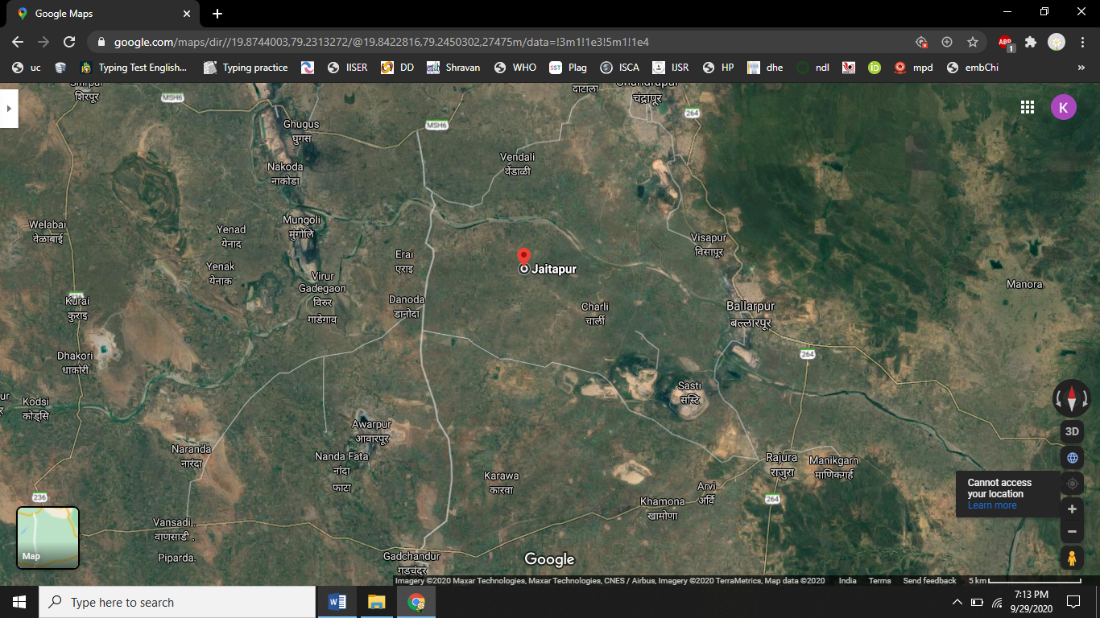
Map shows the Wardha valley of Jaitapur river basin, district-Chandrapur, Maharashtra, India. (Image Google Source 19°52'24.9"N 79°13'46.6"E)

3. Results
During the summer months when water level drops we visit to above mentioned site from which some paleozoological material was collected which are as fallows.
A. Impression
Unpreserved impression of operculum of gastropod shell were found on limestone bearing a concentric whorl which is about 7 in number and size about 6 x 3.2 cm, which is elliptical or lunette oblong in outline from the external morphological examination the above material appear like present day operculum of gastropods of family Viviparidea (Fig. No. 1)
B. Mineralized cast of Gastropods
Number of gastropods collectively found in mineralized sedimentation, which are deposited along with minerals in which calciferous part and margin of shell is well demarked. The size of shell varies in length and breadth and which is found near about 2.8 x 1.7 cm. The cast shell is univalve but coiled around central axis in right handed direction. The top of the shell is commonly called as apex and below apex spire consisting of several successive larger whorls or coil followed by penultimate whorl and largest whorl or body whorl which encloses most of body. The lines between the whorls are called sutures. Internally all the whorls of the shell are freely communicated with one another; such a shell is called unilocular and sinistral in position (Fig.3, 4,5and 6).

4. Discussions
Fossils of organism's bodies are usually the most informative type of evidence. The most common type is wood, bones, and shells. Further, only the parts of organisms that were already mineralized are usually preserved, such as the shells of molluscs. Since most animal species are soft-bodied, they decay before they can become fossilized. As a result, although there are 30-plus phyla of living animals, two-thirds have never been found as fossils (Cowen, 2000).
Fossil mollusc faunas, often in association with other marine groups, are commonly used as a tool for paleoenvironmental reconstructions. All molluscan taxa can survive and reproduce only if environmental parameters fit in with their ecological requirements, including a peculiar depth range (Peres & Picard, 1964).
During our paleozoological survey, the impression of gastropod opercula is appear on limestone which was found near the base of strata along the side of bank. The operculum is attached to the upper surface of the foot and in its most complete state; it serves as a sort of "trapdoor" to close the aperture of the shell when the soft parts of the animal are retracted and also to prevent the organism from drying during the aestivation. The shape of the operculum varies greatly from one family of gastropods to another. It is fairly often circular, or more or less oval in shape.
The different structure of opercula already described in extant such as concentric, in which the nucleus is central or sub central as in Lithoglyphus and Ampullaria. And in other the nucleus is near the parietal margin of the shell, in Imbricate, or lamellar opercula it grows only on one side, and the nucleus is marginal, ex. Purpura, Xenophora, and Paludomus.
In Claw-shaped, or unguiculate opercula the nucleus is apical or in front, ex. Turbinella and Fusus, serrated in Strombus while in case of spiral it grows only on one edge, and revolves as it grows, it is always sinistral, in dextral shells.
Paucispiral or Oligogyrous opercula with few spirals, as in Littorina. Subspiral or scarcely spiral, in Thiara; Multispiral or polygyrous having many closely spaced spirals as in Trochus, where they sometime amount to twenty; the number of turns which the operculum makes is not determined by the number of whorls in the shell, but by the curvature of the aperture, and the necessity that the operculum should revolve fast enough to fit it constantly articulated, when it has a projection, as in Nerita radiated is a modification of the articulated operculum in which the spiral is not so evident as in Navicella (Day,2007).
The present impression of opercula of gastropod is similar to elliptical or lunette oblong in outline. Which shows the numerous concentric rings of growth around well marked nucleus. the number of rings which shown in the impression are seven in number and nucleus is central in position. The coiling may be was right handed in direction and which is called as dextral. The above morphological features of opercula is correlated with extant such as Pyrula; Purpura; Littorina; Aulopoma; Torinia; Neritopsis; Strombus; Conus Lithoglyphus and Ampullaria. The characters are matches with the Ampullariidea family of genus Pila. At present various species of genus Pila exhibit on earth but the most common are Pila globosa, Pila scala, Pila scutata etc., but the structure opercula of Pila scutata is more or less similar with above impression of gastropod as seen in image (Fig.1 and 2), but few differences seen in the position of nucleus and number in annular rings. From the above discussion the above impression of opercula is belongs to family Ampullariidea of genus Pila.
While the cast was Collected from ground sedimentation of Wardha river valley of Jaitapur basin where the lower Gondwana Belt is exposed in the form of strata which is approximately nearly 150-200 feet in height from the bank (Fig.3 and 4).
Collected material bears cast of gastropods which are 3-4 in number and length varies from1.7 cm - 3.7cm. All three material are morphologically appear similar but vary in size, out of which morphology of only one shell can be described here and others not due to high cementation on cast structure not exposed properly. The collected cast of gastropod is globose with prominent spire, the whorls are rounded and separated by impressed sutures, and apertures are partially preserved in some material, body whorl not greatly enlarged and sinistral in position (Fig.5 and 6).
After morphological examination of gastropod cast with various species of family Septariidea, Ampulariidea, Viviparidae., Thiariidea, Bithyniideathe present material is more or less similar with Bellamya species of family Viviparidae.
Related fossils of Bellamya celsipiralis of late Pliocene period from upper Shiwalik subgroup of Jammu were reported by Nath, 2013 along with the fossils of bivalvia. Also some mollusc of family Viviparidae also reported by Haldar and Sinha, 2014, from Kutch, western India.
As per as paleoecology is concerned the above molluscan taxa recovered from Wardha river basin or which may transport from nearby area through riverine flow or from same site flower lower Gondwana system of eastern vidarbha area which are closely related forms of living fauna so above species is may considered as extant mollusc and report of such species in this area is very much important to study the diversity, evolution and ecology of past environment.

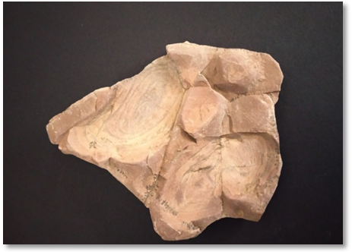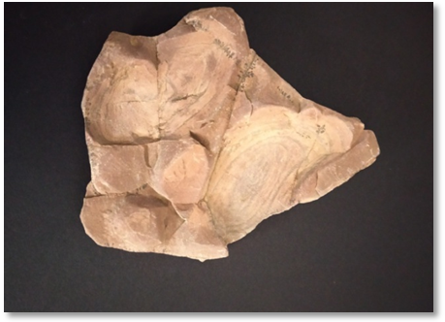
Fig.1 Fig. 2
Fig.1 and 2 show the impression of the concentric annular rings on opercula of gastropod.

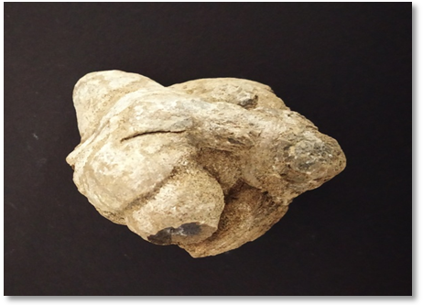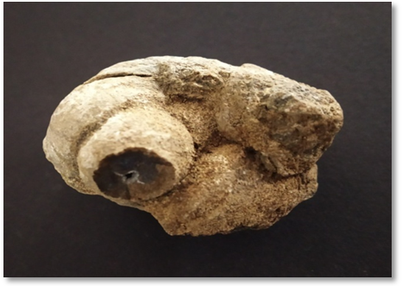
Fig.3 Fig.4
Fig.3 and 4 show the cast 2-3 gastropod in different views.

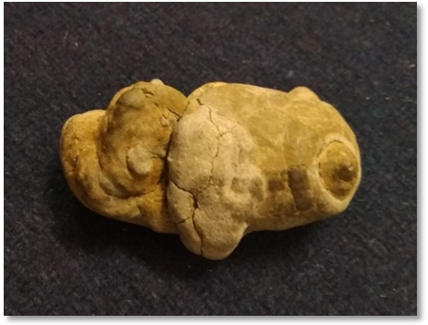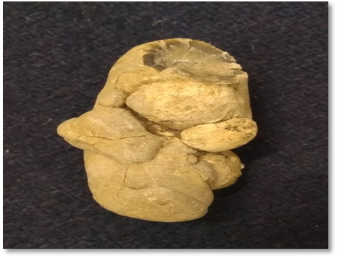
Fig.5 Fig.6
Fig.5 and 6 show cast of 3-4 Gastropods.

Acknowledgments:
The author is grateful to President and Secretary of Chanda Shikshan Prasarak Mandal Chandrapur for their continuous encouragement and support and also to Principal Janata Mahavidyalaya Chandrapur (M.S.) for providing necessary laboratory facilities to carry out this work.

References:
- Cowen R. A textbook of History of Life. Blackwell Science. 2000; 3:61.
- Dey A. The handbook on Indian freshwater molluscs, published by the Zoological Survey of India, Kolkata, India. 2007;140-141.
- E.N.K. Clarkson. A textbook on Invertebrate Paleontology and Evolution. Second Edition. Published by Allen & Unwin Ltd., Printed and bound by Cambridge University Press.1986.
- Halder K, Sinha P. Some Eocene Cerithioids (Gastropoda, mollusca) from Kutch, western India, and their bearing on Palaeobiogeography of the Indian subcontinent. Hindawi Publishing Corporation. 2014.
- Nath, K S. Late Pliocene (Piacenzian Stage) fossil molluscs from upper Siwalik subgroup of Jammu and Kashmir. International Research Journal of earth science India.2013;1(4)10-17.
- Pe´re`s JM, Picard J. Nouveau manuel de bionomie benthique de la Me´diterrane´e. Recueil des Travaux de la Station Marine d’Endoume. 1964;3(1)137.
- Prasad B. Recent and Fossil Viviparidae. A study in distribution, evolution and Palaeogeography. Memoirs of the Indian Museum. 1928; 8(4):156.
- Tyagi A P. Book of An Introduction to Paleontology. Published by S. Chand & company Ltd.1976; 1-10, 27-29, 36-40, 122-128.

10/4/2020

