Mechanical Properties of Two Varieties of Melon (Colocynthis citrullus)

Oyerinde, A. S. ¹, Sedara, A. M. ¹, Oladimeji, S. T. ², Ezenwogene, R. C. ², Akinsanya, O. M. ³ and Ogunlade, C. A.³

¹Department of Agricultural and Environmental Engineering, Federal University of Technology, Akure
²Department of Agricultural and Bio-environmental Engineering, Federal College of Agriculture, Moor Plantation, Ibadan.
³ Department of Agricultural Engineering, Adeleke University, Ede, Osun State, Nigeria

Abstract: The study of the mechanical properties of biomaterials gives the significant knowledge in quality evaluations and control of mechanical damage in size reduction, this study aimed at determining the mechanical properties of two selected varieties (Bara and Sewere) of melon. The strength properties of the two varieties were determined using a Universal Testing Machine (Testometric Machine) with a 25 KN compression load cell and Integrator. The properties determined include deformation, force, strain, stress, time to failure, time to peak and young modulus, they were determined in two loading orientations (laterally and longitudinally). The data obtained were statistically analysed and difference of means were tested at 95% level of confidence. the deformation, compressive force, strain and stress at the limit of proportionality ranges between 0.74-0.90mm, 9.13-11.13N, 4.63-5.65% and 0.06-0.07N/mm² respectively for longitudinal orientation of Bara and 1.48-2.51mm, 8.22-14.15N, 9.24-15.6%, 0.05-0.09N/mm² respectively for transverse orientation of Bara while for Sewere, the deformation, compressive force, strain and stress ranges between 1.28-1.69mm, 5.40-6.57N, 8.03-10.55% and 0.03-0.04N/mm² respectively for longitudinal orientation and 1.20-1.58mm, 5.47-8.37N, 7.51-9.85%, 0,03-0.05N/mm² respectively for transverse orientation. There exists a significant difference in the force required to attain the yield point between the longitudinal and transverse orientation for Bara while there is no significant difference between longitudinal and transverse orientation in Sewere but Bara in transverse orientation is significantly higher that of Sewere and Bara in longitudinal orientation is significantly higher than that of Sewere. The deformation, compressive force, strain and stress at peak point ranges between 1.57-.65mm, 35.43-44.91N, 9.81-10.29% and 0.22-0.28N/mm² respectively for longitudinal orientation of Bara and 2.20-3.02mm, 22.68-30.35N, 13.77-18.89%, 0.14-0.19N/mm² respectively for transverse orientation of Bara while for Sewere the deformation, compressive force, strain and stress ranges between 3.90-5.79mm, 13.22-23.50N, 24.39-36.25% and 0.08-0.15N/mm² respectively for longitudinal orientation and 2.42-3.08mm, 18.17-22.72N, 15.11-19.22%, 0.11-0.14N/mm² respectively for transverse orientation.
[Oyerinde, A. S., Sedara, A. M., Oladimeji, S. T., Ezenwogene, R. C., Akinsanya, O. M. and Ogunlade, C. A. Mechanical Properties of Two Varieties of Melon (Colocynthis citrullus). N Y Sci J 2020;13(7):33-42]. ISSN 1554-0200 (print); ISSN 2375-723X (online). http://www.sciencepub.net/newyork. 4. doi:10.7537/marsnys130720.04.

Keywords: Melon varieties, mechanical properties, machine design, strength characteristics

1. Introduction
Melon (Colocynthis citrullus L.) is an extensively cultivated and consumed oil seed crop in Nigeria and West Africa (Bankole, 2010). It is the fourth most important crop in the world in terms of production (18 metric tons), after orange, banana and grape (Aguayo, 2004). These seeds are vastly nutritious, furnishing the human diet with good quality protein (Ogbonna, 2007). It contains about 41.51% essential amino acids and other essential nutrients (Sabo et al., 2015). Melon seed is also a good source of minerals, vitamins, oil and energy in form of carbohydrates (Olaniyi, 2008). The seed contains 0.6 proteins, 4.6g carbohydrates, 33 mg vitamin C, 0.6 g crude fiber, 230 mg K, 16 mg P, 17 g Ca per 100 g edible seeds and unsaturated fatty acids.
Egusi seed are small and flat one end of the seed is rounded and the other is tapered (Bankole, 2010) thus making it more tasking to design its post harvest equipment. Egbe et al. (2015) stated that oil can be extracted mechanically by using hydraulic or screw press to press out the oil from melon seed. According to Odigboh (1999), it can also be extracted by using solvent like ethanol. The oil extracted from melon seed can be used for cooking and the residue left after extraction of the oil is high in protein which can be incorporated into baby food and local food such as “Igbalo” or “Jogi” which are mostly fried. All these are taken along with pap and also used for making
soap, melon cake are used for livestock feed. According to Ojeih et al. (2015), melon seed can provide valuable sources of oil used for both home, consumption and for export.
Melon is grown and utilized as food source in most parts of Nigeria. Africa is lacking behind in the development and designing of Agricultural machineries to solve her agriculture challenges mainly due to non-availability of information on the engineering of the crops necessary for design and development of machinery. The engineering properties of the crops include physical, mechanical/rheological, thermal, electrical, and optical properties which serve as an information in designing and construction of post harvest machinery (Aremu et al., 2014b; Jaiyeoba et al., 2016a and b; Jaiyeoba and Ogunlade, 2017; Ogunlade et al., 2016 and 2018; Oladimeji et al., 2019). The physical properties of two varieties of melon (Bara and Sewere) including dimensional, gravimetric and frictional properties have been reported (Oyerinde et al., 2020) while there is dearth of information on the mechanical properties of these two varieties. The study of the mechanical properties of biomaterials gives the knowledge significant in quality evaluations and control of mechanical damage in size reduction. Mechanical properties of agricultural materials affects their processing, handling storage and consumption and they are important in the design of planters, harvesters and in postharvest operations such as cleaning, conveying and storage (Balasubramanian et al., 2012 and Asoegwu et al., 2006; Aremu et al., 2014b). Results obtained from the study of the mechanical properties of two varieties of melon would be essential in the designing of equipment for its processing as well as the designing of facilities for its storage and will also predict the behavior of this agricultural material under load, the maximum allowable load and the minimum energy requirement for size reduction. This study therefore aimed at determining the mechanical properties of two selected varieties (Bara and Sewere) of melon.

2. Material and Methods
2.1 Sample Preparation: Two varieties of melon, namely Bara (Variety A) and Sewere (Variety B) used in the study were procured from Bodija market at Ibadan, Oyo state, Nigeria. The samples were cleaned to remove foreign materials, and broken or immature seeds.
2.2 Determination of Mechanical Properties
The strength properties of the two varieties were determined using a Universal Testing Machine (Testometric Machine) (Model M500) with a 25 KN compression load cell and Integrator. The properties determined include deformation, force, strain, stress, time to failure, time to peak and young modulus. The properties were determined in two orientations (laterally and longitudinally). The test was based on the force-deformation characteristics of the seeds. The universal testing machine has three main components which are stable up and motion bottom of platform; a driving unit, and a data acquisition system. During a compressive test the melon seed sample with an area of 160.000mm² was placed laterally and longitudinally on the stable up platform (Figure 1) and was compressed with a motion probe at a constant speed of 20 mm/min until the specimen fractured, the counter reading was taken immediately the first cracking sound was heard and the mechanical parameters of the test were automatically generated by the machine when programmed to determine the required mechanical properties of the melon seed. The results and the force-deformation curves obtained at each loading orientation were analyzed for the following: Elastic behavior; Limit of proportionality; Yield point; Breaking point; Peak point; Time to failure, time to peak and Young Modulus.

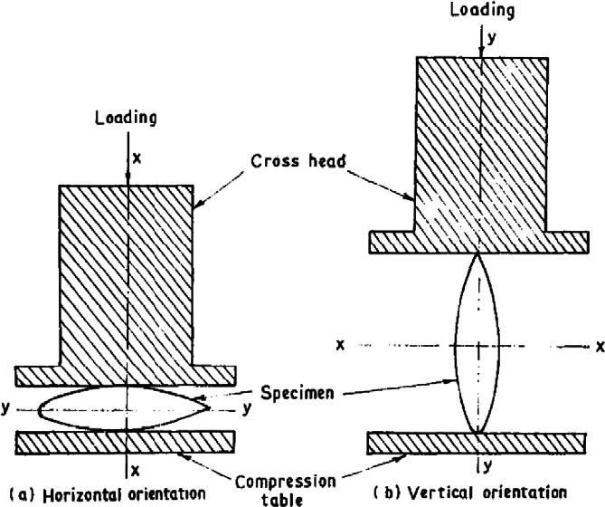
Figure 1: Orientation of African oil bean seed under compressive loading (Aremu et al., 2014)

2.3 Data Analysis
The data acquisistion unit of the Testometric machine gave out analysed results however, the raw data obtained were statistically analysed and difference of means were tested using Microsft Excel, 2013 version at 95% level of confidence.

3. Results
3.1 Elastic behavior of melon seed
The force-deformation diagram of the two varieties of melon with respect to the applied with respect to the load applied. It was observed that variety A had the maximum deformation under applied load in Longitudinal direction while variety B had the lowest in traverse direction.

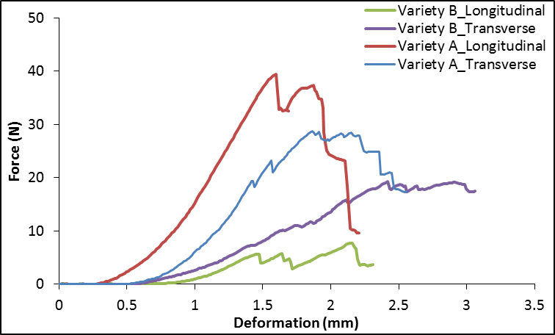
Figure 2: Force vs Deformation of Melon Seed (Bara and Sewere) in two major orientation

3.2 Mechanical behavior at Limit of Proportionality
The limit of proportionality measures the maximum point to which the melon seed obeys the Newton rule of elasticity that point at the linear relationship between the material deformation and the compressive load applied during compression. It was observed that the limit of proportionality of Bara is higher in transverse direction than the longitudinal orientation and vice versa for the Sewere. Table 1 shows the statistical summary of the mechanical behavior at the limit of proportionality. The table reveal that there is no significant difference in the force required to attain the limit of proportionality between the longitudinal and transverse orientation for the two variety (p <0.05) but Bara in transverse orientation is significantly higher than that of Sewere.
The table also shows that the deformation, compressive force, strain and stress at the limit of proportionality ranges between 0.74-0.90mm, 9.13-11.13N, 4.63-5.65% and 0.06-0.07N/mm² respectively for longitudinal orientation of Bara and 1.48-2.51mm, 8.22-14.15N, 9.24-15.6%, 0.05-0.09N/mm² respectively for transverse orientation of Bara while for Sewere, the deformation, compressive force, strain and stress ranges between 1.28-1.69mm, 5.40-6.57N, 8.03-10.55% and 0.03-0.04N/mm² respectively for longitudinal orientation and 1.20-1.58mm, 5.47-8.37N, 7.51-9.85%, 0,03-0.05N/mm² respectively for transverse orientation.
3.3 Mechanical behavior at Yield Point
The yield point measures the stress beyond which a material deforms by relatively large amount for a small increase in the stretching force. It was observed that the deformation and strain of the transverse orientation of Bara and Sewere is higher than the longitudinal orientation at the yield point also, the force and strength of the longitudinal orientation of Bara is higher than the transverse orientation at the yield point and vice versa for Sewere.
However, Table 2 shows the statistical summary of mechanical behaviour of melon seed at the yield point. There exists a significant difference in the force required to attain the yield point between the longitudinal and transverse orientation for Bara while there is no significant difference between longitudinal and transverse orientation in Sewere but Bara in transverse orientation is significantly higher that of Sewere and Bara in longitudinal orientation is significantly higher than that of Sewere.

Table 1: The Mechanical Properties of Melon Seed at the Limit of Proportionality
Properties | Statistics | Bara |  | Sewere
 |  | Longitudinal | Transverse | Longitudinal | Transverse
Deformation (mm) | Mean | 0.843^{bc} | 1.856ª | 1.47^{ab} | 1.432^{ab}
 | Max | 0.904 | 2.506 | 1.688 | 1.576
 | Min | 0.74 | 1.478 | 1.284 | 1.201
 | SD | 0.09 | 0.566 | 0.204 | 0.202
 | CV (%) | 10.641 | 30.482 | 13.862 | 14.099
Force (N) | Mean | 10.013^{ab} | 11.33ª | 6.077^{c} | 7.04^{bc}
 | Max | 11.13 | 14.15 | 6.57 | 8.37
 | Min | 9.13 | 8.22 | 5.4 | 5.47
 | SD | 1.02 | 2.976 | 0.606 | 1.465
 | CV (%) | 10.189 | 26.263 | 9.975 | 20.807
Strain (%) | Mean | 5.269^{bc} | 11.598ª | 9.19^{ab} | 8.948^{ab}
 | Max | 5.65 | 15.663 | 10.55 | 9.85
 | Min | 4.625 | 9.238 | 8.025 | 7.506
 | SD | 0.561 | 3.535 | 1.274 | 1.262
 | CV (%) | 10.64 | 30.482 | 13.861 | 14.102
Stress (N/mm²) | Mean | 0.063^{ab} | 0.071ª | 0.038^{c} | 0.044^{bc}
 | Max | 0.07 | 0.088 | 0.041 | 0.052
 | Min | 0.057 | 0.051 | 0.034 | 0.034
 | SD | 0.007 | 0.019 | 0.004 | 0.009
 | CV (%) | 10.625 | 26.335 | 9.488 | 20.83
Mean values on the same row with different alphabet are significantly different at p<0.05

The table also shows that the deformation, compressive force, strain and stress at yield point ranges between 1.57-1.65mm, 35.43-44.91N, 9.81-10.29% and 0.22-0.28N/mm² respectively for longitudinal orientation of Variety A and 1.87-3.02mm, 17.49-28.47N, 11.69-18.89%, 0.11-0.18N/mm² respectively for transverse orientation of Bara while for Sewere the deformation, compressive force, strain and stress ranges between 1.58-2.03mm, 6.09-14.02N, 9.89-12.71% and 0.04-0.09N/mm² respectively for longitudinal orientation and 1.38-2.42mm, 9.97-18.17N, 8.64-15.11%, 0.06-0.11N/mm² respectively for transverse orientation.

Table 2: Mechanical Properties of Melon Seed at the Yield Point
Properties | Statistics | Bara |  | Sewere
 |  | Longitudinal | Transverse | Longitudinal | Transverse
Deformation (mm) | Mean | 1.596^{abc} | 2.267ª | 1.755^{ab} | 1.85^{ab}
 | Max | 1.647 | 3.023 | 2.033 | 2.418
 | Min | 1.57 | 1.87 | 1.583 | 1.383
 | SD | 0.044 | 0.655 | 0.243 | 0.525
 | CV (%) | 2.749 | 28.876 | 13.862 | 28.37
Force (N) | Mean | 39.553ª | 23.78^{b} | 9.36^{c} | 13.33^{c}
 | Max | 44.91 | 28.47 | 14.02 | 18.17
 | Min | 35.43 | 17.49 | 6.09 | 9.97
 | SD | 4.859 | 5.662 | 4.144 | 4.296
 | CV (%) | 12.284 | 23.811 | 44.27 | 32.226
Strain (%) | Mean | 9.977^{abc} | 14.171ª | 10.967^{ab} | 11.563^{ab}
 | Max | 10.294 | 18.894 | 12.706 | 15.113
 | Min | 9.813 | 11.688 | 9.894 | 8.644
 | SD | 0.274 | 4.092 | 1.52 | 3.28
 | CV (%) | 2.749 | 28.876 | 13.859 | 28.371
Stress (N/mm²) | Mean | 0.247ª | 0.149^{b} | 0.059^{c} | 0.083^{c}
 | Max | 0.281 | 0.178 | 0.088 | 0.114
 | Min | 0.221 | 0.109 | 0.038 | 0.062
 | SD | 0.031 | 0.036 | 0.026 | 0.027
 | CV (%) | 12.465 | 23.974 | 44.493 | 32.673
Mean values on the same row with different alphabet are significantly different at p<0.05

3.4 Mechanical Behavior of Melon at Breaking Point
Breaking point measures the degree of tension or stress at which the material breaks. Figures 3 a-d shows the graphical representation of mechanical behavior at the breaking point which are deformation, force, strain and stress respectively for two varieties of melon seed in two major orientation (longitudinal and transverse). The deformation, compressive force, strain and stress ranges between 1.85±0.31mm, 25.17±13.42N, 11.58±1.94% and 0.16±0.08N/mm² respectively for longitudinal orientation of Bara and 3.17±0.67mm, 15.67±11.38N, 36.74±5.23%, 0.05±0.02N/mm² respectively for transverse orientation of Bara while for Sewere the deformation, compressive force, strain and stress ranges between 5.88±0.84mm, 8.62±3.39N, 19.84±4.21% and 0.10±0.07N/mm² respectively for longitudinal orientation and 3.57±0.46mm, 11.84±1.87N, 22.31±2.87%, Figure 3a shows that the deformation of the transverse orientation of Bara is higher than the longitudinal orientation at the breaking point and vice versa in Sewere, Figure 3b shows that the force of the longitudinal orientation of Bara is higher than the transverse orientation at the breaking point and vice versa for Sewere while Fig 3c shows that the strain of the transverse orientation of Bara and Sewere is higher than the longitudinal orientation at the breaking point and vice versa for strength in Fig 3d. There is no significant difference in the force required to attain the breaking point between the longitudinal and transverse orientation for Bara and Sewere. 0.07±0.01N/mm² respectively for transverse orientation.

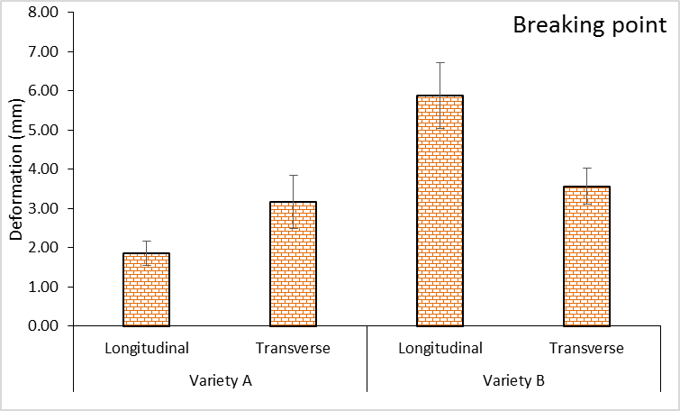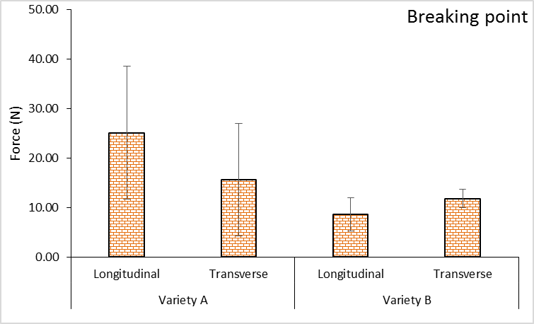
- (b)

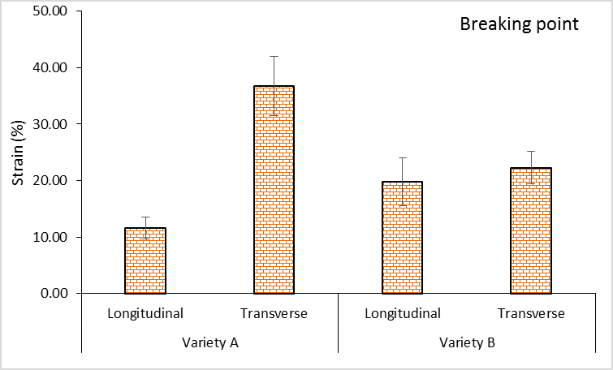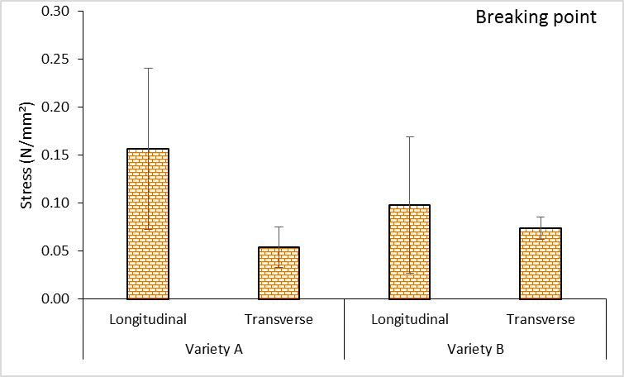
(c) (d)
Figure 3: (a) – Deformation, (b) – Force, (c) – Strain, (d) – Stress the melon seeds at breaking point

3.5 Mechanical behavior of Melon at Peak Point under loading
The deformation, compressive force, strain and stress at peak point ranges between 1.57-.65mm, 35.43-44.91N, 9.81-10.29% and 0.22-0.28N/mm² respectively for longitudinal orientation of Bara and 2.20-3.02mm, 22.68-30.35N, 13.77-18.89%, 0.14-0.19N/mm² respectively for transverse orientation of Bara while for Sewere the deformation, compressive force, strain and stress ranges between 3.90-5.79mm, 13.22-23.50N, 24.39-36.25% and 0.08-0.15N/mm² respectively for longitudinal orientation and 2.42-3.08mm, 18.17-22.72N, 15.11-19.22%, 0.11-0.14N/mm² respectively for transverse orientation. It was observed that the deformation and strain of Bara in transverse orientation is higher than the longitudinal orientation at the peak point, and vice versa in Sewere; also, the force and strength of Bara in longitudinal orientation is higher than the transverse orientation at the peak point and vice versa for Sewere. Table 3 shows the statistical summary of mechanical behaviour of melon seed at peak point. The table reveals that there is significant difference in the force required to attain the yield point between the longitudinal and transverse orientation for Bara while there is no significant difference between longitudinal and transverse orientation in Sewere but Bara in longitudinal orientation is significantly higher than that of Bara and Sewere in transverse orientation is significantly higher than that of Sewere.

Table 3: Statistical summary of mechanical property at peak point
Properties | Statistics | Bara |  | Sewere
 |  | Longitudinal | Transverse | Longitudinal | Transverse
Deformation (mm) | Mean | 1.596^{bc} | 2.598^{b} | 4.979ª | 2.672^{b}
 | Max | 1.647 | 3.023 | 5.799 | 3.075
 | Min | 1.57 | 2.203 | 3.902 | 2.418
 | SD | 0.044 | 0.411 | 0.974 | 0.353
 | CV (%) | 2.749 | 15.813 | 19.566 | 13.209
Force (N) | Mean | 39.553ª | 27.167^{b} | 18.517^{c} | 20.677^{bc}
 | Max | 44.91 | 30.35 | 23.5 | 22.72
 | Min | 35.43 | 22.68 | 13.22 | 18.17
 | SD | 4.859 | 3.998 | 5.147 | 2.31
 | CV (%) | 12.284 | 14.715 | 27.797 | 11.173
Strain (%) | Mean | 9.977^{bc} | 16.238^{b} | 31.117ª | 16.7^{b}
 | Max | 10.294 | 18.894 | 36.244 | 19.219
 | Min | 9.813 | 13.769 | 24.388 | 15.113
 | SD | 0.274 | 2.568 | 6.088 | 2.206
 | CV (%) | 2.749 | 15.813 | 19.565 | 13.208
Stress (N/mm²) | Mean | 0.247ª | 0.17^{b} | 0.116^{c} | 0.129^{bc}
 | Max | 0.281 | 0.19 | 0.147 | 0.142
 | Min | 0.221 | 0.142 | 0.083 | 0.114
 | SD | 0.031 | 0.025 | 0.032 | 0.014
 | CV (%) | 12.465 | 14.694 | 27.627 | 10.971
Mean values on the same row with different alphabet are significantly different at p<0.05

3.6 Time to failure, Time to Peak and Young Modulus
The time to failure, time to peak and young modulus ranges between 4.97-13.88s, 4.76-4.92s, 2.60-3.40N/mm² respectively for longitudinal orientation of variety A and 20.18-29.87s, 17.07-27.63s, 1.49-2.03N/mm² respectively for transverse orientation of Bara while for Sewere, the time to failure, time to peak and young modulus ranges between 7.79-11.78s, 6.67-9.09s, 3.12-4.43N/mm² respectively for longitudinal orientation and 9.22-11.88s, 7.30-9.26s, 0.64-1.97N/mm² respectively for transverse orientation. Fig 4 - 6 shows the time to failure, time to peak and young modulus respectively for two varieties of melon seed in two major orientation (longitudinal and transverse). Figure 4 shows that the time to failure of Bara and Sewere in the transverse orientation is higher than the longitudinal orientations while Figure 5 shows that the time to peak of Bara and Sewere in transverse orientation is higher than the longitudinal orientation. Figure 6 shows that the young modulus of Bara and Sewere in longitudinal orientation is higher than its transverse orientation.

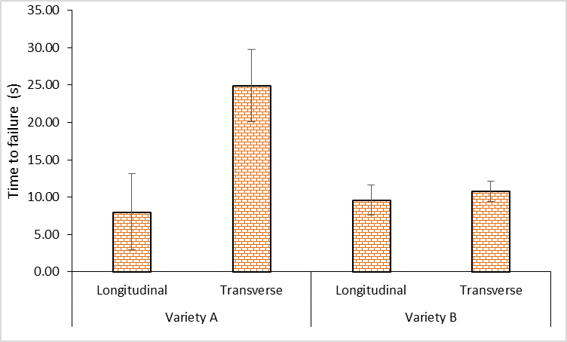
Figure 4: The failure time of the melon seed under compression test

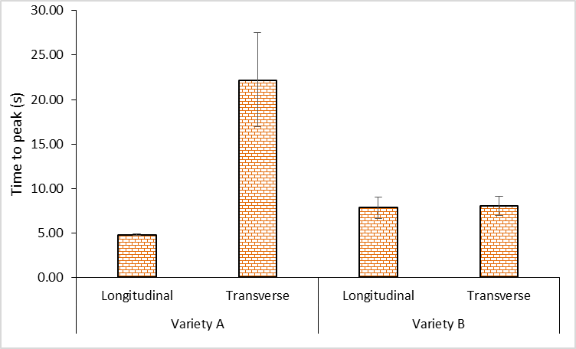
Figure 5: The time taken the melon seed to attain peak point under compression test

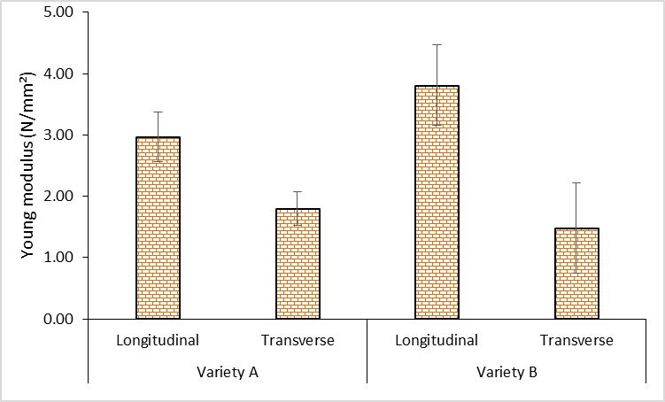
Figure 6: The young modulus of elasticity of melon seeds under compression test

4.0 Conclusions
The mechanical properties of two varieties of melon (Bara and Sewere) were investigated prior to design of post harvest machine. The mechanical behavior (stress, strain, force and deformation) at limit of proportionality, peak point, breaking point and yield point for two varieties of melon seed in two major orientation (longitudinal and transverse) was determined. There was no significant difference in the force required to attain the limit of proportionality between the longitudinal and transverse orientation for the two variety (p <0.05) but Bara in transverse orientation is significantly higher that of Sewere. There was significant difference in the force required to attain the yield point between the longitudinal and transverse orientation for Bara while there was no significant difference between longitudinal and transverse orientation in Sewere but Bara in transverse orientation is significantly higher that of Sewere. There was no significant difference in the force required to attain breaking point between the longitudinal and transverse orientation for the two varieties while there was a significant difference in the force required to attain the yield point between the longitudinal and transverse orientation for Bara and no significant difference for both orientations of Sewere. The time to failure of the transverse orientation of Bara and Sewere is higher than the longitudinal orientations while the time to peak of the transverse orientation of Bara and Sewere is higher than the longitudinal orientation, also, the young modulus of the longitudinal orientation is higher than the transverse orientation of Bara and Sewere. The data obtained will be guide for food and agricultural engineers, processors and stakeholders involved in design and development of various post harvest handling equipment and machinery.

Corresponding Author:
Dr. Oyerinde A. S.
Department of Agricultural and Environmental Engineering Federal University of Technology Akure

References
- Adeniran, M. O. and G. F. Wilson (2001). “Seed type classification of egusi Melon in Nigeria” Paper presented at the 6th African Horticultural Symposium, University of Ibadan, 9th – 25th, July. Agrophysic., 21 (4): 349.
- Ahmadi, and Mollazade, K. (2009): Some Physical and Mechanical Properties of Fennel Seed (Floeniculum bulgane) Journal of Agric. Sci., 1(1):66-75.
- Ajibola, O.O., Eniyemo, S.E., Fasina, O.O. and Adeko K.A. (1990). Mechanical extraction of oil from melon seeds. Journal of Agricultural Research, 45: 1.
- Aremu, A. K., Ademuwagun, A. A. and Ogunlade, C. A. (2014). Effects of Moisture Content and Loading Orientation on Some Mechanical Properties of African Oil Bean Seeds (Pentaclethra macrophylla Benth). African Journal of Agricultural Research Vol. 9(49): PP 3504-3510. Also available online at http://www.academicjournals.org/AJAR
- Aremu, D. O., Babajide, N. A. and Ogunlade, C. A. (2014). Comparison of some Engineering Properties of Common Cereal Grains in Nigeria: International Journal of Engineering and Science Invention (IJESI). Vol. 3(4): 10-14. ISSN (online): 2319-6734 and ISSN (print): 2319-6726.
- Asoegwu, S., Ohanyere, S., Kanu, O., Iwueke, C. (2006): Physical properties of African oil Bean seed (Pentaclethra macrophylla Benth). Agricultural Engineering International: the CIGR Ejournal. Manuscript FP 05 006. Vol. VIII.
- Bal, S., and Mishra, H.S., (1988). Engineering properties of soybeans, proceedings of the National seminar and utilization in India, 146-165.
- Balasubramanian, S., Singh, K.K., Kumar, R. (2011): Physical properties of coriander seeds at different moisture content. Int. Agro-physics, 26, 419-422.
- Bankole, S.A. (2010). Effect of lemon grass powder and essential oil on mould deterioration and aflatoxin contamination on melon seeds. African Journal of Biotechnology, 3: 52–59.
- Bart-Plange, A., Mohammed-Kamil A.P., Addo A. and Teye E. (2012): Some Physical and Mechanical Properties of cashew nuts and kernel grown in Ghana. International Journal of Science and Nature. 3(2): 406-415.
- Davies, R. M. (2010). Engineering properties of three varieties of melon seeds as potentials for development of melon processing machines. Advance Journal of Food Science and Technology, 2(1): pp. 63-65.
- Egbe DE, Mayah TF, Ebot EG, Egbe PA, Abraham JP (2015). Performance evaluation and improvement on a melon seed shelling machine. World Journal of Agricultural Sciences and Engineering 1: 1-10.
- Jaiyeoba, K. F. and Ogunlade, C. A. (2017). Some Physical Properties of Fermented Locust Bean Produced in Four different locations in Nigeria. International Journal of Research in Engineering and Applied Sciences (IJREAS). Vol. 7 Issue 4, April-2017, pp. 38~44. Available online at http://euroasiapub.org/some-physical-properties-of-fermented-locust-bean-produced-in-four-different-locations-in-nigeria/
- Jaiyeoba, K. F., Jekayinfa, S. O., Ogunlade, C. A., Oke, A. M. and Apata, M. M. (2016b). Physical and Thermal Properties of Mango (Mangifera indica) Seeds. Science Focus Vol. 21 (1) 2016 pp. 126 – 132. Faculty of Pure and Applies Sciences, LAUTECH, Ogbomosho, Printed in Nigeria.
- Jaiyeoba, K., Jekayinfa, S. O., Oloyede, C. T., Ogunlade, C. A. and Oke, A. M. (2016a). Moisture-dependent physical properties of cocoa (Theobroma cacao) pods. International Journal of Organic Agriculture Research & Development, Volume 13, Sept. (2016): Pp 40 – 46.
- Klenin, N.L., Popov I. F and Sukun V.A (1985): Agricultural machine Theory of operation, Computation of controlling parameters and the conditions of operation. A merind publishing Co. PVT. Ltd., New Delhi, Pp 633.
- Kochhar, A and Hira, C.K. (1997): Nutritional and cooking evaluation of green gram cultivars. Journal of food sciences and Technology, 34(4): 328-330.
- Koocheki, A., Razavi, S.M., Milani, F., Meghadam, T.M., Abedini, M., Alamatiyan, S. and Izadkhah, S. (2007): Physical properties of watermelon seed as a function of moisture content and variety. Int.
- Lgathinathane, K.G. and Hana H. D. (1998): The physical measurement of quality in canned peas. Common wealth sciences and industry organization (Australia) Bul. 154.
- Matouk, A.M., Radwan S. M., M.M. El-kholy, and T. R. Ewies (2004): Determination of seeds density and porosity for some cereal crops. Misr. J. Of Agric. Eng., 21(3): 623 -641.
- Mohsein, N. N. (1986). Physical properties of plant and animal materials. New York: Gordon and Breach Science Publishers.
- Odigboh, E.U. (1999). Impact Egusi Shelling Machine. Transactions of American Society of Engineers (ASAE), Volume 22, Issue 6, pp. 1264-1269.
- Ogbonna, P.E. and Obi, I.U. (2007). The influence of poultry manure application and plant density on growth and yield of Egusi melon (Colocynthis citrullus) on the Nsukka Plains of South eastern Nigeria. Agro-Science, Volume 1, Issue 1, pp. 22-129.
- Ogunlade, C. A., Alaka, A. C., Babajide, N. A., Aremu, D. O., Anjorin, S. E. and Akinyele, O. A. (2016). Moisture-dependent physical properties of popcorn. Journal of Multidisciplinary Engineering Science and Technology. Vol. 3(2): 4069-4073.
- Ogunlade, C. A., Jaiyeoba, K. F., Oke, A. M. and Onojah, P. E. (2018). Dimensional Properties of Garcinia kola Nuts as Influenced by Moisture Content. International Journal of Research and Reviews, 5 (7): 176 – 181.
- Ojeih, G.C., Oluba, O.M., Ogunlowo, Y.R., Adebisi, K.E Eidangbe, G.O. and Isiosio, I.O. (2007). Physiochemical Properties and Fatty Acid Composition of Citrullus lanatus (Egusi Melon) Seed Oil, Journal of Biological Sciences, 8 (4): 814 – 817.
- Ojo, A.A., Bello, L.L. and Vange, T. (2002): Evaluation of Egusi melon (Colocynthis citrullus L.) Accessions. Tropicat Oil Seed, Journal, Volume 7, pp. 25-29.
- Oladimeji, S. T., Oyerinde, A. S. and Ogunlade, C. A. 2019. Development and Evaluation of a Melon Shelling Machine. Adeleke University Journal of Engineering and Technology [AUJET] 2 (2): 149-155. http://aujet.adelekeuniversity.edu.ng/index.php/aujet/article/view/77
- Olaniyi, J.O. (2008). Growth and seed yield response of egusi melon to nitrogen and phosphorus fertilizers application. American-Eurasian Journal of Sustainable Agriculture 2: 255-260.
- Sabo H, Sadou H, Amoukou IA, Alma MM, Sidikou RS. (2015): Determination and comparison of the amino acid composition of seventeen Lagenaria siceraria varieties and one variety of Citrullus colocynthis seed flours. Pakistan Journal of Nutrition 14: 100-106.
- Sirisomboon, P., P. Kitchaiya, T. Pholpho and W. Mahuttanyara, ( 2007). Physical and mechanical properties of jatropha fruit, nuts and kernels. Biosys.

7/24/2020

