Effect of Pile Length on Load Sharing Of Pile Raft Foundation under Different Loads

Elsamny, M. K. ¹, Ezz-Eldeen, H. A. ¹, Elbatal, S. A. ¹ and Kamar, A. M. ²

¹ Al Azhar University, Faculty of Engineering, Cairo, Egypt
² Sinai University, Faculty of Engineering, - El Arish, Egypt

Abstract: The present study is mainly based on the determination of the effect of pile length on load sharing between piles and soil and distribution of stress under soil before and after redistributed of load from soil to pile under six piles their diameters are fixed (D = 0.6 m) and the spacing between piles is fixed (Sp = 3D) and they have various length (Lp = 34D, 36D, 38D and 40D). The piles subjected to eccentric load (0%,5%,10%,15% and 20%) from centroid in X-direction. Raft on piles the thickness of raft is (t = 1.0D). Finite element package of a PLAXIS 3D version 2013. (a finite element code for soil and rock analysis) has been used to determine the stress under pile and soil before and after redistribution of load on pile from soil, percentage load carried by pile and soil, settlement under piles and distribution of load among pile length. It was found that Pile Length have a great effect on load sharing as increasing pile length increase load carries by pile.
[Elsamny, M. K., Ezz-Eldeen, H. A., Elbatal, S. A. and Kamar, A. M. Effect of Pile Length on Load Sharing Of Pile Raft Foundation under Different Loads. N Y Sci J 2020;13(7):1-15]. ISSN 1554-0200 (print); ISSN 2375-723X (online). http://www.sciencepub.net/newyork. 1. doi:10.7537/marsnys130720.01.

Key words: Pile Length, Pile Raft Foundation

1. Introduction:
The load sharing between the raft and piles for piled raft foundation is affected by a number of different factors but to a varying degree.
Akinmusuru (1980) ^{[2]} studied the effect of pile length and raft geometry on the piled raft load sharing. Experimental results on a single piled raft unit revealed that the raft share increases extensively by enlarging the raft width, whereas the pile length has inconsiderable impact on the load sharing.
Clancy and Randolph (1993) ^{[3]} determined approach for the analysis of piled raft foundations, based on transfer the load of individual piles, together with elastic interaction between different piles and with the raft. They presented the effect raft stiffness and spacing between piles and pile length and stiffness.
Zhuang and Lee (1994) ^{[9]} presented a 3-dimensional finite element analysis for predicting the distribution of load between the piles in a piled-raft foundation. Investigated the effect of structural stiffness, pile length and spacing and the relative stiffness of the raft and the pile on the distribution of load among the piles. They observed that the structural stiffness, the raft rigidity, pile stiffness and pile length to width ratio significantly affect the load distribution among the piles. They also observed that by increasing the pile length and decreasing the raft and pile rigidity the distribution of load becomes more uniform. The raft rigidity increases, the effect of structural stiffness on the load distribution among piles becomes small.
Gandhi and Maharaj (1996) ^{[5]} investigated the sharing load between raft and pile based on 3-D linear finite element method. They discussed the effect of pile length, pile spacing and soil modulus on sharing load between raft and pile.
Reul and Randolph (2004) ^{[6]} conducted a parametric study to investigate the effect of some parameters such as the pile position, the pile number, the pile length, the raft-soil stiffness ratio, and the load distribution on the raft on the behavior of piled-raft foundations. They observed that the Smaller average settlement can be obtained by increasing pile length more than increasing number of piles. And the Raft-soil stiffness ratio and the load configuration have a higher effect on the differential settlement than on the average settlement.
El Sawwaf (2010) ^{[4]} performed an experimental investigation to study the effects of pile length, number of piles, relative density of sand, and load eccentricity on the load settlement behavior of piled raft. It was investigated that the efficiency of the piled raft system depends on the load eccentricity ratio, pile arrangement and relative density; increasing the number of piles could only lead to reduction of settlement until reaches a certain value.
Srilakshmi et al. (2012) ^{[7]} presents two-dimensional plane strain analysis for piled raft. In this parametric study, various piled raft configurations
have been analyzed by two-dimensional plane-strain finite element analyses using ANSYS. From this study it is observed that piled raft foundations having longer piles takes more load at higher values of settlements.
El-Garhy et al. (2013) ^{[8]} conducted an experimental program on model piled rafts in sand soil. reducing piles. Three lengths of piles are used in the study to represent slenderness ratio, L/D, of 20, 30 and 50, respectively. The results of the tests show the effectiveness of using piles as settlement reduction measure with the rafts. As the number of settlements decreasing piles increases, the load improvement ratio increases and the differential settlement ratio decreases.
Juneja, A. et al. (2013) ^{[1]} presented a model to understand the effects of raft thickness, number and length of piles on the load shared by the piles. The load shared by the piles increased with increase in the length of central pile. However, the load sharing did not change significantly when central pile was of larger diameter.
However; needing to study the effect of pile length on load sharing on Pile -Raft foundation under the eccentric load because it has not received much attention from researcher. This paper present 3-D model to simulate pile -Raft foundation under the effect of eccentric load.
The objectives of the presented study are to study the effect pile length on load sharing between piles and soil as follows:
- Determination pile length effect on load sharing of Piled-Raft foundation under different eccentric loads.
- Determination of the settlement under Piled-Raft foundation under different eccentric loads.
- Study the analysis of stresses underneath Piled-Raft foundation.
- Study the distribution of load among pile length under different eccentric loads.

2-Analytical Analysis by Finite Element Analysis:
The used computer program for proposal a three-dimensional finite element model in order to simulate theoretically effect of length between piles on pile raft foundation is a finite element package of a PLAXIS 3D version 2013. (a finite element code for soil and rock analysis).
2.1. Proposed model:
In the present study, a theoretical analysis has been done for a selected site (in governmental project in Semesta, Beni-suef, Governorate, Egypt). Fig. (1) illustrates a borehole for the pervious site was chosen to be used in the analysis. The soil consists of six layers and simulated by a semi-infinite element isotropic homogenous elastic material.
The analysis program consists of pile-raft foundation consists of Six piles their diameters are fixed (D = 0.6m) and the spacing between piles is fixed (Sp = 3D) and they have various pile length (Lp = 34D,36D,38D and 40D). The piles subjected to Vertical load, Eccentric load (5%,10%,15% and 20%) from centroid in X-direction. Raft on piles: the thickness of the raft is fixed (t = 1.0D).
The details and variation of these selected parameters are listed in tables from (1) to (4). and figure (2).

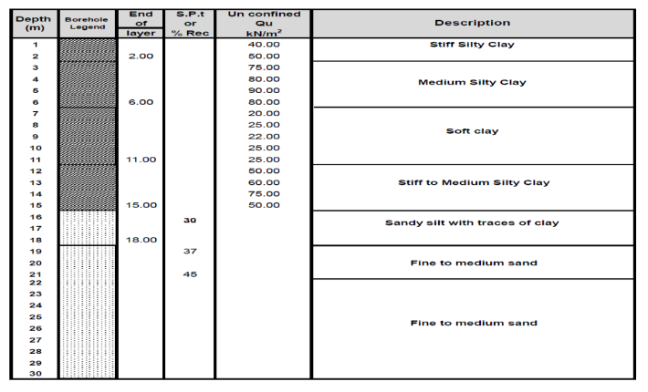
Fig. (1): Borehole Log for Soilused Sesmeta, Beni-Suef Governorate, Egypt Project

Table (1): Investigated cases of study
N0. | Number of piles | pile diameter (m) | Length of piles | Pile spacing | Raft thickness
1 | 6 | 0.6 | 34D  36D  38D  40D | 3D | 1.0D
2
3
4

Table (2): Distance Of Eccentric Load In X-Direction And Raft Dimension
Pile Spacing |  |  |  | Centroid of Piles raft | Raft dimension (cm) | Eccentricity from CG in X-direction (cm)
Sp | SY (cm) | SX1 (cm) | SX2 (cm) | CG (cm) | R. D | Ec 5% | Ec 10% | Ec 15% | Ec 20%
3D | 180 | 180 | 180 | 180 | (480 X300X60) | 12 | 24 | 36 | 48

Table (3): Properties For Soil Layers
Parameters | Name | Stiff silty clay | Medium silty clay | Soft Clay | Stiff to medium silty clay | Sandy silt with traces of clay | Fine to medium sand | unit
Material model | - | Moher column | Moher column | Moher column | Moher column | Moher column | Moher column | -
Thickness | T | 2 | 4 | 5 | 4 | 3 | 12 | m
Young,s modulus | Es | 5000 | 4000 | 2000 | 4500 | 7500 | 15000 | kN/m2
Unit weight | ɣ | 16.65 | 16.35 | 15.65 | 16.55 | 17 | 17.5 | kN/m3
Poisson ratio | ʋ | 0.25 | 0.3 | 0.3 | 0.3 | 0.3 | 0.25 | -
Cohesion | ϲ | 50 | 40 | 12.5 | 25 | 25 | 0 | kN/m2
Friction angle | Ø | 0 | 0 | 0 | 25 | 25 | 30 | °

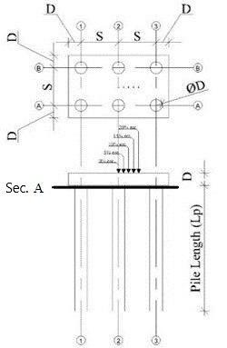
Fig. (2): Cross section of six piled-raft foundation model subjected to different ecc. Load

Table (4): Pile and Raft Properties
Parameters | Pile | Raft
Material model | Elastic | Elastic
Types of material | Concrete | Concrete
Diameter (m) | 0.6 | 0.6
Unit weight (kN/m3) | 25 | 25
young’s modulus Es (kN/m2) | 24*10^6 | 24*10^6
Poisson ratio (ʋ) | 0.2 | 0.2
Cohesion (Cu) (kN/m2) | - | -
Friction angle (Ø) (°) | - | -

The ultimate capacity of pile used in this study and analysis has been estimated through theoretical method by using Meyerhof (1976). The theoretical ultimate capacity for the single pile (Qu) is 1000 kN, However, the total applied load (P) is 6000kN. Thus, the number of piles is six piles.
2.2. Finite element model:
Figures (3) and (4) show the plan in 2-D and 3-D for a selected example for the model of six piles (Lp =34D, D =0.6 m Sp =3D)
3-Therotical Results:
The theoretical results involve the followings:
- Deformed mesh of the soil.
- Settlement under piles.
- Stress under soil before redistribution load on pile from soil.
- Stress under pile after redistribution load on pile from soil.
- Deformation of pile.
- Distribution of load among pile.
3. 1. Finite Element Results:
The obtained results of selected examples for different cases are shown in figures (5 to 14) as follows:
Figure (5) shows the deformed mesh for six piles (Lp = 34D, D = 0.6 m and Sp = 3D).
Figures (6) and (7) show the vertical displacement (settlement) as shading and contour for six piles (Lp = 34D, D = 0.6 m Sp = 3D) and (0% eccentricity).

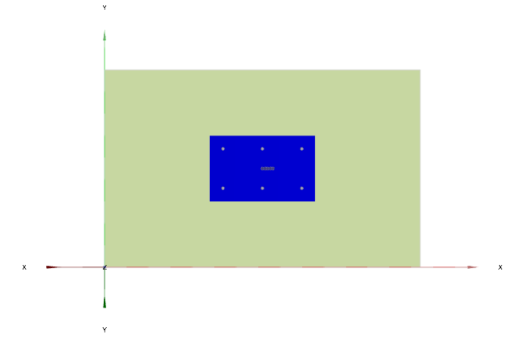
Fig. (3): Plan In 2-D for Six Piles with Raft (L_{p}=34d, S_{p}=3d, D=0.6 M)

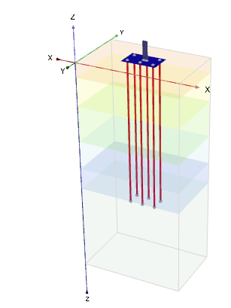
Fig. (4): Plan in 3-D for Six Piles with Raft (L_{p}=34d, S_{p}=3d, D=0.6 M)

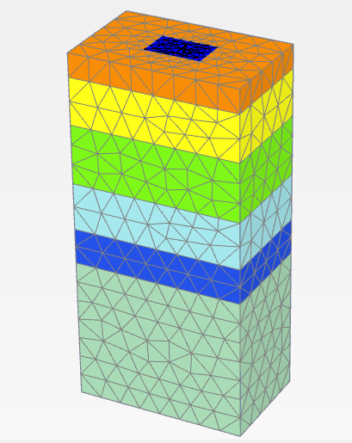
Fig. (5): Deformed Mesh for Six Piles in 3-D with Raft (Lp = 34d, Sp = 3d, D = 0.6 M)

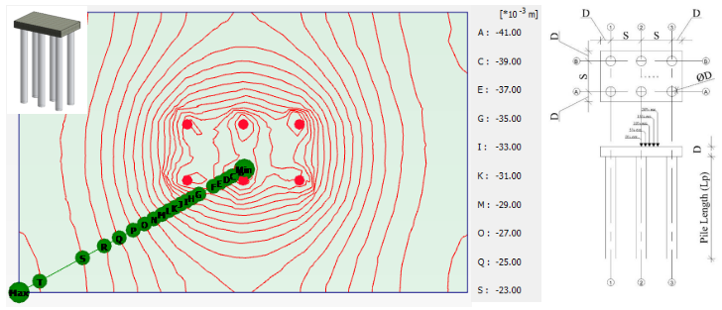
Fig. (6): Vertical Displacement as Contour for Six Piles In 2-D with Raft (L_{p} = 34d, S_{p} = 3d, D = 0.6 M) and (0% Ecc.)

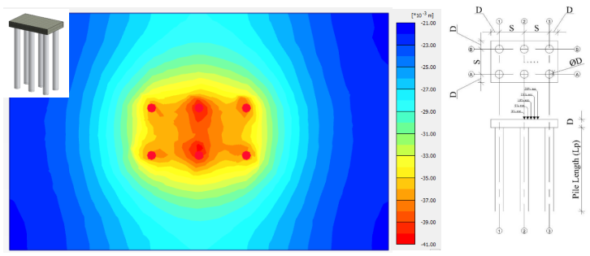
Fig. (7): Vertical Displacement as Shading for Six Piles In 2-D with Raft (L_{p} = 34d, S_{p} = 3d, D = 0.6 M) and (0% Ecc.)

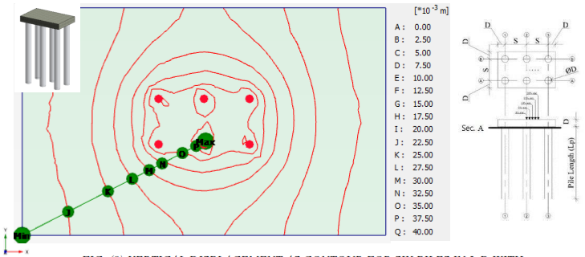
Fig. (8): Vertical Displacement as Contour for Six Piles In 2-D with Raft (L_{p} = 34d, S_{p} = 3d, D = 0.6 M) and (0% Ecc.)

Figures (8) and (9) show the vertical displacement (settlement) as contour for six piles (Lp = 34D and 36D (,) D = 0.6 m Sp = 3D) and (0% eccentricity).
Figures (10) and (11) show the vertical displacement (settlement) as shading under sec (A-A) at (Sp = 3D) (Lp = 34D and 36D (, D = 0.6 m) and (0% eccentricity). From these figures, it can be shown that settlement decreasing by increasing pile length.
Figures (12) and (13) show the distribution of stresses for six piles ((Lp = 34D and 36 D), D = 0.6 m and 20% ecc.) and spacing Sp = (3D) and figure (14) shows the distribution of stresses under sec. (A-A) for three piles (Sp = 3D, D = 0.6 m and 0% ecc.) and various pile length where Lp = 34D,36D,38D and 40D). From these figures, it can be shown that the stresses increase by increasing the pile length. It can be shown that the distribution of stresses is not uniform.

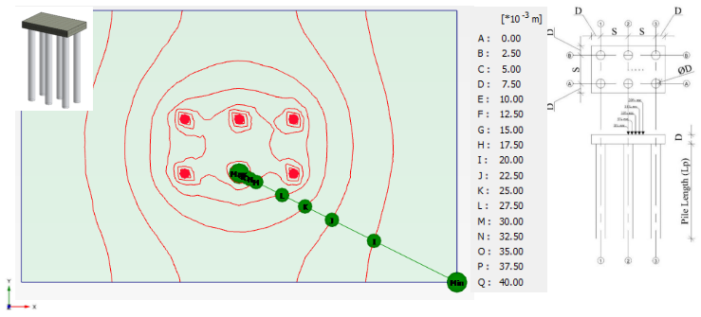
Fig. (9): Vertical Displacement as Contour for Six Piles In 2-D with Raft (L_{p} = 36D, S_{p} = 3D, D = 0.6 M) and (0%Ecc. )

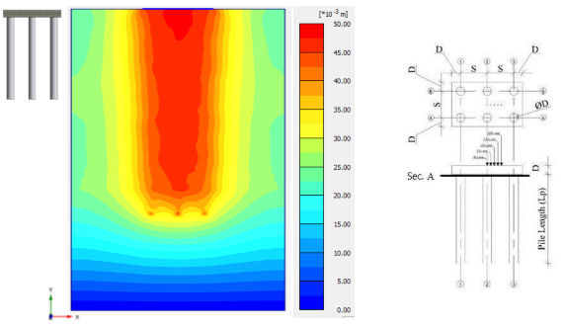
Fig. (10): Vertical Displacement as Shading under Sec (A-A) In 2-D with Raft (L_{p} = 34d, S_{p} = 3d, D = 0.6 M) and (0% Ecc.)

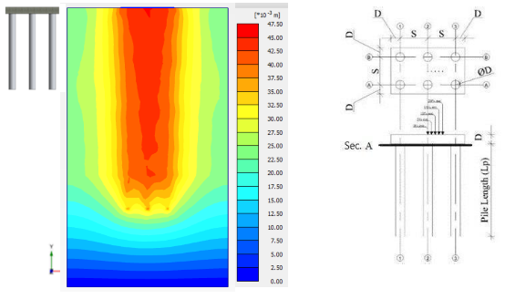
Fig. (11): Vertical Displacement as Shading Sec (A-A) In 2-D with Raft (L_{p} = 36d, S_{p} = 3d, D = 0.6 M) And (0% Ecc.)
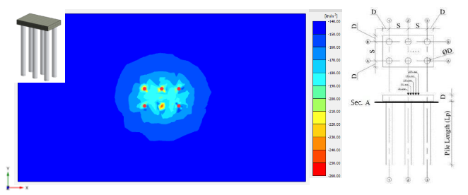
Fig. (12): Normal Stress as Shading for Six Piles In 2-D with Raft, (L_{p} = 34d, S_{p} = 3d, D = 0.6 M) (Ecc = 0%)
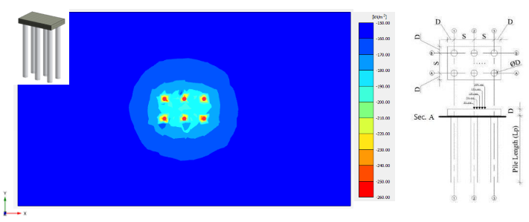
Fig. (13): Normal Stress as Contour for Six Piles In 2-D with Raft, (L_{p} = 36d, S_{p} = 3d, D = 0.6 M) (Ecc = 0%)

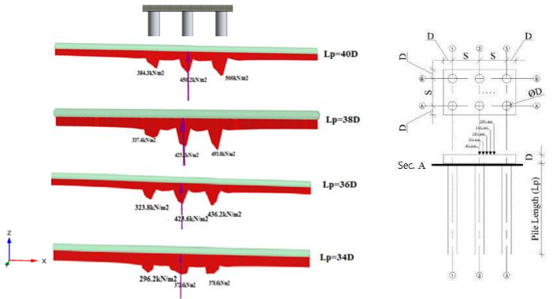
Fig. (14): Distribution of Stresses under Sec (A-A) In 2-D at Different Length (S_{p} = 3d and D = 0.6 M)

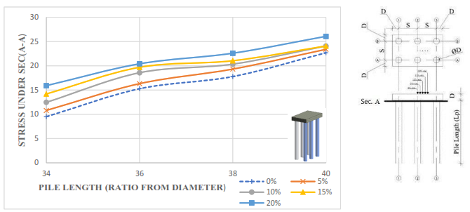
Fig. (15): The relation between stress and pile length for different eccentricity (s_{p} = 3d, d = 0.6 m)

3. 2. Theoretical Analysis:
Figures (15) and (16) show the relationship between stress under sec. (A-A) and pile length where Lp = (34D, 36D, 38D and 40D) for (D = 0.6 m), various ecc. where (Ecc = 0%, 5%, 10%, 15% and 20%). from these figures, it can be shown that the stress increases on pile by increasing pile length.
Figures (17), (18) and (19) show the relationship between the stress under piles and soil under sec. (A-A) before and after redistribution of load from soil at different pile length where Lp = 34D, 36D, 38D and 40D) for (D=0.6 m, ecc= 0% and sp= 3D). From these figures, it can be shown that the stress on soil decrease by increasing the pile length.
Figure (20) shows the relationship between the distance and distribution of stress under sec. (A-A) before and after redistribution of load from soil at different eccentricity in X-direction (ECC.= 0%, 5%, 10%, 15% and 20 %) for (D=0.6 m, Sp= 3D and Lp= 34D) From these figures, it can be shown that increasing eccentricity in X-direction has no significant effect in stresses.
Figure (21) shows the relationship between the distance and distribution of stress under sec. (A-A) before and after redistribution of load from soil at different eccentricity in X-direction (ECC.= 0%, 5%, 10%, 15% and 20 %) for (D=0.6 m, Sp= 3D and Lp= 34D) From these figures, it can be shown that the load increase on pile on the redistribution of load from soil.

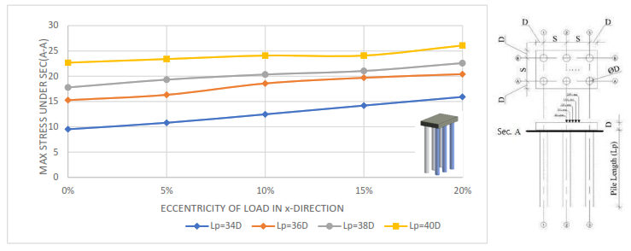
Fig. (16): the relation between stress under sec. (a-a) and eccentricity in x-direction for different pile spacing (l_{p} = 34d, d = 0.6 m)

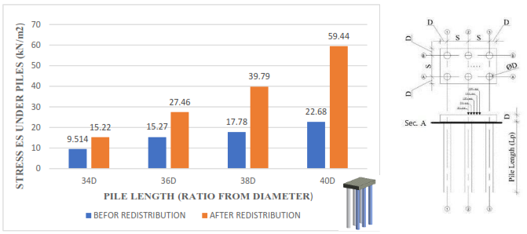
Fig. (17): comparison between total stress under piles under sec. (a-a) before and after redistribution of load at different pile length at (sp=3d, d=0.6 m and ecc=0%)
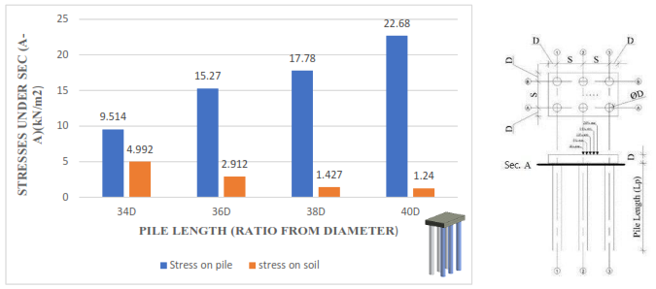
Fig. (18): comparison between total stress under pile and soil under sec. (a-a) at different pile length at (sp=3d, d=0.6 m and ecc=0%)
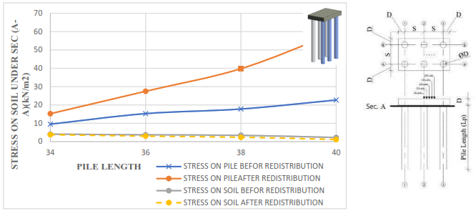
Fig. (19): the relation between stress under sec. (a-a) and pile length for soil and pile before and after redistribution of load (sp=3d, d=0.6 m)
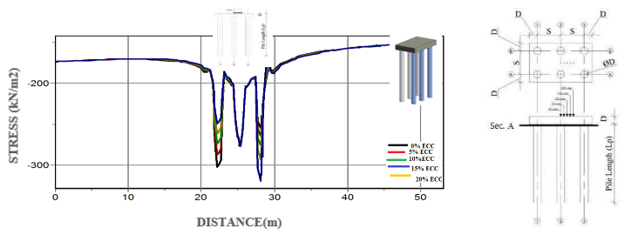
Fig. (20): the relation between stress and distance along sec (a-a) for different eccentricity at (lp=38d, sp=3d, d=0.6 m)

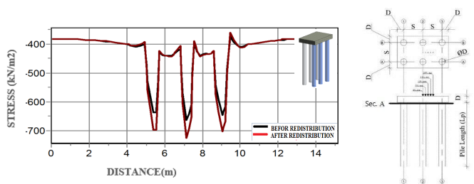
Fig. (21): the relation between stress before and after redistribution of load from soil and distance along sec (a-a) at (l_{p}=34d, s_{p}=3d, d=0.6 m and ecc=0%)

Figure (22) shows the relationship between settlement under sec. (A-A) and pile length where lp= (34D, 36D, 38D and 40D) for (D=0.6 m), various ecc. where (Ecc= 0%, 5%, 10%, 15% and 20%). from this figure, it can be shown that the settlement decreases on pile by increasing pile length And figure (23) shows the relationship between the distance and distribution of settlement under sec. (A-A) at different eccentricity in X-direction (ECC.= 0%, 5%, 10%, 15% and 20 %) for (D=0.6 m, Sp=3D and Lp= 34D) From these figures, it can be shown that increasing eccentricity in X-direction has no significant effect on settlement.
Figures from (24) to (27) show the relationship between distribution of load on pile and length among pile for different pile length under sec. (1-1), (D=0.6 m and sp= (3D).
Figures (28) shows the relationship between stress under sec. (A-A) and various ecc. where (Ecc= 0%, 5%, 10%, 15% and 20%) where Sp= (3D) for (D=0.6 m).
Figures from (29) to (31) show the relationship between load carried by piles under sec. (A-A) by end bearing and friction and various eccentricity where Sp= (3D) for (D=0.6 m) at different pile length (Lp=34D, 36 and 38D), from this figure, it can be shown that the loads transferred to soil by friction increase by increasing pile length.

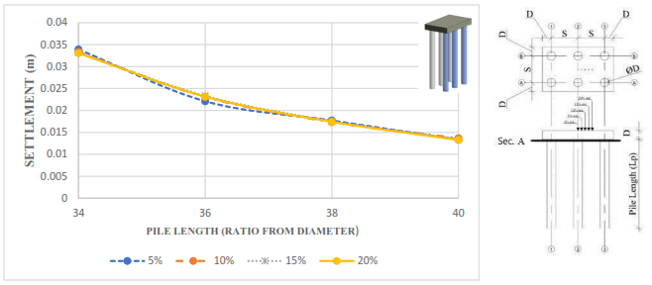
Fig. (22): The relation between settlement and pile length for different eccentricity (s_{p}=34 d, d=0.6 m)

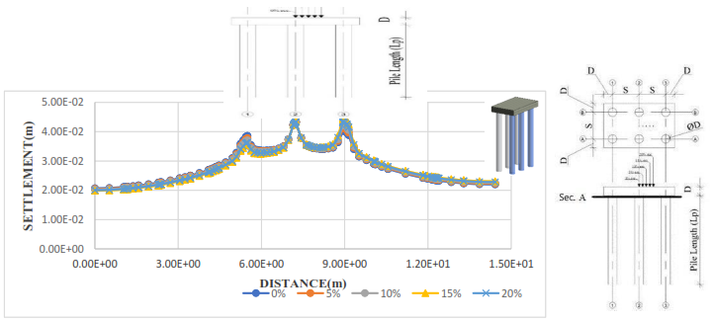
Fig. (23): the relation between settlement and distance along sec (a-a) for different eccentricity at (l_{p}=34d, s_{p}=3d, d=0.6 m)

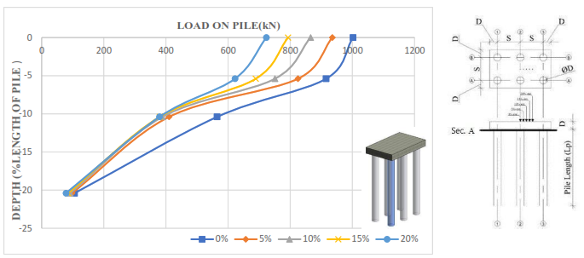
Fig. (24): the relation between load on pile under sec (1-1) and length among pile for different eccentric loads in x-direction (l_{p}=34 d, d=0.6 m and sp=3d)

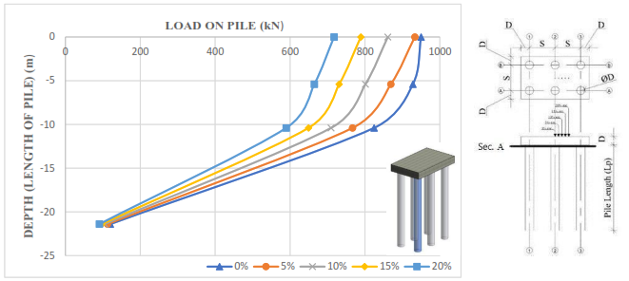
Fig. (25): the relation between load on pile under sec (1-1) and length among pile for different eccentric loads in x-direction (l_{p}=36d, d=0.6 m and sp=3d)

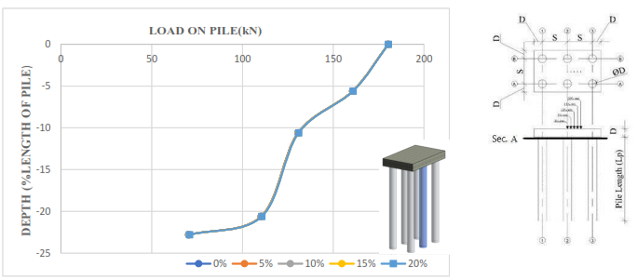
Fig. (26): the relation between load on pile under sec (2-2) and length among pile for different eccentric loads in x-direction (l_{p}=38d, d=0.6 m and sp=3d)

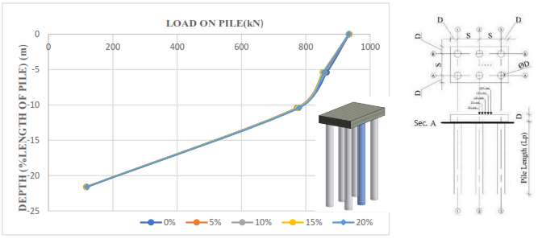
Fig. (27): the relation between load on pile under sec (2-2) and length among pile for different eccentric loads in x-direction (l_{p}=36d, d=0.6 m and sp=3d)

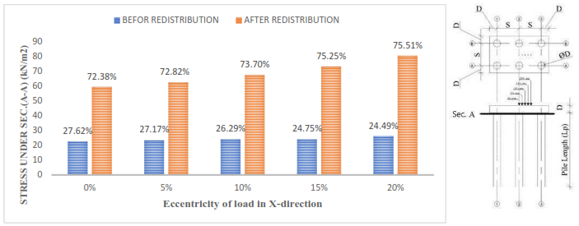
Fig. (28): comparison between max stress under sec. (a-a) before and after redistribution of load at different eccentricity in x-direction at (lp=34d, d=0.6 m and sp=3d)

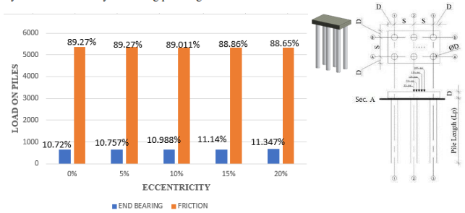
Fig. (29): comparison between load on piles carried by end bearing and friction at different eccentricity in x-direction at (lp=34d, d=0.6 m and sp=3d)

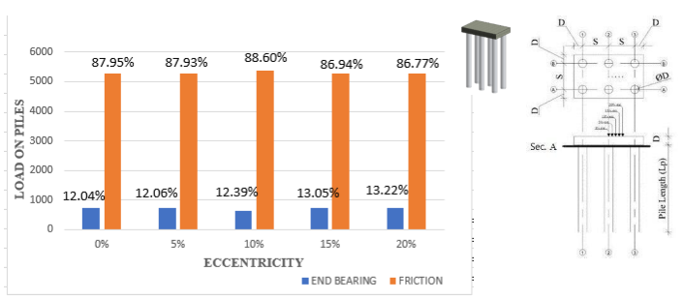
Fig. (30): comparison between load on piles carried by end bearing and friction at different eccentricity in x-direction at (lp=38d, d=0.6 m and sp=3d)

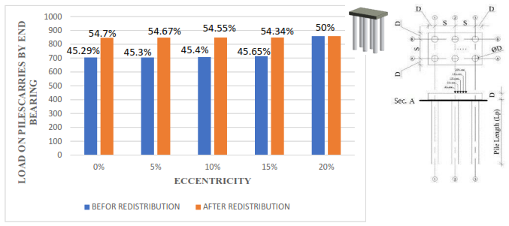
Fig. (31): comparison between load on piles carried by end bearing before and after redistribution at different eccentricity in x-direction at (lp=38d, d=0.6 m and sp=3d)

4-Conclusions:
From the present study, the followings are concluded:
- The stresses increase by increasing the pile length but at Lp≥ 38D there is no significant effect.
- The stresses increase by increasing the eccentricity in X-direction but in case of ecc. ≤ 10 % there is no significant effect.
- Increasing the eccentricity in X-direction has no significant effect by increasing pile length.
- pile length has a great effect on load sharing as increasing pile length increase load carries by pile.
- The stress under pile after redistribution of load on pile from soil increases with ratio (40% to 50%).
- The load increase by increasing the length of pile, Although, the load decrease after (65 to 70) % length among pile.
- The loads transferred to soil by friction increase by increasing pile length.
- The loads transferred to soil by end bearing decrease by increasing pile length.
- The redistribution of load on piles decrease by increasing the length of piles.

References:
- A. Juneja, Akanksha. Tyagi, and Rajendra. Bisht. (2013)."Load Sharing in Piled Raft" Research Gate proceeding of Indian Geotechnical Conference.
- December 22-24, 2013 Roorkee. UKIERI Concrete Congress - Innovations in Concrete Construction.
- Akinmusuru, J. O. (1980), Interaction of Piles and Cap in Piled Footings, ASCE, Vol. 106, No. GT 11, pp. 1263～1268.
- Clancy, P. and Randolph, M. F. (1993) An Approximate Analysis Procedure for Piled Raft Foundations, International Journal for Numerical and Analytical Methods in Geomechanics, Vol.17, No.12, pp.849.869.
- El Sawwaf, M. 2010. Experimental study of eccentrically loaded raft with connected and unconnected short piles, Journal of Geotechnical and Geo-environmental Engineering, ASCE, 136(10), pp. 1394-1402.
- Gandhi S. R and Maharaj D. K. (1996), ‘Analysis of Piled Raft Foundations’, 6th International Conference on Piling and Deep Foundations, Bombay, pp. 1.11.1-1.11.7.
- Reul, O. and Randolph, M. F. 2004. Design Strategies for Piled Rafts Subjected to Nonuniform Vertical Loading. Journal of Geotechnical and Geo environmental Engineering. ASCE. Vol. 130. No. 1. pp. 113.
- Srilakshmi, G., Chethan Gowda R K (2012) Analysis of Piled Raft Foundation by Finite Element Method, Non-Circuit Branches of the 3rd Nirma University International Conference on Engineering.
- El-Garhy, B., Galil, A. A., Abdel-Fattah A. A., Raia, M. A. (2013) Behavior of Raft on Settlement Reducing Piles: Experimental Model Study, Journal of Rock Mechanics and Geotechnical Engineering, Vol.5, pp389.399.
- Zhuang, G. M. and Lee, I. K. 1994. An Elastic Analysis of Load Distribution for Raft-Pile Systems. Finite Element Analysis and Design. Vol. 18. pp. 259- 272.

7/2/2020

