Evaluation of proximate composition and the stability of alligator pepper (Aframomum melegueta) and Ethiopian pepper (Xylopia aethiopica) extracts

Onmeje Godwin Okibe* Ajibola Victor Olatunji, Agbaji Edith Bolanle

Department of Chemistry, Faculty of Physical Science, Ahmadu Bello University, Zaria, Kaduna State, Nigeria
*Correspondence: okibego@gmail.com

Abstract: This study investigated the proximate composition and the stability of the natural food flavouring agents present in Aframomum melegueta and Xylopia aethiopica after Soxhlet extraction using: acidified ethanol; 1.5M HCl, acidified ethanol;1% citric acid, 2% citric acid, acetone and hexane. Efficiency of solvent extraction was determined and four extracts with the highest yields were studied: for stability, the (pH) was monitored for 15 days period of storage and the titratable acidity was also determined over the period. Peroxide values were determined over the period of 5weeks to monitor the shelf-life. Minor changes were observed in the peroxide values during the period of 5 weeks of storage. There was very little secondary oxidation of the extracts during storage. The nutritional potentials of these two medicinal and flavouring plants (seeds and fruits) and their extracts were evaluated through their proximate compositions. Xylopia aethiopica had a higher crude fibre (15.20%) compared with Aframomum melegueta that was 8.55% Moisture contents of Xylopia aethiopica and Aframomum melegueta were 7.35% and 7.47%, respectively. The total ash contents of Xylopia aethiopica and Aframomum meleguata were 3.70% and 3.30%, respectively. Crude lipids of Xylopia aethiopica and Aframomum melegueta were 30.80% and 8.85%, respectively while the total protein of Xylopia aethiopica and Aframomum melegueta were 4.37% and 3.75%, respectively. Total carbohydrate of Xylopia aethiopica was 38.58% and that of Aframomum melegueta was 67.80%. Alligator pepper seeds had higher titratable acidity values than Ethiopian pepper and their extracts have shown high oxidative stability over the periods of this study.
[Okibe GO, Ajibola V.O., Agbaji EB. Evaluation of proximate composition and stability of alligator pepper (Africanonum melegueta) and Ethiopian pepper (Xylopia aethiopica) extracts. N Y Sci J 2020;13(6):74-81]. ISSN 1554-0200 (print); ISSN 2375-723X (online). http://www.sciencepub.net/newyork. 9. doi:10.7537/marsnys130620.09.

Keywords: Alligator pepper, Ethiopia pepper, Aframomum melegueta, Xylopia aethiopica

- Introduction
Flavour is an important factor in the acceptability of food products and food quality can be adjudged on the basis of its flavour. People associate certain food with certain flavour (Delwiche, 2004; Oluwaniyi et al., 2009) and the flavour of food can influence its demand.
Flavourings are defined generally as products that are: not intended to be consumed as such, but are added to food in order to impart or modify odour and/or taste. Made or consisting of the following categories: flavouring substances, flavouring preparations, thermal process flavourings, smoke flavourings, flavour precursors or other flavourings or mixture thereof. There are different types of flavouring products used in food, and these are further defined as follows: ‘Flavouring substance’ means a defined chemical substance with flavouring properties. ‘Natural flavouring substance’ means a flavouring substance obtained by appropriate physical, enzymatic or microbiological process from material of vegetable, animal or microbiological origin either in the raw state or after processing for human consumption by one or more of the traditional food preparation processes (Abd El-Galeel, 2002).
Alligator pepper (Aframomum melegueta) which belongs to the family called ‘Zingiberaceae’ is a spice in the ginger family with the common name; grains of paradise. Local Names: In Bini - ehin-edo; ehie ado; in Igbo - Ose oji; in Urhobo - erhie; in Yoruba - oburo; ata; ata-ire and in Hausas-chitta mai ya’ ya’. It imparts peppery pungency and spicy aroma to classic West Africa soups. Alligator pepper is rich in essential oils that contribute to the pleasant flavour in soups (Ajaiyieoba and Ekundayo 1999). Alligator pepper is a spice that is utilized in medicine due to its antioxidant and antimicrobial properties (Adegoke et al., 2002).
The spice from this pepper is used in West Africa for the purposes of alleviating stomach ache and diarrhea (Ilic et al., 2010) as well as hypertension, tuberculosis and remedy for snake bites and scorpions (Oyedele et al, 2002; Ajaiyeoba et al., 2006). The seeds are also used for culinary reasons due to the
pungency of the seeds (Ilic et al., 2010). They also tend to have general antimicrobial properties similar to many spices (Achinewu et al., 1995) and helps in sexuality (enhances spermatogenesis) and aphrodisa (Kamtchouing et al., 2002).
The aim of this study was to evaluate the proximate composition and the stability of the natural food flavouring agents present in Aframomum melegueta and Xylopia aethiopica.

2. Materials and Methods
Two natural flavours: Alligator Pepper (Aframomum melegueta) and Ethiopia Pepper (Xylopia aethiopica) fruits and seeds were purchased from Samaru Market in Zaria metropolis. The fruits and seeds were identified at the herbarium in the Department of Biological Sciences, Ahmadu Bello University, Zaria. Both seeds and fruits were properly dried under shade and pulverized using mortar and pestle, samples were stored in an air tight bottles and kept in the locker until extractions were carried out.
2.1 Solvent extraction
Soxhlet extraction method was used; the dried and pulverized samples were weighed, 50 g of each sample was transferred into a thimble and extracted using each of the following selected solvents: ethanol acidified with 1.5M HCl (85:15, v/v), ethanol acidified with 1% citric acid. (85:15, v/v), acetone, 2% citric acid solution and hexane (Pouget et al., 1990). The following extracts were obtained:
Alligator pepper Extracts:
AA Ethanol + 1.50M HCl Extract
AB Ethanol + 1% Citric Acid Extract
AC Acetone Extract
AD 2% Citric Acid Extract
AE Hexane Extract
Ethiopia pepper Extracts:
EA Ethanol + 1.5M HCl Extract
EB Ethanol + 1% Citric Acid Extract
EC Acetone
ED 2%Citric Acid Extract
EE Hexane Extract.
Heating mantle was used as the source of heat and the extract obtained from each was concentrated using a rotary evaporator into completely or partially purified forms and allowed to dry in a desiccator.
2.2 Solvent Efficiency
Five millilitres (5 ml) volume of the filtered extract was diluted to 100 ml with the extracting solvent. The colour intensity was measured at 520 nm for water and citric acid solution extracts and 535 nm for acidified ethanol using spectrophotometer while acetone and hexane were measured at 330 nm and 220 nm respectively. The total content was calculated using the following equation:
Total pigment
(Du and Francis, 1973).
2.3 Determination of Stability of the Flavouring Agent with Time
A dilute solution of four extracts with appreciable yield (10 ml in 250 ml of distilled water) were prepared and the stability of the flavouring agents of the extracts was monitored by measuring the _{P}H at ambient temperature (27ºC) for 15 days at 24 hours intervals. The titratable acidity was also determined by titrating 10 ml of each sample with 0.1 M NaOH solution using 1% phenolphthalein indicator. The titration was carried out on daily basis for a period of 15 days. The acid values were calculated using this equation
Where V is the volume of sodium hydroxide (NaOH) solution used in (ml), M is the exact molarity and m is the mass in grams of the sample extract diluted (Saad et al., 2007).
2.4 Determination of Oxidative Stability
This was carried out as described by AOCS (1992).10 ml of the diluted extract was transferred into a 250 ml conical flasks using pipette, 10 ml acetic acid/chloroform mixture (3:2, v/v) was added and stirred for 2 minutes, 1 ml of saturated KI solution added into the solution and then stirred for another 2 minutes. The solution was heated and titrated with 0.10 M sodium thiosulphate, using a starch solution as indicator. A blank test was also conducted. The peroxide values were calculated using the equation 3.3 for the period of 5 weeks of storage after dilution. (Note: titrations were carried out on weekly basis)
PV (meq/kg)
where S and B are the volumes of sodium thiosulphate solution consumed by sample and blank tests, respectively, M is the standardized molarity of sodium thiosulphate and W is the weight of sample (g) (Alhassane et al., 2007).
2.5 Proximate Analysis
Proximate analysis was carried out to check the nutritional values as described by the method of AOCS (1990).
2.6 Moisture content determination
Moisture content was determined by weighing 1.5 g of each sample, oven dried at a controlled temperature, 80ºC for four days. The loss in weight due to loss of moisture is calculated as a percentage of original weight of sample. This gives the percentage moisture content of the sample (Aremu et al., 2006).

2.7 Percentage crude ash determination
Percentage crude ash was determined by igniting 1.5 g of each of the samples in a crucible inside a muffled furnace at a temperature of 600ºC. The ashing was terminated on formation of the white ash from the sample. The ash was cooled in a desiccator for two hours and weighed. The weight after ashing was expressed as a percentage of the sample weight before ashing and this gives the percentage crude ash of the samples.

2.8 Crude protein determination
Crude protein content was estimated by Kjeldahl method. 5 g of each sample was digested with a concentrated sulphuric acid (H₂SO₄) using lithium sulphate as a catalyst. Digestion converted any nitrogen in the food (other than that which was in the form of nitrates or nitrites) into ammonia, and other organic matter to CO₂ and H₂O. Ammonia gas was not liberated in an acid solution because the ammonia was in the form of the ammonium ion (NH₄⁺) which bonded to the sulphate ion (SO₄²⁻) and thus remained in solution:
N (sample) (NH₄)₂SO₄
After the digestion has been completed the digestion flask was connected to a receiving flask by a tube. The solution in the digestion flask was then made alkaline by addition of sodium hydroxide, which converted the ammonium sulphate into ammonia gas:
(NH₄)₂SO₄ + 2 NaOH 2NH₃ + 2H₂O + Na₂SO₄
The ammonia gas that was formed was liberated from the solution and moved out of the digestion flask and into the receiving flask - which contained an excess of boric acid. The low pH of the solution in the receiving flask converted the ammonia gas into the ammonium ion, and simultaneously converted the boric acid to the borate ion:
NH₃ + H₃BO₃ (boric acid) NH₄⁺ + H₂BO₃⁻ (borate ion)
The nitrogen content was then estimated by titration of the ammonium borate formed with hydrochloric acid, using a suitable indicator to determine the end-point of the reaction.
H₂BO₃⁻ + H⁺ H₃BO₃
The concentration of hydrogen ions (in moles) required to reach the end-point was equivalent to the concentration of nitrogen that was in the original food (Equation 3.8). The following equation was used to determine the nitrogen concentration of the sample that was weighed using 1.5 M HCl acid solution for the titration: (Conklin-Brittain et al., 1999).

Where v_{s} and v_{b} are the titration volumes of the sample and blank, and 14 g is the molecular weight of nitrogen N. A blank sample was run at the same time as the material being analysed to take into account any residual nitrogen which may be in the reagents used to carry out the analysis. The nitrogen content determined was converted to a protein content using the appropriate conversion factor: 6.25. Because the Kjeldahl method does not measure the protein content directly a conversion factor (F) is needed to convert the measured nitrogen concentration to a protein concentration. A conversion factor of 6.25 (equivalent to 0.16 g nitrogen per gram of protein) is used for many applications, however, this is only an average value (Conklin-Brittain et al., 1999).

3. Results

Table 1: Proximate Analysis of Flavourant Samples for Alligator Pepper
Flavourant samples | Proximate composition (%)
 | Moisture | Ash | Crude lipid | Crude protein | Crude fibre | Carbohydrate
Seeds | 7.47 | 3.30 | 8.85 | 8.85 | 3.75 | 67.80
AA | 1.13 | 0.67 | 3.03 | 1.04 | 0.00 | 49.72
AB | 0.75 | 0.13 | 1.52 | 0.16 | 0.00 | 33.71
AC | 0.55 | 0.83 | 3.27 | 1.25 | 0.00 | 38.63
AD | 0.89 | 0.12 | 1.80 | 0.08 | 0.00 | 28.28
AE | 0.81 | 0.12 | 2.20 | 0.10 | 0.00 | 31.5
(AA Ethanol + 1.50M HCl Extract; AB Ethanol + 1% Citric Acid Extract; AC Acetone Extract; AD 2% Citric Acid Extract; AE Hexane Extract)

The result for proximate analysis for Alligator pepper and its extracts is shown on Table 2 and indicates the nutritional values of the seeds and the extracts obtained. The result for proximate analysis for Ethiopia pepper and its extracts is shown on Table 3 and indicates the nutritional values of the fruits and the extracts obtained. The result for solvent efficiency for extraction is given in Figure 1. The Figure indicates the solvent efficiency for the various solvents used to carry out the extraction, with AA and EA having the highest followed by EC and AC. The result for the variation for the pH stability for flavourant sample is given in Figure 2 indicates the extracts (AA, AC, EA and AC) studied for the period of fifteen days at ambient temperature. Figure 3 shows the titratable acidity of the various extracts studied with time. These variations are indicated by the curve pattern AA, AC, EA and EC.
The result for the variation for weekly peroxide value of flavourant for Alligator and Ethiopia pepper is given in Figure 4. This indicates the weekly peroxide values for the four extracts studied for the period of five weeks. The curve pattern indicates the variation observed.

Table 2: Proximate Analysis of Flavourant Samples for Ethiopian Pepper
Flavourant samples | Proximate composition (%)
 | Moisture | Ash | Crude lipid | Crude protein | Crude fibre | Carbohydrate
Fruits | 7.35 | 3.70 | 25.80 | 9.37 | 15.20 | 38.58
EA | 1.51 | 0.13 | 10.04 | 1.16 | 0.00 | 26.26
EB | 1.12 | 0.08 | 7.98 | 0.45 | 0.00 | 17.87
EC | 1.30 | 0.27 | 8.68 | 1.36 | 0.00 | 24.84
ED | 0.59 | 0.05 | 6.68 | 0.13 | 0.00 | 21.85
EE | 0.87 | 0.20 | 7.70 | 0.54 | 0.00 | 16.32
(EA Ethanol + 1.5M HCl Extract; EB Ethanol + 1% Citric Acid Extract; EC Acetone ED 2%Citric Acid Extract; EE Hexane Extract)

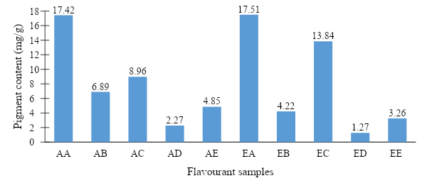
Figure 1: Efficiency of Solvent Extraction
(Alligator pepper= AA: Ethanol + 1.5 M HCl Extract; AC: Acetone Extract)
(Ethiopian Pepper= EA: Ethanol + 1.5M HCl Extract; EC: Acetone Extract)

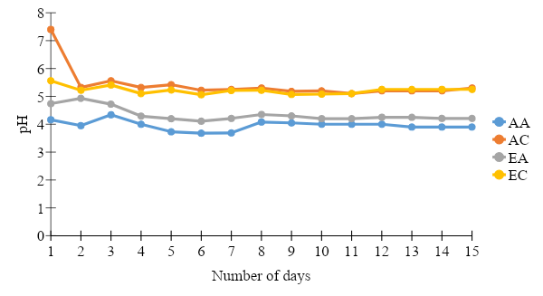
Figure 2: Variation for the pH Stability for Flavourant Samples
(Alligator pepper= AA: Ethanol + 1.5 M HCl Extract; AC: Acetone Extract)
(Ethiopian Pepper= EA: Ethanol + 1.5M HCl Extract; EC: Acetone Extract)

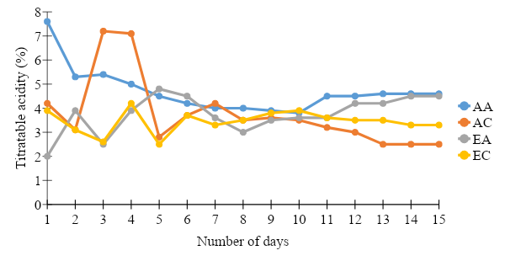
Figure 3: Variation for Titratable Acidity of Flavourant Samples
(Alligator pepper= AA: Ethanol + 1.5 M HCl Extract; AC: Acetone Extract)
(Ethiopian Pepper= EA: Ethanol + 1.5M HCl Extract; EC: Acetone Extract)

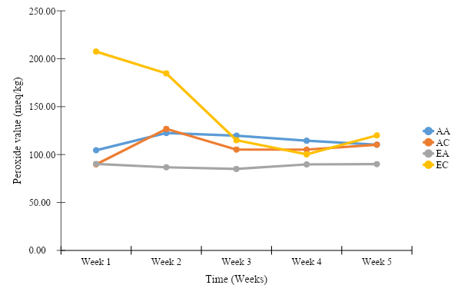
Figure 4: Variation for weekly peroxide value of Flavourant for Alligator and Ethiopian pepper.
(Alligator pepper= AA: Ethanol + 1.5 M HCl Extract; AC: Acetone Extract)
(Ethiopian Pepper= EA: Ethanol + 1.5M HCl Extract; EC: Acetone Extract)

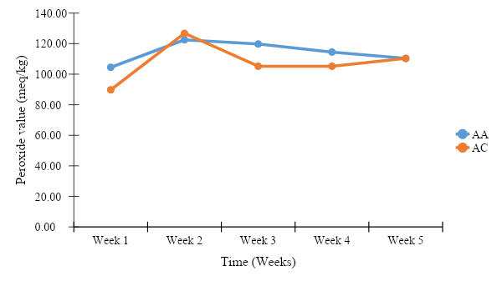
Figure 5: Variation of Peroxide Values for Alligator pepper
(AA: Ethanol + 1.5 M HCl Extract; AC: Acetone Extract)

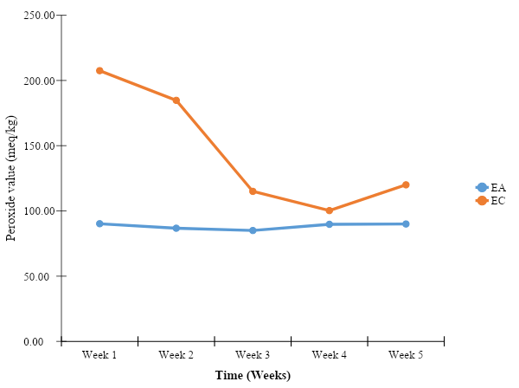
Figure 6: Variation of Peroxide Values for Ethiopia pepper
(Ethiopia Pepper: EA Ethanol + 1.5M HCl Extract; EC Acetone Extract)

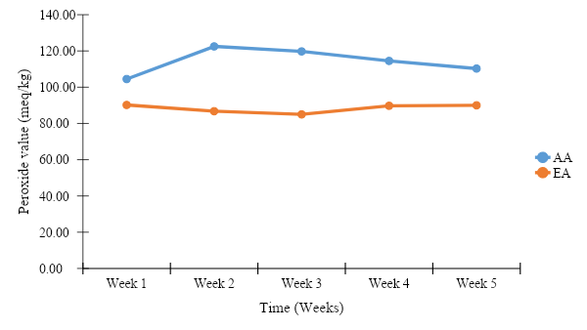
Figure 7: Variation of Peroxide Values for Alligator and Ethiopia pepper
(AA Ethanol + 1.5 M HCl Extract Alligator Pepper; EA Ethanol + 1.5M HCl Extract Ethiopia Pepper)

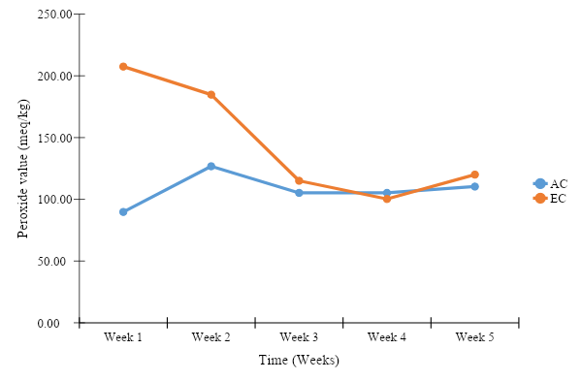
Figure 8: Variation of Peroxide values for Alligator and Ethiopia pepper using the same solvent (Acetone)
(AC: Acetone Extract Alligator Pepper; EC: Acetone Extract Ethiopia Pepper)

Table 3: Correlation between Titratable Acidity and pH of the test samples
 | AApH | ACpH | EApH | ECpH | AATA | ACTA | EATA | ECTA
AApH | 1
ACpH | 0.3760 | 1
EApH | 0.5887 | 0.5356 | 1
ECpH | 0.4641 | 0.7846 | 0.6112 | 1
AATA | 0.4540 | 0.9015 | 0.6996 | 0.8124 | 1
ACTA | 0.4900 | 0.1898 | 0.3257 | 0.1406 | 0.2794 | 1
EATA | -0.7600 | -0.6537 | -0.6082 | -0.5516 | -0.5573 | -0.5089 | 1
ECTA | 0.0600 | 0.1373 | -0.2271 | -0.3293 | 0.0265 | 0.0887 | -0.1673 | 1
Values presented in tables are correlation (R) values.

The correlation between titratable acidity and pH of the test samples is given on Table 3 and it indicates very low positive and negative correlations. Figure 5 shows the variation of peroxide values for Alligator pepper. The two extracts were from the same pepper and the variation between them are shown by the curve pattern. Figure 6 shows the variation of peroxide values for Ethiopia pepper. The two extracts were from the same pepper and the variation between them are shown by the curve pattern. The result of variation of peroxide values for Alligator and Ethiopia pepper using the same solvent is given in Figure 7. The two extracts (AA and EA) were from different pepper and the variation between them are shown by the curve pattern.
The result of variation of peroxide values for Alligator and Ethiopia pepper using the same solvent (Acetone) is given in Figure 8. The two extracts (AC and EC) were from different pepper and the variation between them are shown by the curve pattern.

4. Discussion
4.1 Titratable acidity and pH Stability
The results obtained for the pH values of the samples showed that the pH for all samples are relatively stable i.e. the solutions became more slightly acidic as the time progressed (Figure 2). A sharp increase was observed after 24 hours for EC and AC. AA and EA had similar pH values from day to day and the values ranged between 4.2 and 5.6. The results of titratable acidity are shown in Figure 3. After 24 hours, the titratable acidity of AA decreased up to 10th day and became relatively stable from 11th day to the 15th day. Low acidity values were observed in AC, in general, all the four samples showed a similar relationship; they tend to be stable from day 9 to 15. Samples with high pH values had low titratable acidity and as the pH increased, the acidity decreased. AC with the highest pH values also had the least titratable acidity values.
This study has shown that the flavouring agents of these two peppers were relatively stable during the period of study. From day seven (7) pH stability was observed up to the fifteenth day of storage as shown on Figure 2 and from day eight (8) that of acidity was observed as indicated in Figure 3. This observation agrees with research that percentage total titratable acidity and pH are inversely related (Egbere et al., 2007; Nwafor and Ikenebomeh, 2009).
The test of correlation between titratable acidity of AA and its corresponding pH showed that there was positive correlation (r = 0.4540) between the titratable acidity and pH though the correlation was not statistically significant. Similarly, there was positive correlation (0.1898) between the pH of AC and its titratable acidity but the relationship was not significant.
The pH of EA on the other hand showed a significantly strong negative correlation (-0.6082) with its corresponding titratable acidity; this implies that as the pH value of EA increases, the titratable acidity decreases. Also, there was a negative correlation (-0.3293) between the pH of EC and its titratable acidity. Unlike the EA, the correlation between pH and titratable acidity of EC was weak and insignificant (Table 1).
4.2 Oxidative Stability
The research work was conducted to determine the extent of oxidative deterioration of selected sample extracts under light and ambient temperature condition. The results revealed that oxidation of flavouring agents decreased with increasing storage period up to five weeks of storage. Natural antioxidants decreased the peroxide value in the extracts studied and this supports the findings that these peppers’ extracts are used as preservatives in food industries. The initial peroxide value in sample AA was 105.00 meq kg⁻¹ and in sample AC was 90.00 meq kg⁻¹. At the expiry of the 5th week experimental period, the peroxide values increased from week one to three and then decreased in week four and five:105.00,123.00,120.00,115.00 and 110.00 meq kg⁻¹ for AA and increased slightly in AC from week two through week five: 90.00,127.00,105.00,105.00 and110.00 meq kg⁻¹ as indicated in figure 4.4. This showed there was no significant deterioration of the flavouring agents in the samples.
The same trend was observed for samples EA and EC in peroxide values: 115.00, 90.00, 87.00, 85.00, 90.00, 90.00 meq kg⁻¹ and 110.00, 210.00, 185.00, 115.00, 100.00, 120.00 meq kg⁻¹ respectively. The flavouring agents in the two plants have high oxidative stability, hence an appreciable shelf-life during storage.
4.3 Proximate Analysis
The result of nutritional composition shows that alligator pepper and Ethiopia pepper have similar moisture content, both peppers have a significant amount of protein content 4.37% and 3.75% respectively. The same trend was also observed in their ash content, 3.70% and 3.30%. The protein and ash content of alligator pepper is similar to the values reported by (Odebunmi et al., 2008).
This work is aimed at using the proximate analysis as well as the percentage compositions of some mineral elements to assess the nutritional potentials of the plant parts in relation to the different purposes they are meant for. From the results obtained, Xylopia aethiopica and Aframomum meleguata are high in the amount of total carbohydrate and this is beneficial since carbohydrate constitutes a major class of naturally occurring organic compounds that are essential for the maintenance of plant and animal life and also provide raw materials for many industries (Ebun-Oluwa and Alade, 2007). Xylopia aethiopica is also high in percentage compositions of total fat and crude fibre. Because of the high contents of total carbohydrate, total fat and crude fibre contents of Xylopia aethiopica, it was particularly recommended to women who have newly given birth as a tonic in Ivory Coast (Burkill, 1985). The total fat in Xylopia aethiopica if further analysed may contain essential fatty acids as well as vitamins. Nutritionally, this is of beneficial effect since it had been reported that food fibre aids absorption of trace elements in the gut and reduce absorption of cholesterol (Le Veille and Sanberlich, 1966).
The various extracts of these peppers have shown a significant nutritional values as well as the seeds and fruits. The high amount of lipid observed in Ethiopia pepper and its various extracts may be due to the fruits unlike alligator pepper which only the seeds were used.
The nutrient composition of Xylopia aethiopica fruits differs relatively from what has been reported by other researchers. Abolaji et al. (2007) had earlier reported 2.10±0.25 % protein, 9.55±2.10 % fat and 12.14±0.70% ash in the fruits of Xylopia aethiopica. Another worker also reported 55.80±4.26% carbohydrate, 7.20% crude fat and 10.00 % ash by weight of dried powdered sample of Xylopia aethiopica and 9.00% crude protein. The findings of Abolaji et al. (2007) are quite different from what is being reported in this present study. The varying composition reported by various researchers may imply that the nutrient composition of these peppers vary with season, environment and/or condition or time of evaluation.
Natural antioxidants are found in many fruits and vegetables, which include ascorbic acids, ∝-tocopherole, β-carotene, chlorogenic acids and flavonols. Consumers are becoming increasingly conscious of the nutritional value and safety of their food and its ingredients. Natural antioxidants are believed to be safer than artificial ones (Papadoulos et al, 1991; Tian and White, 1999). It is hoped that the findings will help a lot to the vegetable oil and ghee industries as well as oil seed growers. Therefore, the present study was carried out to determine the extent of deterioration of flavouring agents in Alligator pepper and Ethiopia pepper under ambient temperature.

5. Conclusion
This study has drawn attention to the stability of the flavourants, with particular attention on the acidity of the Alligator pepper as indicated by AA and AC which may make it unsuitable for individuals with a history or tendency of stomach or peptic ulcer. From this research, Ethiopia pepper may be preferred to be used by individuals with the above mentioned health challenges. However, it can be concluded that when considering bio-assimilation, bio-digestibility and easy elimination, both peppers are preferred over the synthetic ones. The higher presence of nutrients and antioxidants in the natural flavours also support their choice over synthetic flavours. Therefore, depending on the usage target or goal, any of the peppers can be used. Based on the nutritional analysis carried out and the elemental analysis, these two peppers can serve as good food supplements and they can be used to produce peppery flavours with an appreciable shelf-life.

Corresponding Author:
Mr. Onmeje Godwin Okibe
Department of Chemistry,
Ahmadu Bello University,
Zaria, 810107, Kaduna State, Nigeria
Telephone: +234 (0) 801-0161-6867
E-mail: okibego@gmail.com

References
- Abd-El-Galeel, M.A.S. (2002). Solubility and stability of natural food colourants in microemulsions. Ph.D. Thesis. Rheinschen Friedrich-Wilhelms-Universitat zu Bonn, 114: 941–50.
- Abolaji, A.O., Adebayo, A.H. and Odesanmi, O.S. (2007). Effects of ethanolic fruit extract of Parinari polyandra (Rosaceae) on serum lipid profile and some electrolytes in pregnant rabbits. Research Journal of Medicinal Plant, 1: 121-127.
- Achinewu, S.C., Aniena, M.I. and Obomanu, F.G. (1995). Studies on spices of food value in the South eastern states of Nigeria 1: Antioxidants Properties. Journal of African Medecinal Plants, 18:135-139.
- Adegoke, G.O., Gbadamosi, R., Evwerhurhoma, F., Uzo–Peters, P.I., Moody, O. and Skura, B. (2002). Protection of maize (Zeamays) and soybeans (Glycine max) using Aframomum danielli. European Journal of Food Research and Technology, 5: 408-411.
- Ajaiyeoba, E.O., Ogbole, O.O. and Ogundipe, O.O. (2006). Ethnobotanical survey of Plants used in the traditional management of viral infections in Ogun State of Nigeria. European Journal of Scientific Research, 13(1):64–73.
- Ajaiyieoba, O.E and Ekundayo, O. (1999). Essential oil constituents of Aframomum melegueta (Roscoe) K. Schum. Seeds (alligator pepper) from Nigeria. Flavour and Fragrance Journal, 14(2): 109-111.
- AOCS. (1990). Official methods and recommended practices of the American Oil Chemists´ Society. 4th ed. Champaign, USA, AOCS. [AOCS Official method Cd 8-53].
- AOCS. (1992). Official methods and recommended practices of the American Oil Chemists´ Society. 4th ed. Champaign, USA, AOCS. [AOCS Official method Ca 5a-40].
- Aremu, M.O., Olaofe, O. and Akintayo, E.T. (2006). Compositional evaluation of cowpea (Vigna unguiculata) and scarlet runner bean (Phaseolus coccineus) varieties grown in Nigeria. Journal of Food Agriculture and Environment, 4: 39-43.
- Burkill, H.M., (1985). The useful plants of West Africa, Royal Botanical Gardens, 1: 11-20.
- Conklin-Brittain, N. L., Dierenfeld, E. S., Wrangham, R. W., Norconk, M. and Silver, S. C. (1999). Chemical protein analysis: A comparison of Kjeldahl crude protein and total ninhydrin protein from wild, tropical vegetation. Journal of Chemical Ecology, 25:2601–2622.
- Delwiche, J. (2004). The impact of perceptual interactions on perceived flavour. Food Quality and Preference, 15: 137-146.
- Du, C.T. and Francis, F.J. (1973). Anthocyanins of Roselle (Hibiscus sabdariffa). Journal of Food Science, 38(5):818-812.
- Ebun-Oluwa, P.O. and Alade, A.S. (2007). Nutritional potential of Berlandier Nettle spurge (Jatropha cathatica) seed. Pakistan Journal of Nutrition, 6: 345-348.
- Egbere, O.J., Anuonye, J.C., Chollom, P.F. and Okpara, P.V. (2007). Effects of some preservation techniques on the quality and Storage stability of zobo drink (A Nigerian, non-alcoholic beverage from Hibiscus sabdariffa. Journal of Food Technology 5(3):225 – 228.
- Ilic, I., Milic, I. and Arandjelovic, M. (2010). Procena kvaliteta, ivota-sadašnji pristupi. Acta Medical Medianae, 49(4):52-60.
- Le Veille, G. and Sanberlich, H.E. (1966). Mechanism of the cholesterol-dressing effect of pectin in the cholesterol fed rat. Journal of Nutrition, 209-214.
- Kamtchouing, P., Fandio, G.Y.M., Dimo, T. and Jatsa, H.B. (2002). Evaluation of androgenic activity of Zingiber officinale and Pentadiplandra brazzeana in male rats. Asian Journal of Andrology, 4: 299-301.
- Nwafor, O. E. and Ikenebomeh, M. J. (2009b). Effect of Different Packaging Materials on Microbiological Physicochemical and Organoleptic Quality of Zobo Drink Stored at Room Temperature. African Journal of Health Technology, 8(12):2848 – 2852.
- Odebunmi, E. O., Oluwaniyi, O. O., Awolola, G.V. and Adediji, O. D. (2008). Proximate and nutritional composition of kola nut (Colanitida), bitter cola (Garcinia cola) and alligator pepper (Aframomum melegueta) African Journal of Biotechnology, 8 (2): 308-310.
- Oluwaniyi, O.O., Dosumu, O.O., Awolola, G.V. and Abdulraheed, A.F. (2009). Nutritional Analysis and Stability Studies of Some Natural and Synthetic Food Colourants. American Journal of Food Technology, 4(5):218-225.
- Oyedele, A.O., Gbolade, A.A., Sosan, M.B., Adewoyin, F.B., Soyelu, O.L and Orafidiya, O.O. (2002). Formulation of an effective mosquito-repellent topical product from Lemongrass oil, Phytomedicine, 9:259-262.
- Papadopoulos, L.S., Miller, R.K., Ringer, L.J. and Cross, H.R. (1991). Sodium lactate effect on sensory characteristics, cooked meat colour and chemical composition. Journal of Food Science, 56(3): 621-635.
- Pouget, M.P., Vennat, B. and Lejeune, B. (1990). Identification of anthocyanins of Hibiscus Sabdariffa L. Lebensmittel-Wissenschaft and Technologie, 23: 101-102.
- Saad, B., Gachet, M.S and Tameen, A.A. (2007). Determination of free fatty acids in palm oil samples using non-aqueous flow injection titrimetric method. Journal of Food Chemistry, 102: 1407-1414.
- Tian, L.L. and White, P.J. (1999). Antioxidant activity of oat extracts in soybean and cottonseed oils. Journal of American Oil Chemical Society, 71: 1079-1086.

6/25/2020

