Evaluation of Pathogenic and Opportunistic Pathogenic Microorganisms among Different Public Environmental Areas in Makkah City (Kingdom of Saudi Arabia) Before and After Ramadan and Hajj months

Hamdi M. Al-Said, Ayman Johargy

Department of Medical Microbiology, Faculty of Medicine, Umm Al-Qura University, Makkah –Saudi Arabia
hamdimustafa1@gmail.com, hmibrahim@uqu.edu.sa

Abstract: An investigation concerned isolation and identification of pathogenic and potential pathogenic bacteria and fungi in and out the Holy Mosque in Mecca. A total of 728 samples resulted in isolation of 213 fungal and bacterial species during four months (Ramadan, Shawwal, Zo-Alheja and Safar). Alcaligenes faecalis and Acinetobacter baumannii the most common pathogenic bacteria isolated inside the Holy Mosque while, Alcaligenes faecalis and Pantoea spp. were the most common bacteria isolated from outside.
[Hamdi M. Al-Said, Ayman Johargy. Evaluation of Pathogenic and Opportunistic Pathogenic Microorganisms among Different Public Environmental Areas in Makkah City (Kingdom of Saudi Arabia) Before and After Ramadan and Hajj months. N Y Sci J 2020;13(4):1-8]. ISSN 1554-0200 (print); ISSN 2375-723X (online). http://www.sciencepub.net/newyork. 1. doi:10.7537/marsnys130420.01.

Keywords: The Holy Mosque, pathogenic bacteria, isolated.

Introduction
Saudi Arabia is the world's leading islamic country which has an estimated population of 27.6 million including an estimated 5,576,076 resident foreigners with different nationalities and hygienic practices. In addition, millions of Muslims peoples like to come each year to Makkah during Umrah and Hajj seasons to perform Umrah rituals (month of Ramadan usually shows the highest peak of crowding) and Hajj (month of Zo-Alheja usually shows the highest peak of crowding)¹. Therefore, the congregation of so many people during Umrah and Hajj seasons from different parts of the world in unavoidably overcrowded conditions within a confined area for a defined period of time presents many public health challenges, and health risks are greatly increased, with potential for both local and international consequences. One of the main health problems correlated with these two seasons crowding is respiratory tract, meningitis and gastrointestinal infections due to its ease of transmission by air droplets, fecal oral route and close contact. These infections can be transmitted from infected people and more significantly from contaminated areas by a pathogenic or opportunistic pathogenic bacterium and fungi². Most people do not realize that microbes are found on many common objects outdoors, in their offices, and even in their homes. Such objects include; playground equipment, ATM keyboards, kitchen sinks, office desks, computer keyboards, escalator handrails, elevator buttons and with the spread of supermarkets and hypermarkets the shopping carts handles. All of the latter objects are places that are most touched by the bare hands of people who are in various hygienic conditions^{3,4}. People believe that microbes are only present in research labs or in hospitals and clinics and thus they have a misleading feeling of security in other places. Lack of knowledge about where germs prowl could be the cause of health problems. In fact, 80% of infections are spread through hand contact with hands or other objects^{5,6,7}. Reynolds et al.⁵ used an invisible fluorescent tracer for artificial contamination of public surfaces, they found that contamination from outside surfaces was transferred to 86% of exposed individual's hands and 82% tracked the tracer to their home or personal belongings hours later. The viability of Gram-positive and some Gram negative organisms under various environmental have conditions been described⁸. Some microbes are infectious at very low doses and can survive for hours to weeks on nonporous surfaces, such as countertops and telephone hand pieces⁵. Enterococci have been found to survive in dry conditions and on various fabrics utilized in the health care environment. Infectious doses of pathogens may be transferred to the mouth after handling an everyday contaminated household object⁹. Ulger et al.¹⁰ have demonstrated that health care workers' hands and mobile phones were contaminated with various types of microorganisms and concluded that mobile phones used in daily practice may be a source of nosocomial infections in hospitals.

In a study carried out in the United State of America by Kelly Reynolds, a microbiologist in the University of Arizona, she tested 30 trolleys at nine supermarkets to estimate the presence of bacteria and fungi in a qualitative and a quantitative matter. Trolleys with young children in them, were swabbed on the area’s most likely touched, like the handles and areas around the seats. The swabs were then cultured and bacteria and fungi were identified. Surprisingly several types of pathogenic bacteria and fungus that could cause disease, especially in immune compromised people were isolated. The most serious bacteria found was enteroccocus facaelis, indicating the presence of fecal matter. In addition bodily fluids like blood, mucus and saliva were also found in the shopping trolleys. The study reported that the shopping trolleys were even dirtier than public bathrooms¹¹. Scientific information about the occurrence of bacteria on various objects outside the health care facilities is very little and needs to be enriched in order to educate people on the necessity of improving the habit of hand washing to reduce microbial transmission.

Materilis And Methods
Period of the study
This study was conducted in several areas inside and surrounding the Holy Mosque of Haram in Mecca. A total of 728 samples were taken from these areas over a period of four months (Ramadan, Shawwal, Zo-Alheja and Safar) in the years 1431 and 1432 Hijra.
Collection of specimens
Samples were collected before and after disinfection with Dettol disinfectant solution from the following sites; shopping trolleys handles, inner surfaces and baby seats in Bin dawood supermarket in the Holy Mosque of Haram area. Escalator handholds inside and outside of the Holy Mosque of Haram area. ATM card slots and buttons in the vicinity of the Holy Mosque of Haram. Front of toilets floor, door handles, toilet seats, and hand-held shower sprayers in the Holy Mosque of Haram vicinity. Zam Zam water buttons located inside and outside of the Holy Mosque of Haram. These samples were retrieved using sterile cotton swabs soaked in sterile peptone water. Samples were placed in Amies transport medium for the preservation of the viability of microbial organisms until they were cultured in the proper media for testing. Collection of these samples was carried out, in four stages during the previously mentioned months with an average of 182 samples collected per month.
Transportation of the specimens
All samples were collected on Amies transport swabs media and transported to the microbiology research laboratory at the Faculty of Medicine of Umm Al-Qura University without any delay.
Cultivation of specimens
All samples were tested in the microbiology research laboratory according to the standard microbiological methods under complete aseptic conditions. All collected swabs were inoculated on MacConkey agar, blood agar, bile esculin agar and Sabouraud dextrose agar and incubated at 37ºC under aerobic conditions.
Isolation and identification of bacteria
All bacteria were isolated and identified according to the conventional microbiological methods. Enterococcus faecails was isolated from bile esculin agar after an overnight incubation as a blackening around the colony. The identification was confirmed microscopically by the characteristic appearance as Gram positive cocci in short chains after being stained by Gram stain; catalase test was also performed in which the organism is characteristic negative. Staphylococcus was isolated from blood agar after an overnight incubation. The identification was confirmed microscopically by the characteristic appearance as Gram positive cocci in clusters after being stained by Gram stain. Catalase test was also performed to differentiate between Staphylococcus (catalase positive) and Streptococcus (catalase negative) then coagulase test was also performed to differentiate between Staphylococcus aureus (coagulase positive) and Staphylococcus spp. (coagulase negative).
Lactose fermenter colonies were isolated from MacConkey agar after an overnight incubation as pink colonies. The identification was confirmed microscopically by the characteristic appearance as Gram negative bacilli. Non – lactose fermenter colonies were isolated from MacConkey agar after an overnight incubation as pale yellow colonies. The identification was confirmed microscopically by the characteristic appearance as Gram negative bacilli. All Gram negative and positive bacteria isolates were then confirmed using VITEK II systems compact 15 "biomatrix", used as an automated identification.
Storage of isolated and identified bacteria
All isolated and identified bacteria were then preserved at –86ºC in an Eppendorf tubes containing 1ml trypticase soy broth with 16% glycerol for further confirmation by VITEK II machine.
Identification of bacteria using VITEK II Machine
Preserved bacteria were sub cultured on the suitable media and incubated accordingly to obtain a pure culture. About 3.0 ml of sterile saline (aqueous 0.45% NaCL, pH7.0) was placed into a clear plastic test tube, then sufficient number of pure bacterial colonies were transferred to the tube containing the saline to make a homogenous suspension with an equivalent density of McFarland (No. 0.50 to 0.63) using calibrated VITEK II DENSICHEK. The tube was then placed in the cassette with the identification card and data entry. Gram negative identification card (GN) and Gram-positive identification card (GP) are based on 43 biochemical tests measured carbon source utilization Enzymatic activities and resistance.
Isolation and identification of fungi
Fungi were isolated from Sabouraud dextrose agar plates after several days of incubation as filamentous fungi. The identification was confirmed by colonial morphology, surface color, texture and rate of growth, as well as microscopic examination "Tease mount preparation'' using lacto phenol cotton blue (LPCB) for checking the presence of conidia and hyphae.

Results
Number of bacteria and fungi isolated in Ramadan month of 1431h year
Figure (1) shows the number of bacteria and fungi isolated in Ramadan month of 1431h year. In total 63 bacterial and fungal isolates were isolated before disinfection and these were reduced to 18 after disinfecting the places of collection by Dettol.

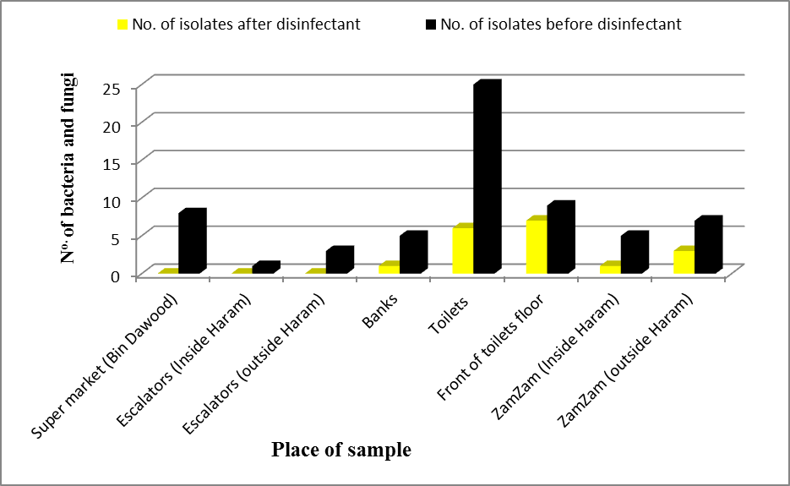
Fig. (1): Number of bacteria and fungi isolated in Ramadan month of 1431h year

Number of bacteria and fungi isolated in Shawwal month of 1431h year
Figure (2) shows the number of bacteria and fungi isolated in Shawwal month of 1431h year. In total 49 bacterial and fungal isolates were isolated before disinfection and there were no bacterial or fungal isolates isolated after disinfecting the places of collection by Dettol.

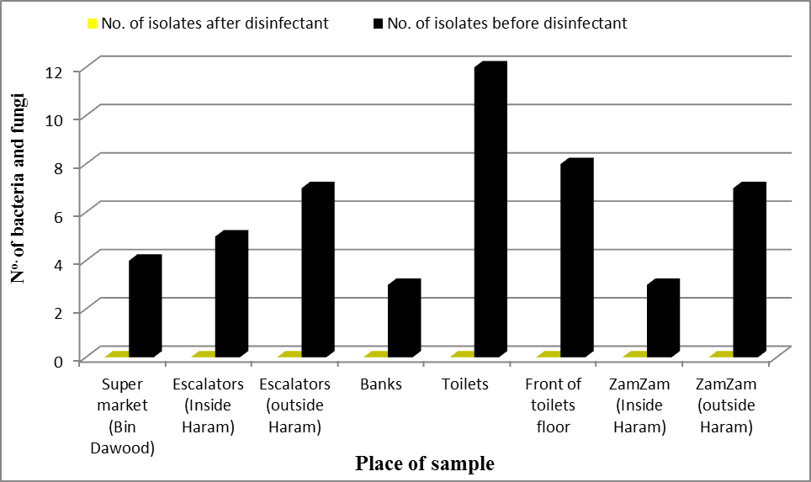
Fig. (2): Number of bacteria and fungi isolated in Shawwal month of 1431h year

Number of bacteria and fungi isolated in Zo-Alhaja month of 1431h year
Figure (3) shows the number of bacteria and fungi isolated in Zo-Alhaja month of 1431h year. In total 68 bacterial and fungal isolates were isolated before disinfection and these were reduced to 5 after disinfecting the places of collection by Dettol.

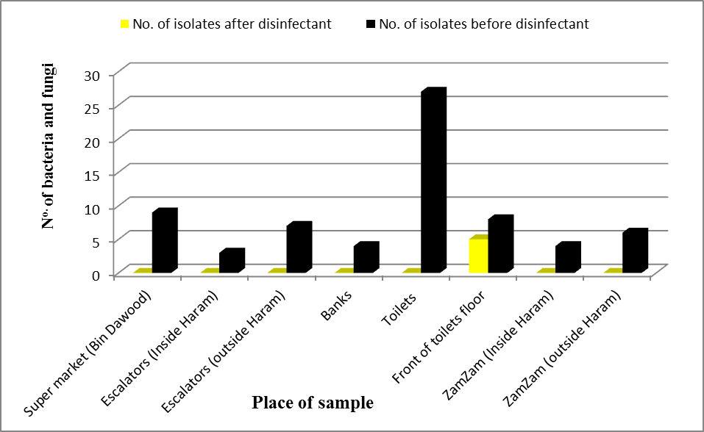
Fig. (3): Number of bacteria and fungi isolated in Zo-Alhaja month of 1431h year

Number of bacteria and fungi isolated in Safar month of 1432h year
Figure (4) shows the number of bacteria and fungi isolated in Safar month of 1432h year. In total 35 bacterial and fungal isolates were isolated before disinfection and these were reduced to 5 after disinfecting the places of collection by Dettol.

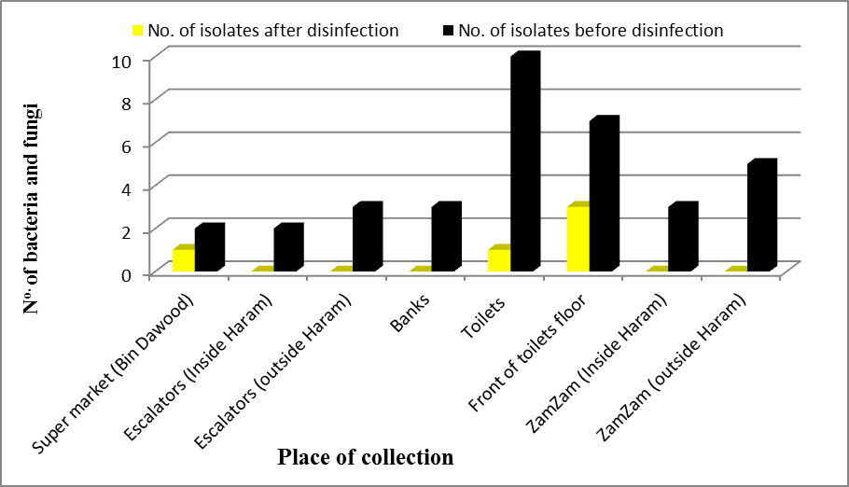
Fig. (4): Number of bacteria and fungi isolated in Safar month of 1431h year

Opportunistic pathogenic bacteria isolated from escalator handholds and ZamZam water-buttons inside and outside the Holy Mosque of Haram
Table (1) shows the pathogenic and opportunistic pathogenic bacteria isolated from escalator handholds and ZamZam water-buttons inside and outside the Holy Mosque of Haram before and after being disinfected by Dettol within Ramadan-Safar, inclusive. From first inspection most of the pathogenic and opportunistic pathogenic bacteria were greatly diminished during Safar (n=8 before disinfection). In addition, it is obviously clear that the Dettol disinfectant removes all bacteria from the escalators and ZamZam water-buttons after being disinfected by Dettol in Shawwal, Zo-Alhaja and Safar.
Furthermore, bacteria isolated outside the Holy Mosque of Haram before disinfection (n=37) were more than those isolated from inside the Holy Mosque of Haram (n=25). Moreover, the most common bacteria isolated inside the Holy Mosque of Haram were Alcaligenes faecalis and Acinetobacter baumannii. While, the most common bacteria isolated from outside were Alcaligenes faecalis and Pantoea spp.

Table 1. Pathogenic and opportunistic pathogenic bacteria isolated from Escalator handholds and ZamZam water-buttons inside and outside the Holy Mosque of Haram.
Isolated organism | Ramadan |  | Shawwal |  | Zo-Alhaja |  | Safar
 | Before  disinfectant | After disinfectant | Before  disinfectant | After disinfectant | Before  disinfectant | After disinfectant | Before  disinfectant | After disinfectant
(Inside haram)
Acinetobacter baumannii | 1 | 0 | 2 | 0 | 0 | 0 | 3 | 0
Alcaligenes faecalis | 0 | 0 | 1 | 0 | 3 | 0 | 0 | 0
Enterobacter gergoviae | 1 | 0 | 1 | 0 | 0 | 0 | 0 | 0
Enterococcus faecalis | 1 | 0 | 0 | 0 | 2 | 1 | 0 | 0
Klebsiella pneumoniae | 1 | 0 | 0 | 0 | 0 | 0 | 0 | 0
Ochrobactrum anthropi | 0 | 0 | 1 | 0 | 0 | 0 | 0 | 0
Pseudomonas luteola | 2 | 1 | 0 | 0 | 0 | 0 | 0 | 0
Serratia odorifera | 0 | 0 | 1 | 0 | 1 | 0 | 0 | 0
Sphingomonas paucimobilis | 0 | 0 | 1 | 0 | 0 | 0 | 0 | 0
Staphylococcus epidermidis | 0 | 0 | 1 | 0 | 0 | 0 | 2 | 0
Total | 6 | 1 | 8 | 0 | 6 | 1 | 5 | 0
(outsides haram)
Acinetobacter lwoffii | 1 | 0 | 1 | 0 | 0 | 0 | 0 | 0
Aeromonas sobria | 1 | 1 | 0 | 0 | 2 | 0 | 0 | 0
Alcaligenes faecalis | 1 | 0 | 5 | 0 | 1 | 0 | 2 | 0
Citrobacter freundii | 1 | 0 | 1 | 0 | 1 | 0 | 0 | 0
Enterobacter cloacae | 0 | 0 | 1 | 0 | 1 | 0 | 0 | 0
Enterococcus faecalis | 2 | 0 | 1 | 0 | 1 | 0 | 0 | 0
Ochrobactrum anthropi | 0 | 0 | 1 | 0 | 0 | 0 | 0 | 0
Pantoea spp | 2 | 1 | 4 | 0 | 2 | 0 | 0 | 0
Pseudomonas stutzeri | 2 | 1 | 0 | 0 | 2 | 0 | 0 | 0
Staphylococcus epidermidis | 0 | 0 | 0 | 0 | 0 | 0 | 1 | 0
Total | 10 | 3 | 14 | 0 | 10 | 0 | 3 | 0

Pathogenic and opportunistic pathogenic bacteria and fungi isolated from Bin Dawood Supermarket and ATM in the vicinity of the Holy Mosque of Haram
Table (2) shows the pathogenic and opportunistic pathogenic bacteria and fungi isolated from shopping cart handles, inner surfaces and child seats in Bin Dawood supermarket at the Holy Mosque of Haram area before and after being disinfected by Dettol. Clearly most of the pathogenic and opportunistic pathogenic bacteria were isolated during Ramadan and Zo-Alhaja months (8 in total). In addition, it is obviously clear that the Dettol disinfectant clears almost all bacteria and fungi after being disinfected by Dettol (2 in total). Furthermore, the most common bacteria and fungi isolated was Alcaligenes faecalis (n=4), Enterococcus faecalis (n=4), Pantoea spp. (n=3), Pseudomonas stutzeri (n=3), and Rhizopus spp. (n=3).

Table 2. Pathogenic and opportunistic pathogenic bacteria and fungi isolated from Bin Dawood Supermarket and ATM in the vicinity of the Holy Mosque of Haram
Isolated organisms | Ramadan |  | Shawwal |  | Zo-Alhaja |  | Safar
 | Before  Disinfectant | After disinfectant | Before Disinfectant | After disinfectant | Before  disinfectant | After disinfectant | Before  disinfectant | After disinfectant
Aeromonas sobria | 1 | 0 | 1 | 0 | 1 | 0 | 0 | 0
Acinetobacter lwoffii | 0 | 0 | 0 | 0 | 0 | 0 | 1 | 0
Alcaligenes faecails | 1 | 0 | 0 | 0 | 3 | 0 | 1 | 1
Enterobacter cloacae | 0 | 0 | 1 | 0 | 0 | 0 | 0 | 0
Enterococcus faecails | 1 | 0 | 0 | 0 | 3 | 1 | 0 | 0
Klebsiella oxytoco | 1 | 0 | 2 | 0 | 0 | 0 | 2 | 0
Morganella morganii | 1 | 0 | 1 | 0 | 0 | 0 | 0 | 0
Ochrobactrum anthropic | 1 | 0 | 0 | 0 | 0 | 0 | 0 | 0
Pantoea spp. | 2 | 0 | 1 | 0 | 1 | 0 | 1 | 0
Pseudomonas fluorescens | 1 | 1 | 0 | 0 | 1 | 0 | 0 | 0
Pseudomonas stutzeri | 2 | 0 | 0 | 0 | 1 | 0 | 0 | 0
Sphingomonas paucimobilis | 0 | 0 | 1 | 0 | 0 | 0 | 0 | 0
Staphylococcus epidermidis | 1 | 0 | 0 | 0 | 1 | 0 | 0 | 0
Rhizopus spp. | 1 | 0 | 0 | 0 | 2 | 0 | 0 | 0
Total | 13 | 1 | 7 | 0 | 13 | 1 | 5 | 1

Pathogenic and opportunistic pathogenic bacteria isolated from door handles, toilet levers, hand-held shower sprayers of the toilets and front of toilets floor in the vicinity of the Holy Mosque of Haram
Table (3) shows the pathogenic and opportunistic pathogenic bacteria and fungi isolated from door handles, toilet levers and hand-held shower sprayers of the toilets in the vicinity Holy Mosque of Haram before and after being disinfected by Dettol. Clearly most of the pathogenic and opportunistic pathogenic bacteria were isolated during Zo-Alhaja month (36 in total). In addition, it is obviously clear that the Dettol disinfectant clears most of opportunistic pathogenic bacteria and fungi after being disinfected by Dettol (13 in total). Furthermore, the most common bacteria isolated were Enterobacter aerogenes (n=5), Alcaligenes faecalis (n=3), Citrobacter freundii (n=3), Enterobacter gergoviae (n=3), E. coli (n=3), Aeromonas veronii (n=3), and Aspergillus spp. (n=3).

Table 3. Pathogenic and opportunistic pathogenic bacteria isolated from door handles, toilet levers, hand-held shower sprayers of the toilets and front of toilets floor in the vicinity of the Holy Mosque of Haram
Isolated organisms | Ramadan |  | Shawwal |  | Zo-Alhaja |  | Safar
 | Before  disinfectant | After disinfectant | Before  Disinfectant | After disinfectant | Before  disinfectant | After disinfectant | Before  disinfectant | After disinfectant
Enterococcus faecails | 2 | 1 | 1 | 0 | 1 | 0 | 1 | 0
Citrobacter freundii | 1 | 0 | 1 | 0 | 3 | 1 | 1 | 0
Enterobacter gergoviae | 2 | 1 | 0 | 0 | 3 | 1 | 1 | 0
Enterobacter aerogenes | 0 | 0 | 3 | 0 | 4 | 1 | 2 | 0
E.coli | 3 | 1 | 2 | 0 | 3 | 1 | 0 | 0
Aeromonas veronii | 2 | 0 | 1 | 0 | 3 | 1 | 1 | 0
Stenotrophomonas maltophilia | 3 | 1 | 0 | 0 | 3 | 0 | 0 | 1
Serratia plymathica | 1 | 0 | 0 | 0 | 0 | 0 | 0 | 0
Serratia odorifera | 1 | 0 | 0 | 0 | 0 | 0 | 0 | 0
Rhizopus spp. | 2 | 1 | 0 | 0 | 0 | 0 | 1 | 1
Aspergillus spp. | 2 | 2 | 0 | 0 | 2 | 2 | 1 | 1
Penicillium spp. | 1 | 1 | 2 | 0 | 1 | 1 | 1 | 0
Acinetobacter baumannii | 1 | 1 | 0 | 0 | 0 | 0 | 1 | 0
Acinetobacter junii | 0 | 0 | 1 | 0 | 1 | 0 | 1 | 0
Acinetobacter lwoffii | 3 | 1 | 1 | 0 | 2 | 0 | 2 | 0
Acinetobacter haemolyticus | 4 | 0 | 2 | 0 | 3 | 1 | 2 | 0
Pseudomonas aeroginosa | 1 | 1 | 0 | 0 | 0 | 0 | 0 | 0
Pseudomonas fluorescens | 0 | 0 | 0 | 0 | 1 | 1 | 1 | 1
Pseudomonas luteola | 2 | 1 | 1 | 0 | 0 | 0 | 0 | 0
Pseudomonas stutzeri | 0 | 0 | 0 | 0 | 1 | 1 | 0 | 0
Alcaligenes faecails | 2 | 0 | 3 | 0 | 3 | 2 | 0 | 0
Pantoea spp | 1 | 0 | 0 | 0 | 2 | 0 | 1 | 0
Morganella morganii | 0 | 0 | 1 | 0 | 0 | 0 | 0 | 0
Total | 34 | 12 | 19 | 0 | 36 | 13 | 17 | 4

Conclusion
From this study we concluded the following: Several pathogenic and opportunistic pathogenic bacteria and fungi were isolated in this study from different environmental public areas before and after Ramadan and Hajj seasons. Most of these pathogenic and opportunistic pathogenic bacteria and fungi were isolated during Ramadan and Zo-Alhaja months. An over the counter disinfectant (Dettol) showed a good efficacy in reducing the number of pathogenic and opportunistic pathogenic bacteria and fungi isolated in this study from different environmental public areas. The most common bacteria isolated from escalators inside the Holy Mosque of Haram were Staphylococcus epidermidis. While, the most common bacteria isolated from escalators outside the Holy Mosque of Haram was Alcaligenes faecalis. The most common bacteria isolated from shopping cart handles, inner surfaces and child seats in Bin Dawood supermarket at the Holy Mosque of Haram was Alcaligenes faecalis. The most common bacteria isolated from Zam Zam water-buttons located inside the Holy Mosque of Haram were Acinetobacter baumannii. While, the most common bacteria isolated from Zam Zam water-buttons located outside the Holy Mosque of Haram was Pantoea spp. The most common bacteria isolated from ATM card slots and buttons in the vicinity of the Holy Mosque of Haram were Pseudomonas fluorescens and Aeromonas sobria. The most common bacteria isolated from door handles, toilet levers and hand-held shower sprayers of the toilets in the vicinity Holy Mosque of Haram was Acinetobacter haemolyticus. The most common pathogen isolated from front of toilets floor in the vicinity of the Holy Mosque of Haram was the fungus Aspergillus spp.

Acknowledgment
The authors would like to thank the Custodian of the Two Holy Mosques Institute of the Hajj Research (CTHMIHR) at Umm Al-Qura University Makkah, Saudi Arabia for funding the research. We also thank students of the third year in the Faculty of Medicine and third year in the Faculty of Applied Medical Science, Umm Al-Qura University for their efforts regarding sample collection and their transportation.

References
- Qureshi H, Gessner B, Leboulleux D, Hasan H, Alam S, Moulton L. The Incidence of vaccine preventable influnenza-like illness and medication use among Pakistani pilgrims to the Hajj in Saudi Arabia. Vaccine. 2000;18.
- Wilder-Smith A, Memish Z. Meningococcal disease and travel. Int. J. Antimicrobial Agents. 2003; 21: 102-6.
- Al-Ghamdi A, Abdelmalek S, Ashshi A, Faidah H, Shukri H and Jiman-Fatani A. Bacterial contamination of computer keyboards and mice, elevator buttons and shopping carts. Afr. J. Microbiol. Res. 2011; 5: 3998-4003.
- Ashgar S, El-Said H. Pathogenic Bacteria Associated with Different Public Environmental Sites in Mecca City. Open J. Med. Microbiol. 2012; 2: 133-137.
- Reynolds KA, Watt PM, Boone SA, Gerba CP. Occurrence of bacteria and biochemical markers on public surfaces. Int. J. Environ. Health Res., 2005; 15: 225-234.
- Malik K, Naeem N. Study of bacteria on computer s mice and keyboards. Int. J. Curr. Microbiol. App. Sci. 2014; 3: 813-823.
- Saati A, Faidah H. Environmental Prevalence of Pathogens in Different Drinking Water Resources in Makkah City (Kingdom of Saudi Arabia). Curr. World Environ. 2013; 8: 37-53.
- Noskin G, Stosor V, Cooper I, Peterson L. Recovery of vancomycin - resistant enterococci on fingertips and environmental surfaces. Infect. Control Hosp. Epidemiol. 1995; 16: 577-581.
- Rusin P, Maxwell S, Gerba C. Comparative surface-to-hand and fingertip-to-mouth transfer efficiency of gram-positive bacteria, gram negative bacteria, and phage. J. Appl. Microbiol. 2002; 93: 585-592.
- Ulger F, Esen S, Dilek A, Yanik K, Gunaydin M, Leblebicioglu H. Are we aware how contaminated our mobile phones with nosocomial pathogens. Annals Clin. Microbiol. Antimicrob. 2009; 8: 7.
- Inside edition, supermarket shopping trolleys can be covered with harmful bacteria. Retrieved from http://www.cleanshopper.com.au/inside.php. 14, 2003.

3/7/2020

