**Jade Stone Inspection by Photon State Parametric Terahertz Grayscale Method**

Ashish Kumar; Liu Xuefeng; Xu Bin

School of Electronics and Optical Engineering Nanjing University of Science and Technology, 200 Xiaolingwei Nanjing China

[ashishkumar@njust.edu.cn](mailto:ashishkumar@njust.edu.cn)

**Abstract:** Absence of jade stone structural inspection and precise measurement technique is general obstacle for imaging a jade stone. A terahertz (THz) photon state parametric gray scale method used for efficiently reduce investigation time duration for analyzing structural detail of jade stone is achieved. An alternative THz parametric grayscale method is proposed. For explaining the ability of this system, a sample with several layers, has taken for analysis. From this method, each layer for jade stone is highlighted and measured for inside deformation. Through our experimental result clearly, show the interior formation and deformation of jade stone. The response of jade stone at each THz angle of polarization help to obtain a clear inside detailed structure. This study and exploration of stone imaging through THz intensity variation method is precise and improve the feasibility of the imaging technique.All measurements done by THz system and analysis through MATLAB are well consistent.

[Ashish Kumar, Liu Xuefeng, Xu bin. **Jade Stone Inspection by Photon State Parametric Terahertz Grayscale Method.** *N Y Sci J* 2020;13(3):92-98]. ISSN 1554-0200 (print); ISSN 2375-723X (online). <http://www.sciencepub.net/newyork>. 10. doi:[10.7537/marsnys130320.10](http://www.dx.doi.org/10.7537/marsnys130320.10).

**Keywords:** THz wave, polarization, Jadestone

1. **Introduction**

The THz (Terahertz) photon state parametric gray scale method is a useful technique in which the THz image of a sample has obtained in less time, and a sample’s optical details can be precisely analyzed. Several publications about the implementation of the THz imaging system has reported for identifying chemical [1,2], tomography [3], and near-field imaging [4]. In these systems, one polarization component of the THz wave field detection was a drawback through which they were able to detect the different material but not the structural property of material like stone or wood. Recently THz polarization control has got attention in research. Many publications about the content which can change polarization in THz is absorbed [5-6]. Variety of THz polarization investigation methods, which include electrical [5,6] and optical [7]. A THz polarization imaging method had first introduced by van der Valk et al [8], and his work on THz imaging has promoted into a new field. But imaging technique used by scanning method to obtain an image was a long time process to develop a real application. A THz optical system had designed for the detection method for improving the signal, and that reduce noise outcome in our various intensity variation imaging methods in our work [9]. Here a THz polarization parametric imaging system is used, which will decrease the imaging time. Detail of jade stone structure for its internal formation, with the help of two polarizers, we can reduce the intensity precisely required for the investigation of jade stone, which has different layers inside it. Our developed system is essential for testing the jade stone internal structure. Through this optical system, it is more easy to precise control of the intensity. If it is more, it will penetrate through the stone in another case; the intensity is not sufficient through detect in the camera.

Precise control of intensity by polarizer is repeatedly used in visible spectrum [12-14] where as in THz imaging system some publication has mention it, in which it can control intensity but process is very time taking and complex [15,16] so here we have presented a simple and fast THz imaging system in which we can control intensity very precisely and image our sample for different perspective.

Jadestone is essential in China has used for jewelry, stone ornaments, and stone structure in which this method can be applied to find out the authenticity of the jade stone [11]. In our experiment, the angle of polarization is a crucial factor imaging where intensity plays a significant role in which we can identify which intensity is suitable for the sample, which is needed to be tested [11]. In the first sample, we have shown that layers have been explored in jade stone when different intensity is varied. While in the second and third samples, we have shown that through our variable intensity imaging system is capable of in-

depth inspection of the jade stone thickness determination. Overall our developed system is capable of exploring structural property like layers, gaps and can detect other material compositions in it.

1. **Jade stone and experimental setup description**:

Jadestone sample are shown in Fig. (1) with all measurements as described. Fig 1(a) is the sample with a length 48 millimeter (mm), width 28 mm, and a thickness of 10 mm. Fig. 1(b) have a length 42 mm, width 20 mm and 4 mm minimum, 10 mm maximum thickness which has distributed in the sample, in fig. 1(c) have a length of 25 mm, the width of 15 mm, having a 3mm minimum and 10mm maximum thickness.

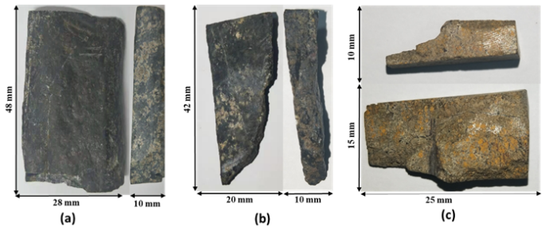

Figure 1. Jade stone sample measurement description (a) jade sample with equal thickness (b-c) jade stone with unequal thickness

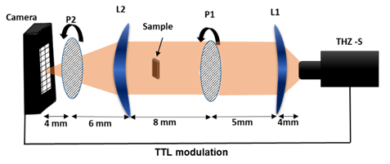

**(a)**

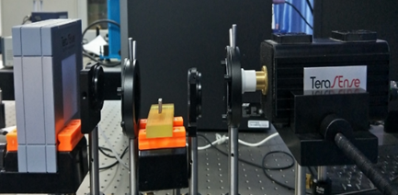

**(b)**

**Figure 2.** (**a**)Schematic of system: L1, L2-lens 1: P1, P2-rotational polarizer: THz-s-Source.(**b**)THz imaging system

The optical imaging setup shows in fig 2. The THz photon state parametric gray scale method consists of an IMPATT generator with a frequency of 100 GHz and an output power of 80/180/400 mW. THz imaging cameras with a wide spectral range of 0.05 THz to 0.7 THz have 1024 pixels where each pixel is 1.5mm, apart from that HRFZ-SI-H lens of a diameter of 50.8mm, (focal length 4mm of L1, 10 mm of L2), polarizer POL-HDPE (high density polyethylene) of a diameter of 50, range of (0.01 -30 THz). Measurement time is speedy, and data can be obtained. Transmitted THz waves are projected on 32x32 array of bolometer detector, after which signal is separated from noise with lock-in amplifier synchronized on the IMPATT generator. In this condition, polarizer control intensity of spectrum that helps in analyzing a sample with different range calculated based on powerless with and without experimental setup.

1. Theory

Mentioned in [8], THz wave intensity received at the detector can be written as

|  |  |  |
| --- | --- | --- |
|  |  | (1) |

Here and ω are the initial intensity and angular frequency of THz wave, η is the reflective index of the detecting stone to the THz wave,and L are the non-zero coefficientof tensor and the thickness of the sensor, is electric field and *c* is speed of light in vacuum. The is defined as the angle between polarizer and the axis of detecting camera. In experiment polarizer were set in front of each other, straight to detector axis, mainly, =90º; and while other polarizer is . Intensity a were concluded by observing Eq. (1) are,



|  |  |  |
| --- | --- | --- |
|  |  | (2) |

|  |  |  |
| --- | --- | --- |
|  |  | (3) |

|  |  |  |
| --- | --- | --- |
|  |  | (4) |

|  |  |  |
| --- | --- | --- |
|  |  | (5) |

|  |  |  |
| --- | --- | --- |
|  |  | (6) |

Equation. (2-6) explain that intensity changes with the change in polarization and can be measured through the detector of the straight field and their proportional coefficient is 45º. Based on the above analysis two polarization intensity variation is obtained. It helps in measurement and effect of polarization for jade stone. Orientation need to be same for more precise measurement.

1. **Experimental result**

The method of imaging is based on a different angle of the polarization due to which intensity is changing. Each layer of jadestone has variation in hardness due to which it will allow specific THz waves to pass through it and act like a filter in our system. In a particular layer, to give a certain level of intensity is a need to test by the variation in intensity by rotating the P1, by which the intensity of the THz wave will change, in decreasing order, helps in the analysis number of layers inside the jade stone. Here precisely control of THz wave intensity allowed as to measure structural properties. The observed intensity from Polarization angle 0 to 35 is a vital factor for analysis. At this intensity, we have the advantage of optimum intensity and less distortion in the image.

1. **Authenticity of method proposed for measurement**

To find the accuracy of the proposed method for measurement (Eq 6), a THz HDPE polarizer is placed after the THz source and its rotation to change THz polarization as per Fig 2 (a). it shows the placement of two polarizer P1 and P2. In which intensity variation can observed through Fig. 3, which shows the variation in intensity due to change in the angle of polarization θ which is measured in every 10 degrees. The calculated result is referred from Xinke Wang et al [8], the comparisons of two result has been shown. Both result is very alike in all term.



Figure 3. Graph shows change in THz intensity measured (right), calculated (left) in terms of variation angle of polarizer.

1. **Layer detection**

For layer detection, a jadestone shown in fig. 1(a) has taken which have equal thickness. The intensity has varied from high to low through the rotation of the polarizer P2, which is explained in fig. 4(b) minimum layer is detected, due to the high intensity of the THz wave. It all passes through while coming to the part fig. 4 (c) the intensity is decreased to 0.45 THz rotating polarizer by 30 degrees, to detect the inner layer, in fig.4 (d) intensity is reduced to 0.4 THz by rotating the polarizer to 40 degrees, at this intensity outer and Some parts of the inner layer were observed. Through this method, we can detect the inner and outer layer of the jade stone. Outer layer can be seen in every image, which is THz layout structure of the jadestone. Contour plot of image has been done with MATLAB.

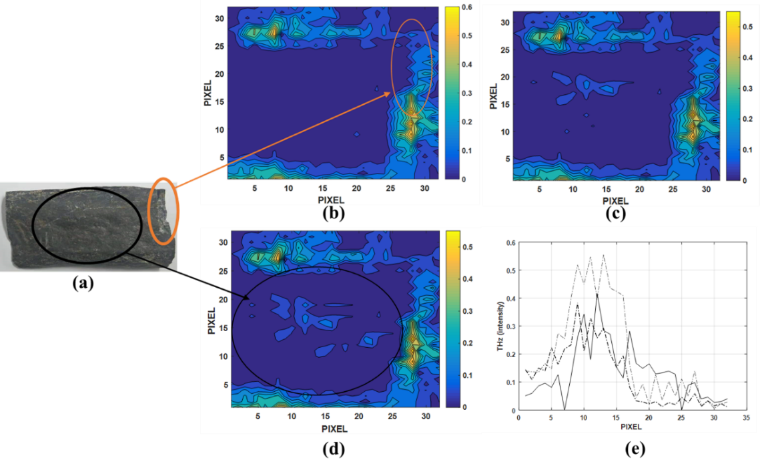

Figure 4. (a) Jade stone sample (b) CTP shows at 0.6 THz intensity no layer detected (c) CTP shows at 0.45 THz internal layer detected intensity (d) CTP shows at 0.4 THz intensity inner and outer layer were detected (e) intensity variation and pixel graph.

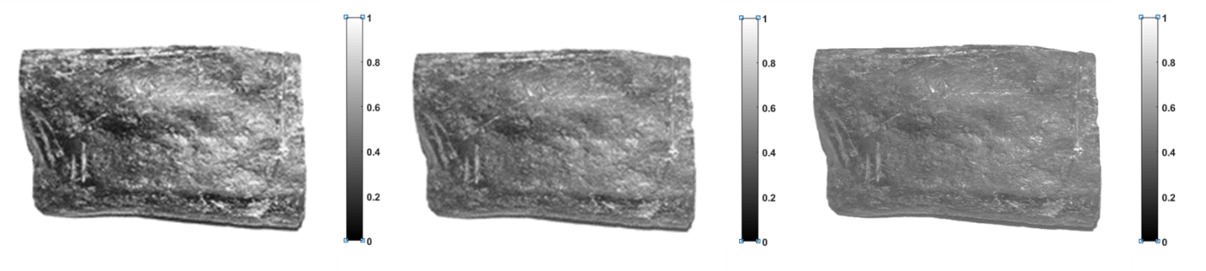

(a) (b) (c)

Figure 5. Conventional gray scale imaging on stereoscopic microscope, from fig 1(a), images are in original size (a) intensity is maximum (b) intensity is medium (c) intensity is low.

1. **Thickness detection**

Two samples were tested with different thickness and of different kind, details measurement, which is mention in the sample description. Here in fig. 6 (a, d) image of the samples has been shown to compare with the THz image by our intensity variation method. In which we were able to examine the different levels of thickness in stone based on the intensity received at the camera. Fig. 6 (b, e) shows the real THz image received by our system. The dark blue region indicates the thick region in jade stone, where the near to green zone indicates a thin area in the jade stone. Fig. 6 (c, f) shows us contour indicate different regions according to the intensity. Which has seen as yellow region mean almost null jade part in the stone where dark blue indicates jadestone, based on the different color levels of thickness has identified.

In THz system for imaging of jade stone we are able to see more detail like layers’ thickness edges and conventional method only outer properties are able to detect like lines and roughness based on the reflection.

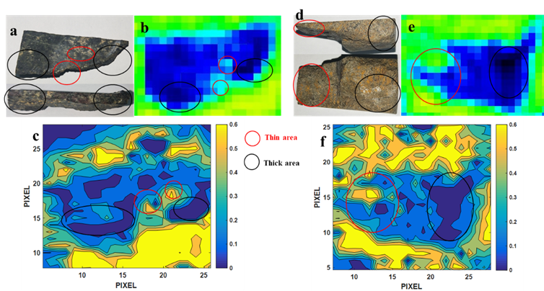

Figure 6. Red marked area is thin area shown and black marked area is thick area (a, d) jade sample front and side facing image with marked area (b, e) THz image with marked area (c, f) CTP shows clear description of layers with marked area.

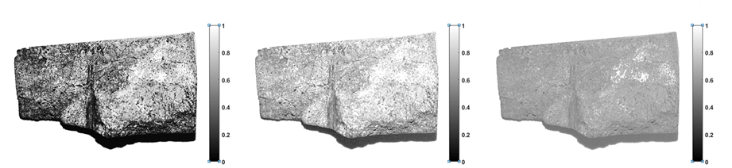

(a) (b) (c)

Figure 7. Conventional gray scale imaging on stereoscopic microscope, from fig 1(c), images are in original size (a) intensity is maximum (b) intensity is medium (c) intensity is low.

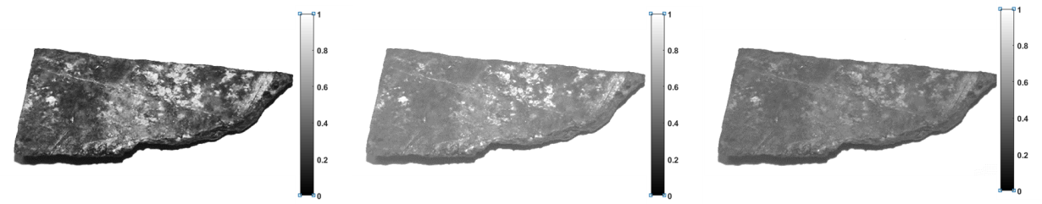

(a) (b) (c)

Figure 8. Conventional gray scale imaging on stereoscopic microscope, from fig 1(b), images are in original size (a) intensity is maximum (b) intensity is medium (c) intensity is low.

1. **Discussion**

THz variable intensity method is capable of detecting the inner layer and outer layer in jade stone. Fig. 3. illustrates, due to change in intensity due to the rotation of the polarizer can make a lot of difference, which is observed precise and can explain the properties of the jade stone. While intensity is the crucial factor for measurement in which precise control of intensity is done by rotating the polarizer. In the second part, the thickness is measured based on the intensity which is received. When a significant difference in intensity, it explains about thickness, and when there are very few changes in intensity, it shows as about layer difference. Both methods to observe the jade stone is rapid and effective and does not include an extra cost for examining. Intensity variation THz imaging system takes much less time as compared to other kinds of THz real-time imaging system and give a precise structure of the jade stone.

**Conclusion**

In this report, a THz photon state parametric gray scale method is developed, which significantly widens the ability of THz polarization imaging. A measurement method has proposed, and its working principle has discussed in brief on the experiment. It is successfully characterizing the different variations of jade stone to THz polarization and has been compared with conventional method of gray scale imaging. The feasibility of the imaging system is well exhibited. The introduction of THz polarization information into real-time precisely improve the potentiality of THz real-time imaging techniques. The work promotes the development of THz imaging in biological imaging and major research studies.

**Acknowledgements:**

The authors wish to acknowledge the financial support of National Major Scientific Instruments and Equipment Development Project (61827814), National Key Research and Development Program of China (2017YFF0107100), Beijing Natural Science Foundation (Z190018) and the Overseas Expertise Introduction Project for Discipline Innovation (111 Project No. B17023), the Fundamental Research Funds for the Central Universities” 锛孨o.30920010011.

**Corresponding Author:**

Ashish Kumar

Department of optoelectronics and engineering

Nanjing university of science and technology

Nanjing, Jiangsu, PRC

E-mail: [ashishkumar@njust.edu.cn](mailto:ashishkumar@njust.edu.cn)

**References**

1. Usami, M., Yamashita, M., Fukushima, K., Otani, C., & Kawase, K. (2005). Terahertz wideband spectroscopic imaging based on two-dimensional electro-optic sampling technique. *Applied Physics Letters*, *86*(14), 141109.
2. Zhong, H., Redo-Sanchez, A., & Zhang, X. C. (2006). Identification and classification of chemicals using terahertz reflective spectroscopic focal-plane imaging system. *Optics Express*, *14*(20), 9130-9141.
3. Wang, X., Cui, Y., Sun, W., Zhang, Y., & Zhang, C. (2007). Terahertz pulse reflective focal-plane tomography. *Optics express*, *15*(22), 14369-14375.
4. Wang, X., Cui, Y., Hu, D., Sun, W., Ye, J., & Zhang, Y. (2009). Terahertz quasi-near-field real-time imaging. *Optics Communications*, *282*(24), 4683-4687.
5. Makabe, H., Hirota, Y., Tani, M., & Hangyo, M. (2007). Polarization state measurement of terahertz electromagnetic radiation by three-contact photoconductive antenna. *Optics express*, *15*(18), 11650-11657.
6. Castro-Camus, E., Lloyd-Hughes, J., Fu, L., Tan, H. H., Jagadish, C., & Johnston, M. B. (2007). An ion-implanted InP receiver for polarization resolved terahertz spectroscopy. *Optics express*, *15*(11), 7047-7057.
7. Kanda, N., Konishi, K., & Kuwata-Gonokami, M. (2007). Terahertz wave polarization rotation with double layered metal grating of complimentary chiral patterns. *Optics express*, *15*(18), 11117-11125.
8. Van der Valk, N. C., van der Marel, W. A., & Planken, P. C. (2005). Terahertz polarization imaging. *Optics letters*, *30*(20), 2802-2804.
9. Zhang, R., Cui, Y., Sun, W., & Zhang, Y. (2008). Polarization information for terahertz imaging. *Applied optics*, *47*(34), 6422-6427.
10. Wang, X., Cui, Y., Sun, W., Ye, J., & Zhang, Y. (2010). Terahertz real-time imaging with balanced electro-opticdetection. *Optics Communications*, *283*(23), 4626-4632.
11. Jiang, Z., Xu, X. G., & Zhang, X. C. (2000). Improvement of terahertz imaging with a dynamic subtraction technique. *Applied optics*, *39*(17), 2982-2987.
12. Wang W, Yadav NP, Shen Z, et al. Two-stage magnifying hyper lens structure based on metamaterials for super-resolution imaging [J]. Optik, 2018, 174: 199-206.
13. Wang W, De La Rue RM, Yadav NP, et al. Analysis on image features for a standard edge by using polarization indirect microscopic system [J]. Optik, 2019, 178: 363-371.
14. Wang W, Yadav NP, Cao Y, et al. Finger skin super-resolved imaging based on extracting polarized light field [J]. Optik, 2019, 180: 215-219.
15. Grady, K. N. et al. Terahertz metamaterials for linear polarization conversion and anomalous refraction. Science 340, 1304 (2013).
16. Kodo Kawase, Yuichi Ogawa, Yuuki Watanabe, and Hiroyuki Inoue. Non-destructive terahertz imaging of illicit drugs using spectral fingerprints, 2549-2554 (2003).

3/23/2020