A comparative study of the nutritional status of under-five male and female children in Ekureku community, Abi Local Government Area of Cross River State, Nigeria

Kimboline Donatus Etim¹ and Randymay E. Kalu²

¹Department of Public Health, University of Calabar, Cross River State, Nigeria
²Federal Medical Centre, Yenogoa, Bayelsa State, Nigeria
e-mail: kim.etim@yahoo.com; randymaykalu@gmail.com

Abstract: Malnutrition which is the consumption of dietary nutrients either insufficiently or exclusively, is a major public health problem in Nigeria that has contributed to high morbidity and mortality among under-five years old children. This study aimed at assessing the nutritional status of under-five years old male and female children and the prevalence of malnutrition among them in rural Ekureku community. With a cross-sectional design, 380 mother-child pair respondents were selected using systematic sampling technique. Questionnaires and nutritional anthropometry were used in gathering data. Data collected were entered and analyzed using Statistical Package for Social Sciences. Student t-test and Chi-square were used to test for inferential statistics at 5% level of significance. The study proved that females were more stunted (16.3%), wasted (7.1%) and underweight (16.1%) than their male counterparts with 12.1% (stunted), 5.3% (wasted) and 12.1% (underweight). Combining the prevalence of malnourished male and female under-five children, the nutritional status showed that 28.4%, 12.4% and 28.2% were stunted, wasted and underweight respectively. The high prevalence of malnourished children could result from low knowledge of child nutrition and poor feeding practices of mothers/caregivers. The alarming rate of malnutrition in Ekureku rural community is significantly due to low knowledge of child nutrition, proper health care seeking behaviour and poor feeding practices of mothers/caregivers. Behavioural change through government intervention is recommended.
[Kimboline Donatus Etim and Randymay E. Kalu. A comparative study of the nutritional status of under-five male and female children in Ekureku community, Abi Local Government Area of Cross River State, Nigeria. N Y Sci J 2020;13(3):69-79]. ISSN 1554-0200 (print); ISSN 2375-723X (online). http://www.sciencepub.net/newyork. 7. doi:10.7537/marsnys130320.07.

Keywords: Malnutrition, under-five children, Ekureku community, nutritional status, Z-scores

Introduction:
Malnutrition has been described as the consumption of dietary nutrients either insufficiently or exclusively, and this includes micronutrient malnutrition, under-nutrition, and over-nutrition (WHO, 2013a; Etim et al., 2017). Malnutrition remains a major health problem and is responsible for one-third of all infant and childhood mortality in third world countries (UNICEF/WHO/World Bank, 2012; WHO, 2013b). WHO (2013a) reports that malnourished children often fail to thrive and are more likely to suffer from impaired physical and intellectual growth which makes them less productive during adulthood (who, 2013a). Also malnourished children are associated with poor school performance, school absenteeism, reduced intellectual achievement, delayed cognitive development and resultant morbidity and mortality among under-five children (Babatunde et al., 2011; Etim, 2017). Long-term malnutrition among children under-five years of age resulting from poor dietary intake can adversely lead to dysfunction of the physical and mental health (Etim, 2016).
The burden of malnutrition commonly occurs within the African and Asian continents of the world, and it is evident that of the 162 million children under-five years who are stunted, 36% reside in Africa while 56% are found in Asia (UNICEF/WHO/World Bank, 2012). Victoria et al. (Victoria et al., 2008) reports that an estimated 60 million under-five children were found to be stunted out of which 11 million were Nigerian children. In Nigeria, the pattern and severity of childhood malnutrition has steadily increased from 11% to 18% in 2013 for wasting; 24% in 2003 to 29% in 2013 for underweight, but declined from 42% in 2003 to 37% in 2013 for children who were stunted (National Population Commission, 2014). An estimated 10 million children die from treatable and preventable illnesses annually (UNICEF, 2009). Sub-Saharan African and Southern Asian countries bear a disproportionate burden of malnutrition (90%) among under-five children (Black et al., 2008; Etim, 2016)).
The existence of poverty especially in poor communities drives the proliferation of malnutrition in children (Goel et al., 2007).
In sub-Saharan Africa, high rates of child mortality can result from factors such as low calories intake, high rates of HIV/AIDS, political instability, poor implementation of government policies, conflicts among groups, etc. For instance, in countries such as Malawi, Burundi and Madagascar, about 50% of children are stunted as a result of poor dietary intake (UNICEF, 2007). In Nigeria, it has been reported that 50% of childhood mortality is caused by malnutrition out of an estimated 80% mortality and 90% morbidity rates in under-five children due to acute respiratory infections, malaria, diarrhoea and vaccine-prevented diseases (National Population Commission, 2014). Nigeria has been identified as one of the most affected countries by malnutrition (Action Against Hunger, 2011).
Several empirical studies have identified factors which affect under-five children nutritional status to include poverty, failure to breastfeed exclusively, maternal factors such as poor nutrition during pregnancy and lack of appropriate weight gain; others are illnesses like diarrhoea, acute respiratory infections, poor consumption of vitamin supplement or fortified foods, large family size, poor sanitation, lack of education and information about good or adequate nutrition, food insecurity and safety (Olanremaya, 2011; Hemel et al., 2015; National Population Commission, 2014; Ejemot-Nwadiaro et al., 2015). Mashal et al. (2008) & Etim (2016) report that the cycle of undernutrition continues to perpetuate especially where malnourished mothers give birth to underweight babies. This is the situation in Ekureku, a small community in Abi Local Government Area of Cross River State, Nigeria, where poverty affects all aspects of their livelihood particularly the nutritional status of under-five children. Therefore, this study aimed at investigating the nutritional status of male and female children under the age of five in Ekureku, Abi Local Government Area of Cross River State, Nigeria, based on their Z-scores for height-for-age, weight-for-age and weight-for-height, considering knowledge of child nutrition among mothers/caregivers, sources of information on maternal and child nutrition, health seeking behaviour of mothers or caregivers and child feeding practices.

2. Materials and methods
To identify the determinants of nutritional status of children under-five years in Ekureku community, Abi Local Government Area of Cross River State, a descriptive-cross-sectional study was adopted.
The study population consisted of all children between 0-59 months of age, and the sample size was determined using the formula n = $\frac{Zq^{2}}{d^{2}}$ (Lutz, 1982).
Where n = sample size, Z = 1.96 (i.e., 95% confidence interval|), d = 0.05 (acceptable margin of error), p = 26.7% = 0.267 (probability of under-five children who are stunted (Odunayo & Oyewole, 2006), q = 1-p = 1-0.267 = 7.733 (probability of under-five children who are not stunted.
Therefore

n = $\frac{{\left(1.96\right)}^{2}*0.267*0.733}{{0.05}^{2}}$= 301

The sample size for this survey was 301. However, to make room for non-response and attrition bias, the desired sample size was increased by 30%, giving a sample size of 390 that was used for this study.

2.1 Sampling procedure
For the selection of respondents for this study, systematic random technique was employed to select every household with under-five children within the study area. The process started near the market square which is the entrance of the community and continued until 390 households were duly selected to participate in the study (Etim et al., 2017). Mothers/caregivers resident in sampled households with under-five children were administered a set of questionnaires. In polygamous homes with many under-five children from different mothers, only one mother with an under-five child was recruited to partake in the study using lottery method (Etim et al., 2017).

2.2 Instrument for data collection
A semi-structured questionnaire that was administered to respondents with both open and closed-ended questions was the instrument for data collection. The questionnaire comprised five sections with 37 items. Sections A, B and C covered mother, child and household characteristics respectively, while sections D and E covered mother’s nutritional knowledge, health seeking behavour and child feeding practices, respectively.

2.3 Nutritional status assessment using anthropometry
Nutritional anthropometry is a technique that measures the physical dimensions and gross composition of the human body as a way of assessing nutritional status, using several variables such as child’s age, sex, height and weight. These measurements were used in generating indices such as height-for-age, weight-for-age and weight-for-height, and compared with WHO standard classification system of malnutrition to obtain the Z-scores values (WHO, 2011; Etim et al., 2017). These values were obtained for children of ages 0-12, 13-24, 25-36, 37-48 and 49-59 months. Of public health significance which are the cut-off values of those indices are >20% for stunting (or small stature for the age, reflecting chronic or longstanding undernutrition), >5% for wasting (a reflection of acute undernutrition) (WHO, 2011; Etim et al., 2017).
Following the attainment of the nutritional anthropometric indices, the percent underweight, percent stunting and percent wasting, the proportion of number of children weight-for-age, number of children with height-for-age and number of children with weight-for-height to total number of children weighed, were respectively calculated (Etim et al., 2017).
The height of children, who were yet to walk, was measured by asking the children to lie on a board placed on a stable surface, and the measurement was taken to the nearest 0.1cm. For those children above two years, the height was measured using a meter rule and reading was taken in centimeters. For measuring the weight, children were asked to stand on the middle of the weighing scale’s surface. Measurements were taken to the nearest 0.1kg. A salfer hanging scale was used to take the measurement of toddlers (Etim et al., 2017).

2.4 Data analysis
The data were analysed using the Statistical Package for Social Sciences software (SPSS 20.0 version, 2012). Results were expressed as percentages and presented in tables and bar chart. Chi-square test and t-test were used to test for the hypothesis at 5% level of significance.

2.5 Ethical clearance
Ethical clearance was obtained from Cross River State Research Ethics Committee, Ministry of Health, Calabar. Informed consent was duly sought and obtained from the respondents who took part in the study.

3. Results
Out of 390 questionnaires that were distributed to the respondents, 380 questionnaires were received for analysis, giving a respondent rate of 97.4%.

3.1 Mothers/caregivers-related factors of child nutritional status
Knowledge of child nutrition based on sources of information on maternal and child nutrition (Figure 1) where health workers provided the largest information, healthcare seeking behaviour and child feeding practices among mothers/caregivers are presented in Tables 1-3. Table 1 shows that 337(88.7% respondents know that breast milk only is food for new born baby, while 312 (82.1%) know that initiation of breast feeding after delivery starts from 1-24 hours. Also, 160(42.1%) respondents know that the type of food recommended for 3 months old babies is breast milk with baby formula; 186(48.9%) know that the age when semi-solid food is given to a baby is 4-6 months. 321(84.5%) of respondents know that both solid and semi-solid foods are given as supplementary diets to babies during weaning, while 357 (93.9%) have knowledge of feeding a baby during illness.
When a child is sick (Table 2) 263(69.2%) respondents rush the child to the nearest health centre/hospital for treatment. About 71(18.7%) say that there were times they could not take their sick babies because of either lack of money, lack of transport or health centre being very far.
Many respondents appear not to have a good feeding practice of under-five children (Table 3) with 93(24.4%) feeding their children with both semi-solid and solid foods, 247(65.0%) have less than 6 months for exclusive breast feeding; 92(26.7%) give semi-solid food after weaning, and irregular feeding of the children when they are sick.

3.2 Mean weight and height of both genders
The mean values for weight was plotted against age as shown in Figure 2. The curve showed a gradual increase in the average weights of both genders from 0-59 months of age. As shown in the line graph, the male children were observed to be heavier in weight than female children across all age groups. The difference in weight and age was statistically not significant (p>0.05) using t-test, whereas at age 37-48 months, there was a significant difference (p<0.05).
When height was plotted against age (Figure 3), the curve showed a progressive increase in the average heights of both genders from 0-59 months of age. The curve also indicated that male children were taller than their female counterparts except for those within 25-36 months of age where the differences in height appear to be the same. The differences in heights were not statistically significant (p>0.05).

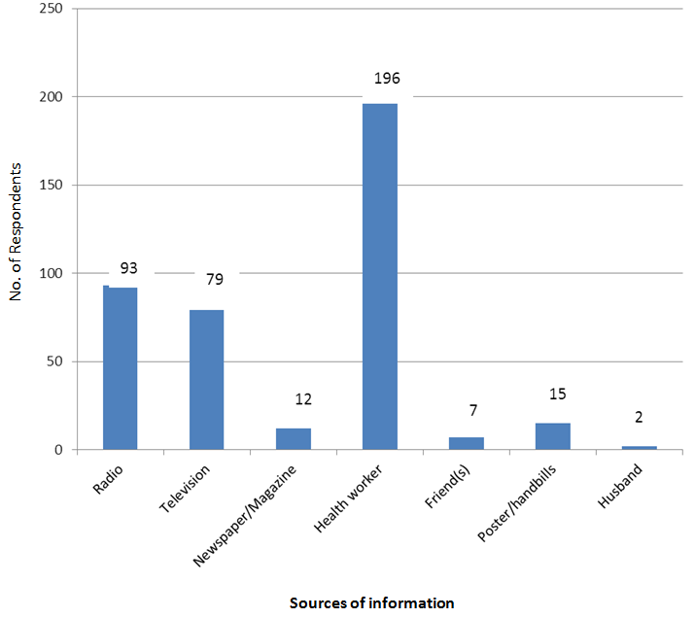
Fig. 1: Sources of information on maternal and child nutrition

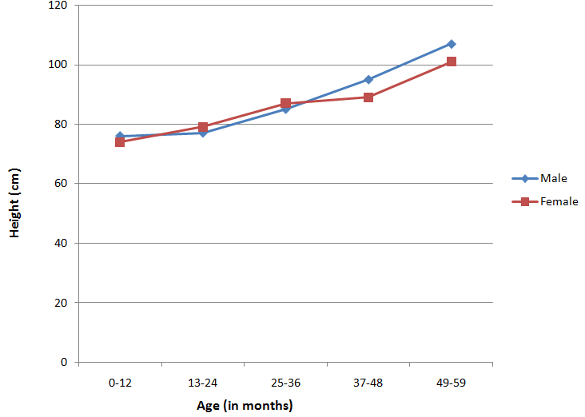
Fig. 2: Mean height plotted against age of under-five children

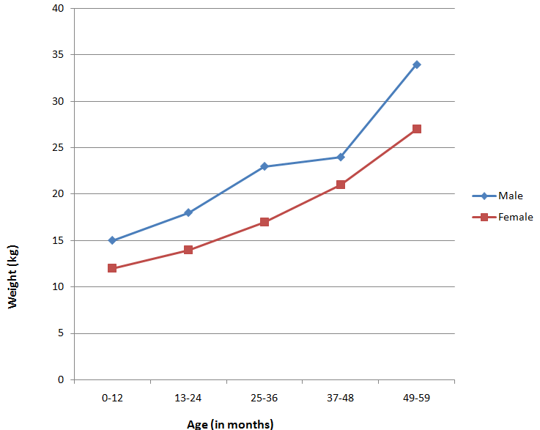
Fig 3: Mean weight plotted against age of under-five children

Table 1: Knowledge of child nutrition among mothers/caregivers, N = 380
Variables | Number Of Respondents | Percentage (%)
Food for new born baby
Breast milk only  Breast milk with baby formula  Total | 337  11  32 | 88.7  2.9  100
Initiation of breastfeeding after delivery
Less than 1 hour  1-24 hours  After 24 hours  Total | 14  312  54  380 | 3.7  82.1  14.2  100
Type of food recommended for 3 months old babies
Breast milk only  Breast milk with baby formula  Breast milk with semi-solid food (baby formula, milk products, pap, etc.)  Breast milk with water  Total | 155  160  21  44  380 | 40.8  42.1  5.5  11.6  100
Age when semi-solid food is given to a baby
Less than 4 months  4-6 months  After 6 months  Total | 71  186  123  380 | 18.7  48.9  32.4  100
Supplementary diets given to babies during weaning
Semi-solid food only (baby formula, milk products, pap, etc)  Both solid and semi-solid food  Total | 59  321  380 | 15.5  84.5  100
Knowledge of feeding a baby during illness
Should be less than normal  Should continue normally  Total | 23  357  380 | 6.1  93.9  100

Table 2: Health seeking behaviour of mothers or caregivers, N = 380
Variables | Number Of Respondents | Percentage (%)
What to do first when the child is sick
Stay at home and give child some medication  Visit the traditional healer/herbalist  Rush to the nearest health center/hospital for treatment  Delay a little and see the outcome of the sickness  Total | 55  34  263  28  380 | 14.5  8.9  69.2  7.4  100
Were there times you wanted to take the child to the clinic but couldn’t
Yes  No  Total | 71  309  380 | 18.7  81.3  100
Reasons for not taking the child to clinic/health center
Lack of money for transport  Health center far from home  Other reasons  Total | 36  22  13  71 | 50.7  31.0  18.3  100

Table 3: Child feeding practices, N = 380
Variables | Number Of Respondents | Percentage (%)
Type of food currently given to under five children
Breast milk only  Breast milk and water  Breast milk and baby formula  Breast with semi-solid/solid food  Solid food only (Garri, rice, bean, foo-foo, vegetable, etc.)  Semi-solid food only (baby formula, milk products, pap, etc)  Both semi-solid and solid food  Total | 23  25  58  61  54  66  93  380 | 6.1  6.6  5.3  16.0  14.2  17.4  24.4  100
Duration of feeding under five children with the above mentioned diet
0-6 months  7-12 months  13-24 months  25 months and above  Total | 61  81  102  136  380 | 16.1  21.3  26.8  35.8  100
Duration of exclusive breastfeeding
Less than 6 months  6 months and above  Total | 247  133  380 | 65.0  35.0  100
Age semi-solid/solid food was given to babies
Less than 4 months  4-6 months  After 6 months  Total | 45  180  132  357 | 12.6  50.4  37.0  100
Type of complementary food given to babies after
weaning
Solid food only (Garri, rice, bean, foo-foo, vegetable, etc.)  Semi-solid food (baby formula, milk products, pap, etc)  Both semi-solid and solid food  Total | 68  92  191  351 | 19.4  26.2  54.4  100
Feeding pattern during child illness
Continue feeding  Discontinue feeding  Undecided  Total | 311  24  45  380 | 81.8  6.3  11.8  100

3.3 Prevalence of malnourished under-five children
The Z-scores and prevalence of malnourished under-five children are represented in Table 4. The table shows that the malnourished group of children aged from 37-48 months were most prevalent 75(19.7%), followed by 66(17.4%) for children aged from 49-59 months. The female under-five children 150(39.5%) were more malnourished than the males 112(29.5%).
Equally, 32(8.4%) of children aged from 37-48 months were most prevalent for stunting followed by 27(7.1%) for children aged 49-59 months. The female under-five children were equally more stunted 62(16.3%) than the male counterparts 46(12.1%). For wasting, the age group 25-36 months with 14(3.7%), was most prevalent, followed by the age group 37-48 months with 12(3.2%). The female children 27(7.1%) were equally more prevalent than their male counterparts with 20(5.3%). For under-weight children 31(8.2%) for age group 37-48 months were more prevalent, followed by children 29(7.6%). Females 61(16.1%) were more prevalent than their males 46(12.1%).
There was no significant difference (p>0.05) between stunted under-five children and other children (Table 4). However, the sex difference in the prevalence of stunting was statistically significant (p<0.05). Also, there was no significant difference (p>0.05) between the most prevalence wasted children (25-36 months) and other age groups; although there was significant difference between the females and the males. Children aged 37-48 months were more underweight than children of other age groups and the difference was not statistically significant (p>0.05). However, the sex difference for underweight children was statistically significant (p<0.05).

Table 4: Prevalence of malnourished under-five children, N = 380
Variables Prevalence (%)
 | Stunting (n=108) | Wasting (n=47) | Under weight (n=107) | Total (n=262) | Critical χ² | χ²_{0.05} | df | P-value
Age (in months) |  |  |  |  | 8.9910 | 15.51 | 8 | 0.000*
<24  25-36  37-48  49-59  Sex  Male  Female | 23(6.1)  26(6.8)  32(8.4)  27(7.1)  46(12.1)  62(16.3) | 11(2.9)  14(3.7)  12(3.2)  10(2.6)  20(5.3)  27(7.1) | 23(6.1)  24(6.3)  31(8.2)  29(7.6)  46(12.1)  61(16.1) | 57(15.0)  64(16.8)  75(19.7)  66(17.4)  112(29.5)  150(39.5) | 11.09 | 5.99 | 2 | 0.000*
*P < 0.05 = Statistically significant

4. Discussion
In this study, malnutrition was observed across the age groups and gender of under-five years children. The first line of factors attributable to this were knowledge of child nutrition among mothers/caregivers, health seeking behaviour of mothers or caregivers and child feeding practices among mothers/caregivers. There was staggered knowledge of nutrition, health seeking behaviour and child feeding practices especially as only 40.1% of respondents feed their 3 months old babies with breast milk (Table 1); 16.1% feed their 0-6 months old babies exclusively with breast milk (Table 3) and 14.5% mothers/caregivers stay at home and give child some medication. These constitute the first lines of determinants of malnutrition in under-five years old children. This agrees with the studies of Etim et al. (2017), Nguyen and Nguyen (2009) and Joshi et al. (2011) who identified knowledge of child nutrition as one of the factors determining malnutrition. This indicates that effective dissemination of information on child nutrition (Figure 1) increases mothers’ knowledge of the right kind of food to give their children at every stage of their growth and development (Etim et al., 2017). Also, Mallik et al. (2013) report that children breastfed exclusively within the first six months of their life tend to be better nourished than children who were not breastfed exclusively (Etim et al., 2017).
The importance of breast milk on child growth cannot be over-emphasized. According to WHO (2013b), breast milk enhances physical growth, improves cognitive learning and protects children against infection. However, in this study, a greater proportion of the respondents suggests that initiation of breastfeeding should be between 1-24 hours after delivery. Only 3.7% knew that early initiation of breastfeeding should be within one hour after delivery. This finding is similarly reported in Nigeria where most mothers appeared not to have good knowledge of the time breastfeeding is initiated, i.e., within one hour after birth (Amosu et al., 2011).
Out of 380 study respondents, 155(40.8%) know that breast milk only is the diet recommended for 3 months old babies. The remaining 59.2% had 3 months old babies. Etim et al. (2017) report that high educational, antenatal clinic (ANC) attendance and previous birth experiences are major contributors to knowledge of diet recommended for 3 months old babies. Even one-third of respondents only (32.4%) know that supplementary diet is introduced after 6 months of age. This result is consistent with a study carried out in Ogun State, Nigeria, where most mothers had poor knowledge of when to commence complementary feeding (Amosu et al., 2011). Lawoyin et al. (2003) in their study, reported that early introduction of supplementary feeding increases the risk of childhood malnutrition, whereas children fed with supplementary diet after 6 months of age are better nourished than those whose supplementary diet was introduced before 6 months of age.
Strange child feeding practice was observed. A greater proportion of respondents (24.4%) fed their children with both semi-solid and solid food as at the time of the survey, suggesting that weaned children were fed on complementary diet, and only 6.1% of the children were fed with breast milk (Van de Poel et al., 2008). Most respondents (81.8%) report that they continue feeding their children even during ill-health, suggesting that mothers knew that good nutrition is the first line defense against infection. On the whole, child feeding practice was identified as a determinant of nutritional status among under-five children. This is supported by a study carried out in Sudan which showed that poor feeding practice increases children’s susceptibility to malnutrition (Ibrahim & Aishiek, 2010). On health seeking behaviour of mothers/caregivers, 263(69.2%) respondents rush their children to the nearest health centres/hospitals for treatment, while the rest either visit traditional herbalist, or stay at home because the health centre/hospital is very far, or there is lack of money. The lack of money is economic based (Etim et al., 2017).
The nutritional status of under-five children was assessed using key anthropometric indices (height-for-age, weight-for-age and weight-for-height) and classified using reference standard (WHO, 2006). The results obtained in this study showed that the level of stunting, wasting and underweight were 28.4%, 12.4% and 28.1% respectively (Table 4). Malnutrition was significantly higher in females than males (p < 0.05). This finding is comparable with other studies carried out within and outside Nigeria (Awoyem et al., 2012; Maken & Varte, 2012; Mekonnen et al., 2013).
The prevalence of stunting in this study (28.4%) is lower than 48.7% reported in India (Maken & Varte, 2012), 30.7% in Ethiopia (Mekonnen et al., 2013) and 46% in Oyo (Awoyem et al., 2012). However, the prevalence was higher than 14.2% reported in Kaduna (Fetuga et al., 2011), 12.5% in Ondo (Akorede & Abiola, 2013) and 13% in Nepal (Joshi et al., 2011). The difference in the prevalence of stunting reported above may be attributed to the method of anthropometric assessment, study design used, number of people recruited to participate in the study and study setting (urban and rural). Children within the age group of 37-48 months were more stunted than those of other age groups but difference was not statistically significant (p>0.05). This shows that older children were more at risk of being stunted than younger children. This may be attributed to poor caring practices, chronic low diet intake, infection such as diarrhoea, poor breastfeeding, etc. Mothers tend to shift attention to their younger children, where attention for older children gradually diminishes, suggesting that birth order is a risk factor for malnutrition.
Female children (16.4%) were shorter than their male counterparts (12.1%) (Fig. 2) and the difference was statistically significant (p < 0.05). This finding is not in agreement with an Indian study where girls were of higher stature than boys (Maken & Varte, 2012). The disparity between males and females who were stunted could be attributed to gender bias, family set-up, diet pattern and parental preferences for male children (Nyaruhucha et al., 2000; Chaudhury et al., 2009). Stunting could be genetic especially in families where both parents are short in height. According to Estourgie-Van Burk et al. (2006), heredity contributes considerably to physical growth.
The prevalence of wasting in this study (12.4%) was found to be higher than 3.7% reported in northern Nigeria (Aliyu et al., 2012) and 5.5% reported in Botswana (Mahgoub et al., 2006) but lower than 21% reported in Oyo (Awoyem et al., 2012), 14.8% in Ondo (Akorede & Abiola, 2013) and 19% in Sudan (Ibrahim & Aishiek, 2010). However, wasting is often associated with extended periods of inadequate food intake, poor dietary quality, etc. (Olack et al., 2011). Children within the age group of 25-36 months were more likely to be thinner than children of age groups and the difference was not statistically significant (p > 0.05). This result indicates that older children are associated with higher risk of wasting than their younger counterparts, suggesting that birth order is a possible factor for malnutrition. Female children (7.2%) appeared to be thinner than male children (5.3%). The gender difference was statistically significant (p < 0.05). This finding is at variance with that of Fetuga et al. (2011) where boys were found to be thinner than girls although the difference was not statistically significant (p > 0.05). In cultural settings where male preference is prevalent, female children are twice vulnerable to poor nutrition than their male counterparts (Chowdhury et al., 2009).
The prevalence of underweight (28.2%) as reported in this study is higher than 8.5% reported in Ondo (Akorede & Abiola, 2013), 15.6% in Botswana (Mahgoub et al., 2006), 22.0% in Kwara (Babatunde et al., 2011), 15.6% in Kaduna (Aliyu et al., 2008) although lower than 35% reported in Sudan (Ibrahim et al., 2010), and 38.7% in Abeokuta (Ekpo et al., 2008). The differences in the prevalence of underweight reported may be attributed to the sample size, method of nutritional assessment, study design, study setting (urban or rural), dietary pattern, increased morbidity and large family size (Etim et al., 2017). Most children under five years old of both genders were found to be moderately underweight according to WHO (2006) criteria for classifying the severity of malnutrition in children. As the study shows, weight-for-age increased progressively with age of which children aged 37-48 months were lighter in weight and those within 0.12 months were heavier than other age groups. However, the age difference with weight was not statistically significant (p>0.05). Male children (12.1%) were heavier in weight than their female counterparts (16.1%) and the difference was statistically significant (p<0.05) (Fig. 3). This result contradicts a study carried out in Sagamu town of Southwestern Nigeria where boys were found to be more underweight than girls (Fetuga et al., 2011). The observed gender difference could be attributed to the state of health of children, exposure rate to infectious diseases, birth order, large family size, low food intake and lack of parental care.

5. Conclusion
Malnutrition is a major public health problem in Nigeria that has contributed to high childhood morbidity and mortality. The assessment of nutritional status of under-five male and female children in this study showed that females were more stunted (16.3%), wasted (7.1%) and underweight (16.1%) than their male counterparts with 12.1% (stunted), 5.3% (wasted) and 12.1% (underweight). Combining the male and female under-five children, the nutritional status showed that 28.4%, 12.4% and 28.2% were stunted, wasted and underweight respectively. The high prevalence of stunting, and wasting and overweight may result from low knowledge of child nutrition and poor feeding practices.

References
- WHO. Global nutrition policy review: What does it take to scale up nutrition actions? World Health Organization, Geneva, 2013a.
- Etim, K. D., Ejemot-Nwadiaro, R. I., Kalu, R. E. A study of malnutrition-dependent factors among under-five children in Ekureku community, Abi Local Government Area of Cross River State, Nigeria. British J. Med. Res. 2017, 1(8):1-10.
- UNICEF/WHO/World Bank. Joint child malnutrition estimates-level and trends, 2013. Retrieved from www.who.int/nutgrowthdb/estimate2012enn/
- WHO. Updates on the management of severe acute malnutrition in infants and children. Geneva, 2013b.
- Babatunde, R. O., Olagunju, F. I., Fakayo, S. D., Sola-Ojo, F. E. Prevalence and determinants of nutrition among under-five children of farming households in Kwara State, Nigeria. J. Agric. Sc. 2011, 3(3):176-181.
- Etim, K. D. Nutritional status of children under-five years in Ekureku community, Abi Local Government Area of Cross River State, Nigeria, 2016. M.Sc. thesis, University of Calabar.
- Victoria, C. G., Adair, L., Fall, C., Hallal, P. C., Martorell, R., Richter, L., Sachder, H. S. Maternal and child undernutrition: Consequences for adult health and human capital. Lancet 2008, 26(371):340-57.
- National Population Commission (NPC) [Nigeria] and ICF International: Nigeria Demographic and Health Survey 2013, Abuja, Nigeria, and Rockville, USA, 2014.
- UNICEF. The state of the word’s children 2009, special edition: Celebrating 20 years of the convention on the rights of the child. New York, United Nations Children’s Fund 2009, 92.
- Black, R. E., Allen, L. H., Butta, Z. A., Caulfield, L. E., de onis, M., Ezzati, M., Mathers, C., Rivera, J. Maternal and child undernutrition: Global and regional exposures and health consequences. Lancet 2008, 371(9608):243-260.
- Goel, M. K., Mishra, R., Gaur, D. R., Das, A. Nutrition surveillance in 1-6 years old children in urban slums of a city in Northern India. Int. J. Epidem. 2007, 5:111-119.
- UNICEF. The state of the world’s children 2007, women and children, New York, 2007.
- Action Against Hunger. Maximizing the nutrition impact of food security and livelihood interventions: A manual for field workers. Retrieved www.actionagainsthunger.org/.../2011/maximising-nutritional-impact... 2011.
- Olanremaya S. Nigeria still wallowing in poverty. The Nigerian Tribune. Retrieved from www.9jabook.com/forum/topics/nigeria-still-wallowing-in-poverty 2011.
- Hemel, C., Enne, J., Omer, K., Ayara, N., Yarima, Y., Cockcroft, A., Anderson, N. Childhood malnutrition is associated with maternal care during pregnancy and childbirth: A cross-sectional study in Bauchi and Cross River State, Nigeria. J. Pub. Health Research 2015, 4(1):139-148.
- Ejemot-Nwadiaro, R. I, Ehiri, J. E., Arikpo, D., Meremikwu, M. M., Critchley, M. Handwashing promotion for preventing diarrhea. Cochrane Database of Systematic Reviews. Issue John Wiley & Sons Ltd. Oxford 2015.
- Mashal, T., Takano, T., Nakamura, K., Kizuki, M., Hamat, S., Waranbe, M., Seinok, L. Factors associated with the health and nutritional status of children under 5 years of age in family behaviour related to women and past experience of war related hardship. BMC Pub. Health 2008, 8(301):1471-2458.
- Lutz, W. International Epidemiological Association. Edinburg 1982.
- Odunayo, S. I. & Oyewole, A. O. Risk factors of malnutrition among rural Nigerian children. Asian Pacific J. Clin. Nutr. 2006, 15(4):491-5.
- WHO. Global Database on Childhood Growth and Malnutrition. Retrieved from www.who.int/nutgrowthdb. 2011.
- Nguyen, N. H. & Nguyen, N. H. Nutritional status and determinants of malnutrition in children under three years of age in Nigeria, Vietnam. Pakistan J. Nutr. 2009, 8:953-964.
- Joshi, H. S., Gupta, R., Joshi, M. L., Mahajan, V. Determinants of nutritional status of school children. National J. Integrated Res. Med. 2011, 2(1):10-15.
- Mallik, S., Dasgupta, U., Naskar, S., Sengupta, D., Choudhury, K., Bhatacharya, S. K. Knowledge of breastfeeding and timely initiation of it among post-natal mothers: An experience from a baby friendly teaching hospital of a metropolitan city. J. Dental Med. Sci. 2013. 4(1):25-30.
- Amosu, A. M., Degun, A. H., Atulomah, N. O. S., Olarewju, M. F. A study of the nutritional status of under-5 children of low income earners in a South-western Nigerian community. Curr. Res. J. Biol. Sci. 2011, 3(6):578-585.
- Lawoyin, T. O., Onadeko, M. O., Kolude, O. Risk factors for malnutrition among under-five years old in an inner city community in Ibadan: A case-control study. Nig. J. Pediat. 2009, 30(1):7-12.
- Van de Poel, E., Hosseinpoor, A., Jehu-Appiah C, Speybroeck N. Malnutrition and socioeconomic gap in malnutrition in Ghana Mimco. Int. J. Equity Health 2008, 6:21.
- Ibrahim, M. M. & Aishiek, M. H. The impact of feeding practices on prevalence of undernutrition among 6-59 months aged children in Khartoum. Sudanese J. Pub. Health 2010, 5(3):151-157.
- WHO. Child growth standards: Length/height-for-age, weight-for-age, weight-for-height and body mass index-for-age: Methods and development. World Health Organization, Geneva 2006, 306-7.
- Awoyem, T. T., Odozi, J. C., Oguniyi, A. A. Environmental and socioeconomic correlates of child malnutrition in Iseyin Area of Oyo State, Nigeria. Food Pub. Health 2012, 2(4):92-98.
- Maken, T. & Varte, L. R. Nutritional status of children as indicated by Z-scores of the Hmars: A tribe of N.E. India. Antrocom Online J. Anthropol. 2012, 8(1):213-227.
- Mekonnen, H., Tadesse, T., Kisi, T. Malnutrition and its correlates among rural primary school children of Fogera District, Northwest Ethiopia. Nutritional Disorders and Therapy 2013, 4(1):1-7.
- Fetuga, M. B., Ogunlesi, T. A., Adekanmbi, A. F., Alabi, A. D. Nutritional status of semi-urban Nigerian school children using the 2007 WHO Reference Population. West Afr. J. Med. 2011, 30(5):331-336.
- Akorede, Q. J. & Abiola, O. M. Assessment of nutritional status of under-five children in Akure South Local Government Area, Ondo State, Nigeria. Int. J. Res. Appl. Sc. 2013, 14(3):671-681.
- Nyaruhucha, C. M., Msuya, J. M., Mamiro, P. S., Kerengi, A. J. Nutritional status and feeding practices of under-five children in Samanjiro District, Tanzania. Tanzania Health Res. Bull. 2000, 162-167.
- Chaudhury, K. K., Hanifi, M. A., Rasheed, S., Bhaiya, A. Gender inequality and severe malnutrition among children in a remote rural area of Bangladesh. J. Health Populat. Nutr. 2000, 18(3):123-30.
- Estourgie-van Burk, G., Bartels, M., van Beijsterveldt, T., Delemarre-van de Waal, H. A., Boomsma, D. I. Body size in five year old twins: Heritability and comparison to singleton standards. Twin Res. Human Genetics 2006, 9(5):646-655.
- Aliyu, A. A., Oguntunde, O. O., Dahiru, T., Raji, T. Prevalence and determinants of malnutrition among pre-school children in Northern Nigeria. Pakistan J. Nutrition 2012, 11(11): 1092-1095.
- Mahgoub, S. E. O., Nnyepi, M., Bandeke, T. Factors affecting prevalence of malnutrition among children under three years of age in Botswana. Afr. J. Food Agric. Nutr. Development 2006, 6(1):1684-5374.
- Olack, B., Burke, H., Cosmas, L., Bamrah, S., Dooling, K., Feikin, D. R., Talley, L. E., Breiman, R. F. Nutritional status of under-five children living in an informal urban settlement in Nairobi, Kenya. J. Health Pop. Nutr. 2011, 29(4):357-363.
- Chowdhury, M. S. I., Akhter, N., Haque, M., Aziz, R., Nahar, N. Serum total protein and albumin levels in different grades of protein energy malnutrition. J. Bangladesh Soc. Physiol. 2009, 3(11):234-245.
- Babatunde, R. O., Olagunju, F. I., Fakayo, S. D., Sola-Ojo, F. E. Prevalence and determinants of malnutrition among under-five children of farming households in Kwara State, Nigeria. J. Agric. Sc. 2011, 3(3): 176-181.
- Ekpo, U. F., Omotayo, A. M., Dipeolu, M. A. Prevalence of malnutrition among settled pastoral Fulani children in South-West Nigeria. BMC Res. Note 2008, 7(1):186-194.

3/7/2020

