Consequence of Thyroid Gland Ablation on Parotid Salivary Glands of Young and Adult Albino Rats

M.B. Helal¹, D.A. Labah², N.H. Sarhan³, N.B. Nagy¹

¹ Oral Biology Department, Faculty of Dentistry, Tanta University, Tanta, Egypt
2 Oral Biology Department, Faculty of Dentistry, Zagazig University, Tanta, Egypt
³ Histology and Cell Biology, Faculty of Medicine, Tanta University, Tanta, Egypt
nsarhan2006@hotmail.com

Abstract: Background: Parotid gland (PG) is a unique major salivary that has distinct microanatomical and microanatomical features. Aim of study: The present study aimed to investigate the effect of rat thyroidectomy on PG ultrastructural features of young adult and adult albino rats. Material and methods: twenty young aged adults two-month-old and twenty adult male aged six-month-old albino rats were allocated equally into two subgroups; control and thyroidectomized groups. Rats of each group were euthanized after five weeks. Bilateral PGs were dissected and were prepared for light, immunohistochemical staining for thyroglobulin antibody and electron microscopic examination. Results: Thyroidectomized young adult rats revealed acinar alteration in the form of accumulation of intracellular inclusions. Also, intralobular ducts revealed indistinct lumen. Immunohistochemically, it disclosed positive thyroglobulin staining in both acinar and ductal cells. Noteworthy, five weeks after thyroidectomyin adult rats revealed normal histological and ultrastructural features of both acinar and ductal cells. Though, some degree of increased thickness of connective tissue septa were reported together with fatty infiltration of parenchymal elements. Conclusion: Thyroidectomy seemed to induce a remarkable cellular change in young adult PG though, minor changes were reported in adult PG.
[M.B. Helal, D.A. Labah, N.H. Sarhan, N.B. Nagy. Consequence of Thyroid Gland Ablation on Parotid Salivary Glands of Young and AdultAlbino Rats. N Y Sci J 2020;13(2):79-84]. ISSN 1554-0200 (print); ISSN 2375-723X (online). http://www.sciencepub.net/newyork. 9. doi:10.7537/marsnys130220.09.

Key words: PG; thyroid gland; thyroidectomized; young adult; adult rats.

1. Introduction
Parotid gland (PG) is a unique salivary gland that has distinguishing embryological, micro-and macro-anatomical features. Although, mammalian PG is generally considered as merely an exocrine gland that secrets saliva, its parenchymal element in young aged rats demonstrated remarkable plasticity. In rats, implanted PG in sella-turcica depicted its transdifferentiation into functional adenohypophysis ⁽¹⁾. Also, cultured PG with synthetic hypothalamic extract revealed its transdifferentiation into adenohypophysial hormone-producing cells with higher concentration of both luteinizing and prolactin hormones ⁽²⁾. In the meantime, delivery of adenovirus vector that encode human pro-insulin-DNA into murine PG excretory ducts, induced the expression and secretion of this pro-insulin into mice blood ⁽³⁾.
Also, PG demonstrated aunique remarkable difference in its secretory products between different aged rats. As, early developing PG were reported to secrete seromucous secretory products, whereas, PG of adult rats secreted serous secretion. As, they found that the PG secretorygranules transformed from completely mucous granules of low electron density in rats aged one week to completely serous granules of high electron density. Also, they added that Lipofuscin granules and lipid droplets were very distinguishing to the old age ⁽⁴⁾.
Moreover, clinical use of radioactive iodine therapy in thyroid disorders, resulted in marked selective distinctive damage to PG striated ducts which was attributed to their unique capacity to concentrate iodide ⁽⁵⁾. Thus, it seemed that both parotid and thyroid glands have an intimate functional relationship. Surgical removal of rat PG caused failure of thyroid gland to neutralize its function which was detected histologically as marked increase in the size and function of its follicular cells ⁽⁶⁾. On the other hand, disturbance of thyroid function or hypothyroidism induced significant histological alterations of PG revealed as vacuolization, pyknotic nuclei and marked glandular fibrosis ⁽⁷⁾.
Therefore, it is of prime importance to study the effect of thyroidectomy on PG structure of two different aged albino rats.

2. Materials and methods
Animals

Two groups of different aged rats were used in this study. Twenty young adult rats aged two months (100 -125 g) and Twenty adult male rats aged six months fed regular diet. These two different aged groups of rats were evenly divided into two subgroups each contain ten rats; subgroup-I (control) rats received no intervention; subgroup-II (thyroidectomized) thyroid gland surgical ablation was done. Rats were euthanized five weeks after surgery. The experimental protocol was designed in accordance with the guidelines for the responsible use of animals in research as a part of scientific research ethics recommendation ⁽⁸⁾ together with the approval of The Ethical Committee at Faculty of Dentistry Tanta University, Egypt.
Surgical ablation of thyroid
After one-week accommodation, extirpation of thyroid glands together with post-operative care were done according to Cimen et al. (2013) ⁽⁹⁾. Anesthesia was accomplished through intra-peritoneal injection of chloral hydrate (400mg/kg) ⁽¹⁰⁾. Post operatively, 100,000 IU of benzyl penicillin procaine suspended in sterile water was injected intramuscularly for five days. Confirmation of efficient thyroidectomy was done through histological examination of the excised tissues.
Rats euthanasia and samples processing
At the end of each experimental period, ten rats from each subgroup were euthanized, by cervical dislocation, and their right and left parotid glands were dissected carefully. The right gland was prepared for light and transmition electron microscopic examination. The left PG was used for immunohistochemical staining with anti-thyroglobulin antibody.

3. Results
- Histological and ultrastructural results
- Subgroup-I (control):
The histological features of rat young adult and adult PG (subgroup-1) that were euthanized at five-weeks study periods, disclosed similar connective tissue (CT) and parenchymal features with no detectable difference. Histologically, the PG showed closely packed serous acini with intralobular ducts in-between. Ultrastructurally, the acinar cells were pyramidal shaped cells basally located spherical nucleus and densely stained basophilic cytoplasm. The intercalated duct depicted central lumen encircled by cuboidal cells with rounded euchromatic nucleus and few mitochondria. Also, the striated ducts reveal its characteristic basal enfolding alternating with vertically oriented mitochondria (Fig. 1 and Fig. 2).

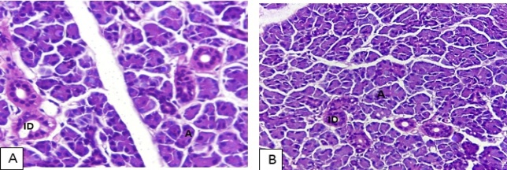
Figure (1): Rat PG in control group, (A) light micrograph of young rat PG shows the normal architecture of the gland, numerous serous acini and intralobular ducts (ID) with distinct lumen. (B) light micrograph of adult rat PG shows the normal architecture of the gland, normal glandular architecture, acini and intralobular ducts (ID) in between (H & E stain original magnification. X1000).

- Subgroup-II (thyroidectomized):
After five weeks thyroidectomy, the histological features of young adult rat PG revealed vascular CT stroma. PG acini showed alteration. Remarkably, intralobular ducts revealed indistinct lumen with colloid-like secretion within their lumen together with rich capillary plexus (Fig. 3-A & B). Ultrastructurally, there were some acinar cells that revealed intracellular inclusions together with widened intercellular canaliculi. In the meantime, the intercalated ducts disclosed indistinct lumen (Fig. 4-A & B).
On the other hand, the adult rat PG parenchyma five weeks after surgery disclosed similar histological features to those reported in the control group, together with dense connective tissue septa in combination with the appearance of fatty tissue infiltration in between the acinar cells. In the meantime, the intercalated ducts revealed distinct lumen (Fig. 3- C & D). Ultrastructurally, it revealed normal pyramidal shaped acini surrounding central narrow lumen. The acini depicted basal nucleus and apical electron dense secretory granules. (Fig. 4- C & D).

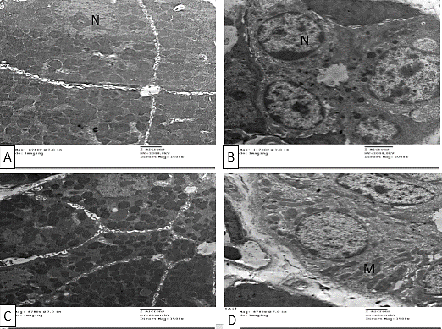
Figure (2): Rat PG in control group, (A-B) young adult rats, (A) Electron micrograph of young rat PG shows pyramidal acini surrounding central narrow lumen. The PG acini shows euchromatic nuclei (N). (B) Electron micrograph shows normalintercalated ducts with distinct lumen. (C-D) Adult rats (C) Electron micrograph of young rat PG shows serous acini with apical electron dense secretory granules. (D) Electron micrograph displays normal striated ducts with its characteristic basal enfolding alternating with vertically oriented mitochondria (M).

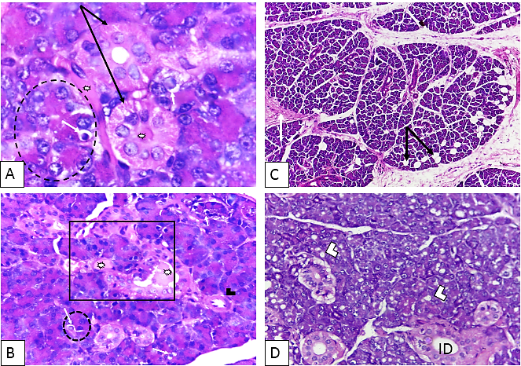
Figure (3): Rat PG in thyroidectomized group, after five weeks. (A-B) young adult rats. (A) Light micrograph, demonstrates close approximation of blood capillary to both intralobular duct and acini. Notice, the acinus (dashed circle) adjacent to blood capillary disclose clear distinction of its proximal site, adjacent to blood capillary, from its distal one. Similarly, the intralobular duct depicts localized change in its surface adjacent to the blood capillary (black arrow). Also, there is a clear-like cell (white arrow) together with colloid-like secretion (asterisk) inside both ductal lumen, blood capillary and acini, (H & E stain, original magnification X 1000). (B) Light micrograph demonstrates a triad formed of closely approximated serous acinar cell, intralobular proliferated duct (squared area) and blood capillary, both ductal lumen and blood capillary contains colloid-like secretory product (asterisk). Notice some changed acinar cells (dashed circle) that contain clear like cell (white arrow), high endothelial venule in a close proximity to both ductal and acinar cells (black arrow head) (H & E stain, original magnification X 400). (C-D) adult rats (C) Light micrograph, shows increased thickness of connective tissue septa (thick white arrow) and intraparenchymal fatty tissue deposition (double arrow head), (H & E stain, original magnification X 100). (D) Light micrograph, displays acinar cytoplasmic vacuolization (arrow head) together with intralobular ducts (ID) with distinct lumen (H & E stain, original magnification X 1000).

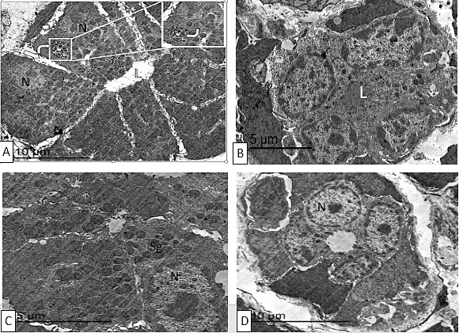
Figure (4): Rat PG in thyroidectomized group, after five weeks. (A-B) young adult rats. (A) Electron micrograph shows secretory serous acinar cells with basal nucleus (N), lumen (L) and apically located multiple secretory granules (Sg) of several sizes. Notice, cellular detachment from the underlying basal lamina (asterisk) together with wide intercellular canaliculi (thick arrow) and intracellular follicular inclusions (budding) formation (angled arrow). Inset showing higher magnification of the squared area. (B) Electron micrograph demonstrates intercalated duct with indistinct lumen (L), with euchromatic nucleus (N). (C-D) adult rats (C) electron micrograph shows pyramidal acinar cells with basally situated heterochromatic nucleus (N) and numerous electron dense apical secretory granules (Sg). Notice, normal intercellular space with prominent canaliculi. (D) Electron micrograph demonstrates intercalated duct with distinct lumen and euchromatic nucleus (N).

4. Discussion
The present study highlighted the effect of thyroid gland surgical ablation on the rat PG of two different aged group of rats.
The rat animal model was used owing to its easily manipulation and relatively small size. Young adult rats with their age (2months old) and adult rats with their age (6 months old) were used. In the former age, many developmental processes are enduring such as postnatal PG branching morphogenesis and functional maturation, thus ensuring cellular plasticity and ability to respond to various stimuli more than the adult aged rats ⁽¹¹⁾.
Remarkably, PG selection as a model for our experiments was based on the previously reported close physiological relation between parotid and thyroid glands ^{(6,7)}.
In the present study, hypothyroidism was successfully produced through complete surgical excision of the thyroid gland. This method was specially used in previous experimental studies on animal models ⁽⁹⁾.
Interestingly, this discussion will focus on two main questions. The first is does there are a relative difference in between young adult and adult PG histological and ultrastructural features after thyroid gland surgical ablation. The second query if the difference is present, what is the possible reasons for this difference between both ages.
The first query is does there is a relative difference in between young adult and adult PG histological and ultrastructural features after thyroid gland surgical ablation, our qualitative (light and electron microscopic) examinations depicted definite concrete differences distinguished the glandular tissue of young aged rats after five weeks of thyroidectomy from those of the adult aged glandular tissue.
five weeks after thyroidectomy in young aged PG, the PG serous acini exhibited close proximity to blood capillaries and altered acinar cells. Ultrastructural results of the current study revealed that the serous acini of PG disclosed widened intracellular canaliculi and intracellular inclusions together with copious amount of different sized and located secretory granules Notably, the present findings are in accordance with the results of Gaikwad et al. (2012) ⁽¹²⁾ who affirmed that the morphological changes in the PG might be an evidence of the withdrawal of a certain part of the glandular parenchyma from functioning as an exocrine secretory unit. As well, the increased vascularity, widening of the intercellular canaliculi and intracellular budding/inclusions might resemble the pre-colloid stage that was reported in developing thyroid gland ⁽¹²⁾.
More importantly, the young PG intralobular ductal cells upon thyroidectomy exhibited great vascularity around them together with colloid-like secretory products within the ductal lumen. These results could be explained by that beside the reported diverse secretory pathways of PG acinar cells which involve either apical/exocrine or basolateral/endocrine pathways ⁽¹³⁾, there is a non-acinar protein secretion pathway via the SD and ExDs. Regarding the SD secretion, Thesleff et al. (1988) ⁽¹⁴⁾ depicted small, secretory vesicles within the cells of the SD in rat PG which were proved to contain bioactive peptides such as epidermal growth factors (EGF), fibroblast growth factors (FGF), insulin-like growth factors (I-LGF), and nerve growth factors (NGF). These vesicles were located in both apical and basal cytoplasm suggesting their exocrine and endocrine secretory pathways, respectively. In the meantime, Tandler et al. (2006) ⁽¹⁵⁾ portrayed that the apical and lateral membranes of the ExDs contained some secretory granules, which depicted different peptide and growth factors, such as FGF, NGF and EGF.
On the other hand, five weeks after thyroidectomy, the adult PG depicted minor changes in the form of increased the thickness of connective tissue stroma. In addition, the PG acini revealed appearance of areas of cytoplasmic vacuolization and fatty tissue infiltration. These results were in accordance with results obtained by Hayat et al., (2010) ⁽⁶⁾. They reported that hypothyroidism induced histological changes in structure of PG including glandular fibrosis and pyknotic acinar nuclei. They concluded that thyroid hormones were essential for PG normal function. In the meantime, the intralobular ducts revealed distinct lumen. Ultrastructurally, the secretory PG acini depicted normal features similar to those reported in control group.
The second query if the difference is present, what is the possible reasons for this difference between both ages. The difference between the response of PG of both ages to thyroidectomy might be based on the previously reported cellular plasticity in young aged rats ⁽¹⁶⁾. Remarkably, some intralobular ducts of young aged rats were surrounded by a rich capillary plexus and contained colloid-like material. The later observation could signify the possibility of transformation of some intralobular ductal cells into thyroid follicular cells.

Conclusion
Thyroidectomy seemed to induce a remarkable cellular change in young adult PG though, minor changes were reported in adult PG. Thus, augments and proves the plasticity of young glandular epithelium and ability to change its fate into thyroid follicular cells after stimulus.

References
- Tresguerres JA, Ariznavarreta C, Granados B, Alvarez-Vega P, Fernandez-Mateos P, Gil-Loyzaga P, et al.: Parotid gland tissue is able partially to assume pituitary functions under the influence of hypothalamic factors: in vivo and in vitro studies. J Endocrinol. 1999; 160:205-216.
- Alvarez-Buylla R and Tsutsumi V: Histo-physiological study of hypophysectomized dogs in which the hypophysis was replaced by parotid gland. Acta Endocrinol. 2005; 25: 12-22.
- Rowzee AM, Perez-Riveros PJ, Zheng C, Krygowski S and Baum BJ: Expression and secretion of human proinsulin-B10 from mouse salivary glands: Implications for the treatment of type-I diabetes Mellitus. PLoS One. 2013; 8: 1-11.
- Ramadan E, Hegab AS, Hussein Y, Abdul Rahman M: Postnatal Developmental Changes of the Parotid Gland in Albino Rats: Histological, Immunohistochemical and Morphometric Study. British J Sci. 2014; 11: 1-15.
- Mandel SJ and Mandel L: Radioactive iodine and the salivary glands. Thyroid. 2003; 13:265-271.
- Matheus G and Moraes NP: Histological study of the thyroids of rats treated with propyl thyouracil, parotidectomyzed and parotidectomyzed treated with propyl thyouracil. Rev Odontol. 1983; 12:47-52.
- Hayat NQ, Tahir M, Munir B and Sami W: Effect of methimazole-induced hypothyroidism on histological characteristics of parotid gland of albino rat. J Ayub Med Coll Abbottabad. 2010; 22:22-27.
- Knight A: The costs and benefits of animal experiments. (1st edition). Hound mills, Basingstoke; New York, Palgrave Macmillan. 2011; pp. 254.
- Cimen SG, Atila K, Cimen S, Sozmen MK and Canda T: Impact of Polyethylene Glycol and Dextran 70 Treatment on Adhesion Formation after Subtotal Thyroidectomy. Int J Surg Res Pract. 2013; 2: 8-12.
- Stokes EL, Elecknell PA and Richardson CA: Reported analgestic and anesthetic administration to rodents undergoing experimental surgical procedure. Lab Anim. 2009; 2: 149-154.
- Fu Y, Rusznak Z, Herculano-Houzel S, Watson C and Paxinos G: Cellular composition characterizing postnatal development and maturation of the mouse brain and spinal cord. Brain Struct Funct. 2013: 218: 1337-1354.
- Gaikwad JR, Santosh KA and Joshi SD: Histogenesis of developing human thyroid. Ind Med Gaz. 2012; 146: 57-61.
- Gorr SU, Venkatesh SG and Darling DS: Parotid secretory granules: crossroads of secretory pathways and protein storage. J Dent Res. 2005; 84:500-509.
- Thesleff I, Viinika L, Saxen L, Lehtonen E and Perheentupa J: The parotid gland is the main source of human salivary epidermal growth factor. Life Sci. 1988; 43: 13-18.
- Tandler B, Gresik EW, Nagato T and Phillips CJ: Secretion by striated ducts of mammalian major salivary glands: review from an ultrastructural, functional, and evolutionary perspective. Anat Rec. 2001; 264:121-145.
- Fujita-Yoshigaki J: Plasticity in differentiation of salivary glands: the signaling pathway that induces dedifferentiation of parotid acinar cells. J Oral Biosci. 2010; 52: 65-71.

2/20/2020

