The Incidence of a Third Head of Biceps Brachii in Egyptian Cadavers

Dr. Kadreya E. Elomrshedy

Anatomy and Embryology Department, Faculty of Medicine, Tanta University, Tanta, Egypt
E-mail: kadreyaelmorshedy@med.tanta.edu.eg

Abstract: Objective: Comparing the incidence of a third head of biceps brachii muscle in Egyptian cadavers to other racial ones. Introduction: A third head of biceps brachii is important both clinically and academically. During routine dissection of cadavers in anatomy department, Tanta and Alexandria universities in Egypt, a third head of biceps brachii was noticed in the upper limb. The third head of biceps brachiimost commonly originated from anteroromedial aspect of the inferior part of shaft of humerus (humeral head).Variations in the biceps brachii muscle heads stands most commonly recognized to cause compression of nearby neurovascular channels which must be respected during armsurgery. Materials and methods: Twenty cadavers were studied for this research. Forty Arms (20 right and 20 left arms) were dissected in the Anatomy Section, Tanta and Alexandria Faculties of Medicine irrespective of age or sex. Results: A third head of biceps brachii was found in two out of forty upper limbs on the left side. Conclusion: awareness of additional head of the biceps brachii in Egyptian population is beneficial in upper limb surgery.
[Kadreya E. Elomrshedy. The Incidence of a Third Head of Biceps Brachii in Egyptian Cadavers. N Y Sci J 2020;13(2):47-51]. ISSN 1554-0200 (print); ISSN 2375-723X (online). http://www.sciencepub.net/newyork. 5. doi:10.7537/marsnys130220.05.

Key words: Biceps brachii, musculocutaneous nerve, supernumerary head, Egyptian, cadavers.

1. Introduction:
Biceps brachii muscle in the anterior arm compartment deriving its name from double-headed muscle originating with a short head from the coracoid process in common with coracobrachialis muscle and a long head arising from the supraglenoid tubercle of the scapula.It’s a flexor and powerful supinator of the forearm (1&2).The two heads fuse in the upper half of the arm to be inserted into the posterior rough part of radial tuberosity. Bicipitalapponeurosis is a medial extension of the biceps tendon that fuses with the deep fascia of forearm over the forearm flexor tendons. It is the only flexor arm muscles crossing the shoulder and the elbow joints acting on both joints (3& 4).(5& 6) have defined the biceps brachii muscle as a uniqueupper limb muscle with the greatestnumerous anatomic discrepancies in the form of accessory heads, third, fourth or fifth heads. The occurrence of this variancedifferscommonly in different people(7).

Aim of the work:
This research was designed to study the frequency of a third head of biceps brachiiin a sample of Egyptian cadavers to link it with other ethnicfrequency from previous researches.

2. Materials and methods:
Twenty cadavers were studied for this research. Forty Arms (20 right and 20 left arms) were dissected in the Anatomy Section, Tanta and Alexandria Faculties of Medicine irrespective of age or sex. The cadavers were immersed in formalin10% for sufficient preservation. The samples werecut up through a verticalcut at the anterior surface of the arm from the acromion process to the elbow region. Dissection and split-up of skin, brachial fascia was done. The muscular system wasuncovered and examined for any disparities. Suitable photos were taken (8).

3. Results:
Distinctorigins of variable frequency of occurrence were noted for a third head of biceps
brachii. 50% of specimens exhibited a 3rd head of biceps brachii in 1 out of the 20 upper limbs (1:20) of brachial origin in which the muscle emerged distally from the medial side of shaft of the humerus, contiguous to and in common with the brachialis(Figs. 1&2). The remaining 20 specimens showed origin of a 3rd head of biceps brachiifrom the medial side of thedeltoid and its area of insertion(the v shaped area on the middle of the anterolateral surface of the humeral shaft) (Figs. 2&3). In all cases, the third head were noted unilaterally, inserted into the common tendon of biceps brachii and established itsnerve supply from the musculocutaneous nerve as the other two heads of the muscle. No other abnormalities were noticed.

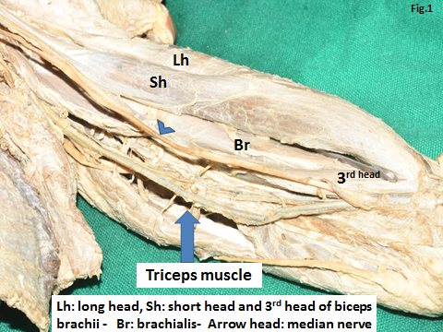
Fig.1: A photograph of left armcadaver showing a 3rd head of biceps brachiioriginated distally from the medial side of the shaft of the humerus, close the brachialis muscle

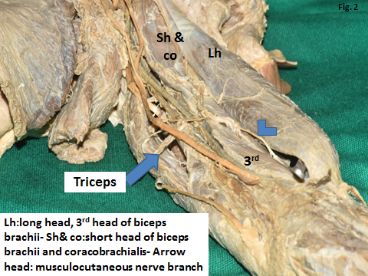

Fig.2: A photograph of the previous part showing amusculocutaneous nerve branch (arrow head) supplying the 3rd head of biceps brachii.
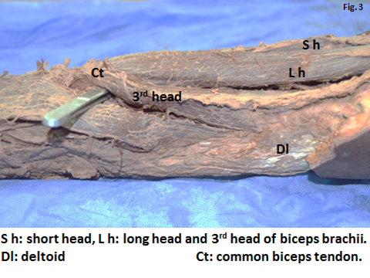
Fig. 3: A photograph of left armcadaver showing the origin of a 3rd head of biceps brachii from the medial aspect of the deltoid muscle and its insertion area (the v shaped area on the middle of the anterolateral surface of theshaft of the humerus)

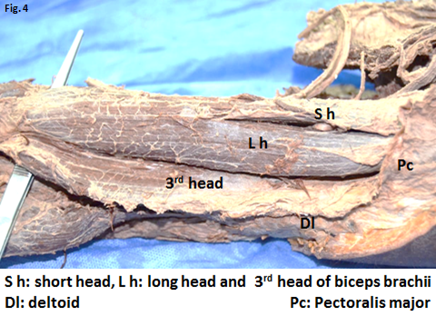
Fig. 4: A magnified photograph of the previous part showing the three headed biceps brachii muscle

4. Discussion:
The Biceps brachii muscle presents a wide series of variations in the form of a bunch of additional fascicles originating from coracoid process, pectoralis minor tendon, proximal head of humerus or articular capsule of humerus ( 9).There cognition of a third head of biceps brachii and its musculocutaneous nerve supplyhas been studied over the preceding time all over the world. Occurrence rates of a third head of biceps brachii have been publicized to differ according to race, sex and body side with the variety of occurred ncestated wide-ranging from 3.3 to 37.5%(10& 11).Gray’s Anatomy stated that the frequency of this difference to be as much as 10% in white European which concurs with the observations of (12& 13) who described the percentage of this anomalyto be about 8 % in Chinese,10% in White European, 12% in Black African ,18% in Japanese, 20.55 % in blacks South African, 8.35 % in South African whites and 37.5 % in Colombians, meanwhile in this research Egyptian cadavers showed a percentage of 0, 05%.Athird head originating from the frontalextremity of the V shaped insertion of deltoid near the pectoralis major tendon insertion was found in one cadaver in this study unilaterally (left sided) which goes hand in hand with Mori, 1964 who reported that supernumerary heads have been described to have the resulting origins as 8% at the distal portion of the deltoid tuberosity, 6% near the coracobrachialis insertion, and finally, 4% at the tendon of pectoralis majorclose to deltoid insertion as was found in one cadaver in this study unilaterally . Other cadaver showed a third head arising from the medial humeral shaft, next to the brachialis muscle unilaterally (left sied) which coincides with (14)who pronounced this disparity of the third head of biceps brachii as a slice of the brachialis muscle servedvia the musculocutaneous nerve, in which the muscle instead of being inserted into the ulna is trans located into the radius.Such variation may be helpful for surgeons operating on the arm other specialties to identify nerve impairment.This third head of biceps brachii muscle may raise the power of flexion and the supination (8&15).The fused higher origin of brachioradialis together with the occurrence of a third head of biceps brachiimay cause compression neuropathy of median nerve and vascular compression signs due to entrapment of brachial artery (3&16).

Conclusion:
Awareness of additional head of the biceps brachiiin Egyptian population is beneficial in management of fracture of humeral shaft, upper limb surgery, radiological assessmentand neurovascular compression syndromes to prevent postoperative complications. The third head of biceps brachiimight be an incidental duringpostmortem or during routine anatomical dissections.These relatively normal incidence rates observed in this study recommends further large sized samples studies regarding race, sex and body side.

References:

Londhe Shashikala. R & Jadhav Ashwini. S (2011): Case Report: Third head of biceps brachii muscle a case study.Biomedical Research (2011) Volume 22, Issue 3.
- Standring,. Sl.; Neel.A.; CRolfe. B and Patricia .C (2016): Gray’s Anatomy the anatomical basis of clinical practice. 41st ed., ISBN: 978-0-7020-5230-9 .British Library Cataloguing in Publication Datahttp://www.elsevier.com.Chap.48, pp.824.

Fating.A.S. &.Salve. V.M. (2011): A third head of the biceps brachii and coexisting fused higher origin of brachioradialis: international journal of anatomical variations (IJAV. 2011; 4: 31–33): www.ijav.org.
- Wahengbam. S.; Karam. R.; Thounaojam.K. & Remei. E (2015): Incidence of Third Head of Biceps Brachii in Indian Population. International Journal of Anatomy and Research, Int J Anat Res 2015, Vol 3(4):1466-70. ISSN 2321- 4287 DOI: http://dx.doi.org/10.16965/ijar.2015.265.
- Poudel. P.& Bhattarai .C. (2009). Study on the supernumerary heads of biceps brachii muscle in Nepalese. Nepal Med. Coll. J. 11(2):96-98.
- Kervancioglu..P &Orthan.M (2011): An anatomical study on three-headed biceps brachii in human fetuses, and clinical relevance. Folia Morphol. (Warsz) 70(2):116-120.
- Kosugi.K, Shibata .S &Yamashita.H (1992). Supernumerary head of biceps brachii and branching pattern of the musculocutaneous nerve in Japanese. Surg. Radiol. Anat. 14:175-185.
- Kumar.H.; Das.S.&Rath.G. (2008): An anatomical insight into the third head of biceps brachii muscle. Bratisl. Lek. Listy 109(2):76-78.
- Sargon.MF.; Tuncali. D.& Celik. H.(1996): An unusual origin for the accessory head of biceps brachii muscle. ClinAnat 1996; 9:160-162.
- Ansari. M, Gupta U.K., LaiqueAhmed. M& Fayya Ali. S (2013): Third Head of Biceps Brachii with Anatomical Consideration and Clinical Implication- A Case Report. Journal of Evolution of Medical and Dental Sciences 2(6):630-634.DOI: 10.14260/jemds/314
- Nasr. A.Y. & Hussein. A.M. (2013): Morphology and clinical implication of the extra-head of biceps brachii muscle. Folia Morphol., 72 (4) (2013), pp. 349-356.
- Bergman. R.A; Thompson.S.A. & Afifi. A.F. (1984): Catalogue of Human Variation. Urban and Schwarzenberg, Munich (1984), pp. 27-30.
- Rai.R.l; Randa.AV.;Prabhu. LV.; Pai. MM. &Prakash (2007): Third head of biceps brachii in an indian population. Singapore Med. J. 48(10):929-931.
- Seetharama.M&Manoj. S (2018): Third Head of Biceps Brachii – A Case Report Int J Ayu Pharm Chem Vol. 9(3): 294-298.
- Roberts.W. (1992): Anomalous course of the median nerve medial to the trochlea and anterior to the medial epicondyle of the humerus. Anat Anz.1992; 174:309-311.
- Yershov.D. & Hudak. R. (2015): Unusual variation of the biceps brachii with possible median nerve entrapment Prague Med. Rep., 116 (2)(2015), pp. 167-172.

1/8/2020

