Assessment of Pancreatic Volume and Fat Content in Type 2 Diabetic Patients by Multi-Detector Computed Tomography

Tarek Gabr Ahmed Zaki Abdellateef, M.B.B.CH.¹, Rania Essam El-Dien Mohammed Ali, MD.², Hanan Ahmad Nagy, MD.³, Waleed Samy Youssef, MD.⁴

¹Ismailia Teaching Oncology Hospital, Egypt.
²professor of Radiodiagnosis & Medical Imagining, Faculty of Medicine, Tanta University, Egypt
³lecturer of Radiodiagnosis and Medical Imaging, Faculty of Medicine, Tanta University, Egypt
⁴professor of Internal Medicine, Faculty of Medicine, Tanta University, Egypt
drtarekgabr@gmail.com, rany1997@yahoo.com, hanan.nagy84@hotmail.com, waleed.samy@med.tanta.edu.eg

Abstract: Background: Fat accumulation in the pancreas and decreased its size can influence pancreatic function attributed to insulin resistance or B-cell dysfunction. Various imaging studies were expected to produce reliable information regarding assessment of any change in pancreatic volume and fat content to provide better, more convenient diagnostic alternatives rather than the needle biopsy techniques. The aim of this study was to assess the value of multidetector computed tomography in estimation of pancreatic volume and fat content with assessment of the relation between these parameters and the development of type 2 diabetes. Results: The type 2 diabetic patients group had relatively smaller pancreatic sizes (mean value of 49.97 ±3.40 cm³), higher pancreatic fat content (mean value of -5.49 ±1.28 HU), and higher laboratory findings to confirm the presenting diabetic history compared to the control group workers who had relatively larger pancreatic sizes (mean value of 63.80 ±5.16 cm³), lower pancreatic fat content (mean value of -2.43 ±0.67 HU), and normal laboratory findings confirming the presenting non-diabetic state. Conclusion: Measurement of pancreatic volume and fat content by multidetector computed tomography can be used as an important tool for screening individuals with high risk for development of type 2 diabetes mellitus.
[Tarek Gabr Ahmed Zaki Abdellateef, Rania Essam El-Dien Mohammed Ali, Hanan Ahmad Nagy, Waleed Samy Youssef. Assessment of Pancreatic Volume and Fat Content in Type 2 Diabetic Patients by Multi-Detector Computed Tomography. N Y Sci J 2020;13(1):24-33]. ISSN 1554-0200 (print); ISSN 2375-723X (online). http://www.sciencepub.net/newyork. 4. doi:10.7537/marsnys130120.04.

Key word: Multidetector computed tomography (MDCT), Pancreatic volume, Pancreatic fat, Type 2 diabetes mellitus.

1. Introduction:
Excessive nutrition and physical idleness lead to increased availability of overabundant free fatty acids and storage of triglycerides in adipose tissue particularly in the abdomen, and subsequently also in non-adipose tissue ^{(1, 2)}.
The deposition of fat in ectopic undesirable sites is attributed to be due to a dysfunctional subcutaneous adipose tissue not able to appropriately store or oxidize the excess energy, this lipid overload is redirected to visceral and ectopic tissues like the liver, muscles and pancreas causing marked insulin resistance, and the pancreas, leading thus to steatosis, lipotoxicity and organ dysfunction ⁽³⁻⁸⁾.
Deposition of fat in the pancreas impacts pancreatic function as the amount of the intra-pancreatic fat has been exceedingly related to pancreatic β-cell dysfunction and therefore development of diabetes ^{(9, 10)}.
Also, it is believed that persons with a larger pancreatic volume had a more B-cells reservoir with higher physiological functions, which can resist the predisposing factors that may precipitate type 2 diabetes development. While others with a smaller pancreatic volume are more liable to develop diabetes, under the same triggers that cause pancreatic damage ⁽¹¹⁻¹⁶⁾.
The retroperitoneal location of the pancreas, its variable shape and occasionally its fuzzy borders make the assessment of its volume and fat accumulation in humans very challenging. Moreover, using pancreatic biopsy as an approach to assess fat accumulation has many disadvantages due to relatively high incidence of procedural complications ^{(17, 18)}.
Various imaging modalities have been employed to quantify pancreatic fat. Ultrasound (US) examination is limited in the evaluation of the entire pancreas due to its location; moreover, it does not provide credible quantitative information. Also, the assessment of volume and/or fat accumulation in the
pancreas by magnetic resonance imaging (MRI), including MR spectroscopy, is very difficult as the pancreas is prone to MR chemical shift artifacts because of its relatively small size, irregular morphology, and surrounding visceral fat ⁽¹⁹⁾.
So, computed tomography (CT) is considered more practical, non-invasive and widely available imaging modality for the pancreas. Additionally, the introduction of multidetector computed tomography (MDCT) as a valuable change along the way of the CT development, has a great increase in acquisition speed, improved spatial resolution, intravenously contrast material bolus timing and reduced motion artifacts, thus facilitating correlation between pancreatic volume and fat content with development of diabetes ^{(20, 21)}.

The aim of this study was to assess the value of multidetector computed tomography in estimation of pancreatic volume and fat content with assessment of the relation between these parameters and the development of type 2 diabetes.

- Methods
  - Patients population:
The current prospective study included a group of 30 adult patients with type 2 diabetes mellitus (T2D group), as proven clinically and confirmed by laboratory investigations and a control group of 10 subjects during the period from May 2018 to May 2019.
Approval of Research Ethics Committee (REC) and informed consent were obtained from all participants in this study after explanation of the benefits and risks of the procedure. Privacy and confidentiality of all patients’ data were guaranteed. All data provision were monitored and used for scientific purpose only.
The included patients were adult diabetic patients with type 2 diabetes with no sex predilection. Exclusion criteria included subjects’ refusal to participate in the research, pediatric patients younger than 18 years old, contraindications or allergy to contrast material, and pregnant females.
  - All the included participants were subjected to the following:
    - Data collection:
Full medical history was obtained from every subject, including name, age, sex, risk factors for diabetes, complete gynaecological and obstetrical history from any female subject in the child-bearing period, and history of any systemic disease or organ failure.

Laboratory investigations were performed for every participant including a 75-grams oral glucose tolerance test (OGTT) performed after fasting for at least 12 hours, fasting plasma glucose (FPG) and post-prandial blood glucose after 2 hours (PG120) and HbA1C. The tests’ results were recorded for correlation with the planned radiological findings.
    - Radiological examination:

All participants were prepared for the radiological examination for assessment of pancreatic volume and pancreatic fat using multidetector computed tomography (MDCT); a 320-detector-row scanner (TOSHIBA Aquilion one).

Image Acquisition:

An initial scout image was taken to determine the table coverage. Axial images of the abdomen were obtained on unenhanced phase. The CT scan acquisition was performed with cranio-caudal direction via using the following parameters: 120 KV, 200 mAs with 3mm slice thickness and lasted approximately for 3 s. A breath hold was required to obtain a fully optimized CT scan of upper abdomen. No oral contrast agent was used.

All the patients were injected by a low osmolality iodinated contrast medium (optiray 350) intravenously, at a rate of 3 ml/s and they were scanned again after contrast injection after the bolus delay time of 60 s (portal phase) using the same parameters and precautions.

Before the patients left the examination room, the available CT images were quickly reviewed on the workstation’s scanner, to insure appropriate coverage and exclude any imaging artefacts requiring rescanning. The IV line was removed.

Image post-processing:

Pancreatic volume assessment:

It was measured in cm³ on axial portal phase images. The boundary of the pancreatic parenchyma was then outlined using the free selection tool installed on the DICOM viewer software, then using the volumetric ability to measure the volume of the selected region in each slide until the entire pancreatic parenchyma in the slice was included, and exclude any adjacent organs.

The pancreatic parenchyma was traced in all the slices, then, pancreatic volume was defined by the summation of the segmented pancreatic area multiplied by the slice interval (3 mm) in each slice. The volume was measured in both control group and T2D group for correlation.

Pancreatic fat assessment:

It was evaluated by using unenhanced images. This was done by evaluating the pancreatic parenchymal attenuation to quantify the pancreatic adipose tissue. We performed an ROI measurement of the HU values of the head, body, and tail of the pancreas as well as, of the spleen on unenhanced images.

Pancreatic attenuation was measured by averaging the HUs of three round ROIs with an area of about 1.5 cm² for each ROI at the three different sites in the pancreas. Care was taken not to include the peripheral margin of the pancreas to avoid any influence of the partial volume effect and of vascular and other adjacent structures. Contrast-enhanced images were used to identify the normal pancreatic parenchyma and vascular structures correctly.

Splenic attenuation was measured by averaging the three HUs at three different sections in the upper, middle, and lower thirds of the spleen, using three ROIs of 1.5 cm².

The difference between pancreatic HU and splenic HU measures (HUp–s = HU pancreas – HU spleen) was used for estimating the pancreatic fat density relative to the spleen. This was done to both control group and T2D group.
    - Statistical analysis:
Data were analysed using statistical program for social science (SPSS) version 21.0. The full detailed form: is SPSS 21, IBM, Armonk, NY, United States of America Quantitative date were expressed as mean± standard deviation (SD). Qualitative data were expressed as number and percentage. Comparison and correlation was done between the Control group and the T2D group, to evaluate the differences in pancreatic volume and fat content between the two groups, and the associated medical significance. The following tests were done:
- Independent-samples t-test of significance was used when comparing between two means.
- Chi-square (X²) test of significance was used in order to compare proportions between two qualitative parameters.
- Pearson’s correlation coefficient (r) test was used for correlating data.
- Probability (P-value): P-value ˂0.05 was considered significant. P-value ˃0.05 was considered insignificant.

3. Results:
Forty subjects were recruited for this prospective study, 30 patients were selected as a group of patients as with type 2 diabetes proven clinically and confirmed by laboratory investigations, and 10 subjects were selected as a control group.
The group of type 2 diabetic patients included 16 males and 14 females with their ages ranged from 21-60 years with mean age of 46± 10.94 years, while the control group included 6 males and 4 females with their ages ranged from 24-60 years with mean age of 45.7±11.65 years.
As regard the laboratory findings, the OGTT, FBG, PG120 and HbA1C showed significantly higher glucose concentration in patients compared to control subjects (P=0.001, in each comparison), as shown in Table (1).

Table (1): The laboratory findings in the two studied groups
 |  | Range |  |  | Mean | ± | S. D | t. test | p. value
OGTT (mg/dl) | T2D | 208 | – | 260 | 233.50 | ± | 17.62 | 403.143 | 0.001*
 | Control | 98 | – | 130 | 113.50 | ± | 11.45
FBG (mg/dl) | T2D | 126 | – | 162 | 144.63 | ± | 10.30 | 296.560 | 0.001*
 | Control | 73 | – | 95 | 83.40 | ± | 7.65
PG120 (mg/dl) | T2D | 229 | – | 310 | 261.00 | ± | 20.06 | 491.431 | 0.001*
 | Control | 105 | – | 127 | 116.20 | ± | 7.39
HbA1c (%) | T2D | 6.9 | – | 11.9 | 9.03 | ± | 1.35 | 110.622 | 0.001*
 | Control | 3.5 | – | 5.3 | 4.36 | ± | 0.58
*= Significant if less than 0.05, T2D= Type 2 diabetes, S. D.= Standard deviation, OGTT=oral glucose tolerance test, FBG= fasting blood glucose, PG120= post-prandial blood glucose.

Regarding the radiological findings, the mean pancreatic volume in patients is significantly lower in comparison to that in control subjects (P=0.001). On the other hand, the difference in fat density between pancreas and spleen (HUp-s) is significantly higher in patients compared to control subjects, as shown in Table (2).

Table (2): The radiological findings in the two studied groups
 |  | Range |  |  | Mean | ± | S. D | t. test | p. value
Pancreatic volume (cm3) | T2D | 45 | – | 55 | 49.97 | ± | 3.40 | 94.920 | 0.001*
 | Control | 55 | – | 70 | 63.80 | ± | 5.16
Pancreatic fat (HUp-s) | T2D | -21.3 | – | -6.4 | -13.41 | ± | 4.84 | 88.247 | 0.001*
 | Control | -5.9 | – | 15 | 4.36 | ± | 6.16
*= Significant if less than 0.05, T2D= Type 2 diabetes, S. D.= Standard deviation, HUp-s= difference in fat density between pancreas and spleen.

The correlation was done between the laboratory findings representing diabetes confirmation, disease progression or exclusion, and the radiological data representing the pancreatic affection regarding its size and fat content, it was noticed that:
The control group had larger pancreatic sizes, lower pancreatic fat contents, and lower/ normal laboratory findings proving normal non-diabetic individuals (Figure 1a, 1b).

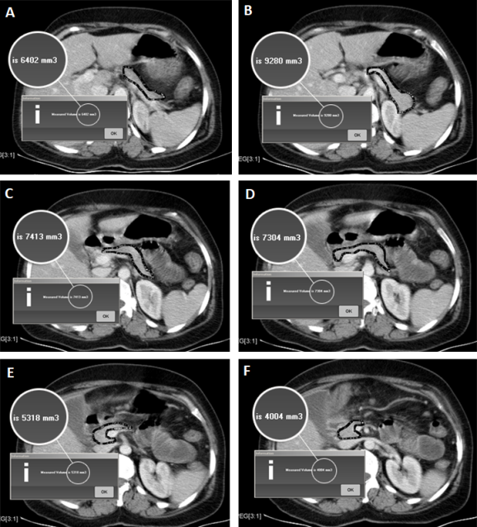

Figure 1a: A 56 years old male patient with nohistory of T2D, laboratory tests were performed, OGTT=115 mg/dl, FBG= 92mg/dl, PG120= 126 mg/dl and HbA1C= 5.3%. Contrast enhanced abdominal CT images (portal phase) (A-F) for measuring the pancreatic volume which is referred to as (a black colored thick line surrounding the pancreatic parenchyma), It revealed a total volume of 62cm³.

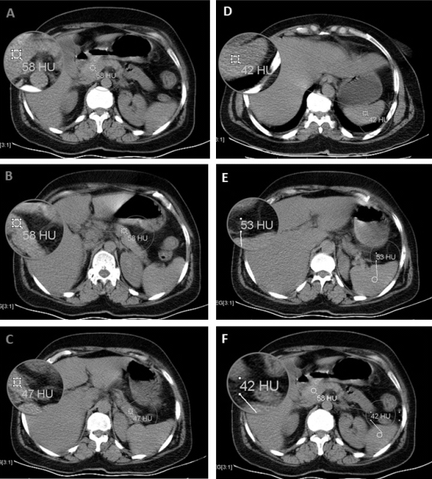

Figure 1b: Non-contrast enhanced abdominal CT images for evaluation of pancreatic fat content by measuring the Hounsfield unit in pancreatic head (A), body (B), and tail (C) and in spleen at the upper, middle and lower third (D-F), and measuring HUp-s, revealed a pancreatic fat index of 8.6 HU.

The T2D group had smaller pancreatic sizes, higher pancreatic fat contents, and higher laboratory findings (OGTT, FBG, PG120 and HbA1C) in patients with different diabetes control (Figure 2a, 2b, 3a, 3b, 4a, 4b).

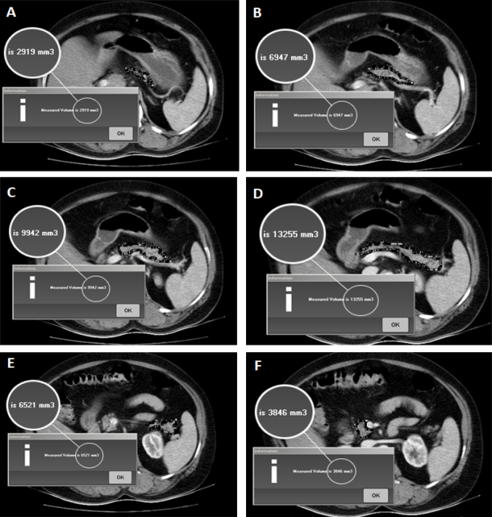

Figure 2a: A 60 years old male patient with history of T2D, laboratory tests were performed to check the diabetic state, OGTT=212 mg/dl, FBG= 143mg/dl, PG120= 257 mg/dl and HbA1C= 7.6%. Contrast enhanced abdominal CT images (portal phase) (A-F) for measuring pancreatic volume, revealed a total volume of 45cm³.

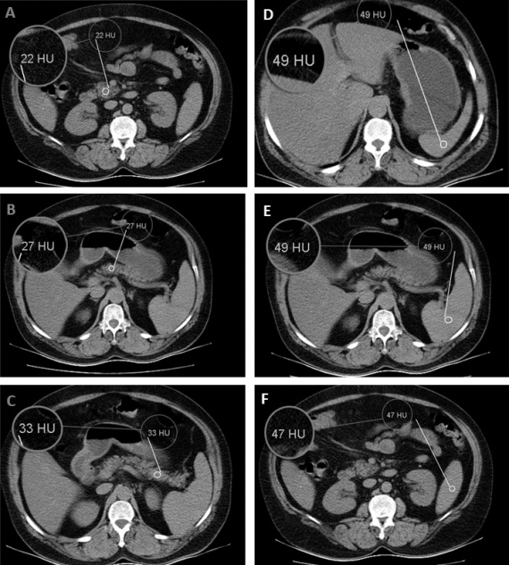
Figure 2b: Non-contrast enhanced abdominal CT images for evaluation of pancreatic fat content by measuring the Hounsfield unit in pancreatic head (A), body (B), and tail (C) and in spleen at the upper, middle and lower third (D-F), and measuring HUp-s, revealed a pancreatic fat index of -21 HU.

These findings are demonstrated in more details in table (3).

Table (3): The correlation between the laboratory findings and the radiological data obtained
 | Pancreatic volume (cm3) |  | Pancreatic fat (HUp-s)
 | (r) | p. value | (r) | p. value
OGTT (mg/dl) | - 0.487 | 0.006* | - 0.496 | 0.005*
FBG (mg/dl) | - 0.523 | 0.003* | - 0.538 | 0.002*
PG120 (mg/dl) | - 0.798 | 0.001* | - 0.804 | 0.001*
HbA1c | - 0.701 | 0.001* | - 0.703 | 0.001*
(r) =Pearson’s correlation coefficient, *= Significant if less than 0.05, OGTT=oral glucose tolerance test, FBG= fasting blood glucose, PG120= post-prandial blood glucose, HbA1C= glycosylated hemoglobin, HUp-s= difference in fat density between pancreas and spleen.

4. Discussion
Pancreatic size and intra-pancreatic fat is thought to be related in some way with the parameters of beta-cell function. Experimental data indicate that adipocyte infiltration of pancreatic islets could contribute to β-cell dysfunction ^{(22).}
The age of the studied diabetic patients ranged from 21-60 years with mean value of 46±10.94 years and the majority of the patients with type 2 diabetes were at the age group from 51 to 60 years, the age was insignificant is our study between the two groups, and had no significant affection on the pancreatic volume and fat content. Tushuizen et al 2007⁽²³⁾ had conducted a similar study on 42 subjects aged 35–65 years with and without type 2 diabetes, with diabetic group aged a mean value of 54.6±2 years, The diabetic and healthy groups did not differ significantly with respect to age. These results agrees with Lim et al 2014 ⁽²²⁾ study. However, a study conducted by Saisho et al 2007 ⁽²⁴⁾ reported that the pancreatic volume is increasing relatively rapidly during childhood, and it reaches a maximum in the third decade of life, and decline gradually over time, it demonstrated also a positive correlation between aging and increased pancreatic fat.
Sex distribution in diabetic patients was 53.3% male and 46.7% female, where a study done by Toledo-Corral et al 2013 ⁽²⁵⁾ included 50% diabetic male and 50% diabetic female., Kim et al 2014 ⁽²⁰⁾ in a similar study recruited 29 diabetic patients with 68% male and 32% female distribution, all of these studies showed no statistically significant data regarding sex difference. Whereas a study of Lim et al 2014⁽²²⁾, which was conducted to 28 men and 22 women in both groups revealed that male subjects in the both group had a significantly greater mean pancreatic volume than did female subjects in the same group, but no sex significant affection upon the fat contents.
In the current study, laboratory investigations were done to both study groups to confirm the diabetic condition in the diabetic group and correlate the findings with the imaging data obtained, OGTT, FBG, PG120 and HbA1C were performed to both groups and the revealed laboratory values proved the previously expected increased all laboratory values in the diabetic group, where the FBG in the diabetic group recorded mean value of 144.6±10.3 mg/dl, and PG120 mean value of 261±20.06mg/dl and HbA1C mean value of 9.03±1.35%, the study also reported a positive association with the pancreatic fat content and negative association with the pancreatic volume.
These results agrees with Tushuizen et al 2007 ⁽²³⁾ study, which showed significantly increased FBG, PG120 and HbA1c values in the diabetic group, where the mean value of FBG was 147.7±9mg/dl and HbA1C mean value of 7.2±0.3%, in addition to increased serum insulin and serum Triglyceride levels in the diabetic patients compared to the non-diabetic (normal) group, similar findings is reported in other two studies by Heni et al 2010 ⁽¹⁰⁾, and Begovatz et al 2015 ⁽²⁶⁾.
In the present study, the pancreatic volume measured by MDCT was noted to be decreased in the diabetic group compared to the control group, where it recorded a mean value of 49.97±43 cm³ in the diabetic group and 63.8±5.16 cm³ in the control group, these results agrees with Lim et al 2014 ⁽²²⁾, who divided the diabetic patients into three subgroups ( newly diagnosed diabetic, diabetic patients for less than 5 years, and diabetic patients for more than 5 years), the revealed results showed nearly the same significant decrease in the pancreatic volume in all diabetic patients compared to the normal individuals, where it recorded a mean value of 49.1±16 cm³ in the diabetic group and 66.3±13.9 cm³ in the control group, it demonstrated also that the longer duration of diabetes had a more deteriorating effect on the pancreatic volume causing it to be much smaller.
Macauley et al 2015 ⁽²⁷⁾, reported that the mean pancreatic volume measured by MRI was found to be 33% less in type 2 diabetes than in normal subjects, where it recorded a mean value of 55.5±2.8 cm³ in the diabetic group and 82.6±4.8 cm³ in the control group, but it noted that no correlation could be found between the duration of diabetes and the pancreatic volume, this may be attributed to using different imaging modality assessing the pancreatic volume. Similar study by Burute et al 2014 ⁽²⁸⁾, comparing the diabetic and normal group, using also MRI in assessing the pancreatic volume, stated that patients with type 2 DM had significantly lower pancreatic volumes than normo-glycemic individuals, where it recorded a mean value of 72.7±20.7 cm³ in the diabetic group and 89.6±22.7 cm³ in the normal group.
Goda et al 2001 ⁽¹³⁾ reported that CT was useful for the measurement of the pancreatic volume, and the pancreatic volume was reduced in the patients with type 2 DM, where it recorded a mean value of 68.7.5±18.8 cm³ in the diabetic group and 71.5±18.7 cm³ in the normal group, Whereas Saisho et al 2007 ⁽²⁴⁾, showed that the total pancreas volumes are decreased in subjects with type-2 diabetes compared with nondiabetic subjects, where it recorded a mean value of 70.0±26.5 cm³ in the diabetic group and 74.9±27 cm³ in the control group, but it showed another negative association with aging as described before.
In the current study, the pancreatic fat content measured by MDCT attenuation values was noted to be significantly increased in the diabetic group compared to the control group, where the pancreatic CT index (HUp-s) recorded a mean value of -5.49±1.28 HU in the diabetic group and -2.43±0.67 HU in the control group, this copes with a study by Lim et al 2014 ⁽²²⁾, who divided the diabetic patients into three subgroups according the duration of diabetes as described before, and the revealed results showed nearly same significant increase in the pancreatic fat content in the diabetic group compared to the normal non-diabetic individuals, where the HUp-s recorded a mean value of -4.6±6.9 HU in the diabetic group and -1.4±8.1 HU in the control group. It is reported also that the longer duration of diabetes had a positive association with the pancreatic fat.
Kim et al 2014 ⁽²⁰⁾ performed their study in order to detect the relationship between the indices of computed tomography (CT) and the amount of pancreatic fat measured histologically in surgical specimens and to evaluate patients with impaired glucose metabolism, they realized that pancreatic fat can be quantified by using CT attenuation indices where the pancreatic CT index (HUp-s) recorded a mean value of -6.8±7.1 HU in the diabetic group and -3.4±4.4 HU in the control group. Lee et al 2009 ⁽²⁹⁾, agreed with the present report after he suggested that subjects with fatty pancreas, measured by both ultrasonography and CT using HUp-s method, showed higher insulin resistance. Toledo-Corral et al 2013⁽²⁵⁾, using MRI and OGTT for correlation, reported also that subjects with prediabetes had 30% higher pancreatic fat content, compared to those with normal glucose tolerance after controlling for age and sex.
In contrast to the present study, Saisho et al 2007 ⁽²⁴⁾ reported that there is no difference in fat contents between subjects with type-2 diabetes compared with the non-diabetic subjects. This may be attributed to different imaging techniques used to evaluate the pancreatic fat content by depending on the pancreatic CT attenuation alone and absence of evaluation of the splenic fat and HUp-s, which is thought to be more accurate.
Limitation: This study was limited by the small number of participating subjects. In this study we measured pancreatic volume, not b-cell mass. Also this was a cross-sectional analysis that could not prove cause-and-effect relationships and further longitudinal studies with serial measurements are needed to achieve this purpose.

Conclusion:
The present study suggests that pancreatic volume and fat deposition may have a great role in the development of type 2 diabetes, and that measuring pancreatic volume and fat content will be beneficial to prove the change in their parameters as a consequence of the type 2 diabetes disease process and for screening individuals at high risk.
We recommend adding pancreatic volumetry and fat content measurement by the previously discussed techniques to the contrast enhanced abdominal CT study protocols, especially for individuals at risk of developing type 2 diabetes, for prediction of any upcoming expected insulin resistance, which may progress by time to type 2 diabetes, and redirect those with positive imaging findings to the internal medicine department for further clinical and laboratory diagnostic approaches.
List of abbreviations: FBG= fasting blood glucose, HbA1C= glycosylated hemoglobin, HUp-s= difference in fat density between pancreas and spleen, MDCT= multidetectior computed tomography, OGTT=oral glucose tolerance test, PG120= post-prandial blood glucose, ROI= region of interest, SD= Standard deviation, T2D= Type 2 diabetes.

References:
- Schrauwen‐Hinderling VB, Kooi ME, Hesselink MK, et al (2005) Intramyocellular lipid content and molecular adaptations in response to a 1‐week high‐fat diet. Obesity research 13(12):2088-94.
- Oh YS, Baek DJ, Park E-Y, et al (2018) Fatty acid-induced lipotoxicity in pancreatic beta-cells during development of type 2 diabetes. Frontiers in endocrinology 9:384.
- Stannard SR, Thompson MW, Fairbairn K, et al (2002) Fasting for 72 h increases intramyocellular lipid content in nondiabetic, physically fit men. American Journal of Physiology-Endocrinology and Metabolism 283(6):E1185-E91.
- Camastra S, Manco M, Mari A, et al (2005) β-Cell function in morbidly obese subjects during free living: long-term effects of weight loss. Diabetes 54(8):2382-9.
- Gastaldelli A (2011) Role of beta-cell dysfunction, ectopic fat accumulation and insulin resistance in the pathogenesis of type 2 diabetes mellitus. Diabetes research and clinical practice 93:S60-S5.
- Després J-P (2012) Body fat distribution and risk of cardiovascular disease. Circulation 126(10):1301-13.
- Szendroedi J, and Roden M (2009) Ectopic lipids and organ function. Current opinion in lipidology 20(1):50-6.
- Wang M-Y, Grayburn P, Chen S, et al (2008) Adipogenic capacity and the susceptibility to type 2 diabetes and metabolic syndrome. Proceedings of the National Academy of Sciences 105(16):6139-44.
- Tushuizen ME, Bunck MC, Pouwels PJ, et al (2008) Lack of association of liver fat with model parameters of β-cell function in men with impaired glucose tolerance and type 2 diabetes. European journal of endocrinology 159(3):251-7.
- Heni M, Machann J, Staiger H, et al (2010) Pancreatic fat is negatively associated with insulin secretion in individuals with impaired fasting glucose and/or impaired glucose tolerance: a nuclear magnetic resonance study. Diabetes/metabolism research and reviews 26(3):200-5.
- Fonseca V, Berger L, Beckett A, et al (1985) Size of pancreas in diabetes mellitus: a study based on ultrasound. British medical journal (Clinical research ed) 291(6504):1240.
- Sakata N, Egawa S, Rikiyama T, et al (2011) Computed tomography reflected endocrine function of the pancreas. Journal of Gastrointestinal Surgery 15(3):525-32.
- Goda K, Sasaki E, Nagata K, et al (2001) Pancreatic volume in type 1 und type 2 diabetes mellitus. Acta diabetologica 38(3):145-9.
- Williams AJ, Thrower SL, Sequeiros IM, et al (2012). Pancreatic volume is reduced in adult patients with recently diagnosed type 1 diabetes. The Journal of Clinical Endocrinology & Metabolism 97(11):E2109-E13.
- Yoon K-H, Lee J-H, Kim J-W, et al (2006) Epidemic obesity and type 2 diabetes in Asia. The Lancet 368(9548):1681-8.
- Chan JC, Malik V, Jia W, et al (2009) Diabetes in Asia: epidemiology, risk factors, and pathophysiology. Jama 301(20):2129-40.
- Djuric-Stefanovic A, Masulovic D, Kostic J, et al (2012) CT volumetry of normal pancreas: correlation with the pancreatic diameters measurable by the cross-sectional imaging, and relationship with the gender, age, and body constitution. Surgical and radiologic anatomy 34(9):811-7.
- Schrader H, Menge BA, Schneider S, et al (2009) Reduced pancreatic volume and β-cell area in patients with chronic pancreatitis. Gastroenterology 136(2):513-22.
- Hu HH, Kim HW, Nayak KS, et al (2010) Comparison of fat–water MRI and single‐voxel MRS in the assessment of hepatic and pancreatic fat fractions in humans. Obesity 18(4):841-7.
- Kim SY, Kim H, Cho JY, et al (2014) Quantitative assessment of pancreatic fat by using unenhanced CT: pathologic correlation and clinical implications. Radiology 271(1):104-12.
- Lee ES, and Lee JM (2014) Imaging diagnosis of pancreatic cancer: a state-of-the-art review. World journal of gastroenterology: WJG 20(24):7864.
- Lim S, Bae JH, Chun EJ, et al (2014) differences in pancreatic volume, fat content, and fat density measured by multidetector computer tomography according to the duration of diabetes. Aca diabetologica 51(5):739-48.
- Tushuizen ME, Bunck MC, Pouwels PJ, et al (2007) Pancreatic fat content and β-cell function in men with and without type 2 diabetes. Diabetes care 30(11):2916-21.
- Saisho Y, Butler A, Meier J, et al (2007) Pancreas volumes in humans from birth to age one hundred taking into account sex, obesity, and presence of type‐2 diabetes. Clinical anatomy 20(8):933-42.
- Toledo-Corral CM, Alderete TL, Hu HH, et al (2013) Ectopic fat deposition in prediabetic overweight and obese minority adolescents. The Journal of Clinical Endocrinology & Metabolism 98(3):1115-21.
- Begovatz P, Koliaki C, Weber K, et al (2015) Pancreatic adipose tissue infiltration, parenchymal steatosis and beta cell function in humans. Diabetologia 58(7):1646-55.
- Macauley M, Percival K, Thelwall PE, et al (2015) Altered volume, morphology and composition of the pancreas in type 2 diabetes. PloS one 10(5):e0126825.
- Burute N, Nisenbaum R, Jenkins DJ, et al (2014) Pancreas volume measurement in patients with Type 2 diabetes using magnetic resonance imaging-based planimetry. Pancreatology 14(4):268-74.
- Lee JS, Kim SH, Jun DW, et al (2009) Clinical implications of fatty pancreas: correlations between fatty pancreas and metabolic syndrome. World journal of gastroenterology: WJG 15(15):1869.

12/25/2019

