Admission Hyperglycemia as a Predictor of Adverse Outcome in Non-Diabetic STEMI Patients Treated by Primary Percutaneous Coronary Intervention

Marwa R. salama MSc, Ayman M. El saeed MD, Taymoor M. Abd Allah MD and Ahmed F. Abd El Gawad Elaarag MD.

Cardiology Department, Faculty of Medicine, Tanta University, Egypt.

Abstract: Background: Admission hyperglycemia is associated with high inhospital and long-term adverse events in patients that undergo primary percutaneous coronary intervention (PCI). Objectives: measure admission blood glucose level in non diabetic patients with acute ST-elevation myocardial infarction who were treated by primary PCI as a predictor of inhospital mortality. Methods: The patients were analyzed in subgroups categorized according to the groups of admission glucose measurements. Group I (glucose equal or less than 110 mg/dl) - Group II (glucose from 111 to 130 mg/dl) - Group III (glucose level above 131 mg/dl.). The study compared between those three groups in the acute stage during hospitalization of the patients according to TIMI Flow and Major Adverse cardiac event (MACE) (Cardiogenic shock - Periprocedural Death Ventricular arrhythmia – Re infarction- Contrast induced nephropathy Acute heart failure). Results: High admission blood glucose associated with more LV systolic dysfunction. In addition recurrent anginal attacks, arrhythmias and cardiogenic shock were also more frequent among those patients. Hyperglycemia can cause QT-interval prolongation, which can trigger ventricular arrhythmias in those with underlying coronary artery disease. also associated with increase risk for developing contrast induced nephropathy In Our study we found that Patients with elevated blood glucose level had high level of CKMB due to more necrosis of myocardium. Also had high risk for developing TIMI 0 or “no-reflow” and peri-procedural death - cardiogenic shock – ventricular arrhythmia- acute heart failure –re infarction – contrast induced nephropathy.
[Marwa R. salama, Ayman M. El saeed, Taymoor M. Abd Allah and Ahmed F. Abd El Gawad Elaarag. Admission Hyperglycemia as a Predictor of Adverse Outcome in Non-Diabetic STEMI Patients Treated by Primary Percutaneous Coronary Intervention. N Y Sci J 2019;12(12):72-79]. ISSN 1554-0200 (print); ISSN 2375-723X (online). http://www.sciencepub.net/newyork. 10. doi:10.7537/marsnys121219.10.

Keywords: hyperglycemia, ST-segment elevation myocardial infarction, mortality, major adverse cardiac events

1. Introduction
Diabetes and cardiovascular diseases (CVD) sometimes appear as twin pathologies. On one side, diabetes mellitus (DM) has always been accompanied with coronary artery disease (CAD), and on the other hand, many patients with established coronary artery disease (CAD) are found to be diabetics or suffering from one of its pre-states. ¹
Although DM is a prominent risk factor for CAD, new information is now available suggesting the need for a careful consideration not only for DM, but also of other disturbances of glucose metabolism, such as impaired glucose tolerance (IGT), to the degree that some reviews consider it as an independent risk factor for cardiovascular disease morbidity and mortality. ²
Previous studies have indicated that there is an increased prevalence of glucose abnormalities in patients admitted with acute coronary syndromes (ACSs), both during and after stay in the coronary care unit (CCU), in those with and without known diabetes mellitus (DM).³
Patients with DM and even impaired glucose tolerance have increased severity of coronary artery disease (CAD). Impaired glucose metabolism during acute coronary events in non diabetic patients could be due to stress-induced activation of cortisol and noradrenaline, growth hormone, and glucagon release. In patients with and without known DM, increased glucose concentrations on admission are known to be predictive of long-term morbidity and mortality and could be used as a marker for risk score assessment.⁴
Aim of the Work
This work aims to determine the potential association between serum blood glucose at admission and mortality, major adverse cardiac events and angiographic findings in patients presenting by STEMI and treated by primary PCI.

2. Patients and methods:
This study was conducted on non-diabetic patients admitted with STEMI and treated with primary PCI at cardiovascular medicine department Tanta university hospitals within 6 months starting from June 2018. The patients were analyzed in subgroups categorized according to the groups of admission glucose measurements. Group I (glucose
equal or less than 110 mg/dl) - Group II (glucose from 111 to 130 mg/dl) - Group III (glucose level above 131 mg/dl.). The study compared between those three groups in the acute stage during hospitalization of the patients according to TIMI Flow and Major Adverse cardiac event (MACE) (Cardiogenic shock - Periprocedural Death Ventricular arrhythmia–Reinfarction- Contrast induced nephropathy Acute heart failure).
Exclusion criteria included patients with prior diabetes mellitus- Patients known to have prior myocardial infarction - Patients with history of prior CABG - Patients with history of bleeding diathesis - patient with history of malignant disease.
Duration of the study: This study was done in six months starting from June 2018.
Statistical Methods
The analysis was calculated by SPSS version 25. Furthermore, the qualitative parameters were described by number of frequency and percentage while the quantitative variables were described by mean, standard deviation and range. In addition, comparison of quantitative variables between the three groups was calculated by Anova test while the comparison of qualitative variables between the three groups were calculated by Chi Square test or Monte Carlo test according to the expected count in the table cells. (P value less than 0.04 consider statistical significant).

3. Results
Patient demographics: The age of the study population ranged from 39 to 80 years. In group I, the age of the patients ranged from (42 -80) years with a mean age of 59.83 ± 10.118 years. In group II the age ranged from (40-78) years with a mean age of 60 ± 10.195 years. In group III the age ranged from (39-76) years with a mean age of 58.72 ± 9.896. There was no statistically significant difference between the three groups (P value =0.771).
Prevalence of risk factors; 100 of the study population appeared to have dyslipidemia. In group I, 25 patients (54.3%). In group II, 18 patients (56.2%). while in group III 57 patients (79.16%). There was statistically significant difference between the three groups (P value =0.007).

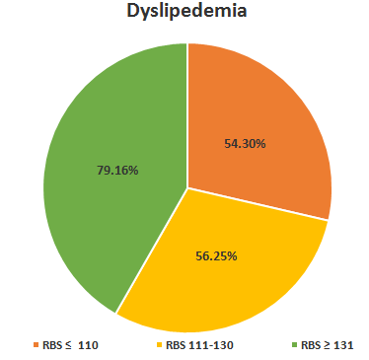
Figure 1: A pie chart showing a comparison of the incidence of dyslipdemia among the three studied groups

Table 1: difference between three groups according to demographic data
 | RBS ≤ 110  Mean ± SD (range)  N=46 | RBS 111-130  mean ± SD (range)  N=32 | RBS ≥ 131  mean ± SD (range)  N=72 | F | P Value
Age | 59.83 ± 10.118  (42 - 80) | 60 ± 10.195  (40 -78) | 58.72 ± 9.896  (39 -76) | F = 0.26 | 0.771
Dyslipedemia | 25 (54.3 %) | 18 (56.25%) | 57 (79.16%) | X²= 9.77 | 0.007

Angiographic finding:
There was no statistical significant difference between three groups according to number of diseased vessel and culprit vessel. According to TIMI flow Group I Final TIMI flow two patients had TIMI flow 0 (4 %), 5 patients had TIMI I flow (11%)- 11 patients had TIMI II flow (24%) and 28 patients had TIMI III flow (61%). Group II Final TIMI flow five patients had TIMI flow I (15 %), 5 patients had TIMI II flow (16%)- 22 patients had TIMI III flow (69 %). Group III: Final TIMI flow: three patients had TIMI flow 0 (4 %), 12 patients had TIMI I flow (17%)- 37 patients had TIMI II flow (51%) and 20 patients had TIMI III flow (28%). There was statistically significant difference between three groups P value = 0.0004 regarding final TIMI flow.

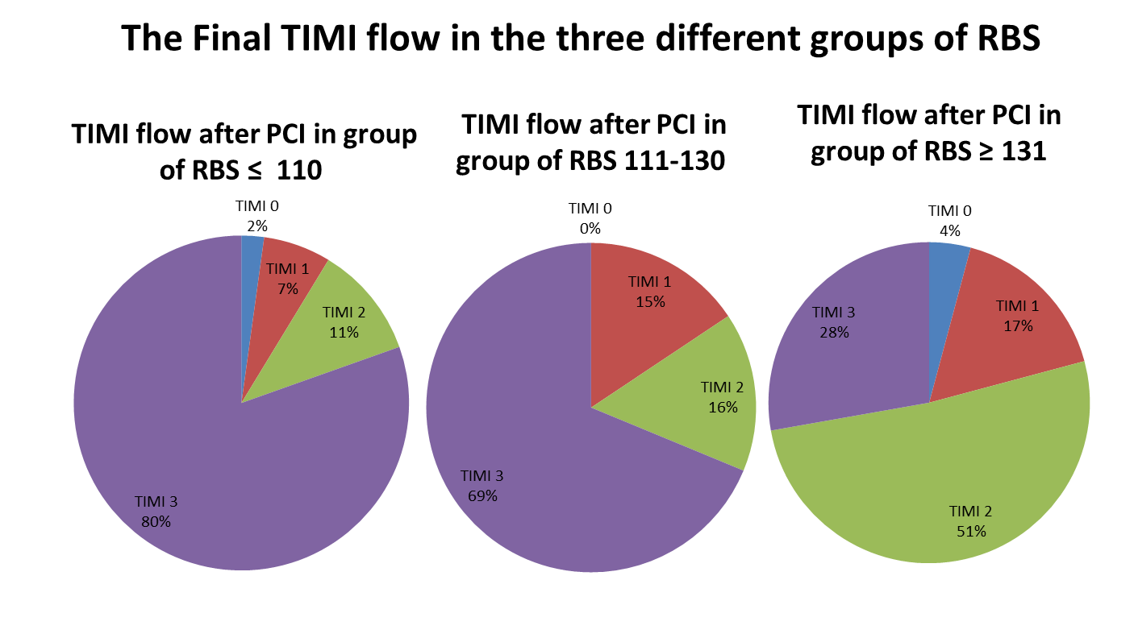
Figure 2: show TIMI flow in three groups.

Table 2: difference between three groups according to angiographic result:
 |  | RBS ≤ 110  Percentage (%)  N=46 | RBS 111-130  Percentage (%)  N=32 | RBS ≥ 131  Percentage (%)  N=72 | X² | P Value
Culprit | LAD | 25 (54.3%) | 20 (61.5%) | 44 (61.1%) | 3.489 | 0.951  Calculated by Monte Carlo
 | LCX | 3 (6.5%) | 3 (9.4%) | 5 (6.9%)
 | RCA | 16 (34.8%) | 8 (25%) | 21 (29.2%)
 | ramus | 1 (2.2%) | 0 (0%) | 0 (0%)
 | diagonal | 1 (2.2%) | 1 (3.1%) | 2 (2.8%)
Number diseased vessel | 1 | 13 (28.3%) | 13 (40.6%) | 28 (38.9%) | 3.201 | 0.525
 | 2 | 16 (34.8%) | 6 (18.8%) | 20 (27.8%)
 | 3 | 17 (37%) | 13 (40.6%) | 24 (33.3%)
TIMI after | TIMI 0 | 1 (2.2%) | 0 (0%) | 3 (4%) | 38.5 | <0.001*
 | TIMI 1 | 3 (6.5%) | 5 (15%) | 12 (17%)
 | TIMI 2 | 5 (10.9%) | 5 (16%) | 37 (51%)
 | TIMI 3 | 37 (80.4%) | 22 (69%) | 20 (28%)

Laboratory investigations:
As regard baseline lab investigations there was no statistically significant difference between three groups. According to CKMB in group I CKMB level ranged from 10 – 80 with mean 29.7 ± 13.3, in group II CKMB level ranged from 10 – 120 with mean 64.3 ± 24.5 while in group III CKMB level ranged from14-247 with mean of 119.5 ±37.2. There was statistically significant difference between the three groups (P value =0.001).

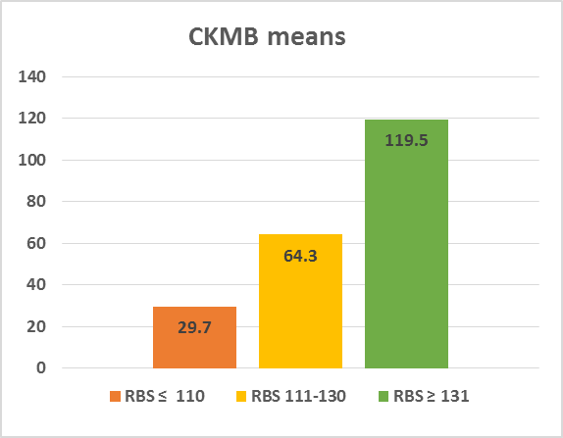
Figure 3: a comparison of the means of CKMB levels among the three studied groups

Echocardiographic findings: in group I ranged from 32%-77% with median 52.26± 12.02, - in group II it ranged from 30%-60% with median 46.56 ± 7.255 while in group III it ranged from 29%-62% with median 44.194 ±8.13. There was statistically significant difference between the three groups (P value =0.002).

Table 3: showing difference between three groups according to ejection fraction.
 |  | RBS ≤ 110  Percentage (%)  N=46 | RBS 111-130  Percentage (%)  N=32 | RBS ≥ 131  Percentage (%)  N=72 | X² | P Value
EF |  | 52.26 ± 12.02  (32 - 77) | 46.56 ± 7.255  (30 - 60) | 44.194 ± 8.13  (29 - 62) | 6.39 | 0.002*

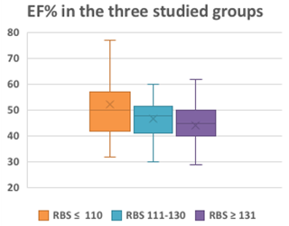
Figure 4: show ejection fraction in three groups

Major Adverse Cardiac Event (MACE):
Periprocedural Death: In group I no patient had periprocedural death - In group II one patients had periprocedural death (3.1%) - In group III sex patients had periproceduarl death (9.7 %) - There was statistically significant difference between the three groups (P value =0.04 calculated by Monte Carlo).
Cardiogenic shock: In group I two patients had cardiogenic shock (4.3%) - In group II five patients had cardiogenic shock (15.6 %) - In group III 15 patients had cardiogenic shock (20.8 %). There was statistically significant difference between the three groups (P value =0.04 calculated by Monte Carlo).
Ventricular arrhythmia: In group I three patients had ventricular arrhythmia (6.5%) - In group II eight patients had ventricular arrhythmia (25%) - In group III 20 patients had ventricular arrhythmia (27.8%) There was statistically significant difference between the three groups (P value =0.017).
Re-infarction: In group I one patients had re-infarction (2.17%) - In group II four patients had re-infarction (12.5%) - In group III 13 patients had re-infarction (18.05%). There was statistically significant difference between the three groups (P value =0.034 calculated by Monte Carlo).
Contrast induced Nephropathy (CIN): In group I no patients had CIN - In group II three patients had CIN (9.3%) - In group III ten patients had CIN (13.9%). There was statistically significant difference between the three groups (P value =0.03 calculated by Monte Carlo).
Acute heart failure (AHF): In group I two patients had AHF (4.3%) - In group II five patients had AHF (15.6%) - In group III 16 patients had AHF (22.2%). There was statistically significant difference between the three groups (P value =0.031 calculated by Monte Carlo).

Table 4: show difference between three groups according to adverse cardiac event.
 | RBS ≤ 110 | RBS 111-130 | RBS ≥ 131 | X² | P Value Calculated by Monte Carlo
 | Percentage (%) | Percentage (%) | Percentage (%)
 | N=46 | N=32 | N=72
Periprocedural Death | 0 | 1 (3.1%) | 6 (9.7%) | 5.647 | 0.045*
 |  |  |  |  | Calculated by Monte Carlo
Cardiogenic Shock | 2 (4.3%) | 5 (15.6%) | 15 (20.8%) | 6.124 | 0.046*
Ventricular Arrhythmia | 3 (6.5%) | 8 (25%) | 20 (27.8%) | 8.2 | 0.017*
Re-infarction | 1(2.17%) | 4(12.5%) | 13(18.05%) | 6.713 | 0.034*  Calculated by Monte Carlo
CIN | 0 | 3(9.3%) | 10(13.9%) | 6.86 | 0.03*
 |  |  |  |  | Calculated by Monte Carlo
Acute heart failure | 2 (4.3%) | 5 (15.6%) | 16(22.2%) | 6.91 | 0.031*
 |  |  |  |  | Calculated by Monte Carlo

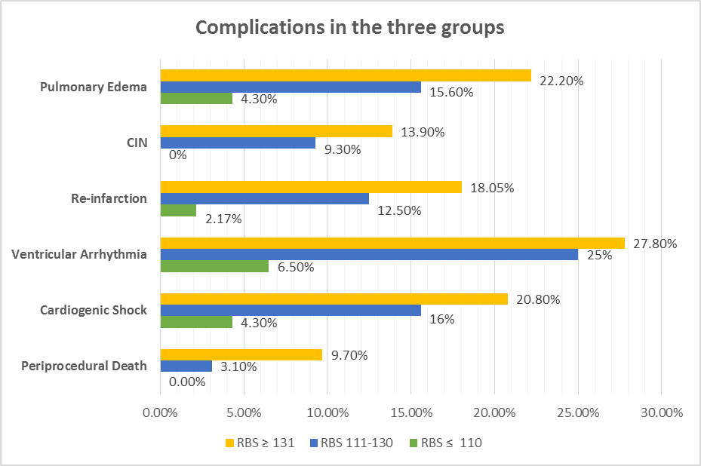
Figure 5: MACE in three groups

4. Discussion
In patients with acute myocardial infarction (MI), glucose metabolism is altered and acute hyperglycemia on admission is common regardless of diabetes status. Among patients without a history of diabetes, admission hyperglycemia (AH) may be resulting from previously undiagnosed diabetes mellitus or glucose intolerance, stress response mediated by cortisol and noradrenaline, or combination of these. Several studies have demonstrated that AH is independently associated with increased mortality after MI, regardless of treatment modality. It has also been reported that non diabetic patients with MI and AH have higher rates of heart failure, cardiogenic shock, ventricular tachycardia and re infarction.⁵
The Comparison between three groups as regard dyslipidemia we found that in group I 25 patients were dyslipidemic 54.31% - in group II 18 patients were dyslipidemic 56.25% while in group III were dyslipidemic 79.16%. There was statistically significant difference between the three groups (p value = 0.007).
And this came in agreement with study conducted by Matthew I. Worthley et al 2007 in this study 980 patients presenting with an ST-segment elevation myocardial infarction and treated exclusively with primary angioplasty were evaluated. Patients were divided into quartiles based on their admission blood glucose level: group 1 (6.6 mmol/L [119 mg/dL]), group 2 (6.7-7.8 mmol/L [120-140 mg/dL]), group 3 (7.9-10.0 mmol/L [141-180 mg/dL], and group 4 (10.1 mmol/L [181 mg/dL]. (This study show that there was statistical significant between four group 0.01)⁶
This came in disagreement with study conducted by Jorik R. Timmer et al 2011 in this study 460 consecutive patients with STEMI treated with primary PCI were included in this analysis. Hyperglycemia was defined as a glucose 7.8 mmol/l (140 mg/dl) so patients divided into two groups group I serum glucose level less than 140mg/dl and group II serum glucose level more than 140mg/dl. (This study show that there was no statistical significant between two groups P value 0.22). ⁷
During echocardiography we found that in group I ejection fraction (EF) ranged from 32%-77% with median 52.26± 12.02, - in group II it ranged from 30%-60% with median 46.56 ± 7.255 while in group III it ranged from 29%-62% with median 44.194 ±8.13. There was statistically significant difference between the three groups (P value =0.002) as patient with high blood glucose level more than 131mg/dl have more decrease in ejection fraction.
And this came in agreement with study conducted by Artur Dziewierz et al in this study 607 AMI patients with complete admission glucose data in the Krakow Registry of Acute Coronary Syndromes were identiﬁed and were stratiﬁed according to glucose admission level. patients were divided into three groups based on non-fasting glucose level on admission group I blood glucose level less than 7.8mmol/L - group II blood glucose level ranged from 7.8–11 mmol/L and group III blood glucose level more than 11mmol/L and there was statistically significant difference between the three groups (P value =0.016). ⁸
This decrease in ejection fraction in patient with hyperglycemia may be due to increase level of myocardium necrosis and the lower rate of spontaneous reperfusion and higher rate of “no-reflow” seen with elevated blood glucose levels in acute myocardial infarctions due to excessive macrovascular and microvascular dysfunction associated with hyperglycemia.
During laboratory investigation we found that CKMB: in group I CKMB level ranged from 17 – 220 with mean 71.33 ± 48.15, in group II CKMB level ranged from 15 – 743 with mean 113.97± 132.68 while in group III CKMB level ranged from1-247 with mean of 73.72±5157. (There was statistically significant difference between the three groups (P value =0.026).
This also came in agreement with the study conducted by Ahmet Ekmekci. et al 2013 This study aimed to evaluate whether hyperglycemia predicts inhospital mortality. This study was conducted on 503 patients. The patients were divided into tertiles according to the admission glucose levels. Tertile I: glucose <118 mg/dL (n ¼ 166), tertile II: glucose 118 to 145 mg/dL (n ¼ 168), and tertile III: glucose >145 mg/dL (n ¼ 169). There were statistically signiﬁcant differences as CKMB level data between three groups (P value 0.05).⁹
CKMB level is high in group III that has high blood glucose level as hyperglycemia is associated with more damage to myocardium so level of CKMB elevated.
After comparison angiographic result in our study we found that In group I one patient had TIMI flow 0 (2.2%) - three patients had TIMI I (6.5%) – five patients had TIMI II (10.9%)-37 patients had TIMI III (80.4%).
In group II: no patient had TIMI 0 flow- five patients had TIMI I flow (15%) – five patients had TIMI II (16%) while 22 patients had TIMI III flow (69%). In group III: three patients had TIMI flow (4%) – 12 patients had TIMI I flow (17%) -37 patients had TIMI II (51%) while 20 patients had TIMI III (28%). There was statistically significant difference between the three groups (p value = 0.001) .
This came in agreement with study conducted by Pei-Chi Chen1 et al 2014 in this study 959 consecutive STEMI patients undergoing primary PCI were divided into five groups based on admission glucose levels of <100, 100–139, 140– 189, 190–249 and ≥250 mg/dL. Their short- and long-term outcomes were compared. In this study there was statistical significant difference between five groups according to TIMI flow after primary PCI (P value 0.001)¹⁰
This also came in agreement with study conducted by Ahmet Ekmekci et al 2013 in this study 503 were divided into tertiles according to the admission glucose levels. Tertile I: glucose <118 mg/dL (n ¼ 166), tertile II: glucose 118 to 145 mg/dL (n ¼ 168), and tertile III: glucose >145 mg/dL (n ¼ 169). Admission hyperglycemia is associated with high inhospital and long-term adverse events in patients that undergo primary percutaneous coronary intervention (PCI). post-PCI TIMI grade <3, were higher in tertile III compared with tertile I and II In this study there was statistical significant difference between three groups according to TIMI flow after primary PCI (P value 0.01) ⁹
It is due to: macrovascular and microvascular dysfunction seen in hyperglycemia is possibly mediated by nitric oxide-mediated endothelial and platelet effect and may account in part for the lower rate of spontaneous reperfusion and higher rate of “no-reflow” seen with elevated blood glucose levels in acute myocardial infarctions.
Patients with higher admission glucose levels tended to have greater incidence of multivessel disease large infarcted area and have signiﬁcantly lower rates of initial success of primary PCI and poorer post-PCI TIMI ﬂow grades.
During hospital admission we found that periprocedural death in group I no patient had periprocedural death - in group II one patients had periprocedural death (3.1%). -in group III sex patients had periproceduarl death (9.7 %). There was statistically significant difference between the three groups (P value =0.04).
This came in agreement with study conducted by Pei-Chi Chen1 et al 2014 in this study 959 consecutive STEMI patients undergoing primary PCI were divided into five groups based on admission glucose levels of <100, 100–139, 140– 189, 190–249 and ≥250 mg/dL. Their short- and long-term outcomes were compared. they found that periprocedural death was more in patient with RBS more than 250 mg/dl. There was statistically significant difference between the five groups (P value =0.001). ¹⁰
This also came in agreement with study conducted by Tamer M. Moustafa 2017 in this study 250 patients were included without known diabetes mellitus admitted with STEMI. Both glucose and HbA1c were measured on admission. All included patients had hemoglobin A (1c) less than 6.5%. In-hospital and 3 months' major cardiac events MACE (mortality, heart failure, arrhythmias, cardiogenic shock and recurrent ischemia) were documented. They were classified into two groups according to the admission mean glucose level (group A with glucose level ≥ 160 ± 52 mg/dl and group B included those glucose level b 160 ± 52 mg/dl). There was statistically significant difference between two groups (P value =0.01). ¹¹
Hyperglycemia has been associated with a larger infarct size, worse left ventricular function, and increases in serum biomarkers of inflammation each of which may promote the development of secondary cardiac arrhythmias mostly ventricular tachycardia In addition recurrent anginal attacks, cardiogenic shock also contrast induced nephropathy and higher rate of “no-reflow” seen with elevated blood glucose levels in acute myocardial infarctions.
Also in our study we found that two patients in group I had cardiogenic shock 4.3% -in group II five patients had cardiogenic shock 15.6 % while in group III 15 patients had cardiogenic shock 20.8%. There was statistically significant difference between the three groups (p value.04).
This came in agreement with study conducted by Matthew I. Worthley et al 2007 in this study 980 patients presenting with an ST-segment elevation myocardial infarction and treated exclusively with primary angioplasty were evaluated. Patients were divided into quartiles based on their admission blood glucose level: group 1 (6.6 mmol/L [119 mg/dL]), group 2 (6.7-7.8 mmol/L [120-140 mg/dL]), group 3 (7.9-10.0 mmol/L [141-180 mg/dL], and group 4 (10.1 mmol/L [181 mg/dL]. they found that incidence of cardiogenic shock was high in group four with high RBS. There was statistical significant difference between four group as regard cardiogenic shock (P value. 01). ⁶
As high admission blood glucose associated with more LV systolic dysfunction. In addition recurrent anginal attacks, arrhythmias and higher rate of “no-reflow” seen with elevated blood glucose levels in acute myocardial infarctions.
Also we found that: in group I three patient had ventricular arrhythmia 6.5% - in group II eight patients had ventricular arrhythmia 25% while in group III 20 patients had ventricular arrhythmia 27.8%. There was statistically significant difference between the three groups (p value = 0.017).
This came in agreement with study conducted by Hoang V. Tran1 et al 2018 in this the association of hyperglycemia with the development of ventricular tachycardia (VT) in patients hospitalized with acute myocardial infarction (AMI) was explained. Hyperglycemia was defined as a serum glucose level ≥ 140 mg/dl at the time of hospital admission. The development of VT was identified from physicians notes and electrocardiographic findings by our trained team of data abstractors. ¹²
Several mechanisms have been proposed to explain the potentially pro- arrhythmic effects of hyperglycemia in patients hospitalized with an AMI. Hyperglycemia can cause QT-interval prolongation, which can trigger ventricular arrhythmias in those with underlying coronary artery disease.
Hyperglycemia has been associated with a larger infarct size, worse left ventricular function, and increases in serum biomarkers of inflammation each of which may promote the development of secondary cardiac arrhythmias.
Hyperglycemia following an ischemic injury may also be a proxy of increased sympathetic activity, which could exert its pro arrhythmic effects through elevated circulatory catecholamines and free fatty acids.
In our study we observed that: in group I one patient had re- infarction 2.17% - in group II four patients had re- infarction 12.5% while in group III 13 patients had re -infarction 18.05% There was statistically significant difference between the three groups (p value = 0.034).
This came in agreement with study conducted by Tamer M. Moustafa 2017 in this study 250 patients were included without known diabetes mellitus admitted with STEMI. Both glucose and HbA1c were measured on admission. All included patients had hemoglobin A (1c) less than 6.5%. In-hospital and 3 months' major cardiac events MACE (mortality, heart failure, arrhythmias, cardiogenic shock and recurrent ischemia) were documented. They were classified into two groups according to the admission mean glucose level (group A with glucose level ≥ 160 ± 52 mg/dl and group B included those glucose level b 160 ± 52 mg/dl). Number of patients developed re infarction in group A 49 (38%) while in group B 16 patients had re infarction (13.3%) (P value.01) ¹¹.
During follow up the patient after primary PCI we found that: In group I no patient had CIN – in group II three patients had CIN 9.3% while in group III ten patients had CIN 13.9% There was statistically significant difference between the three groups (p value = 0.03).
This came in agreement with study conducted by Yacov Shacham et al 2015 in this study 1,065 non diabetic STEMI patients undergoing primary PCI. Patients were stratified according to admission glucose levels into normal (<140 mg/dl), mild (140–200 mg/dl), and severe (>200 mg/dl) hyperglycemia groups. Medical records were reviewed for the occurrence of AKI. Patients having severe admission hyperglycemia had more AKI complicating the course of STEMI [20% vs. patients without (7%) and with mild (8%) hyperglycemia; p = 0.001] and had a significantly higher sCr change throughout hospitalization [0.17 mg/dl vs. patients without (0.09 mg/dl) and with mild (0.07 mg/dl) hyperglycemia; p = 0.04]. ¹³
No significant difference between the groups as regarde amount of contrast used during primary PCI.
It is due to hyperglycemia may lead to an increased production of oxygen free radicals with increased oxidative stress and suppressed flow mediated vasodilatation, inducing medullary hypoxia and ischemia, thus exacerbating the deleterious effect of contrast.
Acute hyperglycemia may induce osmotic diuresis, resulting in volume depletion and increasing the risk for pre renal azotemia and contrast toxicity. Furthermore hyperglycemia was demonstrated to be associated with worse left ventricular systolic function in patients with STEMI. Hyperglycemia may thus represent an epiphenomenon of the stress response, mediated by cortisol and catecholamines, whose release is elicited by the hemodynamic compromise or myocardial damage. Hyperglycemia may, however, exert a direct negative impact on renal function.
During admission two patients had acute heart failure AHF in group I 4.3% - in group II four patient had AHF 12.4% while in group III seven patients AHF 9.7%. There was no statistically significant difference between the three groups (p value = 0.031).
This came in agreement with study conducted by Hoang V. Tran1 et al 2017 patients hospitalized with AMI at all central Massachusetts medical centers between 2001 and 2011 were involved. Hyperglycemia was defined as a serum glucose level ≥ 140 mg/dl at the time of hospital admission so patients divided into two groups group A blood glucose level less than 140mg/dl and group B blood glucose level more than 140mg/dl.
There was statistical significant difference between two group as regard acute heart failure (P value 0.001) ¹².
This explained by increase risk of arrhythmia and the subsequent development of hemodynamic disturbances also decrease left ventricular ejection fraction and increase risk of NO-reflow phenomena.

5. Conclusion
Hyperglycemia on admission in the absence of diabetes mellitus is a significant predictor of adverse outcome and the extent and severity of coronary artery lesions in non-diabetic patients presenting with STEMI high admission blood glucose associated with more LV systolic dysfunction. In addition recurrent anginal attacks, arrhythmias and cardiogenic shock were also more frequent among those patients. Hyperglycemia can cause QT-interval prolongation, which can trigger ventricular arrhythmias in those with underlying coronary artery disease. also associated with increase risk for developing contrast induced nephropathy In Our study we found that Patients with elevated blood glucose level had high level of CKMB due to more necrosis of myocardium.
Also had high risk for developing TIMI 0 or “no-reflow” and peri-procedural death - cardiogenic shock – ventricular arrhythmia- acute heart failure –re infarction – contrast induced nephropathy.

References
- Glasgow RE, Osteen VL. Evaluating Diabetes Education: Are we measuring the most important outcomes? Diabetes Care [Internet]. 1992 Oct 1;15(10):1423 LP – 1432. Available from: http://care.diabetesjournals.org/content/15/10/1423.abstract.
- Sasso FC, Carbonara O, Nasti R, Campana B, Marfella R, Torella M, et al. Glucose Metabolism and Coronary Heart Disease in Patients With Normal Glucose Tolerance. JAMA [Internet]. 2004 Apr 21;291(15):1857–63. Available from: https://doi.org/10.1001/jama.291.15.1857.
- Van de Werf F, Cardiology TTF on the M of AMI of the ES of, Ardissino D, Cardiology TTF on the M of AMI of the ES of, Betriu A, Cardiology TTF on the M of AMI of the ES of, et al. Management of acute myocardial infarction in patients presenting with ST-segment elevation. Eur Heart J [Internet]. 2003 Jan 1;24(1):28–66. Available from: https://doi.org/10.1016/S0195-668X (02)00618-8.
- Yan Q. Toward dynamical systems medicine: personalized and preventive strategies. Per Med [Internet]. 2017 Sep 1;14(5):551–4. Available from: https://doi.org/10.2217/pme-2017-0030.
- Farrokhi F, Smiley D, Umpierrez GE. Glycemic control in non-diabetic critically ill patients. Best Pract Res Clin Endocrinol Metab [Internet]. 2011;25(5):813–24. Available from: http://www.sciencedirect.com/science/article/pii/S1521690X11000546.
- Worthley MI, Shrive FM, Anderson TJ, Traboulsi M. Prognostic Implication of Hyperglycemia in Myocardial Infarction and Primary Angioplasty. Am J Med [Internet]. 2007 Jul 1;120(7):643.e1-643.e7. Available from: https://doi.org/10.1016/j.amjmed.2006.06.043.
- Mansour AA, Wanoose HL. Acute Phase Hyperglycemia among Patients Hospitalized with Acute Coronary Syndrome: Prevalence and Prognostic Significance. Oman Med J. 2011 Mar;26(2):85–90.
- Dziewierz A, Giszterowicz D, Siudak Z, Rakowski T, S Dubiel J, Dudek D. Admission glucose level and in-hospital outcomes in diabetic and non-diabetic patients with acute myocardial infarction. Clin Res Cardiol. 2010 May 1;99:715–21.
- Ekmekçi A, Cicek G, Uluganyan M, Gungor B, Osman F, Serhan Ozcan K, et al. Admission Hyperglycemia Predicts Inhospital Mortality and Major Adverse Cardiac Events After Primary Percutaneous Coronary Intervention in Patients Without Diabetes mellitus. Vol. 65, Angiology. 2013.
- Chen P-C, Chua S-K, Hung H-F, Huang C-Y, Lin C-M, Lai S-M, et al. Admission hyperglycemia predicts poorer short- and long-term outcomes after primary percutaneous coronary intervention for ST-elevation myocardial infarction. J Diabetes Investig. 2014 Feb;5(1):80–6.
- M. Moustafa T. Utility of admission blood glucose level in prediction of short-term course and extent of coronary artery occlusion in non-diabetic patients with ST segment elevation myocardial infarction. Vol. 14, IJC Metabolic & Endocrine. 2017. 16–20 p.
- Tran H V, Gore JM, Darling CE, Ash AS, Kiefe CI, Goldberg RJ. Hyperglycemia and risk of ventricular tachycardia among patients hospitalized with acute myocardial infarction. Cardiovasc Diabetol. 2018 Oct;17(1):136.
- Shacham Y, Gal-Oz A, Leshem-Rubinow E, Arbel Y, Keren G, Roth A, et al. Admission Glucose Levels and the Risk of Acute Kidney Injury in Nondiabetic ST Segment Elevation Myocardial Infarction Patients Undergoing Primary Percutaneous Coronary Intervention. Cardiorenal Med. 2015 Jun;5(3):191–8.

12/17/2019

