Discharge Heart Rate as a Predictor of Left Ventricular Adverse Remodeling in ST-Segment Elevation Myocardial Infarction in Patients Treated with Primary Percutaneous Coronary Intervention

Mohamed Mahmoud Ramadan Abdel Razek (M.B.B.Ch), Seham F. Badr MD, Hatem M. Elsokkary MD, Ayman A. Gaafar MD.

Cardiology Department, Faculty of Medicine, Tanta University.

Abstract: Background: Coronary artery disease is considered the most common cause of death around the world. Left ventricular (LV) dysfunction is the single strongest predictor of mortality and one of the most prevalent and deadly complications following ST-segment elevation myocardial infarction. Objectives: study the discharge heart rate in patients with acute ST-elevation myocardial infarction who were treated by primary PCI as a predictor of LV remodelling and dysfunction. Methods: study population were treated with primary percutaneous coronary intervention, DHR was calculated from predischarge 12-lead electrocardiography. LV volumes were measured with two-dimensional transthoracic echocardiography at baseline and 3-month follow-up. Variables independently associated with the occurrence of LV remodelling were investigated. Results: LV remodelling occurred in 36.6% of patients. Compared with patients without remodelling, these patients had higher DHR (76.0±6.1 bpm vs 70.1±7.8 bpm), hypertension (72.7% vs 21.0%), older age (61.3+12.6 vs 54.6+ 11.6), Diabetes mellitus (77.3% vs 42.0%), culprit LAD (77.3 % vs 50%), more than one vessel disease, higher discharge EF (32-52% vs 34-62%) and higher E/e’. The independent predictors were higher discharge heart rate, LAD as culprit vessel, HTN and discharge E/e’.
[Mohamed Mahmoud Ramadan Abdel Razek, Seham F. Badr, Hatem M. Elsokkary, Ayman A. Gaafar. Discharge Heart Rate as a Predictor of Left Ventricular Adverse Remodeling in ST-Segment Elevation Myocardial Infarction in Patients Treated with Primary Percutaneous Coronary Intervention. N Y Sci J 2019;12(12):54-61]. ISSN 1554-0200 (print); ISSN 2375-723X (online). http://www.sciencepub.net/newyork. 8. doi:10.7537/marsnys121219.08.

Keywords: Left ventricular remodelling – discharge heart rate– primary percutaneous coronary intervention – ST-segment elevation acute myocardial infarction.

1. Introduction
Cardiovascular diseases are currently the leading cause of death in developed countries.¹ Left ventricular (LV) dysfunction is the single strongest indicator of mortality and one of the most frequent and dangerous complications following ST-segment elevation myocardial infarction.² Recently there has been increased interest in the prevalence of remodelling in the interventional cardiology era. From a clinical point of view, it is vital to identify those patients at higher risk for LV remodelling. The early identification of those patients at higher risk of LV remodelling may have crucial therapeutic implications.³ Subsequently, factors predicting post-infarct LV remodelling after MI treated by PPCI stay to be clarified. Besides, heart rate is a basic determinant of myocardial oxygen demand and an important risk factor for developing mortality and morbidity in patients with coronary artery disease.⁴
Aim of the work
This work aimed at study the discharge heart rate in patients presented with acute ST-elevation myocardial infarction who are treated by primary PCI as a predictor of LV remodelling and dysfunction.

2. Patients and Methods:
This study was carried out on 60 patients who were diagnosed with first STEMI within 12 hours from onset of symptoms and treated with primary PCI at The Cardiology Department at Tanta University Hospital, in six months starting from July 2018. The diagnosis of STEMI was made according to the recent 2017 European Society of cardiology guidelines. the patients were followed up for 3 months for the development of ventricular remodelling then divided into 2 groups according to the development of remodelling after 3 months: Group 1 (38 patients): Those without LV remodelling. Group 2 (22 patients): Those who had LV remodelling.
LV remodelling was defined as more than 20% increase in LV end-diastolic volume at 3 months follow-up.^{5,6}
Exclusion criteria included patients with prior myocardial infarction, history of documented LV dysfunction or past history suggestive of heart failure, patients who were in atrial fibrillation at the time of predischarge 12-lead ECG and patients with a pacemaker.
The study compared the two groups according to risk factors, basic laboratory tests, angiographic findings (culprit vessel, baseline TIMI flow score, final TIMI score, single or multi-vessel disease) and 2D echocardiographic findings (filling pressure, EF and LV volumes by Simpson's method). Follow up after 30 days was done to assess LV volume and function by 2D echocardiography.
Duration of the study:
This study was done in six months starting from July 2018.
Statistical Methods
Data were analyzed using IBM SPSS software package version 20.0. (Armonk, NY: IBM Corp). Qualitative data were described using numbers and percent. The Kolmogorov-Smirnov test was used to verify the normality of distribution Quantitative data were described using range (minimum and maximum), mean, median and standard deviation. The significance of the obtained results was judged at the 5% level. The used tests were the Chi-square test (χ2), Fisher's Exact or Monte Carlo correction, Student t-test, Mann Whitney test, and Kruskal Wallis test.

3. Results
Patient demographics:
The mean age in group I was 54.6 ± 11.6 years and 61.3 ± 12.6 years in group II with a statistically significant difference (p =0.048). Group I included 32 males (84.2%) while group II 13 males (59.1%) with a statistically significant difference (p =0.03).
Prevalence of risk factors:
16 patients (42%) of group I and 17 patients (77.3%) of group II were diabetics with a statistically significant difference (p = 0.008). Regarding hypertension, 8 patients (21%) of group I and 16 patients (72.7%) in group II were hypertensive with a statistically significant difference (p <0.001). Regarding dyslipidemia, 26 patients (68.4%) of group I and 12 patients (54.5%) of group II were diagnosed with dyslipidemia, there was no statistically significant difference between the two groups (p =0.282). Regarding smoking, there were 27 smokers in group I (71.1%) and 12 smokers in group II (54.5%) with no statistically significant difference (p = 0.196), (Table 1).

Table 1 Comparison between the two studied groups according to risk factors
Risk Factors | Group I |  | Group II |  | χ² | P
 | No. | % | No. | %
Diabetes Mellitus | 16 | 42.0 | 17 | 77.3 | 6.962 | 0.008
Hypertension | 8 | 21.0 | 16 | 72.7 | 15.502 | <0.001
Smoking | 27 | 71.1 | 12 | 54.5 | 1.669 | 0.196
Dyslipidaemia | 26 | 68.4 | 12 | 54.5 | 1.155 | 0. 282

Angiographic finding:

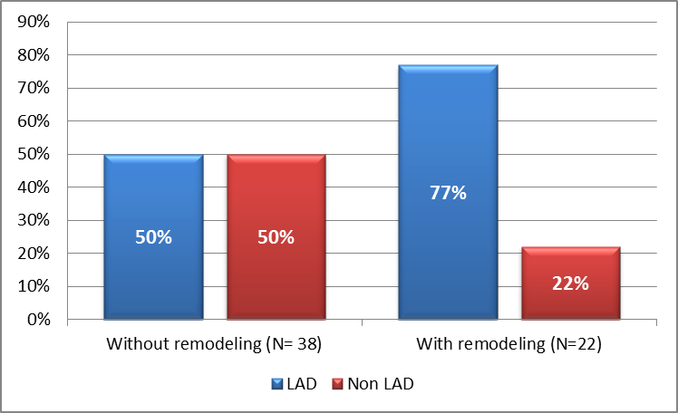
Figure 1. Showing a comparison between both groups according to culprit vessel

There was no statistically significant difference regarding symptoms to balloon time (P = 0.567), TIMI flow before or after PCI (P=0.203, 1.000 respectively). In group I, the culprit vessel was the left anterior descending coronary artery (LAD) in 19 patients (50%), Non-LAD in 19 patients (50%). In group II, the culprit was the LAD in 17 patients (77.3%), non-LAD was the culprit in 5 patients (22.7%). LAD as a culprit vessel was statistically significant being more prevalent in group II (P-value 0.038). (figure 1) (Table 2)

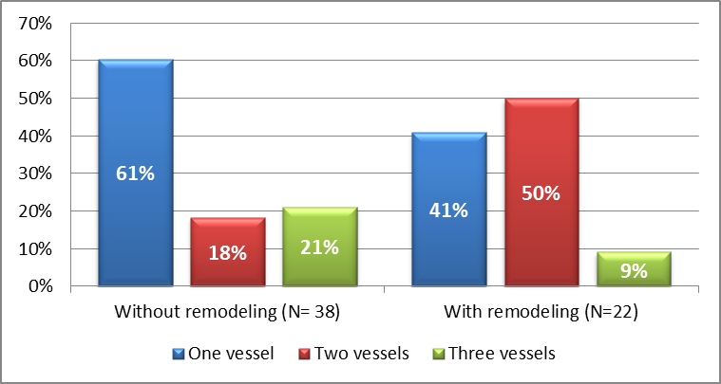
Figure 2: Percentage change in EF between discharge and after 3 month

In group I, 23 patients (60.5%) had single-vessel disease, 7 patients (18.4%) had two-vessel disease and 8 patients (21.1%) had a three-vessel disease. While in group II, 9 patients (40.9%) had single-vessel disease, 11 patients (50%) had two-vessel disease and two patients (9.1 %) had three-vessel disease. Single vessel disease was more prevalent in group I. While more than one vessel disease was more prevalent in group II, (P-value 0.033) (Figure 2) (Table 2).

Laboratory investigations:
As regard baseline lab investigations there was no statistically significant difference between both groups.

Table 2. Showing angiographic characteristics in both groups
 |  | Group I (No LVR) (N=38) | Group II (LVR) (N=22) | χ² | P Value
TIMI Before | TIMI 0 | 34 (89.5%) | 16 (72.7%) | 4.536 | 0.203  Calculated by Monte Carlo
 | TIMI 1 | 2 (5.3 %) | 4 (18.2 %)
 | TIMI 2 | 0 (0%) | 1 (4.5%)
 | TIMI 3 | 2 (5.3%) | 1(4.5%)
TIMI after | TIMI 1 | 1 (2.6%) | 0 (0%) | 0.61 | 1  Calculated by Monte Carlo
 | TIMI 2 | 2 (5.3%) | 1 (4.5%)
 | TIMI 3 | 35 (92.1%) | 21 (95.5%)
Number affected vessel | One | 23 (60.5%) | 9 (40.9%) | 6.833 | 0.033*
 | Two | 7 (18.4%) | 11 (50%)
 | Three | 8 (21.1%) | 2 (9.1%)
Culprit vessel | LAD | 19 (50%) | 17 (77.3%) | 4.31 | 0.038*
 | Non LAD | 19 (50%) | 5 (22.7%)

Echocardiographic findings:
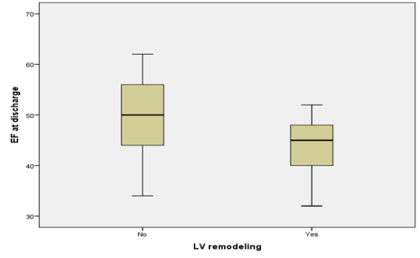
Fig. 3 relation between discharge EF and LV remodeling

There was no statistical significance between both groups as regard EDV at discharge (P=0.256). The median discharge EF in group I was 50 %, ranged from 34-62 %, while in group II, the median discharge EF was 45%, ranged from 32-52 %. Group II showed lower discharge EF (P-value =0.005) (Figure 3).
In group I, mean discharge EDV was 91.2 ± 10.4 ml and the mean EDV after 3 months was 90.1 ± 7.7 ml, the mean percentage change was -0.65 ± 6.9 %.

Table3: Percentage of change in EDV between discharge and after 3 month
Group II (N= 38)  Mean ± SD (range) | Group I (N=22)  Mean ± SD (range) | T  -test | P-Value
-0.65 ± 6.9  (-26 - 12) | 26.08 ± 4.27  (20 - 38) | -18.5 | <0.001*

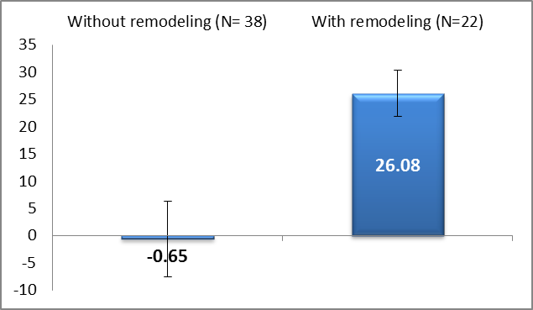
Figure 4: Percentage of change in EDV between discharge and after 3 months

In group II, the mean discharge EDV was 87.6 ± 9.4 ml and the mean EDV after 3 months was 110.5 ± 13.4%, the mean percentage change was 26.08 ± 4.27 %, and was assigned as a group of remodelling. (Table 3, Figure 4).
Percentage change in EF after 3 monthsis shown in Table 4.

Table 4:
Group I (N=22)  Mean ± SD (range) | Group II (N= 38)  Mean ± SD (range) | T  -test | P-Value
-11.4 ± 7.01  (-24 - 3) | 5.7 ± 6.9  (-7 - 22) | 9.13 | <0.001*

Discharge heart rate:
The discharge heart rate of the study population ranged from 55-88 beats per minute (bpm). In group I, it ranged from 55.0 – 82.0 bpm with a mean of 70.1 ± 7.8. In group II, it ranged from 65.0 – 88.0 bpm with a mean of 76.0 ± 6.1. Discharge heart rate was statistically significant, it was higher in group II (P-value =0.002) and by ROC analysis, a cut-off value of 72 bpm showed 77.2% sensitivity and 60.3% specificity (Figures 5, 6).

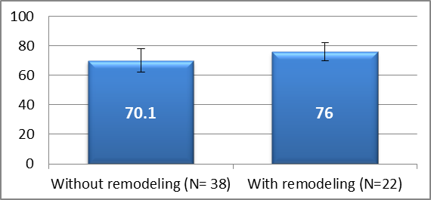
Figure 5: Comparison between both groups as regard discharge heart rate.

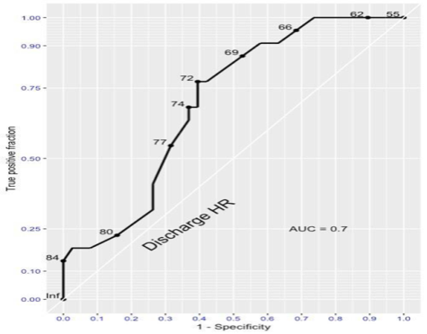
Figure 6: ROC curve for discharge heart rate to predict left ventricular remodeling

By multivariate analysis, higher discharge heart rate, HTN, higher discharge E/e’ and LAD as culprit vessel independently predicted the development of LV remodelling.

 | B | SE | Sig. | OR | 95% CI for OR
 |  |  |  |  | LL | UL
Heart rate | 0.23 | 0.096 | 0.017 | 1.25 | 1.04 | 1.5
Sex (male) | 0.651 | 1.01 | 0.522 | 1.9 | 0.26 | 14.05
DM | -0.915 | 0.935 | 0.327 | 0.4 | 0.06 | 2.5
HTN | -2.4 | 0.921 | 0.009 | 0.09 | 0.015 | 0.54
Number of affected vessel (one) | -0.657 | 0.888 | 0.459 | 0.518 | 0.09 | 2.9
Culprit vessel (LAD) | 2.6 | 1.23 | 0.034 | 13.7 | 1.2 | 155.14
E/e at discharge | 0.603 | 0.253 | 0.017 | 1.8 | 1.1 | 2.99

A subanalysis of DHR vs other predictors showed that higher discharge heart rate was statistically significant in predicting LV remodelling in a subgroup of culprit LAD (P=0.005), a subgroup of non-LAD (P-value =0.033), a subgroup of single-vessel disease (P-value =0.002). (Figures 7-9)

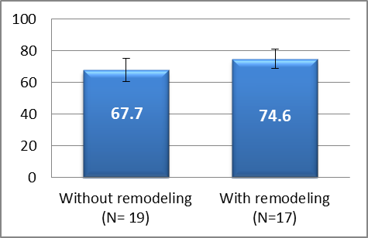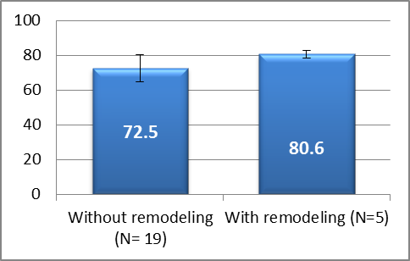
Figure 7: DHR in as subgroup of LAD Figure 8: DHR in a subgroup of Non-LAD

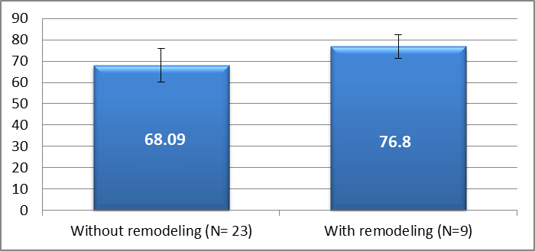
Figure 9: DHR in a subgroup of single-vessel disease

4. Discussion
Coronary artery disease is the leading cause of death worldwide and its frequency is increasing.⁷
Despite the latest advances in management of acute myocardial infarction (AMI), the left ventricular remodelling (LVR) process that leads to congestive heart failure still represents a major problem.⁸
In this study, patients in the LV remodelling group were older than the non-remodelling group (P =0.048) In contrast to this study, the study conducted by Pop et al⁸ on 105 patients and showed no statistically significant difference between both groups as regard mean age (P =0.182). Also, male patients were found to be more prone to the development of LV remodelling (P =0.03), in contrast to the study conducted by Mousa et al⁹ where there was no statistically significant difference between both groups as regard gender (P =0.5).
In this study, DM was shown to have a statistically significant impact on LV remodeling (P =0.008) similar to the study conducted by Joyce et al⁵ on 964 STEMI patients (P =0.05). In contrast to this study, the study conducted by Mousa et al ⁹ on 152 STEMI patients treated with PCI and Pop et al ⁸ on 105 patients showed no statistically significant difference among both groups, (P =0.09 and 0.059 respectively). Also, Hypertension was more prevalent in remodeling group (P< 0.001) similar to study conducted by Hendriks et al^{[145]} on 271 patients participating in the GIPS-III trial (P =0.03), in contrast to current study, The study conducted by Mousa et al^{[144]} on 152 patients showed no statistical significance between both groups (P =0.53).
Ischemic time had no statistical significance for the development of LV remodelling (P =0.567) similar to the study conducted by Hendriks et al¹⁰ (P =0.97) and the study by Zaliaduonyte-Peksiene et al¹¹ on 141 patients with a first-time acute myocardial infarction, which showed no statistically significant difference between both groups.
In contrast to the current study, the study conducted by Farag et al ¹² on 232 patients undergoing primary PCI, There was a significant positive correlation between LVEDV increase and symptom-to-balloon time (P < 0.0001).
Regarding culprit vessel, it was found that the positive remodelling group had a higher rate of LAD stenosis compared to the no-remodelling group, the difference being statistically significant (P =0.038) similar to the study conducted by Pop et al⁸ on 105 patients (P =0.002), also Warren et al¹³ who studied the time course of LV dilatation after MI and effect of IRA; they found that LV dilatation was more prevalent and chronic dilatation significantly more marked (P< 0.001) in patients with culprit LAD as compared with culprit RCA. Also concordant with findings of Loboz-Grudzien et al³ who studied early predictors of adverse LV remodelling after primary PCI in 88 patients with a first-time STEMI and found that LAD as IRA was a significant predictor of LV Remodeling (P < 0.05).
Acute myocardial infarction caused by LAD occlusion is one of the strongest determinates of infarct size which is a strong predictor of LV remodeling.¹⁴
In contrast to this study, the study conducted by Farag et al¹² on 232 patients, LAD was the culprit in 41 patients of remodeling group (60.3%) and 93 patients of the non-remodeling group (56.7%) showed no significant statistical difference between both groups (P =0.87). Besides, Patients with multivessel disease was more prone to LV remodeling compared to patients with single-vessel disease (P=0.033) similar to the study conducted by Bolognese et al⁶ who studied LV remodeling after primary PCI in 284 patients with AMI and found that the presence of multi-vessel coronary artery disease is an independent predictor for developing LV remodeling. Also consistent with findings of Pop et al⁸ who studied predictors of post-infarct LV remodeling in a group of 105 STEMI patients treated by PPCI and found that the presence of multi-vessel coronary artery disease was a significant predictor of LV remodeling.
Unlike Mousa et al⁹ who found no significant statistical difference between both groups (P=0.57).
As regard echocardiographic parameters, lower discharge EF was associated with more development of adverse LV remodelling, similar to the study conducted by Zaliaduonyte-Peksiene et al ¹¹ on 141 patients, 49 of them developed remodelling and they had lower discharge EF (P=0.001). In contrast to the study conducted by Hyun-Min Na et al¹⁵ on 208 patients, 53 patients (25.5%) showed LV remodelling, there was no statistically significant difference between both groups as regard discharge EF (P=0.507).
Also, LV remodelling group had higher LV filling pressure (E/e’) (P =0.003). This came in agreement with the study conducted by Yacov Shacham et al ¹⁶ on 52 patients with ST-segment elevation myocardial infarctions who underwent primary PCI were retrospectively studied. The patients with E/e’ >15 demonstrated worse LV ejection fraction on follow up (mean, 45 + 12% vs. 52 + 8%; P =.03) and higher LV end-diastolic volumes (mean, 81.3 + 22.9 vs. 69.2 +13.4 mL/m2; P =.01) and end-systolic volumes (mean, 33.0 + 12.2 vs. 23.7 +13.4 mL/m2; P =0.02) compared with the first examination, representing LV remodelling. The E/septal e’ ratio has been shown to correlate with mean LV diastolic pressure and was shown to be a very strong predictor of mortality after acute MI, providing superior and incremental prognostic information to clinical factors and conventional measurements of LV systolic and diastolic function.^{17,18}
The discharge EDV had no significant statistical importance for developing LV remodelling, (P=0.25), this came in agreement with Zaliaduonyte-Peksiene et al.¹¹
Unlike Joyce et al⁵ in their study conducted on 964 patients, the remodelling group (296 patients) has higher discharge EDV than the non-remodelling group (668 patients) (p>0.001).
Also, the study conducted by Mannaerts et al¹⁹ on 33 patients with acute MI; 13 of them developed LV remodelling. They had higher discharge EDV. (P=0.01).
Patients who developed LV remodeling had a higher discharge heart rate in comparison with patients who didn't develop remodeling (P =0.002).
The effect of discharge heart rate on the development of LV remodeling was clinically relevant among clinically relevant subgroups.
- With LAD as a culprit vessel (P=0.005).
- With Non-LAD as a culprit vessel (P=0.033)
- In single vessel disease (P=0.002).
Similarly, In the study conducted by Joyce et al ⁵ on 964 STEMI patients treated by primary PCI. Overall 296 patients (30.7%) developed LV remodeling at 6 months follow-up. Patients who showed LV remodeling had significantly higher heart rates on admission (76±19 bpm vs. 72±17 bpm, p=0.002) and discharge (72±11 bpm vs. 68±12 bpm, p < 0.001) compared to the non-remodeling group. Also, multivariate analysis showed that DHR > 69 bpm is an independent risk factor for developing LV remodeling (P=0.01).
Martin Reindl et al ²⁰ conducted a prospective study on 143 STEMI patients, CMR scans were performed on discharge and after 4 months, 29 patients (20%) developed LV remodeling. DHR (74[62-81] vs. 64[58-73] bpm, p=0.008). The associations for all post-admission heart rates were significant after adjustment for clinical (high-sensitivity cardiac troponin T and C-reactive protein, left anterior descending artery as the culprit) and CMR (infarct size, microvascular obstruction, ejection fraction) predictors of left ventricular remodeling.²⁰
In the SHIFT echocardiographic sub-study, a lower heart rate at 8 months was associated with a significantly lower left ventricular end systolic volume index and higher LVEF.²¹
In the current study, discharge heart rate at a cut-off value of 72 bpm had 77.2 % sensitivity and 60.3% specificity, (AUC was 0.7) for prediction of development of LV adverse remodeling, in concordance with the study conducted by Reindl et al ²⁰, (AUC) was 0.68 with cut-off value for discharge heart rate 68 bpm with 75% sensitivity and 61% specificity.

Limitations of the Study
Echocardiographic assessment of global left ventricular systolic function is usually performed subjectively. Two-dimensional echocardiography does not offer very precise data about the ventricular volumes or the infarct size, it is better to be assessed by cardiac magnetic resonance imaging which is considered as the current gold standard for the determination of LVR and, importantly, allows for an additional assessment of the major determinants of LV remodelling (infarction size and microvascular obstruction).
Despite this limitation, 2D echocardiography remains the most widely used non-invasive technique for non-invasive, inexpensive, and widely available. The 3D approach is likely to overcome the geometric challenges during the assessment of LV volumes.
Also, Lack of knowledge of late IRA patency. Coronary angiography was not done at a 3-month follow- up and thus cannot exclude the possibility that recurrent ischemia may have played a role in development of the remodelling process. Also, we didn't evaluate myocardial perfusion after primary PCI which may play an important role in the development of LV remodelling.
The small sample size was a limitation, due to short study duration, difficult tracking of patients and the fact that the study population represent only the subset of patients that had survived after myocardial infarction.

Conclusion
The discharge heart rate was found to be an independent predictor of LV remodelling after primary PCI. Hence, the importance of strict heart rate control in patients with acute myocardial infarction. Thus, conducting large clinical trials utilizing more reliable investigations such as CMR to study predictors of remodelling is a must.
Other predictors were older age, male sex, Diabetes mellitus, hypertension, lower discharge EF, LAD as a culprit vessel and multivessel disease.

References
- Mozaffarian D, Benjamin EJ, Go AS, Arnett DK, Blaha MJ, Cushman M, et al. Heart Disease and Stroke Statistics—2016 Update. Circulation. 2016 Jan 26;133(4):e38-360.
- Brooks GC, Lee BK, Rao R, Lin F, Morin DP, Zweibel SL, et al. Predicting Persistent Left Ventricular Dysfunction Following Myocardial Infarction. J Am Coll Cardiol. 2016 Mar 15;67(10):1186–96.
- Loboz-Grudzień K, Kowalska A, Brzezińska B, Sokalski L, Jaroch J. Early predictors of adverse left ventricular remodelling after myocardial infarction treated by primary angioplasty. Cardiol J. 2007;14(3):238–45.
- Diaz A, Bourassa MG, Guertin M-C, Tardif J-C. Long-term prognostic value of resting heart rate in patients with suspected or proven coronary artery disease. Eur Heart J. 2005 May 1;26(10):967–74.
- Joyce E, Hoogslag GE, Leong DP, Fox K, Schalij MJ, Marsan NA, et al. Association between discharge heart rate and left ventricular adverse remodelling in ST-segment elevation myocardial infarction patients treated with primary percutaneous coronary intervention. Heart. 2013 Apr 15;99(8):556–61.
- Bolognese L, Neskovic AN, Parodi G, Cerisano G, Buonamici P, Santoro GM, et al. Left ventricular remodeling after primary coronary angioplasty: patterns of left ventricular dilation and long-term prognostic implications. Circulation. 2002 Oct 29;106(18):2351–7.
- Pagidipati NJ, Gaziano TA. Estimating deaths from cardiovascular disease: a review of global methodologies of mortality measurement. Circulation. 2013 Feb 12;127(6):749–56.
- Pop S, Hodaș R, Benedek E, Opincariu D, Rat N, Jani L, et al. Predictors of Left Ventricular Remodeling after Revascularized Acute Myocardial Infarction.
- Aboelkasem Ali Mousa M, Abdelsabour Abdallah M, Shamseddin Mohammad H, Ahmad Aly Youssef A. Early predictors of left ventricular remodeling after primary percutaneous coronary intervention. Egypt Hear J. 2018 Dec;70(4):403–7.
- Hendriks T, Hartman MHT, Vlaar PJJ, Prakken NHJ, van der Ende YMY, Lexis CPH, et al. Predictors of left ventricular remodeling after ST-elevation myocardial infarction. Int J Cardiovasc Imaging. 2017 Sep;33(9):1415–23.
- Zaliaduonyte-Peksiene D, Simonyte S, Lesauskaite V, Vaskelyte J, Gustiene O, Mizariene V, et al. Left ventricular remodeling after acute myocardial infarction: Impact of clinical, echocardiographic parameters and polymorphism of angiotensinogen gene. J Renin-Angiotensin-Aldosterone Syst. 2014 Sep 2;15(3):286–93.
- Farag E-SM, Al-Daydamony MM. Symptom-to-balloon time and myocardial blush grade are predictors of left ventricular remodeling after successful primary percutaneous coronary intervention. Cardiovasc J Afr. 2017;28(3):186–90.
- Warren SE, Royal HD, Markis JE, Grossman W, McKay RG. Time course of left ventricular dilation after myocardial infarction: Influence of infarct-related artery and success of coronary thrombolysis. J Am Coll Cardiol. 2003 Jan 1;11(1):12–9.
- Tang W. Predictors of Infarct Size After Primary Coronary Angioplasty in Acute Myocardial Infarction from Pooled Analysis from Four Contemporary Trials. Am J Cardiol. 2007 Nov 1;100(9):1370–5.
- Na H-M, Cho G-Y, Lee JM, Cha M-J, Yoon YE, Lee S-P, et al. Echocardiographic Predictors for Left Ventricular Remodeling after Acute ST-Elevation Myocardial Infarction with Low-Risk Group: Speckle Tracking Analysis. J Cardiovasc Ultrasound. 2016 Jun 1;24(2):128.
- Shacham Y, Khoury S, Flint N, Steinvil A, Sadeh B, Arbel Y, et al. Serial Echocardiographic Assessment of Left Ventricular Filling Pressure and Remodeling among ST-Segment Elevation Myocardial Infarction Patients Treated by Primary Percutaneous Intervention. J Am Soc Echocardiogr. 2016 Aug 1;29(8):745–9.
- Iwahashi N, Kimura K, Kosuge M, Tsukahara K, Hibi K, Ebina T, et al. E/e′ Two Weeks after Onset Is a Powerful Predictor of Cardiac Death and Heart Failure in Patients with a First-Time ST-Elevation Acute Myocardial Infarction. J Am Soc Echocardiogr. 2012 Dec 1;25(12):1290–8.
- Hillis GS, Møller JE, Pellikka PA, Gersh BJ, Wright RS, Ommen SR, et al. Noninvasive estimation of left ventricular filling pressure by e/e′ is a powerful predictor of survival after acute myocardial infarction. J Am Coll Cardiol. 2004 Feb 4;43(3):360–7.
- Mannaerts H, van der Heide JA, Kamp O, Stoel MG, Twisk J, Visser CA. Early identification of left ventricular remodelling after myocardial infarction, assessed by transthoracic 3D echocardiography. Eur Heart J. 2004 Apr 1;25(8):680–7.
- Reindl M, Reinstadler SJ, Feistritzer H-J, Tiller C, Mayr A, Klug G, et al. Heart rate and left ventricular adverse remodeling after ST-elevation myocardial infarction. Int J Cardiol. 2016 Sep 15;219:339–44.
- Tardif J-C, O'Meara E, Komajda M, Böhm M, Borer JS, Ford I, et al. Effects of selective heart rate reduction with ivabradine on left ventricular remodeling and function: results from the SHIFT echocardiography substudy. Eur Heart J. 2011 Oct;32(20):2507–15.

12/17/2019

