**Fractional Carbon Dioxide Laser alone versus Fractional Carbon Dioxide Laser assisted Topical steroid delivery in Treatment of Post-Burn Scars.**

Prof. Dr. Amr Mohamed Zaky, Dr. Shady Mahmoud Attia Ibrahim, Mohammed Elesawy Mohammed

Dermatology, Venereology and Andrology, Faculty of medicine, Al-Azhar University, Cairo, Egypt

## Abstract: Objective: The purpose of this study was to evaluate the clinical and histopathological effects of fractional carbon dioxide laser alone versus fractional assisted corticosteroid delivery in treatment of post- burn scars. Design: This was randomized, blinded, clinically split scar Study Setting: The setting for this study was Dermatology Department at Al-Azhar University in Cairo, Egypt. Participants**:** Thirty patients with mature burn scars were included in the study. Measurements: Twelve fractional carbon dioxide laser sessions followed by application of triamcinolone acetonide suspension on half of the scar then other half treated by fractional CO2 laser alone were done 4 to 6 weeks apart. Outcome Measures: Primary outcome was measured using two scar scales, the Vancouver Scar Scale and the university of north Carolina scar score. Secondary outcomes included evaluation of collagen and elastic fibers using routine hematoxylin and eosin, Masson’s trichrome, and orcein stains. Outcomes were measured one month after the last laser session. Results: Both Vancouver Scar Scale and the university of north Carolina scar score showed significant reduction following treatment (*p*<0.001). area of the scar treated by fractional carbon dioxide laser followed by application of triamcinolone acetonide suspension improved more than the other area treated by fractional CO2 laser alone but the improvement still not significant (p-value > 0.05). The pattern and arrangement of collagen and elastic fibers showed significant improvement (*p*<0.001, *p*=0.001, respectively), together with significant improvement in their amounts (*p*=0.020, *p*<0.001, respectively). Histopathological improvement was significant in area of the scar treated by fractional carbon dioxide laser followed by application of triamcinolone acetonide suspension more than the other area treated by fractional CO2 laser alone area ( *p*<0.001). ****Conclusion**:** Fractional CO2 laser assisted topical steroid delivery could be considered as a promising option for burn scar management as it improves the clinical appearance of the scar, which was detected histologically by changing the dermal collagen orientation and thickness making it much similar to normal skin.

[Amr Mohamed Zaky, Shady Mahmoud Attia Ibrahim, Mohammed Elesawy Mohammed. **Fractional Carbon Dioxide Laser alone versus Fractional Carbon Dioxide Laser assisted Topical steroid delivery in Treatment of Post-Burn Scars.** *N Y Sci J* 2019;12(12):15-26]. ISSN 1554-0200 (print); ISSN 2375-723X (online). <http://www.sciencepub.net/newyork>. 3. doi:[10.7537/marsnys121219.03](http://www.dx.doi.org/10.7537/marsnys121219.03).

**Keywords:** Fractional Carbon Dioxide Laser; Topical steroid delivery; Treatment; Post-Burn Scars

**1. Introduction**

Scars frequently cause both functional and esthetical problems ***(Van Loey et al., 2008).*** Cosmetic disﬁgurement caused by scars may lead patients to suffer from psychosocial problems, which in turn may result in a decreased quality of life ***(Bock et al., 2006).***

Scars are normally classiﬁed according to their clinical behavior and appearance. They are frequently categorized as normotrophic, hypertrophic, and keloidal ***(Verhaegen et al., 2009).***

Standard treatments for burn scars include excision, ultrasound, compression therapy, tissue expanders, silicone gel sheeting, intralesional steroids, interferon injections, and laser treatments ***(Xie et al., 2004).***

Fractional ablative carbon dioxide laser (AFXL) is a viable treatment option for scars ***(Anderson et al.,2014).*** AFXL generates vertical microscopic columns of tissue ablation in the epidermal and dermal layers, leaving intervening tissue intact. Each ablated channel is surrounded by a zone of thermally damaged skin. AFXL exposure elicits a cascade of cytokines and growth factors, leading to activation of ﬁbroblasts, induction of neocollagenesis, and synthesis of elastin ﬁbers. This pathway is assumed to promote structural changes in scar tissue ***(Ozog et al., 2013)***.

Fractional lasers create zones of ablation at variable depths determined by the treatment settings. The unique fractional injury induces a molecular cascade including heat shock proteins and other factors that lead to a rapid healing response and prolonged neocollagenesis with subsequent collagen remodeling ***(Waibel et al., 2009)***. When applied in a fractional pattern, columns of abnormal scar are ablated, allowing new collagen to form in a controlled manner, with rapid epithelialization of surface. Recent work suggests that in addition to

apoptosis of ﬁbroblasts in the semicro thermal zones, or “MTZs,” the hypertrophic scars undergo up regulation of matrix metalloproteinase 1 with alteration of types 1 and 3 procollagen levels and down-regulation of transforming growth factors and basic ﬁbroblast growth factor. Not only are these changes evident in the MTZs, but the entire thickness of the dermis seems to be affected ***(Qu et al., 2012).***

Effective topical delivery of any pharmaceutical agent requires the ability to penetrate the epidermis. Fractional laser therapy creates precise, uniform columns of tissue vaporization which in theory might help to facilitate drug delivery past the epidermal barrier ***(Haedersdal et al., 2010)***.

Ablative fractional laser-assisted corticosteroid delivery may take advantage of the newly formed channels to penetrate uniformly and deeply into dermal scars. Furthermore, injection of triamcinolone acetonide is often painful and consistent dosing is difﬁcult to achieve throughout the scar. In contrast, topical application of triamcinolone acetonide after fractional resurfacing is painless and may be applied with greater uniformity ***(Haedersdal et al., 2010)***.

**Aim of the work**

The aim of this study was to evaluate the clinical and histopathological effects of fractional carbon dioxide laser alone versus fractional assisted corticosteroid delivery in treatment of post- burn scars.

**2. Patients and Methods**

**Patients**:

The present study included **30** patients **(**16males (53,3%) and 14 females (46,7%)**)** with Fitzpatrick skin phototypes II-V; Patients with burn scars presenting to the outpatient clinic of the Dermatology Department at Al-Azhar University hospitals from June 2017 to July 2019 were screened for eligibility of enrollment in the trial. Included in the trial patients with burn scars that were at least one year old.

**Exclusion criteria** for enrollment were recent burn scars, pregnancy, lactation, oral retinoid drugs within the past 6 months and patients unable to follow the treatment protocol.

**Methods**:

The following items were completed for all patients:

• An informed consent before enrollment approved by our dermatology research ethical committee.

• Full history taking and full dermatological examination. Personal history was taking including name, age, sex, occupation and residence. History of present illness included the cause, site, duration of the burn scars, and previous treatment modalities used was documented for each patient.

* Dermatological examination was done to detect the type of Scar, site and extent of the lesion.
* The treated Scars were divided into two parts:

A-The first part was treated by fractional co2 laser followed by topical application of triamcinolone acetonide suspension at a concentration of 10-20mg /ml. The chosen concentration of triamcinolone acetonide was dependent on the extent and thickness of the scar. **(Group 1)**

B-The Second part was treated by fractional co2 laser alone**. (Group 2)**

**Laser treatment.** The target scars underwent twelve treatment sessions using a fractional ablative 10,600 nm CO2 laser (SmartXide DOT®; DEKA, Florence, Italy). Sessions were performed 4 to 6 weeks apart. Topical anesthesia (lidocaine 2.5% and prilocaine 2.5%) was applied to the target area 30 to 60 minutes before the procedure, and then the area was washed off and properly dried before laser application. The following parameters were used in a single pass (in all cases): power, 17 Watts; dwell time, 400µsec; stacking, 2; and spacing, 700µm.

Within 2 minutes of fractional laser treatment, a thin layer of triamcinolone acetonide suspension was drizzled over the site and rubbed gently over the ablated columns.

Post-laser home treatment included topical application of panthenol 2% twice daily for four weeks. Patients were also instructed to use sunscreen regularly (for scars in sun-exposed sites) and to avoid removal of the crust.

**(3) Photography**

All photographs were taken with a Nikon Power Shot D5300 digital camera (13.5 mega pixel resolution) using identical lighting situation and patient positioning. The photos were taken before starting treatment and one month after the last session. Two investigators were performed the assessment, but they were blinded to previous measurements and treatment regimens.

**(4) Histological Evaluation**

A pre-treatment, 4mm punch biopsy was taken from the target scar of each subject. A post-treatment two biopsies were taken one month after the last session (one from the part was treated by fractional Co2 laser followed by application of triamcinolone acetonide suspension and the second biopsy from the part was treated by fractional Co2 laser alone). Each patient was instructed to use topical and/or systemic antibiotic after the biopsy taking. Skin biopsies were collected in 10 % formaline, processed into paraffin blocks and cut into 7 µm paraffin sections that were subjected to the following stains:

o Hematoxylin and eosin for routine histological evaluation.

o Masson's Trichrome stain for collagen fibers.

o Orceinstain for elastic fibers.

**Data management and statistical analysis**:

Clinical and morphometric histological data were coded and entered to an excel spread sheet. All statistical calculations were done using computer programs SPSS version 15, 2010 for Microsoft Windows (Statistical Package for the Social Science; SPSS Inc., Chicago, IL, USA). The data were statistically described in terms of mean ± standard deviation (±SD), median and range, or frequencies (number of cases) and percentages when appropriate. Comparison of numerical variables between the study groups was done using Mann Whitney U test for independent samples. Within group comparison of numerical variables was done using Wilcoxon signed rank test for paired (matched) samples when not normally distributed. For comparing categorical data, Chi square (χ2) test was performed. Exact test was used instead when the expected frequency is less than 5. Within group comparison was done using McNemar test. P values less than 0.05 was considered statistically significant.

**3. Results**

In our study, we applied fractional co2 laser on 30 patients had mature burn scar, 16 males (53,3%) and 14 females (46,7%),. Their age ranged from 10 - 44 years, their Fitzpatrick skin phototypes II-V, duration of burn ranged from (2-9years) (**Table 1**).

**Table 1: Demographic data of the patients with burn scar**

|  |  |  |  |  |  |  |  |
| --- | --- | --- | --- | --- | --- | --- | --- |
| **No.** | **Age (Years)** | **Sex** | **Scar Duration (Years)** | **Burn Type** | **Site** | **Fitzpatrick Skin Type** | **Previous Treatment** |
| 1 | 20 | F | 2 | Scald | Thigh | III | none |
| 2 | 13 | m | 3 | Fire | Arm | III | none |
| 3 | 24 | m | 3 | Scald | Arm | IV | Intralesional steroids |
| 4 | 16 | M | 2 | Fire | Arm | II | Intralesional steroids |
| 5 | 15 | M | 2 | Scald | Arm | V | none |
| 6 | 31 | F | 5 | Fire | Arm | III | none |
| 7 | 27 | M | 2 | Fire | Arm | IV | Intralesional steroids |
| 8 | 19 | F | 3 | Scald | Arm | IV | None |
| 9 | 21 | F | 2 | Fire | Breast | III | None |
| 10 | 15 | F | 3 | Scald | Abdomen | III | None |
| 11 | 19 | M | 2 | Scald | Arm | IV | Topical therapies |
| 12 | 18 | F | 5 | Fire | Chest | IV | None |
| 13 | 41 | F | 9 | Scald | Arm | II | Grafting |
| 14 | 11 | m | 3 | Fire | Arm | III | None |
| 15 | 24 | F | 2 | Fire | Thigh | III | None |
| 16 | 19 | F | 6 | Scald | Arm | III | Surgical release |
| 17 | 18 | F | 3 | Scald | Arm | III | None |
| 18 | 17 | F | 2 | Scald | Arm | II | None |
| 19 | 44 | F | 4 | Fire | Chest | III | None |
| 20 | 32 | M | 3 | Scald | Arm | IV | None |
| 21 | 10 | M | 3 | scald | Thigh | III | Topical therapies |
| 22 | 13 | M | 3 | Scald | Face | III | none |
| 23 | 25 | F | 6 | Scald | Back | IV | Intralesional steroids |
| 24 | 16 | M | 2 | scald | Arm | III | None |
| 25 | 17 | M | 2 | Fire | Face | III | None |
| 26 | 22 | M | 3 | Fire | Back | IV | Topical therapies |
| 27 | 11 | M | 4 | Scald | Thigh | IV | Topical therapies |
| 28 | 14 | F | 3 | Scald | Back | IV | Topical therapies |
| 29 | 10 | M | 2 | Scald | Face | III | Topical therapies |
| 30 | 15 | m | 2 | scald | Arm | III | None |

**Table ( 2): description of demographic data of studied patients.**

|  |  |  |  |
| --- | --- | --- | --- |
| **Demographic data** | | **Studied patients (N = 30)** | |
| **Age (years)** | **Mean ±SD** | 19.9 ± 8.4 | |
| **Min - Max** | 10 – 44 | |
| **Sex** | **Male** | 16 | 53.3% |
| **Female** | 14 | 46.7% |

**According to clinical assessment, the results as follow:**

**Table ( 2)** shows the description of demographic data of studied patients. **As regard age,** the mean age of studied patients was 19.9 ± 8.4 years with minimum age of 10 years and maximum age of 44 years. **As regard sex,** there were 16 males (53.3%) and 14 females (46.7%) in the studied patients.

**Table (3)** shows the description of clinical data of studied patients.

**As regard duration of scar,** the mean duration was 3.2± 1.6 years with minimum duration of 2 years and maximum duration of 9 years.

**Table ( 3): description of clinical data of studied patients.**

|  |  |  |  |
| --- | --- | --- | --- |
| **Clinical data** | | **Studied patients (N = 30)** | |
| **Duration of scar (years)** | **Mean ±SD** | 3.2 **±** 1.6 | |
| **Min - Max** | 2 – 9 | |
| **The Cause of Burn** | **Fire** | 11 | 36.7% |
| **Scald** | 19 | 63.3% |
| **Site of scar** | **Face** | 3 | 10% |
| **Chest** | 2 | 6.7% |
| **Breast** | 1 | 3.3% |
| **Arm** | 16 | 53.3% |
| **abdomen** | 1 | 3.3% |
| **Back** | 3 | 10% |
| **Thigh** | 4 | 13.3% |
| **Fitzpatrick skin type** | **II** | 1 | 3.3% |
| **III** | 17 | 56.7% |
| **IV** | 7 | 23.3% |
| **V** | 5 | 16.7% |
| **Previous treatment** | **none** | 17 | 56.7% |
| **Topical therapies** | 6 | 20% |
| **Intra-lesional steroids** | 5 | 16.7% |
| **Surgical release** | 1 | 3.3% |
| **Grafting** | 1 | 3.3% |

**Table (4):** shows highly statistical significant difference **(p-value < 0.001)** of VSS (vascularity, pigmentation, pliability & height) between (before & group I).

**Table (4 ): comparison of VSS between (before & group I).**

|  |  |  |  |  |  |  |  |
| --- | --- | --- | --- | --- | --- | --- | --- |
| **VSS** | | **Before (N = 30)** | | **Group I (N = 30)** | | ***X2*** | **P-value** |
| **Vascularity** | **Normal** | 2 | 6.7% | 20 | 66.7% | 28.1 | **< 0.001**  **HS** |
| **Pink** | 16 | 53.3% | 10 | 33.3% |
| **Red** | 10 | 33.3% | 0 | 0% |
| **Purple** | 2 | 6.7% | 0 | 0% |
| **Pigmentation** | **Normal** | 2 | 6.7% | 4 | 13.3% | 37.9 | **< 0.001**  **HS** |
| **Hypo** | 4 | 13.3% | 25 | 83.3% |
| **Hyper** | 24 | 80% | 1 | 3.3% |
| **Pliability** | **Supple** | 0 | 0% | 5 | 16.7% | 25.8 | **< 0.001**  **HS** |
| **Yielding** | 4 | 13.3% | 18 | 60.0% |
| **Firm** | 12 | 40% | 5 | 16.7% |
| **Banding** | 14 | 46.7% | 2 | 6.7% |
| **Height** | **< 2 mm** | 0 | 0% | 6 | 20.0% | 48.8 | **< 0.001**  **HS** |
| **2 – 5 mm** | 2 | 6.7% | 23 | 76.7% |
| **> 5 mm** | 28 | 93.3% | 1 | 3.3% |

X2: Chi-square test HS: p-value < 0.001 is considered highly significant.

**Table (5)** shows: Highly statistical significant difference **(p-value < 0.001)** of UNC4P (pruritus, pain, Paresthesia & pliability) between (before & group I).

**Table ( 5): comparison of UNC4P between (before & group I).**

|  |  |  |  |  |  |  |  |
| --- | --- | --- | --- | --- | --- | --- | --- |
| **UNC4P** | | **Before (N = 30)** | | **Group I (N = 30)** | | ***X2*** | **P-value** |
| **Pruritus** | **Non** | 0 | 0% | 15 | 50% | 30.8 | **< 0.001**  **HS** |
| **Mild** | 10 | 33.3% | 15 | 50% |
| **Moderate** | 18 | 60% | 0 | 0% |
| **Severe** | 2 | 6.7% | 0 | 0% |
| **Pain** | **Non** | 0 | 0% | 19 | 63.3% | 35.4 | **< 0.001**  **HS** |
| **Mild** | 14 | 46.7% | 11 | 36.7% |
| **Moderate** | 14 | 46.7% | 0 | 0% |
| **Severe** | 2 | 6.7% | 0 | 0% |
| **Paresthesia** | **Non** | 0 | 0% | 28 | 93.3% | 52.6 | **< 0.001**  **HS** |
| **Mild** | 26 | 86.7% | 2 | 6.7% |
| **Moderate** | 4 | 13.3% | 0 | 0% |
| **Pliability** | **Non** | 0 | 0% | 8 | 26.7% | 18.1 | **< 0.001**  **HS** |
| **Mild** | 12 | 40% | 18 | 60% |
| **Moderate** | 18 | 60% | 4 | 13.3% |

X2: Chi-square test HS: p-value < 0.001 is considered highly significant. S: p-value < 0.05 is considered significant.

**Table (6)** shows highly statistical significant difference **(p-value < 0.001)** of histopathology (dermal thickness, collagen orientation, collagen morphology, elastic density & elastic morphology) between (before & group I).

**Table (6): comparison of histopathology between (before & group I).**

|  |  |  |  |  |  |  |  |
| --- | --- | --- | --- | --- | --- | --- | --- |
| **Histopathology** | | **Before (N = 30)** | | **Group I (N = 30)** | | ***X2*** | **P-value** |
| **Dermal thickness** | **+** | 0 | 0% | 16 | 53.3% | 40.0 | **< 0.001**  **HS** |
| **++** | 0 | 0% | 8 | 26.7% |
| **+++** | 30 | 100% | 6 | 20% |
| **Collagen orientation** | **No change** | 30 | 100% | 2 | 6.7% | 52.5 | **< 0.001**  **HS** |
| **Mild imp.** | 0 | 0% | 8 | 26.7% |
| **Moderate imp.** | 0 | 0% | 20 | 66.7% |
| **Collagen morphology** | **No change** | 30 | 100% | 10 | 33.3% | 30.0 | **< 0.001**  **HS** |
| **Mild imp.** | 0 | 0% | 20 | 66.7% |
| **Elastic density** | **No change** | 30 | 100% | 6 | 20% | 40.0 | **< 0.001**  **HS** |
| **Mild imp.** | 0 | 0% | 8 | 26.7% |
| **Moderate imp.** | 0 | 0% | 16 | 53.3% |
| **Elastic morphology** | **No change** | 30 | 100% | 14 | 46.7% | 21.8 | **< 0.001**  **HS** |
| **Mild imp.** | 0 | 0% | 8 | 26.7% |
| **Moderate imp.** | 0 | 0% | 8 | 26.7% |

**X2: Chi-square test HS: p-value < 0.001 is considered highly significant.**

**Table (7)** shows highly statistical significant difference **(p-value < 0.001)** of VSS (vascularity, pigmentation, pliability & height) between (before & group II).

**Table (7 ): comparison of VSS between (before & group II).**

|  |  |  |  |  |  |  |  |
| --- | --- | --- | --- | --- | --- | --- | --- |
| **VSS** | | **Before (N = 30)** | | **Group II (N = 30)** | | ***X2*** | **P-value** |
| **Vascularity** | **Normal** | 2 | 6.7% | 18 | 60% | 25.4 | **< 0.001**  **HS** |
| **Pink** | 16 | 53.3% | 12 | 40% |
| **Red** | 10 | 33.3% | 0 | 0% |
| **Purple** | 2 | 6.7% | 0 | 0% |
| **Pigmentation** | **Normal** | 2 | 6.7% | 2 | 6.7% | 28.6 | **< 0.001**  **HS** |
| **Hypo** | 4 | 13.3% | 24 | 80% |
| **Hyper** | 24 | 80% | 4 | 13.3% |
| **Pliability** | **Supple** | 0 | 0% | 4 | 13.3% | 18.8 | **< 0.001**  **HS** |
| **Yielding** | 4 | 13.3% | 16 | 53.3% |
| **Firm** | 12 | 40% | 6 | 20% |
| **Banding** | 14 | 46.7% | 4 | 13.3% |
| **Height** | **< 2 mm** | 0 | 0% | 4 | 13.3% | 38.7 | **< 0.001**  **HS** |
| **2 – 5 mm** | 2 | 6.7% | 22 | 73.3% |
| **> 5 mm** | 28 | 93.3% | 4 | 13.3% |

X2: Chi-square test HS: p-value < 0.001 is considered highly significant.

**Table (8)** shows highly statistical significant difference **(p-value < 0.001)** of UNC4P (pruritus, pain & Paresthesia) between (before & group II). Statistically significant difference **(p-value < 0.05)** of UNC4P (pliability) between (before & group II).

**Table ( 8): Comparison of UNC4P between (before & group II).**

|  |  |  |  |  |  |  |  |
| --- | --- | --- | --- | --- | --- | --- | --- |
| **UNC4P** | | **Before (N = 30)** | | **Group II (N = 30)** | | ***X2*** | **P-value** |
| **Pruritus** | **Non** | 0 | 0% | 10 | 33.3% | 33.3 | **< 0.001**  **HS** |
| **Mild** | 10 | 33.3% | 20 | 66.7% |
| **Moderate** | 18 | 60% | 0 | 0% |
| **Severe** | 2 | 6.7% | 0 | 0% |
| **Pain** | **Non** | 0 | 0% | 16 | 53.3% | 32.0 | **< 0.001**  **HS** |
| **Mild** | 14 | 46.7% | 14 | 46.7% |
| **Moderate** | 14 | 46.7% | 0 | 0% |
| **Severe** | 2 | 6.7% | 0 | 0% |
| **Paresthesia** | **Non** | 0 | 0% | 26 | 86.7% | 46.1 | **< 0.001**  **HS** |
| **Mild** | 26 | 86.7% | 4 | 13.3% |
| **Moderate** | 4 | 13.3% | 0 | 0% |
| **Pliability** | **Non** | 0 | 0% | 6 | 20% | 10.4 | **0.005**  **S** |
| **Mild** | 12 | 40% | 16 | 53.3% |
| **Moderate** | 18 | 60% | 8 | 26.7% |

X2: Chi-square test HS: p-value < 0.001 is considered highly significant. S: p-value < 0.05 is considered significant.

**Table (9) shows** highly statistical significant difference **(p-value < 0.001)** of histopathology (dermal thickness, collagen orientation, collagen morphology, elastic density & elastic morphology) between (before & group II).

**Table (9 ): comparison of histopathology between (before & group II).**

|  |  |  |  |  |  |  |  |
| --- | --- | --- | --- | --- | --- | --- | --- |
| **Histopathology** | | **Before (N = 30)** | | **Group II (N = 30)** | | ***X2*** | **P-value** |
| **Dermal thickness** | **+** | 0 | 0% | 8 | 26.7% | 40.0 | **< 0.001**  **HS** |
| **++** | 0 | 0% | 16 | 53.3% |
| **+++** | 30 | 100% | 6 | 20% |
| **Collagen orientation** | **No change** | 30 | 100% | 10 | 33.3% | 30.0 | **< 0.001**  **HS** |
| **Mild imp.** | 0 | 0% | 20 | 66.7% |
| **Collagen morphology** | **No change** | 30 | 100% | 18 | 60% | 15.0 | **< 0.001**  **HS** |
| **Mild imp.** | 0 | 0% | 12 | 40% |
| **Elastic density** | **No change** | 30 | 100% | 12 | 40% | 25.7 | **< 0.001**  **HS** |
| **Mild imp.** | 0 | 0% | 16 | 53.3% |
| **Moderate imp.** | 0 | 0% | 2 | 2.7% |
| **Elastic morphology** | **No change** | 30 | 100% | 14 | 46.7% | 21.8 | **< 0.001**  **HS** |
| **Mild imp.** | 0 | 0% | 16 | 53.3% |

**X2: Chi-square test HS: p-value < 0.001 is considered highly significant.**

**Table (10)** shows no statistical significant difference **(p-value > 0.05)** of VSS (vascularity, pigmentation, pliability and height) between (group I & group II).

**Table (10): comparison of VSS between (group I & group II).**

|  |  |  |  |  |  |  |  |
| --- | --- | --- | --- | --- | --- | --- | --- |
| **VSS** | | **Group I**  **(N = 30)** | | **Group II**  **(N = 30)** | | **Stat. test** | **P-value** |
| **Vascularity** | **Normal** | 20 | 66.7% | 18 | 60% | X2 **=**0.28 | 0.592  NS |
| **Pink** | 10 | 33.3% | 12 | 40% |
| **Pigmentation** | **Normal** | 4 | 13.3% | 2 | 6.7% | X2 **=** 2.5 | 0.288  NS |
| **Hypo** | 25 | 83.3% | 24 | 80% |
| **Hyper** | 1 | 3.3% | 4 | 13.3% |
| **Pliability** | **Supple** | 5 | 16.7% | 4 | 13.3% | X2 **=**0.99 | 0.804  NS |
| **Yielding** | 18 | 60.0% | 16 | 53.3% |
| **Firm** | 5 | 16.7% | 6 | 20% |
| **Banding** | 2 | 6.7% | 4 | 13.3% |
| **Height** | **< 2 mm** | 6 | 20.0% | 4 | 13.3% | X2 **=** 2.22 | 0.329  NS |
| **2 – 5 mm** | 23 | 76.7% | 22 | 73.3% |
| **> 5 mm** | 1 | 3.3% | 4 | 13.3% |

**X2: Chi-square test NS: p-value > 0.05 is considered non-significant. MW: Mann-Whitney Test**

**Table (11 )** shows no statistical significant difference **(p-value > 0.05)** of UNC4P (pruritus, pain, pliability & Paresthesia) between (group I & group II).

**Table (11 ): comparison of UNC4P between (group I & group II).**

|  |  |  |  |  |  |  |  |
| --- | --- | --- | --- | --- | --- | --- | --- |
| **UNC4P** | | **Group I (N = 30)** | | **Group II (N = 30)** | | ***X2*** | **P-value** |
| **Pruritus** | **Non** | 15 | 50% | 10 | 33.3% | 1.7 | 0.190  NS |
| **Mild** | 15 | 50% | 20 | 66.7% |
| **Pain** | **Non** | 19 | 63.3% | 16 | 53.3% | 0.617 | 0.432  NS |
| **Mild** | 11 | 36.7% | 14 | 46.7% |
| **Paresthesia** | **Non** | 28 | 93.3% | 26 | 86.7% | 0.74 | 0.389  NS |
| **Mild** | 2 | 6.7% | 4 | 13.3% |
| **Pliability** | **Non** | 8 | 26.7% | 6 | 20% | 1.73 | 0.419  NS |
| **Mild** | 18 | 60% | 16 | 53.3% |
| **Moderate** | 4 | 13.3% | 8 | 26.7% |

X2: Chi-square test NS: p-value > 0.05 is considered non-significant.

**Table ( 12)** shows Highly statistical significant difference **(p-value < 0.001)** of histopathology (collagen orientation & elastic density) between (group I & group II).

**Table ( 12): comparison of histopathology between (group I & group II).**

|  |  |  |  |  |  |  |  |
| --- | --- | --- | --- | --- | --- | --- | --- |
| **Histopathology** | | **Group I (N = 30)** | | **Group II (N = 30)** | | ***X2*** | **P-value** |
| **Dermal thickness** | **+** | 16 | 53.3% | 8 | 26.7% | 5.3 | 0.069  NS |
| **++** | 8 | 26.7% | 16 | 53.3% |
| **+++** | 6 | 20% | 6 | 20% |
| **Collagen orientation** | **No change** | 2 | 6.7% | 10 | 33.3% | 30.5 | **< 0.001**  **HS** |
| **Mild imp.** | 8 | 26.7% | 20 | 66.7% |
| **Moderate imp.** | 20 | 66.7% | 0 | 0% |
| **Collagen morphology** | **No change** | 10 | 33.3% | 18 | 60% | 4.3 | **0.038**  **S** |
| **Mild imp.** | 20 | 66.7% | 12 | 40% |
| **Elastic density** | **No change** | 6 | 20% | 12 | 40% | 15.6 | **< 0.001**  **HS** |
| **Mild imp.** | 8 | 26.7% | 16 | 53.3% |
| **Moderate imp.** | 16 | 53.3% | 2 | 2.7% |
| **Elastic morphology** | **No change** | 14 | 46.7% | 14 | 46.7% | 10.7 | **0.005**  **S** |
| **Mild imp.** | 8 | 26.7% | 16 | 53.3% |
| **Moderate imp.** | 8 | 26.7% | 0 | 0% |

X2: Chi-square test HS: p-value < 0.001 is considered highly significant. NS: p-value > 0.05 is considered non-significant. S: p-value < 0.05 is considered significant.

* Statistically significant difference **(p-value < 0.05)** of histopathology (collagen morphology & elastic morphology) between (group I & group II).
* No statistical significant difference **(p-value > 0.05)** of histopathology (dermal thickness) between (group I & group II).



**A ) The patient before treatment**



Patient after treatment (***area 1*** treated by fractional co2 laser followed by triamicinoloneacetonide, ***area 2*** treated by fractional laser alone).

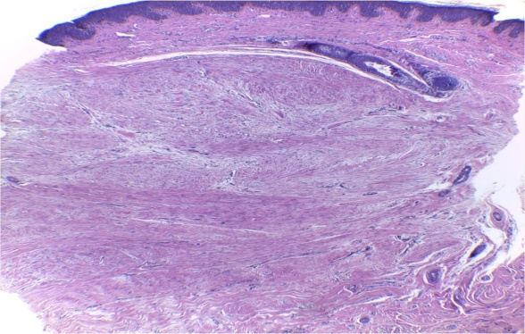

Photomicrograph demonstrating histopathological changes of collagen fibers using routine H & E stain, before treatment show The thick sclerotic collagen bundles in the scar tissue, loss of orientation and increasing of dermal thickness before treatment.

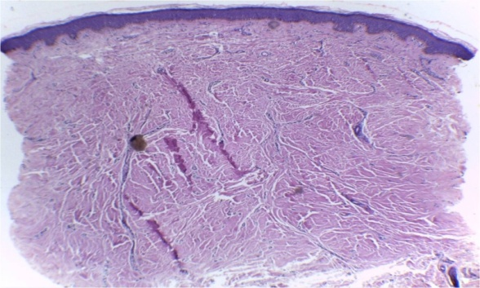

Photomicrograph demonstrating histopathological changes of collagen fibers using routine H & E stain, after treatment by fractional co2 laser followed by triamicinoloneacetonide, The thick sclerotic collagen bundles in the scar tissue before treatment changed to a combination of fibrotic and fibrillar collagen, with vessels starting to appear in the scar tissue perpendicular to the epidermis after treatment.

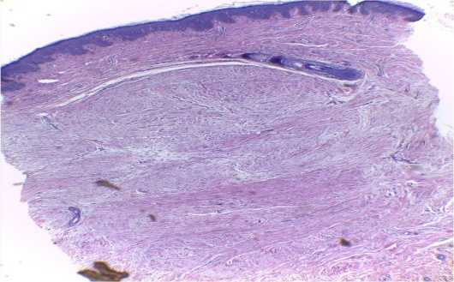

Photomicrograph demonstrating histopathological changes of collagen fibers using routine H & E stain, after treatment by fractional co2 laser alone. The thick sclerotic collagen bundles in the scar tissue before treatment changed to a combination of fibrotic and fibrillarcollagen.

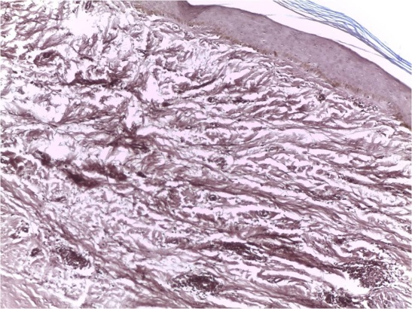

Photomicrographs representing results of **orcein** staining for elastic fibers for the same case **before** treatment. Elastic fibers were completely absent from the scar tissue before treatment

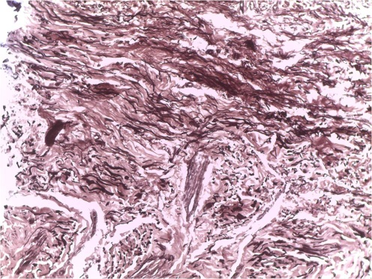

Photomicrograph representing results of orcein staining for elastic fibers for the same case after treatment by fractional co2 laser followed by triamicinoloneacetonide Elastic fibers were started to appear as a combination of short fragmented and fibrillar fibers.

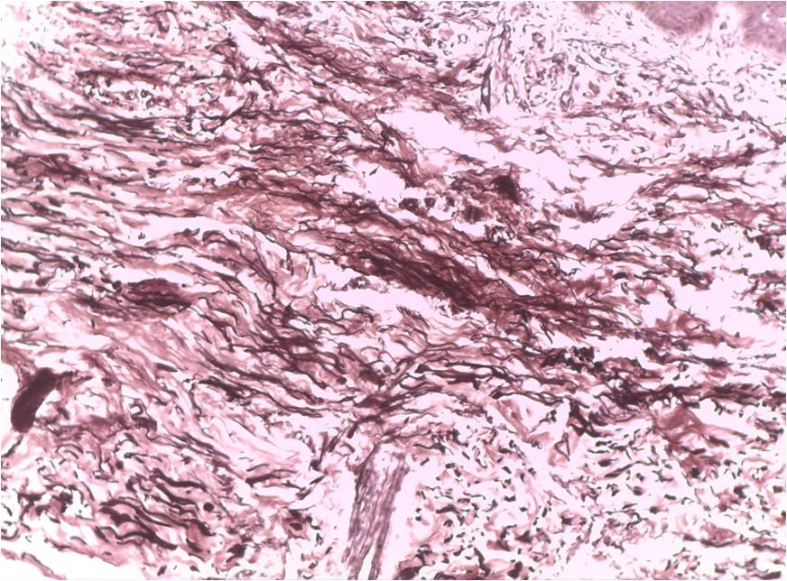

Photomicrographs representing results of orcein staining for elastic fibers for the same case after treatment fractional co2 laser alone, Elastic fibers started to appear as a combination of short fragmented and fibrillar fibers.

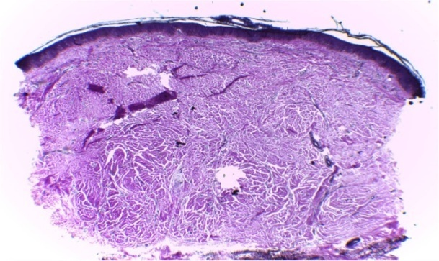

Photomicrograph representing results of Masson’s trichrome staining for collagen fibers for the same case, before treatment show collagen density.

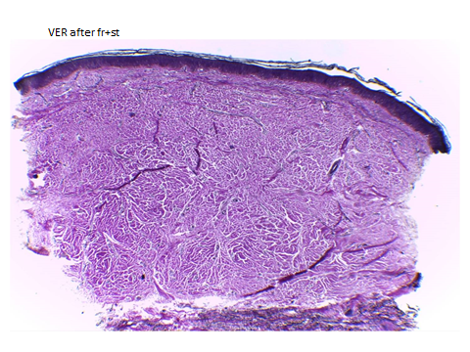

Photomicrograph representing results of Masson’s trichrome staining for collagen fibers for the same case after treatment by fractional co2 laser followed by triamicinoloneacetonide show Reduction in collagen density and improved collagen quality.

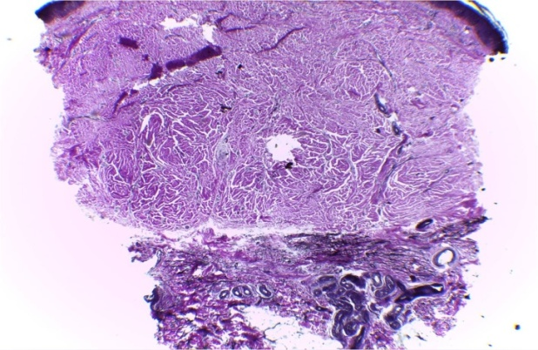

Photomicrograph representing results of Masson’s trichrome staining for collagen fibers for the same case after treatment by fractional co2 laser alone Reduction in collagen density and improved collagen quality.

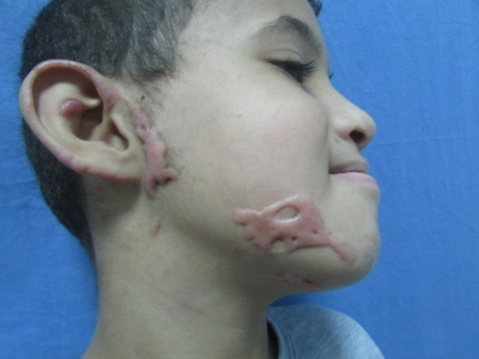

The patient before treatment.



Patient after treatment (***area 1*** treated by fractional co2 laser followed by triamicinoloneacetonide, ***area 2*** treated by fractional laser alone).

## 4. Discussion

Fractional ablative carbon dioxide laser (AFXL) is a viable treatment option for scars ***(Anderson et al., 2014).*** AFXL generates vertical microscopic columns of tissue ablation in the epidermal and dermal layers, leaving intervening tissue intact. Each ablated channel is surrounded by a zone of thermally damaged skin. AFXL exposure elicits a cascade of cytokines and growth factors, leading to activation of ﬁbroblasts, induction of neocollagenesis, and synthesis of elastin ﬁbers. This pathway is assumed to promote structural changes in scar tissue ***(Ozog et al., 2013)***.

Fractional lasers create zones of ablation at variable depths determined by the treatment settings. The unique fractional injury induces a molecular cascade including heat shock proteins and other factors that lead to a rapid healing response and prolonged neocollagenesis with subsequent collagen remodeling ***(Waibel et al., 2009)***. When applied in a fractional pattern, columns of abnormal scar are ablated, allowing new collagen to form in a controlled manner, with rapid epithelialization of surface. Recent work suggests that in addition to apoptosis of ﬁbroblasts in these micro thermal zones, or “MTZs,” the hypertrophic scars undergo up regulation of matrix metalloproteinase 1 with alteration of types 1 and 3 procollagen levels and down-regulation of transforming growth factors and basic ﬁbroblast growth factor. Not only are these changes evident in the MTZs, but the entire thickness of the dermis seems to be affected ***(Qu et al., 2012).***

Effective topical delivery of any pharmaceutical agent requires the ability to penetrate the epidermis. Fractional laser therapy creates precise, uniform columns of tissue vaporization which in theory might help to facilitate drug delivery past the epidermal barrier ***(Haedersdal et al., 2010)***.

Ablative fractional laser-assisted corticosteroid delivery may take advantage of the newly formed channels to penetrate uniformly and deeply into dermal scars. Furthermore, injection of triamcinolone acetonide is often painful and consistent dosing is difﬁcult to achieve throughout the scar. In contrast, topical application of triamcinolone acetonide after fractional resurfacin**g** is painless and may be applied with greater uniformity ***(Haedersdal et al., 2010)***.

Since combination therapy may result in synergistic effects and regarding the lack of studies on this issue, the current investigation was performed to determine the comparative effects of ablative fractional CO2 laser plus triamcinolone acetonide suspension versus ablative fractional CO2 laser alone in the treatment of post burn scars.

In this randomized, blinded, clinically split scar study, objective assessment of the pigmentation, erythema, pliability, and height was done using the Vancouver scar score.

## Subjective assessment of the pain, pruritus, parathesia and pliability was done using the university of north Carolina scar score.

Objective measures showed significant improvement of the burn scars following fractional CO2 laser treatment. This was in agreement with the findings of several researchers using different parameters. ***Waibel et al, ( 2009); Ozog et al, ( 2013); El-Zawahry et al. (2015 ) and El-Hoshy et al. (2017).***

Subjective measures showed a significant change in the opinion of the patients about their scar appearance. This was in agreement with ***Hultman et al. (2014).***

In the current study, improvement was higher for part of the scar treated by fractional CO2 laser plus triamcinolone acetonide than part of the scar treated by fractional CO2 laser alone clinicaly and histopathological but this improvement non significant.

In the current study, improvement was significantly higher for pliability, vascularity, height and pigmentation. This was similar to the finding by ***Kim et al, ( 2014)*** who reported that ablative fractional CO2 laser use was more effective in improving pliability and thickness of surgical scars, while pulsed dye laser (PDL) use was superior regarding treating vascularity and pigmentation. This suggests that firm, irregular scars are the best candidates to respond to fractional CO2 laser use rather than erythematous, hyperpigmented ones. The initial management of hyperemic scars by PDL targeting the vasculature, followed by the fractional CO2 laser, might be a more suitable plan for managing hyperemic scars.

The significant improvement in scar thickness and pliability achieved by fractional CO2 use in our study was shown by histological analysis to be due to its effect on collagen and elastic fibers.

Improvement in scar vascularity by fractional CO2 lasers occurred in our cases and this might be explained by the dermal blood vessels becoming less trapped and more perpendicular to the epidermis as a result of collagen remodeling. This observation was also reported by both ***Ozog et al, (2013), Makboul et al, (2014)*** and ***El-Hoshy et al. (2017).***

Targeting tissue water may lead to thermally induced destruction of the blood vessels ***Glaich et al, (2007)*** with subsequent improvement of erythema.

In both Masson’s trichrome and orceinstained samples, the irregular sclerotic collagen fibers significantly changed to less sclerotic, finer, more fibrillar collagen, with a significant reduction in the amount of collagen fibers. Our findings were in agreement with ***Ozog et al, ( 2013); Makboul et al, (2014); El-Zawahry et al. (2015) and El-Hoshy et al. (2017).***

Fractional CO2 laser induces matrix metalloproteinases (MMPs), which clear the damaged collagen and allow for collagen remodeling to take place, with the formation of new, healthy collagen. (***Reilly et al, 2010***).

A significant improvement in morphology and orientation of elastic fibers was detected in the current study, the amount of elastic fibers increased significantly after treatment. ***Ozog et al, ( 2013) and El-Hoshy et al. (2017))*** reported similar changes.

In contexts other than burn scars, ***Shin et al (2011)*** reported increased density of elastic fibers following fractional CO2 laser treatment of striaedistensae. Also***, Jiang et al (2014)*** performed a single pass fractional CO2 laser session on mice dorsal skin and detected the replacement of lumps of old elastic fibers by slender elastic fibers with a wider distribution within few hours of fractional CO2 resurfacing.

The age of the patient, the scar site and scar duration have been found no differences in the efficacy of treatment. Also ***Haedersdal et al (2009)*** found no differences in the efficacy of treatment with respect to subject age, anatomical location of the scar, or duration of the scar. On the other hand the shorter the scar duration, the better the improvement with fractional CO2 laser. This finding is reiterated in the observation reported by ***Niwa et al, (2009)*** stating that scars less than one year in duration improve more noticeably. This is mostly due to the effect of cytokines and growth factors that influence fibroblast activity early on in wound healing. In treating different types of scar, ***El Taweel and Abd El-Rahman (2014)*** found that clinical improvement was better in younger patients.

Laser plus triamcinolone treatment was more effective on texture and homogenous status in our study. ***Waibel et al. (2013)*** also demonstrated good response of texture in patients under treatment with laser plus triamcinolone.

The present study has conﬁrmed that clinical improvement of burn scars after fractional CO2 laser treatment is mirrored by histologic ﬁndings, which showed an increased epidermal thickness, thinning in the stratum corneum and replacement of the irregular dermal collagen bands with organized parallel new collagen ﬁbrils making it more closely resembling that of normal skin.

Similar to our results, ***Bonan et al. (2013)*** reported that laser makes dermal collagen ﬁner and less dense. They claimed that ischemia from microvascular destruction caused by laser releases collagenase which leads to collagenolysis. Also dermal heat produced from blood vessels irradiated by laser can stimulate the collagen synthesis and remodeling. TGF-b1 has been shown to play an important role in the formation of hypertrophic scar.

**Conclusion**

Fractional CO2 laser assisted topical steroid delivery could be considered as a promising option for burn scar management as it improves the clinical appearance of the scar, which was detected histologically by changing the dermal collagen orientation and thickness making it much similar to normal skin.

**References**

1. Anderson R, Donelan MB, Hivnor C, Greeson E, Ross EV, Shumaker PR, Uebelhoer NS, Waibel JS (2014): Laser treatment of traumatic scars with an emphasis on ablative fractional laser resurfacing: Consensus report. JAMA Dermatol. 150: 187–193.
2. Bock O, Schmid-Ott G, Malewski P (2006): Quality of life of patients with keloid and hypertrophic scarring. Arch Dermatol Res.297: 433–8.
3. El Taweel AI, Abd El-Rahman SH. Assessment of fractional CO2 laser in stable scars. Egypt J Dermatol Venerol.2014;34:74–80.

# El-Hoshy K, Abdel-Halim M R. E, Dorgham D, Salah El-Din S, El-Kalioby M. Efficacy of Fractional Carbon Dioxide Laser in the Treatment of Mature Burn Scars. A Clinical, Histopathological, and Histochemical Study. J Clin Aesthet Dermatol.2017 Dec; 10(12): 36–43.

1. El-Zawahry BM, Sobhi RM, Bassiouny DA, Tabak SA. Ablative CO2 fractional resurfacing in treatment of thermal burn scars: an open-label controlled clinical and histopathological study. J Cosmet Dermatol.2015;14(4):324–331.
2. Haedersdal M, Katsnelson J, Sakamoto FH, et al (2011). Enhanced uptake and photoactivation of topical methyl aminolevulinate after fractional CO2 laser pretreatment. Lasers Surg Med 2011: 43: 804– 813.

# Hultman CS, Friedstat JS, Edkins RE, Cairns BA, Meyer AA(2014). Laser resurfacing and remodeling of hypertrophic burn scars: the results of a large, prospective, before-after cohort study, with long-term follow-up. Ann Surg. Sep;260(3):519-29; discussion 529-32.

1. Jiang X, Ge H, Zhou C et al. The role of transforming growth factor β1 in fractional laser resurfacing with a carbon dioxide laser. Lasers Med Sci. 2014;29(2):681–687.
2. Kim DH, Ryu HJ, Choi JE et al. A comparison of the scar prevention effect between carbon dioxide fractional laser and pulsed dye laser in surgical scars. Dermatol Surg. 2014;40(9):973–978.
3. Makboul M, Makboul R, Abdelhafez AH et al. Evaluation of the effect of fractional CO2 laser on histopathological picture and TGF-β1 expression in hypertrophic scar. J Cosmet Dermatol.2014;13(3):169–179.
4. Niwa AB, Mello AP, Torezan LA et al. Fractional photothermolysis for the treatment of hypertrophic scars: clinical experience of eight cases. Dermatol Surg. 2009;35(5):773–778.
5. Ozog DM, Liu A, Chafﬁns ML, Ormsby AH, Fincher EF, Chipps LK, Mi QS, Grossman PH, Pui JC, Moy RL (2013): Evaluation of clinical results, histological architecture, and collagen expression following treatment of mature burn scars with a fractional carbon dioxide laser. JAMA Dermatol. 149:50–57.
6. Qu L, Liu A, Zhou L, He C, Grossman PH, Moy R, Mi QS, Ozog D (2012): Clinical and molecular effects on mature burn scars after treatment with a fractional CO2 laser. Lasers Surg Med 44:517–524.
7. Reilly MJ, Cohen M, Hokugo A et al (2010;). Molecular effects of fractional carbon dioxide laser resurfacing on photodamaged human skin. Arch Facial Plast Surg. 12(5):321–325.
8. Shin JU, Roh MR, Rah DK et al. The effect of succinylated atelocollagen and ablative fractional resurfacing laser on striaedistensae. J Dermatologic Treat.2011;22(2):113–121.
9. Van Loey NE, Bremer M, Faber AW (2008): Itching following burns: epidemiology and predictors. Br J Dermatol.158: 95 –100.
10. Verhaegen P, Van Zuijlen P, Pennings N (2009): Differences in collagen architecture between keloid, hypertrophic scar, normotrophic scar, and normal skin: an objective histopathological analysis Wound Repair Regen.17: 649–656.
11. Waibel J, Beer K, Narurkar V, Alster T (2009): Preliminary observations on fractional ablative resurfacing devices: Clinical impressions. J Drugs Dermatol. 8: 481–485.
12. Xie Y, Zhu KQ, Deubner H (2007): The microvasculature in cutaneous wound healing in the female red Duroc pig is similar to that in human hypertrophic scars and different from that in the female Yorkshire pig. J Burn Care Res. 28: 500–506.

12/2/2019