**The Management and Response of Government to Flood Disaster and Policy Measurements in Pakistan**

Naeem Ahmed Junejo 1, Meetha Ram 2, Mola Bux 3, Bakhtawar Nizamani 4

1. School of Social Development and Public Policy, Beijing Normal University, Beijing, China. [junejonaeemahmed@gmail.com](mailto:junejonaeemahmed@gmail.com)

2. Department of Sociology, College of Humanities & Social Sciences, Huazhong Agricultural University, Wuhan, Hubei, China

3. Department of Comparative Education Beijing Normal University, Beijing, China

4. Department of Sociology, Faculty of Social Sciences, University of Sindh Jamshoro, Pakistan

**Abstract:** Historically Pakistan has witnessed several major flood disasters affecting approximately 40 million people, a drought affecting 3 million people and major earthquakes in 2005 and 2008 affecting 7 million people. After the earthquake of 2005 National Disaster Management Commission (NDMC) Pakistan came into existence. NDMC was constituted through an ordinance. The main objective of establishing of this national disaster management of authority is to reduce risks and vulnerabilities of the poor and marginalized groups and recovering them from, disaster impact. This NEW policy replaced old Disaster management Organization working in the country since 1973. This document therefore evaluates the old disaster policy and new disaster policy in the country. This document also appraises the “The management and response of Government to Flood Disaster in Pakistan”. In Pakistan the government has been made the all policies belongs flood disaster and management, the institution are placed from national level to district level, but there are some week points like as, lack of coordination between line departments, management do not respond to the public in emergency situation, lack of awareness, lack of capacity, no skilled employees in the government flood related departments, lack of funds/donors, flaws in policy needs to update, political influence/ lack of political spirit. In this regard government should must be take initiatives to improve the above mentioned week points, seriously and immediate basis, there are some recommendation about policy brief like as defined. Policy needs to be redesigned especially at the district level in entire Pakistan, to organize the awareness programs or workshops at community level in most vulnerable areas, improvement in coordination of line departments, NDMA department must be took an active part at the root level. Further the study will provide the policy guide line for different local NGOs, CBOs, Community organization INGOs, social welfare department, and relevant stakeholders for flood management.

[Junejo NA, Ram M, Bux M, Nizamani B. **The Management and Response of Government to Flood Disaster and Policy Measurements in Pakistan.** *N Y Sci J* 2019;12(11):52-58]. ISSN 1554-0200 (print); ISSN 2375-723X (online). <http://www.sciencepub.net/newyork>. 7. doi:[10.7537/marsnys121119.07](http://www.dx.doi.org/10.7537/marsnys121119.07).

**Keywords:** Flood, Disaster, Disaster Management, Government, NGO

**1. Introduction**

Geographically Pakistan is divided into three major areas: the northern highlands; the Indus Plain, (with two major subdivisions corresponding Upper Indus Plain and Lower Indus Plain) (Hussain, 2011). Indus Plain is home majority of the population in Pakistan, historically Indus Plain has witnessed several floods which has inundated the region and devastated large portions of the population in the country which has adversely affected people’s lives ranging from the loss of life. Livestock, cultivated land, crops to stored grains and damaged basic infrastructure, moreover, it has displaces millions of the peoples (Gaurav, Sinha, & Panda, 2011). Therefore it a big challenge both for the government and humanitarian organizations, lack of disaster preparedness policies and procedures (especially on flood preparedness) has aggravated the situation. The catastrophic flood of 2010 along the Indus River began in July with unusually intense but not unprecedented rainfall in the upland catchment. During four months, close to 2,000 fatalities occurred and 20,000,000 inhabitants were displaced (Syvitski).

After the floods, the rehabilitation process such as rebuilding infrastructure, irrigation channels, communication systems, schools, and hospitals, in addition to accommodation of displaced persons remains a major challenge, therefore, a comprehensive planning and policy measures can not only reduce and mitigate those challenges but will save many lives, through the country. Damage Needs Assessment (DNA) documented an estimated $9.7 billion cost of damages to infrastructure, farms and homes, which included reconstruction costs for transport,

communication, energy, health, water, sanitation, irrigation, social protection, and civic administration services. According to the DNA, the farming and livestock sectors were impacted the most, followed by whole or partial damage to a large number of houses, flash floods in the hilly regions of provinces, Azad Jammu and Kashmir/Gilgit Baltistan, Khyber Pakhtunkhwa and Baluchistan swept away people, houses, crops, livestock and stores of feed, food, and seed, roads and irrigation facilities were also seriously damaged, particularly in southern Sindh province of Pakistan (Deen, 2015).

**2. Objectives of the Study**

This paper has below main objectives

1. To find out the past and current policy measures for disaster management and response to flood disaster in Pakistan.
2. To explore the role of public and private institutions towards mitigating disaster risk reduction and provision of relief to people.
3. To provide set of recommendation for policy measurements, public and private institutions towards their role for disaster management and response to flood

**3. Research Methodology**

This study has used secondary data source for this study. In the study past literature including research papers, books, reports and official data sources from internet are included. The study has suggested required recommendations as per the analysis of past literature.

**4. Past Policy for Disaster Management in Pakistan**

The concept of disaster has undergone a dramatic transformation of meaning over time. In the previous, many, if not most, of the civilizations around the world viewed disasters as acts of God (McEntire, 2001). Since independence to 2005 the disaster response policy of Pakistan was not centralized, there was an integrated plan embracing all the emergencies, it was based on both Government and private organizations which was functional, action oriented and flexible, the policy was believed as a serviceable for simple and multiple contingencies which could encourage self-reliance amongst the district officials by furnishing knowledge, training, and by the “preparedness day”, disaster response was the responsibility of district authorities who were responsible to involve Aid-giving agencies and general public in affected areas of the district, historically the disaster operational policy and implementation plan envisioned a “Control entre” with a Disaster Management divided in 3 sections, and 6 Disaster Services set up by the Implementing Agencies in 1997, the disaster relief plan Sukkur, Dadu, Larkana, Jacobabad, and Badin, the Districts disaster relief program Sindh 1997 (Soomro).

**Chart # 01**

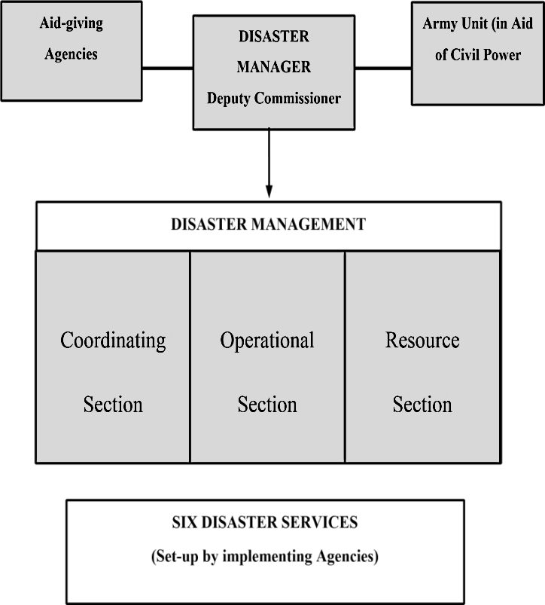

Above Chart shows the Operational Structure of Historical Disaster Relief, Sindh province of Pakistan

*Data Source: (Relief Commissioner Sindh, 1977)*

**Chart # 2**

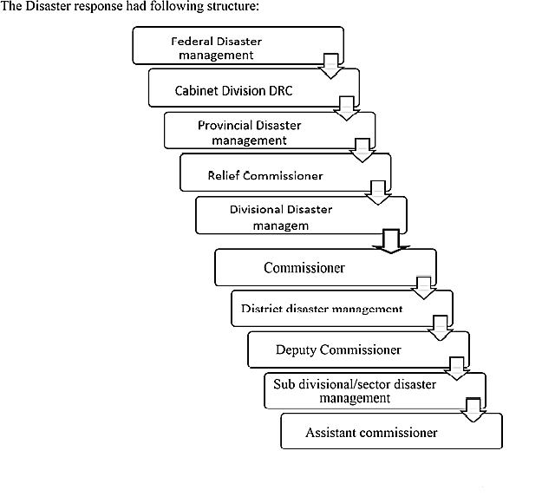

*Data Source:* *(Relief Commissioner Sindh, 1977)*

In addition Pakistan government set the five years plan since 1957, when the national economic council (NEC) approved the final version of the First Five-Year plan, the development paradigm in Pakistan has remained oblivious of the preparedness and management of natural calamities. The plans, however, identified the mismanagement and scarcity of water resources, poor health infrastructure, and flood threats at few stages of the planning and implementation during the last three decades. But the proposed strategies and solutions were either relief-driven or event-based without having an integrated disaster management plan, first Plan (1955-1960) does not comprise any exact measures, strategies or programs in relation to disaster management, it emphasizes for strengthening cultivation sector and efficient development of water resources for irrigation, and drainage, hydro-electric power manufacture, transport, for the then East Pakistan, the major purpose to be served through the first plan was to protect large areas from the saline waters of the tides and to recover waterways for inland water transport, likewise, the second and third five-year Plans also follow the objectives set in the first plan and tend to adopt identical strategies to achieve overall development objectives, however, after ten years, (1970-1975) the fourth five-year plan included flood control program for the then East Pakistan and development of environment in big cities, Specific targets of the Plan were, to assume a major flood control program in East Pakistan outside the Fourth Plan, to protect the entire population from malaria and small-pox and bring about a major improvement in curative health facilities (Khan & Khan, 2008). To launch an Urban Works Program (UWP) to improve the environmental situations in big cities and to cater to the public needs of the abandoned areas, the physical planning and housing element of the plan recognizes that research in environmental sanitation counting air and water pollution needs to be undertaken and results enforced through suitable standards and legislation, the Fifth Plan (1979-1983) did not take up the issue of disaster management at any level and the development progress on other fronts also continued disappointing, the on-farm water management program was started during the fifth plan period to reduce the waterway losses, the Sixth Five-Year Plan (198388) classifies that the Fifth Plan period was disappointing, as there was no sufficient long-term investment either in physical infrastructure or in human resource development, this trend created shortages of energy, telephones, water and other infrastructure and resulted in a very low level of educational literacy and poor health facilities, the Plan appears to achieve physical targets (1983-1988) in the area of cultivation development, the proposed targets were: Fitting of 4312 of fresh and saline ground water tube wells, additional of 810 tube wells and construction of 11446 miles of surface and tile drains, the protection of 5.3 million acres including a disaster area of 2.8 million acres. 4) Continuance of the On-Farm Water management program to decrease the watercourse losses, the Plan (1993-1998) which ended up in achieving far less than projected development targets, dealt with the issues of justifiable environment and management of water resources, efforts were made for improving environmental legislation and enforcement of National Environmental Quality Standards (NEQS) initiating Environmental Impact Assessment (EIA) procedures for public and private funds, and incorporating more environment-related investments in all development expenditures, the Water Resources Development section of the Plan included a specific objective of defensive land and infrastructure from water-logging, salinity, and floods, the strategies adopted for achieving the objective were neither comprehensive nor integrated and water-logging, salinity, and floods, thus, continued to affect the poor and vulnerable sections of the society, the framework, (1998-2003) objectives and strategies of the Plan reflect the apathy of federal administration towards disaster management despite recurrent losses due to floods and landslides in the preceding years, however, it incorporates environmental issue in a more harmonized manner as compared to the previous efforts at State level, based on the performance indicators, gaps and weaknesses of the Eighth Five-Year Plan, following are the specific objectives for water sector development during the Ninth Five-Year Plan,

* To make more actual use of the surface and ground water
* To achieve equitable and assured supply of water
* To store and use river water flood surpluses through storage /carry-over dams
* To decrease the extent of waterlogged lands
* To bring out water-related research readings
* To apply flood flows including harnessing for augmenting water accessibility for irrigation
* To augment reserves in flood control management, including flood warning and forecasting systems (Khan & Khan, 2008).

**5. Current Policy for Disaster Management in Pakistan**

Government plans and policies often end up growing people’s exposure to physical hazards, the malpractices of native elites reduce people’s access to capitals and information, CBDRM (Community Based Disaster Risk management) a long term joint initiative of USAID/OFDA with NDMA Pakistan has helped rise people’s strength through community-based organizations who established contingency plans for dealing with disasters, developing linkages with external governmental and non-governmental stakeholders involved in preparedness and response activities and undertaking micro-mitigation work within groups, agencies have also become better prepared coordinating their DRR work and undertaking DRR-related advocacy through the establishment of a DRR Forum, however, coordination between NGOs at local level is still low, there is no too little exchange of information, resources etc, at the minor level and very limited attempts have been made to develop broader perspectives on the vulnerability status of groups within districts, Moreover DRR work is mainly being done by activities as part of emergency work. CBDRM mostly focuses on response and avoidance and ignores DRR prevention and mitigation dimensions (Sayed & González, 2014).

The features of policies in Pakistan which was made by government

* Disaster management in Pakistan basically revolves around flood disasters with a major focus on rescue and relief. After each disaster episode the government incurs considerable expenditure directed at rescue, relief and rehabilitation.
* Genuine disaster management policy occasionally carries strategic biases that are aimed at defensive locations and set-up of greater economic, political and strategic significance at the charge of areas and societies with lesser influence and significance.

Inside disaster management bodies in Pakistan, there is a dearth of knowledge and information about hazard identification, risk assessment & management, and relations between livelihoods and disaster preparedness. Disaster management policy responses are not normally influenced by methods and tools for cost-effective and sustainable interventions.

Here are no long-term, inclusive and coherent official arrangements to address disaster issues with a long-term vision. For instance, the Emergency Relief Cell is mandated to deal only with post-disaster scenarios. Disasters are observed in inaccessibility from the processes of normal development and poverty alleviation planning. Some of the large-scale development projects are bringing new forms of disaster and addition to the vulnerability of at-risk cultures. The Left Bank Outfall Drainage (LBOD) project and link canals are significant examples in Pakistan. Disaster management, development preparation and environmental management organizations operate in isolation and integrated planning between these sectors is almost lacking. Lack of a central authority for integrated disaster management and lack of coordination within and between disaster related organizations is responsible for actual and efficient disaster management in the nation. National-level disaster attentiveness and mitigation methods are heavily tilted towards structural aspects and weaken non-structural elements such as the information and sizes of local people, and the related livelihood defense problems (Tariq & Van de Giesen, 2012). Disaster and aid units and organizations largely remain under-resourced, untrained, and not given required rank within managerial hierarchy, a dedicated trust for disaster management at the national level has never been a part of the overall development preparation, the officials of two important administrations engaged in disaster management e.g. Disaster Relief Cell and Federal Flood Commission are not provided with adequate training, a great deal of uncertainty triumphs among government teams about their stay in any disaster related organization / department, which contributes towards working with less interest and competence, assumed the regular incidence of floods during monsoon season the administration has taken adequate measures for flood control and management down to district level (Khan & Khan, 2008). The Pakistan Army plays a significant role in flood management by providing search and rescue services and emergency relief in affected areas (Ainuddin, Aldrich, Routray, Ainuddin, & Achkazai, 2013). Flood Commission commences flood destructive plans every year in April and monitors the discharge of water at strategically important barrages and dams, and maintains a regular interaction with all provincial governments in pre, throughout and post flood situations, the district, provincial and federal administrations prepare flood fighting plans annually and ensure timely dissemination of early warning through original and modern modes of statement (Khan & Khan, 2008). Establishment of National Disaster Management Commission (NDMC) Pakistan came into existence after the history’s worst disaster i.e. earthquake of 8 October 2005, this disaster involuntary the government of Pakistan to establish a National Disaster Management Authority (NDMA) at federal level and Provincial/District Disaster Management Authority (PMDA/DDMA) at provincial and district levels respectively (Majeed, 2009). This is aimed at synergizing all efforts for meeting the goal of better reasons like instructional strength, sense of sacrifice, altruism, organizational abilities, nevertheless, myriad of factors, because of deterioration in almost all institutions and lack of accountability, comprehensive instructions issued by NDMA remain wanting in their effect for proper disaster management, although the government has established a comprehensive DRR control system in Pakistan In reality the system suffers from absence of political commitment, funding, skilled human resources, organization, fragmentation, overlapping and unclear plan among management agencies horizontally and vertically, the system is particularly weak at the local district levels where the bulk of operation occurs, the nationwide DRR system focuses mostly on response and ignores other more sustainable and tough dimensions of disaster, such as deterrence and mitigation which can address the root causes of disaster risk within the nation, which because of its physical diversity is vulnerable to a big range of physical hazards, such as floods, earthquakes, tsunamis, and cyclones (Sayed & González, 2014)

**Chart # 3**

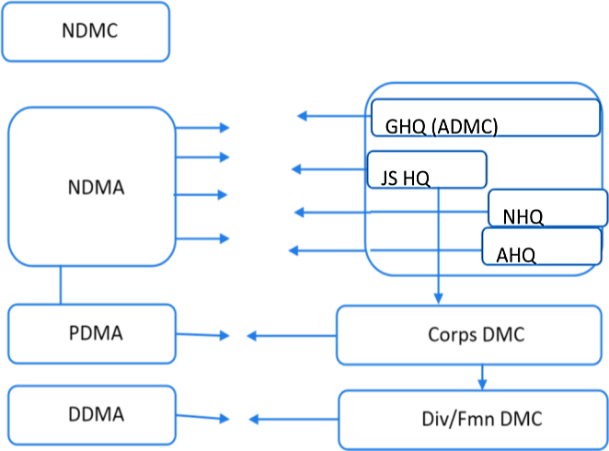

Above chart presents the organizational structure of the NDMA

*Data Source: Khan & Khan, 2008*

NDMA/PDMAs is not fully geared up for proper forecasting, mitigation, preparedness and response/rehabilitation, though, weak implementation, policy/strategy laid down by NDMA/PDMA and plans formulated by DDMA are well thought out and workable, it includes relief and recovery, management of displaced persons and provision of security, if required, relief and rescue operations conducted during floods of 2010 and 2011 evidenced that despite establishments of NDMA/PDMAs greater reliance continues to be on the Army, there is variation in the role and methodology specified for the Army by NDMA and the one highlighted in official website of the Army, by accepting policies to reach the Millennium Development Goals (MDGs), the Ten-Year Perspective Development Plan was implemented into operation on 1st July, 2001to 2011, its total size has been fixed at Rs. 11,287 billion in current prices out of which Rs.8, 747 billion have been envisaged as the investment of private sector and Rs.2, 540 billion as Public Segment Development Program (PSDP), National Water production Development, the Plan recognizes the severity of drought in Sindh and Balochistan and the subsequent shortage of water that has aggravated the ongoing water crises, the major goal of policy formulation and sectorial planning in water resources sector during the Ten-Year Perspective Development Plan is to uplift the agro based economy on the national level by maximizing crop production, this will be achieved through progressively increasing surface water supplies using the latest technologies available and protecting land and infrastructure from water logging, salinity, floods and soil erosion, in this connection NDMA form the below policies and structure to overcome and achieve the goals, Augmentation and conservation measures to overcome the scarcity of water, drainage and reclamation program to protect the disastrous area, flood Control and Protection.

Rehabilitation of irrigation system of Punjab and Sindh and transformation of canals in Punjab the Plan gives high priority to the building of medium and large dams and canals to meet water requirements in the future. The total outlay for the Federal Ten-Year Development Plan for Water Division amounts to Rs.418 billion out of which Rs.63 billion has been projected for the Three-year Program (2002-05), In adding, small irrigation schemes will be started, building of 303 spurs and 1101 kilometers of flood embankments and improvement of flood threatening systems will be carried out. During the three-year program (2002-05), 240 and 68 kilometers of flood banks will be constructed to safeguard life and property (Khan & Khan, 2008).

**6. Recommendations**

Since 1973 Pakistan has had seven major flood disasters affecting approximately 40 million people in total, a drought in 1999 affecting 3 million people and major earthquakes in 2005 and 2008 affecting 7 million people (Deen, 2015). The government of Pakistan referred to the 2010 floods as a ‘super flood’ (Ulander et al., 2011). The flood followed the annual monsoon season, in Pakistan, reaching floods levels that were unprecedented in the known history of the Indus river system. Out of a total of 141 districts, 78 districts (approximately 160,000 km2 of land) were inundated, severe flooding in Khyber Paktunkhwa (KPK), Punjab, and Sindh provinces resulted in the deaths of 2000 people, while 1.8 million homes were either damaged or destroyed, out of a total population of 168 million, nearly 18 million people were adversely impacted, displaced, or impoverished (Deen, 2015). In Punjab alone, 200 villages, 500,000 homes, and 1.7 million acres of farmland were damaged and billions of dollars’ worth of crops and livestock were destroyed (Deen, 2015). In the immediate wake of the 2010 floods the Pakistan military and the government were the primary actors on-ground, despite the short comings in the civilian government's disaster response, there was an (albeit lagged) multi-stakeholder response to the floods, in the absence of good local governance in some regions, local and international NGOs provided flood relief for communities, for example, community based organizations contacted their head-offices in larger cities to provide relief aid and assistance after the 2010 floods, UN agencies and the NDMA under the One UN Disaster Risk Management Program UNDP Pakistan 2009 (Peduzzi, Dao, Herold, & Mouton, 2009) adopted a cluster approach with federal ministries, government departments, armed forces, and donors to distribute relief goods. However, the federal government's efforts were focused in Sindh and KPK province (Guha-Sapir, Vos, Below, & Ponserre, 2012). Pakistan's short-term urgent humanitarian needs to include food, clean water, sanitation facilities, and medical and nutritional supplies, and vaccines, cash for agricultural inputs, land reclamation, and food and medicine for livestock, government and international NGO efforts were jointly supported by small local NGOs and community based organizations (Ek & Fergusson, 2010). Although there was a void in the civilian government's response, the NDMA, PDMAs, and DCOs should not be held entirely responsible, given the dis-connection between the national and provincial decision-making (White, 2011). The NDMA had initiated the process of establishing PDMAs, SDMAs etc., however, the plans for setting up DDMAs, which would work in collaboration with DCOs at district levels are yet to be implemented, and therefore, it is important to note that the PDMAs existed largely on paper at the advent of the 2010 floods, during the floods, the DMAs immediately initiated the process of building their own capacity, in order to get a deeper understanding of how various state and non-state actors coordinated the relief and reconstruction effort, and to understand the various shortcomings and challenges faced, should be reviewed well and removed, it is our argument that the cultural, economic and social geographies of water use, supply and regulation in the Indus basin are integral links in the causal chain of events that led to the disaster, cyclical flooding occasioned by spring snow-melt and then by monsoonal showers occurs frequently in the Indus basin, twenty main floods, and more inconsequential floods, have happened in the 50 years from liberation in 1947 to 1997, while dams dominate other major, highly sediment dry land river rule schemes, the Indus basin is controlled with weirs in addition to dams, which interrupt upstream velocity stimulating sediment delivery the evidence from other regulated rivers in comparable climatic zones such as in the western United States, that have been studied methodically, suggests that dam building and water diversions result in reduction in station width downstream, decrease in floods peaks with a 50 year and lower return period and channel degradation closer to the dam and aggradation further downstream (Mustafa & Wrathall, 2011).

**7. Discussion and Conclusion**

In comparison of new policy “NDMA” it was observed that old disaster management organization was quite mature and was performing well. However, the old organization was not having fully, skilled and dedicated staff to plan for the mitigation and management of disasters situation, Flood safety should be equal with defined flood thresholds at key locations, e.g., low, medium, high, very high, and exceptionally high flood stages, but these limits are often out of time due to aggradation of river stations in the structure, which decreases water and sediment transport volume Therefore, low, medium, and higher level flood threats need to be reviewed. The flood warning system flops in part because the team at the gauging stations is not able to report readings in a timely or correct fashion, e.g., in the 1992 flood many team members were isolated from gauges due to tall water levels and kept recording the last reading they took. When good statistics is received, CPU modeling is not always as rapid or reliable as it needs to be for real-time predicting and management. There is an ongoing need to advance transfer of flood information between administrators in India and Pakistan, Even when correct information is available to management agencies; public warning, evacuation, and safety are unreliable. Inhabitants living opposite the city of Lahore received nearly no warning before the bunds were breached in 1988. Manufacturers received conflicting information from different organizations and sometimes from the same agency. Some flood officials described rural warning as consisting of little more than local police giving information to occasional passersby. While flood emergency procedures have been framed, water managers and relief agencies are not correctly drilled in emergency procedures to work under time schedules where split-second results are required to stave off disaster. Basin operations sometimes accentuate flood peaks. Whereas in NDMA has well skilled personals. It happened to me to visit the flood affected areas and according to the person’s response in flood affected areas “the NDMA is performing well, with the passage of time it will get mature and this country will have a very strong organization in the shape of NDMA”. It has capacity and access to the resources and technology which will ultimately benefit the marginal communities which are facing recurrent flood situations in the country. I would recommend that community based organizations may be linked well with NDMA to developed and network. The NDMA must work at grass-root level in order to reduce the loss. Emergency centers with advance tools for the information, early warning systems may be established at Union Council level in the country.

**Corresponding Author:**

Bakhtawar Nizamani

Department of Sociology, Faculty of Social Sciences

University of Sindh Jamshoro, Pakistan

E-mail: [bakhtawarnizamani1990@gmail.com](mailto:bakhtawarnizamani1990@gmail.com)

**References**

1. Ainuddin, S., Aldrich, D. P., Routray, J. K., Ainuddin, S., & Achkazai, A. (2013). The need for local involvement: Decentralization of disaster management institutions in Baluchistan, Pakistan. International journal of disaster risk reduction, 6, 50-58.
2. Deen, S. (2015). Pakistan 2010 floods. Policy gaps in disaster preparedness and response. International journal of disaster risk reduction, 12, 341-349.
3. Ek, C., & Fergusson, I. F. (2010). Canada-US relations.
4. Gaurav, K., Sinha, R., & Panda, P. (2011). The Indus flood of 2010 in Pakistan: a perspective analysis using remote sensing data. Natural hazards, 59(3), 1815.
5. Guha-Sapir, D., Vos, F., Below, R., & Ponserre, S. (2012). Annual disaster statistical review 2011: the numbers and trends: Centre for Research on the Epidemiology of Disasters (CRED).
6. Hussain, Z. (2011). Application of the regional flood frequency analysis to the upper and lower basins of the Indus River, Pakistan. Water resources management, 25(11), 2797-2822.
7. Khan, H., & Khan, A. (2008). Natural hazards and disaster management in Pakistan.
8. Majeed, S. (2009). Integration of ecosystem management in livelihood restoration after a disaster. BRAC University.
9. McEntire, D. A. (2001). Triggering agents, vulnerabilities and disaster reduction: towards a holistic paradigm. Disaster Prevention and Management: An International Journal, 10(3), 189-196.
10. Mustafa, D., & Wrathall, D. (2011). Indus basin floods of 2010: souring of a Faustian bargain? Water Alternatives, 4(1).
11. Peduzzi, P., Dao, H., Herold, C., & Mouton, F. (2009). Assessing global exposure and vulnerability towards natural hazards: the Disaster Risk Index. Natural Hazards and Earth System Sciences, 9(4), 1149-1159.
12. Relief Commission Sindh, O. (1977). District Disaster Relief Plans. Hyderabad: Government of Sindh, Pakistan.
13. Sayed, S. A., & González, P. A. (2014). Flood disaster profile of Pakistan: a review. Science Journal of Public Health, 2(3), 144-149.
14. Syvitski, J., & Brakenridge, G. (2013). Causation and avoidance of catastrophic flooding along the Indus River, Pakistan. GSA Today, 23(1), 4-10.
15. Soomro, M. U. MH Panhwar’s contribution towards history of Sindh.
16. Tariq, M. A. U. R., & Van de Giesen, N. (2012). Floods and flood management in Pakistan. Physics and Chemistry of the Earth, Parts A/B/C, 47, 11-20.
17. Ulander, L., Gustavsson, A., Flood, B., Murdin, D., Dubois-Fernandez, P., Depuis, X. Fransson, J. (2011). BioSAR 2010: Technical assistance for the development of airborne SAR and geophysical measurements during the BioSAR 2010 experiment: Final report. Eur. Space Agency (ESA), Paris, France, Tech. Rep. Contract No. 4000102285/10/NL/JA/ef.
18. White, S. (2011). The 2010 Flooding Disaster in Pakistan: An Opportunity for Governance Reform or another Layer of Dysfunction. Center for Strategic and International studies publication.

11/24/2019