Standard Economic Analysis to Study the Most Important Factors Affecting the Egyptian Agricultural Production

Dr. Ehab Moreed Sharabin

Agricultural Economics Research Institute, Agricultural Research Center, Egypt

Email: Dr.ehab19712012@yahoo.com

Abstract: This research aims to study the most important factors affecting the Egyptian agricultural production for the period 1982-2018 through the use of traditional and modern approaches. To achieve the objectives of the study the method of multiple regression analysis has been used in the traditional way, and the use of econometric analysis by estimating the cointegration model in the modern way. The research considers the variables affecting the agricultural production; crop area, labor, agricultural investments and agricultural exports and imports. The study indicates that, in the absence of stationarity in time series, the regression obtained between the variables of the time series to estimate the most important factors affecting the value of the Egyptian agricultural production in the multiple regression (traditional) method was spurious regression. The study also confirms that there is a long-run equilibrium relationship between the Egyptian agriculture production and the independent variables of the study. The pace of adjustment in the short run to achieve long-run equilibrium is 50.64% per year which means that agricultural production requires about 2 years for absorbing the changes. It confirms that there is a long-run causal relationship between the independent variables and the dependent variable in its logarithmic form.
[Ehab Moreed Sharabin. Standard Economic Analysis to Study the Most Important Factors Affecting the Egyptian Agricultural Production. N Y Sci J 2019;12(11):18-34]. ISSN 1554-0200 (print); ISSN 2375-723X (online). http://www.sciencepub.net/newyork. 4. doi:10.7537/marsnys121119.04.

Keywords: Unit Root Test, stationary, integration, Lags Length test, Vector Error Correction Model, causality, Spurious Regression

1. Introduction:
Agriculture has great influence and importance in the Egyptian economy. Although the agricultural areas are small in proportion to the size of the country, the agricultural sector contributes about 5.68 % of total Egypt exports in which an important part of foreign exchange is provided. This includes both the value of agricultural, animal and fish production. The value of agricultural production contributes the largest share followed by the value of animal and fish production. Egyptian agricultural production is one of the most important pillars of economic development in Egypt. It relies on this production to achieve high levels of economic and social welfare; it contributes about 15.92% of Egypt GDP as an average for the period (1982-2018), which is still modest compared to the economically developed countries ⁽⁸⁾ ⁽²²⁾ ⁽²⁴⁾.

Research Problem: -
Despite the increase of agricultural production value from about 10.89 billion pounds in 1982 to about 498.1 billion pounds in 2018, it doesn't not commensurate with its leading role in the development process, especially Egypt is currently in the stage of economic re-construction, which negatively affects the agricultural sector and the lack of optimal exploitation of resources due to its limitation on one hand and increasing population on the other. This requires examining the most important factors affecting agricultural production.

Research Objectives:
The research aims to study the most important factors affecting the Egyptian agricultural production for the period 1982-2018 by using two approaches:
1 – Traditional approach, using multiple regression method.
2 - Modern approach, through which methods of analysis of time series are applied to determine their stationary and cointegration using the vector error correction model, VECM to reach the long-run equilibrium relationship between Egyptian agricultural production and the factors affecting it.

2. Methodology:
Multiple regression model analysis (traditional model) has been used; and the econometric analysis method was employed to analyze the time series to reach its stationarity; building the cointegration model, determining the Lag periods of the model, the error correction vector, finding the causality test, diagnosing the model, examining the standard problems, conducting and analyzing the components of the variance of the model, and finally doing the shock test
to find out the most important factors that production value relies on in the modern method.

First: Stationarity analysis of time series:
The regression theory that uses time series is often non-stationary, resulting in a spurious regression. Among the initial indicators indicated by the high R² and the increase of the statistical significance of the parameters of the estimated function (t) and (f) significantly with an autocorrelation. This is because time series often has a general trend that reflects certain conditions that affect all variables, making them change in the same direction, although there is no real relationship between them ⁽²⁾.
Stationarity is therefore a prerequisite for time series to obtain sound and logical estimates therefore, certain time series characteristics must be available in order to be stationary, which can be illustrated as follows:
(A) The stationarity of mean values over time $E\left(Y_{t}\right)=U$
(B) The stationarity of variance over time $Var\left(Y_{t}\right)=E{\left(Y_{t}-U\right)}^{2}= σ^{2}$
(C) The Covariance between any two values of the same variable should be based on the time gap (K) and not on the actual value of the time calculated for the variance. $Cov\left(Y_{t,}Y_{t-k}\right)=\sum{\left[\left(Y_{t}-U\right)\left(Y_{t-k}-U\right)\right]}=Y_{k}$
$U$Whereas: $U$ the mean, $σ^{2}$variance and${ Y}_{k}$ coefficient of variance ⁽¹⁾
One of the most important methods used in the processing of data that suffer from non-stationarity i.e. the presence of the Unit Root is the Augmented Dickey - Fuller (ADF) test which is based mainly on:
1- Estimating the following models:
(None Trent and Intercept) Model l: ${∆Y}_{t=}\left(ρ-1\right)Y_{t-1}+\sum_{j=1}^{K}{ρ_{j}{∆Y}_{t-j}+ξ_{t}}$
(Intercept) Model ll: ${ ∆Y}_{t=}α+\left(ρ-1\right)Y_{t-1}+\sum_{j=1}^{K}{ρ_{j}{∆Y}_{t-j}+ξ_{t}}$
(Trent and Intercept) Model ll1: ${∆Y}_{t=}α+βT+\left(ρ-1\right)Y_{t-1}+\sum_{j=1}^{K}{ρ_{j}{∆Y}_{t-j}+ξ_{t}}$
Where represents the Intercept, $T$the time trend and is calculated as follows:
$T=(t-1-\frac{1}{2}N)t=(2,3,4……….N)$
$K_{max}$Represents the greatest Lag Length, which can be determined based on the following formula: $K_{max=}\operatorname{int}{{\left(\frac{N}{100}\right)}^{1/4}}$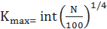$int=integr$
2- N Sample size
3- α Sample level
Under the assumptions:
$H_{0 }:ρ=1$
$$H_{0 }:ρ<1$$
If ρ is significant and less than one, we accept the substitute assumption with no Unit Root, i.e. the variable is Stationary ⁽³⁾.
Added to the previous test, Phillips Peron (PP), is a non-parameter test that takes into account the conditional test of errors, which based on the same limited distributions of the Dickey Fuller-Extended test. PP test is estimated by the following equation:${∆Y}_{t=}µ_{0}+µY_{t-1}+ξ_{t}$
It uses the same critical values as the ADF test. ⁽⁵⁾

Second: Cointegration test:
The technique of cointegration was developed by Anger-Granger in 1983 and was based on stationary time series but this technique is based on nonstationarity, but stationary time series within its linear structure.
If there are two non-stationary series, it is not necessary to use them in estimating a relationship to obtain a Spurious Regression if they have the cointegration. If we have a variable that is stationary in its original form, i.e. before making modifications, it is said to be a zero-degree cointegration and Written in the following form:
$$Y_{t}\sim I (0)$$
If this variable is nonstationary in its original form, but get stationary after taking the first differences that is

$${∆Y}_{t=}Y_{t}-Y_{t-1}$$
it is said on this variable that it is first-class integrated and written in the following form:
$$Y_{t}\sim I (1)$$
In general, if the time series of a variable becomes stationary after obtaining a number of differences equals d, it is said that the sequence is d-level integrated and written in the following image:
$$Y_{t}\sim I (d)$$
There are some features related to the integration of the time series, if there are two variables and the order of each is as follows:
$$X_{t}\sim I (0)$$
$$Y_{t}\sim I (d)$$
The series referring to their group are integrated at the first level
On this basis, cointegration can be defined as being associated with two or more time-series so that fluctuations in one can lead to the cancellation of fluctuations in the other in such a way that the ratio between their values is fixed over time, and this may mean that time series data may be nonstationary if taken separately but as a stationary group and therefore reflect a long-run equilibrium relationship ⁽¹⁷⁾.
There are many ways to estimate cointegration, but in particular, the Johansson Juselius method, which is based on two tests:

Trace Test:
The assumption that there are at most q of the integrations vectors is tested versus the unbound generic model r=q and the statistic of the probability of this test is calculated from the following relationship:
$$λ_{Trace}=-T\sum_{i=r+1}^{p}{ln}\left(1-\hat{λ_{1}}\right)$$
Where T is the sample size, r is the number of vectors of coinegration, λ smaller subjective vector values p-r. The null hypothesis states that there are a number of cointegration vectors equal to at most r, i.e. that the number of such vectors is less than or equals r.

Max-Eigen Statistic Test:
This was calculated by statistics according to the following relationship:
$$λ_{Max}\left(r,r+1\right)=-Tln\left(1-\hat{λ_{r+1}}\right)$$
The null hypothesis test, which states that r is a cointegration vector versus an alternative hypothesis that states that r+1 of cointegration vectors; if the calculated value of the LR range exceeds the critical value at a certain significant level, we reject the null hypothesis that there is no cointegration vector and, if less, we cannot reject the null hypothesis of at least one cointegration vector ⁽³⁾.

Data sources:
The study relied on secondary data from published and unpublished government agencies, such as the Annual Statistical Book issued by the Central Agency for Public Mobilization and Statistics, the Ministry of Economic Development and the Economic Bulletin of the National Bank in the period (1982-2018).

Descriptive Statistics of Study Variables:
Reviewing the data of Table (1), it is noted that most of the values had a decline except the variables of agricultural labor and agricultural imports in 2012 and this is due to the outbreak of the Arab Spring Revolution in Egypt January 25, 2011. It shows also the fluctuation in the data of the study variables, which led to nonstationarity where it turns out that there is a positive Skewness of all the study variables except the crop area with negative Skewness, It is also evident that the Kurtosis coefficient of Egyptian agricultural exports is symmetric with a value of about 3.05; while it was tapered for both agricultural production, agricultural investments and agricultural imports amounting about 5.55, 5.38 and 6.16, respectively, while the area of crop and agricultural labor was kurtosis where the kurtosis coefficient of about 2.20, 2.41, respectively.

Table (1): Statistical Parameters of the Study Variables.
Variables | Unit | Mean | Median | Std. Dev. | Skewness | Kurtosis | Max. | Min.
Value of agricultural Production (AP) | (LE billion) | 99.29065 | 52.845 | 118.4002 | 1.745483 | 5.545808 | 498.098 | 4.54
Crop area (A) | (thousand acres) | 14164.51 | 14474 | 1565.374 | -0.70266 | 2.200009 | 15919 | 11127
Agricultural labor (AL) | (million workers) | 5.194892 | 5.069 | 0.699208 | 0.712558 | 2.411648 | 6.69 | 4.296
Agricultural Investments (AIn) | ( LE billion) | 6.417216 | 6.743 | 5.293806 | 1.360093 | 5.384069 | 24.699 | 0.393
Agricultural Exports (AEx) | (LE billion) | 11.17632 | 1.483 | 15.6743 | 1.227009 | 3.05676 | 49.89 | 0.157
Agricultural Imports (AIm) | (LE billion) | 41.11489 | 13.166 | 57.77757 | 1.931176 | 6.163467 | 241.954 | 1.848
Source of date:
(1) Ministry of Economic Development, Economic and Social Development Plan, Volumes1982-2018.
(2) General Mobilization and Statistics Organization, Statistical Yearbook of the Arab Republic of Egypt, Volumes1982-2018.
(3) National Bank, Research Department, Economic Bulletin, Volumes1982-2018.

First, Traditional Method:
The most important factors affecting agricultural production was estimated by multiple regression where the Agricultural Production Logarithm represents the dependent variable (LnAP), and the explanatory variables represented in the Logarithm of the crop Area (LnA), Logarithm of Agricultural Labor (LnAL), Logarithm of Agricultural Investments (LnAIn), Logarithm of Agricultural Exports (LnAEx), and Logarithm of Agricultural Imports (LnAim). The results of the estimation can be found in the absence of stationarity in time series, the regression we get between time series variables is often Spurious Regression. One of the preliminary indications is the increase of value of R²which reached about 0.96, the statistical significance of F increased to about 135.35, Autocorrelation with DW is less than 0.86. The model also suffers from the problem of Multicollinearity and is detected by applying the correlation matrix as seen from Table (2) which shows that there is a strong correlation between the independent variables on one hand and the irrelevance of the parameters in the estimated model on the other hand. Using the Breusch-Pagan- Godfrey test, Hetroskedasticity problem between the variables of the study was detected, where at a probability level of less than 5% accept the null hypothesis and acknowledge the existence of the problem of heterogeneity. The results of the analysis show that the value Obs*R-squared is about 20,437 and its significance is 0.001, which is less than the probability level of 5% which means accepting the null hypothesis.
It is also clear from the economic criterion that the constant coefficient sign is negative and does not conform with the economic theory which means that the value of agricultural output when the value of independent variables is constant; Moreover, some parameters is inconsistent with the economic logic, since the parameter of agricultural imports has positive sign. This is because data series often has a general trend that reflects certain conditions that affect all variables and makes them change in the same direction, although there is no real relationship between agricultural production and the factors affecting it as evident from the following estimation equation:

LnAP=

-6.42+0.479LnA+2.89LnAL+0.198LnAIn+
(-0,298) (0.223) (1.846) (0.969)
0.197LnAEx +0.184LnAIm
(0.854) (0.628)
R²=0.96 R⁻²=0.95
F =135.35** DW=0.86
Therefore, the analysis of cointegration test by focusing on the behavior of residuals in this model enables us to overcome such problem and can thus develop a long-run equilibrium relationship between the variables and this is dealt with by this research.

Table (2): correlation matrix between each study pair.
Variables | Statement | LnA | LnAEx | LnAIm | LnAIn | LnAL | LnAP
LnA | Corr. | 1
 | Prob. | -----
LnAEx | Corr. | 0.906924 | 1
 | Prob. | 0 | -----
LnAIm | Corr. | 0.89563 | 0.984607 | 1
 | Prob. | 0 | 0 | -----
LnAIn | Corr. | 0.943999 | 0.850571 | 0.882434 | 1
 | Prob. | 0 | 0 | 0 | -----
LnAL | Corr. | 0.845628 | 0.955843 | 0.967855 | 0.846347 | 1
 | Prob. | 0 | 0 | 0 | 0 | -----
LnAP | Corr. | 0.904748 | 0.962785 | 0.969968 | 0.892945 | 0.9562 | 1
 | Prob. | 0 | 0 | 0 | 0 | 0 | -----
Source: Compiled and calculated from the data in Table (1).

Table (3): Unit root test results using the Augmented Dickey- Fuller Extended (ADF) and Phillips Peron (PP) tests for the study variables at the level during the study period (1982-2018).
Variable | ADF test at level
 | Trent and Intercept |  | Intercept |  | None Trent and Intercept
 | t-Stati. | Prob. | t-Stati. | Prob. | t-Stati. | Prob.
LnAP | -3.74 | 0.03 | 0.35 | 0.98 | 2.71 | 1
LnA | -1.3 | 0.87 | -2.02 | 0.28 | 2.92 | 1
LnAL | -2.45 | 0.35 | 0.09 | 0.96 | 2.96 | 1
LnAIn | -1.74 | 0.71 | -1.17 | 0.68 | 1.47 | 0.96
LnAEx | -2.29 | 0.43 | -0.3 | 0.92 | 1.32 | 0.95
LnAIm | -2.3 | 0.42 | 0.04 | 0.96 | 3.42 | 1
PP test at level
LnAP | -3.67191 | 0.0375 | 0.830122 | 0.9932 | 3.814173 | 0.9999
LnA | -0.99 | 0.93 | -3.44 | 0.02 | 2.93 | 1
LnAL | -2.27 | 0.44 | 0.52 | 0.99 | 4.26 | 1
LnAIn | -1.73 | 0.72 | -1.17 | 0.68 | 1.05 | 0.92
LnAEx | -2.1 | 0.53 | -0.33 | 0.91 | 0.6 | 0.84
LnAIm | -2.29 | 0.43 | 0.2 | 0.97 | 3.83 | 1
Critical value of the level of sign. at 1% | -4.23 |  | -3.63 |  | -2.63
Critical value of the level of sign. at 5% | -3.54 |  | -2.95 |  | -1.95
Critical value of the level of sign. at 10% | 3.20 |  | -2.61 |  | -1.61
Source: - Prepared by the researcher based on the output of Eviews program.

Second: Modern Method
This was estimated using the Cointegration Model and the Vector Error Correction Model and achieved through the following steps:
1- Unit Root Test:
Data from Table (3) and from Figure (1) show that all of time series are nonstationary at the level, that is, there is a problem of Unit Root (The absolute value of T is less than its tabular value), while the chains became Stationary after the first difference and was found integrated of first class 1~(I) either at Trent and Intercept, Intercept, or None Trent and Intercept and this is done using the Augmented Dickey Fuller (ADF) and Phillips.

Table (4): Unit Root test results using the Augmented Dickey Fuller Extended ADF and PhillipsPeronPP tests for the study variables at the first difference during the study period (1982-2018).
Variable | ADF test at 1St difference
 | Trent and Intercept |  | Intercept |  | None Trent and Intercept
 | t-Stati. | Prob. | t-Stati. | Prob. | t-Stati. | Prob.
LnAP | -7.73 | 0 | -7.54 | 0 | -6.11 | 0
LnA | -6.42 | 0 | -5.83 | 0 | -4.76 | 0
LnAL | -8.25 | 0 | -8.14 | 0 | -6.33 | 0
LnAIn | -6.92 | 0 | -6.82 | 0 | -2.8 | 0.01
LnAEx | -4.85 | 0 | -4.93 | 0 | -3.8 | 0
LnAIm | -6.99 | 0 | -7.12 | 0 | -4.77 | 0
PP test at 1 St difference
LnAP  LnAP | -7.78 | 0 | -7.56 | 0 | -6.21 | 0
LnA | -12.43 | 0 | -5.83 | 0 | -4.84 | 0
LnAL | -10.64 | 0 | -8.36 | 0 | -6.37 | 0
LnAIn | -6.84 | 0 | -6.74 | 0 | -5.67 | 0
LnAEx | -4.8 | 0 | -4.89 | 0 | -3.76 | 0
LnAIm | -7 | 0 | -7.13 | 0 | -5.06 | 0
Critical value of the level of sign. at 1% | -4.23 |  | -3.63 |  | -2.63
Critical value of the level of sign. at 5% | -3.54 |  | -2.95 |  | -1.95
Critical value of the level of sign. at 10% | 3.20 |  | -2.61 |  | -1.61
Source: - Prepared by the researcher based on the output of Eviews program.

Peron (PP) tests, i.e. it is a first class integrated, as shown in the data of Table (4) above and the illustration in Figure (1).

Autocorrelation and partial correlation of time series before Their Stationary | Autocorrelation and partial correlation of time series After Their Stationary
 | 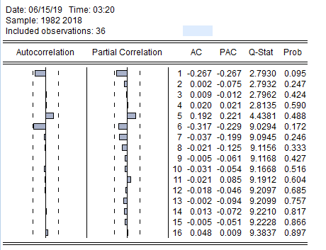
LnAP)) | D (LnAP)
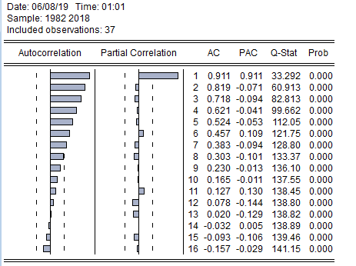 | 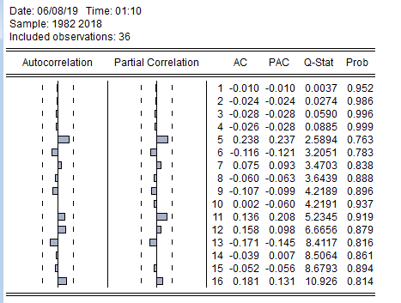
LnA)) | D (LnA)
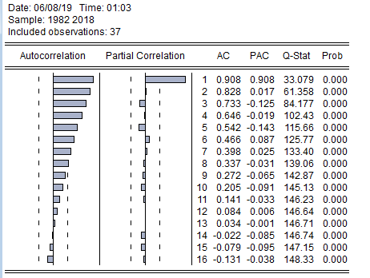 | 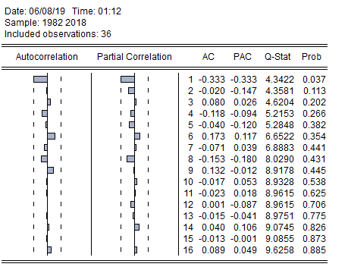
(LnAL) | D (LnAL)
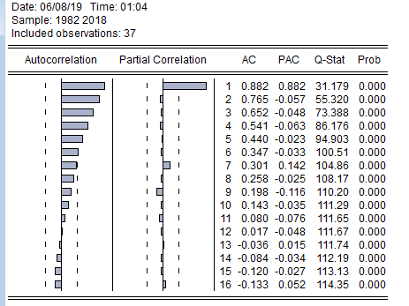 | 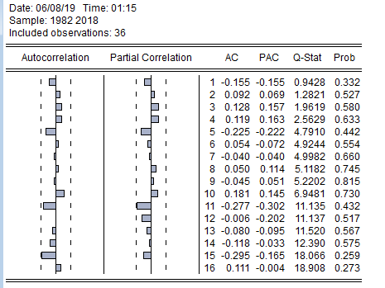
(LnAIn) | D (LnAIn)
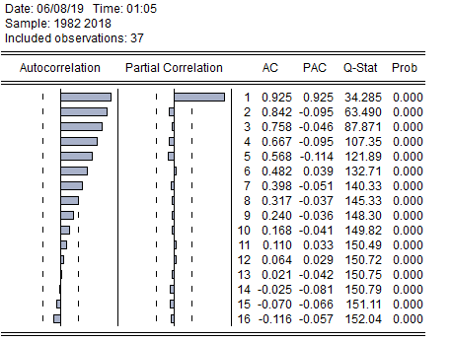 | 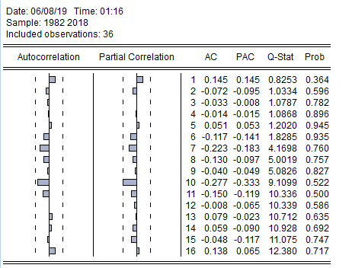
(LnAEx) | D (LnAEx)
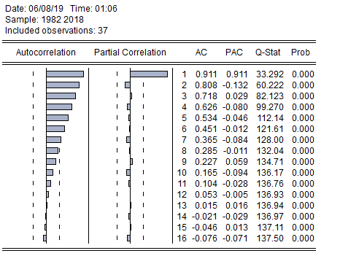 | 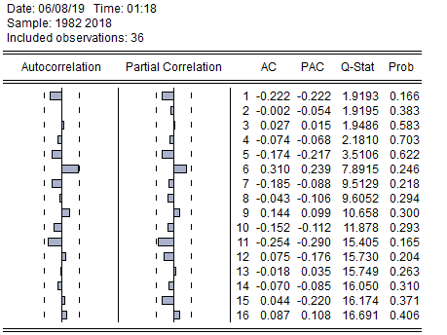
(LnAIm) | D (LnAIm)
Time series curves before Their Stationary | Time series curves after Their Stationary
(LnAP) | D (LnAP)
(LnA) | D (LnA)
(LnAL) | D (LnAL)
(LnAIn) | D (LnAIn)
(LnAEx) | D (LnAEx)
(LnAIm) | D (LnAIm)

Figure (1): Functions of variables before and after Their Stationary during the study period

Table (5): The Johansson test for the cointegration of the logarithmic formula using the MacKinnon test on the linear image at the Intercept (no trend) in CE and test VAR of the study variables.
Coint. | H0 | Trace Statistic | Critical Value | Prob.** | Coint. | Max-Eigen Statistic | Critical Value | Prob.**
None * | r=0 | 130.2229 | 95.75366 | 0 | None * | 49.74293 | 40.0776 | 0.0031
At most 1 * | r≤1 | 80.48 | 69.81889 | 0.0055 | At most 1 * | 34.1426 | 33.8769 | 0.0465
At most 2 | r≤2 | 46.33741 | 47.85613 | 0.069 | At most 2 | 25.8517 | 27.5843 | 0.0819
At most 3 | r≤3 | 20.48571 | 29.79707 | 0.3905 | At most 3 | 13.08448 | 21.1316 | 0.4445
At most 4 | r≤4 | 7.401233 | 15.49471 | 0.5315 | At most 4 | 7.349169 | 14.2646 | 0.4487
At most 5 | r≤5 | 0.052063 | 3.841466 | 0.8195 | At most 5 | 0.052063 | 3.84147 | 0.8195
Trace, Max-Eigen test indicates 2 cointegrating eqn (s) at the 0.05 level
* denotes rejection of the hypothesis at the 0.05 level
**MacKinnon-Haug-Michelis (1999) p-values
Source: - Prepared by the researcher based on the output of the program Eviews

2- Cointegration test:
It is clear from the data in table (5), the existence of a synchronous integration relationship between the variables of the study. It is also noted that the number of concurrent integration vectors is r = 1 at the 5% level of significance; this explains the synchronization of agricultural production and other variables, i.e. there is a static linear combination between agricultural production and other explanatory variables.
3- Lag Length test:
It is clear from Table (6) that the results of the Lag Length test showed the selection of two Lags periods based on criteria (AIC, FPE, LR), while standard ( HQ, SC) showed choosing one Lagperiod. In our study, two Lags periods was chosen, which correspond to the smallest value on each test to test the Vector Error correction Model, VECM|.

4-Vector Error Correction Model, VECM
After the variables are subjected to Unit Root and co-integration testing, VECM can be appreciated which is a restricted Auto-regression model by adding the equilibrium error to the equations of the model; This is called the VECM where the following conditions are met:
-All variables are non-Stationary at the level, and all variables become Stationary after applying the differences at the same degree of difference.
-The existence of at least one vector of co-integration between variables.

Table (6) test for Lags periods of the model.
Lag | LogL | LR | FPE | AIC | SC | HQ
0 | 64.3342 | NA | 1.44E-09 | -3.333383 | -3.066752 | -3.241342
1 | 230.5653 | 265.9698 | 8.71E-13 | -10.77516 | -8.908743* | -10.13087*
2 | 275.1874 | 56.09632* | 6.44e-13* | -11.26785* | -7.801647 | -10.07132
* indicates lag order selected by the criterion
LR: sequential modified LR test statistic (each test at 5% level)
FPE: Final prediction error
AIC: Akaike information criterion
SC: Schwarz information criterion
HQ: Hannan-Quinn information criterion
Source:- Prepared by the researcher based on the output of the Eviews program.

Estimation of the catalog VECM model:
D (LnAP) = C (1) * (LnAP (-1) + 3.47103197254 *LnA (-1) + 1.01514412338 * LnAL (-1) -1.0771012675 * LnAIn (-1) -1.52859551363 * LnAEx (-1) + 1.3098422246 * LnAIm (-1) – 39.2256185632 + C (2) * D (LnAP (-1)) + C (3) * D (LnAP (-2)) + C (4) * D (LnA (-1)) + C (5) * D (LnA (-2)) + C (6) * D (LnAL (-1)) + C (7) * D (LnAL (-2)) + C (8) * D (LnAIn (-1)) + C (9) * D (LnAIn (-2)) + C (10) * D (LnAEx (-1)) + C (11)* D (LnAEx (-2)) + C (12) *D (LnAIm (-1)) + C (13)*D (LnAIm (-2)) + C (14)
whereas:
- C (1): Error correction limit, which refers to the amount of adjustment required in the short term to make equilibrium the relationship between variables in the long term, and is required to be negative and significant to be a causal relationship in the long term, moving from independent variables to the dependent variable.
- C (2), C (3): The first difference coefficient of the value of the (LnAP) in the logarithmic formula at a Lags period equal to 1,2.
- C (4), C (5): The first difference coefficient of the (LnA) in logarithmic formula at an equal delay1,2.
- C (6), C (7): The first difference coefficient of the (LnAL) in the logarithmic formula at a Lags period equal to 1, 2.
- C (8), C (9): The first difference Coefficient of for the (LnAIn) in the logarithmic formula at a Lags period of 1,2.
- C (10), (11): The first difference coefficient of the (LnAEx) in logarithmic formula at a slowing period equal to 1, 2.
- C (12), C (13): The first difference coefficient of the (LNAIM) in logarithmic form at a Lags period equal to 1, 2.
- C (14) Constant.
The results of the estimation shown in Table (7) indicate that 42.67% of the changes in the dependent variable (LnAP) interpreted by the independent variables (LnA, LnAL, LnIn, LnAEx, LnAIm) listed in the model. The value of C (1) indicates that the short-run adjustment speed is 50.64% over a period of one year, which leads to equilibrium in the relationship between the variables of the study in the long-run. This means that the value of Egyptian agricultural production needs approximately 1.97 years to absorb the full shock or changes in the independent variables that affect the value of Egyptian agricultural production. The LnA coefficient was a one-year Lag with a positive and significant sign at the level of 5% reaching 6.17. This is not consistent with the economic theory. For the coefficient of (LnAEx) by Lags one or two years, it was negative and significant at the level of 5%, which indicates the direct relationship between (LnAEx) and (LnAP), which is in line with economic logic reaching a value of about -0.52 and -0.42, with a Lag period of one and two years respectively, As for the change in the coefficient of (LnAIm) and a one year Lag, an inverse relationship has emerged, with a value of 0.54 and significant at the level of 5%, which is consistent with the economic logic.
5- Model causality test:
Granger Causality Test is used to determine the direction of causality between variables. Since all variables are Stationary at the same degree of difference, the direction of causality is determined using VECM.
The long-run and short-run causal relationship is estimated as follows:

A- Long-run causal relationship:
Causality in the long- run is determined by two conditions:
- The significance of the (t) statistic for the error correction factor (λ) where the significance is achieved if the calculated (t) statistic is greater than its tabular value.
by which any disruption is corrected in the short -If the error correction factor coefficient c (1) is negative and significant, it shows the mechanism run, to reach the long-run equilibrium position among the dependent variables and the rest of the other variables.
By fulfilling these two conditions, we can say that there is a long-run causal relationship that is driven by the independent variables included in the model towards the dependent variable in their logarithmic form and this is illustrated by the previous table.

Table (7): Estimation of the equation of the error correction model in the short run for the value of the Egyptian agricultural production during the study period.
Vari. | Coefficient | Std. Error | t-Statistic | Prob.
C (1) | -0.50645 | 0.103501 | -4.8932 | 0.0001
C (2) | -0.37422 | 0.147554 | -2.53617 | 0.0197
C (3) | -0.43368 | 0.162593 | -2.6673 | 0.0148
C (4) | 6.170078 | 2.327873 | 2.650522 | 0.0153
C (5) | 2.486749 | 1.93487 | 1.285228 | 0.2134
C (6) | -1.68753 | 1.639006 | -1.0296 | 0.3155
C (7) | -2.48505 | 1.584611 | -1.56824 | 0.1325
C (8) | -0.04871 | 0.165958 | -0.29349 | 0.7722
C (9) | 0.157736 | 0.172615 | 0.913798 | 0.3717
C (10) | -0.52059 | 0.212936 | -2.44484 | 0.0239
C (11) | -0.42158 | 0.203011 | -2.07664 | 0.0509
C (12) | 0.544108 | 0.225615 | 2.411663 | 0.0256
C (13) | 0.435701 | 0.250072 | 1.742304 | 0.0968
C (14) | 0.162724 | 0.074 | 2.198982 | 0.0398
F-statistic | 2.889868 |  |  | 0.016153
R-squared | 0.652586
Adjusted R-squared | 0.426768
Durbin-Watson | 1.880381
Source: - Prepared by the researcher based on the output of the Eviews program.

B-Causal relationship in the short term:
To find a short-run causal relationship between independent variables and the needed dependent variable parameters, Wald-Test is needed for each of the independent variables C (4), C (5), C (6), C (7), C (8), C (9), C (10), C (11), C (12), and C (13) where we reject the null hypothesis that there is no causal relationship going from the dependent variable to the independent variable if the test results are statistic (F) Chi-square Significant at 5% level; Thus we accept the substitute hypothesis and vice versa. Table (8), data indicate that there is a causal relationship moving from the agricultural production variable to the variables of independent factors C (4), C (10), C (11) and C (12) due to the rejection of the null hypothesis.

C-Two-way causal relationship:
VEC Granger Causality/Block Exogeneity Wald Tests is used and that gave the same results of Wald Test where table (9) shows that there is a two-way causal relationship between (LnAP) and each of LnA and LnAEx, while there is a one-way causal relationship heading From (LnAIm) to (LnAP), as well as a one-way causal relationship.

Table (8): Wald test results of the short-run causal relationship between independent and dependent variables during the study.
Null hypothesis H0 | Chi-square | Prob | the decision | Significance
C (4)=0 | 7.025265 | 0.008 | Reject null | A causal relationship
C (5)=0 | 1.651811 | 0.1987 | Do not reject null | Lack of sufficient evidence of a causal relationship
C (6)=0 | 1.060082 | 0.3032 | Do not reject null | Lack of sufficient evidence of a causal relationship
C (7)=0 | 2.459375 | 0.1168 | Do not reject null | Lack of sufficient evidence of a causal relationship
C (8)=0 | 0.086138 | 0.7691 | Do not reject null | Lack of sufficient evidence of a causal relationship
C (9)=0 | 0.835028 | 0.3608 | Do not reject null | Lack of sufficient evidence of a causal relationship
C (10)=0 | 5.977238 | 0.0145 | Reject null | A causal relationship
C (11)=0 | 4.312425 | 0.0378 | Reject null | A causal relationship
C (12)=0 | 5.81612 | 0.0159 | Reject null | A causal relationship
C (13)=0 | 3.035623 | 0.0815 | Do not reject null | Lack of sufficient evidence of a causal relationship
Source: - Prepared by the researcher based on the output of the Eviews program

Table (9): Results of VEC Granger Causality / Block Exogeneity Wald Tests
H0 | Chi-square | Prob. | the decision | Direction of causation
Change in D (LnA) causes change in D (LnAP) | 7.625019 | 0.0221 | Reject null | D (LnA) → D (LnAP)  ←
Change inD (LnAL) does not causes change in D (LnAP) | 2.613539 | 0.2707 | Do not reject null | D (LnAL) ─ D (LnAP)
Change in D (LnAIn) does not causes change in D (LnAP) | 0.965335 | 0.6171 | Do not reject null | D (LnAIn) ─ D (LnAP)
Change in D (LnAEx) causes change in D (LnAP) | 7.434216 | 0.0243 | Reject null | D (LnAEx) → D (LnAP)  ←
Change in D (LnIm) cause the change in D (LnAP) | 6.385211 | 0.0411 | Reject null | D (LnAIm) → D (LnAP)
Change inD (LnAL) does not cause change in D (LnA) | 1.878326 | 0.391 | Do not reject null | D (LnAL )─ D (LnA)
Change in D (LnAIn) does not cause change in D (LnA) | 2.622006 | 0.2695 | Do not reject null | D (LnAIn) ─ D (LnA)
Change in D (LnAEx) does not cause change in D (LnA) | 1.849925 | 0.3965 | Do not reject null | D (LnAEx) ─ D (LnA)
Change in D (LnAIm) does not cause change in D (LnA) | 1.899002 | 0.3869 | Do not reject null | D (LnAIm )─ D (LnA)
Change in D (LnAP) does not cause change in D (LnAL) | 3.719423 | 0.1557 | Do not reject null | D (LnAP )─ D (LnAL)
Change in D (LnA) does not cause change in D (LnAL) | 0.229679 | 0.8915 | Do not reject null | D (LnA) ─ D (LnAL)
Change in D (LnAIn) cause change in D (LnAL) | 11.87182 | 0.0026 | Reject null | D (LnAIn) → D (LnAL)
Change in D (LnAEx) does not cause change in D (LnAL) | 1.623093 | 0.4442 | Do not reject null | D (LnAEx)─ D (LnAL)
Change in D (LnAIm) does not cause change in D (LnAL) | 1.699371 | 0.4275 | Do not reject null | D (LnAIm )─ D (LnAL)
Change in D (LnAP) causes change in D (LnAIn) | 5.865367 | 0.0533 | Reject null | D (LnAP )─ D (LnAIn)
Change in D (LnA) causes change in D (LNAIn) | 3.017105 | 0.2212 | Do not reject null | D (LnA )─ D (LnAIn)
Change in D (LnAL) does not cause change in D (LnAIn) | 0.098947 | 0.9517 | Do not reject null | D (LnAL) ─ D (LnAIn)
Change in D (LnAEx) does not cause change in D (LnAIn) | 1.799583 | 0.4067 | Do not reject null | D (LnAEx )─ D (LnAIn)
Change in D (LnAIm) causes change in D (LnAIn) | 5.829612 | 0.0542 | Reject null | D (LnAIm)─ D (LnAIn)
Change in D (LNA) does not cause change in D (LnAEx) | 1.323461 | 0.516 | Do not reject null | D (LnA)─ D (LnAEx)
Change in D (LnAL) does not cause change in D (LnAEx) | 1.676664 | 0.4324 | Do not reject null | D (LnAL)─ D (LnAEx)
Change in D (LnAIn) does not cause change in D (LnAEx) | 0.613791 | 0.7357 | Do not reject null | D (LnAIn)─ D (LnAEx)
Change in D (LnAIm) does not cause change in D (LnAEx) | 1.625332 | 0.4437 | Do not reject null | D (LnAIm)─ D (LnAEx)
Change in D (LnAP) does not cause change in D (LnAIm) | 1.742955 | 0.4183 | Do not reject null | D (LnAP)─ D (LnAIm)
Change in D (LnA) does not cause change in D (LnAIm) | 2.296152 | 0.3172 | Do not reject null | D (LnA)─ D (LnAIm)
Change in D (LnAL) does not causes change in D (LnAIm) | 1.4743 | 0.4785 | Do not reject null | D (LnAL) ─ D (LnAIm)
Change in D (LnAIn) does not change in D (LnAIm) | 0.140744 | 0.932 | Do not reject null | D (LnAIn) ─ D (LnAIm)
Change in D (LnAEx) does not causes change in D (LnAIm) | 3.819653 | 0.1481 | Do not reject null | D (LnAEx) ─ D (LnAIm)
Source: - Prepared by the researcher based on the output of the Eviews program

6- Diagnosis of the study model:
Standard problems of the model are detected by:
- Autocorrelation:-
The null hypothesis is that there is no Autocorrelation and rejecting the null hypothesis when the probability value is less than or equal to 5%, which means an Autocorrelation between the study variables and vice versa. It is clear from table (10) that there is no problem of Autocorrelation and acceptance of Null hypothesis as the probable value is greater than 5%, at 0.150.
- Hetroskedasticity:-
Null hypothesis states Hetroskedasticity. Rejecting the null hypothesis when the probability value is less than or equal to 5%, which means there is no Hetroskedasticity between study variables and vice versa. The data of Table (10) indicate that there is a Hetroskedasticity in the variability between the study variables and this is due to the high probability value of the model where it is 0.839.
- Normal Distribution of Residues:
The null hypothesis is that the distribution of the Residues does not follow the normal distribution. Rejecting the null hypothesis when the probability value is less than or equal to 5%, which means that the residual distribution is not normal, and vice versa. It is clear from the table that the residues are distributed normally, where the probability value is greater than 5% at 0.0896 and this is shown in Figure (2).

Table (10): Diagnosis of the study model by the detection of standard problems
Test | Chi-square | Prob | the decision
Autocorrelation | 3.792372 | 0.1501 | There is no Autocorrelation
Heteroskedasticity | 12.34392 | 0.829 | There is homogeneity in variance
Jarque –Bera | 4.824 | 0.0896 | Distribution is normal
Source: Prepared by the researcher based on the output of Eviews program.

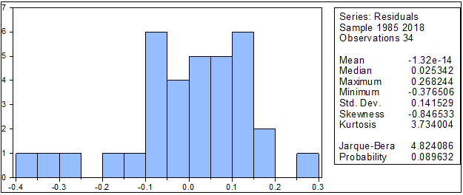

Figure (2): To detect the diagnosis of the study model Natural distribution test

7- Variance analysis test Variance Decomposition of (LnAP):
The analysis of variance shows the relationship between variables and the effect of each in each other by determining the amount of variance in the prediction for each variable and the amount of return from the prediction error in the same variable and the amount due to the prediction error in other variables. Table (11) shows the analysis of the variance components of the value of agricultural production that about 100% of the prediction error in the variance is attributed to the same variable during the first period, and this percentage in the tenth year to 51.86%. It is also clear that the impact of crop area on the value of agricultural production is very weak and gradually decreases, it does not exceed 1.27%, and the impact of agricultural labor on the value of agricultural production is weak despite the gradual rise, but the impact does not exceed 1.76% as well as the impact of agricultural imports where it does not exceed 1.31%. As for agricultural exports and agricultural investments, they strongly affect the value of agricultural production where the values ​​of each rise gradually, which confirms that their results appear in the long term in influencing the value of agricultural production, which shows the relative importance of both agricultural exports and agricultural investments in agricultural production over time. This is confirmed by the results of the causality test.

Table (11): Variance Decomposition of LnAP:
Period | S.E. | LnAP | LnA | LnAL | LnAIn | LnAEx | LnAIm
1 | 0.181797 | 100 | 0 | 0 | 0 | 0 | 0
2 | 0.220913 | 84.36033 | 4.83747 | 0.372453 | 5.254372 | 4.658896 | 0.516476
3 | 0.264313 | 76.92626 | 3.451484 | 1.50628 | 7.387036 | 9.608116 | 1.120822
4 | 0.321997 | 67.69627 | 3.0309 | 1.014952 | 6.590098 | 20.01245 | 1.655338
5 | 0.365907 | 62.32242 | 2.347129 | 1.02573 | 7.714573 | 25.23556 | 1.354585
6 | 0.398744 | 58.12901 | 2.020805 | 1.337655 | 8.065079 | 29.04676 | 1.400691
7 | 0.430266 | 55.50895 | 1.743853 | 1.573788 | 8.382594 | 31.36267 | 1.428154
8 | 0.461262 | 53.8162 | 1.565481 | 1.536765 | 8.382427 | 33.2613 | 1.437826
9 | 0.488166 | 52.63078 | 1.397929 | 1.633669 | 8.72254 | 34.26719 | 1.347883
10 | 0.512235 | 51.864 | 1.271257 | 1.755208 | 8.940509 | 34.8589 | 1.310124

Continued Table (11):Variance Decomposition of LnA:
Period | S.E. | LnAP | LnA | LnAL | LnAIn | LnAEx | LnAIm
1 | 0.016312 | 0.64754 | 99.35246 | 0 | 0 | 0 | 0
2 | 0.024967 | 8.349981 | 90.05665 | 0.498305 | 0.173063 | 0.345291 | 0.576712
3 | 0.030347 | 6.927896 | 87.43598 | 3.684991 | 0.695568 | 0.861825 | 0.39374
4 | 0.033019 | 5.853348 | 86.14966 | 5.758064 | 0.788682 | 0.764997 | 0.685248
5 | 0.036639 | 4.951563 | 85.17247 | 6.245339 | 1.052013 | 1.431224 | 1.147394
6 | 0.042057 | 3.884543 | 80.71527 | 7.236864 | 1.395001 | 4.947548 | 1.820778
7 | 0.046862 | 3.414717 | 76.76034 | 7.785497 | 1.756916 | 8.195789 | 2.08674
8 | 0.051164 | 3.600368 | 72.99275 | 7.919325 | 2.187287 | 10.92702 | 2.373248
9 | 0.055533 | 3.814086 | 69.81655 | 7.908949 | 2.637578 | 13.0992 | 2.72364
10 | 0.060005 | 3.953283 | 67.1054 | 7.96898 | 3.0777 | 14.90343 | 2.991207
Variance Decomposition of LnAL:
Period | S.E. | LnAP | LnA | LnAL | LnAIn | LnAEx | LnAIm
1 | 0.020837 | 2.204146 | 0.335384 | 97.46047 | 0 | 0 | 0
2 | 0.026761 | 1.629787 | 0.216086 | 96.79209 | 0.018535 | 0.015432 | 1.328075
3 | 0.032875 | 1.396566 | 1.138389 | 85.27144 | 7.066217 | 4.081604 | 1.045782
4 | 0.037319 | 1.253725 | 2.237041 | 86.47601 | 5.776339 | 3.386955 | 0.869929
5 | 0.04254 | 1.322748 | 1.770312 | 83.36681 | 8.576556 | 2.95637 | 2.007205
6 | 0.046721 | 1.338038 | 1.486626 | 83.88404 | 9.042931 | 2.467697 | 1.78067
7 | 0.051486 | 1.195431 | 1.286077 | 83.55817 | 9.874239 | 2.119729 | 1.96635
8 | 0.055224 | 1.90148 | 1.370013 | 82.40249 | 10.41913 | 1.854071 | 2.052819
9 | 0.059312 | 2.056837 | 1.20557 | 81.34508 | 11.40091 | 1.71283 | 2.278767
10 | 0.063219 | 2.193142 | 1.077943 | 80.72321 | 11.83314 | 1.740009 | 2.432558
Variance Decomposition of LnAIN:
Period | S.E. | LnAP | LnA | LnAL | LnAIn | LnAEx | LnAIm
1 | 0.20259 | 42.78816 | 8.366731 | 5.33715 | 43.50796 | 0 | 0
2 | 0.271859 | 46.27054 | 10.86553 | 4.86881 | 36.12328 | 1.87182 | 1.95E-05
3 | 0.37604 | 41.93815 | 5.976895 | 2.546623 | 36.82159 | 7.559192 | 5.157546
4 | 0.459362 | 41.88778 | 4.018558 | 1.713753 | 37.69485 | 10.26617 | 4.418894
5 | 0.548225 | 39.05018 | 2.915641 | 1.416982 | 37.67139 | 14.5514 | 4.39441
6 | 0.636556 | 40.21229 | 2.532798 | 1.051224 | 36.21835 | 15.61252 | 4.37281
7 | 0.724675 | 39.76107 | 2.004545 | 0.834752 | 36.26636 | 16.54014 | 4.593136
8 | 0.80451 | 38.8949 | 1.637221 | 0.761352 | 35.91853 | 18.06535 | 4.722645
9 | 0.883085 | 38.59691 | 1.395644 | 0.688549 | 35.72868 | 18.84514 | 4.745073
10 | 0.956861 | 38.63348 | 1.238282 | 0.616065 | 35.45024 | 19.32491 | 4.737028
Variance Decomposition of LnAEX:
Period | S.E. | LnAP | LnA | LnAL | LnAIn | LnAEx | LnAIm
1 | 0.219715 | 0.952626 | 0.18102 | 0.554105 | 0.543988 | 97.76826 | 0
2 | 0.360068 | 2.809483 | 0.642592 | 0.510093 | 0.249377 | 95.5964 | 0.192055
3 | 0.506679 | 14.10191 | 1.04429 | 1.728496 | 0.183621 | 82.80728 | 0.134402
4 | 0.606466 | 15.5281 | 0.770897 | 1.86162 | 0.681707 | 81.03429 | 0.123378
5 | 0.693115 | 15.85883 | 0.594806 | 1.566342 | 0.893659 | 80.99141 | 0.094953
6 | 0.760708 | 17.58713 | 0.618503 | 1.740858 | 0.994006 | 78.93937 | 0.120126
7 | 0.818534 | 19.12043 | 0.642602 | 1.928709 | 1.136977 | 77.05851 | 0.112768
8 | 0.867352 | 19.77214 | 0.593583 | 1.979843 | 1.25349 | 76.29693 | 0.104016
9 | 0.912433 | 20.22325 | 0.558301 | 1.984644 | 1.333429 | 75.79411 | 0.10626
10 | 0.954529 | 20.68089 | 0.561178 | 2.036177 | 1.36619 | 75.23686 | 0.118704
Variance Decomposition of LnAIM:
Period | S.E. | LnAP | LnA | LnAL | LnAIn | LnAEx | LnAIm
1 | 0.201184 | 14.19741 | 5.597996 | 3.375659 | 23.52707 | 9.522869 | 43.77899
2 | 0.273045 | 13.97149 | 5.656441 | 3.033115 | 25.12724 | 20.66353 | 31.54818
3 | 0.322115 | 17.95007 | 4.315104 | 6.376768 | 24.23822 | 18.09581 | 29.02403
4 | 0.360767 | 16.32687 | 4.744497 | 6.077738 | 24.4769 | 20.79571 | 27.57829
5 | 0.401881 | 15.44248 | 4.795003 | 5.841252 | 25.06731 | 23.01544 | 25.83851
6 | 0.440694 | 16.05868 | 4.487127 | 6.332406 | 24.84047 | 22.84001 | 25.44131
7 | 0.474357 | 15.86234 | 4.353761 | 6.516566 | 25.13728 | 23.06913 | 25.06092
8 | 0.50441 | 15.80055 | 4.303837 | 6.670673 | 25.36199 | 23.15392 | 24.70902
9 | 0.533717 | 15.71322 | 4.252473 | 6.829643 | 25.5842 | 22.94192 | 24.67855
10 | 0.560922 | 15.54222 | 4.204126 | 6.918875 | 25.85196 | 22.83923 | 24.64359
Cholesky Ordering: LnAP LnA LnALLnAIN LnAEX LnAIM
Source: Prepared by the researcher based on the output of Eviews program.

For the details of the variance Decomposition for the effect of each of the independent variables individually on agricultural production value during study period please refer to table (11) in the above.

8-Response Test:-
It follows the time path of random response which the variables under study can be exposed to. A shock in one of the variables has an effect on the rest. Since the subject of the research is the factors affecting the value of agricultural production, therefore research is conducted on the impact of the Occurrence of individual shocks in external (independent) variables, and its effects on the internal variable of the value of agricultural production. In other words, the extent of the response of the value of agricultural production to the shocks associated with other variables as shown in Figure (3). For example, when there is a random shock in agricultural exports and agricultural investments and of same standard deviation, negative impact on the value of agricultural production in the first period and then show the positive effect of increasing and continuity in the future.

-.05
.00
.05
.10
.15
.20
1
2
3
4
5
6
7
8
9
1
0
L
N
A
P
LNA
L
N
A
L
L
N
A
I
N
L
N
A
E
X
L
N
A
I
M
R
e
s
p
o
n
s
e

o
f

L
N
A
P

t
o

C
h
o
l
e
s
k
y
O
n
e

S
.
D
.

I
n
n
o
v
a
t
i
o
n
s
-.012
-.008
-.004
.000
.004
.008
.012
.016
.020
1
2
3
4
5
6
7
8
9
1
0
L
N
A
P
LNA
L
N
A
L
L
N
A
I
N
L
N
A
E
X
L
N
A
I
M
R
e
s
p
o
n
s
e

o
f

L
N
A

t
o

C
h
o
l
e
s
k
y
O
n
e

S
.
D
.

I
n
n
o
v
a
t
i
o
n
s
-.010
-.005
.000
.005
.010
.015
.020
.025
1
2
3
4
5
6
7
8
9
1
0
L
N
A
P
LNA
L
N
A
L
L
N
A
I
N
L
N
A
E
X
L
N
A
I
M
R
e
s
p
o
n
s
e

o
f

L
N
A
L

t
o

C
h
o
l
e
s
k
y
O
n
e

S
.
D
.

I
n
n
o
v
a
t
i
o
n
s
-.2
-.1
.0
.1
.2
.3
1
2
3
4
5
6
7
8
9
1
0
L
N
A
P
LNA
L
N
A
L
L
N
A
I
N
L
N
A
E
X
L
N
A
I
M
R
e
s
p
o
n
s
e

o
f

L
N
A
I
N

t
o

C
h
o
l
e
s
k
y
O
n
e

S
.
D
.

I
n
n
o
v
a
t
i
o
n
s
-.2
-.1
.0
.1
.2
.3
.4
1
2
3
4
5
6
7
8
9
1
0
L
N
A
P
LNA
L
N
A
L
L
N
A
I
N
L
N
A
E
X
L
N
A
I
M
R
e
s
p
o
n
s
e

o
f

L
N
A
E
X

t
o

C
h
o
l
e
s
k
y
O
n
e

S
.
D
.

I
n
n
o
v
a
t
i
o
n
s
-.10
-.05
.00
.05
.10
.15
1
2
3
4
5
6
7
8
9
1
0
L
N
A
P
LNA
L
N
A
L
L
N
A
I
N
L
N
A
E
X
L
N
A
I
M
R
e
s
p
o
n
s
e

o
f

L
N
A
I
M

t
o

C
h
o
l
e
s
k
y
O
n
e

S
.
D
.

I
n
n
o
v
a
t
i
o
n
s

Figure (3): Response Analysis of the Study Model

Conclusion:
From the study we could conclude the following results:
- The agricultural sector contributes about 15.92% of GDP; through the export of agricultural products, about 5.68% of total agricultural production in the study period.
- The results of the estimate in the traditional way show that there is a Spurious Regression in the estimation of the most important factors affecting the value of agricultural production because of the nonstationarity in the time series.
- In the modern way confirmed the existence of a cointegration relationship between the dependent and independent variables; Long-run equilibrium relationship; and the short-run adjustment speed for achieving the long-run equilibrium is 50.64% per year which means that agricultural production requires about 2 years to absorb the changes, and that 42.67% of the changes in the dependent variable at their logarithmic level are explained by listed independent variables.
- There is a long-run causal relationship between the independent variables listed in the model and dependent variable in their logarithmic level.
- A short-run causal relationship has also been shown from the changing agricultural production to crop area, agricultural exports and agricultural imports.
- Also a two-way causal relationship between the value of agricultural production and each of area and agricultural exports has been established. While there is a one-way causal relationship that tends from agricultural imports to the value of agricultural production.
- The study model is free from standard problems, i.e. there is no Autocorrelation but there is homogeneity in variance between study variables, and there is also normality of residuals distribution.
- The analysis of the variance components of the value of agricultural production shows that about 100% of the prediction error in variation is due to the variable itself during the first period, and this ratio in the tenth year is 51.86%.
- The value of both agricultural exports and agricultural investments strongly affect in the value of agricultural production since the irrespective values rise gradually, which confirms that their effect in the long run appear in influencing the value of agricultural production.
- Finally, the study shows that when agricultural exports and agricultural investments is hit by a random shock and a single standard deviation that negatively affects the value of agricultural production in the first period, then the positive impact of increasing and continuing in the future and this is explained by the fact that the increase in both agricultural exports and agricultural investments is leading to a significant increase in the value of agricultural production.

References:-
- Atiya, A. Q. M. (2004), "The standard economy between theory and application", the collective house for printing and publishing, Alexandria, Page 648.
- ALmosabbeh, I. E. A. (2006), " Determinants of Inflation in Syria during the period 1970-2004", Journal of Social Sciences, Kuwait University, Scientific Publishing Council, vol. 34(4):45-71.
- Abdel Razek, K., and Hassan, A. (2012), "Comparative study in methods of estimating the decline of joint integration with practical application", Iraqi Journal of Economic Sciences, vol. 33 (10):151-172.
- Allawi, K. K. and Rahi, M. G. (2015), "Analysis and measurement of the relationship between financial expansion and economic variables 2010-in Iraq for the period 1974", Al-Ghri Journal of Economic and Administrative Sciences, Vol. 32 (10): 21-32.
- Ali, S., and Al Jufi, F. (2018), "Limiters of Demand for Employment in the Agricultural Sector in Libya for the period 1975-2014 application study using the Dynamic Smaller Squares Method DOLS", Journal of Mokhtar Science, vol. 33(4).
- Abbas, G., Bhowmik, R., Koju, L., and ct al. (2017), "Cointegration and Causality relationship Between Stock Market, Money Market and Foreign Exchange Market in Pakisten", Journal of systems science and information, Vol. 5 (1), pp. 1-20.
- Cheng, B. S. (1999). "Causality between energy consumption and economic growth in India: an application of cointegration and error-correction modeling", Indian Economic Review, 39-49.‏
- General Mobilization and Statistics Organization, "Statistical Yearbook of the Arab Republic of Egypt", Volumes1982-2018.
- Engle, R. F., & Granger, C. W. (1987). "Co-integration and error correction: representation, estimation, and testing. Econometrica", journal of the Econometric Society, 251-276.‏
- Elhashimi, A. K., and Al Fil, M. (2012), "Measuring Markets Integration of Sudanese Sesame and Exports Competitiveness ", Faculty of Agriculture, University of Khartoum.
- Franses, P. H. (2001). How to deal with intercept and trend in practical cointegration analysis?. Applied Economics, 33(5): 577-579.‏
- Hondroyiannis, G., and Papapetrou, E. (1996), "An examination of the Causal relationship Between Government Spending and revenue: A Cointegration Analysis", Kluwer Academic publishers, printed in the Netherlands, public choice 89: 363-374.
- Hassan, Y., and Zaki, H. (2010), "Analyzing the relationship between the oil markets and the Iraqi oil policy by relying on time series", Al Ghari for economic and administrative sciences, Vol. 8( 25):7-28.
- Johansen, S. (1992),"Cointegration in partial systems and the efficiency of single-equation analysis", Journal of econometrics, 52(3): 389-402.‏
- Jalal, R., Mohammed, K., and Hadi, Z. (2017), "Economic Analysis of Maize Supply response in Iraq using Cointegration and error correction for the period 1980-2014", Tikrit University Journal of Agricultural Sciences, vol. 17(1):274-286.
- Jethaq, S. (2016.), "Algeria's unemployment limiters Applied Study", Journal of the University of Sharjah Social Humanities, vol. 13( 2).
- Kadhim, I., Youssef, H., and Abd Al-Latif, H. (2018), "Estimate the value of consumption in Iraq using the method of joint integration", Diyala University, Faculty of Administration and Economics, Vol. 2(1):49-72.
- Khalil, T. M., and Shehata, E. A. E. (2004), "An Econometric Study of Dynamic models with Application on Forecasting Labor in Egypt", Egyptian Statistical Society, the 29th International Conference of Statistics, Computer Sciences and its Applications, 17-22 April 2004;133-154.
- Lee, C. C. (2005),"Energy consumption and GDP in developing countries: a cointegrated panel analysis", Energy economics, 27(3): 415-427.
- Mohamed, D., Yehia, A. R. (2014), "Standard Econometric Analysis of Agricultural Investment in Egypt", Egyptian Economics Research Institute, ARC, Giza, Egypt, Vol. 92 ( 3):1175-1206.
- Mohamed, D. M. (2017), "The Impact of Investment on The Growth of Egypt's Agricultural Sector ", Egyptian Journal of Agricultural Economics, vol. 95( 1):405-432.
- Ministry of Economic Development, "Economic and Social Development Plan", Volumes1982-2018.
- Mohammad, A. S. (2013), "Stabilizing effect of the time series to estimate the function of Investment in Iraq submitted", Diyala University, Faculty of Administration and Economics, Vol. 9(4):58-75.
- National Bank of Egypt, Department of Economic Research, "Economic Bulletin", Volumes1982-2018.
- Spyros, E., and John, M. ( 1996), "Does The Fisher Effect Applyin Greece? Acointegration ANALYSIS, Paper presented in the International Conference in Quantitative Analysis in the University of Piraeus- Greece, 7-9 November, Vol. 48 (1-4), pp. 49-65.
- Sobhee, S. (2004), The Causality Between Tax and Spend of the Public Sector in Mauritius: A VECM Approach, International Journal of Applied Econometrics and Quantitative Studies, Vol. 1(3):115-130.

11/22/2019

