Beneficiation, and Mineralogy of Magnetite in Ras Abda stream sediment, northern Eastern Desert Egypt.

Fatma S. Ramadan¹, Ali A. Omran², Hesham A. El-Nahas², Ehab K. Abu Zeid², Mohamed Hassan ^{2*}

¹ Geology Dept., Fac. Sci., Zagazig Univ., 44511 Zagazig, Egypt
² Nuclear Materials Authority; P.O. Box: 530 El-Maadi, Cairo, Egypt.
*Correspondence: geo.mohamedhassan86@gmail.com
Authors Emails: Fatma_r@yahoo.com, A_Omran@yahoo.com, Hesham_nahas@yahoo.com, Ehab_zeid@yahoo.com, geo.mohamedhassan86@gmail.com, geo.mohamedhassan86@gmail.com
Phone number: +2-01120133300

Abstract: This study investigates the stream sediments of South Wadi Ras Abda area, northern eastern desert, located approximately 20 km southwest of Safaga City on the Red Sea. The area is primarily covered by subduction-related older granites intruded by intraplate-magmatism of younger gabbro. These two rock types are cutting by acidic dykes followed by intrusion of microgranite and emplacement of basic dykes. The raw sample was subjected to screening to remove the sizes over +2mm then sand size sample was concentrated by wet tabling which separates the heavy minerals from the other gangue minerals, and the concentration of heavy minerals was subjected to magnetic separation to separate magnetite. Where all samples undergo heavy liquid separation using bromoform and methylene iodide solutions and the heavy fractions were subjected to magnetic separation with using Isodynamic magnetic separation to facilate the process of identification and separation of each individual mineral by binocular stereo-microscope and then studied under scanning environmental microscope. The grain size distribution of the stream sediments relevant that the sand size is the main component, and it ranges from (57.69% - 97.68%) with an average (81.62 %). The grain size distribution of magnetite of the study area is unimodal with medium sand size class, which constitutes more than 51.35 wt% of the particles, then the fine sand size class contains 32.54 wt%. The total magnetite content in the industrial scale was 1.33%, where the total magnetite content in the laboratory scale fluctuates between natural (0.17 % and 38.54%) with a general average of about 2.07%.

[Fatma S. Ramadan, Ali A. Omran, Hesham A. El-Nahas, Ehab K. Abu Zeid, Mohamed Hassan. Beneficiation, and Mineralogy of Magnetite in Ras Abda stream sediment, northern Eastern Desert Egypt. N Y Sci J 2019;12(10):69-82]. ISSN 1554-0200 (print); ISSN 2375-723X (online). http://www.sciencepub.net/newyork. 9. doi:10.7537/marsnys121019.09.

Key words: Ras Abda; Northern Eastern Desert; Egypt; magnetite; mineralogy.

Introduction
Magnetite is an important iron ore on which the modern societies are based. The theoretical Fe-content of 72.4 % (the highest of all Fe- minerals) with chemical formula Fe3O4 (FeO + Fe2O3) which is easily weathers to Fe2O3 (hematite), and the shape of magnetite crystals frequently remains intact during this conversion. Magnetite is only rarely attained because of the presence of isomorphous additions of Al, Ti, Mg and V. In particular Ti and V lower the value of the mineral as an iron ore, possibly turning Ti-V magnetites into ores of these two elements. Hammoud (1966) concluded that the black sand magnetite has low grade in iron and steel production due to their impurity contents especially chromium and vanadium.
Magnetite is characterized by high bulk density, high physical and chemical resistance, good thermal conductivity, high magnetic sensitivity, and non-toxicity, so Magnetite is used for the following purposes outside of the metallurgical sphere: as additive in toners for laser printers and copiers, as an iron additive for the manufacture of cement, as a functional filling material in chemistry for sound insulation, in physical water treatment for the removal of turbidity, algae and other impurities, as a raw material in the manufacture of pigments for special colors, as a blasting abrasive, as a molding sand for foundry purposes, and used as an additive in fertilizers.
Magnetite can form under magmatic, metamorphic, sedimentary and even biogenic conditions, but the most important are the early crystallisates from basic magmas in plutonites (diorite, gabbro etc.) due to crystallization differentiation, i.e. gravitative precipitation of the heavy elements Fe and V in ultrabasic and basic magmas. Globally this process resulted in the formation of important intramagmatic magnetite and titanomagnetite deposits.
The aim of this study is improve the available data to investigate the potentiality of physical upgrading of magnetite using gravity and magnetic
separation techniques in both laboratory scale and industrial scale.
The study area
Ras Abda area is located in the Northern Eastern Desert of Egypt at, about 20 km westward from Safaga City at the Red Sea coast. The area can be easily accessed via a newly established part of Qena – Safaga asphaltic road, along W. Barud Al Abyad, which runs directly to the north of the area. The study area bounded by latitudes 26º 43' 20'' and 26º 43' 33'' N and longitudes 33º 45' 31'' and 33º 45' 49'' E (Fig. 1). Recently, Nuclear Materials Authority (NMA) lunched a comprehensive exploration program.

Geological Setting
The geology of Ras Abda area and its surrounding, the structural set-up and their potentialities for mineralizations have been discussed by various workers (Omran, 2005 & El Hadary et al, 2010 and 2013 and Omran, 2015), (Fig. 1). The study area is characterized by Moderate to highly topography relative to its surroundings. According to Omran (2015), the studied area is occupied with Precambrian basement suites comprise older granitoids and wadi deposits Quaternary age, which injected with basic and acidic dykes of different attitudes. According to Omran (2005), the older granitoids range in composition from granodiorite to quartz diorite. The basic dykes are mainly basaltic in composition and trend in NNW direction with decreasing order of abundance, and are intersected with acidic ones. The acidic dykes are the less in number and the largest in terms of size and space compared to the basic ones. They are mainly represented by rhyolites, and microgranite dykes. The rhyolite dykes occupy the middle area and extend from the extreme southwest to the northeast. They form high and huge blocks, with irregular shapes in NE-SW direction. The microgranite dykes occur as swarms of abnormal radioactivity and poly mineralization. They encountered at the northeastern part and extend to the southwestern part of the area. They are restricted to a highly deformed, faulted, and sheared narrow zone, in NE to NNE directions. The zone has been split into two parts under the action of a NW-SE left lateral strike-slip fault (Fig.1).
Structurally, Faults represent the main structural features in the study areas. The NE and NW trends comprise both left-lateral and right lateral strike-slip faults (Fig. 1). The NW-trending faults are the oldest fracture planes, followed by the NE orientations.

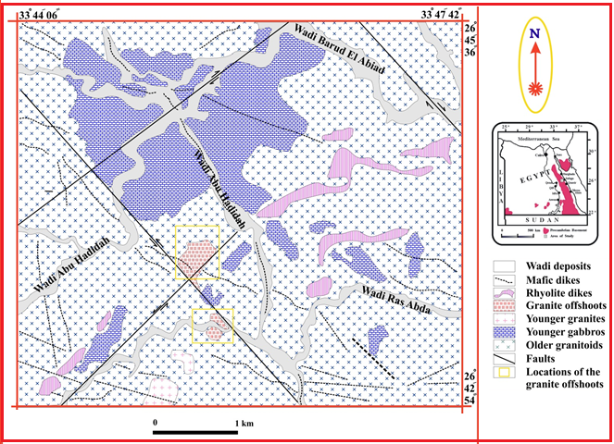
Figure (1): Regional geological map of Ras Abda area, Northern Eastern Desert, Egypt (Omran, 2015)

Sampling and Methodology
Sampling can be performed by different methods depend on the type and nature of the sampled rocks. In the present study, the samples were collected for the detailed laboratory investigations. Therefore, trench samples for stream sediments were collected for detailed mineralogical studies.
The studied sediments are mainly composed of a mixture of different particle sizes ranging from clay sizes to cobble sizes. Therefore, trench samples were collected to represent both upstream and downstream of Wadi Ras Abda. Streams are responsible for the heavy minerals concentration. It was taken by digging a rectangular hole to a depth of 90 cm, 120 cm in length, and 70 cm width. Each sample weighing from 10 to 15kg. The obtained sample resulting from quartering was put in a cloth bag and serially labeled.
Forty seven grab samples were collected from the stream the samples were selected according to the difference in lithology of the surrounding rocks and the locations of meandering in each basin (Fig. 2). The samples were prepared for different analyses by drying to remove the water content and splitting to obtain a representative samples. The simple method for obtaining representative samples from the main sample material is to divide it into quarters using John’s Splitter and rotary splitter until reach to amount of sample weighting about 200 g suitable for different investigation is obtained, while the rest returned to the stored sample.

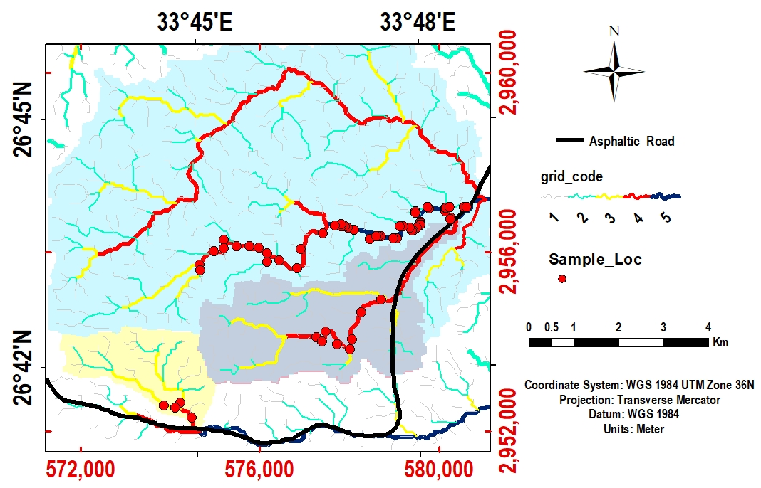
Fig. 2: Location map showing sample locations, stream-orders, and stream-basins of the study area.

The apparent specific gravity was calculated for each selected sample, using John’s Splitter a representative sample of about 2 kg is taken and weighted and slowly poured inside a calibrated cylinder and compacted very well by shaking to be analogous to the field deposit. The weight of the sand was divided by its volume to obtain the apparent specific gravity.
The grain size distributions were carried only on the bulk stream sediment samples using conventional dry sieving technique. The samples were subjected to mechanical analysis with using a set of sieves selected according to the Wentworth Grade Scale for the sand size (Wentworth, 1922). The aperture diameters for these sieves were 2.00, 1.00, 0.50, 0.25, 0.125 and 0.063 mm. The sieves were arranged in a descending order and the pan beneath them and the cover on the top sieve. The sieves with the sample on the top sieve were shacked for about 30 minutes using an automatic vibratory shaker.
The mineralogical studies were conducted on forty seven samples on the sand size less than 1.0 mm in order to estimate the distributions of the total heavy minerals in different sand sizes. Mohamed (1998) stated that the total heavy minerals were concentrated in the medium, fine and very fine sand sizes fraction. So the results fraction from grain size (0.5, 0.25, 0.125, and 0.63mm) were undergone heavy liquid separation using number of different heavy liquids. The aim is to separate the samples into a series of fractions according to density, establishing the relationship between the high and low specific gravity minerals. Hence two conventional heavy liquids were used to concentrate the heavy economic minerals. Bromoform (specific gravity of 2.8 gm/cm3) may be used to separate the quartz and feldspars from the total heavy minerals. Methylene Iodide (di-iodomethane) (specific gravity of 3.3 gm/cm3) was used to reduce the size of the obtained heavy fractions to facilitate the magnetic separation beside remove part of green silicate (pyroxenes and amphiboles). Then the magnetite (ferromagnetic mineral) is removed from each heavy fraction with a hand magnet. Each heavy fraction was sprinkled on a glazed paper to form a thin layer of particles to facilitate the magnetite separation. This process repeated many times until complete removal of magnetite grains. The separated mineral recognized by stereomicroscope, identified by XRD and confirmed by electron scanning microscope (ESEM). All of these analyses were done in the Labs of the Nuclear Materials Authority (NMA) of Egypt.

Ore Dressing Concentration (Gravity Concentration)
Gravity concentration process is the oldest beneficiation method known to mankind. It is an environment-friendly process, which utilizes simple equipment with few moving parts. Throughout the history of mineral processing, many different types of gravity separation devices have been utilized (e.g., Reichert cone, Humphrey spiral, and Wilfley shaking table). Each of these devices takes advantage of density differences between valuable and gangue minerals, beside the specific gravity of the grains, other factors such as the size and shape of the particles affect the relative movement and hence the separation process. The easy or difficulty of separation depends upon the relative differences in these factors.
The shaking table (Figure 3) is selected because the sample weight is not suitable for the Reichert cone or Humphrey spiral as these devices need samples in ton. Also, shaking tables are less expensive than other concentration devices. The effective separation of mineral particles using the shaking table requires a suitable adjustment of the operation condition variables. According to Burt (1989), Barakat (2004, 2016), Moustafa (2007), El-Nahas (2002) and El-Shafey (2011, 2016), these variables can be classified into machine variables and feed variables (Table 1). The Wilfley shaking table may be used for rough concentration or for cleaning process. The concentrate fraction was subjected to magetic separation using dry low intensity cross-belts magnetic separator (Figure 4).

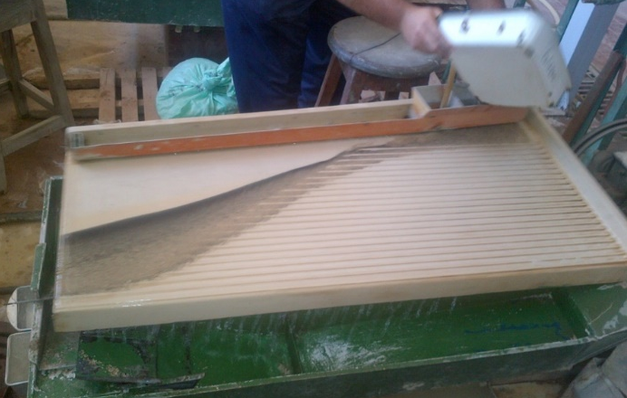
Fig. 3: The laboratory Wilfley shaking table (No.13) | Fig. 4: Photograph of cross belt magnetic separator.

Table (1): Parameters affecting operations of shaking table (After Wills, 1992)
Machine variables | Feed variables
Stroke:  Length and frequency.  Inclination:  Side and longitudinal.  Riffles pattern.  Deck surface. | Solid characteristics:  Size range of the particles.  Capacity of the feed.  Cut points of the discharge.  Pulp characteristics:  Flow rate.  Density.  Wash water.

Most of gangue minerals which consist mainly of quartz and green silicate minerals are removed and rejected in the obtained first tailing fraction. A considerable amount of green silicate minerals in association with some of economic minerals is separated in a middling fraction from the first tabling stage. the middling fraction was retreated again to minimize loss of the economic heavy mineals in the middling fraction.

Results

Grain size analysis
Grain size analyses were carried for a representative sample weighting about 200 g for each sample and the retained material on each sieve and in the pan was taken and weighted and the frequency for each size was calculated as shown in table (2). The grain size distribution data of the stream sediments in the Ras Abda area showed that the deposits are composed of mixed sizes which all sizes are present, the gravels (over 2 mm) are range from (0.95% - 41.83%) with an average (14.27 %), the sand size is the main component of the most studies sediments (2 – 0.063 mm) are ranging from (57.69% - 97.68%) with an average (81.62 %), the silt size (under 0.063 mm) are ranging from (0.186% - 9.73%) with an average (1.8 %) and it recorded in all studied samples.

Heavy minerals separation Technique
Heavy minerals are defined as high density minerals, which have specific gravities greater than 2.9 (Mange and Maurer 1992). They are deposited and sorted according to differences in size, shape and density (Padmalal et al., 1998 and Komar, 1976, 2007).

Table (2): Frequencies of gravel, sand, and mud of the studies stream sediments and description.
Sample  No | Grain Size distribution (mm)
 | Gravels % | Sands % |  |  |  |  | Muds %
 | > 2.0 mm | 2.0 – 1.0 mm | 1.0 – 0.5 mm | 0.5 – 0.25 mm | 0.25 – 0.125 mm | 0.125 – 0.063 mm | < 0.063 mm
S1 | 21.024 | 11.553 | 20.200 | 27.500 | 11.355 | 5.493 | 2.874
S2 | 26.859 | 8.827 | 11.546 | 26.782 | 13.654 | 8.553 | 3.780
S3 | 13.857 | 12.079 | 21.924 | 28.774 | 11.982 | 8.192 | 3.193
S4 | 19.468 | 24.063 | 29.052 | 18.046 | 5.977 | 2.522 | 0.872
S5 | 8.208 | 15.684 | 37.448 | 28.017 | 6.366 | 2.347 | 1.930
S6 | 34.237 | 21.972 | 25.480 | 12.166 | 2.983 | 1.899 | 1.263
S7 | 12.265 | 17.641 | 29.925 | 29.395 | 8.005 | 2.005 | 0.766
S8 | 3.146 | 4.178 | 20.116 | 45.038 | 21.839 | 3.617 | 2.065
S9 | 18.102 | 11.542 | 32.666 | 28.759 | 4.579 | 2.600 | 1.752
S10 | 9.709 | 8.326 | 11.292 | 18.176 | 19.156 | 23.855 | 9.486
S11 | 10.753 | 23.152 | 44.974 | 15.368 | 2.156 | 2.492 | 1.104
S12 | 0.950 | 6.318 | 35.761 | 41.229 | 11.835 | 2.072 | 1.835
S13 | 22.716 | 15.445 | 26.530 | 23.509 | 5.349 | 3.215 | 3.235
S14 | 16.908 | 10.974 | 22.727 | 29.270 | 10.776 | 5.038 | 4.306
S15 | 11.517 | 19.187 | 35.007 | 24.602 | 5.177 | 2.587 | 1.923
S16 | 3.468 | 8.839 | 38.239 | 40.256 | 6.051 | 2.027 | 1.121
S17 | 27.520 | 21.985 | 28.029 | 18.278 | 1.734 | 1.189 | 1.265
S18 | 12.321 | 9.619 | 31.703 | 32.564 | 7.435 | 3.443 | 2.916
S19 | 2.663 | 13.419 | 41.978 | 34.184 | 5.473 | 1.503 | 0.781
S20 | 38.018 | 22.787 | 24.168 | 10.837 | 2.071 | 1.391 | 0.728
S21 | 8.918 | 15.330 | 29.029 | 23.182 | 8.401 | 6.917 | 8.223
S22 | 41.834 | 16.937 | 23.683 | 13.200 | 2.778 | 1.100 | 0.468
S23 | 17.070 | 30.387 | 37.042 | 13.272 | 1.457 | 0.587 | 0.186
S24 | 14.597 | 19.786 | 38.457 | 20.808 | 3.212 | 1.931 | 1.209
S25 | 20.561 | 12.857 | 23.024 | 27.253 | 9.446 | 3.317 | 3.542
S26 | 21.115 | 10.414 | 20.199 | 34.822 | 8.178 | 2.606 | 2.665
S27 | 3.280 | 9.849 | 61.401 | 6.995 | 11.080 | 3.743 | 3.653
S28 | 22.696 | 14.207 | 26.893 | 24.061 | 6.992 | 3.010 | 2.140
S29 | 7.028 | 12.313 | 36.253 | 33.984 | 5.764 | 2.247 | 2.410
S30 | 13.530 | 15.888 | 33.870 | 28.593 | 5.849 | 1.521 | 0.750
S31 | 33.787 | 16.725 | 23.113 | 17.989 | 4.874 | 2.332 | 1.181
S32 | 1.036 | 7.994 | 50.903 | 32.651 | 4.768 | 1.370 | 1.278
S33 | 18.944 | 22.752 | 38.544 | 16.169 | 1.758 | 0.955 | 0.876
S34 | 4.671 | 10.727 | 37.386 | 36.047 | 7.485 | 2.500 | 1.183
S35 | 11.747 | 10.067 | 22.816 | 27.918 | 8.085 | 9.635 | 9.732
S36 | 9.751 | 13.283 | 33.800 | 33.607 | 6.460 | 2.110 | 0.991
S37 | 11.702 | 21.494 | 36.792 | 19.603 | 5.354 | 3.484 | 1.571
S38 | 35.901 | 23.342 | 25.641 | 9.920 | 2.023 | 2.017 | 1.155
S39 | 12.622 | 23.168 | 42.978 | 16.809 | 2.665 | 1.195 | 0.564
S40 | 26.905 | 27.552 | 27.861 | 10.232 | 3.276 | 2.434 | 1.739
S41 | 1.018 | 9.211 | 38.468 | 34.105 | 9.417 | 4.578 | 3.203
S42 | 28.956 | 22.468 | 34.506 | 10.113 | 1.876 | 1.447 | 0.634
S43 | 9.003 | 27.787 | 45.766 | 14.596 | 1.496 | 1.038 | 0.314
S44 | 13.368 | 16.525 | 36.415 | 26.279 | 4.755 | 1.613 | 1.046
S45 | 16.239 | 32.487 | 32.931 | 12.757 | 2.226 | 2.124 | 1.235
S46 | 21.891 | 25.758 | 34.889 | 14.886 | 1.773 | 0.431 | 0.373
S47 | 21.391 | 21.320 | 31.147 | 20.284 | 3.825 | 1.307 | 0.727

Bromoform separation
About 188 fractions of the four sand size classes from the 47 stream sediments were subjected to bromoform separation (sp. gr. 2.8 gm/cm3). Both heavy and light fractions were dried, weighted and their percentages were calculated and tabulated in table (3). The ranges and the averages of heavy bromoform fractions which referred as total heavy in the four sand sizes were calculated and tabulated in table (3).

Methylene Iodide Separation
The obtained heavy fractions during the bromoform separation were subjected to Methylene Iodide (3.3 gm/cm3). Both heavy and light fractions of the four sand sizes were washed with acetone, dried, weighted and their percentages were calculated and tabulated in table (3). The ranges and the averages of heavy Methylene Iodide fractions which referred as total heavy in the three sand sizes were calculated and tabulated in table (3).

Magnetite Separation
Magnetite grains (ferromagnetic mineral) removed from each heavy fraction with a hand magnet. Each heavy fraction was sprinkled on a glazed paper to form a thin layer of particles to facilitate the magnetite separation. This process repeated many times until complete removal of magnetite grains. The separated magnetite was weighted and its percentage relative to the weight of the original sample was calculated and quoted in Table (3), and graphically represented in Figure (5).

Table (3) Percentages of heavy fractions and magnetite in coarse, medium, fine and very fine sand size of stream sediments in the studied area.
Sample | Coarse Sand  (1000-500 mm) |  |  | Medium Sand  (500-250 mm) |  |  | Fine Sand  (250-125 mm) |  |  | Very Fine Sand  (125-63 mm)
 | H-BR | H-MI | Mag. | H-BR | H-MI | Mag. | H-BR | H-MI | Mag. | H-BR | H-MI | Mag.
S1 | 0.481 | 0.109 | 0.075 | 2.787 | 0.725 | 0.446 | 3.226 | 1.088 | 0.585 | 1.049 | 0.433 | 0.220
S2 | 0.894 | 0.340 | 0.269 | 3.158 | 1.201 | 0.750 | 3.767 | 1.452 | 0.671 | 1.504 | 0.653 | 0.297
S3 | 0.680 | 0.132 | 0.086 | 3.978 | 1.143 | 0.636 | 4.241 | 1.873 | 1.089 | 1.464 | 0.582 | 0.294
S4 | 1.561 | 0.689 | 0.520 | 4.650 | 2.883 | 2.167 | 2.735 | 1.865 | 1.438 | 0.505 | 0.225 | 0.127
S5 | 3.975 | 2.271 | 1.480 | 14.871 | 10.449 | 6.827 | 6.514 | 5.369 | 3.631 | 0.838 | 0.513 | 0.323
S6 | 0.947 | 0.219 | 0.135 | 1.628 | 0.523 | 0.309 | 0.715 | 0.267 | 0.136 | 0.221 | 0.066 | 0.024
S7 | 1.553 | 0.601 | 0.429 | 9.698 | 5.402 | 3.280 | 9.113 | 7.346 | 5.476 | 1.205 | 0.959 | 0.690
S8 | 1.653 | 0.780 | 0.559 | 17.052 | 11.135 | 7.024 | 20.923 | 18.187 | 12.901 | 2.620 | 2.154 | 1.601
S9 | 2.238 | 0.744 | 0.471 | 7.209 | 2.769 | 1.506 | 2.705 | 1.272 | 0.724 | 0.484 | 0.189 | 0.085
S10 | 0.340 | 0.055 | 0.045 | 2.235 | 0.691 | 0.533 | 3.582 | 1.492 | 0.975 | 2.426 | 0.800 | 0.368
S11 | 2.465 | 0.729 | 0.496 | 5.426 | 2.857 | 1.940 | 1.874 | 1.437 | 1.049 | 0.230 | 0.098 | 0.060
S12 | 2.908 | 1.387 | 0.987 | 17.204 | 11.737 | 8.660 | 12.225 | 10.497 | 8.432 | 1.002 | 0.698 | 0.491
S13 | 1.358 | 0.348 | 0.246 | 8.209 | 5.508 | 3.947 | 5.095 | 4.122 | 3.121 | 0.603 | 0.258 | 0.154
S14 | 3.759 | 2.173 | 1.496 | 17.966 | 14.241 | 9.238 | 12.705 | 11.390 | 8.853 | 1.391 | 0.749 | 0.503
S15 | 2.564 | 1.249 | 0.884 | 8.831 | 6.290 | 4.351 | 3.498 | 2.861 | 2.280 | 0.387 | 0.156 | 0.090
S16 | 2.528 | 0.746 | 0.523 | 11.549 | 4.961 | 2.675 | 5.470 | 2.979 | 1.617 | 0.894 | 0.373 | 0.201
S17 | 2.057 | 0.554 | 0.400 | 4.899 | 1.598 | 0.877 | 1.525 | 0.624 | 0.351 | 0.209 | 0.071 | 0.034
S18 | 1.239 | 0.334 | 0.245 | 5.958 | 2.756 | 1.935 | 4.109 | 2.320 | 1.507 | 0.936 | 0.422 | 0.231
S19 | 2.765 | 0.879 | 0.589 | 9.609 | 4.932 | 3.153 | 3.683 | 2.236 | 1.360 | 0.613 | 0.253 | 0.154
S20 | 1.361 | 0.384 | 0.266 | 4.082 | 1.919 | 1.319 | 2.182 | 1.485 | 1.102 | 0.413 | 0.203 | 0.125
S21 | 1.627 | 0.166 | 0.137 | 3.779 | 0.749 | 0.509 | 3.083 | 1.052 | 0.667 | 1.289 | 0.465 | 0.228
S22 | 1.175 | 0.227 | 0.166 | 3.392 | 1.550 | 1.082 | 1.353 | 0.899 | 0.670 | 0.250 | 0.105 | 0.063
S23 | 3.500 | 1.670 | 1.193 | 9.136 | 6.089 | 4.025 | 2.560 | 1.959 | 1.336 | 0.372 | 0.159 | 0.108
S24 | 1.512 | 0.380 | 0.286 | 4.272 | 1.708 | 1.131 | 1.458 | 0.825 | 0.573 | 0.276 | 0.095 | 0.052
S25 | 2.844 | 1.587 | 1.185 | 12.717 | 8.639 | 5.052 | 8.295 | 6.519 | 3.779 | 1.414 | 0.784 | 0.487
S26 | 4.425 | 4.194 | 3.921 | 27.354 | 26.470 | 24.756 | 11.027 | 10.413 | 9.408 | 1.200 | 0.742 | 0.456
S27 | 3.847 | 1.656 | 1.169 | 18.812 | 12.302 | 8.461 | 7.799 | 6.151 | 4.447 | 1.121 | 0.405 | 0.255
S28 | 3.985 | 2.403 | 1.923 | 13.803 | 10.764 | 8.227 | 5.818 | 4.708 | 3.391 | 0.969 | 0.392 | 0.227
S29 | 7.955 | 5.716 | 4.319 | 19.267 | 15.095 | 10.261 | 6.014 | 4.700 | 3.551 | 1.057 | 0.225 | 0.137
S30 | 3.624 | 2.429 | 1.915 | 13.044 | 9.360 | 6.851 | 4.531 | 3.253 | 2.383 | 0.629 | 0.321 | 0.194
S31 | 0.892 | 0.368 | 0.291 | 4.434 | 2.624 | 2.152 | 3.628 | 2.543 | 2.076 | 1.049 | 0.538 | 0.304
S32 | 6.599 | 3.591 | 2.543 | 12.527 | 7.177 | 3.852 | 2.627 | 1.369 | 0.662 | 0.460 | 0.202 | 0.079
S33 | 0.613 | 0.105 | 0.077 | 1.241 | 0.303 | 0.219 | 0.382 | 0.132 | 0.091 | 0.120 | 0.029 | 0.009
S34 | 1.057 | 0.305 | 0.188 | 7.148 | 2.983 | 1.898 | 4.842 | 3.456 | 2.590 | 0.601 | 0.266 | 0.200
S35 | 0.385 | 0.048 | 0.023 | 1.928 | 0.326 | 0.147 | 1.572 | 0.428 | 0.189 | 0.881 | 0.264 | 0.076
S36 | 6.503 | 5.299 | 4.198 | 21.590 | 18.900 | 13.707 | 7.242 | 6.286 | 4.751 | 0.809 | 0.466 | 0.271
S37 | 0.608 | 0.121 | 0.053 | 2.128 | 0.511 | 0.251 | 1.269 | 0.404 | 0.203 | 0.543 | 0.166 | 0.067
S38 | 0.731 | 0.096 | 0.065 | 1.997 | 0.537 | 0.396 | 0.823 | 0.285 | 0.216 | 0.293 | 0.066 | 0.027
S39 | 1.800 | 0.457 | 0.261 | 3.323 | 1.147 | 0.604 | 0.783 | 0.291 | 0.172 | 0.195 | 0.054 | 0.021
S40 | 0.709 | 0.207 | 0.120 | 2.156 | 1.126 | 0.802 | 1.134 | 0.733 | 0.563 | 0.369 | 0.130 | 0.061
S41 | 0.691 | 0.106 | 0.061 | 2.640 | 0.585 | 0.278 | 1.908 | 0.513 | 0.224 | 0.870 | 0.290 | 0.093
S42 | 0.818 | 0.169 | 0.084 | 1.807 | 0.729 | 0.424 | 0.811 | 0.477 | 0.360 | 0.218 | 0.088 | 0.068
S43 | 1.174 | 0.233 | 0.156 | 3.168 | 0.950 | 0.658 | 1.345 | 0.510 | 0.314 | 0.399 | 0.163 | 0.046
S44 | 1.187 | 0.254 | 0.103 | 3.810 | 1.231 | 0.574 | 1.789 | 0.837 | 0.539 | 0.367 | 0.148 | 0.074
S45 | 0.520 | 0.059 | 0.031 | 1.019 | 0.161 | 0.065 | 0.534 | 0.142 | 0.052 | 0.217 | 0.057 | 0.022
S46 | 2.795 | 1.560 | 1.082 | 6.490 | 4.480 | 3.423 | 1.929 | 1.459 | 1.241 | 0.208 | 0.082 | 0.039
S47 | 0.758 | 0.205 | 0.161 | 2.506 | 0.975 | 0.740 | 1.012 | 0.366 | 0.257 | 0.240 | 0.078 | 0.031
Min | 0.340 | 0.048 | 0.023 | 1.019 | 0.161 | 0.065 | 0.382 | 0.132 | 0.052 | 0.120 | 0.029 | 0.009
Max | 7.955 | 5.716 | 4.319 | 27.354 | 26.470 | 24.756 | 20.923 | 18.187 | 12.901 | 2.620 | 2.154 | 1.601
average | 1.486 | 0.537 | 0.381 | 5.740 | 3.034 | 1.995 | 3.627 | 2.437 | 1.686 | 0.733 | 0.348 | 0.202

Ore dressing concentration
The concentration and separation of magnetite and other heavy mineral using the ore dressing techniques are the cheapest, fastest, and at least dangerous to human and environment compared with heavy liquid techniques. These techniques are very important in concentration and separation of economic heavy minerals on industrial scale using a suitable flow sheet based on the physical and chemical characteristics of mineral grains.
The representative sample were prepared from the collected field samples, and subjected to heavy mineral concentration and separation of magnetite using a simple flow sheet including gravity and magnetic methods as shown in figure (6).

Figure 5: graphic representation showing the average percentages of magnetite in different sand sizes along Wadi Ras Abda studied stream samples.
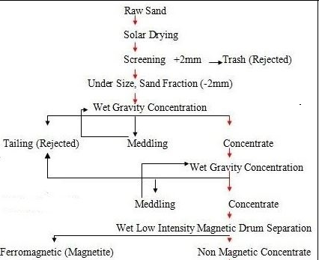
Figure 6: A simple flow sheet used for concentration and separation of magnetite.

In general, the cleaning operation was optimized by using less feed, less water, less tilt as much as possible, and shorter length of stroke beside a low speed of the deck. On contrary, the rough concentration require more feed, more water, more water, more tilt, and longer stroke. Using half-size Wilfley shaking table (Figure 3), under the condition shown in table (1). The table deck side tilt is 12mm/m, deck longitudinal tilt is 5.7 mm/m, and stroke frequency is 310rpm. The table feed rate is 90kg/h, and the washing cross flow water 70 L/min. The sample were divided into three fractions, concentrate, middling, and tail fractions. The tail fraction which is composed mainly from quartz anf feldspars was removed and rejected. A considerable amount of the heavy minerals were associated with the green silicate separated in the middling fraction of the first tabling stage, so this farction was retreated again to minimize loss of the heavy minerals. The obtained economic concentrate heavy minerals fraction of the Wilfley shaking table was weighted and its percentage is calculated. The separated magnetite from the concentrate by low intensity cross-belts magnetic separator was weighted and its percentage relative to the weight of the original sample was calculated and tabulated in table (4). the studied stream samples have a concentrate content (1.86 %), and the magnetite content (1.33 %).

Table (4): original weight, concentration weight in gram, concentration percentage, and magnetite weight in the studied stream sediments samples of Ras Abda area.
Sample | Original W. | conc. | conc. % | Non-Mag. % | Mag. %
W. Abda | 300990 | 5600 | 1.86 | 0.53 | 1.33

Table (5): The apparent specific gravity of stream sediments in the studied area.
Sample | W | V | S.g. | Sample | W | V | S.g. | Sample | W | V | S.g.
S1 | 1611.11 | 1000 | 1.61 | S18 | 1717.45 | 1000 | 1.72 | S32 | 1781.63 | 1000 | 1.78
S3 | 1539.62 | 1000 | 1.54 | S20 | 1636.59 | 1000 | 1.64 | S34 | 1708.78 | 1000 | 1.71
S5 | 1781.05 | 1000 | 1.78 | S22 | 1659.63 | 1000 | 1.66 | S36 | 2033.33 | 1000 | 2.03
S8 | 1934.17 | 1000 | 1.93 | S25 | 1768.69 | 1000 | 1.77 | S39 | 1546.86 | 1000 | 1.55
S11 | 1752.23 | 1000 | 1.75 | S27 | 1829.28 | 1000 | 1.83 | S42 | 1382.89 | 1000 | 1.38
S14 | 1881.4 | 1000 | 1.88 | S29 | 1853.22 | 1000 | 1.85 | S44 | 1491.85 | 1000 | 1.49
S16 | 1732.98 | 1000 | 1.73 | S30 | 1765.34 | 1000 | 1.77 | S47 | 1593.23 | 1000 | 1.59

Discussion

Apparent specific gravity
The apparent specific gravity is directly proportion to the heavy mineral content (Dabbour, 1991), and considered very simple tool throwing the light on the concentration of heavy economic minerals in the raw sand. Also, it is necessary for the transformation of cubic meters of raw sand to tons during determination of the reserve of economic mineral in tons. So, the apparent specific gravity for field sample collected from the study area was measured. The apparent specific gravity varies from 1.38 to 2.03 g/cm³ with average 1.64 g/cm³.

Relations between apparent specific gravity and total magnetite and total heavy contents:
A scatter plot diagram has been constructed between magnetite content and apparent specific gravity, and the total heavy mineral and the apparent specific gravity (Fig. 7) for the study stream sediments.

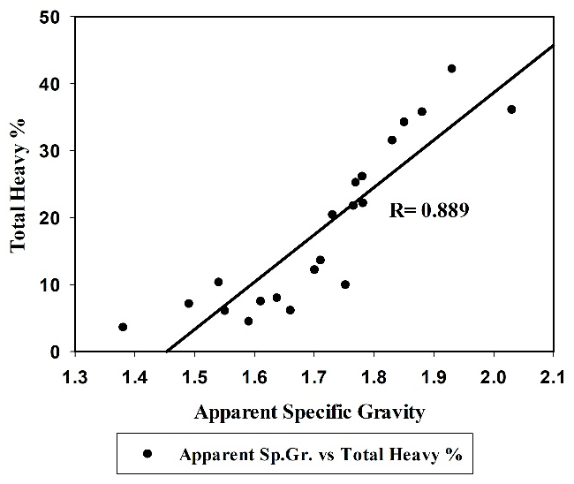  b | 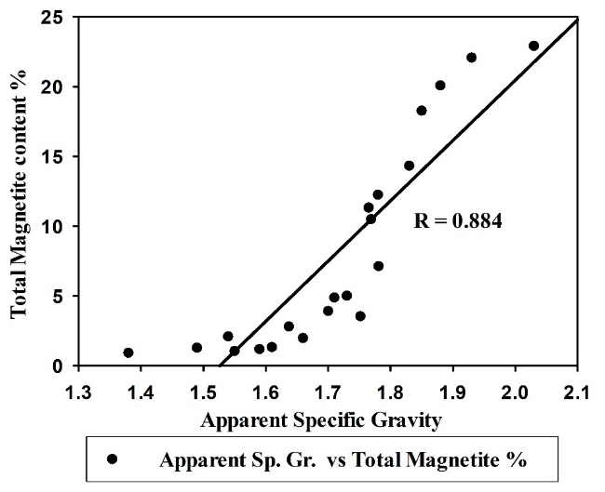  a
Fig (7): Scatter plot diagram between (a) total magnetite percentage vs apparent specific gravity, (b) total heavy minerals percentage vs apparent specific gravity for the selected studied stream samples.

The relations between total magnetite percentage and apparent specific gravity indicated that, strong positive direct relation between magnetite contents and the apparent specific gravity were recorded, and it indicated that as the apparent specific gravity increase the magnetite content increases revealed that the apparent specific gravity considered as good indicator of the total magnetite in fine sizes.
The relations between total heavy minerals percentage and apparent specific gravity indicated that, strong positive direct relation between the heavy minerals contents and the apparent specific gravity were recorded, and it indicated that as the apparent specific gravity increase the heavy minerals content increases revealed that the apparent specific gravity considered as good indicator of the total heavy minerals contents in fine sizes.

Grain size analysis
The description of the studied sediments based on the data of size fractions is the majority of specimens are range from very slightly muddy slightly gravelly sand to gravelly sand size, except four samples (S20, S22, S31, and S38) were abundant in the gravel. From the present study of the grain size analysis, we can calculate that these sediments were deposits in arid conditions characterized by rare rainfall by erosion process.
The grain size distribution of magnetite of the study area is unimodal with medium sand size class, which constitutes more than 51.35 wt% of the particles. The fine sand size class contains 32.54 wt% from the particles as shown in table (6). So, grain size distribution of mineral grains is an important factor in concentration and separation of economic heavy minerals during exploitation of black sands and stream sediment (Lawver et al. 1986; Burt 1989; Kelly and Spottiswood 1989 and Moustafa 1999). Also, the grain size distribution is important in metallurgy and chemical treatments of mineral grains.

Relations between magnetite and total heavy:
A scatter plot diagram has been constructed between magnetite and the total heavy mineral (Fig. 8) for the study stream sediments. The relations indicated that as size decreases, strong positive direct relation between magnetite and total heavy were recorded, and its show the maximum in the medium sand size fraction then the relation start to decrease again, and that is due to the weathering processes and transportation were not enough to release magnetite from the rock fragment in fine grains, beside that the positive relation in the all fraction sand size revealed that the magnetite considered as good indicator of the total heavy minerals particularly in fine sizes.

Table (6): The grain size distribution of magnetite in coarse, medium, fine and very fine sand size of stream sediments in the studied area.
Sample | Total magnetite % | coarse magnetite | medium magnetite | fine magnetite | very magnetite
S1 | 1.33 | 5.69 | 33.62 | 44.10 | 16.59
S2 | 1.99 | 13.52 | 37.74 | 33.80 | 14.95
S3 | 2.10 | 4.07 | 30.20 | 51.76 | 13.97
S4 | 4.25 | 12.23 | 50.97 | 33.82 | 2.98
S5 | 12.26 | 12.07 | 55.68 | 29.62 | 2.63
S6 | 0.60 | 22.33 | 51.20 | 22.58 | 3.89
S7 | 9.87 | 4.34 | 33.22 | 55.46 | 6.98
S8 | 22.09 | 2.53 | 31.81 | 58.42 | 7.25
S9 | 2.79 | 16.91 | 54.06 | 26.00 | 3.03
S10 | 1.92 | 2.32 | 27.74 | 50.78 | 19.16
S11 | 3.54 | 14.00 | 54.74 | 29.59 | 1.68
S12 | 18.57 | 5.32 | 46.64 | 45.41 | 2.64
S13 | 7.47 | 3.29 | 52.85 | 41.79 | 2.06
S14 | 20.09 | 7.44 | 45.99 | 44.07 | 2.50
S15 | 7.60 | 11.62 | 57.22 | 29.98 | 1.18
S16 | 5.02 | 10.42 | 53.34 | 32.24 | 4.00
S17 | 1.66 | 24.07 | 52.76 | 21.14 | 2.03
S18 | 3.92 | 6.26 | 49.39 | 38.46 | 5.89
S19 | 5.26 | 11.20 | 59.99 | 25.88 | 2.92
S20 | 2.81 | 9.46 | 46.91 | 39.18 | 4.46
S21 | 1.54 | 8.91 | 33.03 | 43.27 | 14.80
S22 | 1.98 | 8.40 | 54.62 | 33.81 | 3.18
S23 | 6.66 | 17.90 | 60.43 | 20.05 | 1.61
S24 | 2.04 | 13.98 | 55.39 | 28.07 | 2.55
S25 | 10.50 | 11.28 | 48.10 | 35.98 | 4.64
S26 | 38.54 | 10.17 | 64.23 | 24.41 | 1.18
S27 | 14.33 | 8.16 | 59.03 | 31.03 | 1.78
S28 | 13.77 | 13.97 | 59.76 | 24.63 | 1.65
S29 | 18.27 | 23.64 | 56.17 | 19.44 | 0.75
S30 | 11.34 | 16.88 | 60.40 | 21.01 | 1.71
S31 | 4.82 | 6.02 | 44.62 | 43.05 | 6.30
S32 | 7.14 | 35.63 | 53.98 | 9.28 | 1.10
S33 | 0.40 | 19.42 | 55.42 | 22.85 | 2.31
S34 | 4.87 | 3.85 | 38.93 | 53.12 | 4.10
S35 | 0.43 | 5.18 | 33.84 | 43.58 | 17.41
S36 | 22.93 | 18.31 | 59.79 | 20.72 | 1.18
S37 | 0.57 | 9.25 | 43.68 | 35.32 | 11.75
S38 | 0.70 | 9.27 | 56.28 | 30.65 | 3.80
S39 | 1.06 | 24.65 | 57.09 | 16.24 | 2.02
S40 | 1.55 | 7.73 | 51.90 | 36.40 | 3.97
S41 | 0.66 | 9.28 | 42.40 | 34.11 | 14.20
S42 | 0.94 | 9.02 | 45.28 | 38.48 | 7.22
S43 | 1.17 | 13.31 | 56.05 | 26.71 | 3.93
S44 | 1.29 | 7.98 | 44.51 | 41.76 | 5.76
S45 | 0.17 | 18.28 | 38.15 | 30.55 | 13.02
S46 | 5.78 | 18.71 | 59.18 | 21.44 | 0.67
S47 | 1.19 | 13.50 | 62.25 | 21.61 | 2.64
Average | 2.07 | 11.18 | 51.35 | 32.54 | 4.93

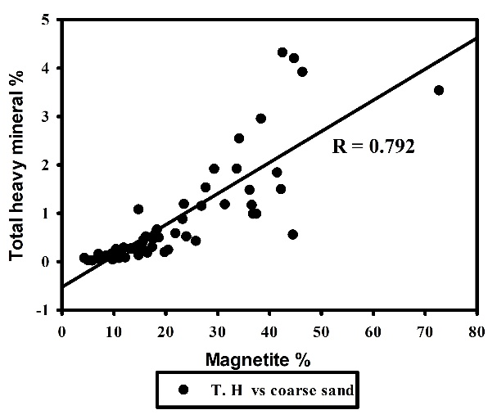 | 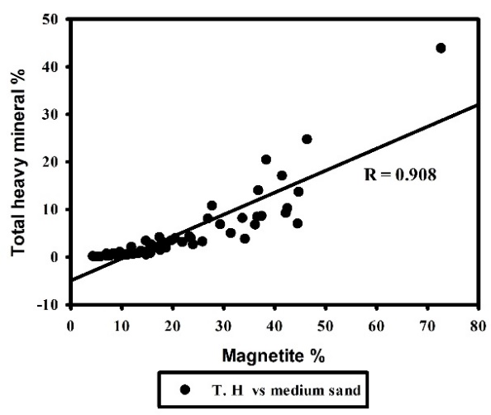
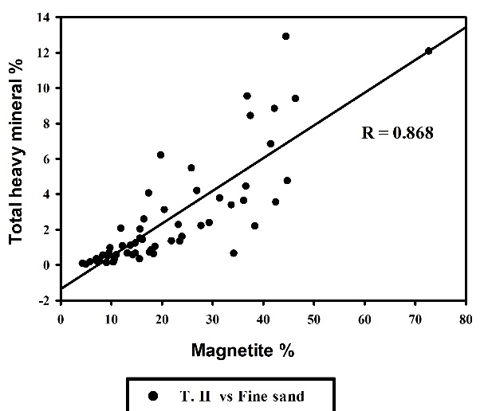 | 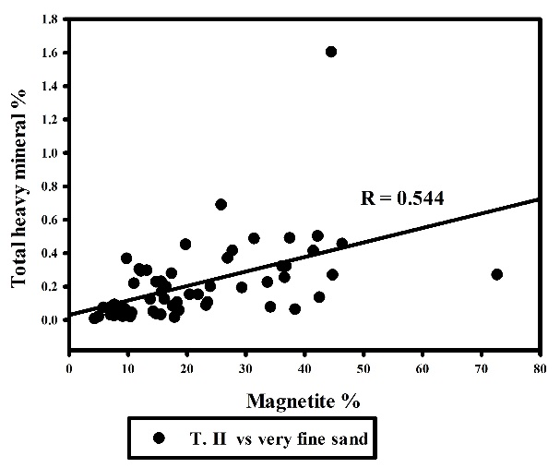
Fig (8): Scatter plot diagram between the total heavy minerals percentage and magnetite percentage for the studied stream samples.

Relation and comparison between the magnetite percentage in both laboratory scale and industrial scale
In the present study, the total magnetite content in the industrial scale was 1.33, where the total magnetite content in the laboratory scale fluctuates between natural (0.17 and 38.54) with a general average of about 2.07 (higher than the industrial scale). By the examination with the binuclear stereomicroscope, it is clarified that the magnetite contents obtained from the separated laboratory samples have a noticeable percent of composite grains of magnetite with amphiboles, pyroxenes, epidotes, and olivine. And these grains were gone as a tails in the industrial scale on the shacking table.

Magnetite geochemistry
Generally, magnetite is the most magnetic of all the naturally occurring minerals on the earth, and typically carries the dominant magnetic signature in rocks. It has been a critical tool in paleo-magnetism and important in studying the plate tectonics. Magnetite has been very important in understanding the conditions under which rocks formed and evolved. It was recorded in the studied sediments as common accessory mineral. It is considered as valuable source and one of the most important of iron ore, due to the highest of all iron content which reach 72.4%. Because of its properties it is used in the following purposes, as additive in toners for laser printers and copiers, as an iron additive for manufacture of cement, as filling materials for sound insulation, in physical water treatment for removal of turbidity and impurities, fine ground (<45μm) mix with water produces dense medium gravity separation used in coal flotation, as raw material in the manufacture of pigments for special colors, as blasting abrasive, and used as additive in fertilizers.
Magnetite displays deep reddish brown to black color, with metallic to dull luster. Their habit ranges from massive, granular, and angular to sub-angular. The fine size is very common and the octahedron crystals of magnetite are more frequent. The EDX/BSE images of magnetite of study area ESEM were shown in figure (9), and the X-ray diffraction data were shown in table (7).

Table 7: X-ray diffraction data of magnetite mineral.
Analyze sample |  | Magnetite  ASTM card (19-0629)
dAº | I/I_{o} | dAº | I/I_{o}
4.83 | 10 | 4.85 | 8
2.96 | 29 | 2.967 | 30
2.53 | 100 | 2.532 | 100
2.42 | 11 | 2.424 | 8
2.1 | 8 | 2.099 | 20
1.72 | 19 | 1.715 | 10
1.63 | 18 | 1.616 | 30
1.48 | 15 | 1.485 | 40
1.41 | 3 | 1.419 | 2

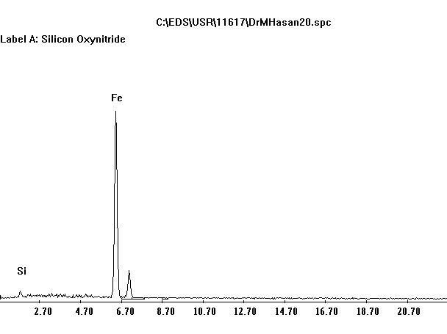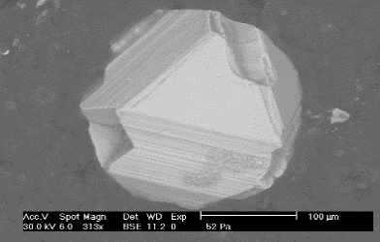 |  | Element Wt % At %  O 18.63 43.9  Si 1.75 2.35  Fe 79.62 53.75  Total 100 100
Fig. 9: ESEM spectrograph, BSE image and stereo photograph for magnetite mineral tailed with chemical analysis.

Reserve of magnetite of the study area
Wadi Ras Abda studied area has a length of about 10 km and average width reach to 50 m. The studied area is more or less plainer surface so that the volume of sediments is roughly calculated as length × width × depth in cubic meter, which attains 0.5 million m3. The tonnage of the raw sand was calculated by multiplying the volume by the calculated average apparent density of the raw sand (0.82 million t). The tonnage of magnetite was calculated by multiplying the tonnage of the raw sands of the studied area by the calculated weight percentage of magnetite obtained by laboratory and ore dressing techniques, which amounts to (16,974 t and 10,9060 t, Table 8), respectively. The value in ore dressing techniques is lower than the value in laboratory techniques by the amount of the green silicate contents (6,068 t).

Table 8: The average content (wt %) and reserve tonnage of magnetite in the studied area
Volume of study area (m³) | Average apparent density of raw sands (t/m³) | Tonnage of raw sands (t)
10,000 × 50 × 1 = 500,000 | 1.64 | 820,000
Magnetite average content (wt%) and reserve (t) | Reserve (t) in laboratory technique | Reserve (t) in ore dressing technique
 | 2.07 % × 820,000 = 16,974 | 1.33 % × 820,000 = 10,906

Conclusions
The studied area has length of about 10 km and width reach to 50 m, covered by 47 samples to a depth of 1 m. The following remarks can be concluded:
- The majority of the studied stream deposit samples is gravelly sand sediment.
- The apparent specific gravity of the studied samples varies from 1.38 to 2.03 g/cm ³ with 1.64 g/cm³ average.
- The heavy Bromoform fractions representing total heavy minerals content varies in the different sand sizes and the highest content present in the medium sand size class, which range from 1.02 to 27.35 % with an average 5.74 wt% of the particles, then the fine sand size class contains range from 0.38 to 20.92 % with an average 3.63 wt%.
- The heavy methylene iodide fractions representing total heavy minerals content varies in the different sand sizes and the highest content present in the medium sand size class, which range from 0.16 to 26.47 % with an average 3.03 wt% of the particles, then the fine sand size class contains range from 0.13 to 18.19 % with an average 2.43 wt%.
- The grain size distribution of magnetite is unimodal with medium sand size class, which constitutes more than 51.35 wt% of the particles, then the fine sand size class contains 32.54 wt%.
- There are positive correlations between the average contents of magnetite and that of apparent specific gravity and total and economic heavy minerals.
- The magnetite content obtained by laboratory techniques ranges from 0.17 to 38.54 wt% with 2.07 wt% average. It represents one third of the total economic minerals. Close relationships between concentration of magnetite and concentration of other economic heavy minerals were recorded. So, the magnetite content which can be easily obtained by using of a hand magnet can be considered as a pathfinder for the concentration of the associated economic minerals.
- The magnetite content obtained by ore dressing techniques reached to 1.33 wt%.
- The tonnage of magnetite obtained by laboratory and ore dressing techniques is 16,974 t and 10,906 t, respectively.
- Magnetite grains have generally irregular shape and subangular and surrounded particles. Some of them exhibit octahedron crystals.
- The chemical data obtained by ESEM showed that the mineral is composed mainly from iron contents is 79.62 suggest that the studied magnetite is probably derived from the basic volcanic rocks.

Names of authors:

Fatma S. Ramadan, Ali A. Omran, Hesham A. El-Nahas, Ehab K. Abu Zeid, Mohamed Hassan
Affiliation (s) and address (es) of the author (s):
- Fatma Sayed Ramadan
Professor of geology, Zagazig University, Zagazig, Egypt.
E-mail: Fatma_r@yahoo.com
P.O. Box: 44511 Zagazig, Egypt.
- Ali Ahmed Omran
Professor of geology, Nuclear Materials Authority, Cairo, Egypt.
E-mail: A_Omran@yahoo.com
P.O. Box: 530 El-Maadi, Cairo, Egypt.
- Hesham Abd El-Aziz El-Nahas
Professor of geology, Nuclear Materials Authority, Cairo, Egypt.
E-mail: Hesham_nahas@yahoo.com
P.O. Box: 530 El-Maadi, Cairo, Egypt.
- Ehab Korany Abu Zeid
Assistant Professor of geochemistry, Nuclear Materials Authority, Cairo, Egypt.
E-mail: Ehab_zeid@yahoo.com
P.O. Box: 530 El-Maadi, Cairo, Egypt.
- Mohamed Hassan (corresponding author)
Assistant Lecturer, Nuclear Materials Authority, Cairo, Egypt.
E-mail: geo.mohamedhassan86@gmail.com
P.O. Box: 530 El-Maadi, Cairo, Egypt.
Name of corresponding author: Mohamed Hassan
Assistant Lecturer, Nuclear Materials Authority, Cairo, Egypt.
E-mail: geo.mohamedhassan86@gmail.com
P.O. Box: 530 El-Maadi, Cairo, Egypt.
Phone number: +2-01120133300

References
- Hammoud NMS. Concentration of monazite from Egyptian black sands employing industrial techniques. M.Sc. Thesis, Fac. Sci., Cairo Univ., Cairo, Egypt. 1966; 198 p.
- Omran AA. Geological, petrochemical studies and potentiality of uranium-thorium occurrences in Gabal Um Taghir El-Tahtani area with emphasis on the granitic rocks, Central Eastern Desert, Egypt. Ph.D. thesis, Ain Shams Univ. Cairo 2005; 189 p.
- EL Hadary A, El Azab A., Omran AA. Contributions to the geology and mineralogy of wadi Ras Abda area, Central Eastern Desert, Egypt. Arab. J. of Sci. 2010; V.7: 245-259.
- EL Hadary A, El Azab A., Omran AA. Contributions to the geology and mineralogy of wadi Ras Abda area, North Eastern Desert, Egypt. Nu. Sci. Sci. J. 2013; 2, 15.
- Omran AA. Geology, mineralogy and radioelements potentiality of microgranite dikes to the south of wadi abu hadieda area, northern eastern desert Egypt. Al-Azhar Bull Sci 2015; V.26: 67–89.
- Wentworth CK. A scale of grade and class terms for clastic sediments. J. Geo. 1922; V. 30: 377-392.
- Mohamed SSM. Radioactivity and Mineralogical studies on Wadi Abu Dabbab alluvial deposits, Central Eastern Desert, Egypt. M. Sc. Thesis, Fac. of Sci., Ain Shams Univ. 1998; 204p.
- Burt RO. Gravity concentration technology. Elsevier Science Publishers B.V., Amestrdam, the Netherlands, 1989; 605 p.
- Barakat MG. Sedimentological studies and evaluation of some black sands deposits on the northern coast of Egypt. M.Sc. Thesis, Fac. Sci. Alex. Univ., Egypt, 2004; 176 p.
- Barakat MG. Evaluation and mineralogy of beach economic minerals for the top meter in the Egyptian black sand, east Rosetta, Egypt, with emphasis on ilmenite. Ph.D. Thesis, Fac. Sci. Zag. Univ., Egypt, 2016; 316 p.
- Moustafa MI. (): Separation flow sheet for high purity concentrates of some Ec. Min. from El-Burullus Baltim sand Dunes Area, North coast, Egypt. The fifth international conference on the geology of Africa, 2007; V. 1: 111-124.
- El-Nahas HA. Mineralogy, evaluation and upgrading studies on some economic minerals in beach black sands. El Arish area, Egypt. M.Sc. Thesis, Fac. Sci., El Minufiya Univ., Egypt, 2002; 162 p.
- El-Shafey AM. Mineralogical, evaluation and beneficiation of the economic minerals of Egyptian black sands especially Cassiterite, in Abu-Khashaba area, east Rosetta, Egypt. M.Sc. Thesis, Fac. Sci. Zag. Univ. 2011.
- El-Shafey, A.M. Upgrading and mineralogical studies for some economic and nuclear elements bearing minerals of Rosetta black deposits, Egypt, with especial emphasis on monazite. Ph.D. Thesis, Fac. Sci. Zag. Univ. 2016; 172 p.
- Wills BA. Mineral processing technology. 5th Ed., Pergman Press, Oxford, England, 1992; 855p.
- Mange MA, and Maurer HF. Heavy Minerals in Colour. Chapman & Hall, London. 1992.
- Padmalal D, Ramachandran KK, and Seralathan P. Significance of heavy mineral suite in riverine and estuarine sediments in the southwest coast of India- a case study. Indian J. Of Marine Science, 1998; V.27: 185-189.
- Komar PD. Beach processes and sedimentation. Prentice Hall, Englewood cliffs, New Jersy, 1976; 289p.
- Komar PD. The entrainment, transport and sorting of heavy minerals by waves and currents. In: Mange M.A. & Wright D.T. eds. Heavy Minerals in Use, Developments in Sedimentology, 2007; V.58: 3-48. Elsiver, Amsterdam.
- Dabbour GA. Heavy minerals content in relation to the apparent specific gravity of the Egyptian black sands. Bull., Fac. Sci., EL Mansoura University, Special Issue, 1991; 212 – 220.
- Lawver JE, Taylor JB, Knoll FS. Laboratory testing for electrostatic concentration circuit design. SME-AIME Annual Meeting, March, 1986; 454-477.
- Burt RO. Gravity concentration technology. Elsevier Science Publishers B.V., Amestrdam, the Netherlands, 1989; 605 p.
- Kelly EG, Spottiswood DJ. (): The theory of electrostatic separations: a review, Part I. Fundamentals. Minerals Eng. 1989; V.2, No.1: 33-46.
- Moustafa MI. Mineralogy and beneficiation of economic minerals in the Egyptian black sands. Ph.D. Thesis, Fac. Sci., El Mansoura Univ., Egypt, 1999; 316 p.

10/21/2019

