Efficacy of Scarpa Fascia Preservation during Abdominoplasty: Systematic Review And Meta-Analysis

Awad Hassan El-Kayal, Barakat Abd El-Reheem Mahmoud, Mona Mohamed Mohamed Omarah

Department of General Surgery, Faculty of Medicine- Ain Shams University, Egypt.
Email: mona.omarah@gmail.com

Abstract: Background: Abdominoplasty is one of the most frequent aesthetic surgical procedures performed worldwide. Postoperative seroma formation remains the most frequent complication, also hematoma is considered to be a serious complication that has a high reoperation rate. Objective: To evaluate the effectiveness and efficiency of preserving Scarpa’s Fascia in reducing postoperative complications during abdominoplasty. Patients and Methods: This systematic review and Meta-Analysis were conducted to estimate the pooled benefits and adverse of preserving Scarpa‘s fascia during abdominoplasty, highlight the evidence and quality of the included studies and to share in modifying the current guidelines. Results: The pooled estimate of the seven included studies suggested that Scarpa’s fascia preservation was associated with significantly reduced seromas relative to the control group. However, Scarpa’s fascia preservation could not significantly decrease the risk of hematoma or infection. Compared with the control group, Scarpa‘s fascia preservation was associated with a significantly reduced overall rate of complications. Conclusion: Scarpa fascia preservation could significantly reduce seroma, time until drain removal, drain output, and hospital stay following abdominoplasty.
[Awad Hassan El-Kayal, Barakat Abd El-Reheem Mahmoud, Mona Mohamed Mohamed Omarah. Efficacy of Scarpa Fascia Preservation during Abdominoplasty: Systematic Review And Meta-Analysis. N Y Sci J 2019;12(10):28-35]. ISSN 1554-0200 (print); ISSN 2375-723X (online). http://www.sciencepub.net/newyork. 4. doi:10.7537/marsnys121019.04.

Keywords: Superficial fascial system, abdominoplasty, scarpa‘s fascia

1. Introduction
Abdominoplasty is one of the most performed operations in Plastic Surgery in the world. Its main objective is to improve the body contour by means of excising redundant skin and fat tissue and tightening of the abdominal muscles. The number of abdominoplasty surgeries has been increasing in proportion with the rising number of bariatric surgeries in response to the increasing number of obesity cases in both developed and developing countries ⁽¹⁾.
Obesity is considered a worldwide health problem, ⁽²⁾, according to WHO 39% of adults aged 18 years and over were overweight in 2016, and 13% were obese.
Truncal deformity consists of excess tissue in the abdominal region both vertically and horizontally, and it is the chief concern of most patients presenting for abdominoplasty ⁽³⁾.
It usually occurs after repeated pregnancies because Pregnancy stretches the skin beyond its biomechanical capability to spring back and stretches the musculoaponeurotic structures of the abdominal wall. The result is stretching and thinning of these structures and diastasis of the rectus muscle. Massive weight loss, whether from dieting or after a gastric bypass surgery, also plays a role in excess skin and laxity of the abdominal wall. ⁽⁴⁾.
Redundant abdominal skin can result in physiological and psychological problems related to an unusual body habitus. Patients complain of difficulties with daily activities, choice of clothing, social acceptance, etc. Abdominoplasty has proven to be an important part of the rehabilitation of the morbidly obese patient ⁽²⁾.
Complications related to abdominoplasty include seroma formation which is the most frequent complication, pseudo-bursa, small areas of ischemia and poor wound healing. Also include minor complications like poor scars and dog ears. The most worrisome complications are the ones which threaten the life or severely affect the aesthetic result of the procedure like huge hematomas, significant infection, necrosis, and DVT/PE. Most of these complications are preventable by proper patient and procedure selection, careful planning and adequate surgical technique ⁽⁴⁾.
Multiple surgical strategies have been described to lower the complication rate, such as Scarpa’s fascia preservation, lipoabdominoplasty, selective undermining, high tension sutures techniques, use of pressure dressings, and fibrin glue. The technique
used to raise the abdominal flap (scalpel vs electrosurgery) has also been implicated ⁽⁵⁾.
The classical technique of abdominoplasty is preformed through a premuscular plane of dissection. A supra scarpa’s preservation technique using a more superficial plane has been proposed as a way to decrease the complications associated with abdominoplasty through using two plane of dissection opposite to the single plane used in the classical abdominoplasty. Both techniques are identical in the supraumbilical region, but in the infraumbilical region the dissection is more superficial at scarpa fascia level and this modification aims to reduce the seroma rate by means of lymphatic preservation ⁽⁶⁾.
Aim of the Work
The aim of the study is to evaluate the effectiveness and efficiency of preserving Scarpa’s Fascia in reducing postoperative complications during abdominoplasty.

2. Materials and Method
We performed this systematic review and meta-analysis in accordance to the recommendations of the Preferred Reporting Items for Systematic Reviews and Meta-Analyses (PRISMA) statement and Meta-analysis Of Observational Studies in Epidemiology (MOOSE) statement. PRISMA and MOOSE are reporting checklists for Authors, Editors, and Reviewers of Meta-analyses of interventional and observational studies. According to International committee of medical journal association (ICJME), reviewers must report their findings according to each of the items listed in those checklists ⁽⁷⁾.
Study Selection and Eligibility Criteria: The present review included studies that fulfilled the following criteria:
Studies that included adults’ patients with abdominal tissue excess after massive weight loss or women with abdominal tissue excess after childbirth that underwent abdominoplasty; Studies that assessed the safety and effectiveness of Scarpa’s fascia preservation in preventing seroma formation during abdominoplasty; Studies that compared Scarpa’s fascia preservation with conventional abdominoplasty or no comparison; Studies that reported any of the following outcomes: rates of seroma, hematoma, and/or infection. Studies that were randomized controlled trials (RCTs), comparative studies, prospective cohort, or retrospective charts studies.
We excluded review articles, non-English studies, theses, dissertations and conference abstracts, and trials with unreliable date for extraction.
Search Strategy and Screening:
An electronic search was conducted from the inception till August 2019 in the following bibliographic databases: Medline via PubMed, SCOPUS, Cochrane Central Register of Controlled Trials (CENTRAL), and Web of Science to identify relevant articles. We used different combinations of the following queries: ("Abdominoplasty" [All Fields] OR (("human body" [MeSH Terms] OR ("human" [All Fields] AND "body"[All Fields]) OR "human body"[All Fields] OR "body"[All Fields]) AND countering [All Fields])) AND (Scarpa [All Fields] AND ("fascia"[MeSH Terms] OR "fascia"[All Fields]).
Screening:
Retrieved citations were imported into EndNote X7 for duplicates removal. Subsequently, unique citations were imported into an Excel sheet and screened by two independent reviewers; the screening was conducted in two steps: title and abstract screening, followed by a full-texts screening of potentially eligible records.
Data Extraction:
Data entry and processing were carried out using a standardized Excel sheet and reviewers extracted the data from the included studies. The extracted data included the following domains: (1) Summary characteristics of the included studies; (2) Baseline characteristics of studied populations; and (3) Study outcomes. All reviewers’ independently extracted data from the included articles and any discrepancies were solved by discussion.
Risk of Bias Assessment:
The quality of the retrieved RCTs was assessed according to the Cochrane Handbook for Systematic Reviews of Interventions 5.1.0 (updated March 2011) using the quality assessment table provided in the same book (part 2, Chapter 8.5). The Cochrane risk of bias assessment tool includes the following domains: sequence generation (selection bias), allocation sequence concealment (selection bias), blinding of participants and personnel (performance bias), blinding of outcome assessment (detection bias), incomplete outcome data (attrition bias), selective outcome reporting (reporting bias) and other potential sources of bias. The authors’ judgment is categorized as ‘Low risk’, ‘High risk’ or ‘Unclear risk’ of bias.
Dealing with Missing Data:
Missing standard deviation (SD) of mean change from baseline was calculated from standard error or 95% confidence interval (CI) according to Altman ⁽⁸⁾.
Direct two-arm Meta-analysis:
Continuous outcomes were pooled as mean difference (MD) or standardized mean difference (SMD) using inverse variance method, and dichotomous outcomes will be pooled as relative risk (RR) using Mantel-Haenszel method. The random-effects method was used under the assumption of existing significant clinical and methodological heterogeneity. We performed all statistical analyses using Review Manager (RevMan) 5.3 or Open Meta-analyst for windows.
Assessment of Heterogeneity:
We assessed heterogeneity by visual inspection of the forest plots, chi-square, and I-square tests. According to the recommendations of Cochrane Handbook of Systematic Reviews and meta-analysis, chi-square p-value less than 0.1 denote significant heterogeneity while I-square values show no important heterogeneity between 0% and 40%, moderate heterogeneity from 30% to 60%, substantial heterogeneity from 50% to 100%. If any trials were judged to affect the homogeneity of the pooled estimates, we planned to perform a sensitivity analysis to assess outcomes with and without the trials that were affecting the homogeneity of the effect estimates.
Assessment of publication biases:
We intended to test for publication bias using funnel plots if any of the pooled analysis included more than 10 studies in the review.

3. Results

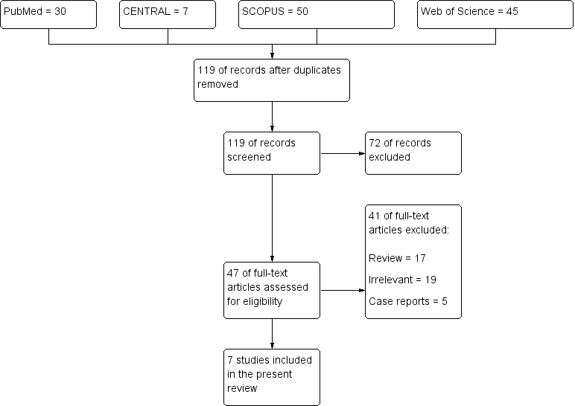
Figure (1): PRISMA flow-chart.

Table (1): Summary Characteristics of the included studies
Study | Year | Country | Study design | No. | Intervention | Control | Follow-up  (months) | Main Findings
Anlatıcı et al, | 2018 | Turkey | Retrospective  cohort | 55 | Scarpa  preserving | None | 6 | Combined postbariatric operations are  very effective and the likelihood  of serious complications could be  decreased significantly when  performed under certain condition
Correia-Gonçalves  et al | 2017 | Portugal | Retrospective  cohort | 51 | Scarpa  preserving | Classic  full | 6 | Preserving Scarpa fascia during a full  abdominoplasty in postbariatric  patients improves recovery
Costa-Ferreira  et al | 2009 | Portugal | Prospective  nonrandomized  cohort | 208 | Scarpa  preserving | Classic  full | NR | Preservation of the Scarpa  fascia during abdominoplasty  has a beneficial effect on patient recovery
Di Martino et al | 2010 | Brazil | Prospective | 58 | Scarpa  preserving a | Classic  full | 1 | Abdominoplasty with quilting  sutures and lipoabdominoplasty  are effective techniques
Fang et al | 2010 | United States | Retrospective  cohort | 202 | Scarpa  preserving a | Classic  full | NR | Flap elevation in a plane superficial to  the standard suprafascial  approach during abdominoplasty  may decrease the length of time  required for drains in the postoperative  period in the abdominoplasty patient
Koller and  Hintringer | 2011 | Austria | Prospective  nonrandomized  cohort | 50 | Scarpa  preserving | Rectus  Fascia | 6 | Scarpa fascia preservation seems to  reduce postoperative seroma formation
Costa-Ferreira  et al | 2013 | Portugal | Randomized  controlled  study | 160 | Scarpa  preserving | Classic  full | 6 | Preservation of the Scarpa fascia  during abdominoplasty has  a beneficial effect on patient recovery

Table (2): Baseline Characteristics of the included studies
Study | No. | Percentage women | BMI, kg/m2 | Mean age (SD) of control group, years | Mean age (SD) of treatment Group, years | Seroma detection | Deformity
Anlatıcı et al, | 55 | 85.45% | 35 | NA | 39 (25 - 69) | US | NR
Correia- Gonçalves | 51 | 100.00% | 28.6 ± 3.4 | 38.3 ± 7.8 | 39.1 ± 8.9 | Clinical | NR
Costa- Ferreira et al | 208 | 100% | 25-30 | 41.1 (9.0) | 37.8 (6.9) | Clinical | III/IV, M
Di Martino et al | 58 | 100% | <25 | 34.8 (NR) | 34.7 (NR) | US | III, N
Fang et al | 202 | 99% | <25 | 44 (8.0) | 44 (9.6) | Clinical | II/III, M
Koller and Hintringer | 50 | NR | 25-30 | 39 (NR) | 37 (NR) | Clinical/US | IV, M
Costa- Ferreira et al | 160 | 100% | 25-30 | 38.5 (9.2) | 40.6 (8.3) | Clinical | III/IV, M

Table (3): Outcomes of the included studies (A):
Study | No. | Complication rates |  | Seroma formation |  | Hematoma |  | Infection |  | Hypertrophic scar |  | liposuction revisions
 |  | Scarpa group | Control group | Scarpa group | Control group | Scarpa group | Control group | Scarpa group | Control group | Scarpa group | Control group | Scarpa group | Control group
Anlatıcı et al, | 55 | 31 (56.3%) | NA | 18 (32.73%) | NA | NR | NR | 2 (3.64%) | NA | 1 (1.82%) | NA | 10 (18.18%) | NA
Correia- Gonçalves | 51 | 6 (11.7%) | 8 (15.6%) | 4 (19%) | 2 (6.7%) | 1 (4.8%) | 2 (6.7%) | 1 (4.8%) | 0 | 0 | 4 (13.3%) | NR | NR
Costa- Ferreira et al | 208 | NR | NR | NR | NR | NR | NR | NR | NR | NR | NR | NR | NR
Di Martino et al | 58 | NR | NR | 2 (10%) | 8 (40%) | NR | NR | NR | NR | NR | NR | NR | NR
Fang et al | 202 | 17 (16.5%) | 32 (32.2%) | 2 (1%) | 7 (7.1%) | 2 (1%) | 2 (1%) | 3 (2.9%) | 5 (5.1%) | 5 (4.8%) | 8 (8.1%) | NR | NR
Koller and Hintringer | 50 | NR | NR | 0 | 4 (8%) | NR | NR | NR | NR | NR | NR | NR | NR
Costa- Ferreira et al | 160 | NR | NR | 2 (2.5%) | 15 (18.75%) | 5 (6.3%) | 1 (1.3%) | NR | NR | NR | NR | NR | NR

Table (4): Outcomes of the included studies (B):
Study | No. | Time until drain removal |  | Drain output (ml) |  | Hospital stay, days |  | Readmission |  | Reoperation
 |  | Scarpa group | Control group | Scarpa group | Control group | Scarpa group | Control group | Scarpa group | Control group | Scarpa group | Control group
Anlatıcı et al, | 55 | NR | NR | NR | NR | NR | NR | NR | NR | NR | NR
Correia- Gonçalves | 51 | 3.4 ± 1.5 | 10.1 ± 9.4 | 250.7 ± 219.8 | 1181.9 ± 1177.2 | 4.3 ± 1.7 | 9.3 ± 5.1 | 1 (3.3%) | 1 (4.8%) | 1 (3.3%) | 1 (4.8%)
Costa- Ferreira et al | 208 | 3.17 ±1.42 | 5.14 ± 3.08 | 214.85 ±201.75 | 523.11 ± 521.61 | 4.91 ± 1.70 | 6.80 ± 3.24 | NR | NR | NR | NR
Di Martino et al | 58 | NR | NR | NR | NR | NR | NR | NR | NR | NR | NR
Fang et al | 202 | NR | NR | NR | NR | NR | NR | NR | NR | NR | NR
Koller and Hintringer | 50 | NR | NR | 93 | 157 | NR | NR | NR | NR | NR | NR
Costa- Ferreira et al | 160 | 3.29 ±1.34 | 6.24 ±3.44 | 210.13 ±152.80 | 609.25 ±460.21 | 3.69 ±1.36 | 6.69 ±3.19 | 1 (1.3%) | 2 (2.5%) | 0 | 1 (1.3%)

Table (5): Newcastle-Ottawa Scale (NOS) for Grading Nonrandomized Studies
Study | No. of stars
 | Selection  (maximum, 4) | Comparability  (maximum, 2) | Outcome  (maximum, 3) | Overall  (maximum, 9)
Anlatıcı et al, | 3 | 2 | 1 | 6
Correia-Gonçalves | 3 | 2 | 2 | 7
Costa-Ferreira et al | 3 | 2 | 2 | 7
Di Martino et al | 3 | 2 | 3 | 8
Fang et al | 3 | 2 | 2 | 7
Koller and Hintringer | 3 | 2 | 3 | 8

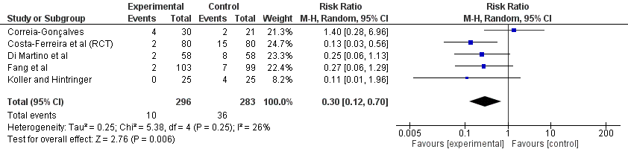
Figure (2): Forest plot of Seroma formation.

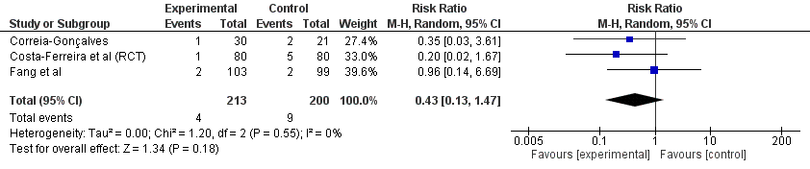
Figure (3): Forest plot of hematoma formation.
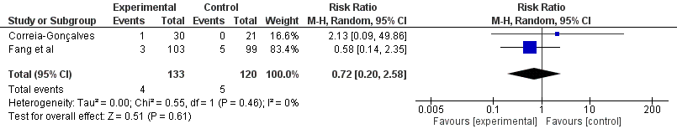
Figure (4): Forest plot of infection rates.

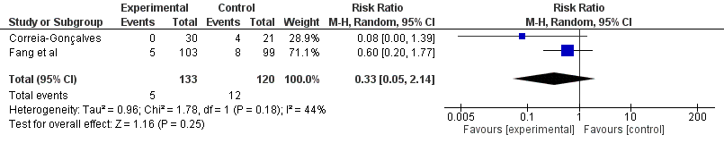
Figure (5): Forest plot of the rate of hypertrophic scars.

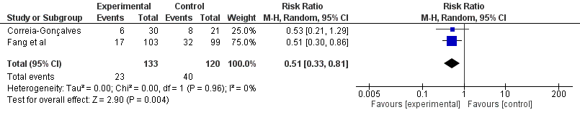
Figure (6): Forest plot of overall complications rate.

4. Discussion
The subcutaneous tissue of the abdominal wall consists of two distinct fat compartments, superficial and deep, which are separated by the scarpa fascia. Preservation of the scarpa fascia was accompanied by preservation of the deep fat compartment along with its connective tissue, lymphatic vessels, arteries, and veins ⁽⁹⁾.
There were two distinct areas of lymph drainage that included the epigastric area drains to the axilla and the hypogastric area drains to the inguinal area. The connections between the deep fat compartment and the inguinal area were maintained after scarpa fascia preservation. Some blood supply and lymphatic drainage could be retained compared to the excision of scarpa fascia ⁽¹⁰⁾.
The risk of seroma formation after abdominoplasty is well documented, with incidence ranging from 5% to 43%. Its causes are still unclear, though lymphatic channels disruption, “dead space” formation, as well as the shearing forces between abdominal flap and the fascia have been implicated. Seroma formation is usually self-limited; however, it can be associated with complications such as wound dehiscence and flap necrosis (due to increased pressure to the wound) or infection (due to contamination) ⁽¹¹⁾.
Untreated chronic seroma may lead to the formation of a pseudocyst. For decades closed suction drains have been considered to be the standard of care for seroma prevention ⁽¹²⁾. The use of drains is associated with a significant increase in postoperative pain, as well as complications including retrograde bacterial migration and infection. Consequently, multiple preventive surgical strategies have been proposed over the years in order to reduce seroma rate ⁽¹³⁾.
So, the aim of this study was to evaluate the effectiveness and efficiency of preserving Scarpa’s Fascia in reducing postoperative complications during abdominoplasty.
The present systematic review included seven studies (No of patients = 784) assessed the efficacy of Scarpa fascia preservation on the seroma formation and other complications after massive weight loss following bariatric surgery or pregnancy. Three of those studies were conducted in Portugal, and one in each Turkey, Brazil, Austria, and United States. Only one included study was a randomized controlled trial; while the rest of the studies were either prospective (N = 3 studies) or retrospective study (N = 3 studies). Only one study was uncontrolled retrospective study. The sample size of the included patients ranged from 55 to 208 patients.
The duration of follow-up ranged from 1 – 6 months. All included studies agreed that Scarpa fascia preservation seems to reduce postoperative seroma formation and improves patient's recovery.
In our meta-analysis four included studies recruited women only; one study had 99% women; one study had 85.45% women; and one study did not address gender. Four studies were of overweight patients (BMI, 25-30 kg/m2), and the rest of the studies were of patients with normal BMI (<25 kg/m2). The mean age of the included patients in the intervention group ranged from 34.7 to 44 years old.
In agreement with another meta-analysis which included 664 abdominoplasty patients. The mean age of participants was 40 years, ranging from 34.7 to 45.4 years. Mean body mass index (BMI) ranged from 23.7 to 27.7 kg/m2 in 8 studies. Obese patients, who had achieved massive weight loss after bariatric surgery, were recruited in one study (BMI, 36 kg/m2). The mean BMI was 26.8 kg/m2. Subgroup analyses found female predominance with significant difference ⁽¹⁴⁾.
The pathogenesis of postabdominoplasty seromas remains elusive, and several explanations have been suggested. Elevation of the large skin flap results in serous fluid collection following the inflammatory stimulus of injury. Flap elevation and redundant skin resection could injure lymphatic vessels and lead to a compromised state of lymphatic drainage after the operation. In addition, any dead space might lead to the formation of acute fluid collections ⁽¹⁵⁾.
Scarpa fascia preservation on the infraumbilical area could protect some structures and physiology of the abdominal wall, and theoretically, it could reduce bleeding (due to the preservation of the inferior perforating vessels), promote good adherence between the flap and the deep layers, and result in less fluid collection and seroma formation due to preservation of deep lymphatic vessels as confirmed by some clinical studies ⁽¹⁰⁾.
Seroma formation rate was first reported by Pitanguy ⁽¹⁶⁾, followed by several case series and retrospective studies. A great inconsistency, in terms of overall complication and seroma rates after abdominoplasty has been reported, accentuating the confusion regarding the prevention of seroma formation.
This is in agreement with our study in which six studies reported the incidence of seroma formation, the rate of seroma formation ranged from 1 to 32.7% in the scarpa’s fascia preservation group and from 6.7% to 40% in the control group. The overall effect estimates favored Scarpa’s fascia preservation over the classic technique in terms of risks of postoperative seroma formation (RR 0.3, 95% CI [0.21, 0.7]; P =0.006). The pooled estimate showed no significant heterogeneity (p =0.25; I2 =26%).
In recent systematic review and meta-analysis about "the Effects of Abdominoplasty Modifications on the Incidence of Postoperative Seroma" Fifteen studies (1824 total patients) met the criteria for inclusion. The overall risk of bias was high, mainly owing to the nonrandomized nature of most studies. Abdominoplasty with preservation of Scarpa’s fascia was associated with a significantly reduced incidence of seroma compared with that of standard abdominoplasty (P < 0.0001). The incidence of seroma after abdominoplasty ranges from 1% to 57% with a generally accepted rate of 10% (average effect size, 16%; odds ratio, 0.16; 95% CI, 0.07-0.38; P < 0.0001) ⁽¹⁷⁾.
This is also in agreement with Seretis et al. ⁽¹⁴⁾ study in which Seroma rate was 7.5% to 19.5% OR (95% CI) was 0.26 (0.10, 0.67), P =.006, favoring the prevention group. Consequently, the odds of seroma in patients undergoing abdominoplasty using one of the surgical prevention measures were, on average, four times as low as the odds of seroma for those receiving conventional abdominoplasty. Significant heterogeneity (Q P value =.02, I2 = 56%) was found between the studies.
Durai et al. ⁽¹⁸⁾, proposed liposuction behind the abdominal superficial fascia followed by dissection first located at the deep side of this fascia and then changing plane at the level of the umbilicus to reach the premuscle fascia plane. This author updated his experience with his technique, reporting no seroma formation and shorter hospitalization in a clinical series of 65 patients. Other authors further developed this principle. Roostaeian et al. ⁽¹⁹⁾, proposed limited and selective undermining and total abdominal liposuction along with preservation of the Scarpa fascia. Nasr et al. ⁽²⁰⁾, proposed total abdominal liposuction performed with abdominoplasty with preservation of the lymphatic vessels below the Scarpa fascia without upper flap undermining.
Haematomas are less frequent than seromas or skin necrosis, with a reported incidence of 2% ⁽¹²⁾. Neither Samra et al. ⁽²¹⁾, nor Hensel et al. ⁽²²⁾, encountered any differences in the rate of this complication between patients who underwent abdominoplasties and those who underwent lipoabdominoplasties (Level of Evidence: Prognosis, IV).
The clinical presentation of a haematoma depends on its volume. If it is small enough, it can be completely asymptomatic, but if larger it manifests with swelling, localized pain, and ecchymosis, usually during the first 24 hours. Large hematomas with active bleeding can consequently result in hemodynamic instability and hypovolemic shock, which is a reason why they need to be carefully monitored in order to decide promptly whether exploration is indicated ⁽²³⁾.
The risk factors for hematoma as a complication of abdominoplasty, as for any other surgical procedure involving the abdominal wall, are hypertension, unsuccessful hemostasis during the operation, and congenital and acquired coagulopathies. Moreover, a higher incidence of hematoma has been demonstrated in patients with a higher body mass index (Level of Evidence: Prognosis, IV) ⁽²⁴⁾.
Similarly, three studies in our results reported the rate of postoperative hematoma formation. The overall effect estimates did not favour Scarpa’s fascia preservation over the classic technique in terms of risks of postoperative hematoma formation (RR 0.43, 95% CI [0.13, 1.47]; P =0.18). The pooled estimate showed no significant heterogeneity (p =0.55; I2 =0%).
Infections are the second most common complication following abdominoplasty, with an estimated incidence between 1% and 3.8%, including operative site infections and infected seromas. There is often inflammation of a delimitated area that typically presents erythema, oedema, tenderness, and an elevated local temperature. Exudate and systemic symptoms might also be present in more severe infections ⁽²⁵⁾.
In the present meta-analysis, three studies reported the rate of infection in the Scarpa’s fascia preservation group that ranged from 2.9% to 4.8%. The overall effect estimates did not favour Scarpa’s fascia preservation over the classic technique (RR 0.72, 95% CI [0.2, 2.58]; P =0.61). The pooled estimate showed no significant heterogeneity (p =0.46; I2 =0%).
In Seretis et al. ⁽¹⁴⁾, study OR for hematoma [0.50, (0.23, 1.13), P =.09] and wound dehiscence [0.84, (0.50, 1.41), P =.51] indicated no significant differences. Heterogeneity between the studies for any of the three outcomes was low.
To avoid seroma after full abdominoplasty, many surgeons also place closed suction drains, which was done in this meta-analysis. Among seven studies included in our meta-analysis, three included studies reported the average time until drain removal, drain output, and hospital stay. The average time till drain removal ranged from 3.14 to 3.4 days and the average hospital stay ranged from 3.69 to 4.3 days.
In Seretis et al. ⁽¹⁴⁾, study the seroma rate was examined, comparing patients undergoing conventional abdominoplasty (control group, CG) with patients having abdominoplasty with concomitant use of preventive surgical methods (prevention group, PG) for seroma formation, such as Scarpa’s fascia. The weighted mean difference for total drain output [6 studies, −144.19, (−315.98, 27.61), P =.10] indicated no differences, while for time to drain removal [5 studies, −1.80, (−2.74, −0.86), P =.0002] significant differences were revealed, both favoring the PG. Significant heterogeneity for both outcomes was found between the studies.
Ardehali and Fiorentino ⁽¹⁷⁾, believe that preservation of Scarpa fascia involves “leaving a thin layer of subscarpa fascia fatty tissue on the abdominal wall.” Leaving a thin layer of areolar tissue on the abdominal wall is a traditional method used by most plastic surgeons; it is not the same as Scarpa fascia preservation, which typically leaves a thick layer of tissue (depending on patient weight of course) on the abdominal wall that includes the Scarpa fascia and subscarpal fat.
Overall, the rate of complications in the current meta-analysis ranged from 11.7% to 56.3% in the Scarpa’s fascia preservation group and 15.6% to 32.2% in the control group. The overall effect estimates favoured Scarpa’s fascia preservation over the classic technique (RR 0.51, 95% CI [0.33, 0.81]; P =0.004). The pooled estimate showed no significant heterogeneity (p =0.96; I2 =0%).
The strength of this study is its comprehensive and rigorous approach to include studies of moderate-to-high quality according to NOS scale. The meta-analysis quantitatively summarized the best available evidence on the subject, pooling the data from RCTs and high quality PSs, which in the field of plastic surgery remain still scarce. The methodology overcomes the insufficient study power of several RCTs to measure more than one endpoint due to small sample sizes and obviates the methodological flaws of retrospective studies or case series. The results of this meta-analysis apply to a general population of patients eligible for abdominoplasty with a BMI ≤ 30 kg/m2 and, most likely, to postbatiatric patients with massive weight loss and BMI > 30 kg/m2, with controlled or no comorbidities. Compression garments are routinely applied in the postoperative period. Clinical evaluation remains the main tool to determine seroma formation and can be supplemented by ultrasound.
The study has some limitations. The summary measures of effect sizes are based on a relatively small number of seven studies. Based on the thorough statistical analysis of the data it seems that a homogenous group of subjects was analyzed, which corresponds to the typical candidate for abdominoplasty. Heterogeneity between the studies was low for the majority of analyses, increasing the strength of the outcomes. Sensitivity analyses showed similar consistent effect sizes for the outcomes of interest.

Conclusion
Scarpa fascia preservation could significantly reduce seroma, time until drain removal, drain output, and hospital stay following abdominoplasty.

References
- Kitzinger B, et al. “After Massive Weight Loss: Patients' Expectations of Body Contouring Surgery.” SpringerLink, Springer, 20 Nov. 2011, 11695-011-0551-6.
- Schechner SA et al. “Plastic and Reconstructive Body Contouring in the Post-Vertical Banded Gastroplasty Patient: a Retrospective Review.” SpringerLink, Springer, 1 Dec. 1991.
- Colwell AS. “Current Concepts in Post-Bariatric Body Contouring.” SpringerLink, Springer, 28 Mar. 2010.
- Allen G and Subhas G. “Abdominoplasty.” Sickle Cell Anemia Differential Diagnoses, 29 May 2018.
- Hunstad JP and Repta R. “Atlas of abdominoplasty. “Elsevier, Philadelphia, 2009.
- Alberto Di G and Melvin A. Shiffman. “Scarpa Fascia Preservation during Abdominoplasty.” Aesthetic Plastic Surgery of the Abdomen, Springer, 2016.
- Moher D, Kiberati ATJ and AD. The PRISMA Group. Preferred Reporting Items for Systematic Reviews and Meta-Analyses: The Prisma Statement. Ann Intern Med 2009; 151: 264-9.
- Altman DG and Bland JM. Standard deviations and standard errors. BMJ 2005;331: 903.
- Koller M and Hintringer T. Scarpa fascia or rectus fascia in abdominoplasty flap elevation: a prospective clinical trial. Aesthet Plast Surg 2012;36:241–243.
- Swanson E. Evidence-Based Body Contouring Surgery and VTE Prevention. 10.1007/978-3-319-71219-2. 2018.
- Di Summa PG and Kalbermatten DF. Abdominoplasty complications and seroma: from prevention to effective treatment. Aesthet Plast Surg Abdom pp 2016;487–491.
- Matarasso A, Matarasso DM and Matarasso EJ. Abdominoplasty: classic principles and technique. Clin Plast Surg 2014;41:655–672.
- Xiao X and Ye L. Efficacy and safety of scarpa fascia preservation during abdominoplasty: a systematic review and meta-analysis. Aesthetic plastic surgery, 2017; 41(3), 585-590.‏
- Seretis K, Goulis D, Demiri EC and Lykoudis EG. Prevention of seroma formation following abdominoplasty: a systematic review and meta-analysis. Aesthetic surgery journal, 2017;37(3), 316- 323.
- Marsh DJ, Fox A, Grobbelaar AO and Chana JS. Abdominoplasty and seroma: a prospective randomised study comparing scalpel and handheld electrocautery dissection. J Plast Reconstr Aesthet Surg 2015;68(2):192–196.
- Pitanguy I. Body contour. Am J Cosmet Surg 1987; 4: 283.
- Ardehali B and Fiorentino F. A meta-analysis of the effects of abdominoplasty modifications on the incidence of postoperative seroma. Aesthetic surgery journal, 2017;37(10), 1136-1143.
- Durai R and Ng PC. Surgical vacuum drains: types, uses, and complications. AORN J. 2010; 91 (2): 266-271; quiz 272.
- Roostaeian J, Harris R, Farkas JP, Barton FE and Kenkel JM. Comparison of limited-undermining lipoabdominoplasty and traditional abdominoplasty using laser fluorescence imaging. Aesthet Surg J. 2014; 34 (5): 741-747.
- Nasr MW, Jabbour SF, Mhawej RI, Elkhoury JS and Sleilati FH. Effect of tissue adhesives on seroma incidence after abdominoplasty: a systematic review and meta-analysis. Aesthet Surg J. 2016;36(4):450-458.
- Samra S, Sawh-Martinez R, Barry O, et al. Complication rates of lipoabdominoplasty versus traditional abdominoplasty in high-risk patients. Plast Reconstr Surg. 2010;125:683–90.
- Hensel JM, Lehman JA Jr, Tantri MP, et al. An outcomes analysis and satisfaction survey of 199 consecutive abdominoplasties. Ann Plast Surg 2001; 46: 357.
- David JS, Spann C, Marcotte G, et al. Haemorrhagic shock, therapeutic management. Ann Fr Anesth Reanim. 2013;32:497–503.
- Rogliani M, Silvi E, Labardi L, et al. Obese and nonobese patients: complications of abdominoplasty. Ann Plast Surg. 2006;57:336– 8.
- Neaman KC, Armstrong SD, Baca ME, et al. Outcomes of traditional cosmetic abdominoplasty in a community setting: a retrospective analysis of 1008 patients. Plast Reconstr Surg. 2013;131:403e– 410e.

10/9/2019

