**Inevitable Factors for the Metallic Destruction in Crude Oils and their Attributes**

Suresh Aluvihara1, Jagath K. Premachandra2

1. Department of Chemical and Process Engineering, University of Peradeniya, Peradeniya, 20400, Sri Lanka

2. Department of Chemical and Process Engineering, University of Moratuwa, Katubedda, 10400, Sri Lanka

[sureshaluvihare@gmail.com](mailto:sureshaluvihare@gmail.com)

**Abstract:** Metallic destruction is a result of either chemical or electrochemical reaction in between the metal and the environment also crude oils are some sort of corrosive compounds because of the contents of salts, organic acids and sulfur. The metallic destruction due to the effects of such compounds in the crude oil refining industry was the dominant objective of this research. The chemical compositions of selected metals and such corrosive properties of selected crude oils were tested by the standard methods and instruments. The corrosion rates of selected metals were tested by the weight loss method after immersion in crude oils for the particular time period with the aid of the microscopic observation stage to perform the accuracy. Apart from that the decayed metallic concentrations into crude oils simultaneously with the corrosion and the reductions of the initial hardness of metals due to the corrosion were investigated. There were obtained least corrosion rates from stainless steels among other metals with respect to each crude oil, formation of the FeS in most of cases, decay of ferrous and copper from some of metals during the corrosion and the slight deductions in the initial hardness of metals due the corrosion as the primitive results of the research.

[Suresh Aluvihara, Jagath K. Premachandr. **Inevitable Factors for the Metallic Destruction in Crude Oils and their Attributes.** *N Y Sci J* 2019;12(9):45-54]. ISSN 1554-0200 (print); ISSN 2375-723X (online). <http://www.sciencepub.net/newyork>. 9. doi:[10.7537/marsnys120919.09](http://www.dx.doi.org/10.7537/marsnys120919.09).

**Keywords:** Crude oils, Ferrous metals, Corrosive factors, Weight loss, Destruction

1. **Introduction**

Metallic destruction is a commonly used term regarding the most of metal industries foremost the industry of crude oil refining because of the corrosive tendency of crude oils as the result of the contents of elemental sulfur, active sulfur compounds, organic acids and salts in such crude oils. According to the general definitions the metallic destructions are happened either chemical or electrochemical reaction between such metals and the surrounded environment although regarding the metals especially the destruction process is happened due to the chemical oxidizing reactions [1] [3] [5]. Under this definitions the metal need to react with some specific oxidizing agent which is stronger than Fe2+ or any system which is consisted with water and oxygen. Ferrous metals have wide range of applications in the crude oil refining industry with the necessity of confronting to various situations and volatile conditions such as the different temperature conditions and environments which are consisted with some of corrosive compounds in high percentages. Therefore, the investigation of the possible ways of metallic destructions due to the effects of such corrosive compounds would be a salient chapter regarding the crude oil refining industry and metals [1]-[6].

There have been obtained the effect of sulfur, organic acids and salts which are presence in crude oils on the corrosion of some kind of metals and the changes of the surface under most of previous researches and case studies [1]-[15]. In the aforesaid research there were expected to speculate the strength of such corrosive properties of two different types of crude oils separately on the destruction rates of seven different types of ferrous metals which are typically used in the crude oil refining plants with the concurrence incidents of the formations of the corrosion compounds on the metallic surface such as the decay of metals into crude oils and the important changes of the surfaces of the metals.

**2. Material and Methods**

According to the scope of the research and by considering the domain of the study area of the research there were chosen seven different types of ferrous which are using for the special tasks and essentials in the crude oil refining plant. The selected ferrous metals and their specific applications have been shortlisted in the below [1] [5].

* Carbon Steel (High) – Transportation tubes, storage tanks, pipes
* Carbon Steel (Medium) - Transportation tubes, storage tanks
* Carbon Steel (Mild Steel) – Heat exchanges, pre heaters
* 410-MN: 1.8 420-MN: 2.8 (Stainless Steel) - Crude distillation unit, pre heaters
* 410-MN: 1.7 420-MN: 1.7 (Stainless Steel) - Crude distillation unit, desalting unit
* 321-MN: 1.4 304-MN: 1.9 (Stainless Steel) - Crude distillation unit
* Monel 400 - Heat exchangers, pre heaters

The chemical compositions of each type of metal were detected by the XRF detector. That is an instrument working under the principle of penetration the X-ray through the materials and it gives the consisted percentages of all of metals and most of non-metals excluding carbon in a particular material.

In the selections of the crude oils samples there were chosen two different types of crude oils namely as Murban and Das Blend also these crude oils are slightly or excessively different in their chemical compositions. Usually the Das Blend crude oils is known as a “sour” crude oil because of the higher content of sulfur and active sulfur compounds although Murban is a prosy crude oil yet according to the composition and properties of such crude oils [2] [6] [8]. There were found large scale of applications in both crude oils in most of crude oil refineries at around the world. Therefore, the current investigation would be appropriated. The elemental corrosive properties in both crude oils were tested by the standard methodologies and instruments as explained in the Table 1 [11]-[15].

Table 1. Standard test methodologies to investigate the corrosive compound sin crude oils

|  |  |  |
| --- | --- | --- |
| Property | Method | Readings |
| Sulfur content | Directly used the crude oil samples to the XRF analyzer. | Direct reading were recorded |
| Acidity | Each sample was dissolved in a mixture of toluene and isopropyl and titrated with potassium hydroxide. | End points were recorded and calculated |
| Mercaptans content | Each sample was dissolved in sodium acetate and titrated with silver nitrate. | End points were recorded and calculated |
| Salt content | Each sample was dissolved in organic solvent and exposed to the cell of analyzer. | Direct readings were recorded |

A batch of similar sized metal coupons were prepared including each type of metal as six metal coupons from each metal type and altogether forty two metal coupons in same dimensions as a precaution of the determination of the corrosion rate which is defined in ahead. The prepared set of metal coupons has been shown in the Figure 1.

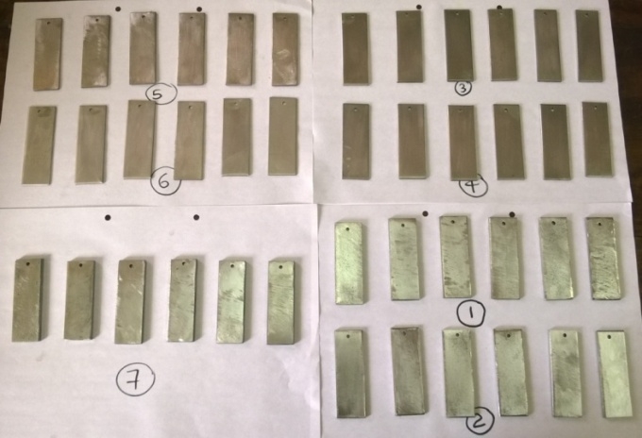

Figure 1. Prepared metal coupons

Each metal coupon was immersed in the relevant crude oil sample separately as three homogeneous metal coupons for each crude oil sample as altogether seven Murban crude oil samples and seven Das Blend crude oil samples. The setup of the samples has been shown in the Figure 2.

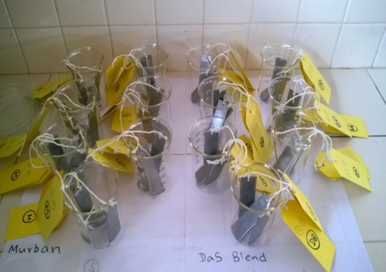

(a)

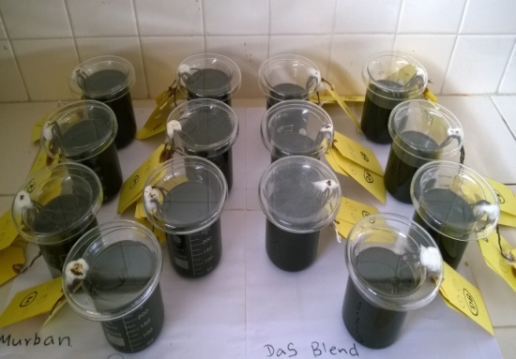

(b)

Figure 2. (a) Metal coupons and (b) sample set up

Fifteen days after wards the immersion one metal coupon from each crude oil sample was taken out as altogether fourteen metal coupons for the first batch. The corroded metal surfaces were observed by the 400X lens of the laboratory optical microscope and the corroded metal surfaces were cleaned by sand papers and isooctane as the necessity of the determination of the weight loss for further calculations of the corrosion rates by the weight loss method and the final weights of each metal coupon were measured by the electronic balance. The corrosion rate of each metal coupon was determined by the weight loss method which is expressed in the following equation 1 [10].

$CR=W*k /(D*A*t)$

Where W is the weight loss in of metal coupon in grams, k is the constant (22,300), D is the metal density in g/cm3, A is the surface area of metal piece (inch2), t is the exposure time (days) and CR is the corrosion rate of metal piece.

The same procedure was followed again for another remaining two batches of samples same as the previous batch samples in order of after thirty and forty five days from the immersion and their corrosion rates were determined by following the same method of weight loss as explained above. Finally the average corrosion rates of each metal type were determined with respect to the both Murban and Das Blend crude oils by the obtained results for the corrosion rates for each type of metals in order of fifteen, thirty and forty five days from the immersion.

As the qualitative analysis of the corrosion compounds and the surface changes of metal coupons the microscopic analysis component was annexed with this research. According to the scope of the research each metal coupon was observed under the 400X lens of the laboratory optical microscope initially and after formation of the corrosion on each metal surface based on following intents.

* Make a corrosion free metal surface before immersion in crude oils
* Identification of corrosion compounds qualitatively based on the visible features
* Confirmation of the corrosion free metal surface to determine the weight loss

Based on the observations of the invisible weight loss of some metal coupons during the determinations of the corrosion rates of such metal coupons the analysis of the decayed ferrous and copper amounts into crude oil samples from the metal coupons were tested by the atomic absorption spectroscopy (AAS). The decayed ferrous concentrations were tested in crude oil samples which were exposed to stainless steels and carbon steels also the decayed copper concentrations were tested in crude oils samples which were exposed to Monel metal. According to the methodology of sample preparation 1 ml of each crude oil sample was diluted with 9 ml of 2-propanol and filtered.

As a confirmation stage of the formation of the corrosion the variations of the initial hardness of metal coupons were tested by the digital Vicker’s hardness tester. The working principle and the hardness calculation method of the Vicker’s hardness tester have been shown in the Figure 3 and Equation 2.

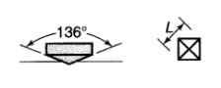

Figure 3. The indenter of Vicker’s hardness tester

$HV=1.854*\frac{P^{2}}{L^{2}}$

Where P is the applied load on the surface of metal, L is the diagonal length of square and HV is the Hardness.

According to the instructions regarding the operation of the instrument there were measured the hardness at least three points on the metal surface at once and the average value was interpreted as the hardness [1] [4] [5]. As the mandatory measurements the initial hardness and the hardness after formation of the corrosion were measured by the digital Vicker’s hardness tester and the average values were calculated with respect to the moments of the readings.

**3. Results and Discussion**

According to the obtained results for the analysis of XRF for the chemical compositions of selected ferrous metals the elemental chemical compositions of such metals have been concluded in the Table 2.

Table 2. Chemical compositions of selected ferrous metals

|  |  |  |  |  |
| --- | --- | --- | --- | --- |
| Metal | Fe (%) | Ni (%) | Cr (%) | Cu (%) |
| (1)Carbon Steel (High) | 98.60 | 0.17 | 0.14 | 0.37 |
| (2)Carbon Steel  (Medium) | 99.36 | - | - | - |
| (3) Carbon Steel  (Mild Steel) | 99.46 | - | <0.07 | - |
| (4) 410-MN: 1.8  420-MN: 2.8  (Stainless Steel) | 88.25 | 0.18 | 10.92 | 0.10 |
| (5) 410-MN: 1.7 420-MN: 1.7  (Stainless Steel) | 87.44 | - | 11.99 | - |
| (6) 321-MN:1.4  304-MN:1.9  (Stainless Steel) | 72.47 | 8.65 | 17.14 | - |
| (7)Monel 400 | 1.40 | 64.36 | <0.04 | 33.29 |

There were observed basically higher ferrous amounts in carbon steels, moderate ferrous amounts in stainless steels and the trace amount of ferrous in Monel metal. Especially when considering the chemical compositions of stainless steels there were observed the doping of some trace metals such as chromium, nickel and molybdenum based on the enhancements of some important mechanisms in such stainless steels rather than the normal ferrous metals as given in the below [1] [3] [4] [5].

* Enhancements of the strength
* Improve the durability and the hardness
* Reduce the corrosion rate/ enhance the corrosive protection strength

The obtained results for the analysis of corrosive properties of both Murban and Das Blend crude oils are shortlisted in the Table 3.

Table 3. Contents of corrosive compounds in both crude oils

|  |  |  |
| --- | --- | --- |
| Property | Murban | Das Blend |
| Sulfur content (Wt. %) | 0.758 | 1.135 |
| Salt content (ptb) | 4.4 | 3.6 |
| Acidity (mg KOH/g) | 0.01 | 0.02 |
| Mercaptans content (ppm) | 25 | 56 |

The obtained values for the organic acid contents in both crude oils showed Das Blend has higher corrosion ability than Murban because of the higher acid content approximately twice of the acidity of the Murban. Organic acids are the corrosive compounds that presence in crude oils since the occurrences of such crude oils [2] [9]. Usually it doesn’t require specific conditions to happen the chemical reaction in between the metals and crude oils also these organic acids are known as “naphthenic acids” which are having a general formula of RCOOH. In addition the organic acids are identified as the modification compounds of the chemical oxidation process of metallic destruction [1] [3] [15]. The general chemical reactions of the destructions of the metals due to the effect of organic acids are given in the following equations.

$Fe + 2 RCOOH → Fe (RCOO)2 + H2$

$FeS + 2 RCOOH → Fe (COOR)2 + H2S$

$Fe (COOR)2 + H2S → FeS + 2 RCOOH$

According to the obtained results for the salt contents of both crude oils the Murban had a higher amount of salts rather than the Das Blend. Basically there have been found NaCl, MgCl2 and CaCl2 as the salts that presence in crude oils since the occurrences of such crude oils [7]. In this experiment, the obtained values interpreted the summation of such salts in a particular crude oil. By referring obtained values for the salt contents of both crude oils there can be predicted the corrosive tendency of Murban crude oil than the corrosive tendency of Das Blend crude oil. Because salts are identified as a corrosive compounds that presence in crude oils and also a modification agent of the chemical oxidizing process on metals [1] [3] [5]. When increasing the temperature of the system such salts tend to reach with either water or steam and formed HCl molecules as shown in the following equations.

$CaCl2 + H2O → CaO + 2HCl$

Although at this stage it is impossible to find any corrosive tendency from such molecules because they do not have any electron affinity or releasing ability electrons due to the phase of individual molecules. When reducing the temperature of the system such HCl molecules tend to react with water or moisture in the crude oils and formed hydrochloric acids and hydrogen sulfide. Any way the effect of hydrogen sulfide is limited for short time period because hydrogen sulfides are in the phase of gas even though rush corrosive compounds [7]. Consequently the hydrochloric acids are remaining in the system for a substantial duration and cause a metallic corrosion while affecting the metals forever as shown in the chemical reaction that given in the below.

$HCl + Fe → FeCl2 + H2$

$FeCl2 + H2S → FeS + 2HCl$

The obtained results for the elemental sulfur contents and Mercaptans sulfur contents of both crude oils Das Blend crude oil was rich in both compounds rather than the Murban crude oil. According to the natural formations crude oils may be composed with some significant amounts sulfur because of the abundance of sulfur in the both earth crust and mantle of the earth. There were found that the presence in difference of such sulfur in crude oils such as the elemental sulfur, Mercaptans, hydrogen sulfides, thiophenes and sulfoxides also most of them are noted as highly corrosive compounds. Mercaptans are active sulfur compounds commonly nominated as the formula of RSH [2] [6]. The corrosive processes and required conditions related with such compounds are slightly different with type of functional groups of such sulfur compounds [8]. The corrosive process due to the Mercaptans and other active sulfur compounds of sulfur is known as the “sulfidation” which is extremely depending on the temperature and approximately required 2300C for the proper chemical reaction with higher productivity. Also the corrosive process due to the elemental sulfur is known as the “localized corrosion” similarly required some specific temperature approximately 800C for the proper chemical reaction [11] [13]. The general chemical reactions for the corrosion due to above processes have been given in the following equations.

$S8(s) + 8 H2O (l) → 6 H2S (aq) + 2 H2SO4$

$8 Fe + S8 → 8 FeS$

When considering the obtained results and the references together there can be predicted the effect of Das Blend crude oils on the corrosion rates of selected ferrous metals might be stronger than the effect of Murban crude oil because of the higher compositions of sulfur and organic acids since weaker in the salt content. Also there can be predicted the formation of FeS as the corrosive compound related with the observations of the current research because of the theoretical explanations of the formations of corrosion compounds on the relevant metals under each process.

The average values of the obtained results for the corrosion rates of metals in order of after fifteen, thirty and forty five days from the immersion with respect to both Murban and Das Blend crude oils have been shown in the Figure 4.

Figure 4. Average corrosion rates of metals in both crude oils

The above graph shows the relatively higher corrosion rates of carbon steels (high) and carbon steels (medium) in both Murban and Das Blend crude oils, moderate corrosion rates from mild steels and Monel in both crude oils and relatively in deficit corrosion rates from stainless steels in both Murban and Das Blend crude oils. When comparing the corrosion rates of stainless steels with other metals the corrosion rates of such stainless steels are significantly lower than the corrosion rates of other metals especially carbon steels. According to the chemical compositions of stainless steels there were found some amounts of nickel and chromium in such stainless steels. Regarding the doping of chromium and nickel with the stainless steels specially expected the corrosive protection because of the ability of the formation of the self corrosive protection layer on the relevant metal surface itself. The minimum chromium amount for the corrosive protection layer is ~12% with sufficient amount of nickel [1] [4] [5]. The least corrosion rates were found from 321-MN: 1.4 304-MN: 1.9 (Stainless Steel) which is having ~18% of chromium and ~8% nickel. The highest corrosion rates among stainless steels were found from 410-MN: 1.7 420-MN: 1.7 (Stainless Steel) which is having ~12% of chromium although lack of nickel. The intermediate corrosion rates among stainless steels were found from 410-MN: 1.8420-MN: 2.8 (Stainless Steel) which is having ~11% of chromium and ~0.2% of nickel. By referring these results there can be concluded the importance of both chromium and nickel for the protection layer against the corrosion properly within the recommended amount as at least 12% of chromium with sufficient amount of nickel as well. There cannot be expected the self corrosive protections from any metal when the nickel and chromium compositions are very low.

By considering the corrosion rates of metals with respect to both crude oils there were found their higher corrosion rates from four types of metals in Murban crude oil while other three types of metals were showing their higher corrosion rates in Das Blend crude oils. When comparing the corrosive tendency of both crude oils Das Blend was ahead in sulfur content and acidity although sometimes unable to show the corrosive behaviors properly. Therefore, it can be concluded the improper progresses of the “sulfidation” and “localized corrosion” at the lower temperatures and the higher corrosive tendency of salts rather than the corrosive tendency of organic acids in the normal environmental conditions by referring the obtained results for the corrosion rates of metals and corrosive properties of crude oils [6] [8] [9] [14] [15].

The obtained results for the corrosion rates of metal coupons in order of after fifteen, thirty and forty five days from the immersion with the exposure time to both crude oils have been presented as a sequence of the exposed time in the Figure 5.

(a)

(b)

Figure 5. Variations of the corrosion rates of metals with the exposure time in (a) Murban and (b) Das Blend

There were identified the most similar sequences regarding each type of metal with respect to both Murban and Das Blend crude oils. According to each sequence of corrosion rates with the exposure time period against the crude oils there were identified the reduction of the corrosion rate when increasing the exposure time. There can be concluded the validity of the inversely proportional relationship in between the corrosion rate and the exposed time to the corrosive environment as explained in the weight loss method [10].

According to the qualitative analysis of the corroded metal surfaces through the 400X lens of an optical microscope there were observed some of various features and such features were categorized and identified based on their visible properties such as the color and some specific surface features such as the cavities and cracks [1] [3] [4]. The most highlighted observations have been shown in the Figure 6.



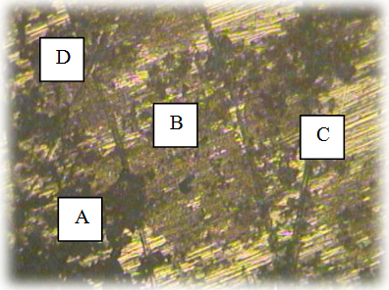

(a)



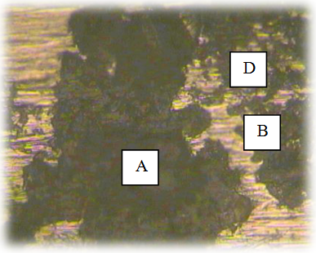

(b)



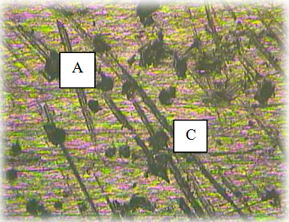

(c)

Figure 6. Corroded metal surfaces of (a) carbon steel (mild steel) in Murban (b) 410-MN: 1.8 420- MN: 2.8 (Stainless Steel) in Murban and (c) Monel in Das Blend

The foremost observations have been shortlisted below and the theoretical explanations have been given for that in the Table 4.

* A- Black colored cues on the metal surfaces in irregular shapes
* B- Rusty colored cues on the metal surfaces in irregular shapes
* C- Some cracks and cavities on the metal surfaces in irregular shapes
* D- Cavities on the metal surfaces

Table 4. Visible features on the surfaces of metals

|  |  |  |
| --- | --- | --- |
| Compound | Appearances | Observations |
| FeS | Black, brownish black, property of powder, pitting corrosion, cracks | Observed most of features in each metal piece. |
| Fe2O3 | Rusty color | Observed rarely. |
| CuS | Dark indigo/ dark blue | Unable to specify. |

According to the observations and the theoretical references of the corrosion compounds there can be concluded the formation of FeS in most of observations as explained in previous sections [1] [3] [4] [5]. Also there were observed the formations of Fe2O3 rarely on some metals. Usually crude oils are consisted with water and possible to be dissolved some amount of oxygen in crude oils at the room temperatures. Therefore, it is possible to cause the general oxidation process of metals with water and oxygen although regarding the crude oils it is rarely happened. When considering the observations thoroughly there can be predicted that the formations of CuS regarding the Monel metal only with the visible features of CuS. As a special thing some corrosion cracks and cavities were observed on some of corroded stainless steel surfaces apart from the dominant corrosion compounds. It is possible to suggest a compositional analysis of the corrosion compounds to distinguish each compound such as the X-ray diffraction (XRD).

(a)

(b)

Figure 7. (a) Decayed ferrous concentrations and (b) decayed copper concentrations into crude oils

As the conclusion of the obtained results of the analysis of the amounts decayed metals into crude oils the decayed ferrous concentrations into crude oils from the stainless steels and carbon steels and also the decayed copper concentrations into crude oils from the Monel metal have been shown in the Figure 7.

According to such results there were obtained higher ferrous concentrations in both Murban and Das Blend crude oil samples which were exposed to carbon steel (high) and carbon steel (medium) also found highest corrosion rates from such two types of metals. In addition some significant copper concentrations were found in both Murban and Das Blend crude oil samples which were interacted with Monel metal which was composed ~33% of copper since the ferrous composition was ~1.4%. Similarly there were not observed any amount of copper or ferrous in any crude oil sample which were exposed to any type of stainless steel or mild steel which were shown lower corrosion rates in both Murban and Das Blend crude oils. Also again possible to suggest the compositional analysis of such crude oil samples to identify the decayed form of relevant corrosion compounds such as the X-ray diffraction (XRD). As a result of the formation of the corrosion compounds on the metal surfaces such compounds tend to remove from the initial metal surfaces under the effects of attractive and repulsive forces between successive electrons and the protons. Therefore, it can be concluded the formations of the corrosion and the decay of metal into crude oils under such mechanism and also can be confirmed the formation of the corrosion [1] [3] [5].

The variations of the initial hardness of metal coupons after interaction with the crude oils have been shown graphically in the Figure 8.

(a)

(b)

Figure 8. Deductions of the initial hardness of metal coupons in (a) Murban and (b) Das Blend crude oils

There were observed slight reductions of the initial hardness of each type of metal after exposed to the crude oils while destructing the surfaces of such metals. After the formations of the corrosion compounds on the metal surfaces also possible to create some unstable conditions on such metal surface because of the hold the reins of some attractive and repulsive forces between the successive electrons and protons on the metal surface [3] [5]. Therefore, it can be concluded that there was a linkage between the formations of the corrosion and the reductions of the initial hardness of metals also confirmed the formation of the corrosion.

**4. Conclusion**

Based on the observations and obtained results that there can be concluded the higher contents of corrosive compounds in Das Blend crude oil than Murban and there cannot be expected the proper contribution from sulfur in the metallic corrosion at lower temperatures and the strength of salts in crude oils regarding the metallic corrosion is stronger than the strength of organic acids on the metallic corrosion. There were observed higher performances from the self corrosive protection layer above the chromium amount 12% with sufficient amount of nickel has been doped with that. The formations of FeS as the major corrosion compound with some corrosion cracks and cavities on the corroded metal surfaces with the effect of the corrosive background crude oils. The significant amounts of decayed ferrous and copper into crude oils from some metals which were shown higher corrosion rates and the deductions of the initial hardness of metals after the formation of the corrosion compounds on the metal surface.

**Acknowledgements:**

The author glad to commend on behalf of the great guidance of the supervisor, technical support from technical officers and the aids of laboratory staff members on the effectiveness of the research works.

**Corresponding Author:**

Mr. Suresh Aluvihara

Department of Chemical and Process Engineering

University of Peradeniya

Peradeniya, 20400, Sri Lanka

E-mail: [sureshaluvihare@gmail.com](mailto:sureshaluvihare@gmail.com)

**References**

1. Khana, O. P. (2009). Materials Science and Metallurgy. New Delhi: Dhanpet Rai and Sons publication.
2. Fahim, M. A., Alsahhaf, T. A., Elkilani, A. (2010). Fundamentals of Petroleum Refining. Elsevier, 516. doi: https://doi.org/10.1016/c2009-0-16348-1.
3. Calister, W. D. (2003). An Introduction of Materials Science and Engineering. New York: John Wiley and Sons, 820.
4. Davis, M. E., Davis, R. J. (2003). Fundamentals of Chemical Reaction Engineering. New York: McGraw-Hill.
5. Singh, R. (2006). Introduction to Basic Manufacturing Process and Engineering Workshop. New Delhi: New Age International Publication, 475.
6. Bolton, W. (1993). Engineering Materials Technology. Elsevier, 468. doi: https://doi.org/10.1016/ c2013-0-04622-1.
7. Ajimotokan, H. A., Badmos, A. Y., Emmanuel, E. O. (2009). Corrosion in Petroleum Pipelines. New York Science Journal, 2 (5), 36–40.
8. Speight, J. G. (1999). The Chemistry and Technology of Petroleum. Boca Raton, 934. doi: https://doi.org/10.1201/9780824742119.
9. Afaf, G. A. (2007). Corrosion Treatment of High TAN Crude. Khartoum.
10. Okpokwasili, G. C., Oparaodu, K. O. (2014). Comparison of Percentage Weight Loss and Corrosion Rate Trends in Different Metal Coupons from two Soil Environments. International Journal of Environmental Bioremediation & Biodegradation, 2 (5), 243–249.Usman, A. D., Okoro, L. N. (2015). Mild Steel Corrosion in Different Oil Types. International Journal of Scientific Research and Innovative Technology, 2 (2), 9–13.
11. , I. M., Elnour, M. M., Ibrahim, M. T. (2014). Study the Effects of Naphthenic Acid in Crude Oil Equipment Corrosion. Journal of Applied and Industrial Sciences, 2 (6), 255–260.
12. Ahmed [13] Rickard, D., Luther, G. W. (2007). Chemistry of Iron Sulfides. Chemical Reviews, 107 (2), 514– 562. doi: https://doi.org/10.1021/cr0503658.
13. Fang, H., Nesic, S., Young, D. (2008). Corrosion of Mild Steel in the Presence of Elemental Sulfur. International Corrosion Conference and Expo.
14. Bota, G. M., Nesic, S., Qu, D., Wolf, H. A. (2010). Naphthenic Acid Corrosion of Mild Steel in the Presence of Sulfide Scales Formed in Crude Oil Fractions at High Temperature. International Corrosion Conference and Expo.

9/21/2019