Modeling The Activities Of A Specialist In Physical Culture As The Basis For Improving The Educational Process

Khudayberganov Otabek Erkinovich

Urgench State University, 220100, Khorezm Region, Urgench City, Kh. Alimdjan Street, 14
Phone: (998-62) 224-67-00, Fax: (998-62) 224-66-16, Web-site: www.urdu.uz

Abstract: The article discusses the issues of improving the educational process by building a structural model of the activities of a specialist in physical education, as well as the impact of various sports on the formation of pedagogical skills.
[Khudayberganov Otabek Erkinovich. Modeling The Activities Of A Specialist In Physical Culture As The Basis For Improving The Educational Process. N Y Sci J 2019;12(9):10-13]. ISSN 1554-0200 (print); ISSN 2375-723X (online). http://www.sciencepub.net/newyork. 3. doi:10.7537/marsnys120919.03.

Keywords: professional activity, professional skills, training model, constructive activity, communicative activity, organizational activity, gnostic activity, motor activity, physical education.

Introduction.
The problem of improving higher education, modeling the activities of a specialist has long been under the scrutiny of many scientists. The analysis of scientific works devoted to the development of models of specialists in physical education and sports allows us to conclude that the activities of the physical education teacher and trainer in the chosen sport are multifunctional.
I.N. Resheten's, V.M. Koretsky's (1982), G.S. Tumanyan's (1987), A.Ya. Korkh's (2000), R. S. Salamova's (2004), A.N. Abdieva' s (2004) researches are devoted to the studies of problems of the activities and training of specialists in physical culture ad sports.
Based on the fact that pedagogical activity in the field of physical culture and sports can be considered as a complex system-structural education with specific functions and relationships, an approach to the study of the functional activities of specialists with higher education should be based on a system-structural analysis and expert assessment method (3). The systematic approach is based on the combination of the studied objects in aggregate, the establishment of properties and relationships within it, as well as on the identification of factors most important for achieving the goals. In turn, mathematical and statistical methods of expert assessments make it possible to determine the quantitative relations between the dependent and independent variables characterizing the object of study are of significant interest for the study of the educational process, as they ensure the accuracy of judgments, their evidence, which is lacking in pedagogical science. The main content of this work is devoted to the issue of improving the educational process by constructing structural, activity models of physical education teachers, while the model is a number of qualities ranked by importance that are necessary for highly professional teachers. It is the definitions for the above profession of the importance of qualities representing knowledge, abilities and skills that, in our opinion, can serve as a tool that provides specialized, in-depth training for students of pedagogical universities studying at the faculties of physical education for their upcoming work activities.
The aim of the work is to build such a model and on its basis the development of specific recommendations indicating ways to improve the educational process for the implementation of a differentiated approach in the training of specialists with higher physical education.
The objectives of the study. To identify the content and components of the professional activity of a specialist in physical education, to determine their relationship and interdependence.
These skills were offered to the leading teachers of the physical education departments of pedagogical universities, as well as the Uzbek State Institute of Physical Culture for examination by the method of preference. The purpose of the examination was to identify the most important qualities that comprehensively reflect the essence of the professional activity of specialists with higher physical education, as well as determine the degree of influence of sports specialization on the formation of professional skills of a teacher in physical education. As a result of processing expert assessments, the dominant skills that received the most points were highlighted. These skills, according to the classification proposed by N.V. Kuzmina (1973), were

divided into 5 functional groups of professional and pedagogical activity: communicative, gnostic, motor, constructive, organizational.
The constructed model of the activity of a specialist with higher education working as a physical education teacher included three models: specialist training model based on the opinions of IV year students who have completed pedagogical and practical training; the current model, based on the opinions of students of the faculty of continuing education, with at least 5 years of practical experience; perfect model based on the views of the faculty of the departments of physical education of pedagogical universities.
The expert opinions of each group were checked for consistency by calculating the coefficient of concordance. The level of agreement among experts of each group turned out to be quite high (W = 0.79).
Each of the constructed models is a complex structure, the links of which are 5 main types of activity of specialists working in the field of physical culture and sports: constructive activity, communicative activity, organizational activity, gnostic activity, motor activity. Of course, the structure of the activity of the teacher of physical education is much more complicated and ramified. But in this study, only the narrowly professional side of the activity of this specialty is considered.
In order to check whether they are different from each other and to what extent the links of the constructed model was used H-criterion by the Kraskel-Wallis (1). Comparisons were made for each link of structural models, which is a variety of professional activities.
As a result of the calculation, the following H values were obtained:
1) constructive activity H = 3.96; 2) communicative activity Н = 1,665; 3) Gnostic activity H = 1.527; 4) organizational activities H = 0.775; 5) motor activity H = 0.985.
A comparison of the calculated values with the tabulated values allows us to draw the following conclusion: since all the calculated values of H are less than the tabulated values of the H-criterion, the null hypothesis that the samples belong to the same general population is rejected and the alternative hypothesis is accepted: the considered samples are significantly different from each other. This means that the constructed models are significantly different.
Specialist models require a holistic analysis of the internal structure of his professional activity. Every holistic education has its own content and structure. Content is the totality of those elements and processes that make up the basis of objects, and structure is a regularity, stable connection and interconnection of parts and elements of the whole, system (3).
To study the content of a certain professional activity, it is necessary to identify not only the totality of its components, but also to reveal their relationship and interdependence. To do this, it is necessary to establish how the links within each model correlate with each other, whether there is any regularity of connections between different types of activity.
To calculate the degree of interconnection within the models, the Spearman rank correlation coefficient was used (2). Using calculations, the values of the correlation coefficients are determined within the models of professional activity of a teacher of physical education (pic.1).
The data presented reflecting the nature of the relationship of activities within the training model, the current model and the ideal model of a teacher of physical education, reveal a complex system of links of professional activity. The presence of negative values of the correlation coefficients indicates that various types of activities have in practice completely independent opposite methods of implementation, requiring specific skills.
Speaking about modeling the activities of a specialist in order to improve the process of his training at the university, it is necessary to determine what will be the standard - the current model, the ideal or the training model.
Based on the fact that university training is the best way to prepare a specialist for the upcoming practical activities, we believe that the current model is the reference model, built on the basis of opinions expressed by students of continuing education courses. Comparing the students' opinions (training model) with the reference model, it is possible to establish what disadvantages exist in the educational process of the physical education departments of pedagogical universities. After analyzing the opinions expressed by teachers of the departments of physical education, ways can be found that make it possible to eliminate these shortcomings.

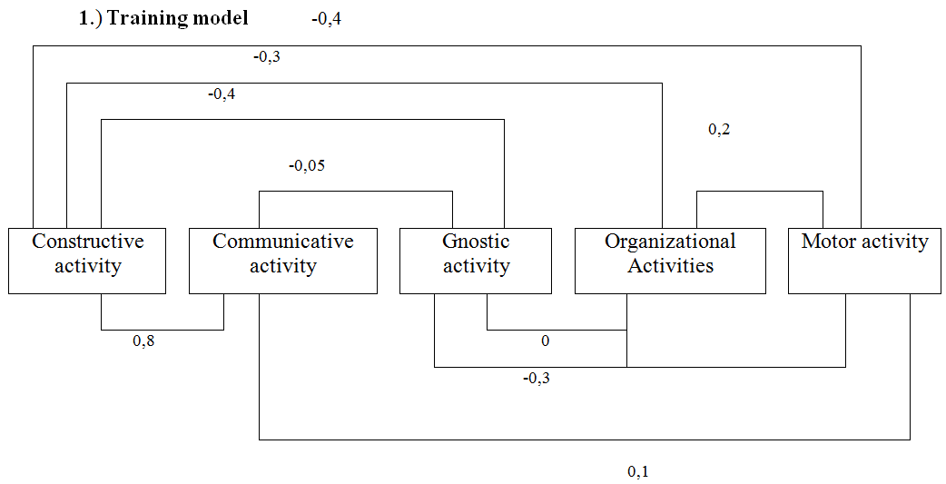

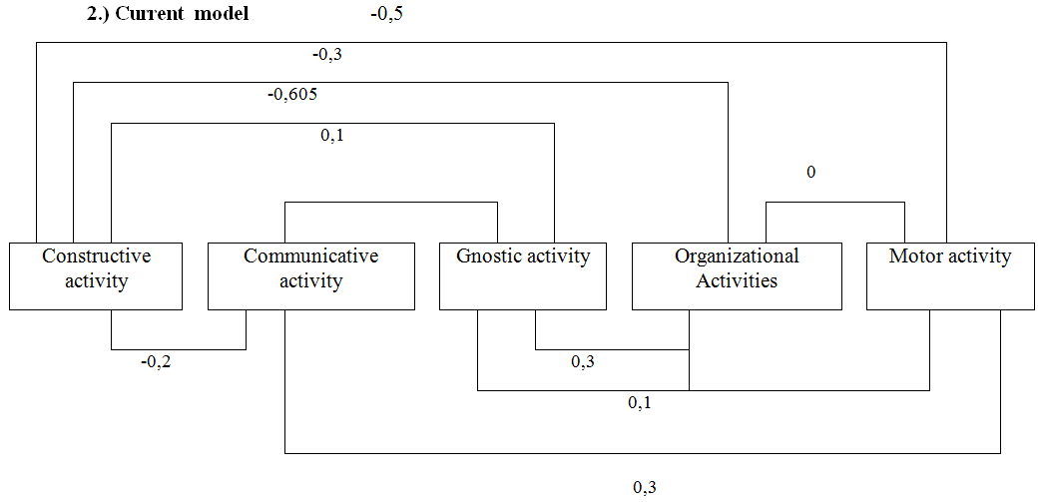

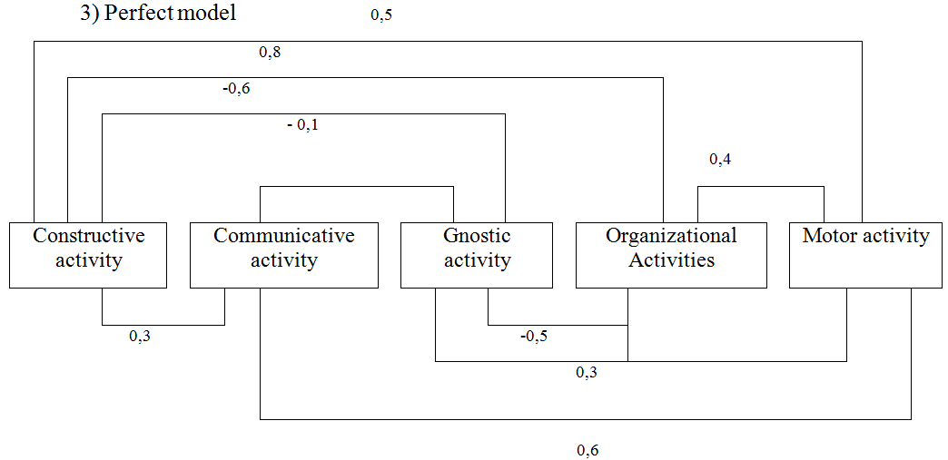

Analyzing the results of a survey of experts on the degree of influence of various sports on the formation of pedagogical skills, we consider it necessary to note the following: the most formed professional qualities and abilities in sports games marked the will to win (4.97 b), activity (4.85), self-control (4.68 b.), endurance, determination, industriousness, sense of duty, sociability. In complex coordination sports, 100% of respondents put in the first place a creative attitude to business (5.00 b.), then responsibility (4.93 b.) and hard work (4.93 b.). Survey participants, who specialize in martial arts, highlighted the will to win, stress resistance and activity, representatives of cyclic sports - industriousness (5.00 b.), Will to win (4.86 b.), Perseverance (4.82 b.) and shutter speed (4.82 b). It was revealed that, when engaged in sports games, in comparison with other sports, pedagogical abilities, strong-willed, intellectual and psychophysiological qualities are formed to the greatest extent. Thus, the opinion expressed by the majority of experts and researchers about the legitimacy of the question is confirmed that there is a difference in the influence of various sports on the formation of necessary professional skills.

Conclusion.
The results of the research are as follows: a model of a physical education teacher is built, consisting of three models: a training model, an operating model, and an ideal model. Within each model, there is a complex structure of inter-link dependencies. Comparison of indicators of the training model with the characteristics of the current model revealed shortcomings in the professional training of students of the faculties of physical education identified the causes and specific ways to address these shortcomings.

References
- Saks L. Statistical evaluation. - M.: Statistics, 1976.
- Zatsiorsky V.M. Sports metrology. - M.: Fi S, 1982.
- Kolotilova I.M., Taranova A.V., Malikhina L.A. Functional characteristics of the "models" of the university teacher. - Tashkent, 1987.
- Korkh A.Ya. Trainer: Activity, personality: Textbook. - M.: Terra - Sport, 2000.
- Resheten I.N., Kargopolov B.G. The problem of personality models, activities and training of a specialist in physical education and sports // Theory and practice of physical education. - No. 11. - 1982.
- Tumanyan G.S. Improving the system of physical education // Method. Recommendations. - M. SCMLIPhC, 1987.

9/2/2019

