**Indirect Vector Control of Induction Motor by Adjusting PI Parameter Using Genetic Algorithm**

Mehdi Akbarpour 1, Hamed Sadeghi 2, Mohammad Lohi 3, Hosein Khalilifar 4

1. Department of Electrical Engineering, Minab Branch, Islamic Azad University, Minab, Iran

2. Department of Electrical Engineering, Astara Branch, Islamic Azad University, Astara, Iran

3. Hormozgan Electrical Power Distribution Company, Hormozgan, Iran

4. [Nima](mailto:mohammadlohi@yahoo.com) Consultant Engineering Company, Mazandaran, Iran

[akbarpourmehdi@gmail.com](mailto:akbarpourmehdi@gmail.com)

**Abstract:** Entering alternating rotary electrical machines such as induction motors, electrical drivers industry have changed. They changed so much that despite of DC motor drivers, they had low control. Complicated structures and were used for fixed speed uses. With development of engineering science and the theory of vector control in drive industry, the industry developed basically and gradually they were good substitutions for DC drivers in a wide range. In this paper, we’ll study indirect vector control ways. Here, we try to improve the function of this control method by an improving method so that by getting controlling coefficients of drive speed, better results will be got. Genetic which was figured based on the best factors and controlling coefficients of PI set using it, was used in this case which proves the better function of the system. Genetic algorithm considers the decrease of speed error integral and gets proper parameters for PI current controller in different loading conditions.

[Mehdi Akbarpour, Hamed Sadeghi, Mohammad Lohi, Hosein Khalilifar. **Indirect Vector Control of Induction Motor by Adjusting PI Parameter Using Genetic Algorithm.** *N Y Sci J* 2019;12(8):81-90]. ISSN 1554-0200 (print); ISSN 2375-723X (online). <http://www.sciencepub.net/newyork>. 12. doi:[10.7537/marsnys120819.12](http://www.dx.doi.org/10.7537/marsnys120819.12).

**Keywords:** PI current controller; induction motors; indirect vector control; genetic algorithm

**1. Introduction**

Today, significant power electronic developments, automation and processing provides the uses of AC drives in different industrial processes. Control with the orientation of induction motor fields is better than other controlling techniques with changing frequencies. Here, induction motor act like DC motors. So, AC drives controlled in this method are good substitutions for DC motors in variety of uses (Leonhard, 2006). In the past, using DC motors was common in works requiring accurate speed because the armature of field was separated from the and because of independent control of transformation specially in DC motors causes a wide range of speed and dynamic reactions (Vas, 2000). But these motors have some problems and disadvantages too mainly because of Commutator and brushes (Leonhard, 2006). Regular services and inspections, function limit and short lifetime of Commutator and brushes in too light or too heavy loads are the problems and disadvantages (Boldea, 2002) We can deal with and overcome these problems by using alternative current motors. These motors are cheaper power, simple structure, strong, firm and assured can’t work. What limits AC motor in control which is too complicated, multi variation and non linear and not economical. Development of semi conductors and electronics drive and it is predicted that these drives will be cheaper in future and high speed and cheap microprocessors will be used in vector controls of AC drives instead of DC drives (Leonhard, 2006; Krishnan, 2002). Using vector control techniques of transformation will be possible and responding features of AC machines will be similar to DC machines (Leonhard, 2006). But provided different from DC machines. According to this method, the phases of stator current will be possible into two elements of flux producer and torque in AC machines and responding features of AC machines will be like DC machines. But despite DC machines which control of the size of armature and field current is decoupled enough, in AC machines the frequency, phase and the size of stator current are vertical and fixed because of Commutator and brushes, while in AC machines, the vectors of current phasor, flux and magnetic fields are dynamic and control of size and position is outside the motor by an inverter (Leonhard, 2006; Vas, 2000; Boldea, 2002). So, different inverters are used to control these motors like current source inverters, voltage source inverters and Cycloconverters. Because of the reasons above, taking apart of vector control of induction motors is more complicated than DC motors.

In vector control technical, the reference frame can be applied in the same direction with rotor flux and stator flux or magnetic flux which each of them has its advantages and disadvantages so in references, their strength and weaknesses and the manner of permanent and temporary response mode and level of sensitivity based on parameter changes have been studied (James, 2005; Mathew, 2005).

The analysis of induction motor actions controlled by vector method is possible in two techniques. First, using a real machine and an inverter and a vector controller which its algorithm is coded on a microprocessor or microcontroller in the C language, induction motor function will be studied. Second, simulating the system and cheaper than first method (Krishnan,2002; Tsai Pan, 2003).

Second method has some advantages like it is reachable, easily observable the system optional fluctuations, testing the machines without other extra machines or equipment. While practical tests are expensive and time consuming and maybe impossible (Krishnan,2002).

**2. Material and Methods**

**2.1. Indirect vector control**

Difference between indirect vector control and direct type is the way unit vectors production. At direct way, unit vectors are produced by charge signals. At indirect way by means of signals, speed  and slip frequencies  are counted. (Figure 1) shows slip vectors diagrams at the state of indirect vector control. Vectors qs – ds are stable and vectors qe – de are cycling which turn at synchrony. Angle , is expressed by sum of rotor angle  slip angle . In order to reviewing the way machine function at the state of indirect vector control, we consider the rotor charge equations by equivalent axis q. d of inductive motor at revolving reference frame (Vas, 2000; Boldea, 2002).

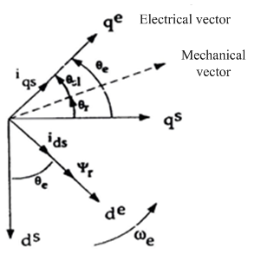

Figure 1. Vector diagram at the state of indirect vector

 (1)

 (2)

Now according to vector diagram at fig. 1 and this fact that axis vector control de is over lapped rotor charge vector, so we an express:

 (3)

 (4)

 (5)

If we place above values eq.1 and 2, we have:

 (6)

 (7)

Now by means of torque relation and according to this fact that at the state of vector control certainly, charge value along with axis q equals zero, we will have:

 (8)

 (9)

(Figure 2) shows the way of indirect vector control for a situation controller system, closed links of situation control and speed at the diagram, is seen which at the first step, situation error is crossed to controller PI and output is equivalent with reference speed  and at the second step, again the speed error is crossed to controller PI and then to a restrictor and output is equivalent with reference current on the revolving axis q as iqe*s (Dumitrscu, 2009).

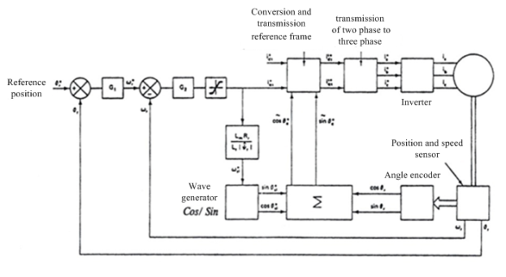

Figure. 2 Indirect vector control a induction motors

Value of reference current on the revolving axis d as ide*s is accounted by means of Equation (10).

 (10)

Also value of reference slip  is accounted by Equation (10).

At the next step, by value of rotor speed and slip, value and is accounted  as revolving domain situation angle, and then will be accounted values of unit vector , . Measures related to reference currents modification from revolving from reference to constant and then modifying currents from two-phase system to three-phase system are similar to indirect vector control.

Indirect vector control can work well at four areas of speed torque. This way works well at low velocities and near to zero. At this way, problem of harmony existence at signals causing disturbance in indirect way, don’t have subjectivity. Main problem in this way is change of machine parameters causing the disturbance at estimation of reference slip and finally it leads to becoming coupled of variables and as a result, the system go out of the state of vector control.

**2.2. Optimization of suggestive model by using of Genetic algorithm**

In this paper, the optimization of suggestive model is accepted by using genetic algorithm.

Genetic algorithm is applied for optimization:

The first step: 1) The production of initial population from chromosomes which all of the chromosomes provide constraints, 2) Set the repetition number equal to 1.

The second step: 1) Calculation of the value of objective function, 2) Calculation of the amount of sufficiency, 3) Selecting elite.

Third step: Reproduction by means of increasing and spring with introduced procedure.

Fourth step: 1) Consideration the constraints: if constraints aren't provided by a chromosome, that part of chromosome, which over step from the free bridle is produced accidently than that constraint will be produce finally, 2) edit the repetition number: If the repetition number is smaller than its maximum, it goes to second step, if not, goes to fifth step.

Fifth step: the result of optimization.

Regarding to the explained stages, the flowchart of optimization by using genetic algorithm is as (Figure 3).



Figure 3. Flowchart of optimization by using of genetic algorithm

**2.3. Control of inductive motor with adjusting parameter Pi by means of genetic algorithm**

At (table 1), features of simulated inductive motor drive have been shown.

Table 1. Simulated inductive motor parameters

|  |  |
| --- | --- |
| Parameter | Value |
| Power | 2.5 Kw |
| Phase Number | 3 |
| Voltage rated | 220V |
| Stator resistance | 3.55 ohm |
| Flux rated | 0.965 Weber |
| Stator inductance | 0.01 H |
| Rotor inertia | 0.002 Kg m2 |
| Pole | 4 |
| Frequency | 50 Hz |
| Speed rated | 1400 rpm |
| Rotor resistance | 1.8ohm |
| Magnetizing inductance | 0.3016 H |

In this section the optimum operation stages of suggestive model on a sample model is done for different parameters and the result of optimization are studied.

Also a comparison is done among the different states of optimization and finally the function of obtained answers for different parameters of model is considered. At first, by means of inductive motor equations, we simulate motor at stable reference machine. At low speed functions and also at situation control, using flux sensors because of integral errors at these sensors didn’t show satisfactory results. Fashionable alternative in this state is indirect vector control which don’t uses direct measure of air gap flux, but in order to track revolving field suitably, satisfy conditions for following equations.

Torque with adjusting current  and slip speed  is controllable. Also rotor flux with adjusting current is controllable. Necessary flux  and current  is accounted at following equation.

 (11)

For alternative torque  with produced roto flux, wanted value  equal with:

 (12)

Equation (12) is shown that with suitable tracking, we can set  equal with zero and . So we can slip speed equation as Equation (13):

 (13)

Separation at rotor voltage equation is reached by above conditions which its accuracy is based on measure of rotor parameters (T. K. Teng, 2003). At inductive motor, because rotor resistance values and magnetization inductance changes more than other parameters, we can use simultaneous collation techniques for adjusting variable parameters of motor. (Figure 4) shows indirect vector control for an inductive motor stimulant by hysteresis inverter controlled with current.

Angle of field direction  is measured from sum of rotor angle  and angle . Values of  and  are accounted by Equation (14).

 (14)

As we can see from diagram block of fig.4, speed error enters to speed controller. According to mentioned matters about indirect vector control, speed controller output is reference torque an as a result of Equation (12), produce current  at revolving flux rotor. On the other hand rotor reference flux according to flux reduction at high velocities has been generated from a flux restrictor and according to Equation (11) generates the reference current  at revolving rotor flux reference system. Also with regards to speed measurement and slip angle, we take the reference current works at rotor revolving flux system toward stable reference system and according to park conversation, stator three-phase works are generated. These reference three-phase current enter to an hysteresis inverter, so switching of the stator phases is done.

**3. Program Exit and Analysis of Results**

In this paper we use (Figure 5) and f0llowing results are represented.

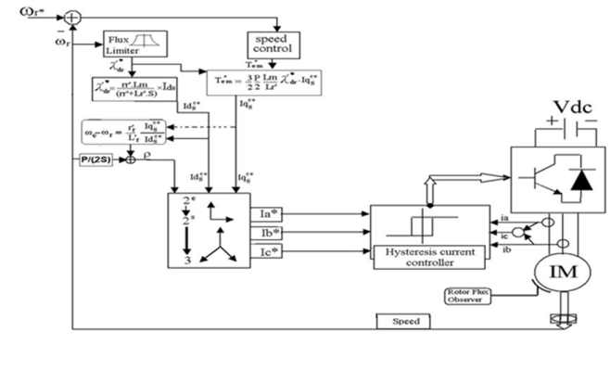

Figure 4. Indirect vector control in a three phase inductive stimulant (IM)

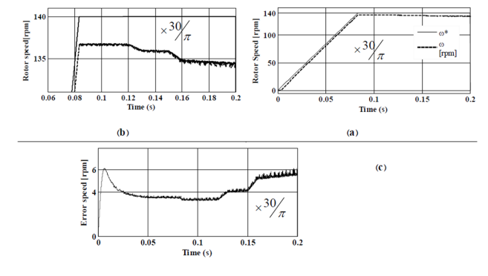

Figure 5. Chart related to rotor speed, by mean of controller lead-lag without optimal adjustment

As is seen at (Figure 5), system followed its reference as fairly suitable. However there is error of steady state considerably. Existence of steady error can be result of lock of suitable adjustment of controller coefficients. Indeed because of loading on the motor, is seen the velocities drop at those times.



Figure 6. Electromagnetic torque chart



Figure 7. Stator phase current chart

At the figure of (6) and (7) we can observe chart related to phase sinusoidal current of inductive motor phase and also related torque chart. Load torque at different times changed which result of system function is seed at figure related to torque.

(Figure 8) show the chart related to rotor flux which didn’t change with load changes and moves toward damping.

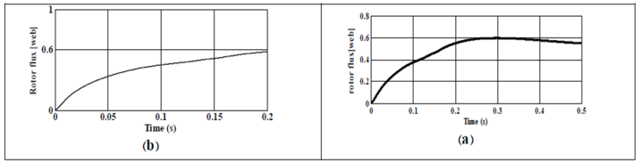

Figure 8. Magnetic flux chart of rotor

Also (Figure 9) show output voltage chart of inverter phase forced to stator phases.

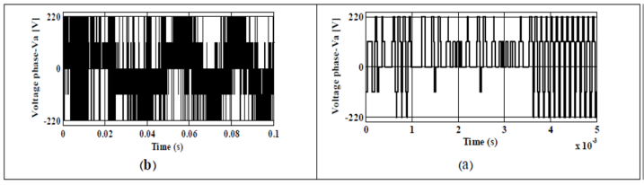

Figure 9. Output voltage chart of inverter phase forced to stator phases

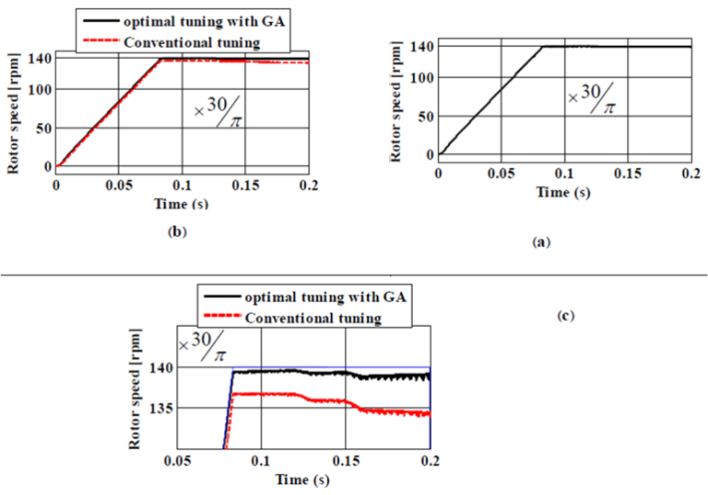

Figure 10. Chart of inductive motor speed drive

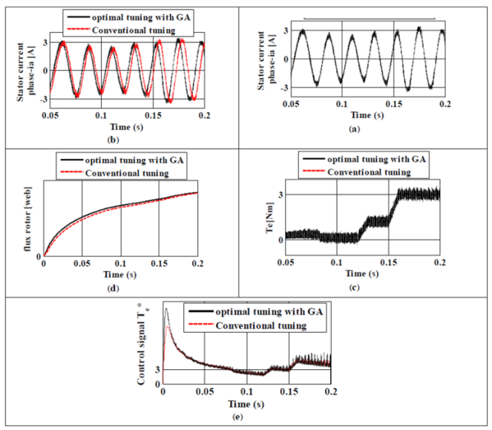

Figure 11. A & b) stator phase current of inductive motor drive, c) electromagnetic torque, d) rotor magnetic flux e) controller output signal (reference torque)

Now with exercising genetic optimization algorithm to controller lead-lag speed, we repeat results of motor function for above conditions. Exercised genetic algorithm has 20 generations, 18 chromosomes and 2 genes. Each gene representing an optimization parameter has 24 bits. For encoding the chromosomes and genes have been used logical encoding based on 2. We considered the integration coefficient as 0.5 and spring coefficient as 0.15. These two parameters have been regarded for optimization of controller coefficients lead-lag.

In order to observe and compare the results of adjustment of speed controller coefficients lead-lag at following charts, both of two related wave shapers, were (Figure 10).

a) by GA optimal adjustment b & c) comparison with lead-lag without GA optimal adjustment.

As we can see from above charts, control system by means of coefficients adjustment with genetic algorithm, follow the speed reference optimally. As at the end of speed chart, its error is moving toward zero. These charts at third figure along with speed chart related to non optimal controller have been drowning. As we see, by adjustment of coefficients as optimal system has a desirable function.

(Figure 11) is related to magnetic flux. As we can see, when using GA, this chart received partial improvement, although at both of two experiment states, flux control system didn’t change. Finally, F is objective function and H (s) is speed control converter function.

b=[1.6368]; a=[0.28712], Best Value of object function (cost) = 0.087



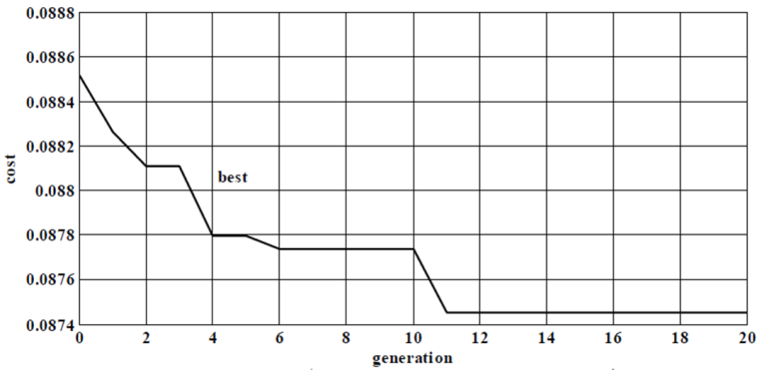

Figure 12. chart procedure of GA optimization

(Figure12) is about certainty of optimization algorithm function and as we can see, at very generation, a better response was received and finally the curve leaded to saturation. This topic shows the best response.

Now the results for controller PI, H (s) are represented according to following cases:

Best Value of object function (cost) = 0.011394730015



Population size = 18 mutrate = 0.15 # par = 2# generations=20 best cost=0.011394730015

Best solution: a=3.9985 & b=3.9498

Binary genetic algorithm each parameter represented by 24 bits.

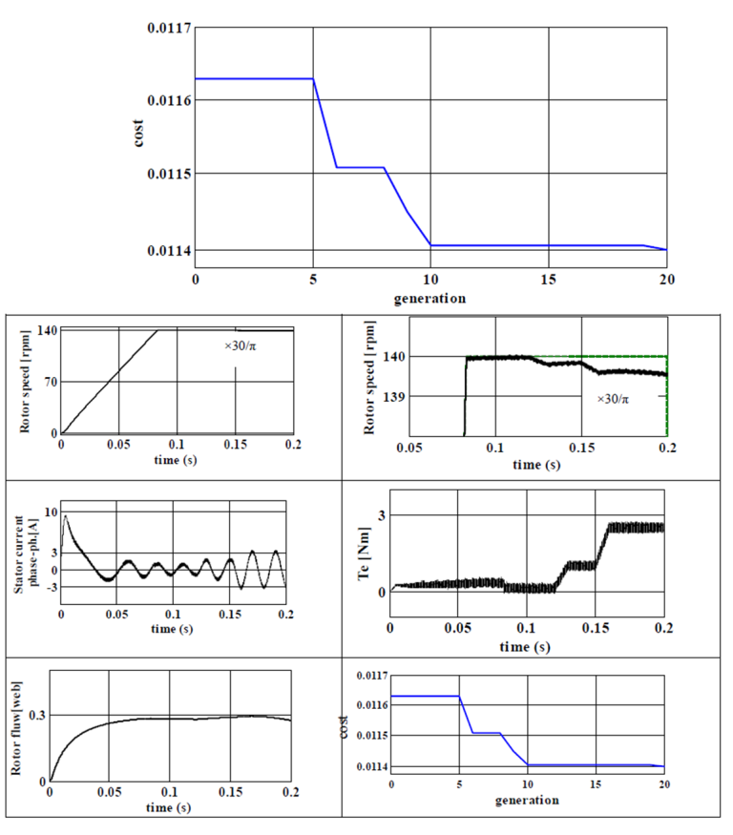

Figure 13. charts related to indirect vector control of inductive motor drive, with controller PI adjusted to GA

At continue in order to review the results exactly, charts produced from simulation are represented at 2 seconds simulation.

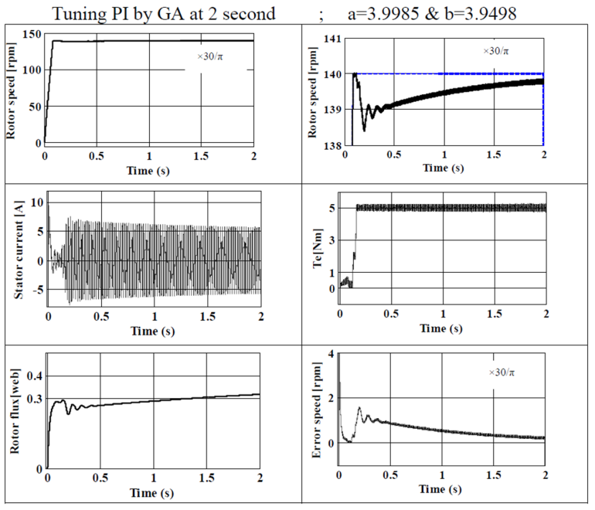

Figure 14: chart produced from simulation at the state of adjustment by means of GA

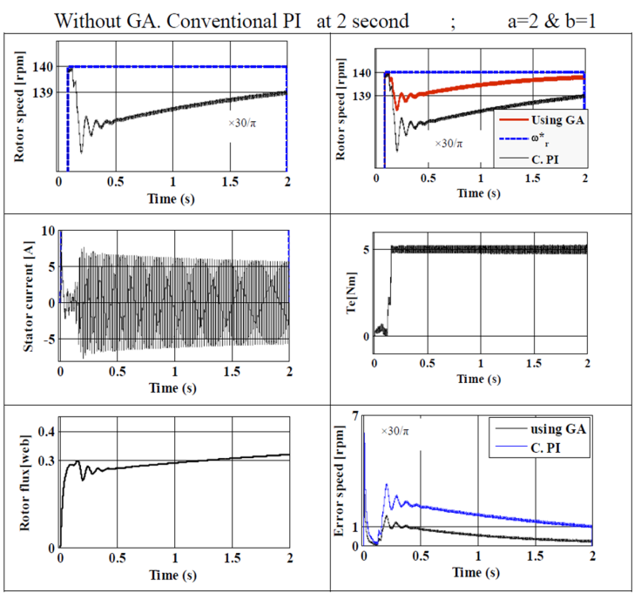

Figure 15. Charts produced from simulation at state of manual adjustment of controller coefficients

The survey results in the form of (Figure 14, 15) are show, its comes on every control state error due to the Integrator will eventually goes to zero. But as we can see, speed chart at time of using the optimal adjustment of have distortion with tower range and higher damping speed.

**4. Conclusions**

In this paper it is presented asynchronies drives at industrial applications were considerable because of its specific advantages besides of these advantages subject of their control for researches was very important. Indirect vector control is one of the suitable ways responses to applications of these electrical drives. This control way act based on vector control base at low velocities, response to itself function desirably. This control way which has low cost, needs to suitable adjustment of coefficients of controller PI. In this paper by means of genetic algorithm, this adjustment was done which caused to function improvement. As we saw in experiments related to coefficients adjustment, at the time of doing genetic algorithm, many changes at load torque were generated which thus produced coefficients for different changes during ordinary function of drive as average are suitable. Although at the procedure of doing optimization algorithm of changes, any coefficient caused to change of control process quality. Using of optimization algorithms is done as off line.

**Corresponding Author:**

Mehdi Akbarpour

Department of Electrical Engineering, Minab Branch, Islamic Azad University, Minab, Iran

E-mail: [akbarpourmehdi@gmail.com](mailto:akbarpourmehdi@gmail.com)

**References**

1. W. Leonhard. ( 2006). Control of Electrical Drives. Springer-Verlag, Berlin.
2. P. Vas. ( 2000). Vector control of AC machines. press Oxford.
3. I. Boldea, S.A Nasar. ( 2002). Vector Control of AC Drives. CRC Press, London.
4. R. Krishnan. ( 2002). Electric Motors Drives Modeling Analysis and control. Publication Prentice Hall of India.
5. James A. norris. (2005). motion control specialist warner Electric/seco Electronics. Division Lancaster, P.P. 1-8.
6. R. Mathew, D. Houghton, & W. Oghanna. (2005). Vector Control Techniques for Induction. IEEE, P.P. 813-818.
7. A. Dumitrscu, Denes Folder, & T. Jokinen. (2009). Modeling and Simulation of Electric Drive Systems using Matlab/Simulink Environments. IEEE, P.P.451-453.
8. A. Dumitrscu, Denes Folder, & T. Jokinen. (2009). Modeling and Simulation of Electric Drive Systems using Matlab/Simulink Environments. IEEE, P.P.451-453.
9. R. A. Krohling, J. P. Rey. (2001). Design of optimal disturbance rejection PID controllers using genetic algorithms”, IEEE Transactions on Evolutionary Computation, Vol. 5, pp. 78-82.
10. T. K. Teng, J. S. Shieh. (2003). Genetic algorithms applied in on-line auto tuning PID parameters of a liquid control system. Transactions of Institute of Measurement and Control, Vol. 25, pp. 433-450.

8/16/2019