Effects of Metformin on Serum Insulin, Anti-Mullerian Hormone, Androgen Levels and Ovarian Ultrasound Appearance in Patients with Polycystic Ovarian Syndrome

Abd Elmonem Mohamed Zakria¹, Mohammed Elsayed Hammour¹, Mekky Abd Elmonem Ali², Mohamed Sobhy Mohamed Ali¹

¹Obstetrics and Gynecology Department, Faculty of Medicine, Al-Azhar University, Egypt
²Clinical Pathology Department, Faculty of Medicine, Al-Azhar University, Egypt

Abstract: Objective: Evaluate the effect of metformin on serum insulin (fasting and 2hr postprandial), androgens (total and free testosterone, DHEAS and SHBG) and AMH in PCOS patients at 3 and 6 months interval. Design: Prospective study Setting: Damn hour teaching Hospital, Obstetrics and Gynecology Department. Patients: 50 hyperandrogenic PCOS patients. Interventions: 1700 mg metformin was given for a period of 6 months; serum insulin, previously mentioned androgens and AMH were measured at baseline, 3 months and 6 months of treatment. Main outcome measure: serum fasting and 2 hrs. postprandial insulin and glucose levels, insulin resistance, serum total and free testosterone, DHEAS and SHBG and serum AMH. The impact of treatment and biochemical changes on menstrual regularity, clinical manifestations of hyperandrogenism, ovarian morphology and fertility. Results: Metformin treatment produced a significant reduction in insulin, serum androgens and AMH levels. 62% of the patients had improvement in their cycle regularity and 2 out of 50 patients had spontaneous pregnancy. However, there were no improvement in hyperandrogenic manifestations or change in ovarian morphology. Conclusion: Metformin as an insulin sensitizing agent improved insulin resistance in PCOS patients and improved biochemical but not clinical hyperandrogenism. Metformin produced significant reduction in AMH levels and modest improvement in cycle regularity; but no change in the ovarian morphology. Metformin could not be used for the treatment of hirsutism or in improving fertility in PCOS.
[Abd Elmonem Mohamed Zakria, Mohammed Elsayed Hammour, Mekky Abd Elmonem Ali, Mohamed Sobhy Mohamed Al. Effects of Metformin on Serum Insulin, Anti-Mullerian Hormone, Androgen Levels and Ovarian Ultrasound Appearance in Patients with Polycystic Ovarian Syndrome. N Y Sci J 2019;12(7):21-32]. ISSN 1554-0200 (print); ISSN 2375-723X (online). http://www.sciencepub.net/newyork. 4. doi:10.7537/marsnys120719.04.

Keyword: PCOS-AMH-ACTH-DHEA- AE-PCOS

1. Introduction
Polycystic Ovary Syndrome (PCOS) is the most common endocrinological disorder affecting 4-12% of reproductive aged women (Diamanti-Kandarakis et al 1999). It has also been the most medical condition that caused a lot of controversy in its every aspect (Lashen 2010).
PCOS is a disorder with a combination of reproductive and metabolic characteristics (Lashen 2010). Diagnosis of PCOS should include at least two of the following features: oligo/anovulation, hyperandrogenism and enlarged ovaries with multiple follicles ranging in size from 2-10 mm by ultrasound scan ESHRE/ASRM, 2004).
However the Androgen Excess Society recommends that androgen excess should remain a constant feature of PCOS, regardless of the morphological appearance of the ovaries and their ovulatory function (Azziz et al, 2006).
PCOS is a life course disease, that in addition to its reproductive impact, it has long term effects with the risk of developing Type II Diabetes mellitus and the metabolic syndrome (Apridonidze et al, 2005) as well as cardiovascular disease (Grundy, 2002).
Insulin resistance is a condition characterized by hyperinsulinemia secondary to failure of the target cells to respond to normal or ordinary levels of insulin (Le Roith and Zick, 2001). IR has been linked to the pathogenesis of PCOS through the effect of hyperinsulinemia on increasing serum androgen levels via a central role (Barbieri et al, 1986) or by decreasing the circulating levels of SHBG (Nestler et al, 1991).
Hyperinsulinemia has also been attributed to increased AFC and ovarian volume in PCOS women (Carmina et al, 2005). It is unclear if PCOS related hyperinsulinemia state could induce the development of antralfollicles by increasing the sensitivity of granulosa cells to FSH, thus resulting in increased ovarian volume and higher follicular count seen by ultrasound in such patients (Loucks et al, 2000).
Though IR is not considered a diagnostic criteria in PCOS (ESHRE, ASRM, 2004), yet it is recognized by many as a common feature in PCOS independent of obesity (Dunaif et al, 1987). The prevalence of IR has been estimated to be 60-70% (De- Urgarte et al, 2005).
PCOS is also characterized by elevated AMH levels. The relationship between elevated serum AMH levels and pre-antral follicular number and PCOS patients has been a matter of controversy (Piltonen et al, 2005, Chen et al, 2008, Catteau-Jonard et al, 2008). Therefore, it is still unknown if AMH excess in PCOS is secondary to an intrinsic increase in AMH production by the granulose cells (Angela- Talbu et al,2010).
Therapies directed for treatment of PCOS, had arrived at reducing hyperinsulinemia as a contributing factor to hyperandrogenism (Lashen, 2010). The biguanide metformin is an insulin sensitizing drug routinely used for its antidiabetic effect in NIDDM (Bailey, Turner, 1996). Metformin as antihyperglcemic action and does not cause clinical hypoglycaemia, as it acts by decreasing basal hepatic glucose production and increases glucose uptake in insulin stimulated state after meals (Bailey 1992; Dunn and Peters,1995).
Metformin action on insulin resistance had been investigated in non- diabetics, where improvements in insulin sensitivity have been reported in first degree relatives of diabetics (Widen 1992), subjects with upper body obesity (Scheen et al, 1995).
Attia et al demonstrated in vitro experiments in 2001, that metformin significantly inhibited both androstenedione and testosterone production by the cells. In addition, Bailey and Turner suggested in their review in 1986, that metformin reduces hyperandrogenism through suppression of adrenal production of both the ovary and adrenal gland. In addition, metformin also reduces pituitary LH and increases the production of SHBG by the liver (Bailey and Turner,1996).
On the other hand, Harborne and colleagues reported no significant change in SHBG in hirsute patients (Harborne et al, 2005). They assigned that improvement of symptoms was due to reduction of insulin levels.
Concerning the effect of metformin on ovarian morphology and volume, the available data are scarce (De Leo V et al 1999, Stadtmauer et al, 2001 and Elter et al, 2002). Similarly, the effect of metformin on serum AMH. Some authors demonstrated a reduction in serum AMH levels during metformin treatment (Terhi et al, 2005). Others demonstrated no effect on serum AMH (Nascimento et al, 2013).

Aim of Work
- Evaluate the effect of metformin treatment on serum insulin, andorgens and AMH in PCOS patients.
- The role of metformin in improving cycle regularity in PCOS.

Patients and Methods
The study was conducted at the Obstetrics and Gynaecology department at Damnhour teaching Hospital, (April 2017 - March 2019), after the approval of the research and ethical committee at Faculty of Medicine, Al-Azhar University in April 2017. Fifty PCOS patients (18-35 yrs) attending the OBGYN clinic at Damnhour teaching hospital were included in the study. The diagnosis of PCOS was made based on the three criteria set by the Rotterdam Consensus meeting definition of PCOS (ESHRE, ASRM, 2004). The criteria were as follows:
  - History of chronic anovulation defined as cycle length > 35 days, or less than 9 cycles per year or amenorrhoea (cycle length >12wks)
  - Infertility with hirsutism or acne or elevation of one or more of serum androgen levels.
  - Ultrasonographic findings of polycystic ovaries (increased ovarian volume, more than eight follicles in an ovary ranging from 2-10mm).
Patients excluded from the study were those with prior history of glucose intolerance, history of gestational diabetes, NIDDM patients, crushing’s syndrome thyroid dysfunction, hyperprolactinemia, congenital adrenal hyperplasia and patients on prolonged corticosteroid course, or other medications that alter the hormonal or metabolic profile; including PCOS patients who were on OCPs or cyclic progestagens.
All patients included in the study were not pregnant; however patients who got pregnant during the course of therapy were not excluded. Instead they were part of the outcomes of the study. It was a prospective study, in which the studied subjects received metformin 850 mg twice daily over a period of 6 months. Blood samples were collected at the start of the study, before receiving metformin, where baseline serum insulin (fasting and 2 hr postprandial), sex hormone binding globulin (SHBG), total and free testosterone, Dihydroepiandrostenedionesulphate (DHEAS) and Antimullerian Hormone (AMH) were obtained before starting metformin. Blood samples were collected at 3 and 6 months respectively of metformin treatment, to assess its effect on serum levels of the previously mentioned hormonal parameters. The effect of metformin on PCOS patients regarding its clinical and radiological parameters was also assessed. Each patient was asked to keep a diary of her menstrual periods over the study period; to elicit if there could be an effect by metformin on the regulation of menstrual cycles secondary to improvement of ovarian function as a result of improving insulin resistance in such patients. The effect of metformin on ovarian morphology by ultrasound was also assessed at baseline, 3months and 6 months of the study period; ovarian volume was noted down at each visit.
At the end of study, infertile patients’ response to inducing drugs as clomiphene citrate and human menopausal gonadotropins was also assessed. Spontaneous pregnancy during the course of the study was regarded as a secondary outcome parameter.

Laboratory work:
For each patient an 8 ml blood sample was withdrawn and pit in to a plain test tube. Serum was obtained from blood samples by centrifugation of clotted samples at room temperature. The obtained serum samples were stored at 20 C.
Serum SHBG concentrations were analyzed using sandwich ELISA principle.
By akitpurchased from IBL international GMBH. The sensitivity of the assay was 0.77 nmol/L, the intra assay variation was 4-9 % and inter assay variation was 3.1- 8%.
AMH concentrations were analyzed using enzymatically amplified two site immunoaasay ELISA by a kit purchased from Beckmen Coulter Germany. The sensitivity of the assay was 0.08 ng/ml, the intra assay variation was 5.8-7.7 % and inter assay variation was 5.3-5.7%.
Insulin and DHEAS serum concentrations were analyzed using Callibration Vertification principle and total testosterone was analyzed using competition principle. The kits for the insulin, DHEA-S and total testosterone were purchased from Roche Diagnostics; and this was done by automated cobas E 411. For DHEAS, the sensitivity of the assay was 0.100 ug/dl, the intra assay variation was 1.7-2.8 % and inter assay variation was 2.4-4.7%. For insulin, the sensitivity of the assay was 0.2 uU/ml, the intra assay variation was 0.9-1.5% and 2.4-4.9%. For total testosterone, the sensitivity of the assay was 0.087nmol/ml, the intra assay variation was 1.2- 4.7% and inter assay variation was 2.4- 4.9 %. Glucose was analyzed using glucose oxidase/mediator reaction principle using Accutrend Glucose kit purchased from Rochediagnostics.

Free testosterone was calculated as a percentage using the following formula:

AT=k (A)$×$FT

The calculator was obtained through the following website:
www.issam.ch/free
Where AT is the albumin-bound testosterone, K is the association constant of albumin foe testosterone, and (A) is the albumin concentration. Albumin concentration was set at 4.3.

In addition, the insulin resistance was calculated using the HOMA formula:

Fasting Insulin (mIU/ml) $×$ Fasting glucose (mg/dl)
450

The reference values used were as follows:
    - Fasting Insulin ≤ 25mIU/ml.
    - 2hpp Insulin ≤ 84mIU/ml.
    - Fasting glucose 64-125mg/dl.
    - 2hpp glucose 70-140mg/dl.
    - SHBG 18-114nmol/l.
    - Dihydroepiandrosteronesulphate 100-350ug/dl.
    - Total Testosterone 0.200-0.800ng/ml.
    - Free testosterone as percentage0.4-2.4%.
    - AMH 1-5ng/ml

Results
According to the inclusion and exclusion criteria, 55 patients were recruited for the study, 5 patients discontinued the study due to side effects of metformin.
The study was completed by 50 hyperandrogenic PCOS patients, where the following tables show the mean values of their biochemical and hormonal parameters at baseline (before metformin treatment), after 3 months of metformin treatment and after 6 months of metformin treatment. During the study, one patient got pregnant spontaneously, her missing values at 6 months were managed by using the (imputation) technique to estimate the missing value for this patient. Imputation procedure was processed using SPSS statistical package.

Table (1): AMH Description:
Variables | Minimum (ng/ml) | Maximum (ng/ml) | Mean (ng/ml) | Standard deviation
AMH (baseline) | 6.28 | 22.81 | 15.65 | 4.78
AMH (3 months) | 5.1 | 22.06 | 13.6 | 4.47
AMH (6 months) | 2.5 | 19.4 | 11.43 | 4.03

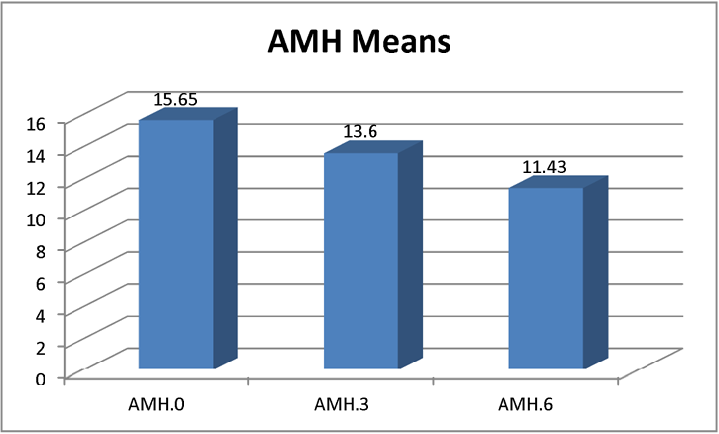
Figure (1): AMH Mean Values at Baseline, After 3 Months and After 6 Months of Treatment.

Table (1) and Figure (1) show that: AMH levels decreased over the course of treatment. AMH Mean was 15.65 ng/ml before starting treatment and decreased to13.6 ng/ml after 3 months, also continued to decrease and reached 11.43 ng/ml after 6 months.

Table (2): SHBG Description:
Variables | Minimum (nmol/ml) | Maximum (nmol/ml) | Mean (nmol/ml) | Standard deviation
SHBG. (baseline) | 1.7 | 42.4 | 16.53 | 9.48
SHBG (3 months) | 3.5 | 63.7 | 29.01 | 15.38
SHBG (6 months) | 15.3 | 178.3 | 47.13 | 34.15

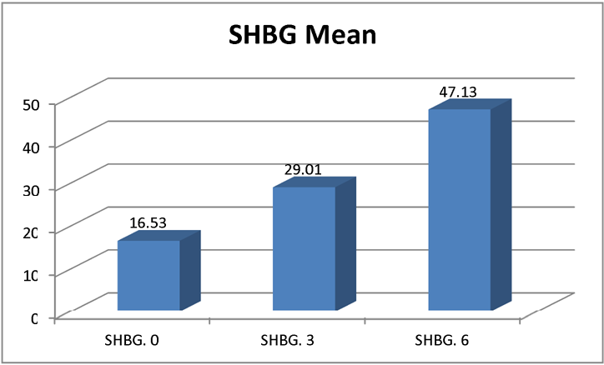
Figure (2): SHBG Mean values at baseline, 3 months of treatment and 6 months after treatment.

Table (2) and Figure (2) show: SHBG levels increased over the course of treatment, SHBG mean value was16.53nmol/mlatbaseline, and increased to 29.01 nmol/ml after 3months, also continued to increase and reached 47.13 nmol/ml after 6 months.

Table (3): DHEA-S Description:
Variables | Minimum (ug/dl) | Maximum (ug/dl) | Mean (ug/dl) | Standard deviation
DHEA-S. (baseline) | 84.85 | 474.1 | 285.55 | 129.195
DHEA-S (3months) | 52.58 | 393.7 | 190.76 | 82.89
DHEA-S (6 months) | 39.9 | 310.8 | 154.83 | 67.307

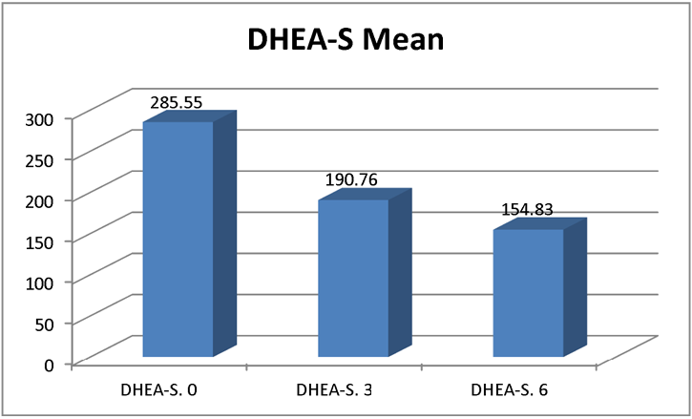
Figure (3): DHEA-S Mean.

Table (3) and Figure (3) show: DHEA-S levels decreased over the course of treatment as the baseline DHEA-S mean was 285.55 ug/dl and decreased to 190.76 ug/dl after 3 months and continued to decrease and reached 154.83 ug/dl after 6 months.

Table (4): Total Testosterone Description:
Variables | Minimum (ng/ml) | Maximum (ng/ml) | Mean (ng/ml) | Standard deviation
T-Test. (baseline) | 0.154 | 8.862 | 0.702 | 0.78
T-Test. (3 months) | 0.178 | 0.851 | 0.409 | 0.064
T-Test. (6 months) | 0.087 | 0.788 | 0.433 | 0.787

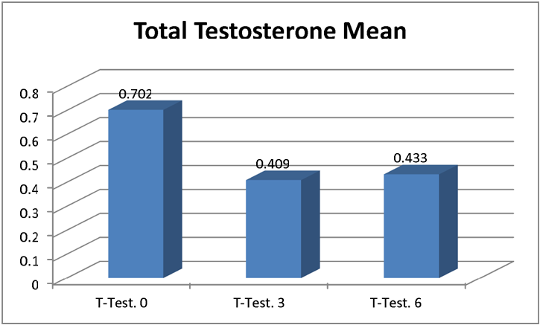
Figure (4): Total Testosterone Mean Values at Baseline, after 3 months and after 6 months of treatment.

Table (4) and Figure (4) show that: total testosterone levels decreased over 6 months of treatment (total testosterone mean was 0.702 ng/ml before starting treatment and decreased to 0.409 ng/ml after 3 months, also continued to decrease reaching 0.433 ng/ml after 6 months.

Table (5): Free Testosterone Description:
Variables | Min. % | Max. % | Mean % | Standard deviation
F-Test. (baseline) | 1.71 | 3.98 | 2.9 | 0.498
F-Test. (3 months) | 1.16 | 3.71 | 2.3 | 0.595
F-Test. (6 months) | 0.496 | 2.88 | 1.7 | 0.602

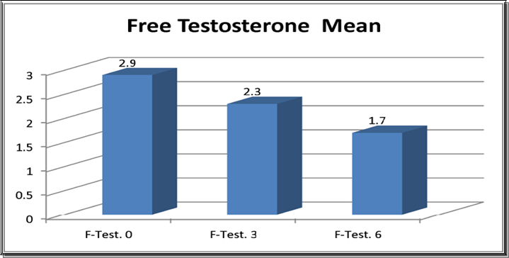
Figure (5): Free Testosterone Mean Values at baseline, after 3 Months and after 6 months of treatment.

Table (5) and Figure (5) show that: Free testosterone serum levels decreased over the course treatment (free testosterone mean was 2.9% at baseline, and decreased to 2.3 % after 3 months, and continued to decrease to 1.7 % after 6 months).

Table (6): Fasting Insulin Description:
Variables | Minimum (uIU/ml) | Maximum (uIU/ml) | Mean (uIU/ml) | Standard deviation
F-Insulin (baseline) | 3.46 | 37.16 | 19.178 | 8.97
F-Insulin (3 months) | 3.05 | 39.58 | 14.165 | 8.1
F-Insulin (6 months) | 4.01 | 25.40 | 11.365 | 5.51

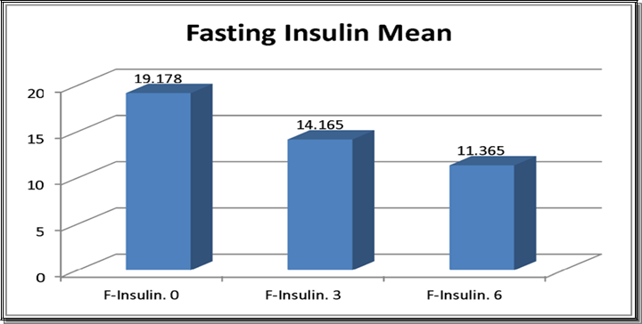
Figure (5): Fasting Insulin Mean Values at Baseline, After 3 months and 6 months of treatment

Table (5) and Figure (5) show that: fasting Insulin levels decreased over the course of treatment (fasting Insulin mean was 19.178 uIU/ml at baseline and decreased to 14.165 uIU/ml after 3 months, also continued to decrease and reached 11.365 uIU/ml after 6months.

Table (6): Calculated Insulin Resistance (IR) Description:
Variables | Minimum | Maximum | Mean | Standard deviation
IR (baseline) | 0.657 | 7.7 | 3.7 | 1.89
IR (3months) | 0.558 | 8.5 | 2.89 | 1.78
IR (6months) | 0.347 | 5.64 | 2.17 | 1.183

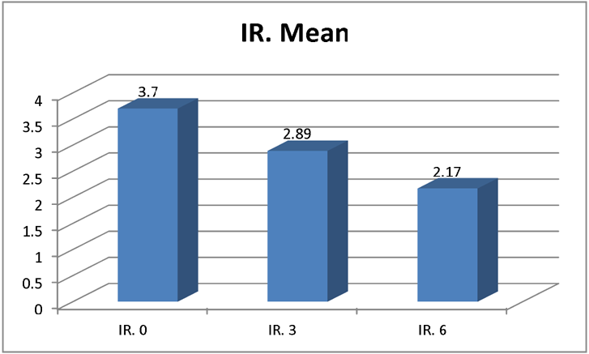
Figure (6): Calculated Insulin Resistance (IR) Mean Values at baseline, after 3 months and after 6 months of treatment.

Table (6) and Figure (6) show: IR levels decreased after 3 months of treatment, Mean was3.7 at baseline and decreased to 2.89, and continued decreasing to reach 2.17 after 6 months.

Table (6): Ovarian Volume Description:
Variables | Min. (ml³) | Max. (ml³) | Mean (ml³) | Standard deviation
Ovarian volume (baseline) | 10.08 | 18.28 | 13.53 | 2.14
Ovarian volume (3 months) | 9.60 | 18.01 | 13.22 | 2.358
Ovarian volume (6 months) | 9.54 | 18.30 | 13.08 | 2.359

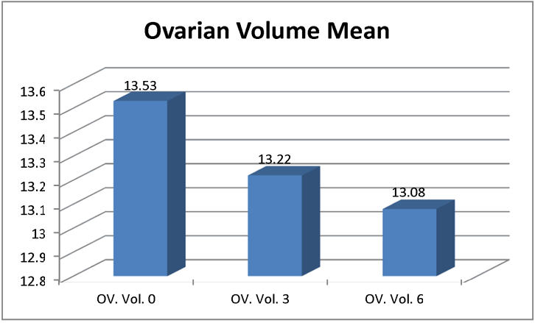
Figure (6): Ovarian Volume Mean values at baseline, after 3 months and after 6 months of treatment.

Table (6) and Figure (6) show: Ovarian Volume decreased after 3 months of treatment mean was 13.53 ml³before starting treatment and decreased to 13.22 ml³and continued decreasing to reach 13.08 ml³after 6 months.

Table (7): Ovarian Volume Analysis:
Variables | Mean (ml³) | Standard deviation | P-Value
Ovarian Volume (0-3 months) | 0.306 | 1.504 | 0.244
Ovarian Volume (3-6 months) | 0.146 | 0.461 | 0.074
Ovarian Volume (0-6 months) | 0.452 | 1.594 | 0.108

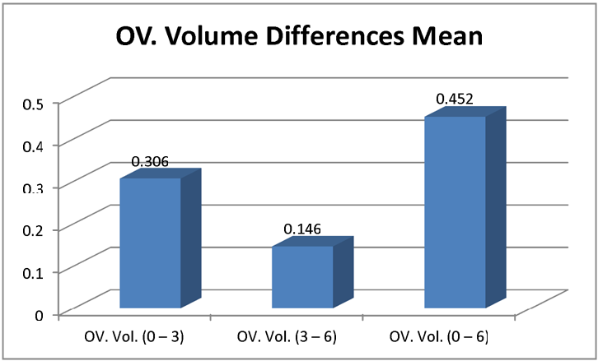
Figure (7): Ovarian volume mean differences between baseline and 3 months of treatment, 3 months and 6 months of treatment and between baseline and 6 months of treatment.

Table (7) and Figure (7) show:
    - Mean of the difference for the baseline minus values after 3 months treatment is in positive sign, which means that ovarian volume decreased by treatment over the first 3 months.
    - Also the mean value of the difference between 3 months and 6 months was found to be in the positive sign, which means that the ovarian volume continued to decrease.
    - P-value for these differences tests indicated for acceptance of the Null hypothesis for the used test which is (Mean = 0). Hence, we have an effect for treatment on ovarian volume but this effect was found to be statistically insignificant.

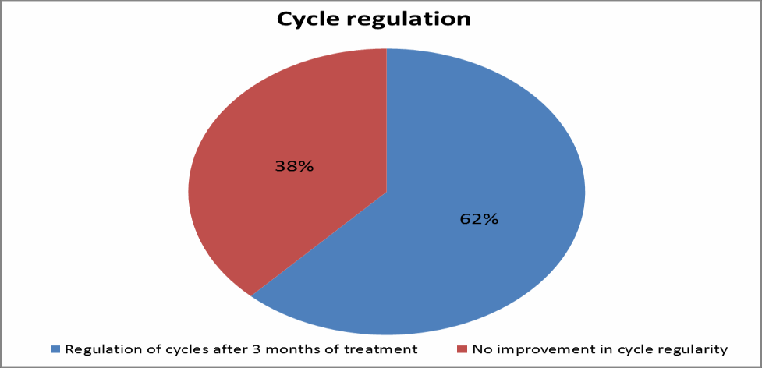
Figure (8): Effect of metformin on cycle regulation after 6 months of treatment.

Table (8): Cycle regulation with treatment:
Cycle regulation | Number | Percentage %
Regulation of cycles after 3 months of treatment | 31 | 62
No improvement in cycle regularity | 19 | 38

Figure (8) shows: the effect of metformin on cycle regulation, it was found that 31 patients (62%) of our sample had regulation of their cycles after 3 months of treatment, while 19 patients (38%) of our sample had no improvement in cycle regularity.

4. Discussion
In our study, we have found out that metformin plays an important role in PCOS through improvement of the biochemical and hormonal parameters. However, the study did not elucidate a significant effect on fertility, despite this improvement. The study was completed by 50 hyperandrogenic PCOS patients, 47.05% of the patients demonstrated hyperinsulinemia in the form of high fasting insulin >25uU/ml, which forms the basis of the pathophysiology of PCOS (Barber et al., 2006). The use of metformin in this group of patients demonstrated a reduction in insulin levels from 19.17 uU/ml to 11.365 uU/ml which was statistically significant. Fasting glucose and 2hr pp glucose levels did not change during the study. The calculated insulin resistance based on fasting insulin and glucose levels showed a significant decrease in insulin resistance. Those effects brought about by metformin are through inhibition of hepatic gluconeogenesis and increasing glucose uptake and utilization by activating membrane-bound glucose transporters GLUT-1 and GLUT-4 (Bosi, 2009).
The effect of metformin on hyperinsulinemia and improvement in insulin resistance was matched with a similar effect in androgen levels. There was a significant increase in SHBG levels, a decrease in free testosterone and DHEAS levels. However, there were no significant changes in total testosterone levels. The effect was more pronounced during the first 3 months of treatment and was maintained throughout the rest of the study. This effect of metformin on both androgens and insulin confirms the association between hyperinsulinemia and insulin resistance and hyperandrogenism. Increased insulin levels are associated with inhibition of SHBG synthesis in the liver thus increasing the proportion of free testosterone (Ehrmann DA, 2005; Barber TM, 2006). Hence, the reduction in insulin levels by metformin treatment will result in increased SHBG and a subsequent reduction in free testosterone levels. In addition, hyperinsulinemia stimulates ovarian androgen production (Speroff and Fritz, 2011). Hence the reduction in insulin levels is accompanied by a decrease in ovarian steroidogenesis and increase in serum SHBG with subsequent reduction in free testosterone (Peiris et al., 1989; Plymate et al., 1990). Moreover, the reduction in androgen levels resulted in further reduction in SHBG levels (Diamanti-Kanadarakis et al., 1998).
DHEAS was elevated in 50 % of the studied sample (25 out of 50 patients) defined as upper limit 350 ug/dl. In their literature Hoffman DI et al (1984) and Lobo RA (1991) demonstrated a 50 % prevalence of elevated DHEAS in PCOS. The elevation in DHEAS was mild to moderate 350- 475 ug/dl. Although the ovary is the principal source of androgens in most PCOS patients (Rosenfield et al., 1990), yet the observation of DHEAS elevation in some of PCOS patients, which is adrenal in origin, and the onset of symptoms of the syndrome around puberty led to the hypothesis that PCOS arises as an exaggeration of adrenarche with increased adrenal sensitivity to ACTH (Rittmaster,1998).
Metformin showed significant reduction in DHEAS levels, the reduction was more pronounced during the first 3 months of treatment compared to the second three months of treatment. This means that maximum effect was obtained during the early phase of treatment, and was maintained throughout the rest of the treatment period. The reduction in adrenal DHEAS secondary to insulin reduction by metformin explains the role of hyperinsulinemia in increasing adrenal androgens production (Speroff and Fritz, 2011). These results are in concordance with similar studies (Crave et al., 1995 and Acbay O et al., 1996).
In our study, 98% of the studied samples were obese, though obesity was not included in the selection of subjects. This could be explained by the frequent occurrence of obesity among PCOS. Bracero and Zacur stated that obesity is linked to hyperinsulinemia in the non PCOS population; despite this, Bracero and Zacur in their study in 2001 could not demonstrate a clear association of obesity with hyperinsulinemia in PCOS population inspite of its increased prevalence among such population.
In our study, 70.5% of the studied subjects demonstrated clinical hyperandrogenism in the form of acne and hirsutism. Only 30% reported improvement of acne and nonereported improvement in hirsutism. However, they did not show any progression in their androgenic manifestations. The persistence of hirsutism despite the reduction in androgen levels could be due to the variable degree of increased 5α reductase activity in the hirsute PCOS patients (Serafini et al., 1985; Miles et al., 1992). The results of this study agree with other studies in the lack of beneficial effect of metformin in improving hirsutism and acne, despite its effect on the biochemical markers (Legro et al., 2013). However, former studies proved metformin to be effective in improving androgenic manifestations in PCOS patients (Kolodziejczyk et al., 2000).
In our study, the mean AMH level among the studied group was 15.65ng/ml. The levels are 2 to 3 folds higher in women with PCOS compared to healthy women; which confirms the results of previous studies (Fallat et al., 1997; Cook et at., 2002; Pigny et al., 2003; Laven et al., 2004; Mulders et al., 2004; Piltonen et al., 2005).
Regarding the effect of metformin on serum AMH, the study showed a significant reduction in AMH levels over 3 and 6 months treatment with metformin. These results agree with a number of similar studies conducted by Pitonen et al., 2005; Sauerbrun et al., 2012; Neagu and Cristescu, 2012).
Metformin produced a desirable improvement in cycle regularity in 62% of the patients. The effect was not brought about before 3 months of treatment. The remaining patients did not show any improvement in cycle regularity, perhaps prolongation of the duration of treatment was required to bring about this effect. Different studies evaluating the effect of metformin on cycle regularity showed similar effects; Glueck CJ et al., 1999 (90%); Kolodziejczyk et al in 2000 and Zafar S, 2006 (86%). The Endocrine society in its issue in October 2013 recommended the use of metformin as second line drug in treatment of menstrual irregularities in patients who could not tolerate combined contraceptive pills (Laidman, 2013).
Despite the improvement in insulin and androgen levels, 2 out of 50 patients had spontaneous pregnancy after 3 and 6 months of treatment respectively. The rest of the patients did not show any improvement in the ovulation and pregnancy rate. They underwent induction of ovulation and the response rate to clomiphene citrate was disappointing only 14% were clomid sensitive and 86% were clomid resistant. Perhaps the duration of treatment was too short to induce such significant changes, or the resistance was due to high AMH levels. The study was started by 55 PCOs patients, 50 of which completed the study without reporting any adverse effects due to metformin treatment. 5 patients abandoned the study before completing 3 months due to side effects of metformin. One case reported allergic skin reaction in the form of itching, 2 cases reported severe flatulence and the remaining 2 reported fatigue and nausea. Side effects of metformin were reported in 12.7 % of cases which affected their compliance with treatment. In general, metformin is a tolerable medication with inter individual variation which is consistent with other studies (Morin-Papunen et al., 1999).

Conclusion
Metformin as an insulin sensitizing agent improved insulin resistance in PCOS patients and improved biochemical but not clinical hyperandrogenism. Metformin produced significant reduction in AMH levels and modest improvement in cycle regularity. Metformin could not be used for the treatment of hirsutism or in improving fertility in PCOS.

References
- Apridonidze T, Essah PA, Iuorno MJ, et al: Prevalence and characteristics of the metabolic syndrome in women with polycystic ovary syndrome. J Clin Endocrinol Metab. 2005;90(4):1929-35.
- Attia GR, Rainey WE and Carr BR.: Metformin directly inhibits androgen production in human thecal cells. Fertil Steril. 2001;76(3):517-24.
- Azziz R, Carmina E, Dewailly D, et al: Positions statement: Positions statement: criteria for defining polycystic ovary syndrome as a predominantly hyperandrogenic syndrome: an Androgen Excess Society guideline. J Clin Endocrinol Metab. 2006;91(11):4237-45.
- Bailey CJ and Turner R: Metformin Drug Therapy. N Engl J Med.1996;334(9):574-9.
- Bailey CJ: Biguanides and NIDDM: Diabetes Care. 1992;15(6):755-72.
- Barber TM, McCarthy MI, Wass JA, et al: Obesity and polycystic ovary syndrome. Clin Endocrinol (Oxf). 2006; 65(2):137-45.
- Barbieri RL, Makris A, Randall RW, et al: Insulin stimulates androgen accumulation in incubations of ovarian stroma obtained from women with hyperandrogenism. J Clin Endocrinol Metab. 1986;62(5):904-10.
- Bosi E: Metformin: The gold standard in Type 2 diabetes: what does the evidence tell us? Diabetes Obes Metab. 2009;11(2):3-8.
- Bracero N and Zacur HA: Polycystic ovary syndrome and hyperprolactinemia.
- Obstet Gynecol Clin North Am. 2001;28(1):77-84.
- Carmina E, Orio F, Palomba S, et al: Ovarian size and blood flow in women with polycystic ovary syndrome and their correlations with endocrine parameters. Fertil Steril. 2005;84(2):413-9.
- Catteau-Jonard S, Jamin SP, Leclerc A, et al: Anti-Mullerian hormone, its receptor, FSH receptor, and androgen receptor genes are overexpressed by granulosa cells from stimulated follicles in women with polycystic ovary syndrome. J Clin Endocrinol Metab. 2008;93(11):4456-61.
- Chen MJ, Yang WS, Chen CL, et al: The relationship between anti-Mullerianhormone, androgen and insulin resistance on the number of antral follicles in women with polycystic ovary syndrome. Hum Reprod. 2008;23(4):952-7.
- Cook Cl, Siow Y, Brenner AG, et al: Relationship between serum mullerian- inhibiting substance and other reproductive hormones in intreated women with polycystic ovary syndrome and normal women. Fertil Steril. 2002;77(1):141-6.
- Crave JC, Fimbel S, Lejeune H, et al: Effects of diet and metformin administration on sex hormone-binding globulin, androgens and insulin in hirsute and obese women. J Clin Endocrinol Metab. 1995;80(7):2057-62.
- De Leo V, la Marca A, Ditto A, et al: Effects of metformin on gonadotropin- induced ovulation in women with polycystic ovary syndrome. Fertil Steril. 1999;72(2):282-5.
- De-Ugarte CM, Bartolucci AA, Azziz R: Prevalence of insulin resistance in the polycystic ovary syndrome using the homeostasis model assessment. Fertil Steril. 2005;83(5):1454-60.
- Diamanti-Kandarakis E, Kouli CR, Bergiele AT, et al: A survey of the polycystic ovary syndrome in the Greek island of Lesbos: hormonal and metabolic profile. J Clin Endocrinol Metab. 1999;84(11):4006-11.
- Dunaif A, Graf M, Mandeli J, et al: Characterization of groups of hyperandrogenic women with acanthosisnigricans, impaired glucose tolerance, and/or hyperinsulinemia. J Clin Endocrinol Metab. 1987;65(3):499-507.
- Dunn CJ and Peters DH: A review of pharmacological properties and therapeutic use in non-insulin dependent diabetes mellitus. Drugs. 1995;49(5):721-49.
- Ehrmann DA: Plycystic ovary syndrome. N Engl J Med. 2005;352(12):1223-36.
- Elter K, Imir G and Durmusoglu F: Clinical, endocrine and metabolic effects of metformin added to ethinyl estradiol-cyproterone acetate in non-obese women with polycystic ovarian syndrome: a randomized controlled study. Hum Reprod. 2002;17(7):1729-37.
- ESHRE/ASRM: Revised 2003 consensus on diagnostic criteria and long- term health risks related to polycystic ovary syndrome (PCOS). Hum Reprod.2004;19(1):41-7.
- Fallat ME, Siow Y, Marra M, et al: Mullerian- inhibiting substance in follicular fluid and serum: a comparison of patients with tubal factor infertility, poycystic ovary syndrome, and endometriosis. Fertil Steril. 1997;67(5):962-5.
- Glueck CJ, Wang P, Fontaine R, et al: Metformin-induced resumption of normal menses in 39 of 43 (91%) previously amenorrheic women with the polycystic ovary syndrome. Metabolism. 1999; 48(4): 511-9.
- Grundy SM: Obesity, metabolic syndrome, and coronary atherosclerosis. Circulation.2002;105(23):2696-8.
- Harborne LR, Sattar N, Norman JE, et al: Metformin and weight loss in obese women with polycystic ovary syndrome: comparison of doses. J Clin Endocrinol Metab. 2005;90(8):4593-8.
- Hoffman DI, Klove K and Lobo RA: The prevalence and significance of elevated dehydroepiandrosterone sulfate levels in anovulatory women. Fertil Steril. 1984; 42(1):76-81.
- Kolodziejczyk B, Duleba AJ, Spaczynski RZ, et al: Metformin therapy decreases hyperandrogenism and hyperinsulinemia in women with polycystic ovary syndrome. Fertil Steril. 2000;73(6):1149-54.
- Laidman J: Endocrine Society Develops New Guidelines for PCOS J Clin Endocrionol Metab, Published online, October 22, 2013.
- Lashen H: Role of metformin in the management of polycystic ovary syndrome. Ther Adv Endocrinol Metab. 2010;1(3):117-28.
- Laven JS, Mulders AG, Visser JA, et al: Antimullerian hormone serum concentrations in normoovulatory and anovulatory women of reproductive age. J Clin Endocrinol Metab. 2004;89(1):318-23.
- Le Roith D and Zick Y: Recent advances in our understanding of insulin action and insulin resistance. Diabetes Care. 2001;24(3):588-97.
- Legro RS, Arslanian SA, Ehrmann DA, et al: Diagnosis and Treatment of Polycystic Ovary Syndrome. J Clin Endoc Metab. 2013;98(12); 4565- 92.
- Lobo RA: Hirsutism in polycystic ovary syndrome, current concepts. Clin Obstet Gynecol. 1991;34(4):817-26.
- Loucks TL, Talbott EO, McHugh KP, et al: Do polycystic-appearing ovaries affect the risk of cardiovascular disease among women with polycystic ovary syndrome? Fertil Steril.2000;74(3):547-52.
- Miles RA, Cassidenti DL, Carmina E, et al: Cutaneous application of an androstenedione gel as an in vivo test of 5 alpha-reductase activity in women. Fertil Steril. 1992;58(4):708-12.
- Morin-Papunen LC, Koivunen RM, Ruokonen A, et al: Metformin therapy improves the menstrual pattern with minimal endocrine and metabolic effects in women with polycystic ovary syndrome. Fertil Steril. 1999;69(4):691-6.
- Mulders AG, Laven JS, Eijkemans MJ, et al: Changes in antimullerian hormone serum concentrations over time suggest delayed ovarian ageing in normogonadotrophicanovulatory infertility. Hum Reprod. 2004;19(9):2036-42.
- Nascimento AD, Silva Lara LA, Japur de Sá Rosa-e-Silva AC, et al: Effects of metformin on serum insulin and anti-Mullerian hormone levels and on hyperandrogenism in patients with polycystic ovary syndrome. Gynecol Endocrinol. 2013;29(3):246-9.
- Neagu M and Cristescu C: Anti-Műllerian hormone--a prognostic marker for metformin therapy efficiency in the treatment of women with infertility and polycystic ovary syndrome. J Med Life. 2012;5(4):462- 4.
- Nestler JE, Powers LP, Matt DW, et al: A direct effect of hyperinsulinemia on serum sex hormone-binding globulin levels in obese women with the polycystic ovary syndrome. J Clin Endocrinol Metab. 1991;72(1):83- 9.
- Peiris AN, Mueller RA, Struve MF, et al: Relationship of anrogenic activity to splanchnic insulin metabolism and peripheral glucose utilization in premenopausal women. J Clin Endocrinol Metab. 1987;64(1):162-9.
- Pigny P, Merlen E, Robert Y, et al: Elevated serum level of anti-mullerian hormone in patients with polycystic ovary syndrome: relationship to the ovarian follicle excess and to the follicle arrest. J Clin Endocrinol Metab. 2003;88(12):5957-62.
- Piltonen T, Morin-Papunen L, Koivunen R, et al: Serum anti-mullerian hormone levels remain high until late reproductive age and decrease during metformin therapy in women with polycystic ovary sundrome. Hum Reprod. 2005;20(7):1820-6.
- Plymate SR, Hoop RC, Jones RE, et al: Regulation of sex hormone-binding globulin production by growth factors. Metabolism. 1990;39(9): 967- 70.
- Rittmaster RS: Differential suppression of testosterone and estradiol in hirsute women with the superactive gonadotropin releasing hormone aagonistleuprolide. J ClinEndocrinolMetab. 1988;67(4):651-5.
- Rosenield RL, Barnes RB, Cara JF, et al: Dysregulation of cytochrome P450c 17 alpha as the cause of polycystic ovarian syndrome. Fertil Steril. 1990;53(5):785-91.
- Sauerbrun M, Lederman M, Keltz M, et al: Serum antimüllerian hormone levels (AMH) decrease after metformin administration in women with bothlean and overweight polycystic ovary syndrome (PCOS). Fertil Steril. 2012; P-341.
- Scheen AJ, Letiexhe MR and Lefebvre PJ: Short administration of metformin improves insulin sensitivity in android obese subjects with impaired glucose tolerance. Diabet Med. 1995;12(11):985-9.
- Serafini P, Ablan F and Lobo RA: 5 alpha-Reductase activity in the genital skin of hirsute women. J Clin Endocrinol Metab. 1985;60(2): 349-55.
- Stadtmauer LA, Toma SK, Riehl RM et al: Metformin treatment of patients with polycystic ovary syndrome undergoing in vitro fertilization improves outcomes and is associated with modulation of the insulin-like growth factors. Fertil Steril. 2001;75(3):505-9.
- Widén EI, Eriksson JG and Groop LC: Metformin normalizes nonoxidative glucose metabolism in insulin-resistant normoglycemic first-degree relatives of patients with NIDDM. Diabetes. 1992;41(3):354-8.
- Zafar S: Role of Metformin in correcting Hyperinsulinemia, Menstrual Irregularity and Anovulation in Polycystic Ovary Syndrome. J Ayub Med Coll Abbottabad. 2005;17(4):54-6.

7/2/2019

