Studies on diagnosis of some urinary tract diseases in sheep in reclaimed areas at Sohage governorate

Adel E. Ahmed¹; Nehal M. Awad² and Nesreen E. Mohammed³

¹Proffessor and vice Dean for the community services and environmental affairs Department of Animal Medicine, Faculty of Veterinary Medicine, South Valley University, Egypt
2Researcher At Animal Health Research Institute, Sohage Regional Lab, Egypt
³Researche Assistant At Animal Health Research Institute, Sohage Regional Lab, Egypt
* Email: nesreen_elsayed2018@yahoo.com

Abstract: This study conducted using 113 sheep from different slaughtered houses in Sohage governorate included (Sohage, Balasfora and Akhmim slaughterhouses) aged from 6 months to 3 years. Out of them, 83 sheep suffered from urinary diseased included (37 cases of nephrosis, 27 cases of nephritis, 17 cases of cystitis and 2 cases of urolithiasis) and 20 animals used as control animals, which were apparently healthy and free from internal and external parasites. Urine andblood samples on EDTA and in plain tubes collected from each sheep. Another type of sample collected was kidney tissue of diseased cases from slaughtered houses. On each urine samples physical, chemical and microscopic examination were determined while, each blood sample with EDTA used for blood picture estimation and each serum samples used for detection of kidney function tests, total protein, albumin, some minerals included (sodium, chloride, calcium, phosphorus, and potassium). The kidney tissues used for gross examination and histopathological examination by staining with H & E.
[Adel E. Ahmed; Nehal M. Awad and Nesreen E. Mohamme. Studies on diagnosis of some urinary tract diseases in sheep in reclaimed areas at Sohage governorate. N Y Sci J 2019;12(7):6-12]. ISSN 1554-0200 (print); ISSN 2375-723X (online). http://www.sciencepub.net/newyork. 2. doi:10.7537/marsnys120719.02.

Keywords：Study; diagnosis; urinary tract; disease; sheep; reclaimed area；Sohage governorate

1. Introduction:
Sheep are considered as one of the most animals species due to their biological identity, such as short production interval, twining, short growing periods and medium space demand. They found in all production arrangements (Robinson et al., 2006). Sheep play an important role in the agriculture chart particularly, in the desert and marginal areas. Small ruminants are significant animals among livestock in Egypt especially as asource of meat, wool, and milk. They can live in different environmental systems and on different vegetation (Hiendle et al., 2002). Per public health service guideline, domestic drinking water should contain 400 of TDS; concentrations >1,000 ppm considered saltwater (Ghanem et al., 2018).
Diseases of the bladder and urethra are more frequent and more critical than diseases of the kidneys in farm animals occasionally, renal insufficiency develops as a consequence to diseases such as pyelonephritis, embolic nephritis, amyloidosis, and nephrosis. The kidney eliminates the end products of tissue metabolism (except for carbon dioxide), and sustain fluid, electrolyte, and acid-base- balance, by changing the volume of water and the concentration of solutes in the urine. Diseases of the kidneys, and in some instance of the ureters, bladder, and urethra diminish the efficiency of the kidneys functions leading to disruption in protein, acid-base, electrolyte, and water homeostasis and in the expelling of metabolic end products (Constable et al., 2017)
The sheep with urinary disorders showed decline of the level of total leukocytic count, Hb Content, PCV and basophils in case of sheep has urinary disease affections when compared to control ones while, the level of MCV, total leukocytic count, lymphocytes, monocytes, and eosinophil increased in diseased animals when compared to healthy ones as stated by (Gazi et al., 2015).
There were an increment in the level of urea, creatinine and phosphorousin case of sheep has urinary diseases disorders when compared to healthy control ones and there was a decrement in the level of sodium, chloride, potassium, and calcium in diseased sheep when compared to healthy control ones as mentioned by (Abdalla and Rizk 2018).
The level of total protein, albumin and globulin decreased in sheep has urinary diseases affections when compared to healthy control animals as mentioned by (Vinodhkumar et al., 2010 and Nehal 2004).

2. Materials and Methods:
This study conducted in 113 sheep aged 6 months to 3 years from different slaughtered houses at Sohage governorate (Sohage, Balasfora, and Akhmim). Out of them, 83 sheep suffered from urinary diseases and 20 animals used as control animals, which were apparently healthy and free from internal and external parasites.
Routine Urine analysis included physical characters ( transparency, blood, and color) chemical investigations (specific gravity, PH, blood, nitrate, glucose, urobilirubin, protein and ketones bodies) by using of test kits provided by (Medi- Test Combi 10-SGL) and microscopic examination through examination urine sediment.
Jugular blood samples collected in plain tubes for measurement of all biochemical variables. The blood was allowed to clot and centrifuged then, clear and non-hemolyzed blood serum was separated and stored at -20 °C until analyzed. And another type of blood sample collected at EDTA tube for complete blood picture estimation by hemocytometerand Hb. by using the automatic analyzer.
The separated sera used for detection of kidney function tests (Tietz, 1986 & 1990), total protein (Tietz, 1994) and albumin (Tietz, 1990) by using of commercial test kits supplied by Spectrum Egyptian company of Biotechnology and by the using of (RoBonic) Prietest ECO biochemistry analyzer.
Serum minerals by using tests kits supplied by Spectrum Company of biotechnology and by using atomic absorption (CORNEY AFT-500) according to the method described by (Tietz, 1976).
Both Kidneys of slaughtered animals examined grossly to screen their texture for calculi, hydronephrosis or any other lesions and kidney tissue examined microscopically by using of H & E stain according to the method described by (Banchroff et al., 1990).
Statistical analysis:
The obtained data statistically analyzed after the methods described by (Snedecor and Cochran, 1980) analysis of variance, least significant difference by using (SPSS) computer program and ANOVA test.

3. Results:
The physical examination of the urine samples of diseased sheep revealed that there were turbidity, blood, and change in normal color of collected samples while, chemical examination showed protein, blood and nitrite, change in specific gravity and urine PH. Furthermore, the microscopic examination of urine revealed the presence of casts, crystals, RBCs, WBCs and epithelial cells as showed in table 1 and 2.

Table 1: physical and chemical analysis of urine samples of diseased sheep:
Group | Uro. | Bil. | Ket. | Gluc. | Pro. | Bl. | Nit. | PH | Sp. gr.
Nephrosis  Nephritis  Urolithiasis  Cystitis | Neg  Neg  Neg  Neg | -ve-  -ve  -ve  -ve | Neg.  Neg.  Neg.  Neg. | -ve  -ve  -ve  -ve | 50-100  50-100  30-50  30-50 | + to ++  + to ++  + to ++  + to ++ | +ve  +ve  +ve  +ve | 7.8-8.7  8-8.7  7.5-8  7.5-8.5 | 1.03 -1.040  1.035-1.045  1.045-1.060  1.045-1.050

Table 2: Results of urine microscopic examination:
Diseases | Color | Turbidity | RBCs | WBCs | Crystals | Casts | Epith.  Cells
Nephrosis  Nephritis  Urolithiasis  Cystitis | Whitish  White to dark yellow  dark yellow  dark yellow | Turbid  Turbid  Turbid  Turbid | 5-13  23-29  13-24  3-11 | 4-11  12-19  5-12  4-8 | Oxalate  Non to oxalate  Phosphate  Oxalate to uricacid | Epith.  None to  Epith  hyaline | 3-7  3-8  3-7  1-4

In this study we measuredthe total RBCs, PCV, Hb. content, total leukocytic count, neutrophils%, eosinophil%, lymphocyte% and monocyte %by blood cell counting and the results revealed the mean values were (9.2x106/mm3, 26.1%, 8.7g/dl, 11.5x103/mm3,26.3%, 3.3%, 65.3% and 5%) respectively while, in control animals the results were (12.6x106/mm3, 33.7%, 11.8g/dl, 9.2x103, 17%, 1.2%, 75.5% and 6.34%) respectively as showed in table 3.
In addition to, we measured urea, creatinine, total proteins, albumin, globulin by using of spectrophotometer and the results revealed that the mean values were (36.5mg/dl, 1.4g/dl, 4.9g/dl, 2.4g/dl and 2.5g/dl) respectively while, in control animals the results were (15.7g/dl, 0.32g/dl, 6.8g/dl, 3.8g/dl and 3g/dl) respectively as showed in table 4.
We also, measured calcium, phosphorous, sodium, chloride, andpotassium by using of atomic absorption and the results revealed that the mean values were (1.7mmol/l, 5.3mmol/l, 132mmol/l, 98mmol/l and 4mmol/l) respectively while in control animals the results were (2.9mmol/l, 7mmol/l, 143mmol/l, 105mmol/l and 5.8mmol/l) respectively as showed in table 4.
The results of macroscopic examination of both kidneys revealed that were congestionand enlargement in size in case of nephrosis and paleness and enlargement in case of nephritis as showed in figure 1 & 2 while, microscopic examination revealed the presence of atrophy of glomerulus with marked fibrosis around the renal tubules, the renal tubules losing its epithelial lining, focal lymphocytic cellular aggregations, and renal calculi as shown in figure 3. Furthermore, figure 4 showed desquamation of the tubular epithelium and the renal tubules showing cystic dilatation and inflammatory cellular infiltration.

Table 3: Effect of urinary diseases on hematological parameters:
Parameters (X-±SD) | Control animals | Diseased animals
R.B.Cs (x106/mm3) | 12.6 ± 2.3 | 9.2 ± 0.4*
Hb Concentration (g/dl) | 11.8 ± 1.3 | 8.7 ± 0.2*
PCV (%) | 33.7 ± 1.9 | 26.1 ± 0.8**
MCV (fl) | 31.8 ± 0.8 | 31.2 ± 0.9
WBCs (103/mm3) | 9.2 ± 1.2 | 11.5 ± 0.9*
Neutrophils % | 17 ± 3.3 | 26.3 ± 1.7*
Monocytes % | 6.2 ± 0.2 | 5 ± 0.4*
Esinophils % | 1.2 ± 0.4 | 3.3± 0.5*
Lymphocytes % | 75.5 ± 3.4 | 65.3± 2.5**

Table 4: Effect of urinary diseases on biochemical parameters:
Parameters (X-±SD) | Control animals | Diseased animals
Urea (g/dl) | 15.7 ± 10 | 36.5 ± 10.3**
Creatinine (g/dl) | 0.32 ± 0.35 | 1.4 ± 0.7*
Total proteins (g/dl) | 6.8 ± 1.2 | 4.9 ± 1.3*
Albumin (g/dl) | 3.8 ± 0.5 | 2.4 ± 0.12*
Globulin (g/dl) | 3 ± 0.27 | 2.5 ± 0.11
Calcium (mmol/l) | 2.9 ± 0.76 | 1.7 ± 0.5*
Phosphorus (mmol/l) | 3.4 ± 0.3 | 4.7 ± 0.6*
Sodium (mmol/l) | 143 ± 0.7 | 132 ± 0.6**
Potassium (mmol/l) | 5.8 ± 0.11 | 4 ± 0.7*
Chloride (mmol/l) | 105 ± 0.25 | 98 ± 2.6**
X-= mean values SD= standard deviation * means P values ˂0.05 ** means P values ˂0.01

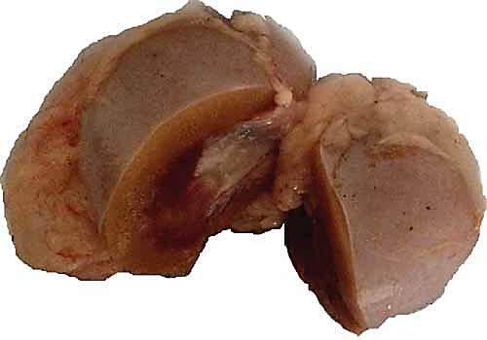
Figure 1: gross pathology hydronephrosis in kidney of sheep (pale and enlarged in size).

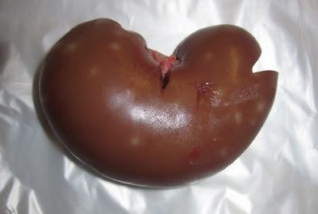
Figure 2: gross pathology nephritis in the kidney of sheep (congested and enlarged in size).

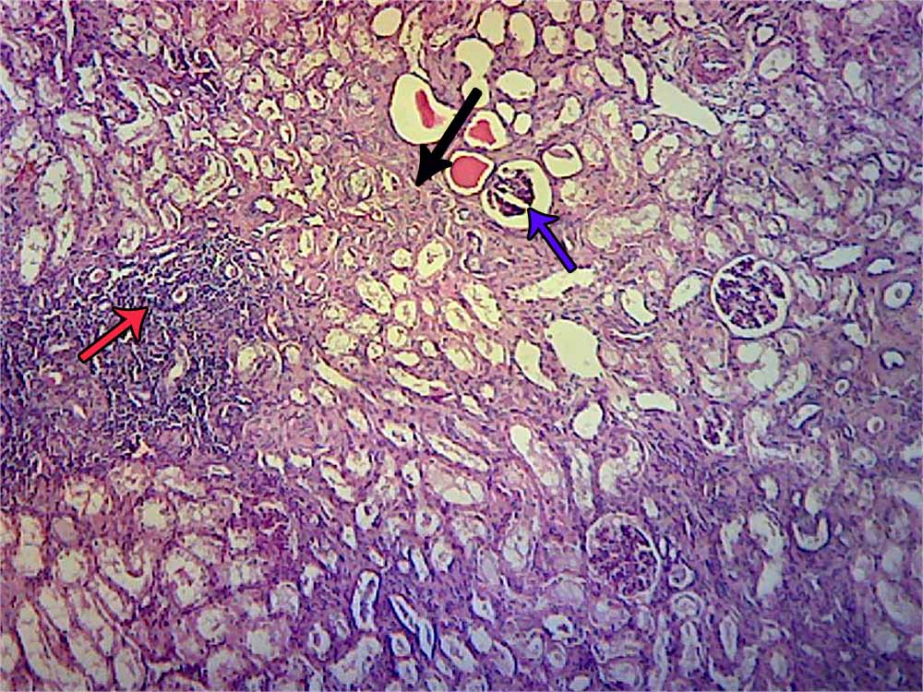
Figure 3: (blue arrow) atrophy of glomerulus with marked (black arrow) fibrosis around the renal tubules, the renal tubules losing its epithelial lining, (red arrow) focal lymphocytic cellular aggregations and renal calculi.

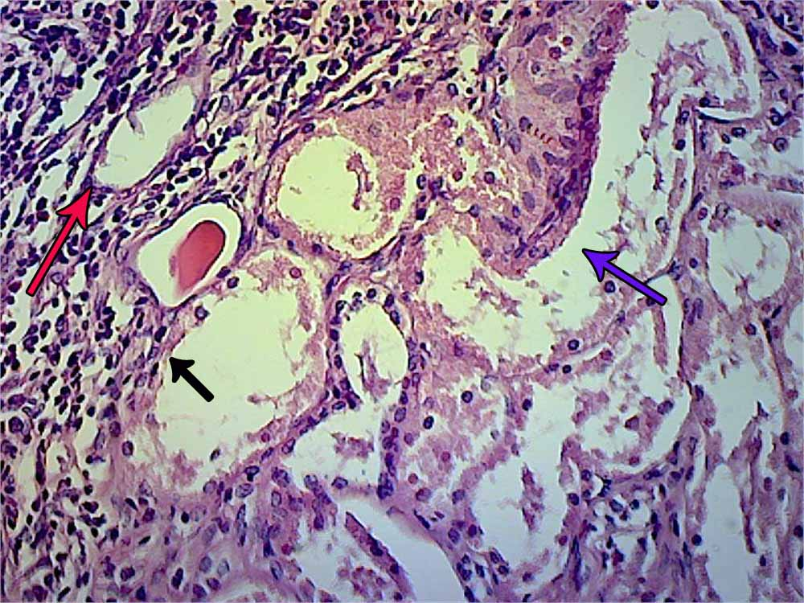
Figure 4: (red arrow) desquamation of the tubular epithelium and the renal tubules showing (black arrow) cystic dilatation and (blue arrow) inflammatory cellular infiltration.

4. Discussion:
Urinalysis, despite being an extremely beneficial method, is perhaps the most underused test in veterinary routine. When performed properly a urinalysis, specifically the measurement of urine specific gravity can be a measure of tubular function. Finding casts, WBCs and bacteria in urine is the best way to identify renal disorders before the onset of renal failure (Parrah et al., 2013).
The normal color of urine depends on the concentration of urochromes. The alteration in the color of urine of the affected sheepmay be due tothe concentration of urine, accumulation of sediments and hemorrhage. Brownish urine is indicative of mixing ofblood in the urine, which could be due to hematuria ornephritis. Dirty yellow colored urine maybe due to the presence of sedulous materials in the urinarybladder. Reddish coloration of urine is indicative ofhematuria, which could be due to injury by calculi or hemorrhage (Kannan and Lawrence, 2010).
Specific gravity directly proportional to urine osmolarity, measures solute concentration and urine density, or the capability of the kidney to concentrate or dilute the urine over that of termed plasma. It is therefore a valuable test, as the loss ofconcentrating ability of the kidneys is among the first signs of renal tubular disease. Urine with a specific gravity outsidethe range i.e.> (1.020-1.040) proposes alteration by the renal tubules (Wisnewski et al., 2004). High specific gravity indicated the presence of diseases such as dehydration, nephrotic syndrome and acute glomerulonephritis (Kraft and Duer, 2005).
Urinary PH is an evaluation of the ability of the kidney to conserve hydrogen ions, thus it provides a rough but useful estimate of the body's acid-base statushowever, urine pH does not necessarily reveal the body's pH, as it is highly affected by diet, storage time, metabolic, recentfeeding, bacterial infection, and respiratory alkalosis and urinary retention (Mavangira et al., 2012). The PH of ruminant normally alkaline and acidosis occurred in case of animals with diabetes mellitus also, occurred in case of excess or shortage diet in protein (Darling et al., 2009).
Urine chemical analysis for evaluation its protein reflects the index of disease. The causes of proteinuria may be renal or post renal. Renal due to abnormal renal handling of normal plasma proteins, which attribute to structural or functional lesions within the kidneys such as glomerular lesions or tubular lesions or interstitial as in case of interstitial nephritis. Postrenal may be urinary origin due to entry of proteins originated from exudative processes or hemorrhagic affecting the walls of the urine excretory pathway, renal pelvis, ureter, urinary bladder and urethra or maybe extraurinary origin due to entry of proteins derived from secretions or from hemorrhagic and/or exudative processes affecting the genital tract and/or external genitalia during evacuation the urinary bladder or in the process of collecting urine for analysis (Less et al., 2005).
The microscopic examination of urine is of significant clinical importance. The important structures toidentify include erythrocytes, leukocytes, crystals, casts, and bacteria (Gyory et al., 1984).
Crystalluria is a common finding during the routine examination of urine sediments. In most instances the precipitation of crystals of calcium oxalate, uric acid, triple phosphate, calcium phosphate, and amorphous phosphates or urates due to transient oversaturation of urine, ingestion of specific foods or by alterations of urine temperature and/or PH which occur upon standing after micturition. Crystalluria is also associated with pathological conditions such as acute uric acid nephropathy, urolithiasis (Thamilselvan and Khan, 1998).
Presence of a particular number of epithelial cells in urine is normal. The presence of increased number of leukocyte is noticeable in cystitis and pyelonephritis (kerbl et al., 2002)
There were a significant decrement in the levels of RBCs, Hb concentration, PCV and MCV of animals with urinary disorders compared with the control animals. These results may attribute to the presence of anemia in diseased sheep. In advanced chronic renal diseases, the synthesis of erythropoietin decrease and is insufficient to meet the demands for production of new red blood cell leading to anemia (Fisher, 2003). These results agreed with that reported by (Maciel et al., 2017) and disagreed with (Mahajan et al., 2017 and Abdalla and Rizk, 2018).
There was a significant increment in the levels of the total leukocytic count, neutrophils % and eosinophil % while, there was a significant decrement in the levels of monocytes %, lymphocytes %, and basophils %. The leukocytosis, neutrophilia, and lymphocytopenia may attribute to cystitis, urethritis and acute renal infection (Pugh, 2004) or renal tissues necrosis. The results of the total leukocytic count, neutrophils % and lymphocytes % in agreed with that reported by (Vinodh Kumar et al., 2010 and Maciel et al., 2017) respectively and disagreed with that reported by (Mahajan et al., 2017)
There was a significant increment in the levels of urea and creatinine in sheep with urinary disorders when compared to healthy control ones. The causes of azotemia divided into renal and postrenal condition. Diseases of the kidney, such as nephritis, cause renal azotemia and postrenal azotemia is associated with the inhibition of the urinary outflow for example by obstruction by urinary calculi (Otter, 2013). Creatinine is the waste product of creatine, which is implicated in the muscle contractions. The concentration of creatinine in the blood increases mainly because of impairment of the excretory function of kidney and renal damage. These results agreed with that mentioned by (Villar et al., 2003; Ewoldt et al., 2006; parrah et al., 2011; Gazi et al., 2015 and Riedi, 2018).
There was a decrement in total proteins, albumin and globulin levels in diseased sheep when compared to healthy control ones. The result of hypoproteinemia may attribute to glomerular diseases because of increased urinary loss of protein. It is also may be due to malnutrition and liver dysfunctions. While, the result of hypoalbuminemia may attribute to severe damage of hepatocyte or increased renal excretion of albumin due to glomerular diseases (Otter, 2013). These results in agreed with that reported by (Nehal, 2004) and disagreed with that stated by (Vinodh Kumar et al., 2010; Mahajan et al., 2017 and Riedi, 2018).
There was a decrement in the levels of some minerals included calcium, sodium, chloride, and potassium while, there was an increment in the level phosphorus in diseased sheep when compared to healthy control animals. Hypocalcemia and hyperphosphataemia recorded in the present study may attribute to many factors such as the diet delivered to the animals characterized by low in calcium content and abundant in phosphorous content. Or may due to phosphate retention is increased as the progress of renal failure. As a result of phosphate binding and decreased formation of calcitriol in the kidney, the ionized calcium concentration progressively decreases, thus leading to a progressive increase of PTHsecretion, which improve calcium mobilization from bone and absorption from the intestine and phosphate elimination by the kidney (Nagode and Chew, 1992) another reason for calcium decrease may be a competitive effect of hyperphosphataemia.
Decreased glomerular filtration rate might be the cause of hyperphosphataemia in ruminant animals with renal damage. Further, there is an opposite relationship between calcium and phosphorous and a decrease in serum calcium values as observed in this study might be the cause of increased inorganic phosphorous level.
The results of Ca and Na in agreed with that reported by (Sharma et al., 2005 and George et al., 2007 ) and not agreed with (Riedi, 2018); Cl agreed with that reported by (Nehal, 2004) while, K and phosphorus agreed with that reported by (Nehal, 2004 and Gazi et al., 2016) and disagreed with that reported by (George et al., 2007 and Vinodh Kumar et al., 2010).
The results of macroscopic examination revealed the presence of nephritis with no significant increase in size and may attribute to mononuclear cells infiltration, fibrosis, presence of protein casts and interstitial hemorrhage (Singh et al., 2013). And nephritis with a significant increase in the weight of the kidneys which may attribute to urine stagnation (Dutte et al., 2016).
The results of the microscopic examination of the kidney tissues proved the presence of large numbers of lymphocytic cellular aggregation due to the immune cellular response of the animal against microorganisms invasion. These results were in agreed with that reported by (Sastry and Rao, 2006) and (Jones et al., 2006).

References:
- Abdalla, A. and Rizk, A. 2018. Clinical, Haematological and Biochemical Findings Based Surgical Management of Obstructive Urolithiasis by Tube Cystostomy in Buffalo Calves (Bubalus Bubalis). Alex. J. Vet. Sci. Vol., 56 (2):69-77.
- Bancroff, J. P.; Stevenes, A. and Turner, D. R. 1990. Theory and practice of histopathological techniques, 3rd ed. Clurechill Livingstone, Edinburgh, London.
- Carnfield, P. G. 1986. Screening test available for practotionare. Proceeding no. 93. Clinical pathology. Pp. 83-91.
- Constable, P. D.; Hinchcliff, K. W.; Done, S. H. and Gronberg, W. 2017. veterinary medicine: a text book of diseases of cattel, horse, sheeps and pigs. 11 edition. Volume, 1. St. Louis, Missouri.
- Darling, A. L.; Millward, D. J.; Torgerson, D. J.; Catherine, E.; Hewitt and Susan A. L. 2009. Dietary protein bone health: a systematic review and meta-analysis. Vol., 90:1674–1692.
- Dunegan, L. J.; Knight, D. C., Brennan, M. F. and Moore, F. D. 1978. Urea distribution in renal failure. J. Surg. Res. Vol., 24: 401- 403.
- Dutta, S.; Rahman, Q. S.; Azmi, S.; Prawez, S.; Kour, N. and Wani, H. 2016. Patho-morphological Changes in Kidneys of Slaughtered Sheep and Goats in Jammu Region. Journal of Animal Research. Vol., 6(4): 705-709.
- Ewoldt, J. M.; Anderson, D. E.; Miesner, M. D. and Saville, W. J. 2006. Short- and long-term outcome and factors predicting survival after surgical tube cystotomy for treatment of obstructive urolithiasis in small ruminants. Vet. Surg. Vol., 35: 417-422.
- Fisher, J. W. (2003). Erythropoietin: physiology and pharmacology update. Exp. Biol. Med. (Maywood). Vol., 228: 1- 14.
- Gazi, M. A.; Makhdoomi, D. M.; Mir, S. A. and Sheikh, G. N. 2016. Urinalysis - A Diagnostic Factor for Urolithiasis and Prognostic Factor for its Recurrence in Young Ruminants. J Veterinar Sci Technol. Vol., 7(4): 336:342.
- Gazi, M. A.; Makhdoomi, D. M.; Khan, M. A.; Siraj, G.; Hussaien, S. D. and Abdull, Q. M. (2015). Possible role of calcium, phosphorus, magnesium shift in blood, urine and calculi in calves affected by urolithisis. African J. of Agriculture Reasearch. Vol., 10(4): 207-214.
- Ghanem, M.; Zeineldin, M.; Eissa, A.; El-ebissy, E.; Mohammed, R. and Abdelraof, Y. 2018. The effects of saline water consumption on the ultrasonographic and histopathological appearance of the kidney and liver in Barki sheep. J. Vet. Med. Sci. Vol., 80(5): 741–748.
- Gyory, A. Z.; Hodfield, C. and Laner, C. S. 1984. Value of urine microscopy in predicting histological changes in thekidney. Double blind comparison. Br. Med. J. Vol., 288: 819-822.
- Hiendleder, S., Kaupe, B., Wassmuth, R. and Janke, A. (2002). Molecular analysis of wild and domestic sheep questions current nomenclature and provides evidence for domestication from two different subspecies. Proc. Biol. Sci. Vol., 269: 893–904.
- Jacobson, L. O.; Goldwasser, E.; Fried, W. and Plzak, L. F. 1957. Studies on Trans. Assoc. Am. Phys. Vol., 70: 305-317.
- Jones, T. C.; Smith, H. A. and Hunt, R. D. 2006. Veterinary pathology, 6th Edn. Lea and Febiger, Philadelphia. pp. 715716.
- Kannan, K. V. A. and Lawrence, K. E. 2010. Obstructiveurolithiasis in a Sannen goat in NewZealand, resulting in a ruptured bladder. Newzeland. Vet. J. Vol., 58 (5): 269-271.
- Kerbl, K.; Rehman, J.; Landman, J.; Lee, D.; Sundaram, C. and Clayman, R. V. (2002). Current management of urolithiasis: progress or regress? J. Endourol. Vol., 16:281-289.
- Kraft, W. and Dürr, U. M. 2005. Klinische Labor diagnostikin der Tier medizin, (Give the English name) 6th Edition. Pp. 136-203 and 483-484.
- Lees, G. E.; Brown, S. A.; Elliott, J.; Grauer, G. E. and Vaden, S. L. 2005. Assessment and management of proteinuria in dogs and cats: 2004 ACVIM Forum Consensus Statement (small animal). J. Vet. Intern. Med. Vol., 19: 377-385.
- Maciel, T., A.; Inalda, A. R.; Rafael, J.; S.; Pierre, C. S.; Cleyton, D. C.; Rinaldo, J. S.; Lizandra, A.; Silvana, M. B.; José, A. B.; Daniela, O. 2017. Clinical and Biochemical Profile of Obstructive Urolithiasis in Sheep. Acta Scientiae Veterinariae. Vol., 45: 1515.
- Nagy, D. W. (2009). Urolithiasis in small ruminants Proceedings on Animal feed Resources, CVC in Kansas City4.
- Mahajan, A.; Kumar, A. G.; Singh, M. B.; Ahmad, M. B. and Raj, H. B. (2017). Occurrence and Management of Obstructive Urolithiasis in Ruminants. Journal of Animal Research. Vol., 7(4): 723-731.
- Mavangira, V.; Cornish, J. M. and Angelos, J. A. 2012. Effect of ammonium chloride supplementation on urine pH and urinary fractional excretion of electrolytes in goats Journal of American Veterinary Medical Association. Vol., 237(11):1299-1304.
- Meyer, D. J. and Harvey, J. W. 1998. Veterinary Laboratory Medicine. Interpretation and diagnosis.2 ed. E. B. Saunders Company, Philadelphia.310-346.
- Nehal, M. A. 2004. Laboratory and clinical studies on possible causes of renal diseases in sheep. PhD. Faculty of veterinary medicine. Assuit University. Egypt.
- Nagode, L. A. and Chew, D. J. 1992. Nephrocalcinosis caused by hyperparathyroidism in progression of renal failure: treatment with calcitriol. Semin. Vet. Med. Surg. (Small Anim.). Vol., 7: 202-220.
- Otter, A. 2013. Diagnostic blood biochemistry and hematologyin cattle. In Practice. Vol., 35: 7-16.
- Parrah, J. D.; Moulvi, B. A.; Hussain, S. S. and Bilal, S. (2011). Innovative tube cystostomy for the management of bovine clinical cases of obstructive urolithiasis. Vet. Arhiv. Vol., 81(3): 321-337.
- Parrah, J. D.; Moulvi, B. A.; Gazi, M. A.; Makhdoomi, D. M.; Athar, H.; Din, M. U.; Dar, S. and Mir, A. Q. 2013. Importance of urinalysis in veterinary practice–Areview. Vet. World. J. Vol., 9(6): 640-646.
- Park, R. and Rabinowitz, L. 1969. Effect of reduced glomerular ﬁ ltration rate on the fractional excretion of urea in the animals. Proc. Soc. Exp. Biol. Med. Vol., 132: 27- 29.
- Pugh, D. J. 2002. Sheep and goat medicine.1 ed. Saunders Company. pp. 290-303.
- Pugh, D. G. 2004. Clínica de ovinos e caprinos. São Paulo: Roca, 513p.
- Riedi, A. K.; Knubben-Schweizer, G. and Meylan, M. 2018. Clinical findings and diagnostic procedures in 270 small ruminants with obstructive urolithiasis. J Vet Intern Med. Vol., 32:1274–1282.
- Robinsion, J. J.; Ashworth, C. J.; Rooke, J. A.; Mitchell, L. M. and Evoy, T. G. 2006. Nutrition and fertility in ruminant livestock production in UK. A report to Ministery of Agriculture, Fisheries and Food, UK. P. P.112.
- Sastry, G. A. and Rao, P. R. 2006. A textbook of veterinary pathology, 7th Edn. CBS Publishers, New Delhi.
- Saw, M.; London, J. L.; Theodorsone, L. and Stromme, J. H. 1983. IFCC method for g-glutamyltransferase. Clin. Chem. Acta. 135:315F- 338F.
- Sendecor, G. W. and Cochran, W. G. 1980. Statistical Method.7th ed., Iowa State Univ. Press, Ames, Iowa, USA.
- Sharma, A. K.; Mogha, I. V.; Singh, G. R.; Amarpal and Aithal, H. P. (2005). Clinico-physiological and hemato-biochemical changes in urolithiasis and its management in bovine. Ind. J. Anim. Sci. Vol., 75(10): 1131-1134.
- Sharma, P., Singh; K. Singh, J. and Kumar, A. 2006. Bacteriological, biochemical and histopathological studies in uroproteniemia in buffaloe calves. Idian J. Anim. Scien. Vol., 76 (2): 124-126.
- Sharma, P., Singh; K. Singh, J. and Kumar, A. 2006. Bacteriological, biochemical and histopathological studies in uroproteniemia in buffaloe calves. Idian J. Anim. Scien. Vol., 76 (2): 124-126.
- Sockett, D. C.; Knight, A. P.; Fettman, M. J.; Kichl, A. R.; Smith, J. A. and Arnold, S. M. 1986. Metabolic changes due to experimentally induced rupture of the bovine urinary bladder. Cornell Vet. Vol., 76: 198-212.
- Tietz, N. W. 1976. Fundamentals of Clinical Chemistry. Pp. 874.
- Tietz, N. W. 1990. Ed. Clinical Guide to laboratory tests. 2 nd ed. Philadelphia: WB Saunders, 26-29.
- Tietz, N. W. 1994. Fundamentals of Clinical Chemistry: 2 nd ed. NW Tietz, editor, 692.
- Tietz, N. W. 1976. Fundamentals of Clinical Chemistry. Pp. 903-908.
- Tietz, N. W. 1976. Fundamentals of Clinical Chemistry. Pp. 876.
- Thamilselvan, S. and Khan, S. R. 1998. Oxalate and calcium oxalate crystals are injurious to renal epithelial cells: results of in vivo and in vitro studies. Journal of Nephrology. Vol., 1: 66-69.
- Vinodh Kumar, O. R.; Swarnkar, C. P.; Shinde, A. K. and Singh, D. 2010. Clinical, mineral and haemato biochemical studies of urolithiasis in weaner lambs. African Journal of Agricultural Research Vol. 5(15): 2045-2050.
- Villar, D.; Larson, D. J.; Janke, B. H.; Yaeger, M. J.; Carson, T. L. and Blaylock, R. 2003. Case report–obstructive urolithiasis in a feedlot steer. Bovine Practitioner. Vol., 37 (1): 74-77.
- Wisnewski, N.; Clarke, K. B.; Powell, T. D. and Sellins, K. S. 2004. Prevalence of microalbuminuria in cats. Thesis submitted to Virginia Common wealth University, Richmond. Virginia.

6/23/2019

