**Impact Of Waste Dumpsite On Groundwater Quality In Ibadan, Southwestern Nigeria**

Oluwatoyin Opeyemi Akintola And Bodede Adewunmi Idayat Bello

Forestry Research Institute of Nigeria Ibadan, Nigeria

Corresponding author: [toyinakintola73@gmail.com](mailto:toyinakintola73@gmail.com)

**Abstract:** Migration of leachates from waste dump through soils and rocks may pose a threat to groundwater resource if not properly managed. This study assessed the influence of waste dump if any on the groundwater quality and the extent to which it moves from the dumpsite to the surrounding area. Twelve groundwater samples were collected from 7 new and 5 existing hand dug wells at lateral distance (0 – 500 m) away from the dumpsite. Physical parameters such as pH, total dissolved solids (TDS), electrical conductivity (EC) were determined in-situ using a pH/ Temperature meter and Conductivity meter, anions (Cl-, NO3-, HCO3-, and SO42-) and cation ( Na+, K+, Ca2+ and Mg2+) concentrations analysed using Ion Chromatography and Atomic Atomic Absorption Spectrometer (AAS) respectively. Data were analysed using descriptive statistics, graphs, regression and correlation coefficient. The pH ranges from 5.50 to 6.60 indicating the acidic nature of the water samples. High values of TDS (149.67-700.27 mg/l) and EC (299.52-1076.21 μm/S) were observed while respective anions (Cl-, NO3=, HCO3- and SO4=) concentrations range from 123.95-288.10, 8.99-63.50, 122.57-232.12, 170.11- 360.84 mg/l. Cations concentrations are Na+ (14.19-38.56mg/l), K+ (4.19 – 15.11mg/l), Ca2+ (23.25-37.83mg/l) and Mg2+ (12.11 – 22.40mg/l). Strong correlationcoefficient (r =0.90 to 0.98) obtained from the concentration ofdetermined parameters and distance from dumpsite suggest anthropogenic influence on the groundwater quality. This study has shown that Lapite dumpsite has impacted the surrounding groundwater and this has shown a significant threat to public health of the people living in the area.

[Oluwatoyin Opeyemi Akintola And Bodede Adewunmi Idayat Bello. **Impact Of Waste Dumpsite On Groundwater Quality In Ibadan, Southwestern Nigeria.** *N Y Sci J* 2019;12(6):25-39]. ISSN 1554-0200 (print); ISSN 2375-723X (online). <http://www.sciencepub.net/newyork>. 4. doi:[10.7537/marsnys120619.04](http://www.dx.doi.org/10.7537/marsnys120619.04).

**Key words:** Anthropogenic influence, Dumpsite, Groundwater quality, Leachates, Public health

**Introduction**

Solid wastes are generally diverse in nature and have a wide range of chemicals like detergents, metals, inorganic and complex organic chemicals which are harmful to the environment (1). Solid waste includes all the discarded solid materials generated from commercial, municipal, industrial, and agricultural activities (2, 3, and 4). Dumpsite is the common method of municipal solid waste (MSW) disposal employed by many developing countries of the world due to its favourable economics (5, 6, and 7). In most of the developing countries, solid waste disposal has been a chronic problem, particularly in areas with high population density, high production of refuse, and scarcity of land adequate for dumpsite (8). However, this method attracts insects, rodents, various disease vectors, a variety of aesthetic and public health problems (1). The wastes in this site undergoes steady anaerobic decomposition over a span of years and produce considerable amount of leachates consisting leachate gas, heavy metals and varieties of hazardous contaminants which may move from the dumpsite into the underground water (9, 10) As water percolates through the dumpsite, contaminants are leached from the solid waste. These chemicals are picked up by water from surface runoff or precipitation which gradually penetrates into the wastes and leachate out to accumulate at the bottom of the dumpsite (11, 12). This contaminated water from the dumpsite (leachate) can infiltrate through the soils and underling rocks into the groundwater (1). These leachates, which are highly rich in both organic matter and inorganic substances may contain compounds such as sulphates, chlorides, ammonium, calcium, magnesium, sodium, potassium, iron, and heavy metals such as cadmium, chromium, copper, lead, zinc, and nickel (12,13). Contaminants released through leachates into the environment seldom remains at the point of discharge. They are elated through the porous media by four basic mechanisms; advection, molecular diffusion, mechanical dispersion and adsorption (14). Adsorption is one of the most important transport mechanisms that affect the fate of chemicals in soils and determine their distribution in the soil water environment (14). Groundwater pollution occurs mostly due to percolation of fluvial water and infiltration of contaminants through the soil in waste disposal sites ( 15,16). The migration of contaminants into groundwater may pose a great threat and render it unfit for use (17). Areas close to dumpsite have a bigger risk of groundwater contamination due to the impending contaminants originating from nearby waste dumpsites, thus pose a substantial danger to groundwater resource user and natural environment (18). Lapite village is underlain by basement complex rocks and it hosts one of the largest and most active dumpsites in Ibadan. The dumpsite came into existence without prior geotechnical and hydrogeological evaluation for its suitability as a landfill site and its likely impacts on the surrounding surface and groundwater. Study has shown that the rocks underlying the dumpsite hare weathered and fractured and the soils have low clay content and high permeability characteristics (1). These characteristics may encourage the migration of leachates through the soils into the groundwater. This study was designed to assess the influence of waste dump on the groundwater and possibly determine the extent of its impact in the study area.

**Materials And Method**

***Study Area, Hydrogeological and Geological Settings***

The study area, Akinyele local government area of Oyo state is located in Southwestern part of Nigeria. The area falls within the Ibadan metropolis and is made accessible by both old Oyo road and newly constructed Ibadan- Oyo express road (Fig. 1). Ibadan being a state capital and largest city in African has witnessed tremendous growth in population and development. Lapite dumpsite came into use in 1998 and still in use till date without proper environmental evaluation of its usage in terms of site selection, design and management but was established based on its remoteness from the habitable areas (IBWMA, 2008). The dumpsite is situated on high elevation with height ranging from 246 to 265m above sea level. Area extent of the dumpsite is about 400m in length and 200m in width (1). Wastes generated and collected from different locations in Ibadan and its locality are dumped on a daily basis, giving rise to large pile of wastes of varying composition (industrial, agricultural, domestic and medical wastes including used syringes) about 3.0m high. The area is characterized by the presence of tropical rain forest comprises of bushes, herbs, shrubs, trees, grasses, palm vegetation and temperatures ranging from 25°C to 29 °C. The rainy season is characterised by high rainfall with a mean annual rainfall of about 1237mm (1). Hydrogeologically, the direction of drainage is controlled by fractures in the rocks and the drainage layout conforms to the dendritric pattern showing irregularity in direction and tributaries joining the main rivers at different angles. Most of the rivers are generally turbid during the west season owing to high clay content in their upper reaches while in dry season; the flow is considerably reduced and sustained by effluent seepage (1). The study area is well drained by streams and rivers and the pattern of drainage is dendritics Geologically, the study area lies within the Nigerian basement complex terrain characterized by crystalline rocks of Pre-Cambrian age (19). The major rock types are quartzites, banded gneisses, augen gneisses and migmatites while the minor rock types are pegmatite, quartz, amphibolites diorites and zenoliths. The rocks in the study area are fractured and weathered while the soils have low amount of clay and high permeability characteristics (1).

***Field Sampling***

The choice of sampling location was made based on the previous study carried out by (1) in the study area. Water samples were collected from five existing and seven newly dug wells located at the dumpsite, at 20m intervals up to 100m and some distances away on the downslope of the dumpsite. Water used as the control sample was collected from an existing well at a distance of 150m on upslope of the dumpsite based on the availability and its closeness to the site. The field testing kit was taken to the sampling sites and the important in situ parameters such as temperature, electrical conductivity (EC), total dissolved solids (TDS) and pH, were determined using a DIGITAL SATO SK-632 pH/ Temperature meter and COND. METER MODEL CM-1K. Dissolved oxygen (DO) was determined using H13810 DO test kit. The depth of the wells ranged between 1.80 and 7.50ml. Groundwater samples were randomly collected from hand- dug wells around and within the dumpsites with the aid of plastic bucket that has been previously washed and rinsed thoroughly with distilled water and suspended at one end by rope. The sampling bottles were first soaked with nitric acid and washed with distilled water before sampling to avoid potential contamination from the sampling materials. At the identified sampling points, sampling bottles were washed three times with each water sample before collection. Three water samples per well were collected from 5 new and 7existing hand dug wells within the sampling location.

***Sample Preparation and treatment***

After collection of samples, composite samples were gotten from the three samples collected from each well into two 60ml bottles each and labelled accordingly. The pH of the water samples from one of the bottles used for cations analysis was adjusted to about 2 with 3 drops of concentrated nitric acid to inhibit metabolic processes and reduce adsorption of metal compounds to the surface of the container while no preservative was added to the other samples used for anion determination,. Sampling bottles were tightly covered and labelled. They were the transported in an ice cooler from the field. Samples were preserved in the refrigerators for some days before taking to the laboratory for analysis.

***Laboratory analysis***

Chemical analysis of the water samples was done at Acme Analytical Laboratories (Vancouver) Ltd.1020 Cordova St. East, Vancouver, Canada. Cation and anion concentrations in the water samples were analyzed using inductively coupled plasma- atomic emission spectrometry(ICP-AES) and Ion Chromatography methods respectively.

***Data Analysis***

Data were analyzed using descriptive statistics, graphical representation and Regression analysis. Analysed data were compared with various recommendation values for drinking water.



**Figure 1. Location map of the study area after Akintola (2014).**

**Table 1: Mean concentrations of determined parameters and recommended standard values for Drinking Water**

|  |  |  |  |  |  |
| --- | --- | --- | --- | --- | --- |
| Parameters | Mean | SEM | WHO | SON | CS |
| pH | 6.34 | 0.03 | 6.5-8.5 | 6.5 –8.5 | 6.8 |
| DO (mg/l) | 3.22 | 0.38 | 4 – 6 | 4-6 | 1.46 |
| TDS (mg/l) | 339.18 | 0.31 | 1000 | 1000 | 150.22 |
| EC (μm/S) | 534.38 | 0.36 | 1000 | NS | 299.50 |
| Na+(mg/l) | 24.89 | 0.35 | 200 | 200 | 14.01 |
| K+(mg/l) | 8.33 | 0.31 | 200 | 200 | 3.99 |
| Ca2+(mg/l) | 28.41 | 0.31 | 200 | 200 | 23.11 |
| Mg2+(mg/l) | 17.75 | 0.29 | 200 | 200 | 12.41 |
| No3-(mg/l) | 32.01 | 0.33 | 50 | 50 | 8.99 |
| Cl-(mg/l | 185.63 | 0.31 | 250 | 500 | 123.71 |
| HCO3(mg/l) | 176.34 | 0.26 | NS | NS | 122.46 |
| SO42-(mg/l) | 246.76 | 0.25 | 250 | 250 | 169.75 |

SEM- Standard error of mean, SON-Standard Organization of Nigeria for Drinking water quality. ( WHO) World Health Organization Standard for water quality, CW- control water sample

**Resuls And Discussion**

***Hydrochemistry of the Groundwater***

Results obtained from the groundwater samples in and around Lapite dumpsite were given in tables and figures. Mean values of the parameter analyzed in water samples, their values in control samples and standard error of mean with WHO (2006) and SON (2007) drinking water standard (20, 21) in table 1. The analysed parameters pH, DO, EC, TDS, cations and anions were characterized by their median, quartiles, maximum and minimum and represented by box plots in Figure 1. Anion and cation chemistry of the analysed samples were presented in figure 2. Concentrations of the analysed parameters with distance from dumpsite were presented in figure 3 while regression equation and correlation coefficients (r) were given in table 2 closer to the dumpsite could be attributed to presence of sulphur and amino acid compounds from human and animal excreta in the waste dump and also organic matter could have depleted oxygen which could have resulted in a negative redox potential (23, 24). Generally, pH of the water may be attributed to the presence of humic acid associated with the biological decomposition of wastes (1). This can also be associated with the age of the dumpsite since the pH of leachates that gets into the water and soil increases with the landfill age (1).



**Figure 2. Elevation Contour of Lapite Waste Dumpsite**

**Dissolved Oxygen (DO):** DO values of the ground water samples ranged from 1.61- 5.01 mg/l with mean values 3.22+0.38mg/l while the value in the control sample was 7.2 mg/l (table 1 and figure 1b).There is no standard for dissolved oxygen for water quality assessment (25). Low DO values were observed in wells closed and up to 130m distanced from the waste dump. 60% of the water samples were below the standard given by WHO (2006) and SON (2007). A low DO value is an indication of bad odour in water due toanaerobic decomposition of organic wastes (25) and their values in natural waters are dependents on physical, chemical and biological activities prevailing in the water bodies. The level of dissolved oxygen in water also varies with water temperature and altitude. Reduction in DO values is enhanced by high concentration of organic matter of the water bodies (26).

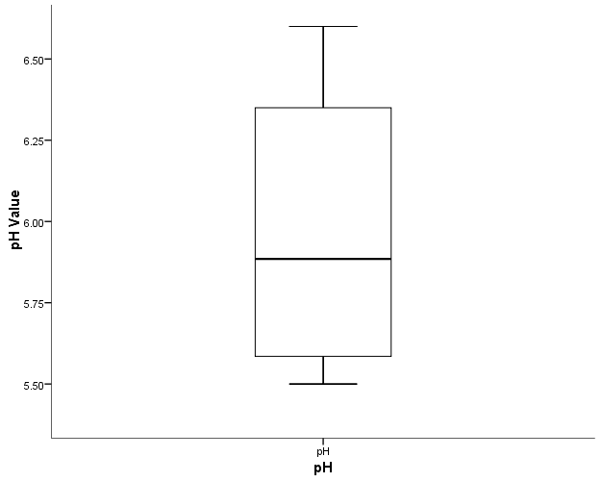

**Figure 1a: Box plot representing minimum, median, quartile and maximum value of pH**

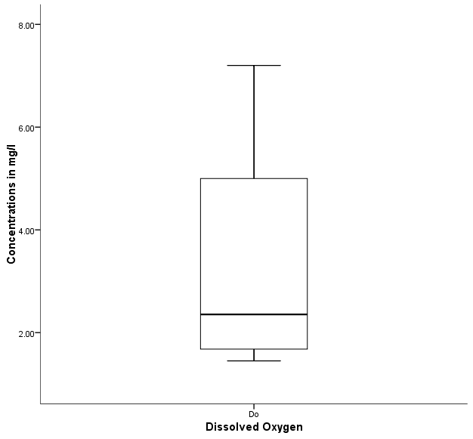

**Figure 1b: Box plot representing minimum, median, quartile and maximum values of Dissolved oxygen (DO)**

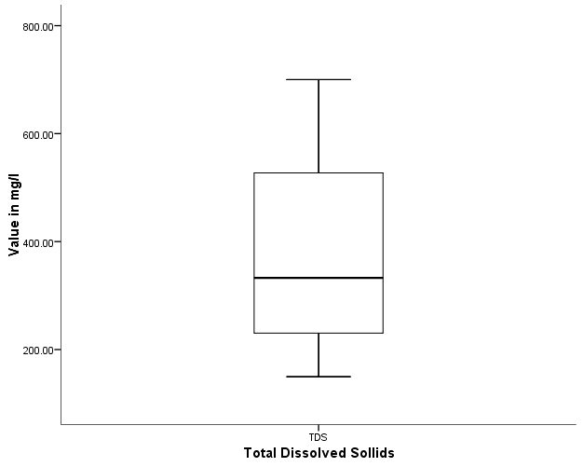

**Figure 1c: Box plot representing minimum, median, quartile and maximum values of Total dissolved solids (TDS)**

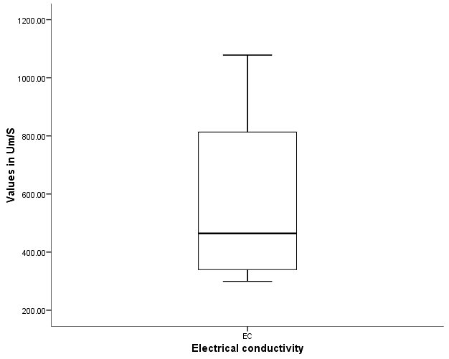

**Figure 1d: Box plot representing minimum, median, quartile and maximum values of Electrical conductivity (EC)**

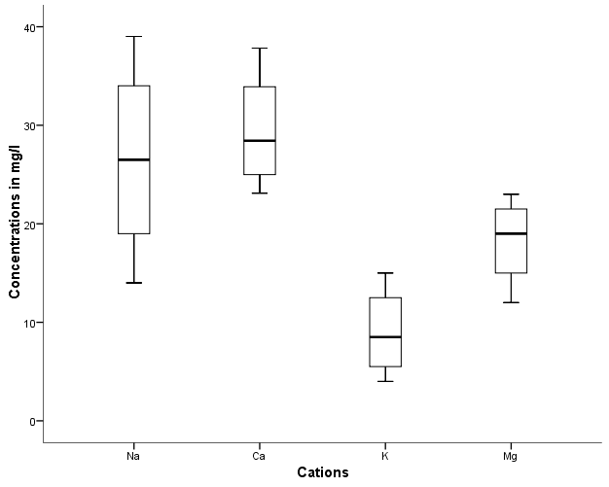

**Figure 1e: Box plot representing minimum, median, quartile and maximum values of Cation (Na, Ca, Mg and K)**

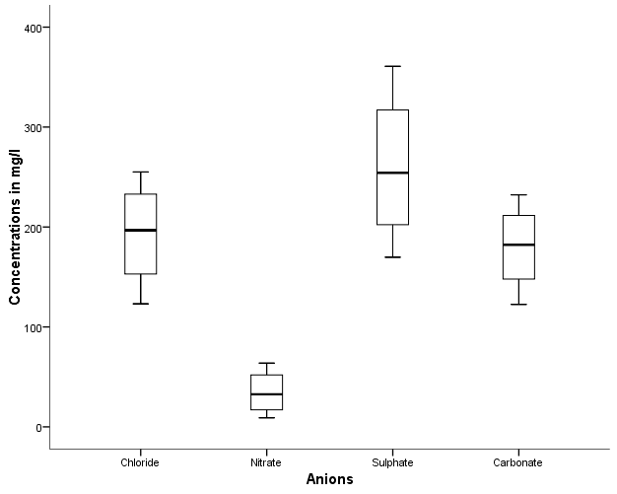

**Figure 1f: Box plot representing minimum, median, quartile and maximum values of Anions ( Cl-, NO3-, S042- and HCO3-)**

**Total Dissolved Solids (TDS) and Electrical conductivity (EC):** Total dissolved solid values in the water samples range from 149.67-700.21mg/l with mean value of 339.18±0.31mg/l while electrical conductivity values ranging from 299.52 to 1076.21μm/S with mean value of 534.38 ±0.36μm/S (table1 and figure 1). The higher values of TDS and EC were observed in the well located within and close to the dumpsite (Fig.4c and 4d). However, TDS and EC values are within standard recommended values for drinking water (20, 21) with the exception of water sample from wells located within the dumpsite where the EC value is above the guidelines for portable water. It was noticed that the farther the wells from the dumpsite, the lower the values of EC and TDS and also the wells closer to the dumpsite have the EC and TDS values higher than the water from the control well (fig. 4c and 4d). High values of EC and TDS observed in some of the waters in the study area could be attributed to leachates from the dumpsite that are generally associated with high ion concentrations ( chloride and nitrate), very low resistivity and high conductivity of the rock formations containing them (1). Electrical resistivity is dependent on textural and structural characteristics and is chiefly responsive to the water content of the geological formation (27). It is habitually dependent on the degree of water saturation, amount of dissolved solids, and content of the organic matter, grain- size and the mineral content of the soil or material forming the medium through which the contaminants get into the groundwater resource. Higher values of EC and TDS observed in some wells in this study agreed with the findings of (28) where he stated that water showed higher conductivity when dissolves salts are present. Thus conductivity is proportional to the amount of salts dissolved in water.

**Figure 2a: Changes in Cations concentration along the flow path (%)**

**Figure 2b: Changes in Anions concentration along the flow path (%) Cation and Anion chemistry**

Concentrations of cations in the water samples were Na+(14.19-38.56), K+(4.19 – 15.11), Ca2+(23.25-37.83) and Mg2+(12.11 – 22.40) mg/l (figure1e). Their mean concentration values (table1) showed that calcium has the highest values than sodium in the water samples and this could be attributed to the mineralogical composition of the underlying rocks (migmatite and banded gneiss) in the study area. However, their concentrations are all within WHO (2006) standard for drinking water. Their elevated concentrations indicated that groundwater the groundwater quality was affected by the migrated leachate from the dumpsite site.

Anions concentrations in water as shown in figure 1f were Cl-(123.95-288.10), NO3-(8.99-63.50), HCO3-(122.57-232.12), and SO42- (170.11- 360.84) mg/l. Most of their values are within WHO (2006) and SON (2007) standard for drinking water with the exception of two wells that are closer to the dumpsite. Sources of nitrate in groundwater could be from natural sources, waste material and irrigated agricultural practices (29) while (30) stated that nitrate contributed from natural sources in groundwater is usually less than 10mg/l and concentration above this value suggest additional contribution from anthropogenic sources. Since the mean concentration of nitrate in the study water is more than 10mg/l (table 1). Thus, the presence of Cl- and NO3- can be used as tracer with relation to leachate percolation form the waste dump (2).

Cation chemistry showed that Na and Ca were dominant ions in the water samples and their concentration covers 24 - 43% of the total cation mass concentration in the samples (figure 2a). Cationic abundance showed that 30% of the samples were in order of Na+ >Ca2+ > Mg2+ >K+ while 70% were in order of Ca2+ >Na+ > Mg2+ >K+. Similarly, anion chemistry of the samples showed that sulphate and chloride is the dominant ion in the samples and their concentration covers 27 - 41% of the total anions mass concentrations in the samples (figure 2b). This implies that the groundwater has the capacity to dissolve mineral salts and hence the concentrations of Ca2+, SO42-, Na+ and Cl- in the water might increase (31, 32, and 33). This could be attributed to the geology of the study area in particular the variation of the mineralogical composition of the bedrock. It is generally known that the ionic composition of water is the result of several factors during water–rock interaction (34, 35).

**Figure 3a. pH values showing influence of the dumpsite on groundwater at sampling locations**

**Figure 3b. Dissolved oxygen concentrations showing influence of the dumpsite on groundwater at sampling locations**

**Figure 3c. TDS values showing influence of the dumpsite on groundwater at sampling locations**

**Figure 3d. EC values showing influence of the dumpsite on groundwater at sampling locations**

**Figure 3e. Na+ concentration showing influence of the dumpsite on groundwater at sampling locations**

**Figure 3f. K+ concentration showing influence of the dumpsite on groundwater at sampling locations**

**Figure 3g. Ca2+ concentration showing influence of the dumpsite on groundwater at sampling locations**

**Figure 3h. Mg2+ concentration showing influence of the dumpsite on groundwater at sampling locations**

**Figure 3i. NO3- concentration showing influence of the dumpsite on groundwater at sampling locations**

**Figure 3j. Cl- concentration showing influence of the dumpsite on groundwater at sampling locations**

**Figure 3k. HCO3- concentration showing influence of the dumpsite on groundwater at sampling locations**

**Figure 3l. SO42- concentration showing influence of the dumpsite on groundwater at sampling locations**

**Table 2: Regression Equation and Correlation Coefficient (r) of determined parameters**

|  |  |  |
| --- | --- | --- |
| Parameters | Regression Equation | Correlation coefficient ® |
| pH | **Y = 0.09X + 5.70** | **0.90** |
| DO  EC | **Y = 0.47X + 0.18**  **Y = 918.10 -62.05X** | **0.93**  **0.91** |
| TDS | **Y = 611.70 – 44.35X** | **0.94** |
| Na+ | **Y = 39.39 – 2.45X** | **0.98** |
| Ca2+ | **Y = 35.61 – 1.19X** | **0.95** |
| Mg2+ | **Y = 23.97 – 1.04X** | **0.98** |
| K+ | **Y = 14.28 – 0.98X** | **0.98** |
| NO3- | **Y = 61.65 – 4.83X** | **0.98** |
| Cl- | **Y = 261.90 – 12.49X** | **0.99** |
| HCO3- | **Y = 234.21 – 9.68X** | **0.97** |
| SO42- | **Y =330.41 - 16.89X** | **0.97** |

***Influence of Waste dumpsite on water quality***

In order to ascertain the source of elevated increase in the determined parameters in the study area, certain factors were considered and assessed. The extent of contamination level of groundwater quality due to leachate percolation from waste dumpsites depends upon a number of factors like chemical composition of leachate, rainfall, depth and distance of the well from the pollution source (2). In this study, groundwater samples were plotted against their distances from dumpsite to understand the level and extent of its influence on groundwater quality in the area. Generally the concentration of all the parameters analyzed in the water sample collected from various distances at down slope side of the dumpsite as shown in figure 3a-3i were higher than the control sample collected at 150m lateral distance of the upslope side of the dumpsite with the exception of pH and DO and this may be attributed to the topographic configuration of the study area and anthropogenic influence of the dumpsite on the water samples. This also agreed with the findings of (1) where she stated that the permeable soils and fractured bedrocks in the study area may allow infiltration of leachates into the surrounding groundwater. The reduction in the concentrations with increase in distance from dumpsite agreed with the findings of (3). This may also be attributed to direction of groundwater flow as stated by (1) that leachates from the dumpsite flow from the eastern (upslope) to western part (downslope) of the dumpsite. Regression equation and correlation coefficients (r) established between distances from waste dumpsite and concentrations of determined parameters in water samples were presented in Table 2. Strong correlations coefficient (0.90 to 0.98) observed in this study indicated the impact of the waste dump on the groundwater quality.It was noticed that the farther the well from the dumpsite, the lower the concentration of determined parameters in the water samples with exception of PH and DO that showed increase. Irrespective of increase or decrease in their concentration in the water samples to their distances (location) from dumpsite, it suggests the migration and infiltration of the leachates from the dumpsite through the permeable and fractured rocks into the groundwater (1), and extent of its influence on the groundwater. Also, regression equations obtained from the concentrations of the analysed parameters with distance from waste dumpsite further suggest anthropogenic influence of dumpsites on the surrounding water. In addition to this, the variation plots (figure 3a- 3l) indicated that the anthropogenic influence from waste dump extent to about 325m from the dumpsite. This implies that distances above 325m from the dumpsite are safe for sittings of wells and boreholes in the study area. This study has shown that concentrations of determined parametres were found to be high in the sampling locations which are near to the dumpsites. Although, the concentrations of some of the parameters did not exceed drinking water standard even then the groundwater quality represent a significant threat to public health. Therefore, the use of groundwater drawn from the wells located in proximity of the waste dumping sites should be avoidable.

**Conclusion**

The higher concentrations of the determined parameters in the water samples compared to the control sample and strong correlation coefficient (R) obtained from the concentrations of the analysed parameters with distance from waste dumpsite suggests anthropogenic influence of dumpsite on the surrounding groundwater. This in turn resulted from migration and infiltration of leachates from the dumpsite through the permable soils and fractured bedrocks in the study area. The influence of the waste dump on the surrounding groundwater has extended to about 325m lateral distance from the dumpsite, so siting of the potable wells and borehole in the study area should be beyond the stated distance. The groundwater quality has shown a significant threat to public health of people living in the study area.

**References**

1. Akintola, O. O. Geotechnical and hydrogeological assessment of Lapitewaste dumpsite in Ibadan, Southwestern Nigeria. Unpublished Ph.D thesis, University Ibadan Nigeria.237p, 2014.
2. Mor, S., Ravindra, K., Dahiya, R. P and Chandra, A. Leachate characterization and assessment of groundwater pollution near municipal solid waste dumpsite site. Environmental Monitoring and Assessment. 2006; 118(1-3), pp.435–456.
3. Rajkumar Nagarajan, Subramani Thirumalaisamy and Elango Lakshumanan: Impact of leachate on groundwater pollution due to non-engineered municipal solid waste landfill sites of erode city, Tamil Nadu, India. Iranian Journal of Environmental Health Sciences & Engineering 2012, 9:35-40.
4. Singh, R. P., Singh, P., Arouja, A. S. F., Ibrahim, M. H., Sulaiman, O. 2011. Management of urban solid waste: vermicomposting a sustainable option. Resourc. Conserv. Recycl. 55, 719–729.
5. Nagendran R, Selvam A, Joseph K, Chiemchaisri C. Phytoremediation and rehabilitation of municipal solid waste landfills and dumpsites: a brief review. Waste Management 2006; 26:1357–1369.
6. Bharat Jhamnani and SK Singh: Groundwater Contamination due to Bhalaswa Landfill Site in New Delhi. International Journal of Civil and Environmental Engineering 1:3 2009.
7. Narayana T. Municipal solid waste management in India: from waste disposal to recovery of resources. Waste Management 2009; 9:1163–1166.
8. Sadek, S. and El-Fadel, M. (2000). The Normandy landfill: A Case Study in solid waste management. Journal of Natural Resources and Life Sciences Education, 29: 155-161.
9. Visvanathan C, Ulrich G. Domestic solid waste management in South Asian Countries – a comparative analysis. Thailand: Asian Institute of Technology; 2006.
10. Bashir MJK, Isa MH, Kutty SRM, Awang ZB, Abdul Aziz H, Mohajeri S, et al. Landfill leachate treatment by electrochemical oxidation. Waste Manage 2009;29:2534–41.
11. Nitin Kamboj and Mohrana Choudhary: Impact of solid waste disposal on ground water quality near Gazipur dumping site, Delhi, India. Journal of Applied and Natural Science 5 (2): 306-312 (2013)
12. Hassan AH, Ramadan MH. Assessment of sanitary landfill leachate characterizations and its impacts on groundwater at Alexandria. J Egypt Public Health Assoc 2005; 80:27–49.
13. Christensen, T. H, Kjeldsen, P., Bjerg, P. L., Jensen, D. L., Christensen, J. B. and Baun, A. 2001. Biogeochemistry of landfill leachate plumes. Appl. Geochem., 16: 659–718.
14. Lee, G. F and Jones-Lee, A. 1993. Groundwater Quality Protection: A Suggested Approach for Water Utilities. Report to the CA/NV AWWA Section Source Water Quality Committee, Aug, 8 p.
15. Kah M, Brown CD (2007) Prediction of the adsorption of ionizable pesticides in soils. J Agric Food Chem., 2007; 55(6):2312–2322.
16. Akaha CT, Christopher IA. Assessment of anthropogenic influence on quality of groundwater in hand-dug wells in parts of Makurdi Metropolis North Central Nigeria. Ife Journal of Science. 2012;14(1):12313.
17. Abdullahi, N. k, Osazuwa, I. b and Sule, P. O. Application of integrated geophysical techniques in the investigation of groundwater contamination: A case study of municipal solid waste leachate. Ozean J. Appl. Sci. 2011; 4 (1) 7–25.
18. Taylor A, Allen A. Waste disposal and landfill: potential hazards and information needs. London: IWA Publishing; 2006.
19. Saarela J: Pilot investigations of surface parts of three closed landfills and factors affecting them. Environ Monit Assess 2003, 84:183–192.
20. WHO (World Health Organisation): Guidelines for drinking water quality [electronic resource]: incorporating first addendum. Vol. 1, Recommendations-3rd ed., Electronic version Web. 595p. Wilcox, L. W., Magistad, O. C. 1943. Interpretation of Irrigation Water Quality and relative Salt, 2006.
21. SON (Standard organization of Nigeria): Nigerian Industrial Standard. Nigeria standard for drinking water quality. IC 13.060.20,.30p. 2007.
22. Mahapathra T. K. and Purohit K. M. Qualitative aspects of surface and groundwater for drinking purpose in Paradeep area, *Ecology of polluted water*, 2000;1:144.
23. Temowo, O. O. Hydrogeological Assessment of Water Quality of Awba Dam, University of Ibadan, Southwestern, Nigeria. Unpublished M.Sc thesis, 151pp, 2004.
24. Efe, S. I.; Ogban, F. E.; Horsfall, M Jr. and Akporhnor, E. E. Seasonal variations of physico-chemical characteristics in water resources quality in western Niger Delta region, Nigeria. *J. Applies Sci. Environ*. Mgt. 2005; 9. 1:191-195.
25. Ashvin G. Godghate, Rajaram S. Sawant and Shobha D. Jadhav1. An Evaluation of Physico-chemical Parameters to Assess Borewell Water Quality from Madyal and Vadgaon Villages of Kagal Tahsil, MS, India. *International Research Journal of Environment Sciences,* Vol. 2(5), 95-97, 2013.
26. Rana B. C. and Palharia S., Physiological and physicochemical evaluation of the River Ayad, Udaipur, Phycos, 27, 211-217, 1988.
27. Arora, T and Shakeel, A. Electrical structure of an unsaturated zone related to hard rock aquifer. Res. Comm. Sci. 2010; 99 (2) 216–220.
28. Abdul Jameel A., Evaluation of drinking water quality in Tiruchirapalli, *Indian J. of. Env. Health*, 44, 108-112, 2002.
29. Canter, I. W. Nitrates in groundwater CRC lewis Publication. New Yor.263p, 1996.
30. Hernandez-Garcia, M. E and Custodio, National baseline quality of Madrid Tertiary Detrital Aquifer groundwater. A basis for aquifer management Environmental Geology. 48:173-188, 2004.
31. Alexakis D. Assessment of water quality in the Messolonghi- Etoliko and Neochorio region (West Greece) using hydrochemical and statistical analysis methods. Environ Monit Assess 182:397–413, 2011.
32. Hui Q, Peiyue L, Jia D, Chao Y, Xuedi Z Formation of the river water chemistry in the middle section of Dousitu River. China EJ Chem 8:727–738, 2011.
33. Sappa G, Barbieri M, Ergul S, Ferranti F. Hydrogeological conceptual model of groundwater from carbonate aquifers using environmental isotopes (18O, 2H) and chemical tracers: a case study in southern Latium Region, Central Italy. J Water Res Prot 4:695–716, 2012.
34. Gamvroula D, Alexakis D, Stamatis G. Diagnosis of groundwater quality and assessment of contamination sources in the Megara basin (Attica, Greece). Arab J Geosci 6(7):2367–2381, 2013.
35. Hamzaoui-Azaza F, Ketata M, Bouhlila R. Hydrogeochemical characteristics and assessment of drinking water quality in Zeuss–Koutine aquifer Southeastern Tunisia. Environ Monit Assess 174(1–4):283–298, 2011.

6/19/2019