**Scientific And Innovative Approach In The Field Of Physical Education And Sport Is A Requirement Of Time**

Farkhod Turdiev

Doctor of philosophy (Ph.D.) in pedagogics, Associate professor

100114, Yunusabad district, avenue-18 (block of flats), house-39, flat 8, Tashkent, Uzbekistan

**Address** (**U.S)** 21030 US Highway 19 N, Clearwater, Florida, 33765, USA

Telephone: +998 (71) 2128435; + 1 (407)-989-74-77(US)

E-mail: [farkhod.turdiyev@mail.ru](mailto:farkhod.turdiyev@mail.ru)

**Abstract**: This article describes the reasons of the success of Uzbek athletes in prestigious competitions, including the World Championships and the Olympic Games. For further improvement of these achievements, the author emphasized the need to pay attention to the scientific and innovative approach to the training of highly qualified athletes and proposed some suggestions in this direction. The article also provides information on improving theoretical and practical knowledge in the field of sports in the United States, promoting Uzbek national sports, participating in prestigious international competitions, continuing research, as well as information about a number of young Uzbek specialists who are engaged in the exchange of experience in international relations.

[Farkhod Turdiev. **Scientific And Innovative Approach In The Field Of Physical Education And Sport Is A Requirement Of Time.** *N Y Sci J* 2019;12(5):76-93]. ISSN 1554-0200 (print); ISSN 2375-723X (online). <http://www.sciencepub.net/newyork>. 14. doi:[10.7537/marsnys120519.14](http://www.dx.doi.org/10.7537/marsnys120519.14).

**Key words:** the national team of Uzbekistan, the Olympic Games, the National Olympic Committee of Uzbekistan, Single Combat Turon, psychological preparation, young Turanians, freestyle wrestling, Greco-Roman wrestling, management, scientific

**Analysis and discussions**

Independent Uzbekistan, which in a short time gained a reputation in the international arena, is known to the world not only for its great successes in ancient culture, scholars, poets and military leaders, but also as a country that has achieved great success in the international sports movement.

There is no continent or any major sporting event in the world in which the anthem of Uzbekistan was not performed in honor of our athletes, and our flag was not raised. Now we can easily say that Uzbekistan has become a large sports country and has experienced a historically period for short time.

Currently, the struggle between states for the demonstration of their strength and talent is a priority in two areas: physical education, sports and intelligence, that is, intellectual activity. The realization of the physical and intellectual potential of people, the formation of appropriate reserves in this direction becomes the key to development and progress in the 21st century.

One of the most important conditions for the development of the country is the training of highly qualified personnel and the further improvement of the education system based on the achievements of modern science. Further improvement of the system of training specialists in the field of physical culture and sports requires solving a number of tasks. Along with raising physical culture and mass sports to a new level, the problem of solving problems in the development of individual sports, identifying theoretical and practical problems, developing sports science, independent thinking and training highly qualified specialists is extremely relevant. In addition, the training of a qualified athlete is very difficult and hard work and a long process.

If a trainer can apply his theoretical knowledge in practical work, this knowledge will be useful. Knowing or application of this knowledge is a different concept. Pedagogical skills are interpreted as a combination of scientific knowledge and highly qualified professional skills. The quality and skill level, in turn, depend on the extent to which they rely on scientific theoretical requirements.

Athletes of the national team take prizes in the Olympic and Asian Games, world and continental championships and other prestigious sports competitions.

Effective use of the scientific approach is a key factor for continuous improvement of high results.

Today in the world of sports there is a steady increase in results, updating records, changing competition rules, improving sports medicine (medical equipment, diagnostics, pharmacology, treatment methods, etc.), modern sports equipment, planning and organizing sports training, the use of which requires scientific approach. In developed countries, there are specialized scientific laboratories specializing in sports and equipped with modern equipment. In addition to teams of coaches, teams of highly qualified specialists, sports psychologists, medical staff, managers and others take part in the training of highly qualified athletes.

Long-term analysis shows that in order to prepare highly qualified athletes in the republic, in most cases the main trainer and the responsible sports coaches conduct trainings based on scientifically unfounded plans. For example, during 1991–2004, the Uzbek boxers were among the strongest in the world rankings, winning the continental Asian championships, world championships, the Asian and Olympic games. At that time, the Uzbek boxing school was recognized worldwide. However, some foreign opponents have developed (scientifically grounded) methods against the methods of Uzbek boxers. Therefore, there was a significant decrease in the achievement of high results by our boxers at prestigious competitions until 2013.

As a long-term analysis shows that not only in boxing, but in other sports, the leaders, especially the head coaches of the national teams of Uzbekistan, instead of conducting sports training using modern scientifically based methods, thought only of high rates. It also turned out that they were irresponsible for scientific research, did not provide practical assistance to researchers, lack of equipment necessary for research, or failure to comply with modern requirements makes it difficult to train highly qualified athletes.

To eliminate these problems in 2013-2016. at the initiative of the National Olympic Committee of Uzbekistan, experienced trainers were invited to the national boxing team, the integrated scientific group (ISG) also assisted in training and training was based on a scientifically based plan based on a collegial decision. In order to achieve high results all organizational issues were resolved by the National Olympic Committee, the Boxing Federation of Uzbekistan and relevant organizations. Thanks to four years of productive work, the Uzbek school of boxing not only regained its former position, but also became one of the strongest in the Asian and world championships and prestigious competitions. In 2016, at the 31st Summer Olympics in Rio de Janeiro, Brazil, the most important sporting event in four years, the boxers team won first place in the team competition, winning the first seven medals in the history of Uzbekistan (3 of them are gold).

The analysis shows that in those cases when qualified athletes are trained by the National Federation (Association) or senior trainers with a scientific approach to training and if special attention is paid to scientific research, the expected results can be achieved.

Because sports specialists, based on international standards and expertise, regularly introduce new methods of sports training, introduce scientific innovations into the process through research.

However, what is being done today in the field of the scientific approach to sport is not satisfactory.

The main reasons for this are:

- lack of knowledge of young people who complete the magistracy in higher education;

- lack of qualified scientific personnel;

- lack of practical value of the research works;

- non-implementation of scientific innovations in practice;

- head coaches or responsible sport managers are irresponsible in their research;

- lack of equipment necessary for research, or inability to meet modern requirements;

Every educated specialist, especially a trainer, must have the necessary knowledge about the scientific organization of sporting events, the development of these activities and personal guidance. Conducting research is primarily based on theoretical knowledge and practical experience, as well as on the use of the most advanced and scientifically based work results, their implementation and the achievement of relevant results. This is often manifested in the management of national teams in sports; lead them to success, achieving high results.

In rapidly developing Uzbekistan, specialists in physical culture and sports are systematically working to strengthen scientific and practical cooperation with foreign partners and further strengthen the reputation of our country in the international arena.

Currently, in our republic, the priority tasks are the improvement of this sphere and the education of young people. One of the ways to solve these problems is to attract foreign scientists, teachers and athletes, including Uzbek specialists who continue to work abroad, create favorable conditions for them, solve existing problems and effectively use their abilities and potential.

Long-term observations have shown that from the first days of independence, athletes and coaches who were leading in several world rankings due to mistakes and shortcomings in this area, as well as for a number of other reasons to satisfy their material needs, went to different countries for a large amount of money. This is still happening today. Nevertheless, the majority of Uzbek citizens working in the field of sports abroad currently have theoretical and practical knowledge, and promote national sports in foreign countries, participate in prestigious international competitions, continue their research and continue to improve their international relations and experience and most of them are youth. It is especially worth noting that these young people actively participate in various competitions and sporting events abroad, demonstrating their theoretical and practical knowledge and it is also worth mentioning that they have an excellent reputation.

In fact, when research work is carried out in foreign practice, as well as athletes are more actively involved in joint exercises with foreign opponents, and the results are put into practice, it is more effective in training highly qualified athletes and it is confirmed by experience.

For example, thanks to the efforts of the Boxing Federation of Uzbekistan in preparation for the Olympic Games in Rio de Janeiro, Brazil (2013-2016), the main team and reserve team held a joint training session with the strongest Cuban team. This, in turn, served as an excellent school for our boxers. Sports fans know the historical victories of the Uzbek boxers at the 2016 Olympics in Rio.

Оf course, to achieve high athletic performance and research are spend a lot of money. But in the system of training highly qualified athletes, equipping staff with scientific and methodological support and thorough training in all aspects have a great effect. Young and dedicated researchers who seek to achieve this should be fully supported by the relevant organizations.

This article will tell about the Uzbek specialists who continue their sports activities and research in the United States, who are leaders in the global sports arena.

**Abdugafur Islamov** was born in 1978, "Master of sports of international class" in Single Combat Turon, coach of the highest category and "International referee" as well as has a 4 DAN black belt on South Korean "HAPKIYUSUL", he has a master's degree.

He has been professionally engaged in sports such as Sambo, Ushu and Turan, during 15 years of sports activities, he was a winner and a prize winner at the Uzbekistan championships, Asian and World Championships.

A. Islamov began his career in 1999 as a sports instructor at the Institute of Geological Research in Tashkent. In 2001, he actively participated in organizing the department of Single Combat Turon at the Republican College of Olympic Reserve. He effectively worked during 2001-2015.

During this period, A. Islamov trained several members of the national team of Uzbekistan in Single Combat Turon, as well as several "masters of sports", "masters of international sports", qualified coaches and judges.

Among his students there are many champions of Uzbekistan, champions of Asian and prestigious international competitions. Among them: B. Yunusov, Y. Shodiev, F. Rasulova, R. Almatov, T. Makhatov, T. Zoirov, A. Bareev, O. Shamurzaev, I. Khalilov, B. Abdurasulov, Sh. Ahadov and others worthily defended honor of our country in international arenas.

Also among his students, there are the majority of representatives of other spheres who carry out the activities of trainers in the regions and make a great contribution to the development of our country.

Honored and highly qualified specialist has earned respect among the sports community of the republic, especially athletes of martial arts, for the effective work to realize the talent of young people.

A. Islamov came to the United States to promote sports and coaching and research activities, especially one of the national sports of Uzbekistan Single Combat Turon.

In 2015-2018, he worked hard on his physical and special sports training; he became the winner and prize winner of several prestigious international competitions in martial arts.

In a very short time of his coaching activity, he managed to win respect among some prestigious sports organizations. Foreign experts highly appreciate our compatriot, who can explain the secrets of martial arts by simple methods, who is a master of his work. For many years of coaching activity, he did a great job on the problem of improving the method of training young Turonians before the competition.

According to A. Islamov, it is necessary to improve the method of preparing the youth team of Uzbekistan constantly in order to record high results in international arenas on Single Combat Turon. To this end, he decided to conduct research on other types of martial arts, using the foreign experience.

An analysis of the participation of members of the national team in international tournaments in the Single Combat Turon shows that the competitive tactics are not set at the required level by team coaches, and the current style is outdated.

From this point of view, it is extremely important to conduct research aimed at improving the effectiveness of training in competitiveness in order to achieve high results in international competitions through a scientific and methodological approach to the system of training qualified Turonians.

The problems of planning and controlling sports loads are at the center of attention of specialists in this field, scientists, pedagogues, trainers.

The novelty and practical significance of scientific research conducted by A. Islamov are as follows:

- Regulation of the time standard of the trainings of the Turanians at the pre-competition stages.

- To plan the load of various directions based on calculation method using curriculum at the preparatory stages.

- Promoting the achievement of more stable results in tournament competitions through rational, direct and individual load planning.

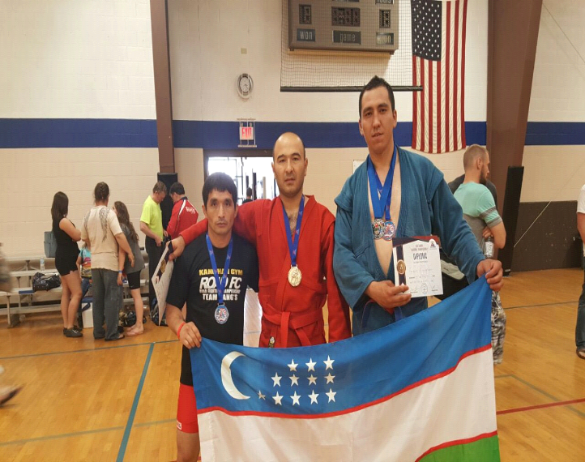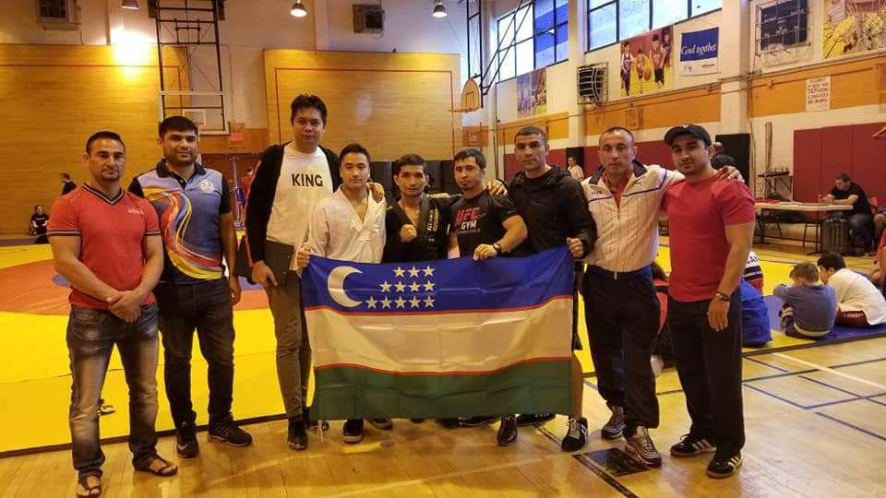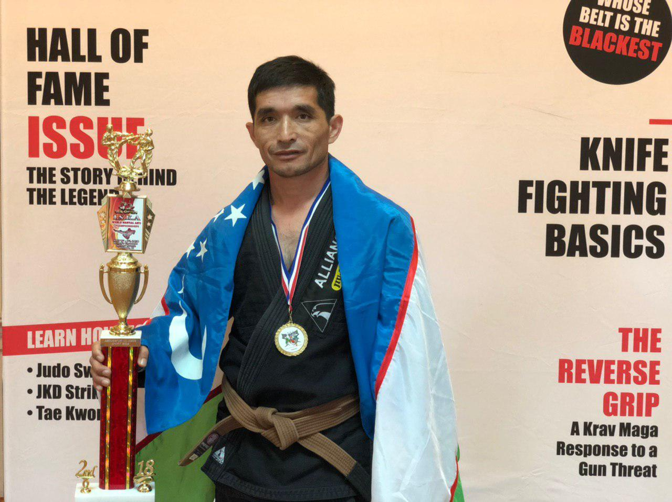

- Development of a methodology for training young Turanians on the basis of improving special competitive exercises in the learning process.

The main goal of the research is to improve the method of training young Turanians before competitions.

Based on an analysis of the research of several scientists in this field, A. Islamov points out that the following problems are encountered in improving sports training:

- Determination of the degree of difference between the planned and actual indicators of the sports training process;

- planning sports training, selection of measured content, parameters of sports results, their dynamics, size, the determination of planned cycles of sports;

- Organization of interdependence of planning and control in the framework of small, medium and large sports training cycles during the sports training process;

- The introduction of modern computer technology in the organization of the sports training process;

- changing of the republican calendar, based on the calendar of the International Federation, by the higher organizations for a number of reasons when a little time left etc.

At present, the concept of planning of sports training in the single combat Turon has changed significantly.

For the successful management of the process of training athletes two important conditions must be taken into account: first, a sharp increase of the size and severity of the load (high performance loading in modern sports is close to the limit of biological norms). Secondly, the equality of parameters and skill levels of sports training (according to the experience of the world's leading athletes). That is why the optimization of the structure of sports training and creating optimal sports training programs remains a top priority.

Sports training should be based primarily on the exact direction in dynamics, taking into account the level of physical fitness of an athlete. In this case, the regulation of loading is of great importance.

According to the analytical findings of the integrated research teams and coaching teams, each sporting exercise should be based on the individual characteristics of the athletes.

Dimensions, seriousness, means of preparation and loading styles will vary depending on the division of sports training into micro, meso and macro cycles.

As a rule, planning is divided into perspective, current and operational planning:

- Perspective- stage, period, year, for a number of years;

- Current - for sports training microclips;

- Operational - for one training.

A long-term plan is also created for each Turanian, as well as for the whole academic group. Planning of future sporting events necessarily requires the development of annual plans. A detailed description of the tools used and sports training loads are included in the annual plans.

In current planning, scientific laws (stabilization and temporary decrease in the occurrence) of the dynamics of the sports form are applied. The current planning structure is influenced by such factors as reading and order of work, course content, the total number of downloads, as well as the specific characteristics of the reaction to the sports load and the qualifications of the Turanians.

Rapid planning is based on daily planning. Such planning involves identifying the various functions, facilities, methods and importance of loading methods. The structure of sports training is determined primarily by the goal of achieving maximum sports performance. According to the accelerated plan of sports training, a conspectus is developed, which describes the main and final parts of the training, the number of repetitions, the duration of breaks and rest characteristics.

In order to eliminate shortcomings in the training of qualified athletes in Single Combat Turon, a survey was conducted among experienced foreign specialists and athletes. At the same time, practical work was carried out within the framework of the self-monitoring of Turanians in pedagogical observation and training.

The theoretical significance of the work is that large loads are systematized, which are widely used at special and competitive stages, as one of the factors of competitiveness of athletes of Single Combat Turon. Methods have been developed for consistently increasing the number of large-scale exercises and their active influence on the state of recovery after basic exercises. For the first time, based on a rational exchange of training, microcycles were obtained for the stages of special and competitive training of Turanians and experimental data were obtained on the relationship between different types of training.

Analysis of external and internal indicators and parameters that determine the level of fatigue of an athlete allows determining the load for the maximum, submaximal, large, medium and small areas within the range of a sports day and a sports training micro cycle.

A. Islamov has developed a system for accounting for the size of the load according to the following characteristics:

I. Direction. It is characterized by the dimensions of general and specialized loads in the following zones: Zone I, where the load does not exceed 150 attempts / min., Zone II, in which the load capacity is about 156-174 attempts / min., Zone III, where the intensity of the load is about 180-186 attempts / min., and IV zones, where the load capacity is more than 192 attempts / min.

II. Specialization. Download specification is carried out by the following parameters:

General physical training - unspecialized, joint loading. Special physical training - 1- specialized small volume loads. Exercises without partners, care and self-care exercises, elements of doing technical and tactical actions by signs, bridgehead exercises. Analysis of the film grams and video grams shows that their specialization does not exceed 30-40%.

Special physical training - 2- exercise on specialization. Usually this is work performed by partners and performing different tasks in different elements. Their specialization reaches 70-90%.

After research in the United States, the following recommendations were made:

* Strategy planning of the load at the stage of the annual cycle of the sports training process of young Turanians was defined and regulated.
* Developed load management software, this is a quick, daily, systematic management of the wrestlers and the load associated with the appropriate planning methodology.
* Unified formats have been developed for planning sports events within the framework of a certain structure of the load on days, weeks and stages of the sports cycle of the annual sports cycle.

When scheduling downloads, the rules of programming and organizing sports training are taken into account.

Summarizing the opinions expressed, it should be noted that, the program of training and sports training, proposed by A. Islamov, is a method of planning and controlling loads, increases the efficiency of training young Turanians and improves the management of sports activities.

Based on the above, A. Islamov offers the following practical recommendations:

* At the pre-competition stages, the system of changing of exercises of various sizes and directions should be improved. From this point of view, it is important to exercise pedagogical and medical supervision over the change of the load to the required level in accordance with the characteristics of the recovery processes of the organism.
* Functional changes occur in the body during the course as a result of prolonged musculoskeletal action and it is proposed to divide the recovery phase, leading to an increase in the level of athlete training, into two interrelated stages: Stage 1 - The first recovery, it may take from several minutes to several hours. Stage 2 - Creates an environment for the response system in the body systems.

The second stage plays a key role in creating opportunities for the body to withstand greater physical exertion. Consequently, in the creation of micro cycles work and rest are of particular importance.

3. In the practice of training qualified athletes workouts should be done twice a day and they must be scientifically and methodically based. Increase the severity of sports activity of athletes in the process of fatigue and recovery of the body, rational exchange of loads of different sizes and directions, the use of different loaded exercises (large, significant, medium, low) is divided in the following order: a) long and short-term special training, which constantly develops endurance; b) exercises that increase the specific power and speed characteristics; c) complex exercises, developing several physical properties one after another, can be increased.

**Ravshanbek Almatov** was born in 1987, "International Master of Sports" in Single Combat Turon, senior coach, "International Referee", has a bachelor's degree.

From the age of 13 he has been professionally engaged in Single combat Turon, for 10 years of sports activities he was the winner and prizewinner in the championships of Uzbekistan, participated and was a winner in Asian and prestigious international competitions.

Ravshanbek was distinguished among A. Islamov's students by his knowledge, hard work and responsibility. Therefore, the head coach of the department Single Combat Turon of the Republican College of Olympic Reserve appointed R. Almatov to be his assistant, and then recommended him as a senior coach.

R. Almatov began his career in 2006 at the Tashkent Specialized School of Olympic Reserve for Children and Adolescents as a coach of Single Combat Turon. From 2007 to 2011, he worked as a coach at the Republican College of Olympic Reserve at the Turon department. During this time, he consistently coached several members and candidates of the national team of Uzbekistan, and regularly coached several "Мasters of sports", "International masters of sports". Among his students are most champions of Uzbekistan, winners and prizewinners of Asian and prestigious international competitions. Among them are T. Islomov, Kh. Islomov, D. Nishonboev, A. Sotiboldiev, H. Ravshanov, Sh. Kholtoev, H. Uktambekov, G. Kholmurodova, S. Sultonov, A. Shukurov, A. Norboev, D. Kholboev, D. Mukhammedova and others worthily defended the dignity of our country in international sports arenas.

From 2013 to 2016 R. Almatov worked as a trainer of the national team of Uzbekistan in Single Combat Turon at the Republican Higher School of Martial Arts and trained several qualified athletes.

Ravshan to expand his knowledge and experience worked as Secretary General of the Uzbekistan Association of Single Combat Turon, Chairman of the Jury, and Assistant President of the International Association of Single Combat Turon. He also improved his qualifications as a specialist in the Ministry of Culture and Sports of Uzbekistan and the National Olympic Committee of Uzbekistan. A young and talented specialist won the respect among the sports community of the republic, sports schools and republican federations and associations through effective work to realize the talent of young people as well as through his productive work in the field of physical education and sports.

R. Almatov temporarily moved to the USA to attract youth to the sport, especially for the popularization of the Uzbek national sport Turon. To promote Single Combat Turоn among the population of America, to create conditions for young people to regularly engage in this sport, as well as to increase their interest in our homeland, to organize various tournaments on Single Combat Turоn and select talents among them on November 25, 2017 in Orlando, state Florida, Ravshan officially registered the sports club “Single Combat Turon LLC”.

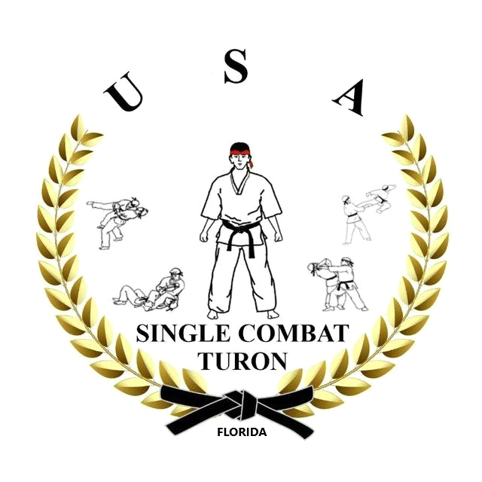

*“Single Combat Turon LLC” sport club logo*

The sports club primarily attracted local youth and Uzbek youth from the United States who came to America for various reasons. Together with their mentor A. Islamov, they successfully participated in prestigious competitions and tournaments, such as the US Open Sambo Championship in New York on May 5-6, 2018 and the “US Open, ISKA World martial arts Championship” in Orlando on July 4-5. They won 3 gold, 2 silver and 3 bronze medals. Among them - A. Islamov, U. Toirov, B. Karimov, B. Norov and others.

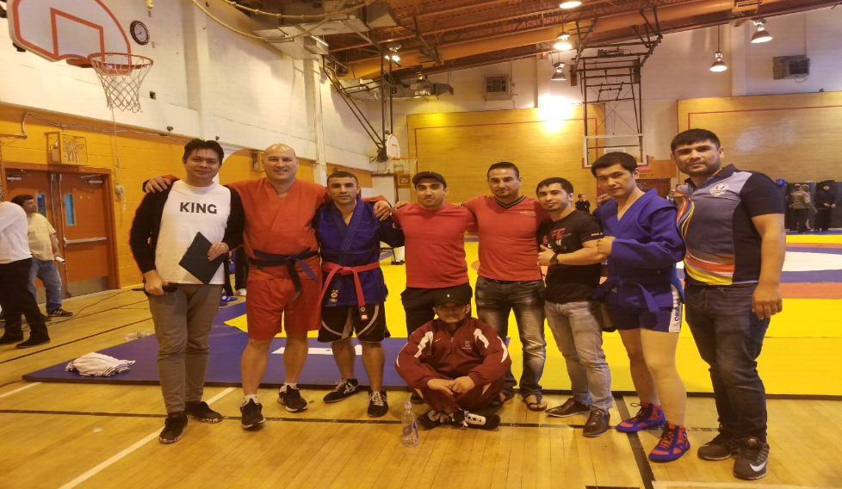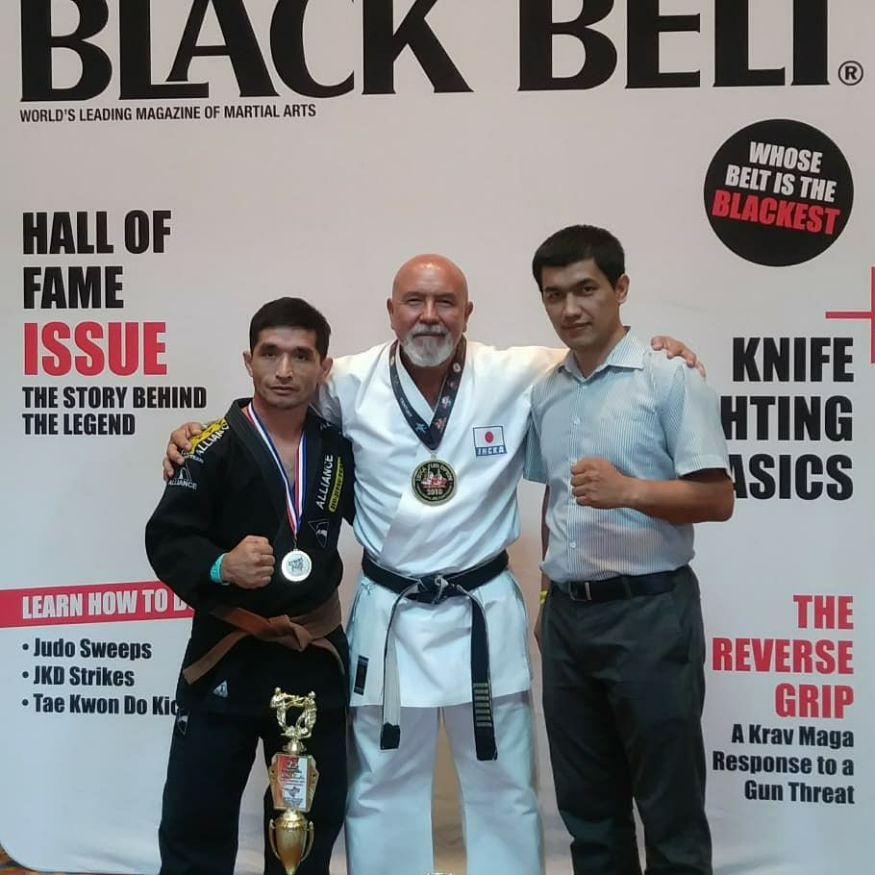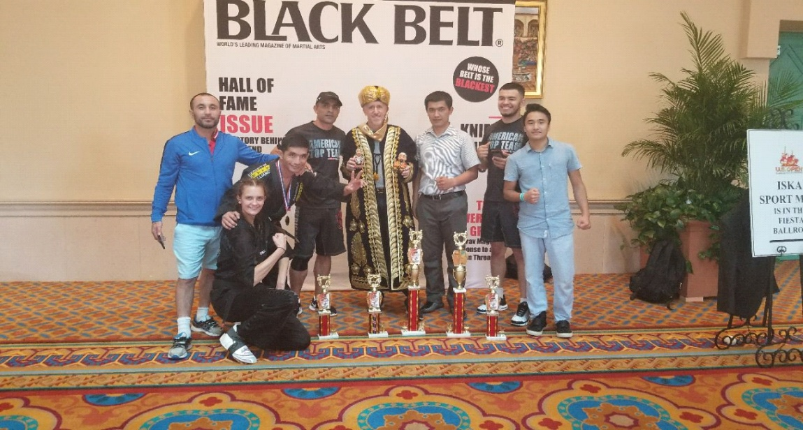

R. Almatov with a group of his compatriots intends to realize big plans in "Single Combat Turon". And also he is going to continue his research work.

Now briefly about R. Almatov's research in the United States.

He began his scientific research with the study of the psychological training of young athletes engaged in Single Combat Turon in sports club.

As you know, high sports results cannot be achieved without a good study of the psyche of athletes. Single Combat Turon is relatively a young type of sports and therefore, the psychological preparation of the Turanians has not been studied yet. Mainly coaches are responsible for the psychological preparation of athletes. However, no coach can provide the full psychological development of an athlete in terms of training and subsequent training.

A professional psychologist with experience in sports can fully prepare an athlete for physical exertion, which is constantly increasing. A psychologist can provide practical assistance in difficult situations that arise during sports trainings and during competitions. Most importantly, a good specialist can provide psychological stability during and after competitions. Therefore, when preparing a highly qualified athlete in the national teams, there must be a sports psychologist in addition to the coach.

The main goals and objectives of the study of R. Almatov are:

- Consideration of the foundations of psychological research of young Turanians.

- Consideration of methods for increasing psychological activity;

- Research of methods for diagnosing psychological aspects of young Turanians,

- Evaluation the features of the psychological training of young Turanians.

Single Combat Turon makes the highest demands on the psyche of athletes.

Physical and technical-tactical training for competition is much easier than psychological preparation.

Psychological preparation plays a special role, often in competitions. An athlete, who does not believe in himself, cannot move quickly and act consciously during a fight. On the contrary, if a Turanian is psychologically well prepared, if he is calm, believes in himself, is able to adjust his mood and movement on the battlefield, he can mobilize even with strong impacts, correctly assess the situation, taking into account the capabilities of his opponent and his ability to successfully perform tactical and technical tasks. It should be remembered that, participating in a tournament, an athlete must take part in at least 2-3 competitions and be psychologically prepared for each of them.

During the psychological preparation of the Turanians, their individual characteristics should be taken into account. Therefore, a sports psychologist must have sufficient knowledge on pedagogy, physiology and medical supervision.

Consequently, the role of the psychologist is that the Turanian must continue to work diligently on mistakes and failures during sports trainings and after failures during competitions and must continue to reach certain heights. In this case, the role of the psychologist can be described as a motivator.

A positive result can be achieved only if a sports psychologist works closely with a team of coaches, because unlike a coach, a psychologist cannot always be with an athlete (trainings, sports competitions, business trips, etc.).

The coach, in turn, can give the psychologist detailed information about the athlete.

Now, the psychological preparation of an athlete is divided into two stages - general psychological preparation and psychological preparation to competitions. Both stages are interrelated, but each has its own specifics and must be taken into account in sports training.

General psychological training is aimed at shaping the basic characteristics of a person: a variety of interests, characteristic aspects of character.

Psychological preparation of the Turanian for the upcoming competition includes tasks that need to be solved in a particular competition.

These include:

- To understand the features of the sports tasks of the upcoming competition;

- To study the strengths and weaknesses of rivals and act in accordance with these features;

- To strengthen self-confidence and ability;

- To overcome negative emotions and to create psychological readiness for the competition;

- The ability to master maximum readiness and physical strength and apply them to competitive conditions;

- The maximum relaxation after the competition and the ability to mobilize for the next competition.

Thus, the athlete's psychological readiness is that the direction of his mind and actions to solve the tasks of sports training and competition. As a rule, before the competition the athlete does not know exactly who will be his opponent. Turanian in the process of sports training should be psychologically ready to meet with any opponent according to his individual characteristics and the way of holding the competition and believe that he is ready.

In the tactical tasks of a trainer in competitions with partners, Turanian will have combat experience and will be confident in his abilities.

Psychological preparation of Turanian for the competition is of particular importance because he have to hold 2-3 competitions per day and maintain his mental and physical condition at a high level during the competition and to avoid injuries until the end of the competition.

In addition, one of the main tasks of the specialists is to ensure the recovery of the athlete in various ways from competition to competition.

Psychological preparation for competitions has four stages:

- Early psychological preparation (about a month before the competition and before the draw);

- Psychological preparation for the competition (from the announcement of the draw to the start of the competition);

- Psychological impact on the athlete and his active self-control during the competition;

- Psychological effects after the competition (depending on the results of the game).

Properly organized sports trainings (the right partners chosen to improve sportsmanship, good working conditions, the attention of the coach and the psychologist to the athlete, interesting and comprehensive exercises), the personalization of educational tasks increase the athlete's mood and enhances his desire to win.

After the draw, opponents will be known, so the coach based on his knowledge of the opponent’s skills, strengths and weaknesses will determine the technical and tactical tasks.

The athlete convince himself that he must win a certain prize (taking into account the readiness for these competitions), to this end makes full use of his technical, tactical and physical capabilities, as well as fully mobilize during the battle. In addition, for some Turanians, some distractions (entertainment, travel, movies, and comrades) play a positive role, while others prefer talking, loneliness, reading books, and so on. However, each of them worries about future competitions, Turanian is excited thinks about how to hold a competition, and he has a lot of imagination, emotions and ideas. They are afraid not to meet the expectations of the team, the coach, and close relatives.

Before a competition, a Turanian may experience strong emotion. A psychologist must help him to find ways and means of getting rid of his excitement. The psychologist or trainer should choose the methods and means to convey a positive mood.

Turanian, who won the competition, morally and physically rests, relaxes, after every competition but after a few hours or days, in the next competition, he is expected to fight a stronger opponent, and this opponent also won earlier. Therefore, he must maintain his morale and build confidence in the next competition. In this case, with analyzes, taking into account the mistakes made in the winning match, with recommendations for correcting them, with tips on better use of emotions that play a positive role has a positive effect. Of course, the victory of a strong opponent inspires the Turanian and adds strength, but it is important to draw attention to the fact that the next match will be equally difficult. In practice, there are situations when athlete wins a champion, and then loses vigilance and loses to a weaker opponent.

After competitions, Turanians have a certain time to reduce the activity of sports training, and can rest for a week. Whether the competition was successful or unsuccessful, the coach and the athlete must carefully analyze their movements in the battle. After the defeat they should not be angry with the judges, do not despair but should objectively analyze the technical and tactical, physical readiness, disclose the shortcomings, by recording positive aspects should reconsider the plans for the following competitions.

A champion Turanian also needs to analyze his movements carefully. The psychologist or trainer should prevent the student from believing that he is a champion and that he cannot be beaten. The psychologist and the trainer should praise the winner for his victory and criticize all his flaws, because his next performance should be at a higher level.

Psychological preparation of a Turanian is a long and complicated process. Aspects of the nature of a Turanian, his views, emotions, hard work, and his sportsmanship are largely determined by the degree of his psychological readiness.

For many athletes, defeat is a great spiritual trauma, a serious mental state. The psychologist must understand their spiritual condition, set them up for future competitions and draw positive conclusions from failures. Thus, he not only helps the Turanian but he also enhances his reputation.

However, the feeling of fear should not be compared with anxiety. This is excitement (even the most experienced Turanians cannot overcome it) and not fear, a manifestation of athlete’s psychological preparation before the competition - his mobilization to fight for the victory. Direct struggle for spiritual superiority occurs during the competition, where the Turanian must act with diligence, intensely and purposefully.

Courage is trained during systematic workouts. In partnerships battles, by setting different tactical tasks for the Turanian, the trainer must demand conscious, active and fearless acts from him.

Team of trainers in collaboration with experts by the end of the competition must discuss the participation of each athlete.

According to this final analysis, serious work is done on errors and omissions in the following sports trainings, and an “Individual Perspective Plan” is drawn up for each athlete to prepare for the next competition.

To achieve good results in sports, sports psychologists must be assigned to each team. Only such an approach personalizes the actions of an expert and create a long-term strategy of psychological preparation. The process of adapting a Turanian to a psychologist takes time, and maximum efficiency is achieved through systematic and individual work in conditions of mutual trust and common goals.

The psychologist should be given specific tasks, and he / she should be responsible for these recommendations in the sports process. Psychologists must be a full member of the coaching staff.

Unfortunately, today some coaches do not take into account the recommendations of the psychologist. Of course, the proposals do not always correspond to the task set, but this is not the basis for refusing psychological preparation, in this case, the psychologist must be replaced.

If there is no mutual trust between the coach and the athlete, the psychologist cannot work effectively. Psychological problems that arise when training a Turanian require different forms of solution: from group discussions to confidential conversations. All information that a psychologist receives from an athlete should be consulted with a trainer. Because the coach is responsible for result.

Summing up, it should be noted that today psychological support plays a special role in the complex preparation of athletes to achieve high results. Responsible leaders of sports organizations should take this issue seriously. Because, despite the fact that the athlete was well prepared for prestigious sports competitions, mistakes and omissions in psychological preparation have negative consequences for achieving high results.

Taking into account the above, in order to ensure good and systematic psychological support during the preparation of national teams of Uzbekistan, to train and coordinate sports psychologists, as well as to conduct research in the field of sports psychology, it is proposed to create a center of sports psychology in the scientific laboratory of the Uzbek State Institute of Physical Culture and Sports.

Bekzod Karimov, winner and medalist of the American martial arts championships, is carefully studying the sports management to help his mentors A. Islamov and R. Almatov. “Sports management plays an important role in the further development of physical culture and sports and in achieving high results,” says Bekzod. In his opinion, in many cases the head coaches of the national team at the same time comprehensively train highly qualified athletes, as well as do sports management. This negatively affects their main activities. Their main task is to prepare an athlete for the following tournaments from technical, tactical, psychological and educational points of view. A sports manager should advertise information about a sports organization, involve all segments of the population, especially young people, in sports, organize various competitions, in particular, commercial events, establish contacts with other sports and related organizations, develop sports business projects and organization strategies and deal with other organizational issues. Moreover, the most importantly a sports manager should help sports specialists achieve high results.

During the implementation of these works, in the future Karimov intends to implement perspective plans for establishing mutually beneficial cooperation between the US and Uzbekistan in the field of physical education and sports.

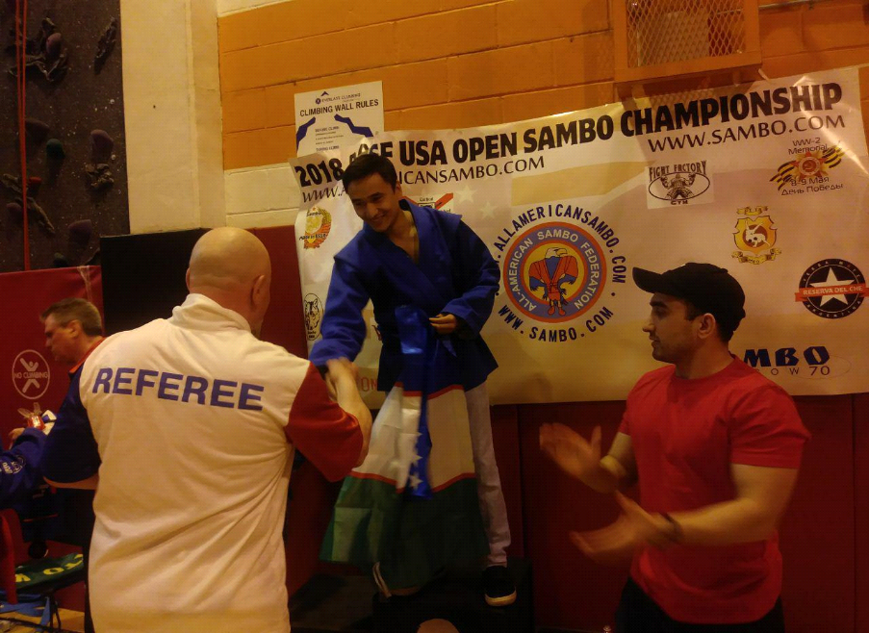

**Ubaydulla Toirov** was born in 1978, Master of Sports in freestyle wrestling, a highly qualified coach, Republican Judge, has a bachelor's degree. He has been doing freestyle wrestling since his youth. Over 13 years of sports activities, he was the winner and prizewinner of the championships of Uzbekistan and international competitions.

U. Toirov began his career in 1997 as a coach in the free-style wrestling department at the Republican School of Olympic Reserve (now the Republican College of Olympic Reserve). He professionally studied the secrets of free-style wrestling during 1997–2008, made a worthy contribution not only to the training of college athletes, but also members of the Uzbekistan national team. An experienced specialist, who diligently and responsibly refers to his work, attracted the attention of the honored coach of Uzbekistan in freestyle wrestling, senior coach of the youth national team of Uzbekistan Alexander Nedorezov. A. Nedorezov, despite the fact that Ubaydulla was young, appointed him as assistant coach, and attracted to the most responsible work in the training of highly qualified athletes. In particular, participation in the preparation of annual, monthly and short-term work plans for the thorough preparation of athletes of the junior team, execution of travel documents for athletes and coaches, supplying athletes with equipment, establishment of regular contacts with the Association of Wrestling of Uzbekistan, the Ministry of Physical Culture and Sports of the Republic of Uzbekistan, National Olympic Committee of Uzbekistan, and also with other organizations, has made the young specialist even more experienced.

U. Toirov was a judge in all republican competitions, along with these, he showed great enthusiasm in all major sporting events in Uzbekistan, including freestyle, Greco-Roman and women's wrestling in the categories of Asia, the world and the Grand Prix.

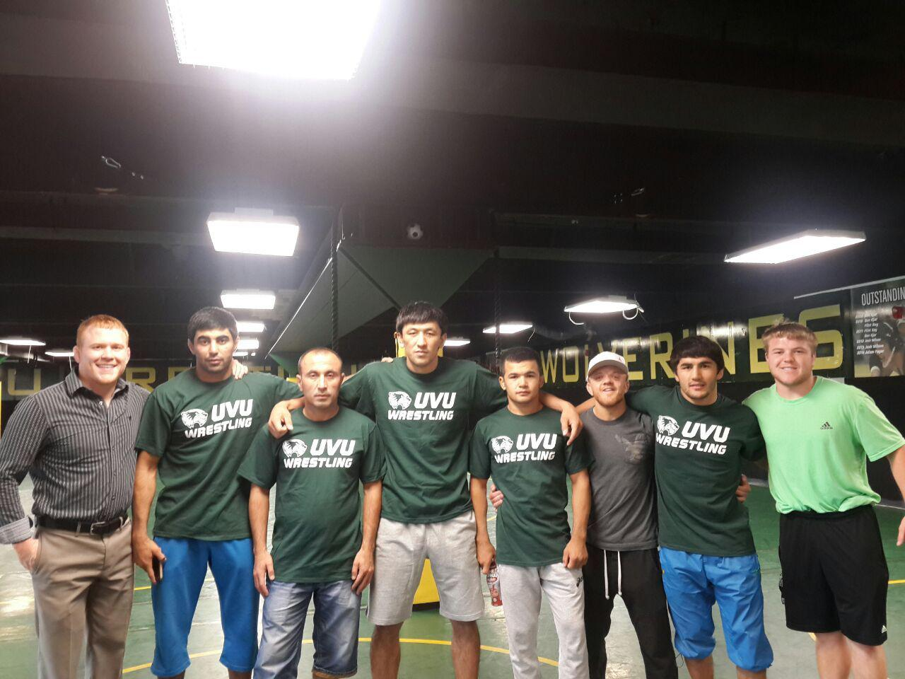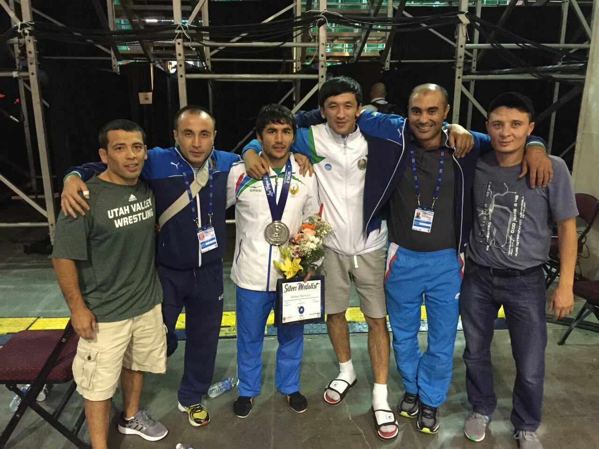

Along with the implementation of these important tasks, Ubaydulla continued to prepare his students with new methods to achieve high results. Because in most Olympic sports, the rules of the tournament change after the Olympic Games, but in the freestyle and Greco-Roman wrestling almost every year changes are made to the rules of the competition. This, in turn, requires coaches a high level of skill, intelligence, creativity, not being afraid to experiment, in general, a scientific and innovative approach to sports. U. Toirov has all these qualities.

His success in his coaching activities began in 2004.

  He assisted the senior coach in preparing the national team athletes for prestigious international competitions. At the international tournament dedicated to the memory of Mushfig Isaev, which was held in Baku (Azerbaijan) from 2005 to 2008, his students won five gold and ten silver and bronze medals. Among them was a young talented Olympic gold medalist Ihtiyor Navruzov who also won the gold medal.

U. Toirov in a short time, along with the training of members of the Uzbekistan national team, also trained many “Masters of sports”, “International masters of sports”, as well as qualified coaches and referees.

The leadership of the Association of Wrestling of Uzbekistan, seeing Ubaydulla's enthusiasm and responsibility, with high confidence appointed him as a senior coach in the department of free-style wrestling which was first opened at the Chirchik Olympic Reserve College in 2008. A year later with junior team he participated in the Asian Championships in Pune, India. His students Z. Mansurov, B. Rakhimov won gold, and J. Akhatov won the silver medal. At the 2010 Asian Championships the student of Chirchik Olympic Reserve College S. Djuraev took a high place in the pedestal. In 2012, Ubaydulla began working as an assistant coach of the national team of Uzbekistan in freestyle wrestling.

In 2013 in Delhi (India), in 2014 in Astana (Kazakhstan), in 2015 in Doha (Qatar) at the Asian Championship U. Toirov helped to prepare the national team at the highest level, and our athletes were among the winners and prizewinners. 2015 World Cup that provided a ticket to the Olympic Games in Las Vegas in the United States was another successful step in the talented coach’s activity. Ubaidulla participated in the world championship as an assistant coach of the national team. Ihtiyor Navruzov, one of his students won a gold medal and won a license for the Olympic Games. Assistant coach Toirov also made a great contribution to awarding Ihtiyor Navruzov (-65 kg) and Magomed Ibragimov (-97 kg) with a bronze medal at the XXXI Olympic Games in Rio de Janeiro, Brazil. In the same year, Ubaidullo participated in the Asian Championship with a junior team. The athletes he prepared won two gold, two silver and one bronze medals and third place in the team competition of 16 countries.

Since 2016, Ubaydulla continues his career as a coach in the United States to help his students develop their talent and achieve high results. In fact, it is difficult to find a place in the country of freestyle wrestling but he has chosen this difficult path and wants to climb the stages of victory.

In this case, his friends 12-time champion of Uzbekistan, three-time world champion among juniors and teenagers in freestyle wrestling Erkin Tadjimetov and several times champion of the country, the winner of the World Youth Championship Muzaffar Abdurahmonov, assist him.

Since 2005, Erkin Tadjimatov has worked as a freestyle-wrestling trainer at the Utah State Agricultural University in the USA. E. Tadjimetov has prepared several American champions and high-ranking wrestling athletes. He also creates all conditions for his fellow countryman-athletes to continue playing sports in America.

N. Safarov is among them. He is one of U. Toirov's students.

**Muzaffar Abdurakhmanov** moved to the United States in 2003 to continue his sports activities. From 2003 to 2007, he participated in American championships on behalf of Uzbekistan and became the strongest freestyle wrestler. Today, Muzaffar continues his coaching activities at Harvard University in Boston, Massachusetts. During this period, along with the training of highly skilled freestyle wrestlers, he provides practical assistance to Uzbek athletes. His brother Bekzod Adburakhmonov is a two-time champion of the Asian Games of 2014 and 2018 and won a bronze medal at the World Championships in those years. Bekzod Abdurakhmanov is a member of the national team of Uzbekistan, mostly his brother Muzaffar trains him in the United States for the most prestigious competitions.

The first victory of U. Toirov in America began with the open American championship, which was held in California on February 23-24, 2018.

Nodirjon Safarov (57 kg), Ubaidulla's pupil, is a member of our national team, defeated five opponents, won the gold medal and became the champion.

**Furkat Isaev** was born in 1972, he is a master of sports of the USSR in Greco-Roman wrestling, a highly qualified coach, a “Republican Judge” and has a master’s degree.

He professionally engaged in Greco-Roman wrestling and participated in various prestigious competitions in the national team of Uzbekistan for many years of his sports activities. He repeatedly won in the championships of Uzbekistan, international competitions and championships of the former USSR.

F. Isaev began his career as a coach at the Republican College of Olympic Reserves in 2005, a prestigious educational institution of the republic. Throughout his career, he coached members of the national team of Uzbekistan in Greco-Roman wrestling, and helped the team of coaches in the preparation of several winners of the Asian and World Junior Cup.

Examples are E. Tasmuradov, E. Khafizov, D. Turdiev, R. Sultanov, M. Shamsitdinov, B. Zaylobidinov, S. Kazakbaev, F. Tukhtaev, A. Murodov and others.

Constantly working on himself, not satisfied with the achieved results Furkat, who is a professional in his field, in a very short time, attracted the attention of the leadership of the Association of Wrestling in Uzbekistan. At their invitation, F. Isaev improved his qualification in many foreign countries. In particular, he coached members of the national teams of India, Morocco, Brazil and Saudi Arabia and made a great contribution to the winners of prestigious competitions. In particular, he played a decisive role in the participation of two wrestlers of the Moroccan national team in the 2012 Olympic Games in London.

Each time studying foreign experience, Furkat wanted to try his new knowledge and skills among his young talented students and introduce new learning styles. O. Kurbanov, the head coach of the Republican College of Olympic Reserve, always helped him in this.

In 2017, F. Isaev came to the United States to continue coaching activities at the invitation of several sports clubs.

In 2018, Furkat successfully began his coaching career at prestigious US sports clubs. He trains American youth in Greco-Roman wrestling, and also prepares Uzbek wrestlers for international tournaments. In particular, he prepared O. Shavkatov, a member of the national team of Uzbekistan, silver medalist of the 2018 Open Championship of Pennsylvania.

Currently F. Isaev is working as an assistant to Eddie Aguar, head coach of the "Bon Island Jiu Jitsu" sports club in Key West, Florida, in MMA, Jiu Jitsu and Wrestling.

In addition, along with coaching he also goes to the carpet as a fighter in prestigious competitions, and amazes everyone. For example, in 2013 he became the bronze medalist of the World Veterans Championship held in Bosnia and Herzegovina, in April 2019, he won one gold and one silver medals at the American Open Championship, held in Nevada, USA, under the flag of Uzbekistan.

The aforementioned heroes today are striving to achieve the highest achievements in the USA, demonstrating in practice what Uzbek sports professionals are capable of, including their coaches. The knowledge and skills acquired by our experts abroad over the years inspire them to new results.

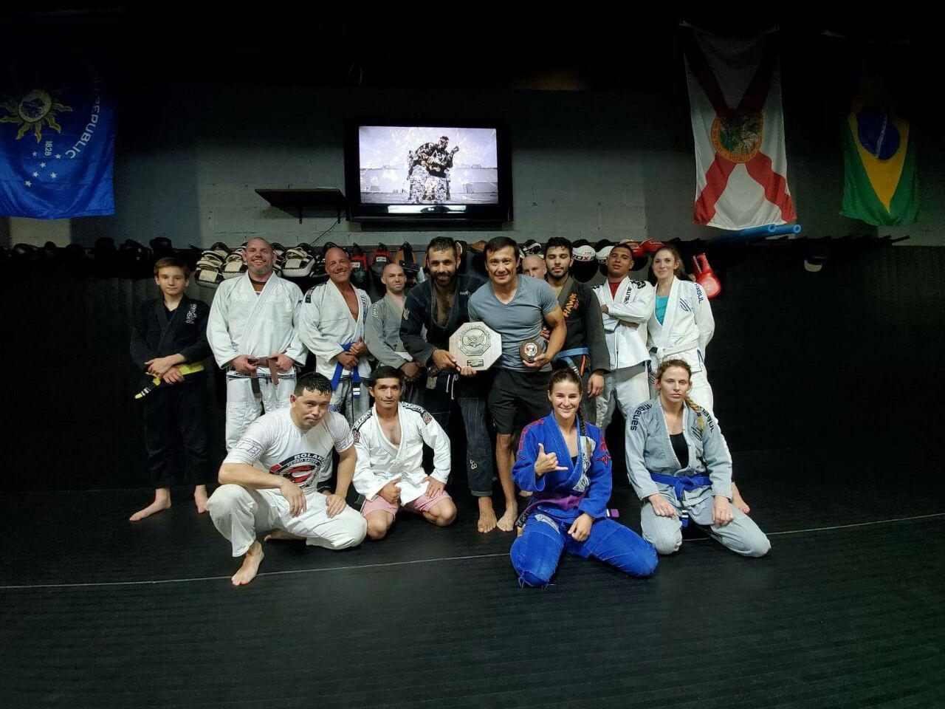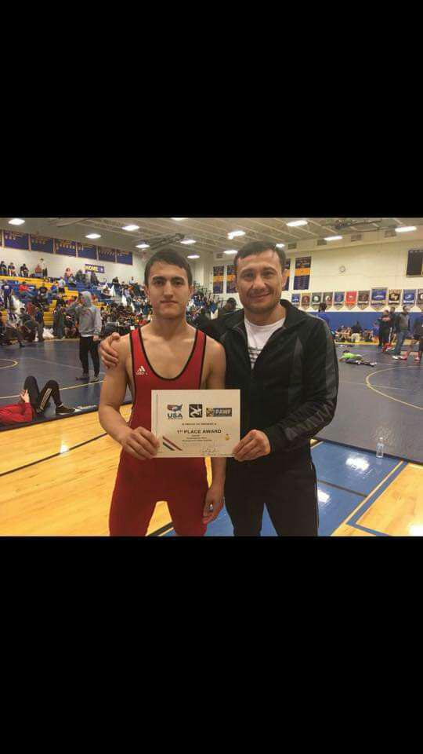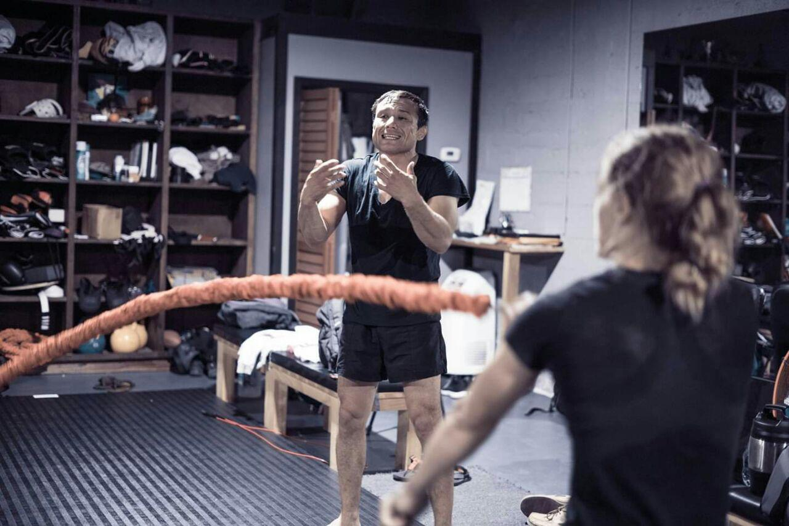

In conclusion, it should be noted that the Decree of the President of the Republic of Uzbekistan Sh. Mirziyoyev dated February 7, 2017 “On the Strategy for the Further Development of the Republic of Uzbekistan” identifies important tasks to further improve the sphere of physical culture and sports along with all spheres in the country. Currently, Uzbek youth has many opportunities to get a good education, demonstrate their talents, play sports and grow competently. As a result, the young people of our country prove that they are not inferior to anyone not only in the sport, but also in every aspect.

What skills and abilities should a sports trainer have today? It is well known that modern sport is constantly moving forward and constantly changing. In particular, martial arts coaches should study the foreign system for training highly qualified athletes in single combat, as well as thoroughly research, apply comparable methods, and introduce innovations in the implementation of the most effective aspects in general.

In this case, the relevant organizations should do the following:

1. To establish contacts with leading foreign sports organizations, including the leading sports clubs and universities that have a rich scientific and practical experience.

2. To summarize the views, considerations and scientific and practical views of our compatriots, who continue their activities abroad, on the development of physical culture and sports.

3. Preparation and dissemination of analytical, scientific journals of our compatriots on the reforms and on the problems that need to be solved in the field of physical culture and sports in Uzbekistan.

4. Formation and support of a positive image of Uzbekistan abroad, as well as the wide use of the potential of our compatriots in the consistent establishment and development of cooperation with prestigious educational and scientific centers, universities, sports clubs, government and non-governmental sports organizations in developed countries.

**Correspondence to:**

Farkhod Turdiev –

Doctor of philosophy (Ph.D.) in pedagogics, Associate professor

100114, Yunusabad district, avenue-18 (block of flats), house-39, flat 8, Tashkent, Uzbekistan

Address (U.S) 21030 US Highway 19 N, Clearwater, Florida, 33765, USA

Telephone: +998 (71) 2128435; + 1 (407)-989-74-77(US);

E-mail: [farkhod.turdiyev@mail.ru](mailto:farkhod.turdiyev@mail.ru)

**Bibliography:**

1. Alikhanov I. I. Technique tactics of freestyle wrestling. Ed. 2nd. -Moscow, “PhCS”, 1986, 304 p.
2. Begidov V. S. and others. Construction of the training process of judo wrestlers 15-17 years old / Methodical recommendations. -Tashkent, 1988, 36 p.
3. Bube H, Fack G. and others. Tests in sports practice. / Trans. from German - M., “PhCS”, 1968, 240 p.
4. Volkov V. M., Ionov S. F., Chumakov E. M. Individual planning of a sambo fighter training session // Methodical recommendations. -M. 1976, 42 p.
5. Volkov V. M., Filin V. P. Sports selection. - M., “FiS”, 1983, 171 p.
6. Godik M. A. Control of training and competitive loads. -M, “PhCS”, 1980, 135 p.
7. Ivankov Ch. T. Fundamentals of the theory and methods of wrestling. -M, 1995, 150 p.
8. Kerimov N. A. Speed-strength training of judo wrestlers and freestyle wrestlers / Methodical recommendations. -T, 1990, 20p.
9. Matveev L. P. Basics of sports training. -M, PhCS, 1977, 280 p.
10. Matveev L. P. Theory of sports (integrative aspects) Textbook for bachelors and masters. -M, 1994, 360 p.
11. Nabatnikova M. Ya. On the training loads of young athletes // Scientific and Sports Bulletin - 1979, No. 2, p. 11-13.
12. Skott J. Status of youth wrestling in the United States of Amerika// International Conference “Wrestling for children and youth” - Moscow, July 10, 1998. p. 37-45.
13. Topalova I. Method for objective diagnostics of the rhythmical -motor coordination/ in the int. dig. “Man in the world of sports: new ideas, technologies, perspectives” Publishing house “Physical culture, education, science”. - M, 1988, pp. 70-72.
14. Shukurov R. S. Single Combat Turon. // Bukhara, 2010. 72 p.
15. Gapparov Z. G. Sport psychology. Textbook. // Tashkent, 2011. 364 p.
16. Baturin N. A. The psychology of success and failure in sports activities. / / Omsk. - 1998.
17. Saidov B. X. Turon. The only rules of the competition. // Tashkent, 2004. 254 p.
18. Islamov. A. A.,. Hidoyatov B. U., Almatov R. T, etc., A textbook for the education and training of coaches and athletes. // Tashkent. MAET. 2010. 304 p.
19. Vyatkina B. A. Managing mental stress in sports competitions. // Moscow, Physical Culture and Sport. 2001.
20. Giessen L. D. Psychology and mental health in sports. // Moscow, 2003. 149 p.
21. Gorbunov G. D. Practical psychologist in sports. // Moscow, 2006. 207 p.
22. Puni A. S. Features of the process of psychological preparation for competition.// Moscow.1999.
23. Ilyin E. P. Psychology of physical education. // Moscow, 1997. 320 p.
24. Marishchuk V. L. The appointment and use of psychodiagnostic methods. // Moscow. Enlightenment, 2002. 8-16 p.
25. Nekrasov V. P. and others. Psychoregulation in the training of athletes. // Moscow. 2005. 132 p.
26. Khudadov N. A. Psychological training of boxers. // Moscow. Physical culture and sport, 1998.

**Internet sites**

1. Methods of diagnosing the status, activity and mood (SAN). <<http://psylist.net/praktikum/41.htm>>.
2. www.turon-iscta.uz
3. www.turon.uz

5/25/2019