Biosynthesis Of Silver Nano-Particles From Plant Extract

Hardeep Singh

Lecturer in Biology, Govt. Senior Secondary School, Singowal in Jind, Haryana (India)
Email: hssonadil@gmail.com

Abstract: In recent science Nanotechnology is a burning field for the researchers. Nanotechnology deals with the Nanoparticles having a size of 1-100 nm in one dimension used significantly concerning medical chemistry, atomic physics, and all other known fields. Nanoparticles are used immensely due to its small size, orientation, physical properties, which are reportedly shown to change the performance of any other material which is in contact with these tiny particles. These particles can be prepared easily by different chemical, physical, and biological approaches. But the biological approach is the most emerging approach of preparation, because, this method is easier than the other methods, ecofriendly and less time consuming. The Green synthesis was done by using the aqueous solution of Ocimum tenuiflorum (Tulsi) leaf extract and AgNO3. Silver was of a particular interest for this process due to its evocative physical and chemical properties. A fixed ratio of plant extract to metal ion was prepared and the color change was observed which proved the formation of nanoparticles. The nanoparticles were characterized by UV-vis Spectrophotometer and its action on bacterial growth.
[Hardeep Singh. Biosynthesis Of Silver Nano-Particles From Plant Extract. N Y Sci J 2019;12(5):37-43]. ISSN 1554-0200 (print); ISSN 2375-723X (online). http://www.sciencepub.net/newyork. 7. doi:10.7537/marsnys120519.07.

Keywords: Silver, Nano-Particles, Plant, Spectrophotometers.

Introduction:
Due to swift industrialization and urbanization, our environment is undergo huge smash up and a large amount of perilous and superfluous chemical, gases or substances are released, and so now it is our need to learn about the secrets that are present in the Nature and its products which leads to the growth of advancements in the synthesis processes of nanoparticles. Nanotechnology applications are highly suitable for biological molecules, because of their exclusive properties. The biological molecules undergo highly controlled assembly for making them suitable for the metal nanoparticle synthesis which was found to be reliable and eco friendly. The synthesis of metal and semiconductor nanoparticles is a vast area of research due to its potential applications which was implemented in the development of novel technologies. The field of nanotechnology is one of the upcoming areas of research in the modern field of material science. Nanoparticle show completely new or improved properties, such as size, distribution and morphology of the particles etc. Novel applications of nanoparticles and nanomaterials are emerging rapidly on various fields.
Metal nanoparticles have a high specific surface area and a high fraction of surface atoms. Because of the unique physicochemical characteristics of nanoparticles, including catalytic activity, optical properties, electronic properties, antibacterial properties, and magnetic properties they are gaining the interest of scientist for their novel methods of synthesis. Over the past few years, the synthesis of metal nanoparticles is an important topic of research in modern material science. Nano-crystalline silver particles have been found tremendous applications in the fields of high sensitivity biomolecular detection, diagnostics, antimicrobials, therapeutics, catalysis and micro-electronics. However, there is still need for economic commercially viable as well as environmentally clean synthesis route to synthesize the silver nanoparticles. Silver is well known for possessing an inhibitory effect toward many bacterial strains and microorganisms commonly present in medical and industrial processes. In medicines, silver and silver nanoparticles have a ample application including skin ointments and creams containing silver to prevent infection of burns and open wounds, medical devices and implants prepared with silver-impregnated polymers. In textile industry, silver-embedded fabrics are now used in sporting equipment.
Nanoparticles can be synthesized using various approaches including chemical, physical, and biological. Although chemical method of synthesis requires short period of time for synthesis of large quantity of nanoparticles, this method requires capping agents for size stabilization of the nanoparticles. Chemicals used for nanoparticles synthesis and stabilization are toxic and lead to non-ecofriendly byproducts. The need for environmental non-toxic synthetic protocols for nanoparticles synthesis leads to the developing interest in biological approaches which are free from the use oftoxic chemicals as byproducts. Thus, there is an increasing demand for „„green nanotechnology”. Many biological approaches for both extracellular and intracellular nanoparticles synthesis have been reported till date using microorganisms including bacteria, fungi and plants.
Plants provide a better platform for nanoparticles synthesis as they are free from toxic chemicals. Moreover, use of plant extracts also reduces the cost of microorganisms isolation and culture media enhancing the cost competitive feasibility over nanoparticles synthesis by microorganisms.
Sometimes the synthesis of nanoparticles using various plants and their extracts can be advantageous over other biological synthesis processes which involve the very complex procedures of maintaining microbial cultures. Many such experiments have already been started such as the synthesis of various metal nanoparticles using fungi like Fusariumoxysporum, Penicillium sp. and using some bacteria such as Bacillus subtilis etc. But, synthesis of nanoparticles using plant extracts is the most adopted method of green, eco-friendly production of nanoparticles and also has a special advantage that the plants are widely distributed, easily available, much safer to handle and act as a source of several metabolites. There has also been several experiments performed on the synthesis of silver nanoparticles using medicinal plants such as Oryza sativa, Helianthus annus, Saccharumofficinarum, Sorghumbicolour, Zeamays, Basella alba, Aloe vera Capsicum annuum, Magnolia kobus, Medicago sativa (Alfalfa), Cinamomumcamphora and Geranium sp. in the field of pharmaceutical applications and biological industries. Besides, green synthesis of silver nanoparticles using a methanolic extract of Eucalyptus hybrid was also investigated.
In the recent days, silver nanoparticles have been synthesized from the naturally occurring sources and their products like green tea (Camellia sinensis), Neem (Azadirachtaindica), leguminous shrub (Sesbaniadrummondii), various leaf broth, natural rubber, starch, Aloe vera plant extract, lemongrass leaves extract, etc. With respect to the microbes, the silver nanoparticles get attached to the cell wall, thereby disturbing the permeability of cell wall and cellular respiration. The nanoparticles may also penetrate deep inside the cell wall, thus causing cellular damage by interacting with phosphorus and sulfur containing compounds, such as DNA and protein, present inside the cell. The bacteriocidal properties of silver nanoparticles are due to the release of silver ions from the particles, which confers the antimicrobial activity. Besides, the potency of the antibacterial effects corresponds to the size of the nanoparticle. The smaller particles have higher antibacterial activities due to the equivalent silver mass content. With respect to the clinical applications of nanoparticle, microorganisms including diatoms, fungi, bacteria and yeast producing inorganic materials through biological synthesis either intra or extracellularly made nanoparticles more biocompatible.
Review of Literature: Nanotechnology is an important field of modern research dealing with design, synthesis, and manipulation of particles structure ranging from approximately 1-100 nm in one dimension. Remarkable growth in this up-and-coming technology has opened novel fundamental and applied frontiers, including the synthesis of nanoscale materials and exploration or utilization of their exotic physicochemical and optoelectronic properties. Nanotechnology is rapidly gaining importance in a number of areas such as health care, cosmetics, food and feed, environmental health, mechanics, optics, biomedical sciences, chemical industries, electronics, space industries, drug-gene delivery, energy science, optoelectronics, catalysis, reorography, single electron transistors, light emitters, nonlinear optical devices, and photoelectrochemical applications. Nanomaterials are seen as solution to many technological and environmental challenges in the field of solar energy conversion, catalysis, medicine, and water treatment. In the context of global efforts to reduce hazardous waste, the continuously increasing demand of nanomaterials must be accompanied by green synthesis methods. [1]
Nanotechnology is fundamentally changing the way in which materials are synthesized and devices are fabricated. Incorporation of nanoscale building blocks into functional assemblies and further into multifunctional devices can be achieved through a “bottom-up approach”. Research on the synthesis of nanosized material is of great interest because of their unique properties like optoelectronic, magnetic, and mechanical, which differs from bulk.
Nanoparticles: The term “nanoparticles” is used to describe a particle with size in the range of 1nm100nm, at least in one of the three possible dimensions. In this size range, the physical, chemical and biological properties of the nanoparticles changes in fundamental ways from the properties of both individual atoms/molecules and of the corresponding bulk materials. Nanoparticles can be made of materials of diverse chemical nature, the most common being metals, metal oxides, silicates, non-oxide ceramics, polymers, organics, carbon and biomolecules. Nanoparticles exist in several different morphologies such as spheres, cylinders, platelets, tubes etc. Generally the nanoparticles are designed with surface modifications tailored to meet the needs of specific applications they are going to be used for. [2] The enormous diversity of the nanoparticles arising from their wide chemical nature, shape and morphologies, the medium in which the particles are present, the state of dispersion of the particles and most importantly, the numerous possible surface modifications the nanoparticles can be subjected to make this an important active field of science now-a-days.
Types of nanoparticles: Nanoparticles can be broadly grouped into two, namely, organic nanoparticles which include carbon nanoparticles (fullerenes) while, some of the inorganic nanoparticles include magnetic nanoparticles, noble metal nanoparticles (like gold and silver) and semiconductor nanoparticles (like titanium oxide and zinc oxide). There is a growing interest in inorganic nanoparticles i.e. of noble metal nanoparticles (Gold and silver) as they provide superior material properties with functional versatility. [3] Due to their size features and advantages over available chemical imaging drug agents and drugs, inorganic particles have been examined as potential tools for medical imaging as well as for treating diseases. Inorganic nonmaterial have been widely used for cellular delivery due to their versatile features like wide availability, rich functionality, good compatibility, and capability of targeted drug delivery and controlled release of drugs. [4]
Silver nanoparticles: These are of interest because of the unique properties (e.g., size and shape depending optical, electrical, and magnetic properties) which can be incorporated into antimicrobial applications, biosensor materials, composite fibers, cryogenic superconducting materials, cosmetic products, and electronic components. Several physical and chemical methods have been used for synthesizing and stabilizing silver nanoparticles. The most popular chemical approaches, including chemical reduction using a variety of organic and inorganic reducing agents, electrochemical techniques, physicochemical reduction, and radiolysis are widely used for the synthesis of silver nanoparticles. [5] Recently, nanoparticle synthesis is among the most interesting scientific areas of inquiry, and there is growing attention to produce nanoparticles using environmentally friendly methods (green chemistry). Green synthesis approaches include mixed-valence polyoxometalates, polysaccharides, Tollens, biological, and irradiation method which have advantages over conventional methods involving chemical agents associated with environmental toxicity. This chapter presents an overview of silver nanoparticlepreparation by physical, chemical, and green synthesis approaches. The aim of this chapter is, therefore, to reflect on the current state and future prospects, especially the potentials and limitations of the above mentioned techniques for industries. Moreover, we discuss the applications of silver nanoparticles and their incorporation into other materials, the mechanistic aspects of the antimicrobial effects of silver nanoparticles. [6]
Need for green synthesis: Biosynthesis of nanoparticles is a kind of bottom up approach where the main reaction occurring is reduction/oxidation. The need for biosynthesis of nanoparticles rose as the physical and chemical processes were costly. Often, chemical synthesis method leads to presence of some of the toxic chemical absorbed on the surface that may have adverse effect in the medical applications. This is not an issue when it comes to biosynthesized nanoparticles via green synthesis route. So, in the search of cheaper pathways for nanoparticles synthesis, scientist used microbial enzymes and plant extracts (phytochemicals). With their antioxidant or reducing properties they are usually responsible for the reduction of metal compounds into their respective nanoparticles. Green synthesis provides advancement over chemical and physical method as it is cost effective, environment friendly, easily scaled up for large scale synthesis and in this method there is no need to use high pressure, energy, temperature and toxic chemicals. [7]
Nanosilver: One of the substances used in nanoformulation is silver (nanosilver). Due to its antimicrobial properties, silver has also been incorporated in filters to purify drinking water and clean swimming pool water. To generate nanosilver, metallic silver has been engineered into ultrafine particles by several methods; include spark discharging, electrochemical reduction, solution irradiation and cryo- chemical synthesis. Nanosilver particles are mostly smaller than 100 nm and consist of about 20-15,000 silver atoms. In addition, nanostructures can be produced as tubes, wires, multifactes or films. At the nano-scale, the silver particles exhibit deviating physico-chemical properties (like pH dependent partitioning to solid and dissolved particulate matters) and biological activites compared with the regular metal. This is due to the higher surface area per mass, allowing a larger amount of atoms to interact with their surroundings. Due to the properties of silver at the nanoscale, nanosilver is nowadays used in an increasing number of consumer and medical products. Because, silver is a soft white lustrous element, an important use of silver nanoparticles is to give a product a silver finish. Still, the remarkably strong antimicrobial activity is the major direction for development of nano-silver products. Examples are food packaging materials and food supplements, odour-resistant textiles, electronics, household appliances, cosmetics and medical advices, water disinfectants and room sprays.
Why Silver: Silver is one of the basic element that makes up our planet. It is a rare, but naturally occurring element, slightly harder than gold and very ductile and malleable. Pure silver has the highest electrical and thermal conductivity of all metals and has the lowest contact resistance. Silver can be present in four different oxidation states: Ag0, Ag2+, Ag3+. The former two are the most abundant ones, the latter are unstable in the aquatic environment. Metallic silver itself is insoluble in water, but metallic salts such as AgNO3 and Silver chloride are soluble in water (WHO,2002). Metallic silver is used for the surgical prosthesis and splints, fungicides and coinage. Soluble silver compounds such as silver slats, have been used in treating mental illness, epilepsy, nicotine addition, gastroenteritis and infectious diseases including syphilis and gonorrhea. Although acute toxicity of silver in the environment is dependent on the availability of free silver ions, investigations have shown that these concentrations of Ag+ ions are too low to lead toxicity (WHO, 2002). Metallic silver appears to pose minimal risk to health, whereas soluble silver compounds are more readily absorbed and have the potential to produce adverse effects. The wide variety of uses of silver allows exposure through various routes of entry into the body. Ingestion is the primary route for entry for silver compounds and colloidal silver proteins. Dietary intake of silver is estimated at 7090μg/day. Since silver in any form is not thought to be toxic to the immune, cardiovascular, nervous or reproductive system an it is not considered to be carcinogenic, therefore silver is relatively non-toxic. Silver demand will likely to rise as silver find new uses, particularly in textiles, plastics and medical industries, changing the pattern of silver emission as these technologies and products diffuse through the global economy. [8]
Action of Silver Nanoparticles on microbes: The exact mechanism which silver nanoparticles employ to cause antimicrobial effect is not clearly known and is a debated topic. There are however various theories on the action of silver nanoparticles on microbes to cause the microbicidal effect. Silver nanoparticles have the ability to anchor to the bacterial cell wall and subsequently penetrate it, thereby causing structural changes in the cell membrane like the permeability of the cell membrane and death of the cell. There is formation of pits on the cell surface, and there is accumulation of the nanoparticles on the cell surface. The formation of free radicals by the silver nanoparticles may be considered to be another mechanism by which the cells die. There have been electron spin resonance spectroscopy studies that suggested that there is formation of free radicals by the silver nanoparticleswhen in contact with the bacteria, and these free radicals have the ability to damage the cell membrane and make it porous which can ultimately lead to cell death. It has also been proposed that there can be release of silver ions by the nanoparticles, and these ions can interact with the thiol groups of many vital enzymes and inactivate them. The bacterial cells in contact with silver take in silver ions, which inhibit several functions in the cell and damage the cells. Then, there is the generation of reactive oxygen species, which are produced possibly through the inhibition of a respiratory enzyme by silver ions and attack the cell itself. Silver is a soft acid, and there is a natural tendency of an acid to react with a base, in this case, a soft acid to react with a soft base. The cells are majorly made up of sulfur and phosphorus which are soft bases. The action of these nanoparticles on the cell can cause the reaction to take place and subsequently lead to cell death. Another fact is that the DNA has sulfur and phosphorus as its major components; the nanoparticles can act on these soft bases and destroy the DNA which would definitely lead to cell death. The interaction of the silver nanoparticles with the sulfur and phosphorus of the DNA can lead to problems in the DNA replication of the bacteria and thus terminate the microbes. It has also been found that the nanoparticles can modulate the signal transduction in bacteria. It is a wellestablished fact that phosphorylation of protein substrates in bacteria influences bacterial signal transduction. Dephosphorylation is noted only in the tyrosine residues of gram-negative bacteria. The phosphotyrosine profile of bacterial peptides is altered by the nanoparticles. It was found that the nanoparticles dephosphorylate the peptide substrates on tyrosine residues, which leads to signal transduction inhibition and thus the stoppage of growth. It is however necessary to understand that further research is required on the topic to thoroughly establish the claims. [9]
Toxicity of silver nanoparticles: The unique physical and chemical properties of silver nanoparticles make them excellent candidates for a number of day-to-day activities, and also the antimicrobial and antiinflammatory properties make them excellent candidates for many purposes in the medical field. However, there are studies and reports that suggest that nanosilver can allegedly cause adverse effects on humans as well as the environment. It is estimated that tonnes of silver are released into the environment from industrial wastes, and it is believed that the toxicity of silver in the environment is majorly due to free silver ions in the aqueous phase. The adverse effects of these free silver ions on humans and all living beings include permanent bluish-gray discoloration of the skin (argyria) or the eyes (argyrosis), and exposure to soluble silver compounds may produce toxic effects like liver and kidney damage; eye, skin, respiratory, and intestinal tract irritations; and untoward changes in blood cells. Since the beginning of the twenty-first century, nanosilver has been gaining popularity and is now being used in almost every field, most importantly the medical field. However, there have been reports of how nanosilver cannot discriminate between different strains of bacteria and can hence destroy microbes beneficial to the ecology. There are only very few studies conducted to assess the toxicity of nanosilver. In one study, in vitro toxicity assay of silver nanoparticles in rat liver cells has shown that even low-level exposure to silver nanoparticles resulted in oxidative stress and impaired mitochondrial function. Silver nanoparticles also proved to be toxic to in vitro mouse germ line stem cells as they impaired mitochondrial function and caused leakage through the cell membranes. There is evidence that shows that silver ions cause changes in the permeability of the cell membrane to potassium and sodium ions at concentrations that do not even limit sodium, potassium, ATP, or mitochondrial activity. The literature also proves that nanosilver can induce toxic effects on the proliferation and cytokine expression by peripheral blood mononuclear cells. Nanosilver is also known to show severe toxic effects on the male reproductive system. Research shows that nanosilver can cross the blood-testes barrier and be deposited in the testes where they adversely affect the sperm cells. Even commercially available silver-based dressings have been proved to have cytotoxic effects on various experimental models. In vivo studies on the oral toxicity of nanosilver on rats have indicated that the target organ in mouse for the nanosilver was the liver. It was also found from histopathological studies that there was a higher incidence of bile duct hyperplasia, with or without necrosis, fibrosis, and pigmentation in the study animals. Hence, it is imperative that more studies be carried out to assess the toxicity effect nanosilver has in vivo before a conclusion on its toxicity is reached. [10]

Materials:
UV Spectro-Photometer, Bacteria, Autoclave, Laminar Air Flow, Incubator, Tulsi leaves, filter paper, Nutrient Media, Petri Plate, Distilled Water, 100 ML Silver Nitrate ( 0.002M ), beakers, flasks, test tubes, micropipettes, hot plate, stirrer.

Method:
Preparationof Plant Extract: Fresh leaves of Ocimum tenuiflorum, were collected from Bhrama Sarovar and washed several times with water to remove the dust particles. Then plant extract was prepared by cutting leaves into small pieces and mixing with distilled water in a 250ml beaker. Then the solution was boiled for 10 min. Then this solution was filtered 4-5 time with the help of filter paper. Then the solution was used for the reduction of silver ions Ag+ to silver nanoparticles (Ago).
Synthesis of silver nanoparticles: 1mM AgNO₃solution was prepared. This solutionwasadded in the prepared plant extract drop by drop. Then the bioreduced aqueous component was used to measuring UV-Vis spectra of the solution.
Characterstics of silver nanoparticles:
Colour change: When plant extract was added to the AgNO₃ solution drop by drop, its colour changes from transparent to dark brown. This colour change indicates the formation of silver nanoparticles.
UV-Vis Spectrophotometer analysis: The optical property of Ag_NPs is determined by UV-Vis spectrophotometer. After the addition of AgNO3 to the plant extract, the spectras were taken between 340 nm to 600 nm. The maximum absorption comes from wavelength of 420-480nm. For Ocimum tenuiflorum maximum absorption was recorded on 460 nm, which indicates the formation of silver nanoparticles.
Action of Silver nanoparticles on microbes: First of all nutrient agar media was made by adding 14g of nutrient agar and 7g of agar powder in 250ml of distilled water and then mixing and boiling it properly. Then this media was sterilized in autoclave. Then this media was poured in sterile petri plates inside laminar air flow a0nd when media got solidified, the micro-organisms, on which we want to check the action of nanoparticles, were spread. We used 4 micro-organisms (Escherichia coli, Bacillussubtilis, Staphylococusaureus and Pseudomonas) in 4 plates. These plates were covered and put for incubation of micro-organisms in incubator for 4-5 hrs at 37.C.
Then 2 wells were made in each petriplate using puncture syringein the laminar air flow and then these wells were filled by the silver nanoparticles solution using micro pipettes. Then these plates were placed in incubator for 1 day at 37.C. Next day, the petri-plates were observed. Clear zones around the wells indicates the formation nanoparticles.

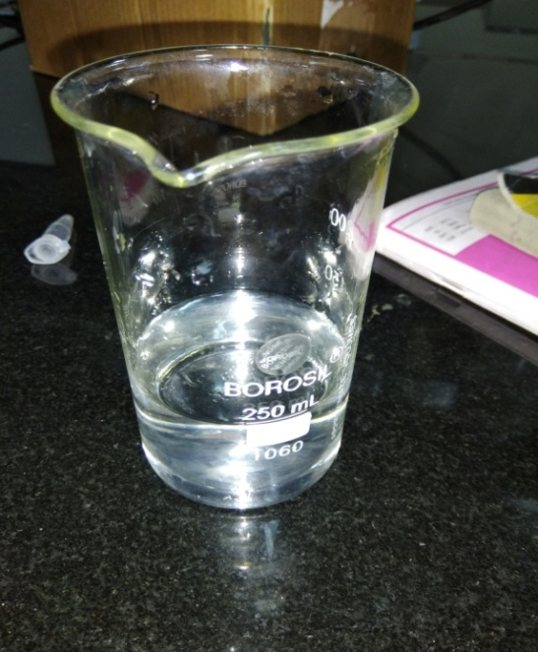
AgNO₃ solution (Fig.1)
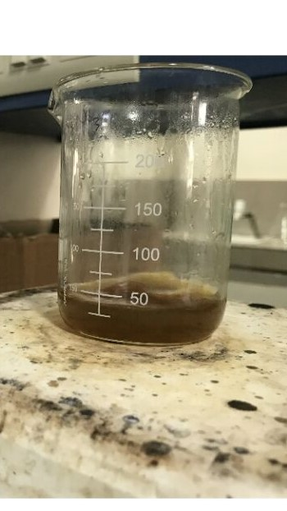
After adding plant extract (Fig.2)

Results:
1. Colour change: Change in colour was observed when plant extract was added in AgNo₃ solution from transparent (as shown in fig.1) to dark brown (fig.2), so the silver nanoparticles were formed.
2. Spectrophotometer analysis: Reduction of silver ions into silver nanoparticles during exposure to plant extracts was observed as a result of the color change. The sharp bands of silver nanoparticles were observed around 460 nm in case of Ocimum tenuiflorum. From different literatures it was found that the silver nanoparticles show peak at around 420-480 nm. From our studies we found the peak for Ocimum tenuiflorum at 460 nm. The reduction of the metal ions occurs fairly rapidly; more than 90% of reduction of Ag+ ions is complete within 4 Hrs. after addition of the metal ions to the plant extract.

Wavelentgh | 340 | 360 | 380 | 400 | 420 | 440 | 460 | 480 | 500 | 520 | 540 | 560 | 580 | 600
Absorbance | 0.899 | 1.121 | 1.542 | 1.79 | 1.97 | 2.103 | 2.424 | 2.189 | 2.018 | 1.896 | 1.786 | 1.534 | 1.452 | 1.315

These readings were obtained from the spectrophotometer analysis

Wavelength
Graph formed by the readings between Wavelength and absorption.
Peak: At 460 nm

Action on microbes: Silver nanoparticles have antibacterial properties, so they can inhibit the growth of certain bacteria. They form clear zones of inhibition which shows that there is no growth of bacteria. Clear zones were observed around the wells, which confirms that nanoparticles were formed and are functional.
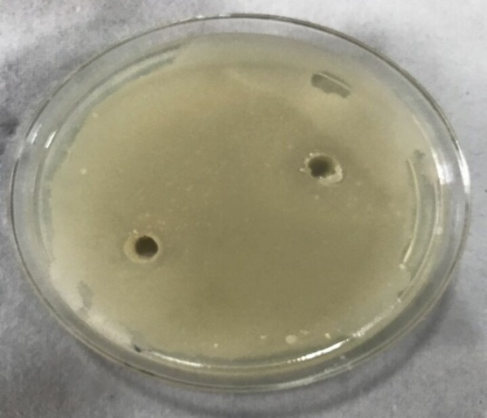
Staphylococus aurus (Fig.3)

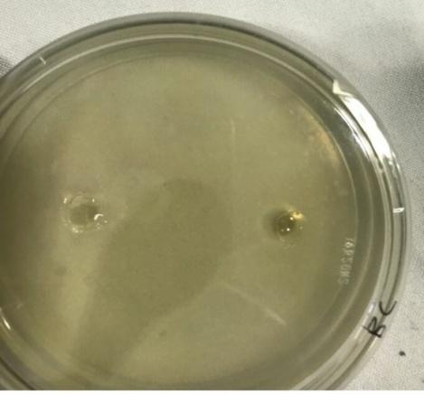
Bacillus subtilis (Fig.4)
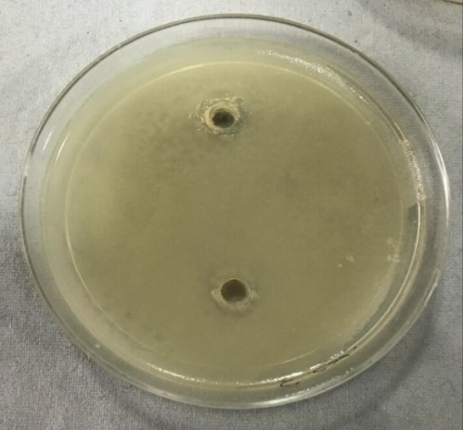
Escherichia coli (Fig. 5)
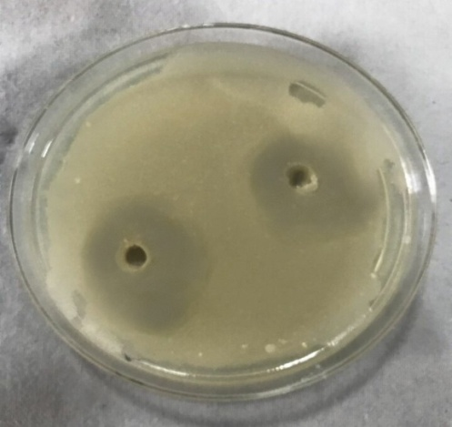
Pseudomonas (Fig. 6)

In Fig.3, Fig.4 and Fig.5 we can see a good growth of Staphylococus aurus, Bacillus subtilis, Escherichia coli respectively all over the surface of media, but in Fig.6 we can see clear zones of inhibition of growth of Pseudomonas around the wells, which represents the antimicrobial property of silver nanoparticles.

Conclusion:
The rapid biological synthesis of silver nanoparticles using Ocimum tenuiflorum leaves extract provides environmental friendly, simple and efficient route for synthesis of nanoparticles. From our study we found that silver nanoparticles made from leaf extract of Ocimum tenuiflorum worked on Pseudomonas properly but other bacteria were not affected to that much extent. From the technological point of view these obtained silver nanoparticles have potential applications in the biomedical field because of their antimicrobial properties and this simple procedure has several advantages such as cost-effectiveness, compatibility for medical and pharmaceutical applications as well as large scale commercial production.

Bibliography:
- Harekrishna Bar, D.K.B., Gobinda sahoo P, priyanka Sarkar, Sankar PD., "Green synthesis of silvernanoparticles using latex of Jatropha curcas.". Colliod surface A, 2009. 39(3): p. 134-139.
- Cassandra D, N.N., Jodi H, Linfeng G, Tan, Li, et al., "Green synthesis of gold and silver nanoparticles from plant extracts.".
- Kaviya S, S.J., Viswanathan B., "Green Synthesis of silver nanoparticles using Polyalthia longifolia Leaf extract along with D-Sorbitol.". Journal of nanotechnology, 2011: p. 1-5.
- Catauro M, R.M., De Gaaetano FD, Marotta A, "Sol–gel processing of drug delivery materials and release kinetics.". J Mater Sci Mater Med, 2005. 16(3): p. 261-265.
- Crabtree JH, B.R., Siddiqi Ra, Huen IT, Handott LL, Fishman A, "The efficacy of silver-ion implanted catheters in reducing peritoneal dialysis-related infections.". Perit Dial Int, 2003. 23(4): p. 368-374. 6. Krolikowska A, K.A., Michota A, Bukowska J, "SERS studies on the structure of thioglycolic acid monolayers on silver and gold.". Surf Sci, 2003. 532: p. 227-232.
- Zhao G, S.J., "Multiple parameters for the comprehensiveevaluation of the susceptibility of Escherichia coli to the silver ion.". Biometals, 1998. 11: p. 27.
- Jiang H, M.S., Wong ACL, Denes FS, "Plasma enhanced deposition of silver nanoparticles onto polymer and metal surfaces for the generation of antimicrobial characteristics.". J Appl Polym Sci, 2004. 93: p. 1411-1422.
- Duran N, M.P., Alves OL, De Souza GIH, Esposito E, "Mechanistic aspects of biosynthesis of silver nanoparticles by several Fusarium oxysporum strains.". J Nanobiotechnol, 2005. 3: p. 8-14.
- RO, B., "Silver ions in the treatment of local infections.". Met Based Drugs, 1999. 6: p. 297-300.

5/23/2019

