Effect of lymphatic pump techniques on liver function in hepatitis C patients

Hany Ezzat Obaya¹, Basant Hamdy Elrefaey^{2,3}, Mona Mohamed Morsy⁴, Emad Mohamed Ibrahim Taha⁵, Elsaied E. Shaaban⁶, and Eman Naser Eid Sayed⁷

¹Assistant Professor of Physical Therapy for Cardiovascular Respiratory Disorders & Geriatrics, Faculty of Physical Therapy, Cairo University, Egypt
² Assistant Professor of Cardiopulmonary rehabilitation, Faculty of physical therapy, Cairo University, Giza, Egypt.
³Associate Professor of medical rehabilitation, Faculty of applied medical sciences, King Khaled University, Abha, Saudi Arabia.
⁴Professorof Internal Medicine, Faculty of Medicine, Alazhar University, Egypt
⁵Lecturerof Physical Therapy for Cardiovascular Respiratory Disorders & Geriatrics, Faculty of Physical Therapy, Cairo University, Egypt
⁶ MD of internal medicine, GIT unit, Elmatarya teaching hospital, Egypt
⁷Demonstrator of Physical Therapy, Faculty of Physical Therapy, Badr University in Cairo, Egypt
dremannaser92@yahoo.com

Abstract: Background: Hepatitis C viral infection is a major public health problem that has impact on the overall quality of life. Objectives: The purpose of this study was to identify the effect of lymphatic pump techniques on liver function in hepatitis C patients. Methods: Forty hepatitis C patients (men and women) with elevated liver enzymes participated in this study. The patients were assigned randomly into two equal groups, (study and control). Patients in the study group received lymphatic pump techniques (during the first month of medical treatment) in addition to their routine medical treatment. Patients in the control group received medical treatment only (sofosbuvir, daclatasvir). The Outcome Measures: Biochemistry analyzer was used in liver function test analysis (Alanine Aminotransferase (ALT), Aspartate Aminotransferase (AST) before and after four weeks for both groups Results: There was statistical improvement in liver function in both groups in favor of the study group. Conclusion: lymphatic pump techniques are effective in improving liver function in hepatitis patients when added to medical treatment.
[Hany Ezzat Obaya, Basant Hamdy Elrefaey, Mona Mohamed Morsy, Emad Mohamed Ibrahim Taha, Elsaied E. Shaaban, and Eman Naser Eid Saye. Effect of lymphatic pump techniques on liver function in hepatitis C patients. N Y Sci J 2019;12(5):16-20]. ISSN 1554-0200 (print); ISSN 2375-723X (online). http://www.sciencepub.net/newyork. 3. doi:10.7537/marsnys120519.03.

Keywords: hepatitis C, lymphatic pump techniques, immunity, liver function

1. Introduction
Hepatitis C is a serious liver disease caused by a viral infection. Hepatitis C viral infection is a major public health problem in Egypt with the highest prevalence rate in the world. It can cause serious, lifelong health problems (1).
Viral hepatitis was estimated to be the 7th leading cause of mortality globally. About half of this mortality is attributed to hepatitis C virus (HCV), a primary cause for liver fibrosis, cirrhosis, cancer and even death (2).
The effects of chronic hepatitis C extend beyond liver related morbidity and impact on the overall quality of life (3).
Individuals with HCV may experience chronic fatigue, depression, fibromyalgia and anxiety resulting in lower quality of life. By increasing the rate of treatment, the expected number of patients will decline significantly in 2030. The current and expected future burden of chronic HCV infection to the Egyptian economy, including direct and indirect costs due to disability and loss of lives. In recognition of the HCV tremendous health and economic burden, the Egyptian government established the National Committee for Control of Viral Hepatitis to implement an integrated nationwide strategy to provide patient care and ensure global treatment access (4).
One of the most common outcome of chronic hepatitis is characterized by raised serum aminotransferases and may lead to fibrosis and cirrhosis in the liver (3).
Fatigue is one of the most frequent and disabling complaints among patients with HCV (4)
During infection, lymph vessels carry antigens and immune cells from infected tissues into peripheral lymph nodes, where antigen-specific immune responses are initiated. Once these antigen-specific lymphocytes become activated, they are transported by lymphatic vessels to the systemic venous circulation (5).
The lymphatic pump techniques are used to treat patients with infections because increasing lymphatic flow improves the filtering and removal of fluid, inflammatory mediators, and waste products from interstitial space (6).
A number of historical references indicated that methods that involved lymphatic pumping, were efficacious for enhancing immune response. Miller developed the thoracic lymphatic pump (TLP) for relieving lymphatic stasis, enhancing immune response, and treating various infections (7).

2. Methodology
Forty hepatitis C patients (men and women) with elevated liver enzymes participated in this study. The patients were conducted at physical therapy department of El Mataria hospital. The patients were diagnosed as having hepatitis c based on laboratory investigations and radiological investigation as US was done to investigate liver for presence of focal lesion or cirrhosis. The patients were divided randomly into two equal groups (Group A) was the study group that was treated by their routine medical treatment in addition to lymphatic pump techniques (Three sessions per week for 4 weeks during the first month of medical treatment- which is for 3month) and (Group B) was the control group that was treated by their routine medical treatment only (follow up was done during first month of treatment).
The patients were chosen under the following criteria:
- Patient is diagnosed as HCV patient.
- Age 20 - 40 years.
- Elevated liver enzymes.
- Body mass index up to 30 kg/ m².
The Current study excluded patients who have:

- Body mass index above 30 kg/m² (obese patients).
- Thoracic trauma
- Systemic diseases
- Malignancy
- Osteoporosis
- Pregnancy
- Liver cancer
- Auto immune disease
- Liver cell failure
- Renal failure
- Hepatitis B virus
- Severe liver cirrhosis
- HIV virus
A verbal explanation about the important justification and main points of achievement of the study was explained to every patient.
The procedures of the current study were divided into two main categories:
Measurement procedures:
a) Initial evaluation procedures (initial phase)
- Each patient was examined medically in order to exclude any abnormal medical problems which previously mentioned.
- Each patient’s information was taken in to collect information about, name, age and BMI.
- The purpose of evaluation procedures was explained for each patient in each group.
b) Technical measurements phases
The patients were assessed before and after the study using:
Biochemistry analyzer (response 920): was used for assessment of liver function including ALT (U/L), AST (U/L). Liver function tests was collected before the 1st session of manipulation techniques and after the last session by 24 hours.
Therapeutic Procedures:
Group A
Patients in this group received lymphatic pump techniques (Three sessions per week for 4 weeks during the first month of medical treatment) in addition to their routine medical treatment (12 sessions in total).
Group B
The patients in this group received medical treatment only (sofosbuvir and daclatasvir) and follow up for them was done after first month of treatment.
Statistical Analysis
SPSS program version number 23 was used to perform the statistical analysis of this trial. Significance level adjusted at (p<0.05). The following statistical analysis was done:
Descriptive analysis:
- The mean was used as an average describing the central tendency of observations.
- The standard deviation was utilized to measure scattering of results around the mean.
Comparison of means:
- Paired t-test was used to assess the significance of changes in the study variables (ALT, AST) before and after one month of the treatment in each group.
-Unpaired t-test was done between the 2 groups to detect significant difference between variables.

3. Results
The study group was composed of 11 males and 9 females, while the control group was composed of 12 males and 8 females. There was no significant difference in age and BMI between the two groups. The age of patients shared in the study ranged from 19 to 41 with mean age of 33.53 ± 6.36 for the study group (G1), and mean age of 30.63 ± 5.79 for the control group (G2). The BMI of patients shared in the study ranged from 18 to 30 with mean BMI of 25.53 ± 3.49 for the study group (G1), and mean BMI of 23.95 ± 3.03 for the control group (G2).
Statistically, there wasn't any significant difference in pretreatment values (AST and ALT) between the two groups, while post treatment results showed significant difference in all of the measured variables in both groups in favor of the study group as shown below.
The obtained data were analyzed, expressed and summarized in tables and graphs as following:
1- Comparison between AST of study and control groups before & after treatment.
Before intervention, there was no significant difference in AST mean value of Study group compared to that of control being 60.84 ± 42.33 and 48.84 ± 23.84 respectively (p= 0.288). After treatment there was a highly significant decrease in AST in both groups compared to that before intervention, where (p= 0.0008) for the study group and (p= 0.001) for the control group. Comparing between study & control both groups post treatment, showed statistically significant difference in AST in favor of the study group as (p= 0.0380) where mean AST equals 21.79 ± 6.39 for the study group with percentage of improvement (↓ 64.18%), while mean AST for the control group equals 28.45 ± 11.85 with percentage of improvement (↓ 41.74%) (Table 1 and Graph 1).
2- Comparison between ALT of study and control groups before & after treatment.
Before intervention, there was no significant difference in ALT mean value of Study group compared to that of control being 71.6 ± 42.7 and 69.9 ± 31.62 respectively (p= 0.8909). After treatment there was extremely significant decrease in ALT in both groups compared to that before intervention, where (p= 0.0001) for the study group and (p= 0.0001) for the control group. Comparing between study & control both groups post treatment, showed statistically significant difference in ALT in favor of the study group as (p= 0.045), where mean ALT equals 19.61 ± 8.21 for the study group with percentage of improvement (↓ 72.61%) while mean ALT for the control group equals 30.5 ± 21.43 with percentage of improvement (↓ 56.37%) (Table 2 and Graph 2).

Table 1: Comparison between mean (±SD) of AST of study and control groups before & after treatment:
AST  (U/L) |  | Study group (n=20)  Mean ± SD | Control group (n=20)  Mean ± SD | Comparison G1/G2
 |  |  |  | T | P
Pre treatment |  | 60.84 ± 42.33 | 48.84 ± 23.84 | 1.077 | 0.288
Post treatment |  | 21.79 ± 6.39 | 28.45 ± 11.85 | 2.154 | 0.038*
Comparison pre/post | T | 4.01 | 3.92
 | P | 0.0008** | 0.001*
% of improvement |  | ↓ 64.18% | ↓ 41.74%
*Significant **Highly significant

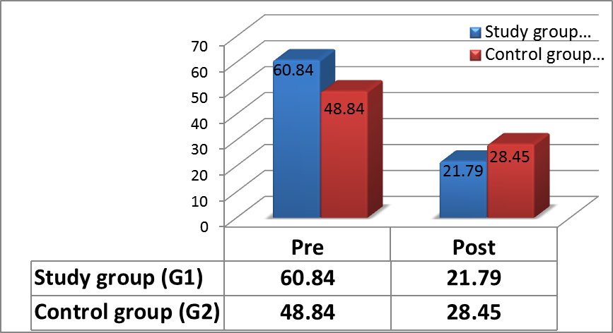
Graph 1: Mean values of AST pre and post treatment in both study and control groups

Table 2: Comparison between mean (±SD) of ALT of study and control groups before & after treatment:
ALT  (U/L) |  | Study group (n=20)  Mean ± SD | Control group (n=20)  Mean ± SD | Comparison G1/G2
 |  |  |  | T | P
Pre treatment |  | 71.6 ± 42.7 | 69.9 ± 31.62 | 0.1381 | 0.8909
Post treatment |  | 19.61 ± 8.21 | 30.5 ± 21.43 | 2.068 | 0.045*
Comparison pre/post | t | 4.958 | 6.96
 | P | 0.0001** | 0.0001**
% of improvement |  | ↓ 72.61% | ↓ 56.37%
*Significant **Highly significant

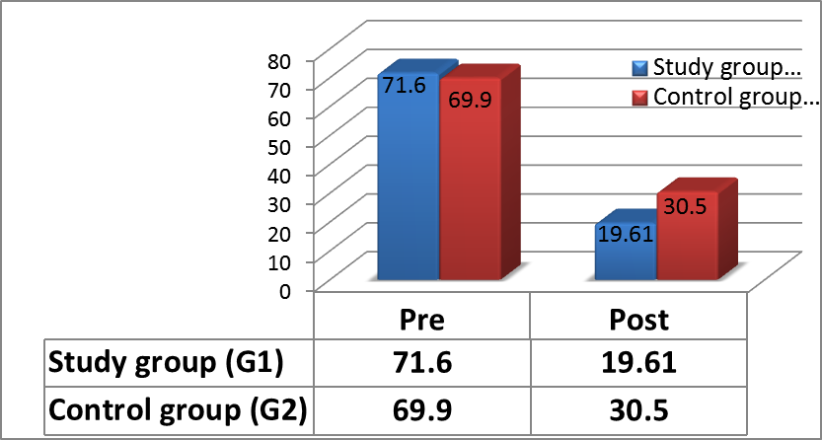
Graph 2: Mean values of ALT pre and post treatment in both study and control groups

4. Discussion
The present study was conducted to identify the effect of lymphatic pump techniques on liver function in hepatitis C patients.
Forty hepatitis C patients (men and women) with elevated liver enzymes participated in this study. The patients were randomly assigned into two equal groups: the study group (group A) and the control group (group B). The study group was treated by lymphatic pump techniques (Three sessions per week for 4 weeks during the first month of medical treatment) in addition to their routine medical treatment. The control group was treated by medical treatment only (sofosbuvir and daclatasvir).
There was significant improvement in the variables (AST and ALT) in both groups -in favor of the study group.
The lymphatic system is important in returning increased interstitial fluid to the circulation of the blood. In this process, substances and interstitial cells are also transported from tissue to blood. As circulation of leukocytes between tissue, blood and lymph occurs, they continuously sample the internal environment for foreign antigens, a process termed ‘immune surveillance’ (Olszewski, 2003) (8).
The processes of the disease that affect lymph flow, such as infection affect recirculation of lymphocyte and exacerbate the disease. Thus, techniques that make lymph flow better may treat infection by increasing circulation of immune products, immune cells and pharmaceuticals. (Hodge and Downey, 2011) (5).
In agreement with Jackson et al., (1998) (9), the improvement in favor of the study group may be caused also be increased antibodies, as consistently higher antibody titers occurred in patients who received lymphatic pump techniques during hepatitis B vaccination than those not receiving lymphatic pump techniques.
In agreement (Yao et al., 2014) (10). The liver enzymes improvement in favor of the study group (group A) may be caused by improving normal circulation and immunological function.
It also may be caused increased lymphatic flow in agreement with (Hodge et al, 2007) (11), LPT significantly increase both leukocyte count and lymph flow of thoracic duct increased significantly after LPT, so enhancement of lymph leukocyte flux occurred. Increased mobilization of immune cells is important mechanism responsible for the enhanced immunity and recovery from infection of patients treated with LPT.
As LPT increase lymph flow, this enhances the circulation of inflammatory mediators into the lymphatic circulation then transport to the blood circulation. LPT is used in treatment of infection, but the ways by which these techniques protect the body from infection are unclear. LPT may increase protect body from infection by enhancing mesenteric-derived inflammatory mediators in circulation, encouraging the re-distribution of these mediators to other tissues. In support of this idea, lymph has been found to re-distribute mesenteric-derived cytokines and chemokines to distant organs. Mesenteric lymph can increase endothelial cell permeability and activate neutrophils. So LPT would enhance this re-distribution and improve immune function. (Schander et al, 2012) (12).
Results of the study was supported by study of (Yao et al., 2014) (10) as they stated that Technique of doming of Diaphragm leads to manipulation of the thoracic diaphragm, which is important muscle involved in lymphatic flow, breathing and blood circulation. The diaphragm helps lymphatic flow by making a pump-like propulsion effect on fluid within vessels. Technique of Rib Raising enhance lymphatic flow by augmenting respiratory excursion and reducing outflow of the sympathetic. Technique of Thoracic Pump enhance lymphatic flow and also other immune cells through a rhythmic compression of walls of lymphatic vessel and regional lymph tissue, especially that of the thoracic duct. The thoracic pump technique provides a mechanical force to enhance lymphatic drainage into the venous circulation.
So these factors may be cause of the improvement in liver enzymes in the study group (who received medical treatment in conjunction with LPT) than in the control group (who received medical treatment only).

Conclusion
In view of the results of this study, it can be concluded that lymphatic pump techniques have a beneficial effect on liver function in hepatitis c patients with elevated liver enzymes patients, so it is recommended to be added to the medical treatment for hepatitis c patients who had elevated liver enzymes.

References
- Gomaa, A., Allam, N., Elsharkway, A., El Kassas, M., & Waked, I. (2017). Hepatitis C infection in Egypt: prevalence, impact and management strategies, Hepatic medicine: evidence and research, 9, 17.
- Kouyoumjian, S., Chemaitelly, H., & Abu-Raddad, L. (2018). Characterizing hepatitis C virus epidemiology in Egypt, systematic reviews, meta-analyses, and meta-regressions. Scientific reports, 8(1), 1661.
- Westbrook, R., & Dusheiko, G. (2014). Natural history of hepatitis C, Journal of hepatology, 61(1), S58-S68.
- Cacoub, P., Comarmond, C., Domont, F., Savey, L., Desbois, A. C., & Saadoun, D. (2016). Extrahepatic manifestations of chronic hepatitis C virus infection. Therapeutic advances in infectious disease, 3(1), 3-14.
- Hodge, L., Downey, H. (2011). Lymphatic pump treatment enhances the lymphatic and immune systems, Experimental biology and medicine, 236(10), 1109-1115.‏
- Knott, E., Tune, J., Stoll, S., & Downey, H. (2005). Increased lymphatic flow in the thoracic duct during manipulative intervention, The Journal of the American Osteopathic Association, 105(10), 447-456.‏
- Breithaupt, T., Harris, K., Ellis, J., Purcell, E., Weir, J., Clothier, M., & Boesler, D. (2001). Thoracic lymphatic pumping and the efficacy of influenza vaccination in healthy young and elderly populations, The Journal of the American Osteopathic Association, 101(1), 21-25.‏
- Olszewski, W. L. (2003). The Lymphatic System in Body Homeostasis: Physiological Conditions. Lymphatic Research and Biology, 1(1), 11–24.
- Jackson, K. M., Steele, T. F., Dugan, E. P., Kukulka, G., Blue, W., & Roberts, A. (1998). Effect of lymphatic and splenic pump techniques on the antibody response to hepatitis B vaccine: a pilot study. The Journal of the American Osteopathic Association, 98(3), 155-160.‏
- Yao, S., Hassani, J., Gagne, M., George, G., & Gilliar, W. (2014). Osteopathic manipulative treatment as a useful adjunctive tool for pneumonia, Journal of visualized experiments: Jove, (87).
- Hodge, L. M., King, H. H., Williams, A. G., Reder, S. J., Belavadi, T., Simecka, J. W., & Downey, H. F. (2007). Abdominal lymphatic pump treatment increases leukocyte count and flux in thoracic duct lymph. Lymphatic research and biology, 5(2), 127-134. ‏
- Schander, A., Downey, H. F., & Hodge, L. M. (2012). Lymphatic pump manipulation mobilizes inflammatory mediators into lymphatic circulation. Experimental Biology and Medicine, 237(1), 58-63.‏

4/29/2019

