To isolate the cellulolytic bactria from termite gut and perform various biochemical tests for their identification.

Hardeep Singh

Lecturer in Biology, Govt. Senior Secondary School, Singowal in Jind, Haryana (India)
Email: hssonadil@gmail.com

Abstract: Number of termites were collected from infected tree of kurukshetra university kurukshetra. These samples were taken to the laboratory for identification and gut extraction. Before gut extraction these sample were sterilized with distilled water and 70% alcohol. After sterilization there gut were extracted in phosphate buffer and preserved in same buffer at -20 degree celsius for future use. Appro. 15-20 guts of workers were homogenized and kept in the vials. Serial dilution was done upto 10 raise to power -5 folds. These diluted sample were spread over the nutrient agar for isolation. They were incubated for 24 hours at 37 degree Celsius. After incubation period bacterial colonies were picked up and streaked on fresh nutrient agar medium. Incubated it for 24 hours at 37 degree temperature. After incubation period there were preserved at 4 degree Celsius. Bacterial strain showing celluloytic activity were identified as well as biochemically. All the bacteria showed cellulose digesting ability. All these isolates showed different potentialities in cellulose digestion. Colonies showing clear zone considered as cellulose positive. Our all the isolates were showed the clear zone. The net clear zone was calculated by subtracting colony diameter from the zone diameter. Maximum clear zone was showed by NJ81 and NJ810 isolates. And the minimum clear zone was showed by NJ83.
[Singh, H. To isolate the cellulolytic bactria from termite gut and perform various biochemical tests for their identification. N Y Sci J 2019;12(4):44-52]. ISSN 1554-0200 (print); ISSN 2375-723X (online). http://www.sciencepub.net/newyork. 7. doi:10.7537/marsnys120419.07.

Keywords: Cellulolytic Bacteria, Termites, Gut, Biochemical Test

Introduction:
Termites are known as social insects that have various morophologies. Based on its reproduction ability, they are classified into two types: reproductive queen and non reproductive (workers and soliders). Queen’s job is to produce and lay eggs. Solider’s job is to gaued the colony and the worker’s job is to nurse, repair the colony and food gathering.^{1,2,3}
Although the termites are considered as a pest, they have ecological functions. They degrade the cellulose matrial such as litter and wood.^{4,5} To digest the cellulose termites have to produce cellulytic enzyme. i.e. cellulose provide by termite itself ans by the termite symbionts^{6,7,8}. Termites contain diverse microbes in their gut ans they are classified into lower and higher termites. Lower termites have protists and bacteria in their gut, although their is less information about the bacteria. However the higher termites lack protest ans contain only prokaryotes^{9,10} Termite gut bacteria can be classified into bactreridales, clostridiales, mycoplasmateles, firmientes, actinobacteria, proteobacteria abd bacillales^{11,12,13,14} Some gut bacteria from terminidae have been identified, Those bacteria had similarity with clostridium genus, Anaerovorax odoriumutants, Erysipeleothrix rhysiopathie, Eubacterium seraeum and Sporobacter termitides^{15,16}
Cellulose is the most abundant biopolymer on earth. It is linear polysaccharide^{17,18} assembled from glucose monomer units, and it is the main constituent on the plant cell wall. Along with several indigestible polysaccharide, cellulose constitutes the main part of dietry fibre. Cellulose shows a variable degree of polymerization eith anywhere from 1000 to 14000 glucose residue comprising a single cellulose polymer. Because of its high molecular weight and crystalline structure, cellulose is insoluble in water and has a poor ability to absorb water. Cellulose is derived from D-glucose units, which condense through beta (1-4)-glycosidic bonds. Cellulose is a straight chain polymer. ^{19,20}
Callulase refers to a suite of enzymes produced by fungi, bacteriaand protozoan’s that catalase cellulysis (i.e. the hydrolysis of cellulose). Microorganism bring about biodegradation of cellulose in Nature using multienzyme complex^{21,22}. Cellulase enzyme which can hydrolyze cellulose forming glucose and other chemicals. Cellulase can be dividing into three types: endoglucanase (endo-1,4-glucosidase): cellobiose hydrolyse or Exoglucanase (Exo-1,4-glucosidase) and beta-glucosidase (1,4-beta-glucosidase).^{23,24} Five general types of cellulases based on the type of reaction catalysed are Endocellulase, Exocellulase, or beta-glucosidase, Oxidative cellulase R and cellulose phosphorylases. Cellulose are important industrial enzymes and find application in several industrial process^{25.} Reasearchers have strong interest in cellulose enzyme because of its application in industries of starch processing, grain alcohol fermentation, malting and brewing, extraction of fruit and vegetables juice, pulps and papaer industry and textile industry.²⁶

Materials And Methods:

Termite Collection
Number of termites were collected from infected tree of kurukshetra university kurukshetra. These samples were taken to the laboratory for identification and gut extraction. Before gut extraction these sample were sterilized with distilled water and 70% alcohol. After sterilization there gut were extracted in phosphate buffer and preserved in same buffer at -20 degree celsius for future use.

Bacterial Isolation:
Appro. 15-20 guts of workers were homogenized and kept in the vials. Serial dilution was done upto 10raise to power -5 folds. These diluted sample were spread over the nutrient agar for isolation. They were incubated for 24 hours at 37 degree Celsius. After incubation period bacterial colonies were picked up and streaked on fresh nutrient agar medium. Incubated it for 24 hours at 37 degree temperature. After incubation period ther were preserved at 4 degree Celsius.

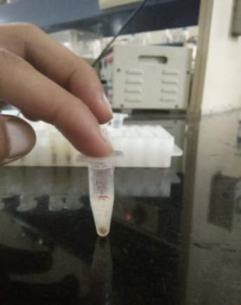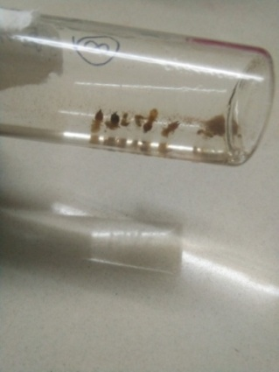

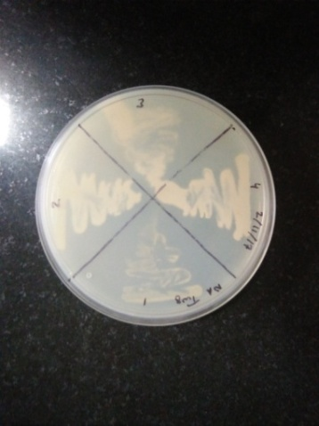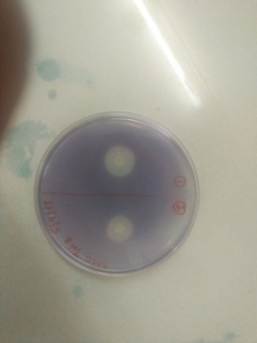
Fig. No. 1: Termites gut preserved at (a) 20degree Celsius, (b) 70% alcohol, (c) isolated bacterial colonies on nutrient agar plate and (d) CMC agar plate showing clear zone.

Screening of cellulolytic bacteria
Isolated pure colonies were cultured on CMC agar plate to check the catalytic activities.
After incubation of 24 hours plates were flooded with gram’s idione for 10 minutes. Then washed with distilled water. A clear zone was appeared that showed the catalyuti activity of the cellulose enzyme present in CMC agar plates that was produced by bacteria. Zone diameter and the colony diameter was recorded.
Clear zone was obtained by subtracting colony diameter from zone diameter.

Table 1: Showing composition of CMC agar.
 | Chemical name | amount in 1000 ml of ditiiled water
1 | Sodium citrate | 2.0gm
2 | Potassium phosphate | 1.0gm
3 | Magnesium phosphate | 0.5gm
4 | Potassium chloride | 0.5gm
5 | Carboxymethylcellulose | 5.0gm
6 | Agar agar | 20gm
Clear zone = zone diameter – colony diameter

Biochemical test for identification of bacteria: The pure colonies of cellulytic bacteria isolated and subjected to various biochemical test for their identification included followings:-

Gram staning: Gram staining or gram stain also called gram’s method is a method of staing used to distinguisg and classify bacterial species into two large groups.

Principle
The structure of the organism’s cell wall determine whether the organisgm is gram positive or gram negative. When stained with a primary stain and fixed by a mordant, some bacteria are able to retain the primary colour ewhile others get decolorised by a decoloriser. Those which bacteria retained the primary stain are called gram positive bacteria. And those bacteria which gets decolorised by decoloriser and then counter stain with secondary stain are called gram negative.

Reagents
- Primary stain:- crystal violet
- Mordant:- gram’s iodine
- Decoloriser:-95% ethanol
- Counterstain:- safranin
Gram positive bacteria:-
Retained primary stain and appear purple.
  - Gram negative bacteria:-
Can’t retained color and Counterstained by safranin and appear red.

Catalase test
This test was performed to find out the catalytic activity of given sample.

Principle:-
The enzyme catalase mediates the breakdown of hydrogen peroxide into oxygen and water. The presence of enzyme in the bacterial isolates wident when a small amount of inoculum is introduced into hydrogen peroxide and rapid elaboration of oxygen bubbles occurs. The lack of catalase is evident by a lack of bubble production.

Procedure:-
- Use a sterile loop to transfer a small amount of colony growth in the surface of clean, dry glass slide.
- Place 2-3 drops of hydrogen peroxide on glass slide obsereve for evolution of oxygen bubbles.
Positive reaction:- immediate bubbling
Negative reaction:- no bubbling
Simmons citrate test: This test was performed to detects the ability of an organism to use as a sole source of carbon and energy.
Principle:-
- Prepare the slants of simmons citrate agar medium.
- Streak the slant back and forth with a light inoculum picked from isolated colony.
- Incubate it at 37degree temperature for 24 hours.
- Observe the colour change in slant.

Positive reation:- Growth with colour change from green to blue along the slant.
Negative reaction:- No growth and no colour change.

Indole test: This test was performed to determine the ability of the organism to convert tryptophan into indole.

Principle: Tryptophan is an amino acid that can undergo deamination and hydrolysis by bacteria that express tryptophanase enzyme. Indole is generated by reductive deamination from tryptophan via the intermidate molecule indolepyruvic acid. Tryptophanase catalase the deamination reaction during which the amino group of the tryptophan molecule is removed.
Final product of the reaction is the indole, pyruvic acid ammonia and the energy. Pyeidoxal phosphate is required as a coenzyme.
When indole is combined with kovacs reagent the solution turns yellow to red or green. Beacuse amyl alcohol is not soluble in the water so the red coloration will form in an oily layer on the top of the broath.
Procedure:-
- prepare the tryptophan broath.
- Inoculate the tube aseptically by taking the growth from the isolated colonies/
- Incubate it at 37degree Celsius for 24 hours and observe.
- After incubation period add 0.5 ml of kovac’s reagent.
- Observe the colour change.
Positive reaction: formation of red colour layer at the top of the medium within seconds of adding the reagent.
Negative reaction:- no colour change even after the addition of appropriate reagent.

Triple sugar iron agar test
This test was performed to test the ability of microorganism to ferment and to produce hydrogen sulphide.

Composition of triple sugar iron agar
Lactoce, sucrose and glucose in concentration of 10:10:1
- 0.1% glucose: if only the glucose is fermented, only enough acid is produed to turn the butt yellow. The slant will remain red.
- 1.0% lactose/1.0%sucrose: a lage amount of acid turns both butt and slant in yellow, thus indicating the ability of the culture to ferment either lactose or sucrose.
- Iron (ferrous sulphate): indicator of hydrogen sulphate.
- Phenol red: indicators of acidification (it is yellow in the acidic solution and red in the alkaline conditions)
- It also contains peptone which act as source of nitrogen.

Procedure
- Prepare the slants of TSI agar
- Inoculate it by first stabbing through the centre of the medium to the bottom of the tube and then streaking on the surface of the agar slant.
- Incubate it at 37 degree Celsius for 24 hours.
After incubation period changes in TSI agar
- If lactose/sucrose is fermented a large amount of acid is produced which turns the phenol red indicator yellow both in butt and in the slant. Some organism generates gases which produce bubbles/ cracks on the medium.
- If lactose is not fermented but the small amount of glucose is the oxygen deficient butt will be yellow remember that butt comparatively have more glucose compared to slant i.e. in slant the acid will be oxidized and the slant will be red.
- If neither lactose/sucrose nor glucose is fermetented, both the butt and slant will be red.

Skim milk agar test: This test was performed to identify ability of microorganism to digest casein protein. Casein is the large protein insoluble in water and found in the skim milk. As it is digested by microorganism’s enzyme, casein is broken down into small amino acid and peptides. Clear patches in the agar plates indicates the region where casein has been broken down.

Procedure
- prepare plates of skim milk agar medium.
- With the sterilize loop inoculate these plates.
- Incubate it at 37 degree Celsius for 24hours.
- Observe the clear zone around the inoculated colony.
Positive reaction:- clear zone will appear. Casease enzyme produced by the bacteria degrades the casein protein present in skim milk agar.
Negative reaction:- no clear zone will appear.

Mannitol salt agar: This test was performed to check the ability of bacteria to grow in the high salt concentration.

Procedure
- Prepare plates mannitol salt agar.
- Inoculate these plates using sterilized loop.
- Incubate it at 37degree Celsius for 24 hours.
- Observe the growth.
Positive reaction:- if bacteria grows on the MSA medium it means they are tolerate to high salt concentration.
Negative reaction:- if bacteria cannot grow on it, it means they are intolerant to high salt concentration.

Oxidase test: This test was performed to identify the bacteria that produce cytochrome 6 oxidase. (an enzyme of electron transport chain)
Bacteria that are oxidase positive are aerobic and can use oxygen as a terminal electron acceptor in respiration. This does not mean that they are strict aerobes. Bacteria that are facultative. They may respire using other oxidase in electron transport.

Procedure
Take a filter paper soaked with the substrate kovac’s reagent.
- Pick the colony to be tested with a sterilized loop and smear in the filter paper.
- Observe inoculated area of the paper for colour change to deep blue or purple within 10-30 seconds.
Positive reaction:- A deep blue or purple colour will appear. Negative reaction:- no colour will appear.
Results: Inoculated plates were showed their result at 37*c within 24 hours on the nutrient agar plates. The plates were characterised by their morophology examined under microscope after gram staining.

Table 2: Showing Cellulolytic index.
Bacterial isolates | zone diameter (zd in mm) | colony diamteter (cd in mm) | zd-cd
NJ81 | 17 | 05 | 12
NJ82 | 15 | 06 | 09
NJ83 | 10 | 06 | 04
NJ84 | 20 | 09 | 11
NJ85 | 13 | 06 | 07
NJ86 | 17 | 10 | 07
NJ87 | 15 | 07 | 08
NJ88 | 16 | 07 | 09
NJ89 | 21 | 11 | 10
NJ810 | 23 | 11 | 12

Isolation and screening of bacteria
Ten bacteria strain were isolated from termite worker guts. The strains were designated as NJ1-NJ10. They showed diversity in their morphology as well as in biochemical reactions.

Identification of bacteria
Bacterial strain showing celluloytic activity were identified as well as biochemically.
All the bacteria showed cellulose digesting ability. All these isolates showed different potentialities in cellulose digestion. Colonies showing clear zone considered as cellulose positive. Our all the isolates were showed the clear zone. The net clear zone was calculated by subtracting colony diameter from the zone diameter.
Maximum clear zone was showed by NJ81 and NJ810 isolates. And the minimum clear zone was showed by NJ83.

  - Table 3: Morophological characterisation of bacterial isolates
Bacterial isolates | Colour | Margins | Surface
NJ81 | Yellowish Brown | Smooth | Shiny
NJ82 | Creamish White | Rough | Shiny
NJ83 | Yellowish Brown | Rough | Shiny
NJ84 | Creamish White | Rough | Shiny
NJ85 | Yellowish Brown | Rough | Shiny
NJ86 | Yellowish Brown | Rough | Shiny
NJ87 | Creamish White | Rough | Shiny
NJ88 | Creamish White | Rough | Shiny
NJ89 | Yellowish Brown | Rough | Shiny
NJ810 | Creamish White | Rough | Shiny

  - Biochemical Tests:-
A number of biochemical tests were performed for identifications of the microbes isolated from the termites guts.
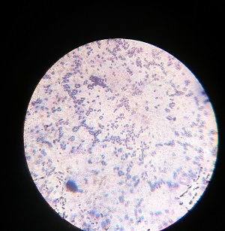
(a)

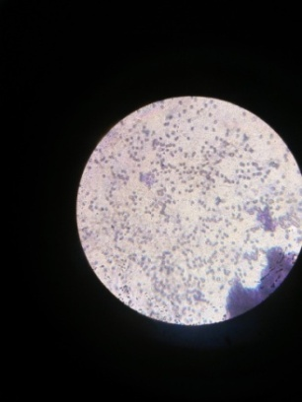
(b)

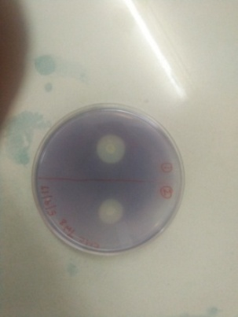
(c)
Fig. 2 (a) Bacillus, (b) cocci and (c) CMC plate showing a clear zone.

  - Gram staining:
Our all isolated bacterial colonies retain the colour after washing with the decolorizer. They were appeared purple coloured in the microscope. Some of the bacteria are rod shaped (bacillus) and some of the bacteria are spherical in shape ( cocci).
Nj81 and NJ83 were bacillus and other bacterial isolates NJ82, NJ84, NJ85,....... NJ810 were spherical in shape (cocci).
  - Cellulase test:-
After adding the gram’s iodine in CMC plates a clear zone was appeared. All the colonies form a clear zone around it which states that all the colonies are cellulolytic active.
  - catalase test: After adding 3% Hydrogen peroxide our all the colonies showed bubble formation.

- (b)
Fig. 3 (a) Slant of TSI agar showing yellow slant and red butt (Y/R) and (b) TSI agar slant showing red slant and yellow butt (R/Y)

  - Triple sugar iron agar test:-

All colonies ferments glucose only so the butt becomes yellow and the slant remains red coloured. But in the case of NJ81 colony its ferments glucose only but the slant becomes yellow and the butt remains red.

Table 4. After the incubation period of 24 hours following changes were observed in slants of TSI agar.
Bacterial isolates | Slant | Butt | H2S
NJ81 | Acidic | Basic | Negative
NJ82 | Basic | Acidic | Negative
NJ83 | Basic | Acidic | Negative
NJ84 | Basic | Acidic | Negative
NJ85 | Basic | Acidic | Negative
NJ86 | Basic | Acidic | Negative
NJ87 | Basic | Acidic | Negative
NJ88 | Basic | Acidic | Negative
NJ89 | Basic | Acidic | Negative
NJ810 | Basic | Acidic | Negative

Simmons citrate test:-
After the incubation period of 24 hours some of the colonies were utilize the citrate as sole source of carbon and energy. These colonies change the colour green to red along the slant. Some of the colonies can’t change the colour which showed that they can’t utilize the citrate as sole source of carbon and energy.

  - 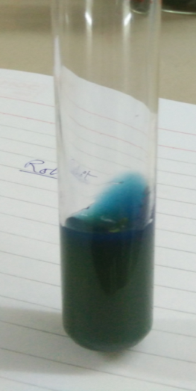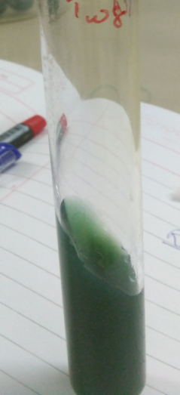
- (b)
Fig. 4. (a) Positive and (b) Negative simmons citrate test.

  - Indole test: After adding the kovac’s reagent their were no colour formation at the top of the broath in all the test tubes. its showed that all the colonies does not produce tryphtophanse enzyme that breaks the trypthophan into indo

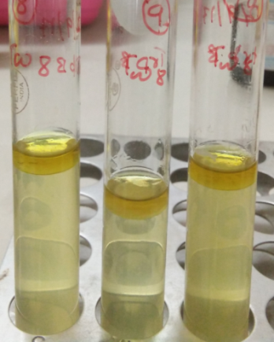

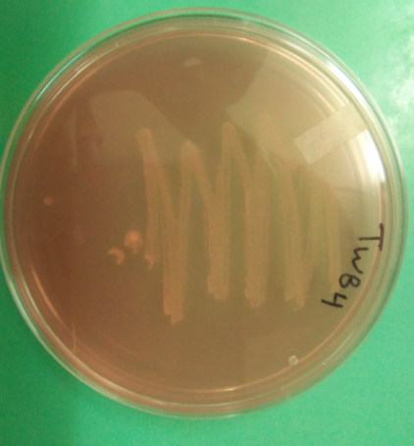
Fig. 5. Negative indole test

  - Mannitol salt agar test:-
All the colonies were grown on the mannitol salt agar plates which showed that all the colonies are able to tolerate high salt concentration.
  - Oxidase test:-
some colonies were gave the purple colour on the paper strip wetted with kovac’s reagent. These colonies are oxidase positive and others colonies that do not gave purple colour on paper strip are oxidase negative.

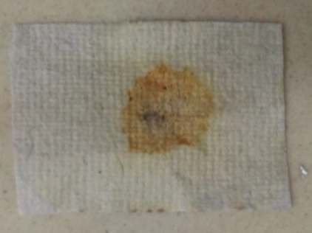
(a)

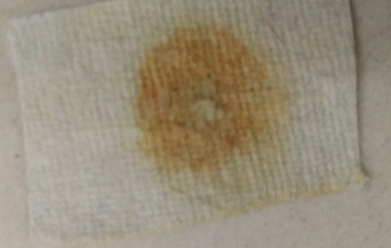
(b)
Fig. 6. (a) positive and (b) Negative Oxidase test.

Oxidase positive isolates are:- NJ81,NJ82,NJ83,NJ84,NJ85
NJ86,NJ88,NJ810.
Oxidase negative isolates are:-NJ87,NJ89.

Corresponding Author:
Hardeep Singh
Lecturer in Biology, Govt. Senior Secondary School,
Singowal in Jind, Haryana (India)
Email: hssonadil@gmail.com
Phone No. -91+9728706261

References:
- Alper1, H.; Stephanopoulos, G. Engineering for biofuels: Exploiting innate microbial capacity or importing biosynthetic potential? Nat. Rev. Microbiol. 2009, 7, 715–723.
- Bayon, C.; Mathelin, J. Carbohydrate fermentation and by-product absorption studied with labeled cellulose in Oryctes nasicornis larvae (Coleoptera: Scarabaeidae). J. Insect Physiol. 1980, 26, 833–840.
- Brodey, C.L.; Rainey, P.B.; Tester, M.; Johnstone, K. Bacterial blotch disease of the cultivated mushroom is caused by an ion channel forming lipodepsipeptide toxin. Mol. Plant Microbe Interact. 1991, 4, 407–411.
- Brune, A. Termite guts: The world’s smallest bioreactors. Trends Biotechnol. 1998, 16, 16–21. 24. Breznak, J.A.; Brune, A. Role of microorganisms in the digestion of lignocellulose by termites. Annu. Rev. Entomol. 1994, 39, 453–487.
- Cazemier, A.E.; Hackstein, J.H.P.; Op den Camp, H.J.M.; Rosenberg, J.; van der Drift, C. Bacteria in the intestinal tract of different species of arthropods. Microb. Ecol. 1997, 33, 189–197. Int. J. Mol. Sci. 2012, 13 2575.
- Cazemier, A.E.; Op den Camp, H.J.M.; Hackstein, J.H.P.; Vogels, G.D. Fibre digestion in arthropods. Comp. Biochem. Physiol. A Physiol. 1997, 118, 101–109.
- Cazemier, A.E.; Verdoes, J.C.; Reubsaet, F.A.; Hackstein, J.H.; van der Drift, C.; Op den Camp, H.J. Promicromonospora pachnodae sp. nov., a member of the (hemi) cellulolytic hindgut flora of larvae of the scarab beetle Pachnoda marginata. Antonie Van Leeuwenhoek 2003, 83, 135–148.
- Chakraborty, N.; Sarkar, G.M.; Lahiri, S.C. Cellulose degrading capabilities of cellulolytic bacteria isolated from the intestinal fluids of the silver cricket. Environmentalist 2000, 20, 9–11.
- Cook, D.M.; Doran-Peterson, J. Mining diversity of the natural biorefinery housed within Tipula abdominalis larvae for use in an industrial biorefinery for production of lignocellulosic ethanol. Insect Sci. 2010, 17, 303–312.
- Delalibera, I.; Handelsman, J.; Raffa, K.F. Contrasts in cellulolytic activities of gut microorganisms between the wood borer, Saperda vestita (Coleoptera: Cerambycidae), and the bark beetles, Ips pini and Dendroctonus frontalis (Coleoptera: Curculionidae). Environ. Entomol. 2005, 34, 541–547.
- Egert, M.; Stingl, U.; Bruun, D.L.; Wagner, B.; Brune, A.; Friedrich, M.W. Structure and topology of microbial communities in the major gut compartments of Melolontha melolontha larvae (Coleoptera: Scarabaeidae). Appl. Environ. Microbiol. 2005, 71, 4556–4566.
- Egert, M.; Wagner, B.; Lemke, T.; Brune, A.; Friedrich, M.W. Microbial community structure in midgut and hindgut of the humus-feeding larva of Pachnoda ephippiata (Coleoptera: Scarabaeidae). Appl. Environ. Microbiol. 2003, 69, 6659–6668.
- Ferreira, A.H.; Marana, S.R.; Terra, W.R.; Ferreira, C. Purification, molecular cloning, and properties of a beta-glycosidase isolated from midgut lumen of Tenebrio molitor (Coleoptera) larvae. Insect Biochem. Mol. Biol. 2001, 31, 1065–1076.
- Geib, S.M.; Tien, M.; Hoover, K. Identification of proteins involved in lignocellulose degradation using in gel zymogram analysis combined with mass spectroscopy-based peptide analysis of gut proteins from larval asian longhorned beetles, Anoplophora glabripennis. Insect Sci. 2010, 17, 253–264.
- Geissinger, O.; Herlemann, D.P.R.; Mörschel, E.; Maier, U.G.; Brune, A. The ultramicrobacterium “Elusimicrobium minutum” gen. nov., sp. nov., the first cultivated representative of the termite group 1 phylum. Appl. Environ. Microbiol. 2009, 75, 2831–2840.
- Huang, S.W.; Zhang, H.Y.; Marshall, S.; Jackson, T.A. The scarab gut: A potential bioreactor for bio-fuel production. Insect Sci. 2010, 17, 175–183.
- Lavelle, P.; Bignell, D.; Lepage, M.; Wolters, V.; Roger, P.; Ineson, P.; Heal, O.W.; Dhillion, S. Soil function in a changing world: The role of invertebrate ecosystem engineers. Eur. J. Soil Biol. 1997, 33, 159–193.
- Lemke, T.; Stingl, U.; Egert, M.; Friedrich, M.W.; Brune, A. Physicochemical conditions and microbial activities in the highly alkaline gut of the humus-feeding larva of Pachnoda ephippiata (Coleoptera: Scarabaeidae). Appl. Environ. Microbiol. 2003, 69, 6650–6658.
- Palleroni, N.J. The Pseudomonas story. Environ. Microbiol. 2010, 12, 1377–1383.
- Talia, P.; Sede, S.M.; Campos, E.; Rorig, M.; Principi, D.; Tosto, D.; Hopp, H.E.; Grasso, D.; Cataldi, A. Biodiversity characterization of cellulolytic bacteria present on native Chaco soil by comparison of ribosomal RNA genes. Res. Microbiol. 2011, doi:10.1016/j.resmic.2011.12.001.
- Watanabe, H.; Tokuda, G. Cellulolytic systems in insects. Annu. Rev. Entomol. 2010, 55, 609–632.
- Wenzel, M.; Schonig, I.; Berchtold, M.; Kampfer, P.; Konig, H. Aerobic and facultatively anaerobic cellulolytic bacteria from the gut of the termite Zootermopsis angusticollis. J. Appl. Microbiol. 2002, 92, 32–40.
- Young, J.M. Drippy gill: A bacterial disease of cultivated mushrooms caused by Pseudomonas agarici n. sp. N. Z. J. Agric. Res. 1970, 13, 977–990.
- Zhang, H.Y.; Jackson, T.A. Autochthonous bacterial flora indicated by PCR-DGGE of 16S rRNA gene fragments from the alimentary tract of Costelytra zealandica (Coleoptera: Scarabaeidae). J. Appl. Microbiol. 2008, 105, 1277–1285.
- Zhou, L.M.; Ju, Q.; Qu, M.J.; Zhao, Z.Q.; Dong, S.L.; Han, Z.J.; Yu, S.L. EAG and behavioral responses of the large black chafer, Holotrichia parallela (Coleoptera: Scarabaeidae) to its sex pheromone. Acta Entomol. Sin. 2009, 52, 121–125.
- Zhou, X.; Smith, J.A.; Oi, F.M.; Koehler, P.G.; Bennett, G.W.; Scharf, M.E. Correlation of cellulase gene expression and cellulolytic activity throughout the gut of the termite Reticulitermes flavipes. Gene 2007, 395, 29–39.

4/21/2019

