A verification of Global and Regional Models for an extreme events over Egypt

AmiraS.Ibrahim¹, Tarek Sayad², Sherein Zahran³, Zeinab Salah¹

¹ Meteorological Authority, Cairo, Egypt
²Astronomy and Meteorology Department Al Azhar University, Cairo, Egypt
³PhD, Researcher, Environment and climate change Research Institute (ECRI), National water research center (NWRC) Ministry of Irrigation and water resources (MIWR), Cairo, Egypt
Assistance Professor at Canadian International Collage (CIC)
sherine_zahran@cairo-cic.com ,shereinzahran@gmail.com

Abstract: In this paper attempt was made to perform diagnostic and prognostic analysis of the event atJanuary 17,2010.This case study represents a heavy rainfall event over Egypt. Although this event occur in winter season, its impact was very unusual for the all the season. It was found out that the 2010 event was due to interaction between tropical and mid-latitude systems. In general, the ECMWF (European Center for Medium Range Weather Forecasts) model among the global models and WRF (Weather Research and Forecasting Model) model with the BM (Betts–Miller ) convection scheme from the regional models performed better in predicting the characteristics of the event.
[AmiraS.Ibrahim, TarekSayad, ShereinZahran, Zeinab Sala.A verification of Global and Regional Models for an extreme events over Egypt. N Y Sci J2019;12(4):31-38]. ISSN 1554-0200 (print); ISSN 2375-723X (online).http://www.sciencepub.net/newyork. 5. doi:10.7537/marsnys120419.05.

Key word: Weather Forecasts, regional models

1. Introduction

1.1. Background Information
Extreme events and their impacts and disasters are very important today to evaluatetheir risks and find their root causes, and therefore use early warning to avoid their effects. About half of environmental disasters, and over two-thirds of disaster deaths, are weather and climate caused (Moawad 2013).
Flash floods are considered to be one of the worst weather related natural disasters. They are dangerous because they are sudden and are difficult to forecast, following of heavy rain. Floods cause about one third of all deaths, one third of all injuries from natural disaster (Askew 1997).
Egypt is located in the northeastern part of Africa. It has shorelines with both the Mediterranean Seaand the Red Sea. It is characterized by arid to semiarid climate.Egypt has four seasons, summer, autumn, winter and spring.The climate in the winter season (December – February) is cold and moist (rainy).
The northern coast of Egypt obtains rainfall mainly in winter (December,January and February).The largest rainfall amounts (annual total larger than 250mm) were existed in Alexandria and Matruh during the last decades (Hafez and Hasanean 2000). In 1970, most of the northern regions received about 20% of the normal rainfall, while years in the 1980s received rainfall totals reached 150% in Matruh. In 1960’s Alexandria and Port Said received nearly 200% of average precipitation (Hafez and Hasanean 2000).
Alexandria on the northern coast receives total annual rainfall averages of 196mm. at Cairo, average annual rainfall has reduced to 25mm and southwards it reduces to only 5mm at Hurghada on the Red Sea coast and less than 2mm at Aswan in Upper Egypt. In interior regions ofEgypt several years may not obtainany significant rain. Previous research shows proof that the severity of flash flooding over Egypt has in fact increased in recent years (EEAA-MSEA 2010). In January 2010, heavy rain exceeding 80 mm/day, caused the worst flash-floods in Egypt since 1994 (Attaher and Medany, 2010). The floods affected the Sinai Peninsula, the Red Sea coast and the Aswan city in the southern part of the country.

1.2. High Impact Rainfall Cases
Rainfall in Egypt is limited to a narrow area along northern coast where Mediterranean lows hardly invade the northern coast. While average annual rainfall along the northern coast can reach 200mm, rainfall amount decreases significantly in interior regions of Egypt, where Cairo receives 10mm of rain yearly. On January, 17 2010, a deep mid-tropospheric low with its unusual southward extension interacted with tropical systems. This interaction drawing with it lots of equatorial moisture, and mixing it with mid-latitude cold air aloft, resulted in widespread extreme rainfall and strong thunderstorms in the eastern half of the interior region of Egypt. The amount of rain as well such kind of interactive weather system was unusual for this time of the year in the region.
Attempt is made to perform diagnostic and prognostic analysis on this extreme rainfall event.
The study area is Egypt (Longitudes 24° to 38° and Latitude 21° to 33°). In order to obtain useful information, the domain was extended in all directions (Longitudes 08° to 60° and Latitudes 15° to 50°).

2.1. Data
Daily accumulated rainfall for January, 17 2010 was obtained from CPC Unified Gauge and CPC/RFE rainfall observation.
GDAS data (1°X1°) was downloaded from the NOAA/NOMADS the diagnostic analysis. Forecast models data (ECMWF, NCEP and UKMET) were downloaded from the ECMWF/TIGGE website. The resolution of these models vary from 0.28°X0.28° to 1°X1°. The 00Z cycle and 30-hr forecast was used for rainfall verification analysis, while 36hr forecast was used for verifying weather systems. The ensembles forecast system data was also used for forecast verification with ECMWF (50 ensembles), NCEP (20 ensembles) and UKMET (23 ensembles).
In addition to the global models, WRF model with Kain-Fritsch, Betts-Miller and non-Convective schemes were used in the diagnostic studies. The resolution for the WRF model is 10km, with 00z cycle, 30hr forecast and GFS initial and boundary conditions.

3. Objective of the Study

3.1. General Objective
The general objective of this study is to perform a diagnostic and prognostic study on the high impact weather of January 17, 2010.

3.2 special objective
To verify the best global model and best scheme for WRF model in forecasting these study.

4.0 Results and Discussion

4.1. Diagnosis of the Events
The rainfall event January 17, 2010 resulted in unusually above average rainfall over Egypt. Many regions were affected by these excess rainfall, with the bigger impact observed over the Sinai and southern regions.

4.1.1. Rainfall
As shown on figure 1, the rainfall associated with the January 17, 2010 event covers most of Sinai region, with maximum amount of 10mm/day and extending along some areas across the Red Sea coast according to unified gauge (top-left panel), while according to CPC/RFE the maximum rainfall over Sinai exceeds 25 mm/day, with some areas in the southern part receiving rainfall with 5mm/day and above (top -right panel).

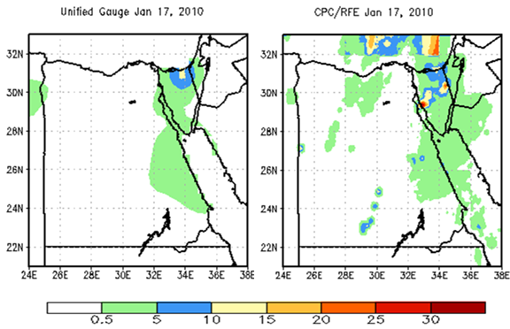
Figure 1. Unified Guage and CPC/RFE Jan 17, 2010

4.1.2. Mean Sea Level Pressure (MSLP)
The GDAS MSLP analysis for January 17, 2010 (figure 2) shows lower value of 1012mb during 00Z and 06Z with localized circular low over eastern Libya. During 12Z, the low pressure extended between southern and northern Egypt, while during 18Z the circulation shifted towards eastern Sinai.

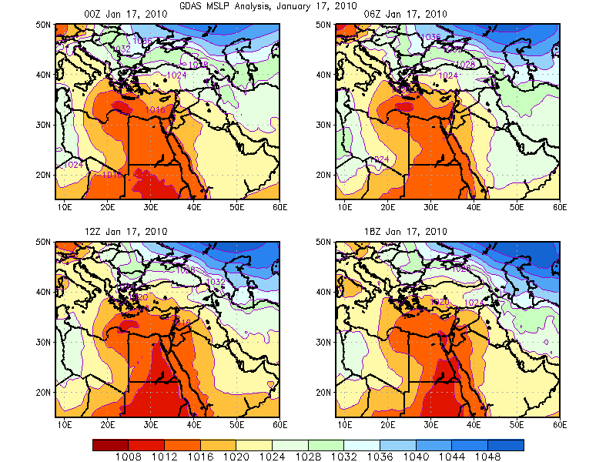
Figure 2. GDAS Mean Sea Level Pressure Analysis: January 17, 2010

4.1.3. 500mb Circulation
At 500mb a combination of geopotential low of 5560GPM and strong southerly wind prevailed over western Egypt at 00Z, while shifting to the east at 18Z (figure 3).

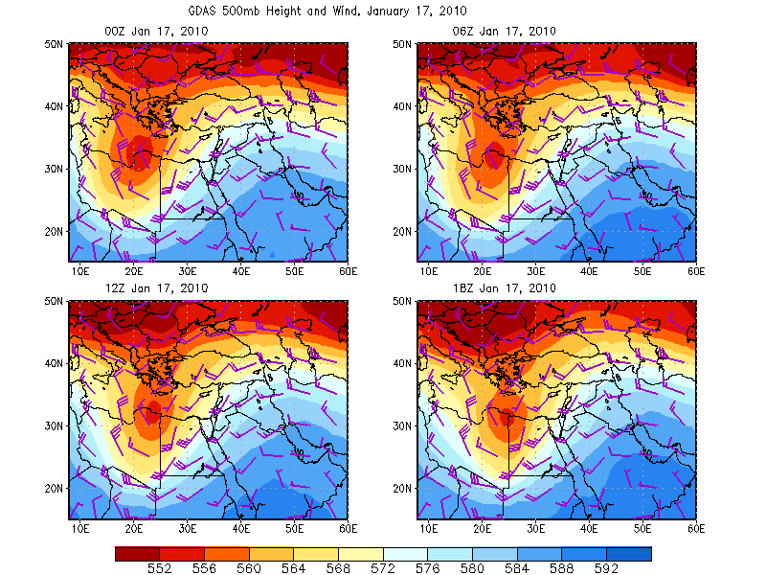
Figure 3, GDAS 500mb geopotential height and wind Analysis: January 17, 2010

4.2.Forecast verification

4.2.1 Global Models
All global models predict heavy rainfall especially over Sinai (figure 4).

4.2.2. WRF Model Forecast Verification
The WRF model forecast with the KF (KainFretch) convection scheme for January 17, 2010 shows maximum rainfall of 30mm/day covering much of northeastern regions and extending to the south. According to WRF model with the BM (Betts Miller) convection scheme shows maximum rainfall of 30mm/day over Sinai, western coast of the Red Sea and parts of the northern region. According to WRF model with no convection scheme shows maximum rainfall over northeastern Egypt (figure 5).

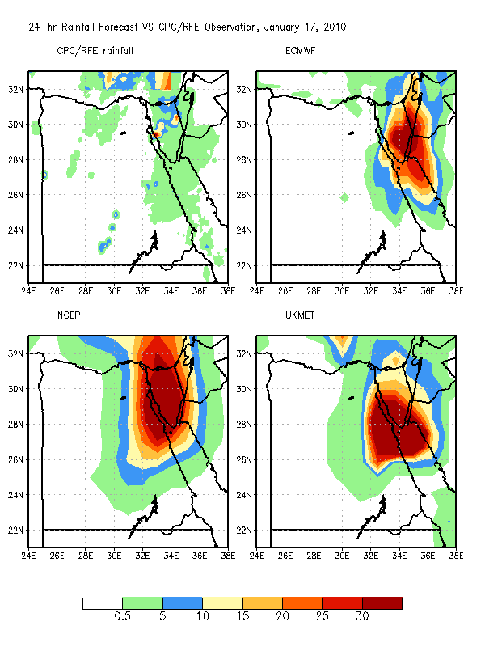
Figure 4. 24-hr accumulated rainfall forecast against CPC/RFE observation: January 17, 2010

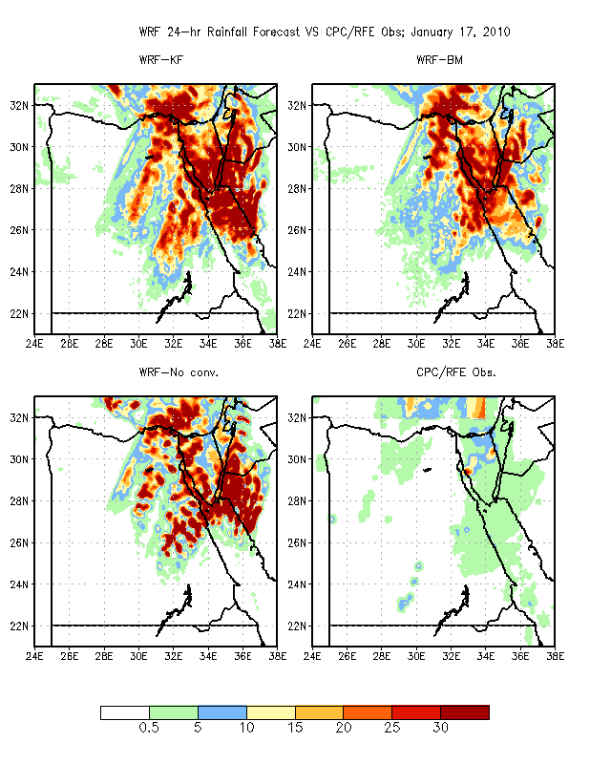
Figure 5. WRF model with different convection schemes VS CPC/RFE observation: January 17, 2010

4.2.3. Multi-model Ensemble Mean
On January, 17 2010, the multi-model ensemble mean for ECMWF, NCEP&UKMET ensemble systems shows maximum rainfall value of 30mm/day over southern Sinai (figure 6).

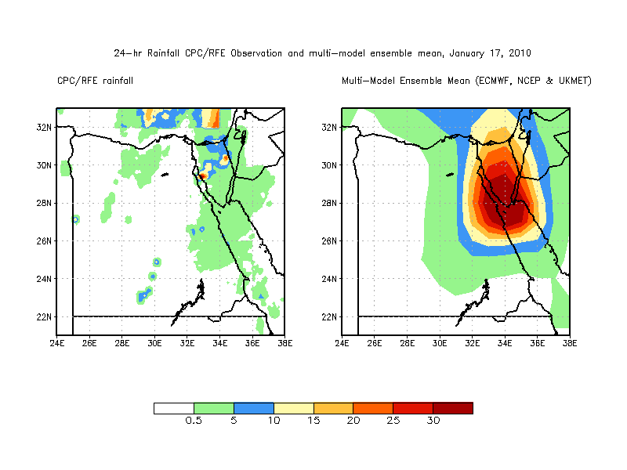
Figure 6. 24-hr accumulated multi-model ensemble mean rainfall forecast (ECMWF, NCEP and UKMET) VS CPC/RFE observation: January 17, 2010

4.2.4. Probabilistic Rainfall Forecast
The ECMWF ensemble probability forecast for 10mm/day threshold shows 90% probability over eastern and southern Sinai. According to the NCEP ensemble systems, the 90% probability covers Sinai and northwester coast along the Red Sea. The UKMET ensemble systems for 10mm threshold show the 90% probability to cover southern Sinai and northwestern coast along the Red Sea (figure 7).

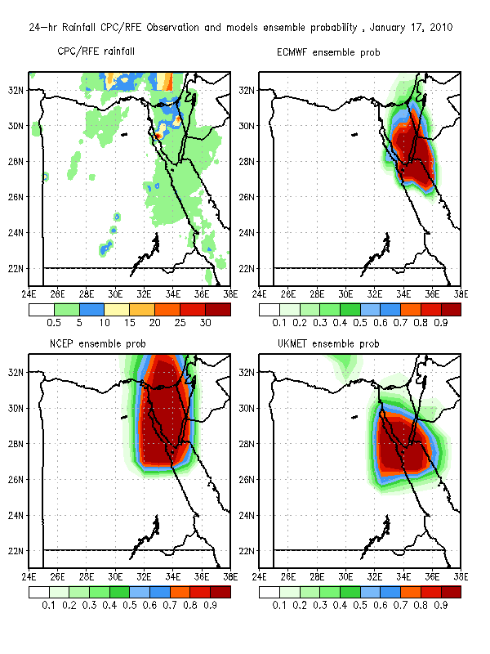
Figure 7. Probability of 24-hr accumulated rainfall forecast for 10mm/day threshold VS CPC/RFE observation: January 17, 2010

4.2.5. Mean Sea Level Forecast Verification
According to NCEP model, the low pressure extends more to the coast of Mediterranean Sea with minimum value of 1012mb. According to both ECMWF and UKMET models the low pressure tends to extend to the north (figure 8).

4.1.6. 500mb Forecast Verifivation
The ECMWF model forecast shows a very good resemblance with GDAS analysis, while the UKMET and NCEP models show weaker system (figure 9).

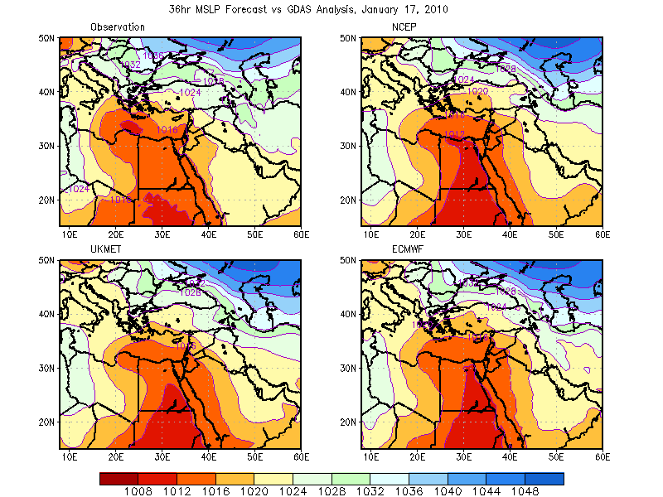
Figure 8, 36-hr MSLP Forecast VS GDAS analysis: January 17, 2010

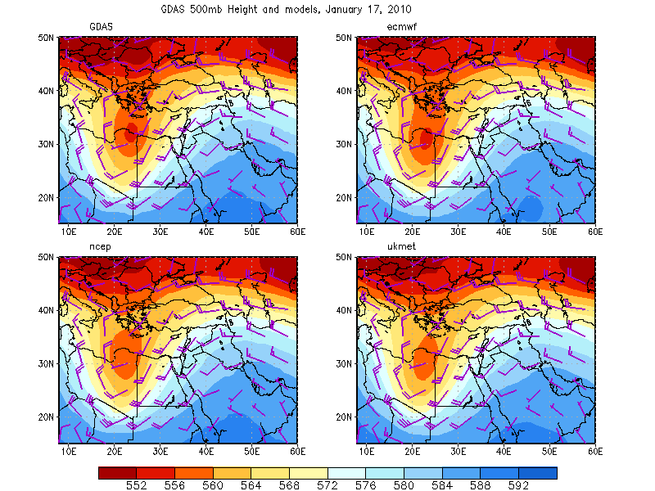
Figure 9. 36-hr 500mb geopotential height and wind forecast VS GDAS analysis: January 17, 2010

4.3. Verification Statistics for Rainfall Forecasts

4.3.1. Mean Error (Bias)
In general, the mean error for January 17, 2010 shows that WRF model with the BM convection scheme and ECMWF Global model (ECMWF_det) gave the lowest error (and positive). On January 17, 2010, the ECMWF ensemble means (ECMWF _ens) and multi-model forecast NCEP and ECMWF (MULTI _N_E) gave the lowest error. (figure10).

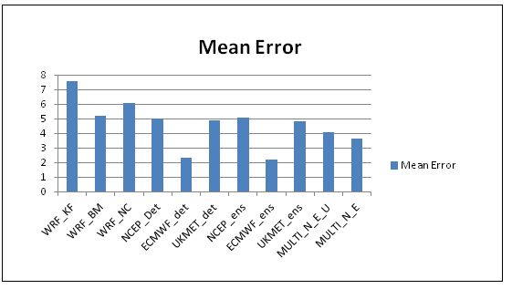
Figure 10, Inter-comparison of forecast models with respect to mean error: January 17, 2010

5. Conclusions and Recommendations

5.1. Conclusions
- The causes for the January 17, 2010 event are an interaction between tropical and mid-latitude systems across Egypt.
- The ECMWF model from the global deterministic and ensemble systems and the WRF model with the BM convection scheme from the regional models performed better in predicting rainfall and weather systems for both events.

5.2. Recommendations
- There is a need to perform more diagnostic and prognostic analysis with some more cases to learn the behavior of each model in a better way.
- There is a need to use rain gauge rainfall observation instead of the satellite estimated rainfall, for better results.

References
- Moawad. B.M: Analysis of the flash flood occurred on 18 January 2010 in wadi El Arish, Egypt (a case study), Geomatics, Natural Hazards and Risk, 2013 Vol. 4, No. 3, –, http://dx.doi.org/10.1080/254 274 19475705.2012.731657.
- Askew. A.J.: water in the international decade for natural disaster reduction, Destructive Water: Water-Caused Natural Disasters, their Abatement and Control (Proceedings of the Conference held at Anaheim, California, June 1996). IAHS Publ. 1997 no. 239.
- ATTAHER, S. M., MEDANY, M. A. & EL-GINDY, A. 2010. Feasibility of some adaptation measures of on-farm irrigation in Egypt under water scarcity conditions. Options Mediterranean’s, 2010. 95, 307-312.
- EEAA 2010. Egypt. Egypt second national communication under the United Nations.
- Framework Convention on Climate Change. Cairo, Egypt: Egyptian Environmental Affairs Agency. Ministry of State for Environmental Affairs.
- Hafez, Y.Y. and Hasanean, H.M. / ICEHM2000, Cairo University, Egypt, September, 2000, page 175- 186.

4/19/2019

