The Flexural Behavior of Two Way Post Tensioned Slabs Pre- Strengthened With External CFRP Strips

Ghada N. Mohamed¹, Ayman H. H. Khalil², Morcos F. Samaan³, Hadad S. Hadad⁴

¹Assistant lecturer, Higher Technological Institute, 10th of Ramadan City, Egypt
²Professor, Ain Shams University, Egypt
³Assistant Professor, Higher Technological Institute, 10th of Ramadan City, Egypt
⁴Professor, Housing and Building National Research Center, Egypt
ghada.nashaat@hti.edu.eg

Abstract: This paper presents the results of an experimental study concerning the flexural strengthening of post-tensioned concrete slabs using external fiber reinforced polymer (CFRP) strips. Four post-tensioned simply supported concrete slabs were tested in the laboratory to evaluate the strength enhancement provided by attaching the CFRP strips. Two were unbonded slabs, One of each was unbonded control and other was unbonded with CFRP strip and two were bonded one of each was bonded control and other was bonded with CFRP strips. The failure of specimens occurred either by concrete crushing and/or by CFRP rupture. The post-tensioned concrete slab with bonded tendons and strengthed with CFRP strips provided an improvement in ductility, initial stiffness, and deflection by 62.18%, 58.2 %, and 37.8%, respectively when compared to control specimens. On the other hand, the post-tensioned concrete slabs that had unbonded tendons and strengthened with CFRP strips provided an increase in ductility, initial stiffness and deflection by 59.87%, 33.8%, and 40.8% respectively when compared to control one.
[Ghada N. Mohamed, Ayman H. H. Khalil, Morcos F. Samaan, Hadad S. Hada. The Flexural Behavior of Two Way Post Tensioned Slabs Pre- Strengthened With External CFRP Strips. N Y Sci J 2019;12(4):14-22]. ISSN 1554-0200 (print); ISSN 2375-723X (online). http://www.sciencepub.net/newyork. 3. doi:10.7537/marsnys120419.03.

Keywords: CFRP, Unbonded, Bonded, Tendon, Cracks, Strengthening, Failure Modes, Post tensioning.

1. Introduction
When compared to conventional repairing and strengthening methods, externally bonded Fiber Reinforced Polymer (FRP) using different shapes provide recommended solutions because of its low cost and durability [1]. using FRP materials to enhance the performance of concrete elements in flexure is very desirable from the applicability point of view due to the ease of handling and installing FRP materials. FRP materials are not subject to either corrosion or rust in the long term usage [2]. Bonding FRP to the tension face of concrete elements increases the flexural strength. Failure of the element may then occur as a result of various mechanisms; concrete crushing or FRP rupture and FRP separation due to end peel or debonding [3]. ACI Committee 440F deals with the debonding mechanism by applying a bond reduction coefficient, but its use is overly conservative for CFRP strengthened pre-stressed concrete due to initial strains present in the concrete due to pre-stressing [4]. Although many works adopted FRP in strengthing RC members, there has been little research on the strengthening of pre-stressed concrete slabs with CFRP materials. There have been some field applications using CFRP to repair existing pre-stressed concrete, yet few full-scale specimens have been tested to failure [5] Hassan and Rizkalla [6] examined the flexural behavior of pre-stressed concrete bridge slabs strengthened with various CFRP systems. The flexural capacity of slabs could be increased by 50% using the CFRP sheets which was the most cost-effective solution. Uksun K. et al [7] studied the nonlinear behavior of unbonded PT one- and two-way slabs under uniformly distributed pressure or area loads. They found that while the deflection was much higher for CFR Pre-paired slabs, the unbonded tendon stress increased was lower than that in the control specimens No fiber tensile failure, debonding, or concrete crushing was observed. Also, the flexural behavior of unbounded post-tensioned concrete members strengthened using external FRP composites investigated by Fatima. E, M. Harajli [8] the study focused on evaluating the use of external fiber reinforced polymer (FRP) laminates for strengthening unbonded post-tensioned concrete members. It was found that the use of FRP laminates increased the load capacity and post-cracking stiffness of unbounded members. Failure of the specimens occurred either by concrete crushing or by FRP debonding or FRP fracture.
The aim of this paper is to present the results of experiment study concerning of strengthening of post-tensioned two-way concrete slabs using external fiber reinforced polymer (CFRP) strips.
2. The Experimental Program
2.1 Details of specimens
Four post-tensioned simply supported concrete slabs were tested in the laboratory to evaluate the strength enhancement provided by attaching the CFRP strips. Two were unbonded slabs, One of each was unbonded control (USC) and other was unbonded with CFRP strip (USS) and two were bonded one of each was bonded control (BSC) and other was bonded with CFRP strips (BSS). Studied and monitored parameters were ultimate load, deflection behavior, ductility index, failure mode and cracking pattern. The slabs were square with 2360 mm side length, a supported span of 2000 mm, and a depth of 150 mm and supported with four square column with 200mm side length and 200 mm height, as shown in Figure1. CFRP strip locations are taken as shown at the locations of critical flexural trends. A summary of the specimens designation and test parameters are provided in Table 1.

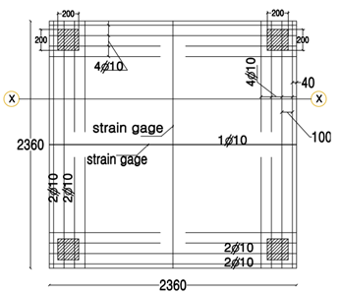

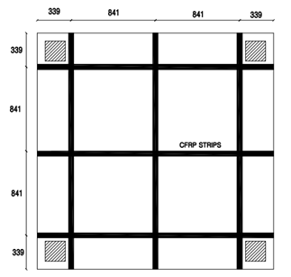
Fig.1: Specimen Dimension, reinforcement, and CFRP Strips Locations [All Dimension in mm]

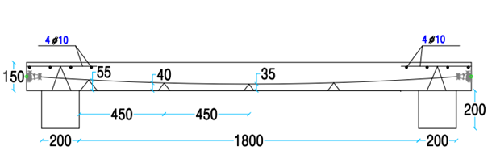
Fig.2: Chair Distribution and tendon profile for Bonded and Unbounded Tendon slabs [All Dimension in mm]

The four half-scale simply supported slabspecimens were tested to failure. The post-tensioned slabs were designed according to Post-Tensioning Manual 6th edition (2006), the Concrete Society Technical Report (TR43) (2005), American Concrete Institute (ACI-318) (2011), Egyptian Code of Practice for Reinforced Concrete Construction (ECP 203-2017) and Guide for the Design and Construction of Externally Bonded FRP Systems for Strengthening Concrete Structures (ACI 440.2R).
The investigated main parameters included: type of post tensioning, number of tendons in X-direction, Number of tendons in Y-direction, and pre-compression ratio. In addition to the pre-stressing steel, each specimen was reinforced with four 10 mm in diameter steel bars that were required as minimum bonded reinforcement above columns in both X and Y directions. in accordance with the ACI Building code (318-14) [2]. In order to simulate actual slab design and construction, no shear reinforcement was provided in the specimens.
As shown in Figure 2, tendon profile and chair distribution, the heights of the chairs were interpolated considering the tendon curvature as a second-degree parabola. Each tendon passes through dead and live anchorages that were identical. The general layout of the unbonded and bonded post-tensioned two-way concrete slabs is shown in Figure 3.

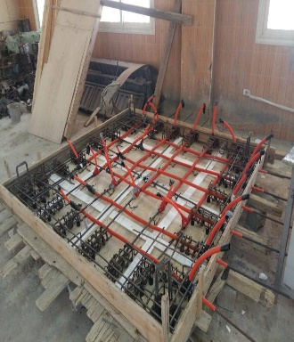

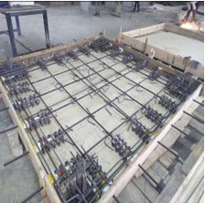
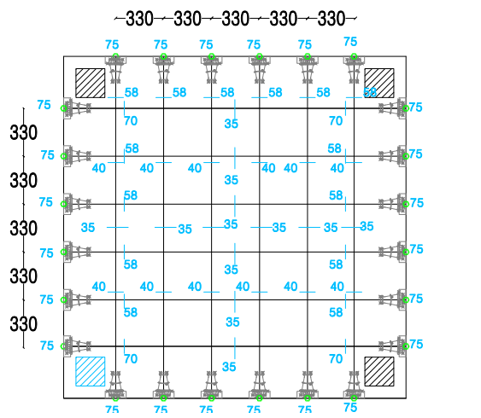

(a) Unbonded Tendon Slab (b) Bonded Tendon slab (c) Tendon Layout and Distribution
Fig.3: Tendon Distribution for Bonded and Unbounded Slabs [All Dimension in mm].

Table 1: Summary of Specimens Type
Notation | Specimen types | Test Parameters
 |  | Type of prestressing | pre-compression ratio in (X-and Y-direction)
UCS | Unbonded Control Slab | unbonded | 1MPa
USS | Unbonded Slab With CFRP Strip | unbonded | 1MPa
BCS | Bonded Control Slab | bonded | 1MPa
BSS | Bonded Slab With CFRP Strips | bonded | 1MPa

2.2 Material Properties
2.2.1 Concrete Properties
The concrete mix was designed the coarse aggregate: sand: cement proportions by weight were 0.47:0.35:0.18, with a water to cement ratio of 0.3. The specified 28-day cube concrete compressive strength was then expected to be 40 MPa. Nine cubes with dimensions of 150 X 150 X 150 mm were taken alongside the specimens in order to test the compressive strengths after 7, 28 and at test days respectively. Strengths were recorded as the average of three specimens of each. Table 2 illustrats the test result of cubes compressive strength.

Table 2: Concrete Compressive Strength
Specimens | Concrete Compressive Strength ƒc (average) (MPa)
 | 7-day | 28-day | test day
UCS | 34 | 42 | 44
USS | 27.2 | 40 | 40.5
BCS | 27.7 | 40.1 | 41.7
BSS | 28 | 40 | 41.1

2.2.2 Carbon Fiber Reinforced Polymer (CFRP) Strips Properties
Unidirectional carbon fiber reinforced polymer (CFRP) strips were used for FRP strengthening and supplied by Haining Anjie Composite Material. The thickness of the fiber reinforcement per ply (t_{f}) was 1.4mm, the ultimate tensile strength ( f_{fu}) was 2,400 N/mm2, the rupture strain (ε_{fu}) was 0.015 mm/mm, the modulus of elasticity of FRP.
laminates (Ef) was 159,400 MP and the width was 50 mm. CFRP strips extended until the face of the support and were applied in accordance with the manufacturer recommendation at the tension face of the slab specimens.
2.2.3 Tendon Characteristics
For the unbonded slab, the tendon was mono-strand with each strand is composed of seven high-strength steel wires comprising six spiral wires wound around a middle wire which remained straight as shown in Fig.4. The strands, that supplied by Strand for Trading & Construction S.A.E., were greased and housed in a thin polypropylene extrusion sleeve, which had been molded directly onto the strand. The grease inhibits corrosion and allows the strand to remain unbonded, as shown in Figure 4. On the other hand, for the bonded slab, the tendon was a mono strand with onion end and duct with vent, as shown in Figure 5. The pre-stressing steel, is selected with a design ultimate tensile strength of 1860 MPa (Grade 270). Each slab had six longitudinal tendons and six transverse tendons, the tendon nominal diameter was 12.7 mm and the area was 100 mm2 for the unbonded case and The tendon nominal diameter was15.24 mm and the area was150 mm2 for the bonded case.
2.3 Slabs Preparation and Pre-Stressing Process
The slabs were casted using Ready Mix concrete with the pre-scriped compressive strength of 40 MPa. Post-tensioned had processed in two stages as recommended in Technical Report 43 (2006); The first stage was conducted at 24 hours after the casting. During this stage, the tendons were tensioned to 10% of the required design stressing load. The second stage was conducted 7 days, later when the slab reached astrength of 30MPa.

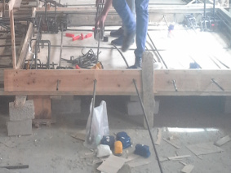
Fig. (4): Unbonded Tendon with Polypropylene Duct.

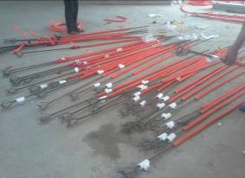
Fig. (5): Bonded Tendon with Onion End.

Hydraulic jacks was used to elongate the tendon and drive the wedges into the live anchorage. Pre-stressing forces is given in Table3, showing the force values at time of stressing and after losses. To resist tensile bursting forces around individual anchorages at pre-stressing process, bursting reinforcement was designed, according to BS8110-1 (2002). As shown in Figure 6, five closed links that tied to four steel bars, 10 mm diameter, with average yield strength and ultimate strength was 560 MPa and 670 MPa respectively. These reinforcements were positioned at each end of the slab adjacent to the dead and live anchorages. Apart from the bursting reinforcement, there was no other conventional (passive) reinforcement included in the slabs.

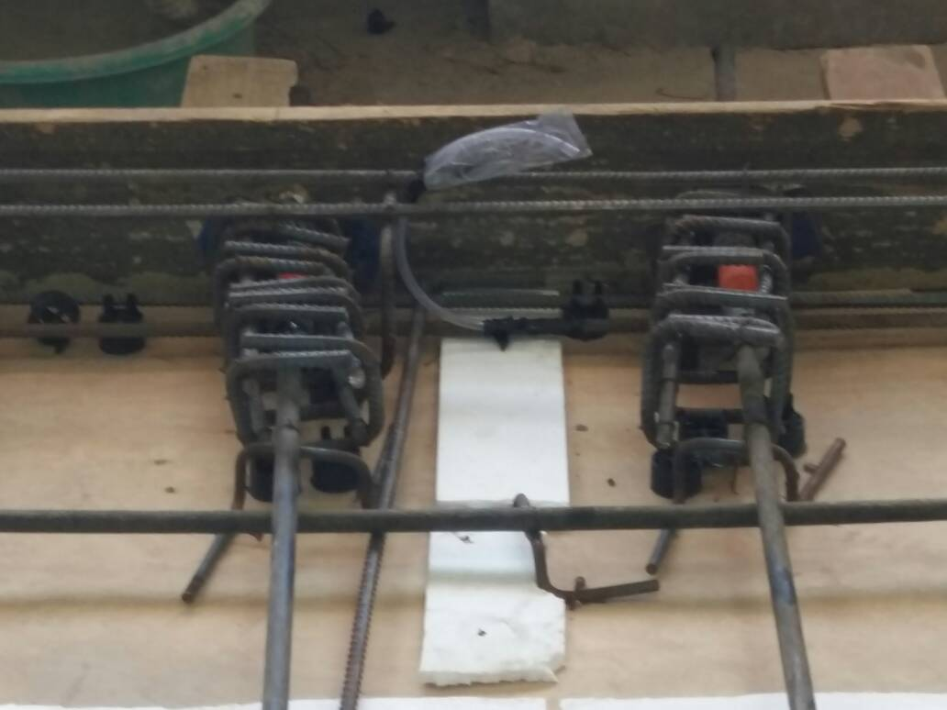
Fig. (6): Bursting Reinforcement

Table 3: Value of Pre-Stressing Force
Specimens | stressing force (kN) | Force of tendons after losses (KN) | Target pre-stressing level
Un Bonded Control Slab (UCS) | 145.3 | 83.0 | 60%
Un Bonded Slab With CFRP Strip (USS) | 145.3 | 83.0 | 60%
Bonded Control Slab (BCS) | 207.3 | 87.8 | 58%
Bonded Slab With CFRP Strips (BSS) | 207.3 | 111.0 | 60%

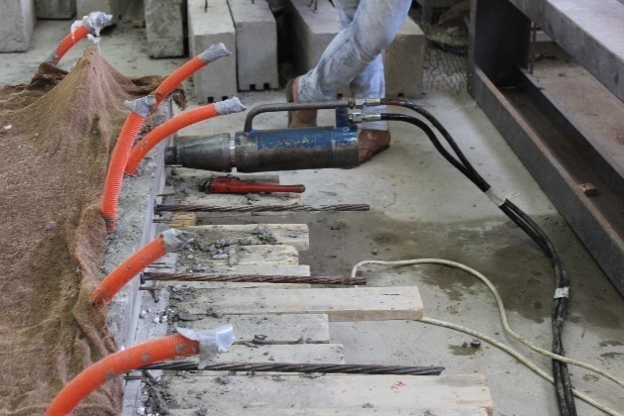
Fig. (7): Pre-stressing Applied Force

2.4 CFRP Strip Attachment
After appling the pre-stressing force and the CFRP strip attachment were conducted according to the technical information of BASF Construction Chemicals for application procedure of CFRP strips. First, the surface was dried and free from dirt and cement laitance were removed. After that mix base and reactor components of Master Protect 2020 was applied for 3to 4 minutes evenly to the substrate using a stiff brush, as shown in Figures 8 and 9. Second, Master Brace ADH4000 was applied to the prepared surface and to FRP strips by using a steel spatula with thickness between 1.0-2.0 mm. After10 minutes, FRP strips were placed on to the substrate and pushed on to the strips with a stiff roller to prevent possible air gaps between the strip and substrate., as shown in Figures 10 and 11.

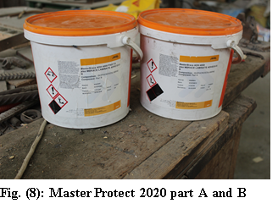
2.5Loading of Specimens
The specimens were loaded with four concentrated area loads applied symmetrically relative to the middle of the span and separated by a distance equal to 1/6 the span length to simulate as closely as possible the moment diagram produced using uniformly applied load. As shown in Figure 12. For each combination of test parameters, two specimens were tested, one control, and one strengthened using FRP reinforcement. the load was applied statically at a rate of approximately 2 kN/min. Electrically bonded resistance (EBR) strain gauges were attached to the FRP strip at mid-span and two EBR strain gauges were attached directly to the concrete on the top of the slab at mid-span, as shown in Figure 12. Linear variable displacement transducers (LVDTS) were used to measure the deflection of all slab specimens. Loading, deflection and strain measurements were recorded by a data acquisition system. At each load stage, the crack patterns were also observed. Noticeable, during the test of the unbonded control slab (UCS), there was a breakdown in the loading form and the test was stopped.
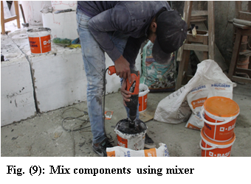

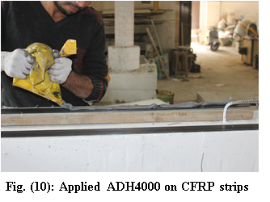
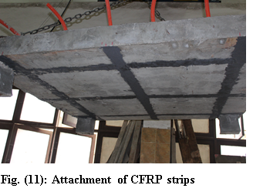

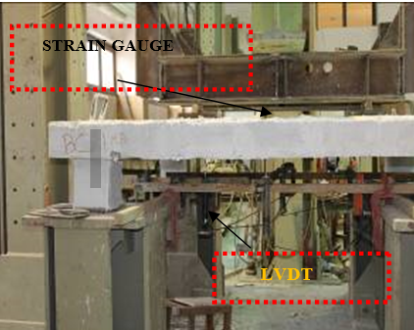

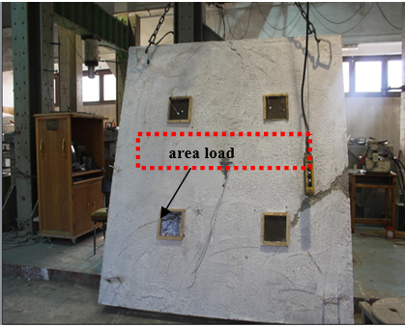
Fig. (12): LVDTS and Strain Gauges (S.G) for All Specimens.

3. Results and Discussions
3.1 Failure Modes and Crack pattern
In the two control specimens (UCS, BCS), it is observed that the first crack has occurred near column. As the load increased, successive cracks were formed also at nearby the flexure zones. It was noticed that by increasing the load; cracks have also occurred in the shear span region.
3.1.1 Control Specimens Failure
Unbonded control slab (UCS) failed in brittle mode due to concrete crushing in the extrem compression fiber of the section within the constant moment region failure load was 474 kN and deflection was 23.0 mm.
Bonded control slab ( BCS) failed due to a combination of pre-stressing steel yielding and a concrete crushing at a load of 464 kN and a deflection of 22.0 mm, with the first crack load 180 KN near column, as shown in figure 13.

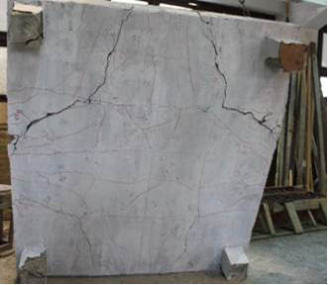
(a) Experimental Crack Pattern

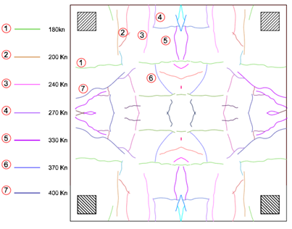
(b) Drawing of Crack Pattern
Fig. (13): Crack Pattern for Control bonded (BCS) From Experimental

3.1.2 FRP Specimens Failure
Unbonded slab with CFRP strip (USS) failed due to rupture of the FRP strip and debonding of FRP at a load of 403 kN and a deflection of 41.0mm, Consequently, a localized concrete crushing within the maximum moment region was also observed. As shown in figure14.
Bonded slab with CFRP strips (BSS) failed due crack of interfacial debonding of the FRP strips and simultaneous rupture of the FRP reinforcement, with the first crack load 200 KN near constant moment region. as shown in figure15.

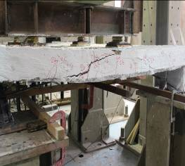
(a) Un Bonded Slab with CFRP Strip (USS) Concrete Crushing

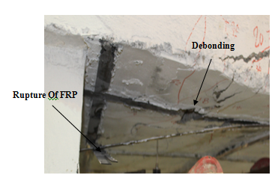
(b) Un Bonded Slab with CFRP Strip (USS) Debonding and Rupture of FRP
Fig. (14): Concrete Crushing, Debonding and Rupture of FRP for USS

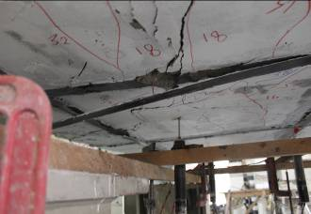
(a) Concrete Crushing and Debonding of FRP for Bonded Slab with CFRP Strips (BSS).

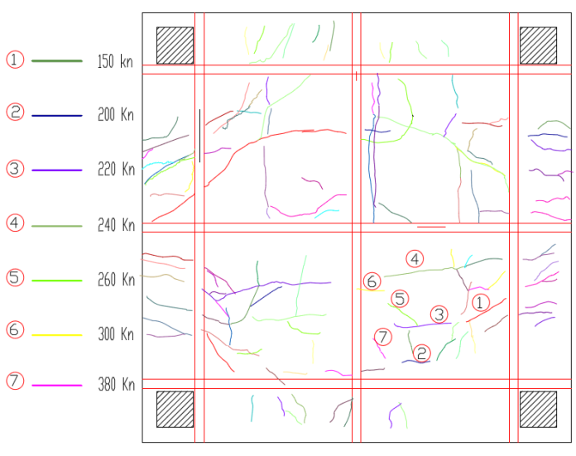
(b) Drawing of Crack Pattern
Fig.(15): Crack Pattern, Concrete Crushing and Debonding of FRP

3.2 Load-Deflection Relationships
The load-deflection behavior of all tested beam specimens is presented in Figure17. From the results, it is indicated that FRP strengthened slabs significantly improved both the ductility and the corresponding deflection. The test result in terms of applied load deflection at cracking, ultimate state, and the modes of failure are shown in Table 4and Table 5.

Table 4: Loads and Deflections Results of the Tested Slabs
specimens | FRP rupture | concrete cover separation | crushing of concrete | plate end interfacial debonding | intermediate crack induced interfacial debonding | shear failure
UCS | N/A | N/A | observed | N/A | N/A | N/A
USS | observed |  | observed | observed | observed | N/A
BCS | N/A | N/A | observed | N/A | N/A | N/A
BSS | N/A |  | observed | observed | observed | N/A

Table 5: Failure modes
specimens | PCR | ∆CR | PU | ∆U | ∆MAX | %strain FRP
UCS | 177.4 | 1.365 | 450 | 11.11 | 17.3 | ---
USS | 150.63 | 1.71 | 403.3 | 24.3 | 46.85 | 38%
BCS | 179.4 | 3.22 | 502 | 27 | 44 | ---
BSS | 149.6 | 1.1 | 480 | 25 | 58 | 34%

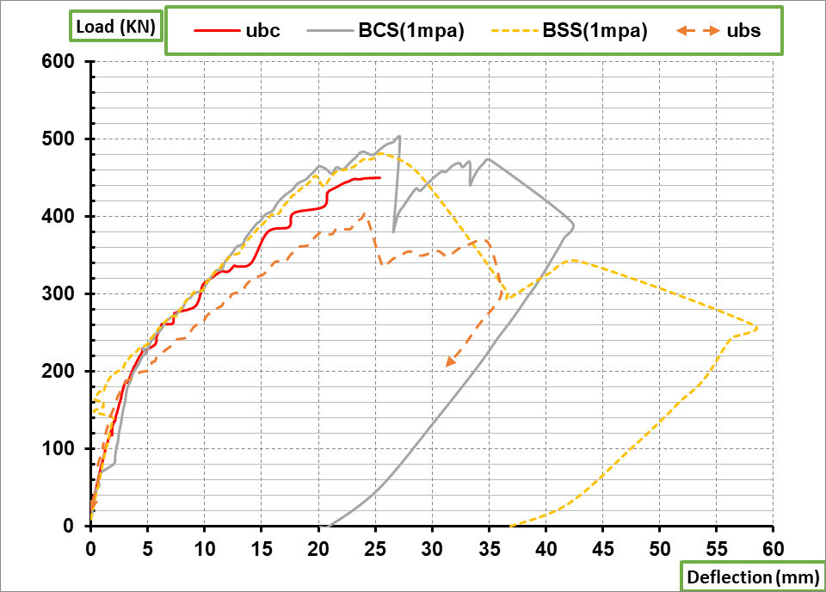
(a) BCS and BSS

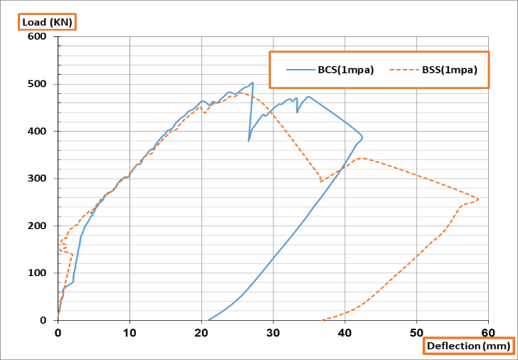
(b) UCS and USS
Fig. (16): Load - Deflection Curve for Bonded and Unbonded Slabs.

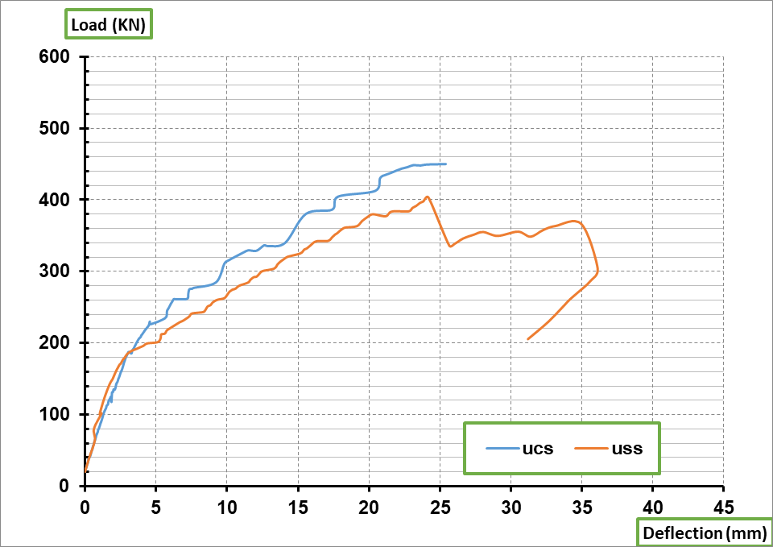
Fig. (17): Load - deflection curve for all cases.

3.3 Ductility Index: The ductility index is an important parameter, that to be considered in a structure to reflect the structural life time. it can be defined as its ability to sustain inelastic deformation without loss in load carrying capacity, prior to failure. The deflection ductility index can be obtained as the ratio of mid-span deflection at ultimate load to the mid-span deflection at yield load. The ductility index was calculated for BSS and BCS tested slabs A maximum increase of 62.18%. and for USS and UCS slabs about 59.87% was obtained as shown in Figure 16.

Table 5: Initial Stiffness& post cracking stiffness
Specimens | Ki: initial stiffness | Ku: post cracking stiffness
UCS | 65.8 | 13.7
USS | 88 | 11.15
BCS | 55.7 | 13.4
BSS | 88 | 12

3.4 Stiffness: The initial stiffness of the strengthened un bonded slab with CFRP strip (USS ) was 33.8% higher than the un bonded control slab (UCS). The initial stiffness of the strengthened bonded slab with CFRP strips (BSS) slab was 58.2% higher than the bonded control slab (BCS). The post cracking was considerably equal for the strengthened slab compared to the control for bonded and unbonded slabs, as shown in Table 5.

3.5 FRP Strips Efficiency
From Figure17, It is concluded that BSS with bonded tendons provides better behavior than USS with unbonded tendons as the increase in Ultimate Load, initial stiffness and the ultimate deflection was 19%, 28%, and 17% respectively.

4. Conclusion
Four post-tensioned simply supported concrete slabs were tested in the laboratory to evaluate the strength enhancement provided by attaching the CFRP strips. Two slabs were unbonded and two were bonded and one of each category was a control and the other was strengthened with CFRP strips. The studied and monitored parameters were ultimate load, deflection, ductility, failure mode and cracking patterns. Based on the experimental program and analysis of the test results, the following conclusions can be made:
1. The failure modes of the slab specimens were concrete crushing, FRP rupture and/or FRP debonding.
2. Strengthening using FRP materials is very effective in increasing the ductility index of both bonded post tensioned concrete slabs and unbonded post tensioned concrete slabs as ductility was increased by 62.18% and 59.87%. respectively when compare to control one.
3. The initial stiffness increase of unbonded strengthened slab (USS) was 33.8 % compare to the control unbonded (UCS). The initial stiffness of the bonded strengthened slab (BSS) was 58.28% compare to the control bonded (BCS).
4. The strain at the top surface of concrete at the unbonded slab followed the same trend of the bonded slab and it was recorded to be is.0035. However, for strengthed slab bonded and un boded concrete strain is 0. 008.
5. The increase in ductility due to FRP strengthening result a significant increase in the deformation capacity when compare to control one about 40.8% for unbonded and 37.88% for bonded.
6. the strain in the FRP reinforcement varied between a minimum of 38% and a maximum of 34% of the specified manufactured rupture strain.

References
- Owen A. R. (2006)" Behavior Of Frp Repair/Strengthening Systems For Prestressed Concrete", Doctor Of Philosophy, North Carolina State University.
- Usama A. E., Hesham M. ( 2004)" Fiber-Reinforced Polymer Strengthening Of Two-Way Slabs", Aci Structural Journal, 101-S64.
- Arya. C., Clarke. J.L, Kay. E.A., O’Regan. P.D. (2002)" TR 55: Design Guidance For Stengthening Concrete Structures Using Fibre Composite Materials: A Review", Engineering Structures, 24-889–900.
- Owen R., Tare K. H., Sami R. (2007) " Flexural Behavior Of Aged Prestressed Concrete Girders Strengthened With Various FRP Systems", Construction And Building Materials, 21-764–776.
- Schiebel S, Parretti R, Nanni A. (2001)" Repair And Strengthening Of Impacted PC Girders On Bridge A4845." Missouri Department Of Transportation, Report RDT01-017/RI01-016.
- Hassan T, Rizkalla S. (2002) "Flexural Strengthening Of Prestressed Bridge Slabs With FRP Systems". PCI J,47.
- Uksun K., Thomas H.-K. K., and Pinaki R. C. (2010)" Rehabilitation of Unbonded Post -Tensioned Slabs with Different Boundary Conditions", pti journal, v8, No2, December.
- Fatima. E, M. Harajli, (2012), "Strengthening Of Unbonded Post-Tensioned Concrete Slabs Using External Frp Composites", Conference Paper · June.
- Post-Tensioning Institute, (2006). "Post-Tensioning Manual (6th edition)".
- Post-Tensioning Institute, (2005). Technical report no.43, "Post-Tensioned concrete design hand book "(2nd Edition).
- American Concrete Institute, (2014). "Building Code Requirements for Structural Concrete and Commentary", ACI 318M-14.
- ACI Committee 440, ACI 440.2R-08, (2008), "Guide for the Design and Construction of Externally Bonded FRP Systems for Strengthening Concrete Structures", American Concrete Institute, P.O. Box 9094, Farmington Hills, Michigan, 48331.
- E.C.P. Egyptian Code of Practice for Reinforced Concrete Construction, Ministry of Development, New Communities, Housing and Utilities, Housing and Building National Research Center, 2017.

4/4/2019

