Evaluation Of Electrical Anisotropy Within Ladoke Akintola University Of Technology Campus Ogbomoso, Southwestern Nigeria.

Akinlabi I. A. and Onifade A. A.

Department of Earth Sciences, Faculty of Pure and Applied Sciences. Ladoke Akintola
University of Technology, P.M.B. 4000, Ogbomoso, Nigeria.

Abstract: Radial Vertical Electrical Soundings (RVES) were carried out within Ladoke Akintola University of Technology campus, Ogbomoso, Southwestern Nigeria (which is part of Ogbomoso Sheet 222) in order to evaluate the electrical anisotropy of the concealed basement complex rock (s) and its implication on the groundwater potential of the area. The study area is underlain by porphyritic gneiss. Sixteen RVES stations were occupied and four Vertical Electrical Soundings conducted at azimuths of 0⁰, 45⁰, 90⁰ and 135⁰ at each station using the Schlumberger electrode array with maximum current electrode spread of 100m. The field data were interpreted by partial curve matching and computer iteration. Resistivity maps were constructed and coefficients of anisotropy were determined. The interpretation of the VES data revealed three main geoelectric units namely: the topsoil, regolith, weathered/fresh bedrock. The basement complex rocks beneath the study area are anisotropic. The anisotropy is caused mainly by foliation. The inferred structural trends were along NE-SW, NW-SE, E-W and N-S. The coefficient of anisotropy varies from 1.05 to 1.45 with a mean value of 1.21. The low bedrock resistivity observed beneath RVES 14 indicates high groundwater potential. Radial Vertical Electrical Sounding is effective for determining the strikes of foliation of concealed basement rocks in which foliation is predominant. The results of radial electrical sounding could aid geologic mapping in areas where the basement rocks are concealed.
[Akinlabi I. A. and Onifade A. A. Evaluation Of Electrical Anisotropy Within Ladoke Akintola University Of Technology Campus Ogbomoso, Southwestern Nigeria. N Y Sci J 2019;12(3):64-73]. ISSN 1554-0200 (print); ISSN 2375-723X (online). http://www.sciencepub.net/newyork. 9. doi:10.7537/marsnys120319.09.

Keywords: Evaluation; Electrical Anisotropy; Ladoke Akintola University; Technology; Southwestern Nigeria

Introduction
Surface geologic mapping basically involves field examination of rock outcrops in their natural location in order to identify the rock types and structural features, and take measurements of strike and dip, among others, useful to establish geological boundaries, reconstruct the geologic history and evaluate the economic potential of the rocks in the area. Observations of rocks are, however, difficult or impossible in areas where the basement rocks are concealed. Subsurface investigation employing Radial Vertical Electrical Sounding (RVES) can thus be used to determine the structural trends or strikes of the predominant structural feature (e.g. foliation) of the concealed rocks. The technique is capable of evaluating electrical anisotropy in Basement Complex areas for geological mapping and groundwater development (Olorunfemi and Opadokun, 1987; Olorunfemi and Opadokun, 1989; Okurumeh and Olayinka, 1992).
Electrical anisotropy in Basement Complex rocks is caused by inhomogeneity in the subsurface resulting from variable degree of weathering and structural features such as faults, joints, foliation and bedding (Billings, 1972) most of which create secondary porosity in rocks and enhance the effective porosity essential for groundwater development. The occurrence of groundwater resources in crystalline basement terrain depends immensely on the development of secondary porosity as well as permeability arising from weathering and fracturing of parent rocks, and to a great extent on the fracture patterns (Carruthers, 1984).
The degree of homogeneity of a medium is expressed in terms of coefficient of anisotropy, λ which can be calculated from geoelectric parameters or deduced from the ratio of the length of the major axis to the length of the minor axis of a resistivity map constructed by plotting apparent resistivity as a function of direction (Keller and Frischknecht, 1966; Zohdy et al., 1974). The resistivity map is circular for isotropic medium and elliptical for anisotropic medium. The azimuth of the major axis of the ellipse lies in the strike direction of the predominant structural feature causing the electrical anisotropy.
It is on this basis that geoelectrical surveys have been carried out within Ladoke Akintola University of Technology Campus, Ogbomoso, in order to evaluate the anisotropic properties and determine the structural trends of the concealed basement rocks from elliptical resistivity maps. The study area is located within latitude 8⁰ 09’ 859”-8⁰ 10’ 363” and longitude 4⁰ 15’ 808”-4⁰ 16’ 217” on Ogbomoso Sheet 222 (Fig. 1). It lies within the Precambrian basement complex of southwestern Nigeria and the dominant rock type is porphyroblastic gneiss (Rahaman, 1988). The predominant structural feature in basement rocks is foliation.

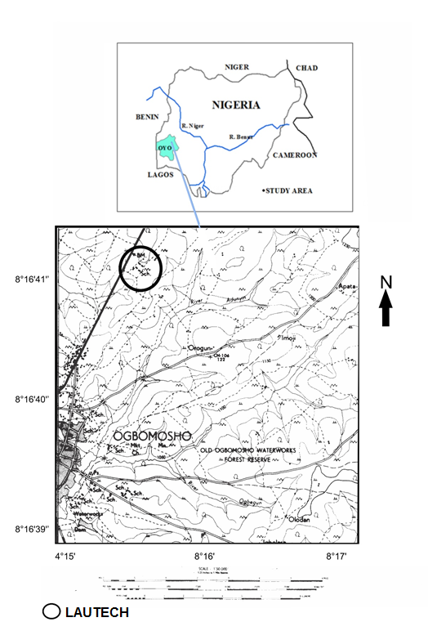
Fig. 1: Location map of study area

Methodology
Radial Vertical electrical soundings (RVES) were conducted at 16 stations along four azimuths: 0°, 45°, 90° and 135° using the Schlumberger electrode array. The maximum current electrode spacing (AB/2) was 75m. Fig. 2 shows the base map of the study area. A total of 64 sounding data sets, comprising four from each RVES station, were interpreted using partial curve matching and computer-aided iteration (Orellana and Mooney, 1966; Zohdy, 1989). The apparent resistivities data recorded along the four azimuths were plotted against electrode spacing (AB/2) and contoured to obtain apparent resistivity maps for the respective RVES stations. For an isotropic homogeneous formation, the resistivity map will assume a circular shape. Any deviation from a circle to an ellipse is indicative of anisotropic nature of the (Mallik et al., 1983; Olorunfemi and Opadokun, 1987; Mamah and Ekine, 1989; Olorunfemi et al., 1991). The azimuths of the major axis of the elliptical resistivity maps correspond to the principal direction of the predominant structural feature (s) responsible for the anisotropy (Keller and Frischknecht, 1966; Habberjam, 1975; Olorunfemi and Opadokun, 1987). The coefficient of anisotropy $(λ)$ at each RVES station was calculated from the ratio of the length of the major axis to the length of the minor axis of the anisotropy ellipse.

Results And Discussion
Interpretation of the sounding data reveals three main layers beneath the study area defined as topsoil, lateritic concretion, weathered layer and fractured/fresh bedrock. A fourth layer in form of lateritic concretion underlies the topsoil at stations 5, 11 and 16. 81% of the sounding curves are H-type ($ρ_{1}> ρ_{2}< ρ_{3}$) while about 16% are KH-type ${(ρ}_{1}< ρ_{2}> ρ_{3}<ρ_{4})$and about 3% are QH type ($ρ_{1}> ρ_{2}> ρ_{3}<ρ_{4}$) respectively. Typical sounding curves are shown in Fig. 3.
Since emphasis is on the degree of inhomogeneity and structural trends of concealed basement rocks with respect to groundwater potential, the data for the bedrock were considered. The depth to the bedrock and bedrock resistivity obtained along the different azimuths (0°, 45°, 90° and 135°) and their descriptive statistics are presented in Tables 1 and 2 respectively. The bedrock is generally shallow as the mean depth to the bedrock is less than 30 m at stations 1, 2, 3, 4, 5, 7, 8, 10, 11, 12, 13, 14, 15 and 16 suggesting thin overburden and limited groundwater potential.

Fig. 2: Base map of study area.

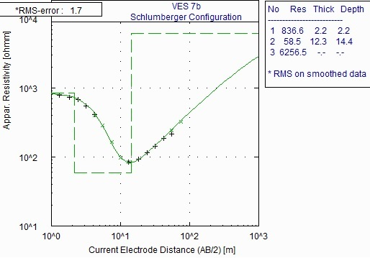

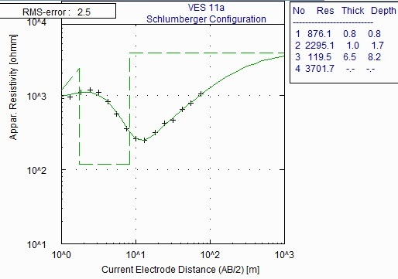

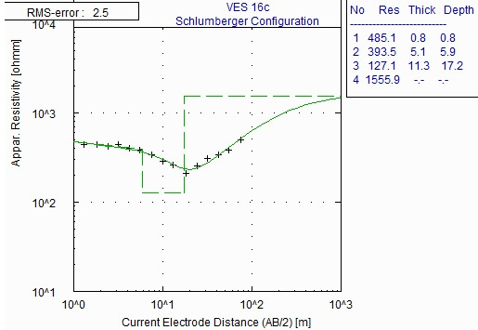
Fig. 3: Typical H-type, KH-type and QH-type curves obtained from the study area.

The shallowest bedrock is beneath station 8 with a mean depth of 7.2±1.1 m while the deepest is at station 9 with a mean depth of 39.0±13.6 m. bedrock. The mean depth to the bedrock greater than 30m obtained at stations 6 and 9 is indicative of thick overburden which would support accumulation of groundwater, especially where a fracture system exists within the bedrock which serves as link with a neighbouring aquifer (Omosuyi, 2000). Depths to the bedrock and/or overburden thicknesses greater than 30 m are characteristic of high groundwater aquifer zones (Olorunfemi and Okhue, 1992; Olayinka et al., 1997; Eduvie and Olabode, 2001).

Table 1: Depth to the bedrock (m) along the different azimuths.
VES | $$0°$$ | $$45°$$ | $$90°$$ | $$135°$$ | Mean | Standard Deviation | Coefficient of Variation (%)
1 | 19.7 | 17.9 | 25.3 | 19.9 | 20.7 | 3.2 | 15.4
2 | 22.1 | 24.8 | 23.2 | 20.9 | 22.8 | 1.7 | 7.3
3 | 14.6 | 15.1 | 20.6 | 18.5 | 17.2 | 2.8 | 16.6
4 | 19.4 | 20.0 | 19.3 | 19.0 | 19.4 | 0.4 | 2.2
5 | 9.4 | 6.9 | 13.5 | 12.6 | 10.6 | 3.0 | 28.6
6 | 35.0 | 24.7 | 41.2 | 28.3 | 32.3 | 7.3 | 22.6
7 | 19.3 | 14.4 | 21.4 | 27.2 | 20.6 | 5.3 | 25.8
8 | 7.5 | 5.6 | 7.5 | 8 | 7.2 | 1.1 | 14.8
9 | 28.7 | 28.2 | 42.3 | 56.9 | 39.0 | 13.6 | 34.8
10 | 11.9 | 10.0 | 11.2 | 9.9 | 10.8 | 1.0 | 9.0
11 | 8.2 | 5.0 | 9.2 | 11.3 | 8.4 | 2.6 | 31.1
12 | 8.9 | 9.2 | 11.1 | 15 | 11.1 | 2.8 | 25.4
13 | 17.7 | 14.2 | 14.6 | 14.6 | 15.2 | 1.6 | 10.7
14 | 7.8 | 8.1 | 14.8 | 7.2 | 9.5 | 3.6 | 37.7
15 | 26.8 | 33 | 29.9 | 27.4 | 29.3 | 2.8 | 9.6
16 | 11 | 18 | 17.2 | 15.5 | 15.4 | 3.1 | 20.3

Water supply boreholes are often sited where the overburden is considerably thick with the hope that the location has optimum groundwater accumulation and occurrence of bedrock fissures (Carruthers and Smith, 1992; Chilton and Foster, 1995; Olayinka et al., 1997). However, groundwater potential rarely depends solely on overburden thickness, but a combination of geoelectric parameters such as depth to the bedrock, saprolite resistivity and fractured bedrock resistivity (Olayinka et al., 1997; Eduvie and Olabode, 2001). The coefficient of variation in the depth to the bedrock ranges from 2.2% to 37.7%. Okurumeh and Olayinka (1998) reported coefficient of variation of 6% to 19% for the basement complex rocks around Okeho, southwestern Nigeria. The larger variation obtained in this study may have resulted from variable degree of weathering of the bedrock.

Table 2: Bedrock resistivity from radial sounding.
VES | 0⁰ | 45⁰ | 90⁰ | 135⁰ | Mean | Standard Deviation | Coefficient of Variation (%)
1 | 1642 | 1428 | 1671 | 1362 | 1526 | 154 | 10
2 | 2287 | 2940 | 2181 | 3111 | 2630 | 464 | 18
3 | 12442 | 13312 | 14451 | 16093 | 14075 | 1577 | 11
4 | 12976 | 19166 | 12428 | 8651 | 13305 | 4355 | 33
5 | 1364 | 525 | 3147 | 851 | 1472 | 1169 | 79
6 | 5776 | 10249 | 8102 | 9090 | 8305 | 1900 | 23
7 | 3871 | 6257 | 3900 | 8066 | 5523 | 2030 | 37
8 | 40214 | 26568 | 51827 | 53572 | 43050 | 12475 | 29
9 | 1317 | 1382 | 2065 | 3134 | 1975 | 844 | 43
10 | 1115 | 1033 | 1872 | 1357 | 1385 | 353 | 25
11 | 3702 | 4098 | 5626 | 36007 | 12358 | 15787 | 128
12 | 3805 | 3114 | 7104 | 1633 | 3914 | 2312 | 59
13 | 3007 | 1021 | 1054 | 2131 | 1803 | 954 | 53
14 | 636 | 629 | 1743 | 600 | 902 | 561 | 62
15 | 4134 | 5060 | 3459 | 3062 | 3928 | 874 | 22
16 | 1540 | 2240 | 1556 | 1960 | 1824 | 339 | 19

The lowest mean bedrock resistivity was recorded at station 14, with a mean of 901.75±560.8 Ωm while the maximum was obtained at station 8, with a mean of 43049.86 ±1900.1Ωm. Deviations in bedrock resistivity reflect inhomogeneity of the bedrock due to near-surface effects, variable degree of weathering (Billings, 1972). The mean bedrock resistivity less than 1000 Ωm obtained at RVES stations 14 is classified as low and indicates high groundwater potential. Those between 1000 and 3000 Ωm recorded at stations 1, 2, 5, 9, 10, 13 and 16 are intermediate and indicative of reduced or fairly low effect of weathering and medium groundwater potential. Values greater than 3000 Ωm recorded at stations 3, 4, 6, 7, 8, 11, 12 and 15 are classified as very high and suggest limited occurrence or absence of fracture in the bedrock and negligible groundwater potential (Okurumeh and Olayinka, 1998; Eduvie and Olabode, 2001).

RVES  No. | Anisotropy Polygon | RVES  No. | Anisotropy Polygon
1 | 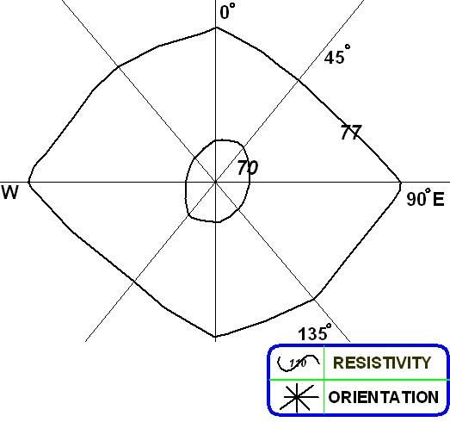 | 2 | 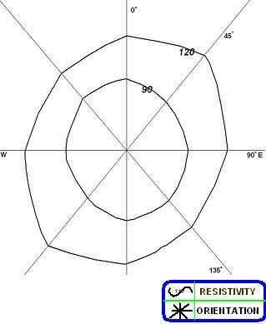

3 | 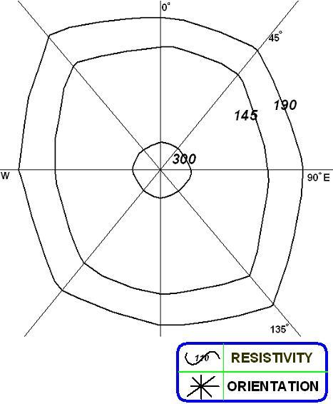 | 4 | 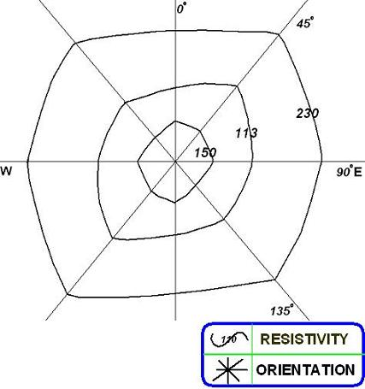
5 | 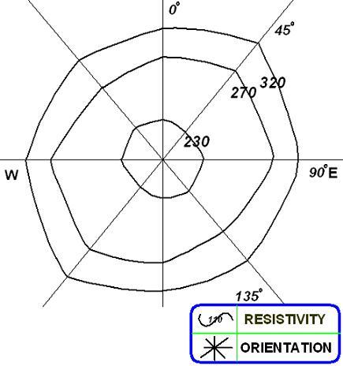 | 6 | 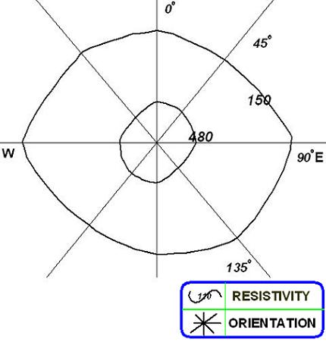
7 | 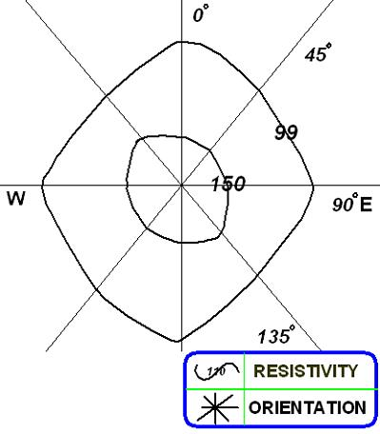 | 8 | 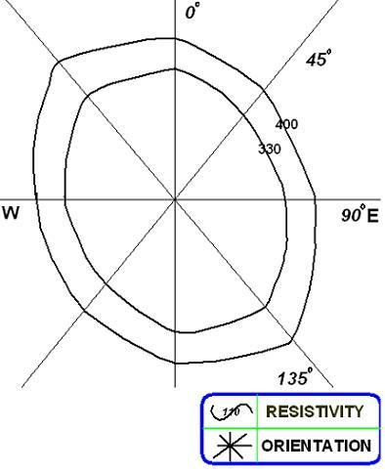

9 | 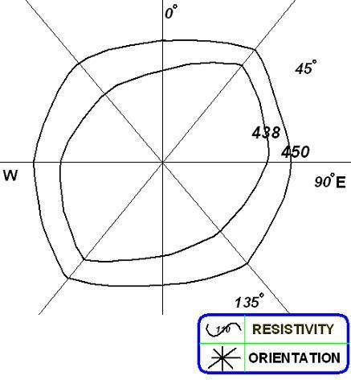 | 10 | 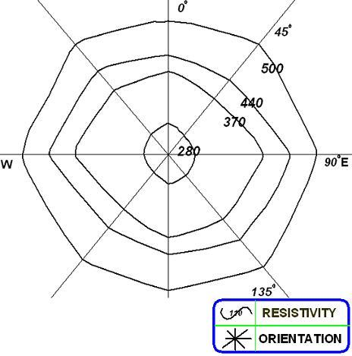
11 | 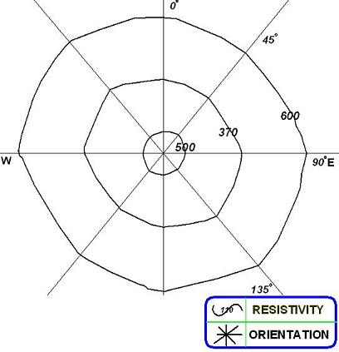 | 12 | 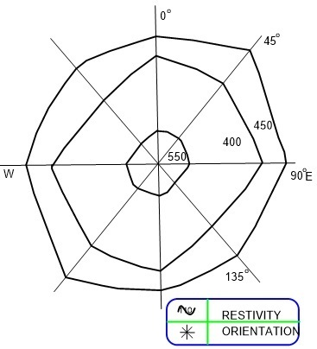
13 | 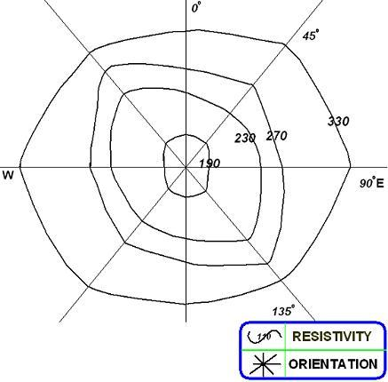 | 14 | 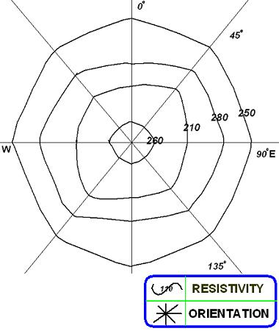

15 | 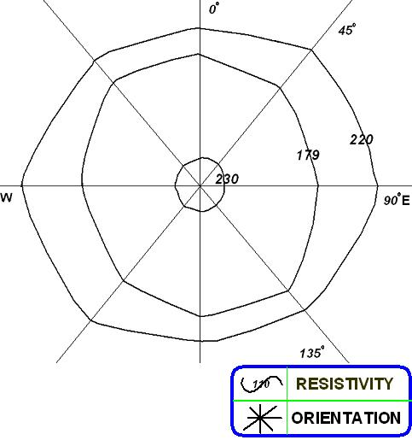 | 16 | 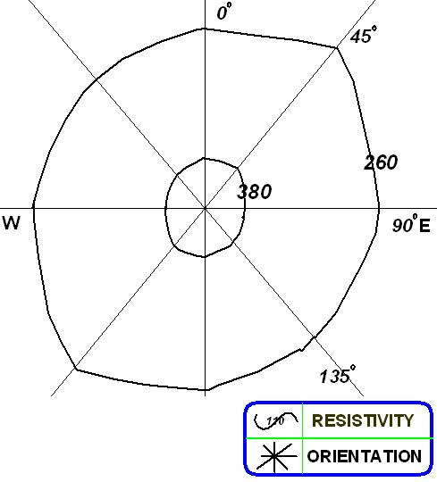
Fig. 4: Apparent resistivity maps constructed from the radial sounding

Table 3: The coefficient of anisotropy and inferred structural trend at the study area
VES | Coefficient of anisotropy, $λ$ | Inferred structural trend
1 | 1.45 | E-W
2 | 1.21 | NE-SW
3 | 1.22 | NW-SE
4 | 1.25 | NE-SW
5 | 1.16 | NE-SW
6 | 1.22 | E-W
7 | 1.21 | N-S
8 | 1.31 | NW-SE
9 | 1.19 | NE-SW
10 | 1.11 | NW-SE
11 | 1.13 | NW-SE
12 | 1.34 | NE-SW
13 | 1.20 | E-W
14 | 1.05 | N-S
15 | 1.15 | E-W
16 | 1.20 | NE-SW

The apparent resistivity maps are shown in Fig. 4 while the value of coefficient of anisotropy and the inferred structural trends are presented in Table 3. The elliptical shape of the resistivity maps is indicative of anisotropy and in homogeneity. The coefficient of anisotropy estimated from the resistivity maps vary from 1.05 (at VES14) to 1.45 (at VES 1) with a mean of 1.21. These values are within the range of coefficient of anisotropy, λ reported for basement complex rocks in literature (Olorunfemi and Opadokun, 1987; Olorunfemi and Opadokun, 1989; Okurumeh and Olayinka, 1998). There is no strong interrelationship between coefficient of anisotropy and depth to the bedrock (Fig. 5).
The bedrock beneath the study area cannot be said to be fractured since the since the reflection coefficient, R computed from resistivities of the bedrock and the weathered layer above it ranges from 0.545 to 0.997. R varies from 0.74 to 0.86 along the sounding azimuths even at station 14 beneath where the mean bedrock resistivity is apparently low. The electrical anisotropy may have thus been caused by foliation which is the predominant structural feature in the basement rocks. It is assumed that structural features in basement rocks remain intact even after weathering (Olorunfemi and Opadokun, 1987).
The azimuth of the major axis of each resistivity maps is the inferred trend of the foliation. The inferred structural trends are NE-SW for RVES 2, 4, 5, 9, 12 and 16; NW-SE for RVES 3, 8, 10, 11; E-W for RVES 1, 6, 13, 15; and N-S for RVES 7 and 14. The inferred structural trends deduced from resistivity maps are expected to correlate remarkably with the strikes of the foliation (Olorunfemi and Opadokun, 1987; Okurumeh and Olayinka, 1998).

Conclusions
The Basement Complex rocks underlying Ladoke Akintola University of Technology campus is anisotropic and inhomogeneous. The structural feature responsible for the electrical anisotropy and in homogeneity is foliation in the bedrock which is composed of porphyroblastic gneiss. The inferred structural trends deduced from the resistivity maps are NW-SE, NE-SW, E-W and N-S. Radial electrical sounding can effectively be used to map subsurface geology in areas where the bedrock is concealed.

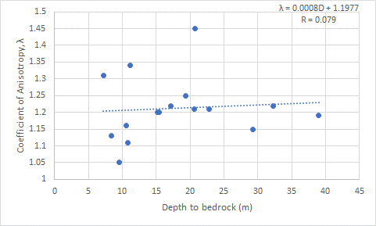
FIG. 5: Interrelationship between Coefficient of correlation and Depth to bedrock

References
- Billings M. P., 1972. Structural Geology (3rd edn.), 33-34. Prentice-Hall Englewood Cliffr. NJ.
- Carruthers R. M., 1984. Reviews of Geophysical Techniques for Groundwater Exploration in Crystalline Basement Terrain. British Geological Survey Report No. RGRGB5/3.
- Carruthers R. M. and Smith I. F., 1992. The use of ground electrical survey methods for siting water supply boreholes in shallow crystalline basement terrains, in Wright E. P. and Burgess W. G. (Ed). The hydrogeology of Crystalline Basement Aquifers in Africa, Geological Society Special Publication, No. 66.
- Chilton P. J. and Foster A. K, 1995. Characteristics of Weathered Basement Aquifers in Malawi in relation to rural water supplies. Challenge in African Hydrology and Water Resources, JAHS, Publication No. 144, p. 57-72.
- Eduvie M. O. and Olabode O. T., 2001. Evaluation of Aquifer potential in the Crystalline Basement using Geoelectric sounding data from the southern part of Kaduna State, Nigeria. Water Resources – Journal of Nigerian Association of Hydrogeologists, Vol. 12, p. 56-61.
- Habberjam G.M, 1975. Apparent resistivity anisotropy and strike measurements. Geophys. Prospect., 23: 211-247.
- Malik S. B., Bhatacharya D. C. and Nag S. K. 1983. Behaviour of Fractures in Hard Rocks- A Study by Surface Geology and Radial VES method. Geoexploration, 21(3): 181-189.
- Mamah L. I. and Ekine A. S., 1989. Electrical Resistivity Anisotropy and Tectonism in Basal Nsukka Formation. Journal of Mining and Geology, vol. 25, Nos. 1 and 2, 121-129.
- Keller G. V. and Frischknecht F., 1966. Electrical methods in Geophysical Prospecting. Pergamon Press, Oxford, 33-39.
- Olayinka A. I., Akpan E. J., Magbagbeola O. A., 1997. Geoelectrical sounding for estimating aquifer potential in the crystalline basement area of Shaki, southwest Nigeria. Water Resources, Vol. 8, No. 1 & 2, p. 71-80.
- Okurumeh O.K. and Olayinka A.I. 1998. Electrical anisotropy of Crystalline Basement rocks around Okeho, Southwestern Nigeria: Implications in Geological mapping and groundwater investigation. Water Resources. JNAH. 9: 41-50.
- Olorunfemi M. O. and Opadokun M. A., 1987. On the application of surface Geophysical measurements in Geological mapping. The Basement Complex of southwestern Nigeria as a Case study. Journal of African Earth Sciences, 6(3), 287-291.
- Olorunfemi M. O. and Opadokun M. A., 1989. Electrical Anisotropy in a Basement Complex area of southwestern Nigeria and its effect on depth sounding interpretation results. Journal of Mining and Geology, vol. 25, No. 1 & 2, 87-95.
- Olorunfemi M. O., Olarewaju V. O., Alade O., 1991. On the electrical anisotropy and groundwater yield in a Basement Complex area of S. W. Nigeria. Journal of African Earth Sciences, 12(3), 467-472.
- Olorunfemi M. O. and Okhue E. T., 1992. Hydrogeologic and Geologic significance of a Geoelectric survey at Ile-Ife, Nigeria. Journal of Mining and Geology, vol. 28, No. 2, 1992.
- Omosuyi G. O., 2000. Investigation of geoelectric parameters, Dar Zarrouk parameters and aquifer characteristics of some parts of North-Central Nigeria. Journal of Science, Engineering and Tech., Vol. 7, No. 4, p. 2835-2848.
- Orellana E. and Mooney H. M., 1966. Master tables and curves for vertical electric sounding over layered structures. Interciencia, Madrid.
- Rahaman, M. A., 1988. Recent Advances in the study of the Basement Complex of Nigeria. In: Oluyide, P. O., Mbonu, W. C., Ogezi, A.E., Egbuniwe, I. G., Ajibade, A. C. and Umeji A. C. (eds.). Precambrian Geology of Nigeria, Geological Survey of Nigeria, p.11-41.
- Zohdy A. A. R., 1974. Application of surface geophysics to groundwater investigation. In: Techniques of water resources investigations of the United States Geological Survey, Book 2, Chapter D1, p. 26-30.
- Zohdy A. A. R., 1989. A new method for the automatic interpretation of Schlumberger and Wenner sounding curves. Geophysics, 54, 245-253.

3/20/2019

