**Subsurface Investigation Of Landslide Using Electrical Resistivity And Self Potential Methods In Oke-Igbo, Southwestern Nigeria.**

Akinlabi I. A., Akinrimisi O. E, Fabunmi M. A.

Department of Earth Sciences, Faculty of Pure and Applied Sciences. Ladoke Akintola University of Technology, P.M.B. 4000, Ogbomoso, Nigeria.

**Abstract:** Electrical resistivity and self-potential profiling were conducted at the location of a landslide in Oke-Igbo, southwestern Nigeria. The event occurred when the slope became unstable and failed after a heavy rainfall on 3rd November, 2013. The aim was to investigate the possible causes of the landslide. The surveys were conducted along four (4) traverses 30 m apart across the landslide axis and one (1) traverse along it. Station spacing and electrode spacing were 10 m while the expansion factor for the resistivity profiling was 5 m. The 2D resistivity models show relatively low resistivity zones indicating weak zones suspected to be loose/water-saturated soils and discontinuities in rocks such as water-filled fractures. The positions of the negative SP anomalies obtained from the SP profiling correlate with those on resistivity models in which areas with high water content and groundwater flow are characterized by low resistivity. The landslide was caused by a combination of the heavy rainfall and the existing weak zones. The electrical resistivity and self-potential profiling are invaluable tools for providing subsurface information in landslide investigation.

[Akinlabi I. A., Akinrimisi O. E, Fabunmi M. A. **Subsurface Investigation Of Landslide Using Electrical Resistivity And Self Potential Methods In Oke-Igbo, Southwestern Nigeria.** *N Y Sci J* 2019;12(3):56-63]. ISSN 1554-0200 (print); ISSN 2375-723X (online). <http://www.sciencepub.net/newyork>. 8. doi:[10.7537/marsnys120319.08](http://www.dx.doi.org/10.7537/marsnys120319.08).

**Keywords:** Slope stability, Groundwater flow, Low resistivity zones, Negative SP anomalies.

**Introduction**

Landslide is a complex geologic body composed of a combination of layers having contrasting and gradational physical properties (Bongoslovsky and Ogilvy, 1977). It comprises a large variety of mass movements ranging from very slow slides in soils to rock avalanches. Landslides may be considered as common natural hazards, usually leading to significant economic losses and even fatalities. Areas affected by landslide usually exhibit dramatic spatial and temporal variations of lithological and hydrogeological conditions. The major factors which trigger the occurrence of landslide is the combination of heavy rainfall and existing weak zones such as loose/water-saturated soils and discontinuities in rocks (e.g. faults or water-filled fractures). Slope failure occurs when water saturation exceeds a certain limit in certain parts of the slope, causes increase in pore pressure, and eventually leads to landslide.

Conventional landslide investigation methods employ satellite, airborne and ground-based sensing techniques which can provide information on the surface characteristics (e.g. geomorphological features and areal extent of the landslide body) of the investigated slope and none about subsoil characteristics. Direct ground-based techniques employing, for example, piezometer, inclinometer, laboratory tests furnish true information on the mechanical and hydraulic characteristics of subsoils of the landslide area, but are point-specific.

Detailed investigation would require closely-spaced sampling and testing and would thus be laborious, time-consuming and expensive. It therefore becomes necessary to use in-situ geophysical methods which can determine physical parameters directly or indirectly linked with the lithological, hydrological and geotechnical characteristics of the terrains affected by the landslide with speed and economy not attainable by the other methods (Sharma, 2002). The field procedures are non-invasive while data interpretation would provide continuous information about the investigated landslide body.

Geophysical methods can provide in-situ subsurface conditions, which, in turn, can be translated into geotechnical information on the parameters of the subsoil, towards a complete understanding of the physical behavior of a slope or the cause (s) of a landslide (Sastry et al., 2016). A large number of geophysical methods have been found applicable at the reconnaissance stage of landslide investigation and these include the seismic, gravity, electromagnetic, ground penetrating radar, electrical resistivity and self-potential methods. The choice of the method (s) to apply depends on the expected contrast in physical parameters, resolution and signal-to-noise ratio. The complex nature of landslides has necessitated the use of a combination of different geophysical methods in order to obtain reliable results (Sharma, 1997, Jongmans and Garambois, 2007). Ambiguities arising from the results of one method may be resolved by considering the results from the other (Kearey *et al*., 2002).

Geophysical methods that detect changes electrical properties of the subsurface are capable of detecting and mapping the rupture surface of a landslide (Goryainov *et al*., 1988; Grandjean *et al*., 2011). The electrical resistivity imaging technique has been largely applied to investigate landslide areas to evaluate spatial and temporal variation of moisture and heterogeneity of subsoil (Griffiths and Barker, 1993; Loke and Barker, 1996; Jongmans *et al*, 2000; Lapenna *et al.,* 2005; Perrone *et al*., 2014). It is based on the measurement of resistivity values and their spatial distribution in the subsoil, and can provide useful information about the landslide geometry and water content (Jongmans and Garambois, 2007). Due to the presence of water, electrical resistivity would be lower in the displaced, unconsolidated materials of a landslide than in the undisturbed materials.

The self-potential (SP) method has been widely applied for delineating groundwater accumulation zones and/or flow paths in landslide bodies (Bongoslovsky and Ogilvy, 1977; Patella *et al.,* 1997; Bruno and Marillier, 2000; Meric *et al*., 2005). The presence of groundwater and its associated flows plays a major role in landslide and slope stability. The application of SP method to water-seepage investigations in a landslide body is based on measurements of spontaneous or natural potentials induced by groundwater flow (Sharma, 2002). These natural potentials represent the electric field signature at the earth’s surface, developed by electrokinetic processes involving subsurface flow of ionic fluids.

Since old landslides can be reactivated and possibly generate new landslides, it is important to investigate older landslides in order understand the subsurface characteristics of the area affected by the previous occurrence. The information obtained could possibly be used to improve current landslide hazard assessment and proffer possible remediation that may help to aver reoccurrence.

It is against this background that the location of a landslide in Oke-Igbo, southwestern Nigeria has been investigated using electrical resistivity imaging and self-potential profiling techniques to determine the probable causes. The landslide occurred on the November 1, 2013 after a heavy rainfall. The objectives of the study are to delineate the landslide structure, determine its lateral extent, define the internal composition of the landslide materials, identify areas with high water content and groundwater movement within the landslide body, and the presence of potentially unstable areas.



**Fig. 1**: **Location map of Oke-Igbo (after Ikubuwaje et al., 2013)**

The study area is located at Oke-Igbo in the western part of Ondo state, southwestern Nigeria. It lies within longitudes of 7.10ᵒN to 7.11ᵒN, and latitudes of 5.05ᵒE to 5.08ᵒE (Fig. 1). The area is underlain by Precambrian basement rockswhich comprises Migmatite gneiss complex, metasediments and older granites (Rahaman, 2006) and is also very rich in quartzites which form ridges and have undergone series of tectonic activities. The quartzites, which are in block forms, are exposed in most of the locations due to weathering and erosion, and serve as sources of the springs in the community.

**Methodology**

The study employed the dipole-dipole and self-potential profiling techniques. The surveys were carried out along four traverses, about 30 m apart, and trending east-west across the landslide zone, and one along the landslide axis in the north-south direction (Fig. 2). The dipole-dipole profiling was performed to determine both vertical and lateral variations of resistivity and used electrode spacing, a = 10 m and expansion factor, n = 5 m. The apparent resistivity data acquired from the dipole-dipole profiling were interpreted by using 2D resistivity inversion procedure which iteratively computes the resistivity response of a two- dimensional model until a reasonable match is achieved between a theoretical pseudosection and the observed pseudosection, based on the finite element method (FEM) of modeling using a 2nd order smoothness constraint (Dey and Morrisson, 1979; Hohnmann, 1982).

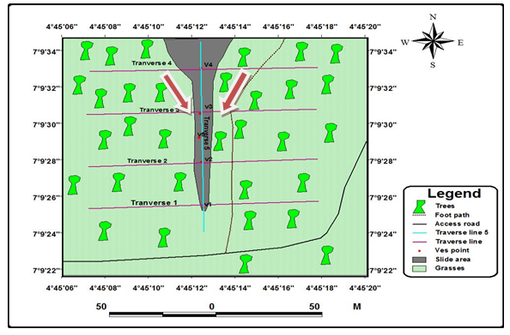

**Fig. 2: Field layout at the location of the landslide at Oke-Igbo, southwestern Nigeria.**

The self-potential measurements were taken with a view to determining the presence of groundwater movement. Traverses were performed by leapfrogging successive electrodes over the survey area along traverse length of about 100m at station spacing of 10m. The electrodes are non-polarizing, consisting of copper immersed in a saturated solution of copper (II) sulphate contained in a porous pot through which it leaks into the ground. The self-potential voltages were measured by a high impedance voltmeter connected between the electrodes, and plotted against the respective distances along the traverses. The anomaly minima were considered to occur directly over the anomalous bodies which were interpreted to indicate the presence of groundwater flow or saturation.

**Results And Discussion**

The electrical resistivity tomogram obtained along Traverse 1 shows resistivity values ranging from 575 Ωm to 5501 Ωm (Fig. 3). Relatively low resistivity values (less than 1000 Ωm) observed from surface to about 10 m depth indicate water saturation while the weathered materials which have resistivity ranging from 1408 Ωm to 2719 Ωm suggestive of clayey sand. These materials are underlain by weathered/fresh bedrock which also outcrops at the eastern end of the profile. Rise in water content and the consequent increase in pore water pressures can play an important role in triggering landslide (Bishop, 1960; Mongenstern and Price, 1965).

Traverse 2 is underlain by weathered materials of resistivity values ranging from 531 Ωm to 1898 Ωm characteristic of clayey sand (Fig. 4). The low resistivity zone (with resistivity values less than 1000 Ωm) occurring at 5 – 10 m depth within these materials reflect water saturation which may trigger fresh landslide. The high resistivity zones indicate the bedrock which is exposed due to erosion of regolith covering it. The moderately high resistivity values (2066 Ωm - 3801 Ωm) at the surface around stations 3, 5, 6 and 8 may be due to rock fragments or rubbles transported down the slope by the landslide.

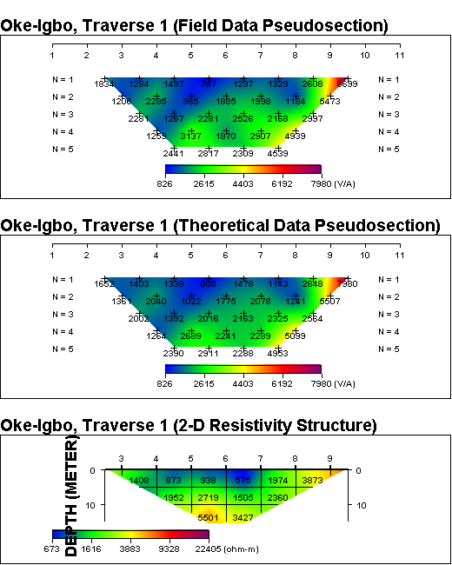

**Fig. 3: Inverse resistivity model along Traverse 1 across the landslide**

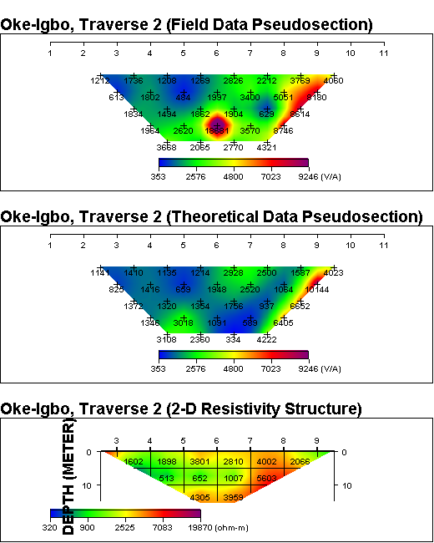

**Fig. 4: Inverse resistivity model along Traverse 2 across the landslide**

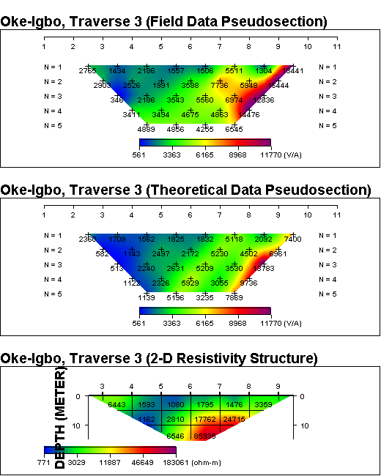

**Fig. 5: Inverse resistivity model along Traverse 3 across the landslide**

The inverse resistivity model beneath Traverse 3 (Fig. 5) shows weathered materials with resistivity ranging from 1476 Ωm to 3359 Ωm. and low resistivity zone suspected to be water-filled fracture with resistivity values 1080 Ωm - 1593 Ωm within the bedrock between station 4 and station 6. The bedrock is fresh beneath stations 6-9 with resistivity values ranging from 17762 Ωm to 85335 Ωm. The west half of Traverse 4 shows weathered materials about 5 m thick, with pockets of groundwater (Fig. 6). It is underlain by bedrock of resistivity varying from 3038 Ωm to 33192 Ωm which is exposed from station 5 to the east end and possibly reflecting surface of rupture.

The inverse resistivity model beneath Traverse 5 along the landslide axis shows overburden materials of resistivity ranging from 1002 Ωm to 1955 Ωm and thickness varying from 6 m to 7 m, underlain by weathered/fresh bedrock of resistivity values 2165 Ωm - 3632 Ωm (Fig. 7). The low resistivity zone at the north end agrees with that observed on Traverse 1 reflecting water saturation.

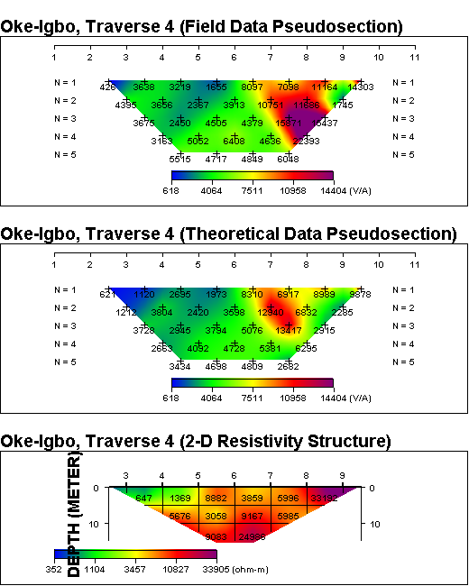

**Fig. 6: Inverse resistivity model along Traverse 4 across the landslide**

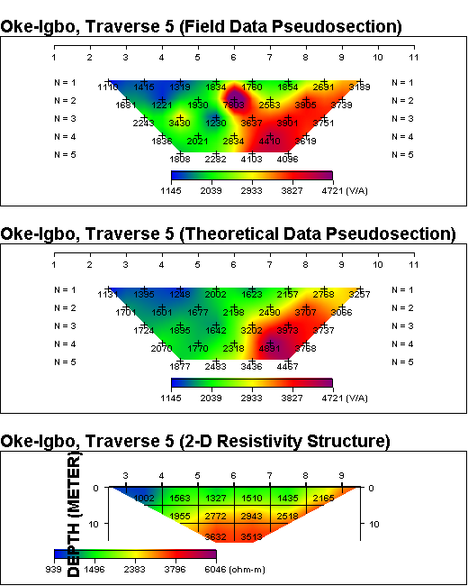

**Fig. 7: Inverse resistivity model for Traverse 5 along the landslide axis**

The SP voltages beneath the landslide zone range from –374.10 mV to +37.25 mV. It ranges from -104.15 mV to 37.25 mV along Traverse 1 (Fig. 8) along which SP minima of -88.75 mV, -104.15 mV and -36.52 mV were observed at distances of 10 m, 30 m and 60 m respectively. These negative SP anomalies may be attributed to the existence of subsurface flow of groundwater. The main source of SP signal in landslide is usually associated with groundwater flow through electrokinetic coupling (Birch, 1998; Sharma, 2002; Rizzo et al., 2004).

The SP voltage along Traverse 2 ranges from -10.22 mV to -188.82 mV (Fig. 9) and SP minima of -159.75 mV and -188.82 mV were observed along the traverse at distances of 40 m and 90 m respectively. While the former may be attributed to the existence of subsurface flow of groundwater as indicated by the inverse resistivity model, the latter may be due to intensely weathered/fractured rocks.

The SP voltage along Traverse 3 ranges from -208.34 mV to -9.22 mV (Fig. 10). The two most prominent SP minima of -91.21 mV and -208.34 mV were observed at distances of 20 m and 70 m respectively, and are attributable to subsurface groundwater flow. The SP voltage along Traverse 4 ranges from -125.04 mV to -6.08 mV (Fig. 11). SP minima of -96.68 mV and -125.04 mV were observed at distances of 10 m and 50 m, attributable subsurface groundwater flow and fracturing respectively. The SP voltage along Traverse 5 ranges from -374.10 mV to -11.49 mV (Fig. 12). SP minima of –374.10 mV, and -71.90 mV and -125.04 mV were observed at distances of 10 m, 50 m and 100 m respectively, and are due to subsurface groundwater flow.

**Conclusions**

Electrical resistivity and self-potential profiling techniques have been applied to investigate a landslide at Okeigbo, southwestern Nigeria to determine the possible causes. The 2D resistivity models show relatively low resistivity zones indicating weak zones suspected to be loose/water-saturated soils and discontinuities in rocks such as water-filled fractures. The positions of the negative SP anomalies obtained from the SP profiling correlate with those on resistivity models in which areas with high water content and groundwater flow are characterized by low resistivity.

The major factor that triggered the landslide is the combination of the heavy rainfall and the existing weak zones. The electrical resistivity and self-potential profiling are invaluable tools for providing subsurface information in landslide investigation.

**Fig. 8: SP anomaly plot for Traverse 1 across the landslide**

**Fig. 9: SP anomaly plot for Traverse 2 across the landslide**

**Fig. 10: SP anomaly plot for Traverse 3 across the landslide**

**Fig. 11: SP anomaly plot for Traverse 4 across the landslide**

**Fig. 12: SP anomaly plot for Traverse 5 along the landslide axis**

Further studies, using field and laboratory geotechnical tests, are recommended to validate results obtained from this study. Integration of geotechnical test data with geophysical data can provide detailed information for subsurface characterization.

**Acknowledgement**

The authors are sincerely grateful to Professor A. M. Gbadebo of Federal University of Agriculture, Abeokuta for providing information about the landslide incident and access to the study location.

**References**

1. Bishop A. W., 1960. The principle of effective stress. Norw. Geotech. Inst. Publ., 32, 1-5.
2. Bongoslovsky V. A. and Ogilvy, A. A., 1977. Geophysical methods for the Investigation of Landslides. Geophysics, 42(3), 562-571.
3. Birch, F. S., 1998. Imaging the water table by filtering self-potential profiles. Groundwater, 36, 779-782.
4. Bruno F. and Marillier, F., 2000. Test of high-resolution seismic reflection and other geophysical techniques on Boup landslide on Swiss Alp. Surveys in Geophysics, 21(4), 333-348.
5. Dey A. and Morrison H.F., 1979. Resistivity modeling for arbitrary shaped two-dimensional structures. Geophys. Prosp., 27, 106-136.
6. Grandjean G., Gourry J. C., Sanchez O., Bitri A., Garambois S., 2011. Structural study of the Ballandaz landslide (French Alps) using geophysical imagery. Journal of Applied Geophysics, 75, 531-542.
7. Griffths D.H., Barker R.D., 1993. Two-dimensional resistivity imaging in areas of complex geology. J Applied Geophysics,29, 211 – 226.
8. Goryainov N.N., Matveev V.S., Varlamov N. M., 1988. Use of geophysical methods for landslide and mudflow investigations. Landslide and Mudflows, 1, UNESCO, Moscow, 134-145.
9. Hohnmann G.W., 1982. Numerical modeling for electrical geophysical methods. Proc. Int. Symp. Appl. Geophs. Trop. Reg. Univ. d. Para. Belem. Brazil. p. 308-384.
10. Ikubuwaje, C, Obasi, R. A, and Jegede, G., 2013. The Geomorphologic Denudation of Oke-Igbo area of Ondo State, Southwest Nigeria: A Hydro-Climatic Influence. Volume 3, Issue 5 (Mar.- Apr. 2013), pp. 62-67.
11. Jongmans D., Hemroulle P., Demanet D., Rennardy F., Vanbrabant Y., 2000. Application of 2D electrical and seismic tomography for investigating landslides. Eur. J. Environ. Eng. Geophys. 5, 75-89.
12. Jongmans D. and Garambois S., 2007. Geophysical investigation of landslides: A review. Bulletin of the Geological Society of France, 178, 101–12.
13. Kearey P., Brooks M. and Hill I., 2002. An Introduction to Geophysical Exploration Third Edition. Blackwell Science Limited, 262p.
14. Lapenna V., Lorenzo P., Perrone A., Piscitelli S., Sdao F. and Rizzo E., 2005.2D Electrical Resistivity Imaging of some Landslides in Lucanian Apennine (Southern Italy). Geophysics, vol. 70, 3, (May-June 2005); P. B11–B18, (2005).
15. Loke M. H. and Barker R. D., 1996. Rapid least-square inversions of apparent resistivity pseudosections by a quasi-Newton method. Geophysical Prospecting, 44, 131-152.
16. Meric O., Grambois S., Jongmans D., Wathelet M., Chatelain J. L., Vengeon J. M., 2005. Application of Geophysical methods for the investigation of the large gravitational mass movement of Séchilieme, France. Can. Geotech. J., 42, 1105-1115.
17. Mongenstern M. R. and Price V.E., 1965. The analysis of the stability of the general slip surfaces. Geotechniques, 15 (1), 71-93.
18. Patella D., 1997. Introduction to ground surface self-potential tomography. Geophys. Prospect., 45, 653–681.
19. Perrone A., Vassallo R., Lapenna V., and Di Maio C., 2008. Pore water pressures and slope stability: a jointed geophysical and geotechnical analysis of a landslide. J. Geophys. Eng. 5, 323-337.
20. Rahaman M. A., 2006.Recent advances in the study of the basement complex of Nigeria.
21. Symposium on the Geology of Nigeria, Obafemi Awolowo University, Nigeria.
22. Rizzo E., Suski B., Revil A., Straface S., Troisi S., 2004. Self-potential signals associated with pumping tests experiments. J. Geophys. Res.,109, B10203.
23. Sastry R. G., Mondal S. K., Pachauri A. K., 2016. 2D Resistivity Tomography of a Landslide in Garhwal, Himalaya. 6th International Conference and Exposition on Petroleum Geophysics, “Kolkata 2016”, p. 997-1001.
24. Sharma P.V., 2002. Environmental and Engineering Geophysics, Cambridge University Press, U. K.

3/20/2019