Effect of Vitamin D₃ vs. Atorvastatin on the progress of Streptozotocin-induced diabetic peripheral neuropathy in rats

Eman El-Sayed El-Metaher, Sabiha Hedya MD, Fleur Fathy MD and Waleed Barakat MD

Pharmacology department, Faculty of Medicine, Tanta University, Egypt
eman.elmohamady@med.tanta.edu.eg

Abstract: Background: Diabetic sensorimotor peripheral neuropathy (DSPN) is a common health problem that is a lifelong disease that affects quality of life. It is a chronic microvascular diabetic complication. The exact cause is not entirely understood. There are many medical therapies, however they have several drawbacks. The aim of the study: to evaluate the possible anti-inflammatory, antioxidant, anti-apoptotic effects of vitamin D₃ & atorvastatin each alone or combined in prevention of STZ induced-DSPN in albino rats. Methods: This experiment was performed on 50 male albino rats divided into 5 equal groups; ( group 1) control group, (group 2) untreated STZ induced-DSPN group, (group 3) vitamin D3 treated, (group 4) Atorvastatin treated, (group 5) vitamin D3 & Atorvastatin treated. At the end of the experiment, serum glucose, CPK-MM, sciatic nerve MDA, catalase activity, NGF & IL-6 were assessed as well as histopathological examination and immunohistochemistry for Caspase-3 activity. Results: the untreated group showed significant increase in serum glucose, MDA, IL-6 & Caspase-3 and significant decrease in catalase activity & NGF, treatment with either vitamin D₃ or atorvastatin produce significant improvement in the most parameters when compared to untreated group, also their combination produces significant improvement in all parameters & produce better response than each drug alone. Conclusion: These findings suggest that each of vitamin D₃ and atorvastatin produce promising effects in prevention of STZ induced-DSPN, also combination of vitamin D₃ and atorvastatin exhibited additional effects superior to each monotherapy. It could be recommended to verify these results in further clinical studies.
[Eman El-Sayed El-Metaher, Sabiha Hedya, Fleur Fathy and Waleed Barakat. Effect of Vitamin D₃ vs. Atorvastatin on the progress of Streptozotocin-induced diabetic peripheral neuropathy in rats. N Y Sci J 2019;12(3):27-35]. ISSN 1554-0200 (print); ISSN 2375-723X (online). http://www.sciencepub.net/newyork. 5. doi:10.7537/marsnys120319.05.

Keywords: DSPN, STZ, Vitamin D3, Atorvastatin.

1. Introduction
Diabetes mellitus (DM) is a metabolic disease in which hyperglycemia and insulin dysregulation occurs, mostly accompanied by chronic complications. Currently, DM affects more than 425 million people all over the world and this number is progressively increasing. Diabetic peripheral neuropathy (DPN) is a popular disabling complication with an estimated prevalence from 13% to 58% among uncontrolled diabetic patients (Pop-Busui et al., 2017). DPN can affect autonomic and sensorimotor peripheral nervous systems. The most common form is diabetic sensorimotor polyneuropathy (DSPN) (Zenker et al., 2013) and accounts for 75% among diabetic neuropathies. However, DSPN occurs in at least 20% of people as a complication of T1DM. DSPN definition is the presence of symptoms and/or signs of peripheral nerve dysfunction in people with diabetes after exclusion of other causes (Pop-Busui et al., 2017). The pathogenesis of DSPN is multifactorial & the exact mechanism of this disease remains poorly understood. Hyperglycemia may be responsible for multiple biochemical changes in the nerve tissue (Stavniichuk et al., 2012). The involved pathological mechanisms are inflammatory changes, oxidative stress, microvascular damage, metabolic disorders, advanced glycation end products & growth factor deficiency (Zochodne, 2007, Van Dam et al., 2013). Impaired insulin signaling and hyperglycemia are primary pathogenic events and multiple pathways involving protein glycation, loss of trophic support, mitochondrial dysfunction, oxidative stress and inflammation (Daugherty et al., 2018). Patients with DSPN usually experience positive sensory symptoms (pain, tingling and paraesthesia) and negative symptoms (allodynia, hyperalgesia) (Feldman et al., 2017).
In Europe, U.S and Canada, Pregabalin and duloxetine have been approved for treatment of DPN. Tapentadol is a novel FDA approved centrally acting opioid for the treatment of DPN pain. However, many non-approved drugs have been used in the treatment of DPN pain e.g. Amitriptyline, imipramine, tramadol & oxycodone (Pop-Busui et al., 2017).
Streptozotocin (STZ) is an antimicrobial agent and chemotherapeutic alkylating agent (Lenzen, 2008, Furman, 2015). STZ is used to induce DM in experimental animals as it causes necrosis of β-cells of the pancreas through oxidative stress & libration of nitric oxide (NO) (Ghasemi et al., 2014) leading to pathological changes that mimic human type I DM. Due to its low cost, it became an attractive model for DM (Furman, 2015).
Vitamin D is an essential fat soluble vitamin; it is formed under the skin during exposure to ultra violet rays or obtained from diet (Sadat-Ali et al., 2014). Nowadays it has been shown to play a role as anti-inflammatory, antioxidant and immunomodulator in primary immune mediated peripheral neuropathies, multiple sclerosis (MS), Alzheimer & Parkinsonism disease (Elf et al., 2014, Wimalawansa, 2016).
Atorvastatin is an antihyperlipidemic drug that acts by inhibition of 3-hydroxy-3-methylglutaryl coenzyme A (HMG-CoA) reductase enzyme. Recently it has been shown to have antioxidant action (neuroprotective) in Alzheimer (Barone et al., 2011) and anti-inflammatory action in experimental autoimmune encephalomyelitis & relapsing-remitting MS (Youssef et al., 2002, Aktas et al., 2003).
The present study was designed to evaluate and compare some possible antioxidant, antiapoptotic and anti-inflammatory effects of vitamin D3 and atorvastatin when used either alone or as combined therapy for prevention of STZ induced-DSPN in rats.

2. Material and Methods
Drugs & chemicals:
Atorvastatin tablets 10 mg purchased from Egyptian International Pharmaceutical Industries co. E.I.P.I.CO, Egypt. It was dissolved in saline and administered orally by oral gavage in a dose of 10 mg/kg/day (Li et al., 2014, AKALIN ÇİFTÇİ et al., 2015).
Pure white powder of water soluble form of cholecalciferol from Supreem Pharmaceuticals Mysore Pvt. Ltd. India purchased from October pharma, Egypt. It was dissolved in distilled water and administered orally by oral gavage in a dose of 0.03 μgm/kg/day (El-Hafiz et al., 2018).
STZ is pure yellow powder purchased from Sigma Aldrich, USA. It was used to induce DM in rats by dissolving the drug in 0.1M sodium citrate buffer (pH4.6). The drug was then injected once i.p. in a dose of 60 mg/kg to induce type Ӏ diabetes; the blood glucose level was checked 3 days later using a blood sample from the tail to detect diabetes (Lee et al., 2003, Malardé, 2012).
Experimental design:
This experiment was carried out using 50 male Wistar Albino rats weighting 150-200 gm., obtained from Tanta university animal house. Animals were acclimatized in the animal house of Pharmacology department of faculty of medicine Tanta university for 14 days before induction of DM, the animals then were kept in plastic cages; they were fed standard food and water ad libitum through the whole period of the experiment. The animals were divided into 5 equal groups (10 rats each) as following:
Group1: Control normal rats each received 1ml citrate buffer i.p. single dose.
Group2: Diabetic rats injected by single injection of 60 mg/kg STZ i.p. to induce T1DM & received saline orally before & after induction of T1DM for 4 weeks.
Group3: Diabetic rats treated with vitamin D3 orally in a dose of 0.03 µgm/kg/day before & after induction of T1DM for 4 weeks.
Group4: Diabetic rats treated with atorvastatin orally in a dose of 10 mg/kg/day before & after induction of T1DM for 4 weeks.
Group5: Diabetic rats treated with both vitamin D3 and atorvastatin orally in a dose of 0.03 µgm/kg/day & 10 mg/kg/day respectively before & after induction of T1DM for 4 weeks.
After 3 days from induction of STZ, blood glucose level was checked via rat tail sample in all rats to exclude non-diabetic rats (blood glucose level<200 mg/dl) (El-Hafiz et al., 2018).
After 4 weeks, the Tail immersion test was done at the end of the experiment as following: the tail of the rat was immersed at warm water (46ᵒ C) until tail withdrawal or signs of struggle were observed (cut off time: 15 sec.). A minimum 10 minutes interval was maintained between each measurement. The test was repeated 2-3 times to obtain a mean value (Courteix et al., 1993, Kamboj et al., 2010).
Then, the rats were anesthetized using ether then blood samples were collected by intracardiac puncture in plain tubes to be centrifuged and serum was separated and stored to be used in detection of serum glucose and creatine phosphokinase (CPK-MM). After that, the rats were sacrificed, and sciatic nerves were dissected. The right one was kept in buffered formalin for histopathological examination & Immunohistochemical assay of caspase-3, and the left one was homogenized and centrifuged, then the supernatant was stored and used for detection of malondialdehyde (MDA), catalase activity, nerve growth factor (NGF), interleukin-6 (IL-6).
Measured parameters:
Serum glucose level (mg/dl): Blood glucose levels were measured in the serum using kit from Biodiagnostic Company according to the technique described by (Trinder, 1969).
Serum creatine phosphokinase (CPK-MM) (pg/dl): CPK-MM was measured in serum by kits obtained from Chongqing Biospes Co., Ltd Company, China, No.: BYEK2098 according to the technique described by (Goldblatt, 1969).
Tissue catalase (U/g): It was measured in the tissue using kit from Biodiagnostic Company, No.CA 25 17 according to the technique described by (Aebi, 1984).
Lipid Peroxides [Malondialdehyde (MDA)] (nmol/g): It was measured in the tissue homogenate using kit from Biodiagnostic Company, No. MD 25 29 according to the technique described by (Kei, 1978, Ohkawa et al., 1979).
Nerve Growth Factor (NGF) (pg/mg): NGF was measured in tissue homogenate by kits obtained from Chongqing Biospes Co., Ltd Company, China, catalog No.: BEK1171 according to the technique described by (Levi-Montalcini, 1987, Fiore et al., 2009).
Interleukin-6 (IL-6) (pg/mg): IL-6 was measured in tissue homogenate by kits obtained from Chongqing Biospes Co., Ltd Company, China, catalog No.: BEK1110 according to the technique described by (Banks et al., 1994).
Histopathological examination: The full thickness sciatic nerve samples were collected and immediately fixed in 10% formalin. Paraffin sections were done (5 micrometer) and stained with heamatoxyllin and eosin (H & E) and examined by light microscope for histopathological changes.
Immunohistochemical staining of Caspase-3: Immunohistochemical study was done to assess the reactivity of the sciatic nerve tissue to the antibody of caspase-3. The caspase protein is a member of the cysteine-aspartic acid protease (caspase) family. This method is according to (Buchwalow and Böcker, 2010). Evaluation of the percent of antigen-positive cells was conducted using a light microscope. Percentage of apoptotic cells per section was scored according to the method described by (BODEY et al., 2004).
Statistical analysis:
Results were analyzed statistically using software Statistical Package for the Social Science (SPSS) for windows, version 23 (SPSS Inc., USA). The level of significance was established as 5% by One Way ANOVA followed by Tukey’s post-Hoc test. Descriptive statistics were presented as Mean + Standard Error of Mean (SEM). Kruskal-Wallis test is a non-parametric test for statistical analysis of the clinical score followed by Mann-Whitney U test to test the difference between groups.

3. Results

Table (1): Collective table for comparison of all parameters in different studied groups.
Groups  Parameter | Group 1 (n=8) | Group 2 (n=8) | Group 3 (n=7) | Group 4 (n=6) | Group 5 (n=8) | *One-way ANOVA  F value (P value)  #Kruskal-Wallis Test X² value (P value)
Withdrawal latency (sec.) | 10.63 ±0.375 | 6.5 ±0.3273 P₁<0.001* | 8.143±0.261 P₂<0.01* | 8.00 ± 0.2582  P₂<0.05*  P₃>0.05 | 9.375 ± 0.183  P₂<0.001*  P₄<0.05*  P₅<0.05* | 29.69 (p<0.001) *
Serum glucose level (mg/dl) | 121 ± 0.655 | 514.1 ± 10.29 P₁<0.001* | 495.7±10.18 P₂>0.05 | 499.8 ± 14.55  P_{2>}0.05  P₃> 0.05 | 478.9 ± 10.57  P₂>0.05  P₄> 0.05  P₅>0.05 | 311.3 (P<0.001) *
Serum CPK-MM levels (pg/mg tissue protein) | 1.098 ±0.21 | 0.944 ±0.19  P₁>0.05 | 1.314 ± 0.204  P₂>0.05 | 2.675 ± 0.168  P₂<0.001*  P₃<0.001* | 1.015 ± 0.179  P₂>0.05  P₄>0.05  P₅<0.001* | 11.99 (p<0.001)*
Nerve tissue catalase activity (U/g tissue protein) | 1.729 ± 0.112 | 0.703 ± 0.062  P₁<0.001* | 1.043 ± 0.01  P₂<0.05* | 1.057 ± 0.019  P₂<0.05*  P₃> 0.05 | 1.673 ± 0.069  P₂< 0.001*  P₄<0.001*  P₅<0.001* | 41.06 (P<0.001)*
Nerve tissue MDA activity (nmol/g tissue protein) | 13.36 ± 0.587 | 35.75 ± 3.117  P₁<0.001* | 28.10 ± 1.462  P₂<0.05* | 27.21 ± 1.130  P₂<0.05*  P₃> 0.05 | 21.30 ± 0.615  P₂< 0.001*  P₄>0.05  P₅>0.05 | 24.86 (p<0.001)*
Nerve tissue NGF levels (pg/mg tissue protein) | 804.8 ± 25.04 | 186.1 ±10.36  P₁<0.001* | 543.5 ± 11.80  P₂<0.001* | 577.9 ± 26.28  P₂<0.001*  P₃> 0.05 | 759.4 ± 57.89  P₂< 0.001*  P₄<0.001*  P₅<0.01* | 59.86 (p<0.001)*
Nervous tissue IL-6 levels (pg/mg tissue protein) | 772.1 ± 42.82 | 1559 ± 35.85  P₁<0.001* | 1035 ± 75.52  P₂<0.001* | 1133 ± 37.22  P₂<0.001*  P₃> 0.05 | 789.2 ± 26.75  P₂< 0.001*  P₄<0.01*  P₅<0.001* | 52.94 (p<0.001)*
Caspase-3 immuno-staining | 0 (0.75) | 4 (0.00)  P₁<0.001* | 3 (1)  P₂<0.01* | 2 (0.25)  P₂<0.01*  P₃> 0.05 | 1 (0.75)  P₂< 0.001*  P₄<0.01*  P₅<0.01* | 27.383 (P<0.001)#
*Significant at P value (< 0.05); values expressed as mean ± SEM. #Significant at P value (< 0.05); values expressed as median (IQR).
P₁= (group 2) versus (group 1), P₂= (group 3), (group 4), (group 5) versus (group 2), P₃= (group 4) versus (group 3),
P₄= (group 5) versus (group 3), P₅= (group 5) versus (group 4). n= number.

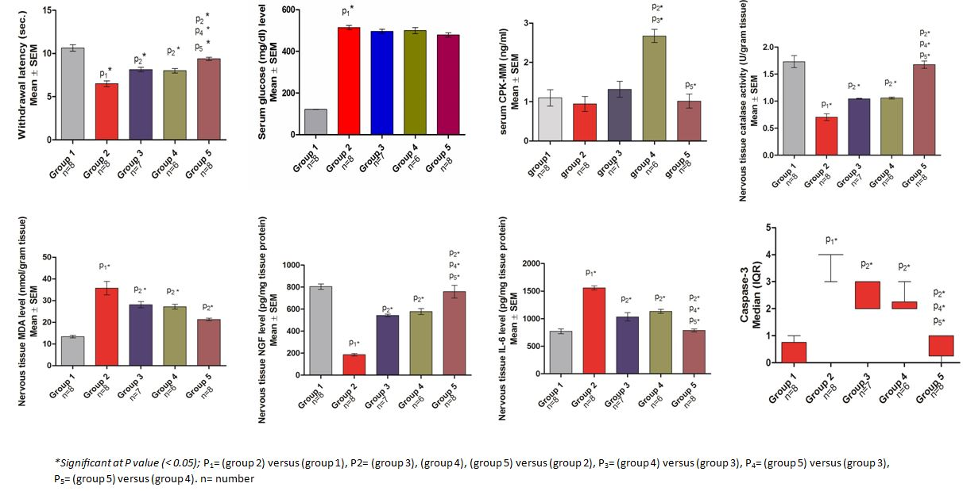
Figure (1): collective statistics of the measured parameters.

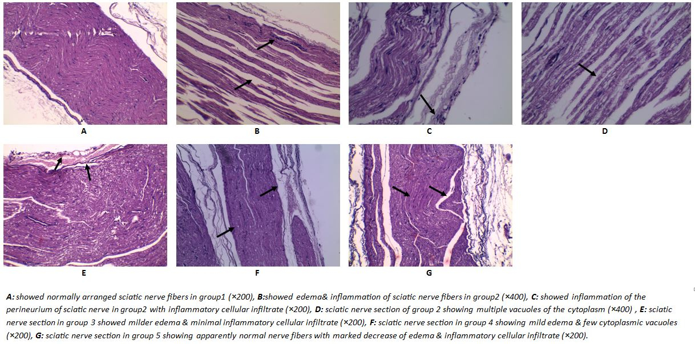
Figure (2): histopathological findings in sciatic nerve samples.

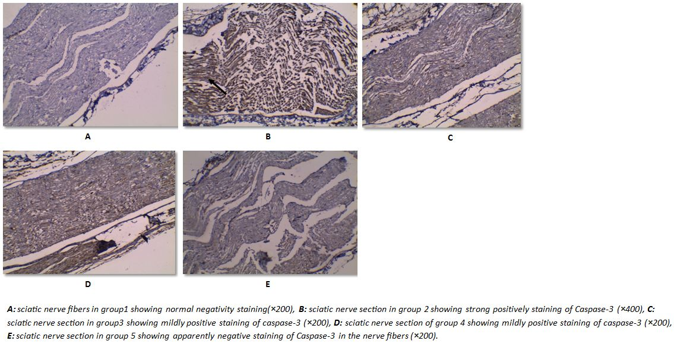
Figure (3): Immunohistochemical staining of caspase-3 in sciatic nerve fibers.

4. Discussions
The present study was designed to evaluate and compare some possible antioxidant, antiapoptotic and anti-inflammatory effects of vitamin D₃ and atorvastatin when used either alone or as combined therapy for prevention of STZ induced-DSPN in rats.
We chose hot tail immersion test in this study as an indicator of pain sensation in the rats. The test measures withdrawal latency in seconds in response to noxious stimulus (Ramabadran et al., 1989). The present study revealed significant decrease of withdrawal latency in the untreated diabetic group in comparison to the control group which agrees with Courteix et al. (1993) who found that the rats that injected by STZ showed signs of hyperalgesia 4 weeks after injection that appeared as diminished withdrawal latency. However, the present study showed significant enhancement of withdrawal latency in vitamin D₃, atorvastatin and combined treated groups in comparison to the untreated diabetic group which agrees with Lee and Chen (2008) who stated that vitamin D supplementation can reduce neuropathic pain in T2DM patients and Pathak et al. (2014) also stated that atorvastatin can enhance withdrawal latency and attenuate neuropathic pain in rat model of neuropathy. However, combined treatment by both vitamin D₃ & atorvastatin showed significant enhancement of withdrawal latency in comparison to monotherapy either by vitamin D₃ or atorvastatin which may be due to additional effect between vitamin D₃ & atorvastatin.
In the present study, the results of untreated STZ induced DSPN group when compared to control group showed significant increase in serum glucose level and this result is in agreement with (Furman, 2015) and (Wu and Yan, 2015).
As regarding to serum CPK-MM, there is significant increase of serum CPK-MM in atorvastatin treated group in comparison to the untreated diabetic group and with vitamin D₃ treated diabetic group which agree with Soininen et al. (2006) & Parker and Thompson (2012) who stated that serum CPK-MM may be elevated with atorvastatin administration which is an indicator of muscle damage. The study showed significant decrease in the combined treated diabetic group in comparison to the atorvastatin treated diabetic group that agree with Glueck et al. (2011) who found that vitamin D supplementation can reverse the atorvastatin induced-muscle adverse effects.
As regarding to the sciatic nerve catalase activity, the present study showed significant decrease in catalase activity in the untreated STZ-induced DSPN in comparison to the control group which agree with Brownlee (2005) who reported that DM can induce DSPN through oxidative stress via ROS. However, treatment either by vitamin D₃, atorvastatin or both showed significant elevation of sciatic nerve catalase activity in comparison to the untreated diabetic group that agree with Eyles et al. (2007) who found that vitamin D₃ has antioxidant activity through different ways including increase expression of catalase enzyme, Chen et al. (2012) also stated that atorvastatin also increase catalase activity in bronchogenic carcinoma, but disagree with Sezer et al. (2011) who found that atorvastatin has non-significant effect on catalase activity in atherosclerosis. Nevertheless, the present study showed that the combined therapy showed significant increase in sciatic nerve catalase activity in comparison to each alone that may be due to synergistic effect.
Several studies reported the importance of oxidative stress in the pathogenesis of DSPN. The present study measured MDA as a marker for lipid peroxidation. We found that there was a significant increase of sciatic nerve MDA level in the untreated diabetic group in comparison to the control group which agrees with Kumar et al. (2007) who pointed out the important role of MDA in the pathogenesis of DSPN. Moreover, we found significant decrease in MDA levels in the treated diabetic groups either by vitamin D₃, atorvastatin or both in comparison to the untreated diabetic group; this agree with Tarcin et al. (2009) who reported the effect of vitamin D₃ replacement in lowering MDA levels in asymptomatic vitamin D deficient patients on their endothelial functions due to antioxidant effect. Meanwhile, Khodayar et al. (2014) found significant decrease in MDA levels in paraquate-induced pulmonary fibrosis in rats due to atorvastatin antioxidant activity.
The NGF plays a great role in neurite growth & modulating neuropathic pain (Khan and Smith, 2015). This study showed significant decrease in sciatic nerve NGF levels in the untreated diabetic group in comparison to the control group which agree with (Gao et al., 2017). In addition to that, we found that there was significant increase of sciatic nerve NGF level in treated diabetic groups either by vitamin D₃, atorvastatin or both in comparison to the untreated diabetic group which agree with Brown et al. (2003) who stated that vitamin D induces NGF synthesis and promotes neurite outgrowth. Ali et al. (2011) also proved that atorvastatin can increase NGF levels in cases of diabetic retinopathy via restoring the balance between pro-NGF & NGF. The present study showed significant increase in sciatic nerve NGF levels in combined treatment by both vitamin D₃ and atorvastatin in comparison to each alone which may be due additional effect.
ILs are group of cytokines named for their ability to communicate between leukocytes. They are either pro-inflammatory e.g. IL-1, IL-6 & IL-8 or anti-inflammatory e.g. IL-4 & IL-10 (Dewanjee et al., 2018). As the inflammatory process has a key role in the pathogenesis of DSPN, IL-6 was chosen as a marker for inflammation in the present study. It showed significant increase in sciatic nerve IL-6 level in the untreated diabetic group in comparison to the control group which agree with Navarro and Mora (2005) who found increased IL-6 levels in experimental DM. The present study showed significant decrease in sciatic nerve IL-6 levels in the diabetic treated groups either by vitamin D₃, atorvastatin or both in comparison to the untreated diabetic group that agree with Gopal et al. (2018) who pointed out the anti-inflammatory effect of vitamin D via lowering IL-6 levels in rheumatoid arthritis. Moreover, Barsante et al. (2005) found that atorvastatin exhibit anti-inflammatory and analgesic effects in rat model of arthritis via local inhibitory effect on IL-6 expression. In addition to that, the present study showed that combined therapy by both vitamin D₃ and atorvastatin showed significant decrease in sciatic nerve IL-6 levels in comparison to monotherapy by each alone which may be due to additional effect.
According to Tolkovsky (2002), apoptosis plays a key role in the pathophysiology of DSPN. One of the hallmarks of apoptosis is condensation and fragmentation of DNA via cleavage and activation of caspase-3 (Sahara et al., 1999). The present study showed significant increased in caspase-3 expression in sciatic nerve fibers in the untreated diabetic group in comparison to the control group which agrees with Cheng and Zochodne (2003) who found increased immunoreactivity of caspase-3 in sciatic and tibial nerves in diabetic rats. In addition to that, the study showed significant decrease of caspase-3 expression in treated diabetic groups by vitamin D₃, atorvastatin and both in comparison to the untreated diabetic group which agrees with Riachy et al. (2002) who documented that vitamin D protects human islet cells via activation of antiapoptotic protein A20. Also, Jazi et al. (2017) reported the antiapoptotic effect of atorvastatin in myocardial infarction in rats. Moreover, there was significant reduction of caspase-3 expression in combined treated group in comparison to monotherapy by each which may be due to additional effect between vitamin D₃ and atorvastatin.
Many of the drugs used in the treatment of DSPN have side effects hindered their use for long periods, it is logical to search for and choose other safe drugs for long-term prevention.

Conclusion:
These findings suggest that each of vitamin D₃ and atorvastatin produces promising effects in prevention of STZ induced-DSPN as each of them decreases inflammation, apoptosis, and oxidative stress and improve histopathological picture that’s all reflected as amelioration in withdrawal latency. However, combination of vitamin D₃ and atorvastatin provided significant additional amelioration on the disease activity when compared to each monotherapy either by vitamin D₃ or atorvastatin as this combination exhibited additional effect superior to each monotherapy in regard to improvement of inflammation, anti apoptotic and antioxidant effect. As a conclusion; either vitamin D3 or atorvastatin or their combination can be used as preventive therapy to decrease the incidence of DSPN.

Acknowledgements:
Special thanks to Ass.Prof.Dr/ Dareen Abd El Aziz, professor of histopathology, Faculty of Medicine, Tanta University, for her cooperation in carrying out the histopathological & immunohistochemical examination & helping us in photo-imaging and in finishing this work.

Corresponding Author:
Dr. Eman El-Sayed El-Metaher.
Pharmacology department
Faculty of medicine, Tanta University.
Tanta, El-Gharbia governorate, Egypt.
Telephone: 01020102502
E-mail: eman.elmohamady@med.tanta.edu.eg

References:
- Aebi, h. 1984. Catalase in vitro methods enzymol 105: 121–126. Find this article online.
- Akalin çiftçi, g., ertorun, i., akalin, a., alataş, i. Ö. & musmul, a. 2015. The effects of atorvastatin on antioxidant/antiinflammatory properties of hdls in hypercholesterolemics. Turkish journal of medical sciences, 45.
- Aktas, o., waiczies, s., smorodchenko, a., dörr, j., seeger, b., prozorovski, t., sallach, s., endres, m., brocke, s. & nitsch, r. 2003. Treatment of relapsing paralysis in experimental encephalomyelitis by targeting th1 cells through atorvastatin. Journal of experimental medicine, 197, 725-733.
- Ali, t. K., al-gayyar, m. M. H., matragoon, s., pillai, b. A., abdelsaid, m. A., nussbaum, j. J. & el-remessy, a. B. 2011. Diabetes-induced peroxynitrite impairs the balance of pro-nerve growth factor and nerve growth factor, and causes neurovascular injury. Diabetologia, 54, 657-668.
- Banks, w. A., kastin, a. J. & gutierrez, e. G. 1994. Penetration of interleukin-6 across the murine blood-brain barrier. Neuroscience letters, 179, 53-56.
- Barone, e., cenini, g., di domenico, f., martin, s., sultana, r., mancuso, c., murphy, m. P., head, e. & butterfield, d. A. 2011. Long-term high-dose atorvastatin decreases brain oxidative and nitrosative stress in a preclinical model of alzheimer disease: a novel mechanism of action. Pharmacological research, 63, 172-180.
- Barsante, m. M., roffe, e., yokoro, c. M., tafuri, w. L., souza, d. G., pinho, v., castro, m. S. D. A. & teixeira, m. M. 2005. Anti-inflammatory and analgesic effects of atorvastatin in a rat model of adjuvant-induced arthritis. European journal of pharmacology, 516, 282-289.
- Bodey, b., bodey, v., siegel, s. E., nasir, a., coppola, d., hakam, a. & kaiser, h. E. 2004. Immunocytochemical detection of members of the caspase cascade of apoptosis in high-grade astrocytomas. In vivo, 18, 593-602.
- Brown, j., bianco, j. I., mcgrath, j. J. & eyles, d. W. 2003. 1,25-dihydroxyvitamin d3 induces nerve growth factor, promotes neurite outgrowth and inhibits mitosis in embryonic rat hippocampal neurons. Neuroscience letters, 343, 139-143.
- Brownlee, m. 2005. The pathobiology of diabetic complications. A unifying mechanism, 54, 1615-1625.
- Buchwalow, i. B. & böcker, w. 2010. Antibody labeling and the choice of the label. Immunohistochemistry: basics and methods. Springer.
- Chen, j., liu, b., yuan, j., yang, j., zhang, j., an, y., tie, l., pan, y. & li, x. 2012. Atorvastatin reduces vascular endothelial growth factor (vegf) expression in human non‐small cell lung carcinomas (nsclcs) via inhibition of reactive oxygen species (ros) production. Molecular oncology, 6, 62-72.
- Cheng, c. & zochodne, d. W. 2003. Sensory neurons with activated caspase-3 survive long-term experimental diabetes. Diabetes, 52, 2363-2371.
- Courteix, c., eschalier, a. & lavarenne, j. 1993. Streptozocin-induced diabetic rats: behavioural evidence for a model of chronic pain. Pain, 53, 81-88.
- Daugherty, d. J., marquez, a., calcutt, n. A. & schubert, d. 2018. A novel curcumin derivative for the treatment of diabetic neuropathy. Neuropharmacology, 129, 26-35.
- Dewanjee, s., das, s., das, a. K., bhattacharjee, n., dihingia, a., dua, t. K., kalita, j. & manna, p. 2018. Molecular mechanism of diabetic neuropathy and its pharmacotherapeutic targets. European journal of pharmacology, 833, 472-523.
- El-hafiz, h. I. A., el batsh, m. M., mohamed, w. M., omar, a. H., yassin, a. E.-r. A., mansour, m. A. & badr, e. A. E. 2018. Effect of vitamin d3 on diabetic nephropathy in rats. Menoufia medical journal, 31, 324.
- Elf, k., askmark, h., nygren, i. & punga, a. R. 2014. Vitamin d deficiency in patients with primary immune-mediated peripheral neuropathies. Journal of the neurological sciences, 345, 184-188.
- Eyles, d., almeras, l., benech, p., patatian, a., mackay-sim, a., mcgrath, j. & feron, f. 2007. Developmental vitamin d deficiency alters the expression of genes encoding mitochondrial, cytoskeletal and synaptic proteins in the adult rat brain. The journal of steroid biochemistry and molecular biology, 103, 538-545.
- Feldman, e. L., nave, k.-a., jensen, t. S. & bennett, d. L. H. 2017. New horizons in diabetic neuropathy: mechanisms, bioenergetics, and pain. Neuron, 93, 1296-1313.
- Fiore, m., chaldakov, g. N. & aloe, l. 2009. Nerve growth factor as a signaling molecule for nerve cells and also for the neuroendocrine-immune systems. Reviews in the neurosciences, 20, 133-145.
- Furman, b. L. 2015. Streptozotocin‐induced diabetic models in mice and rats. Current protocols in pharmacology, 70, 5.47. 1-5.47. 20.
- Gao, z., feng, y. & ju, h. 2017. The different dynamic changes of nerve growth factor in the dorsal horn and dorsal root ganglion leads to hyperalgesia and allodynia in diabetic neuropathic pain. Pain physician, 20, e551-e561.
- Ghasemi, a., khalifi, s. & jedi, s. 2014. Streptozotocin-nicotinamide-induced rat model of type 2 diabetes. Acta physiologica hungarica, 101, 408-420.
- Glueck, c. J., budhani, s. B., masineni, s. S., abuchaibe, c., khan, n., wang, p. & goldenberg, n. 2011. Vitamin d deficiency, myositis–myalgia, and reversible statin intolerance. Current medical research and opinion, 27, 1683-1690.
- Goldblatt, h. 1969. The effect of high salt intake on the blood pressure of rabbits. Laboratory investigation, 21, 126-128.
- Gopal, k., thevarajah, m., ng, c. & raja, j. 2018. Ab1312 effects of vitamin d on disease activity, functional disability and serum interleukin-6 in rheumatoid arthritis. Bmj publishing group ltd.
- Jazi, a. A., abdi, h., shamsaei, n. & khaksari, m. 2017. Combination of atorvastatin–endurance training has positive effect on apoptosis and protein expression of sdf-1α/cxcr4 axis after myocardial infarction in rat's heart tissue. International journal of health studies, 3.
- Kamboj, s. S., vasishta, r. K. & sandhir, r. 2010. N‐acetylcysteine inhibits hyperglycemia‐induced oxidative stress and apoptosis markers in diabetic neuropathy. Journal of neurochemistry, 112, 77-91.
- Kei, s. 1978. Serum lipid peroxide in cerebrovascular disorders determined by a new colorimetric method. Clinica chimica acta, 90, 37-43.
- Khan, n. & smith, m. 2015. Neurotrophins and neuropathic pain: role in pathobiology. Molecules, 20, 10657.
- Khodayar, m. J., kiani, m., hemmati, a. A., rezaie, a., zerafatfard, m. R., nooshabadi, m. R. R. & goudarzi, m. 2014. The preventive effect of atorvastatin on paraquat-induced pulmonary fibrosis in the rats. Advanced pharmaceutical bulletin, 4, 345.
- Kumar, a., kaundal, r. K., iyer, s. & sharma, s. S. 2007. Effects of resveratrol on nerve functions, oxidative stress and dna fragmentation in experimental diabetic neuropathy. Life sciences, 80, 1236-1244.
- Lee, j.-j., yi, h.-y., yang, j.-w., shin, j.-s., kwon, j.-h. & kim, c.-w. 2003. Characterization of streptozotocin-induced diabetic rats and pharmacodynamics of insulin formulations. Bioscience, biotechnology, and biochemistry, 67, 2396-2401.
- Lee, p. & chen, r. 2008. Vitamin d as an analgesic for patients with type 2 diabetes and neuropathic pain. Archives of internal medicine, 168, 771-772.
- Lenzen, s. 2008. The mechanisms of alloxan-and streptozotocin-induced diabetes. Diabetologia, 51, 216-226.
- Levi-montalcini, r. 1987. The nerve growth factor: thirty-five years later. Bioscience reports, 7, 681-699.
- Li, t., wang, d., tian, y., yu, h., wang, y., quan, w., cui, w., zhou, l., chen, j., jiang, r. & zhang, j. 2014. Effects of atorvastatin on the inflammation regulation and elimination of subdural hematoma in rats. Journal of the neurological sciences, 341, 88-96.
- Malarde, l. 2012. Activité physique et produits dérivés du soja: intérêts dans la prise en charge du stress oxydant associé au diabète de type 1. Université rennes 2.
- Navarro, j. F. & mora, c. 2005. Role of inflammation in diabetic complications. Nephrology dialysis transplantation, 20, 2601-2604.
- Ohkawa, h., ohishi, n. & yagi, k. 1979. Assay for lipid peroxides in animal tissues by thiobarbituric acid reaction. Analytical biochemistry, 95, 351-358.
- Parker, b. A. & thompson, p. D. 2012. Effect of statins on skeletal muscle: exercise, myopathy, and muscle outcomes. Exercise and sport sciences reviews, 40, 188.
- Pathak, n. N., balaganur, v., lingaraju, m. C., kant, v., latief, n., more, a. S., kumar, d., kumar, d. & tandan, s. K. 2014. Atorvastatin attenuates neuropathic pain in rat neuropathy model by down-regulating oxidative damage at peripheral, spinal and supraspinal levels. Neurochemistry international, 68, 1-9.
- Pop-busui, r., boulton, a. J. M., feldman, e. L., bril, v., freeman, r., malik, r. A., sosenko, j. M. & ziegler, d. 2017. Diabetic neuropathy: a position statement by the american diabetes association. Diabetes care, 40, 136-154.
- Ramabadran, k., bansinath, m., turndorf, h. & puig, m. M. 1989. Tail immersion test for the evaluation of a nociceptive reaction in mice: methodological considerations. Journal of pharmacological methods, 21, 21-31.
- Riachy, r., vandewalle, b., kerr conte, j., moerman, e., sacchetti, p., lukowiak, b., gmyr, v., bouckenooghe, t., dubois, m. & pattou, f. O. 2002. 1, 25-dihydroxyvitamin d3 protects rinm5f and human islet cells against cytokine-induced apoptosis: implication of the antiapoptotic protein a20. Endocrinology, 143, 4809-4819.
- Sadat-ali, m., bubshait, d. A., al-turki, h. A., al-dakheel, d. A. & al-olayani, w. S. 2014. Topical delivery of vitamin d3: a randomized controlled pilot study. International journal of biomedical science: ijbs, 10, 21.
- Sahara, s., aoto, m., eguchi, y., imamoto, n., yoneda, y. & tsujimoto, y. 1999. Acinus is a caspase-3-activated protein required for apoptotic chromatin condensation. Nature, 401, 168.
- Sezer, e. D., sozmen, e. Y., nart, d. & onat, t. 2011. Effect of atorvastatin therapy on oxidant-antioxidant status and atherosclerotic plaque formation. Vascular health and risk management, 7, 333.
- Soininen, k., niemi, m., kilkki, e., strandberg, t. & kivist, k. T. 2006. Muscle symptoms associated with statins: a series of twenty patients. Basic & clinical pharmacology & toxicology, 98, 51-54.
- Stavniichuk, r., shevalye, h., hirooka, h., nadler, j. L. & obrosova, i. G. 2012. Interplay of sorbitol pathway of glucose metabolism, 12/15-lipoxygenase, and mitogen-activated protein kinases in the pathogenesis of diabetic peripheral neuropathy. Biochemical pharmacology, 83, 932-940.
- Tarcin, o., yavuz, d. G., ozben, b., telli, a., ogunc, a. V., yuksel, m., toprak, a., yazici, d., sancak, s., deyneli, o. & akalin, s. 2009. Effect of vitamin d deficiency and replacement on endothelial function in asymptomatic subjects. The journal of clinical endocrinology & metabolism, 94, 4023-4030.
- Tolkovsky, a. 2002. Apoptosis in diabetic neuropathy. International review of neurobiology. Academic press.
- Trinder, p. 1969. Determination of glucose in blood using glucose oxidase with an alternative oxygen acceptor. Annals of clinical biochemistry, 6, 24-27.
- Van dam, p. S., cotter, m. A., bravenboer, b. & cameron, n. E. 2013. Pathogenesis of diabetic neuropathy: focus on neurovascular mechanisms. European journal of pharmacology, 719, 180-186.
- Wimalawansa, s. J. 2016. Non-musculoskeletal benefits of vitamin d. The journal of steroid biochemistry and molecular biology.
- Wu, j. & yan, l.-j. 2015. Streptozotocin-induced type 1 diabetes in rodents as a model for studying mitochondrial mechanisms of diabetic β cell glucotoxicity. Diabetes, metabolic syndrome and obesity: targets and therapy, 8, 181-188.
- Youssef, s., stuve, o., patarroyo, j. C., ruiz, p. J., radosevich, j. L., hur, e. M., bravo, m., mitchell, d. J., sobel, r. A. & steinman, l. 2002. The hmg-coa reductase inhibitor, atorvastatin, promotes a th2 bias and reverses paralysis in central nervous system autoimmune disease. Nature, 420, 78.
- Zenker, j., ziegler, d. & chrast, r. 2013. Novel pathogenic pathways in diabetic neuropathy. Trends in neurosciences, 36, 439-449.
- Zochodne, d. W. 2007. Diabetes mellitus and the peripheral nervous system: manifestations and mechanisms. Muscle & nerve: official journal of the american association of electrodiagnostic medicine, 36, 144-166.

3/10/2019

