Size-specific feeding habits, diet overlaps and feeding strategies of the reticulate knife fish, Papyrocranus afer Gunther, 1868 from a freshwater tropical lagoon in southwestern Nigeria

*F. V. Oluwale¹ and Ugwumba², A. A. A.

^{1, 2} Department of Zoology, University of Ibadan, Ibadan, Oyo State, Nigeria
*Corresponding author Email: wale_femi@yahoo.com
Phone Number: +234-8062563636

Abstract: The reticulate Knife fish, Papyrocranus afer, is becoming important in fisheries because the juveniles are used as ornamentals. This study describes diet, diet overlap and feeding strategists of (juvenile (≤21.9cm), sub-adults (22 – 33.9cm) and adults (≥40.0cm) P. afer inhabiting Lekki Lagoon. Stomach contents analysis of stomach revealed P. afer exhibited dietary shift from predominantly micro-crustacean feeding in juveniles through insectivorous sub-adults and polyphagous feeding in adults. Schoener’s indices of diets overlap between parallel size-classes (adult-sub-adult; juvenile-sub-adult) were biologically significant (>60%); indicating that these size classes exploit similar resources. The Amundsen plots showed thst P. afer exhibited specialist feeding on decapods crustacean and insects at juvenile and sub-adult stages respectively. Adults were generalists’ feeders on insects, zooplankton, gastropods and fishes. The dietary items for Papyrocranus afer showed carnivorous and predatory habits for the species. This carnivorous habit implied that P. afer may require high protein diet during culture.
[F. V. Oluwale and Ugwumba, A. A. A. Size-specific feeding habits, diet overlaps and feeding strategies of the reticulate knife fish, Papyrocranus afer Gunther, 1868 from a freshwater tropical lagoon in southwestern Nigeria. N Y Sci J 2019;12(3):8-20]. ISSN 1554-0200 (print); ISSN 2375-723X (online). http://www.sciencepub.net/newyork. 3. doi:10.7537/marsnys120319.03.

Keyword: Papyrocranus afer, feeding habits, feeding strategy, Lekki Lagoon.

Introduction
The knife fishes are becoming very popular in the ornamental fish industry in Nigeria. They are endemic to Nigerian waters and are found living in freshwater or brackish water environment in Africa and South-east Asia (Edema et al., 2007; Inoue et al., 2009). They belong to the family Notopteridae, which contains ten species of Osteoglossiform (bony-tongue) fishes represented by two genera, (Papyrocranus and Xenomystus), each with a single species, P. afer and X. nigri in Nigeria, the former being more abundant. Knife fishes have no commercial importance in Nigeria as food fish. However, their true potential lies in the increasing use of their juveniles as ornamental fishes; which is becoming popular in Nigeria.
In spite of the socio-economic importance of ornamental fisheries as provision of foreign exchange, employment, alternative livelihood for fishermen, recreation (Olaosebikan et al., 2011; Ukaonu et al., 2011), little attention is paid to their declining population in Nigerian waters. Ornamental fisheries in Nigeria are largely based on collection from the wild, which is insufficient for this industry. Cowx et al. (2004) reported that the sustainable use of ornamental fishery resources are important issues in the prevailing trend of habitat loss and degradation, harmful fishing practices (overfishing and destructive fishing) and international trade; hence, adequate knowledge of the biology including food and feeding habits, and life history characteristics of ornamental species are increasingly important for their conservation.
In general, populations of fish are often size structure possibly due to their continuous growth and neonate size. Body size remains a strong determinant of possible size range of food particles that are potentially available for consumption. Moreover, fish species often change resource use over their lives. This may segregate size-structured population into ecologically distinct stages based on diet (Olson 1996). Duration of stages and transition among stages has the potential to minimize intra-specific competition for food. Ontogenetic diet shifts (size-related patterns of feeding) are a major feature of fish ecology (Barbarino Duque and Winemiller 2003, Gill and Morgan 2003).
There is a dearth of information on the knife fishes, P. afer and X. nigri in Nigeria. Scanty information available on these species (Reed et al., 1967; King, 1994; Ugwumba and Kusemiju, 1994; Idodo-Umeh, 2003; Edema et al., 2007) does not reflect size-related patterns of feedings, potential dietary overlap or similarity and feeding strategies. Hitherto, the present study presented the diets, degree of diet overlap and feeding strategies of juvenile, sub-adults and adults size classes of P. afer inhabiting Lekki Lagoon. Ample knowledge of aspects of feeding habits including diets, degree of diet overlaps and feeding strategies, of a fish population in the wild is imperative to comprehend their productive capacity and ecological role (Teixeira and Cortes, 2006). Such information is critical to the development of sustainable management plans and conservation.
Materials and Methods
Study area
Lekki Lagoon is a large expanse of freshwater located in Lagos and Ogun States of Nigeria. It lies on longitude 4˚00’ and 4˚15’ E and latitude 6˚25’ and 6˚37’ N (Figure 1); it is fed by River.

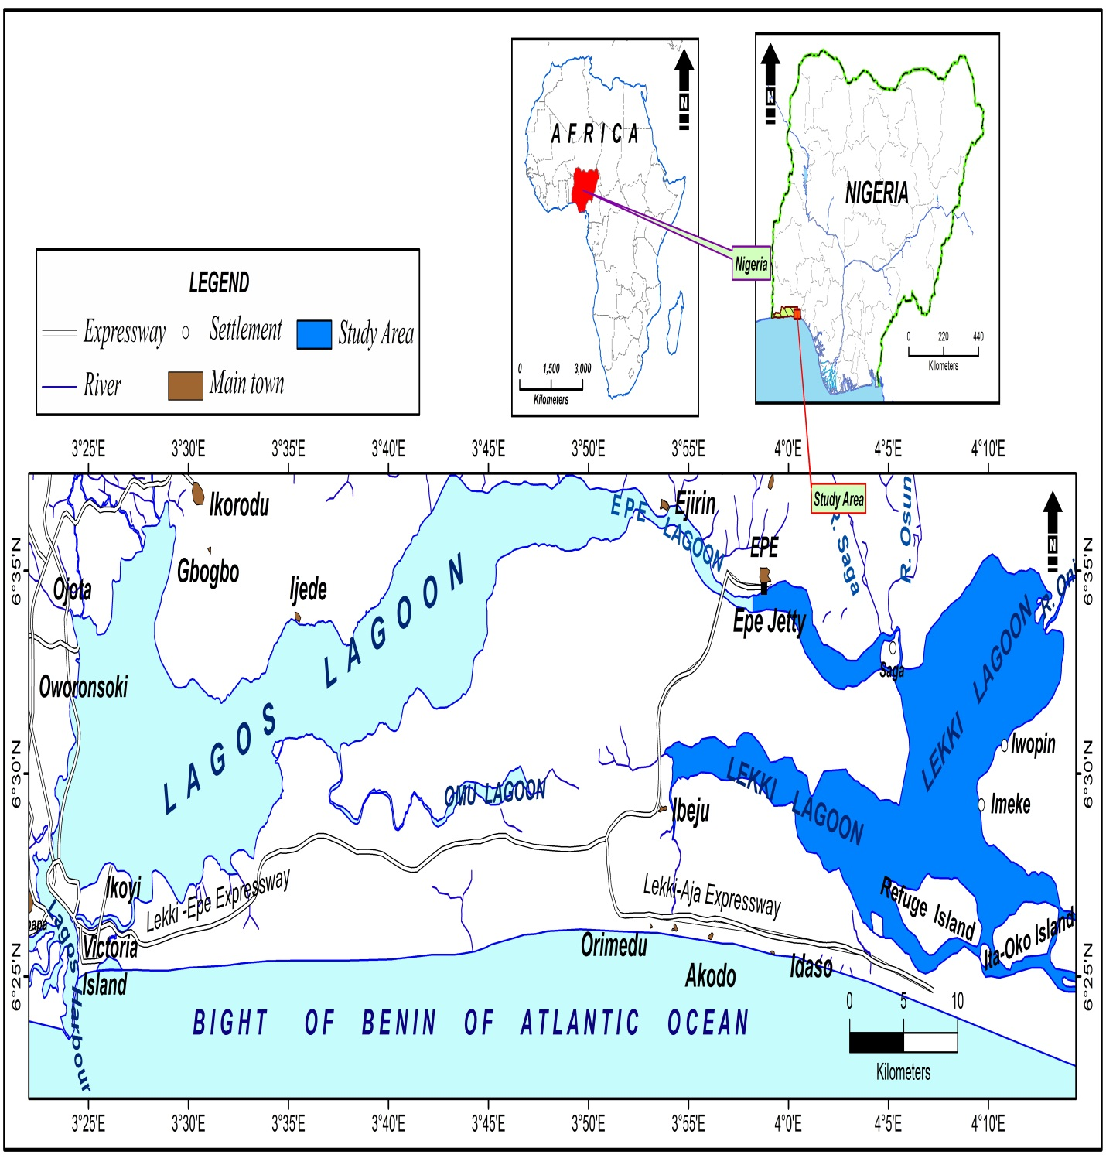
Figure 1: Map of lagoon complex of western Nigeria showing study area ().
Insert: Map of Africa showing location of Nigeria.
Administrative Map of Nigeria showing the study area

Oni discharging into the north-eastern part, and Rivers Oshun and Saga discharging into the North-western parts of the lagoon. It is bounded by Bight of Benin of the Atlantic Ocean in the South, and opens into the sea via the Lagos Lagoon and Lagos Harbour. Lekki Lagoon provides an important source of livelihood for the people of Lagos and Ogun States. It is one of the largest sources of freshwater fish production in these states. The main livelihood of the people around the lagoon is fishing. The lagoon is also used for sand mining, transportation and recreation.
Collection and Analysis of Fish Samples
Monthly samples of P. afer (Figure 2) were obtained from the landing centre of fishermen from Lekki Lagoon, at Epe jetty, from January 2010 – December 2011. The fishermen employed different gears including cast and gill nets (20 – 30 mm), traps, and hook and lines in fishing. The specimen were transported in ice chest containing ice to the laboratory. The specimens were preserved by deep- freezing (-4°C) prior to laboratory analysis.

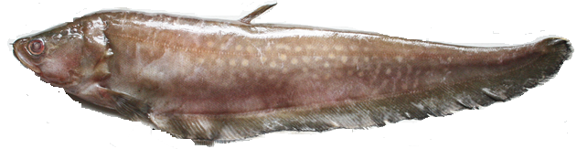
Figure 2: Papyrocranus afer

In the laboratory, specimens were counted, measured (precision 0·1 cm; total length) and weighed (0·1 g, wet weight). The specimens examined were divided into three size-classes based on twin criteria of size as well as colour attributes of sexual maturity stages (gonadal characteristics; single, unpaired ovary and testis) after dissection. Juveniles were described as the non-sex class. Sub adult also non-sex with thick-walled translucent gonads. Adults possessed distinct sexual dimorphic attributes: transparent (yellow/golden yellow ovary) and (creamy-white testes).
Stomach of dissected specimens were removed and condition (i.e. fullness) of the stomach was rated as empty, quarter-full, half-full, three quarter-full or full stomach.
The vacuity index (VI), which expresses the fraction of a fish population with food in their stomach (Euzen, 1987) was also determined:
VI =

Where E_{s} = number of empty stomach samples; T_{s} = total number of stomach samples. Values of feeding intensity based on VI are usually interpreted as follows: - edacious species 0 ≤ VI < 20; relatively edacious species 20 ≤ VI < 40; relatively abstemious 60 ≤ VI < 80 and abstemious 80 ≤ VI < 100.
Stomach contents were sorted, counted, and examined immediately after stomachs were dissected, but when this was not possible, the contents were preserved in 10% formalin and examined later. Volumes of stomach contents and individual food item were determined by water displacement in a measuring cylinder.
The relative components of each of the food items to the diet of the different size group were expressed by numeric percentage (%N), frequency of occurrence (%F) and volumetric percentage (%V), (Hyslop, 1980): where %N was the number of individuals within a prey taxon divided by the total number of food items/prey identified in a stomach of a size group. %F is the number of stomachs containing a specific food item divided by the total number of stomachs with food contents and %V was the volumetric contribution of a prey taxon to the total stomach volume determined by water displacement in a measuring cylinder.
To provide a less bias estimate of the contributions of the various food items, Relative Importance Index (RI) was calculated for each identified food item/prey and group of preys based on the Absolute Importance Index (AI) (George and Hadely, 1979) as follows:

AI = F + V + N
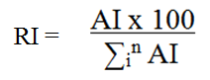

Where: F, V and N represented the percentage values in terms of frequency of occurrence, volume and number of each prey respectively; and n the number of different prey categories. This method invalidates bias by incorporating bulk, number, and occurrence into a single measure (Cortes, 1997).

Dietary overlap
Schoener’s dietary overlap index (Schoener, 1970) expressed as percentage was used to determine dietary overlap between different body forms of P. afer based on bulk (volume) of observed for the food items. Schooner’s index dietary overlap index is defined as:
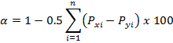
Where α = Schoener’s overlap index, P_{xi} = is the relative proportion of food by volume of food item i in the size class x, P_{yi} is the dietary proportion of food item i in the size-class y and n describes the number of food categories. An index value of zero indicates no overlap, while 1 corresponds to complete overlap. The index value is generally considered biologically significant when it exceeds 60% (Wallace, 1981); and it is used primarily when the prey/ food items abundance is unknown.

Feeding strategy
Papyrocranus afer feeding strategies were determined for the three stages of development under consideration by using the graphical method of Amundsen et al., (1996) based on the modification of Costello (1990). This involves plotting graphs of prey specific abundance (P_{i}) against frequency of occurrence. The distribution and location of point on Amundsen plots revealed the feeding strategies of the each of the size groups as either generalist or specialists.
Prey specific abundance (P_{i}) is expressed as:

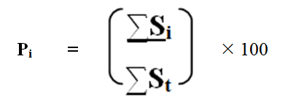
Where S_{i} = sum of food item/ prey i. S_{t} = sum of all prey items found only in those specimen size form (juvenile, sub adult and adult) stomachs that contained food item/ prey i.
The frequency of occurrence F_{i} is represented (N_{i}/N), where N_{i} is the number of specimen with food item i in stomach, N is the total number of specimen of a particular age-class with food in stomach.
Statistical Analysis
Data were subjected to descriptive statistics (means, percentages, proportions) using Microsoft Excel Statistical Tool pack (2010).

Results
Population structure
The total number of P. afer collected during the sample period was 1,156. Their sizes ranged from 5.3 – 75.4 cm in standard length (mean = 34.87 ± 11.16 cm) and weighed 10. 9 – 1958.3 g (mean = 239.68± 279.72). Juveniles examined were 107 in number (5.3-21.9 cm); sub-adults were 606 (22-39.9 cm) and adults were 346 (40-75.9 cm).
Condition (fullness) of stomach and Vacuity Index, (VI)
Of the 1,156 specimens of P. afer collected, 1,059 stomachs were examined; 508 had food in their stomachs indicating an overall vacuity index of 47.96%. Full stomach conditions showed an increasing trend across the size classes from juveniles (1.9%) to adults (15.0%) (Figure 3). Juveniles, sub adults and adults recorded vacuity indices of 49.53%, 0.82% and 4.6% respectively.

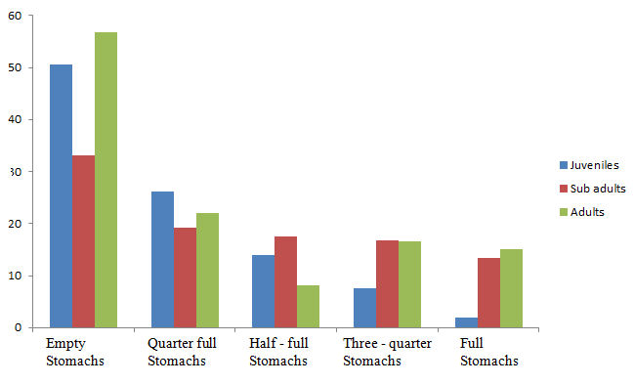
Conditions of stomachs
Percentage number

Figure 3: Variation in condition (fullness) of stomach with size of Papyrocranus afer in Lekki Lagoon

Dietary composition
The food items identified in the stomachs of P. afer for the three size-classes examined are summarized in Table 1. The food items encountered in stomachs of P. afer were typically benthic and low mobility in nature coupled with sporadic planktonic food materials. Decapod crustaceans were the major food of the juveniles; it accounted for 27.6%, 21.1% and 47.8% by number, occurrence and volume respectively. Macrobrachium sp. was the most importance decapod crustacean in the juvenile diet, accounting for 18.9 %, 21.1 % and 38.2 % by number, occurrence and volume respectively. Zooplankton was the next major food of the juveniles and it accounted for 42.2 %, 12.6 % and 13.2 % by number, occurrence and volume respectively. Insects were the major food of the sub adults, accounting for 63 %, 22.1 % and 67.6% by number, occurrence and volume respectively. Pterygotan (odonatan and ephemonopteran) nymphs were the most important insects in the sub adult diet, and they accounted for 21.1 %, 10.3 % and 11.2 % by number, frequency of occurrence and volume respectively. The major food of the adults was fishes accounting for 29.6 %, 9.6 % and 13.3 % by number, occurrence and volume respectively. This was followed closely by decapod crustaceans, 26.6 %, 16.4 % and 13.2 % by number, occurrence and volume respectively. Macrobrachium sp. was also the dominant decapod crustacean in the diet of the adults; it accounted for 14.5 %, 16.4 % and 7.8 % by number, occurrence and volume respectively. Insects, gastropods, bivalves and zooplankton were also prominent in the adult diets.
Based on the relative importance index (Figure 4), decapod crustaceans constituted the most important food category in the juveniles (35.4 %); followed closely by zooplankton (32.1%), while bivalves were the least (0.2 %). Insects (64.1%) were the most dominant food category in the sub adults, followed by decapod crustaceans (25.7%), while zooplankton (1.8%) was the least category of food. In the adults, fishes (29%) were the most important food closely followed by decapod crustaceans (27.2%) while bivalves (5.3%) were the least important food. Macrobrachium sp, Cyclops sp. and Chironomid larvae were the primary food of juveniles; insects (trichopteran larvae and many unidentified insects) for the sub-adults, while Macrobrachium sp, fish and insects were the primary food of the adults (Figure 5).

Table 1: Summary of stomach contents analysis of Papyrocranus afer from Lekki Lagoon
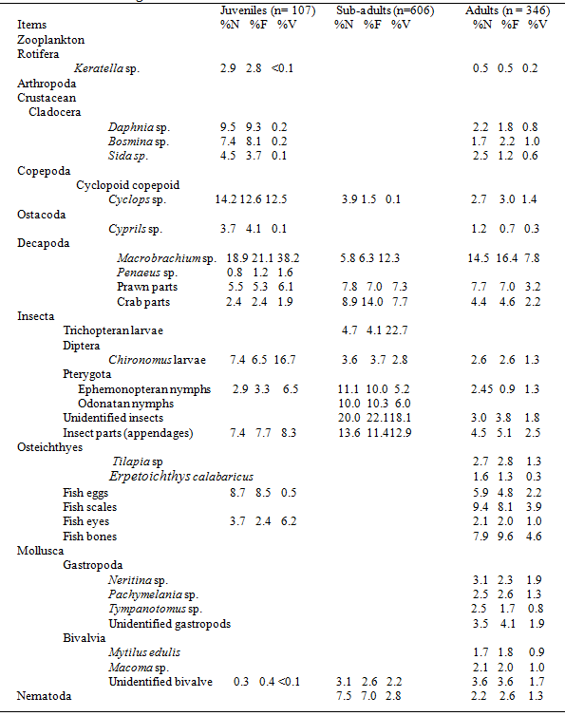
% N = Percentage number
%F = Percentage frequency of occurrence
%V = Percentage volume

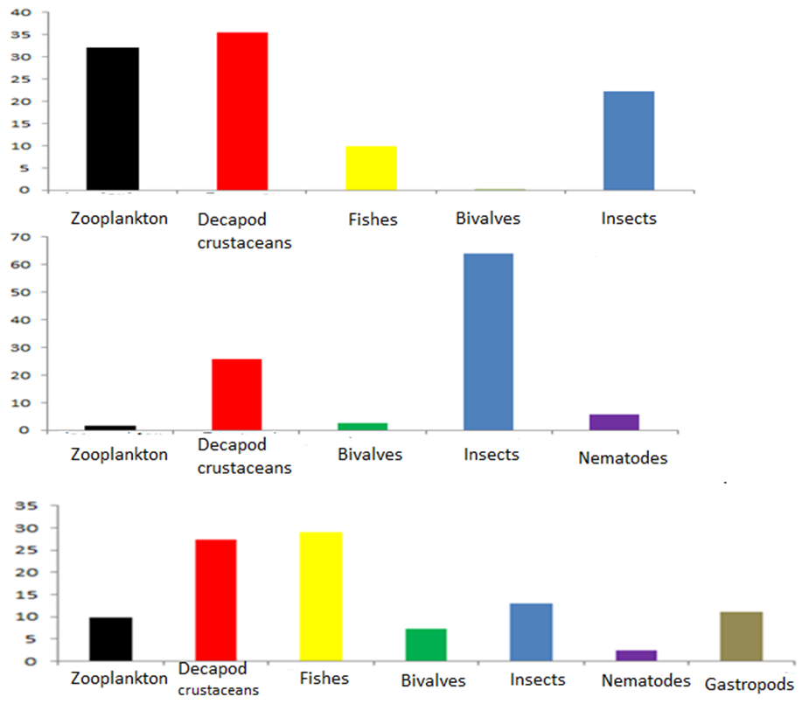
Food category
Relative Importance Index
Sub - adults
Adults
Juveniles

Figure 4: Relative importance indices of the various categories of food items in the stomach of
Papyrocranus afer from Lekki Lagoon

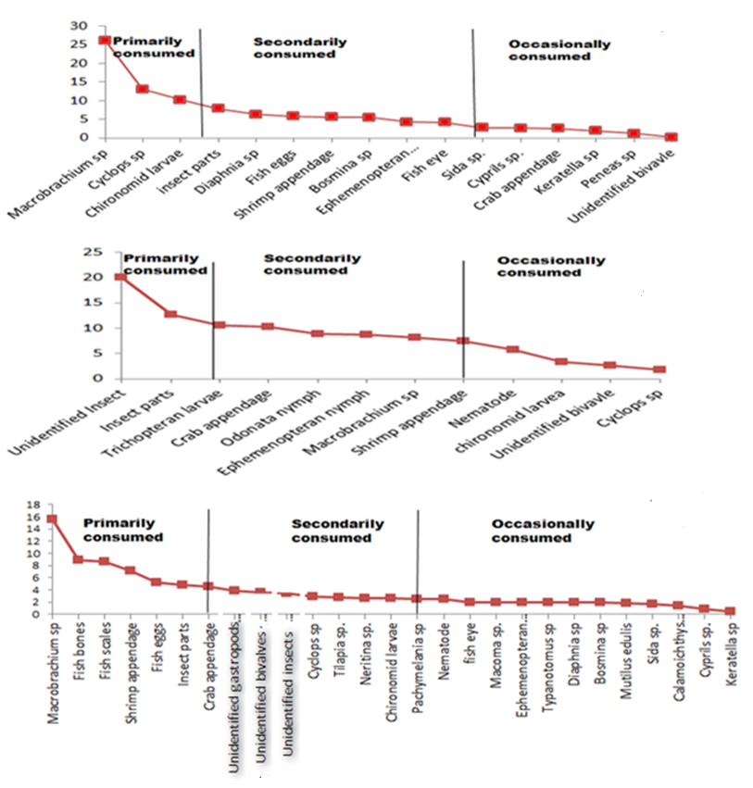
Food items
Relative Importance Index
Sub - adults
Adults
Juveniles
Figure 5: Diet preference of Papyrocranus afer based on relative importance index

Dietary overlap
The index of diet overlaps (α) using Schoener’s formula (Table 2) indicated that there biological significant diet overlap between similar size classes.

Table 2: Percentage value of diet similarity (Schoener’s overlap index, α) of three size classes of Papyrocranus afer inhabiting Lekki Lagoon, * = significant similarity for values of α ≥ 60%
Size-classes | Juvenile | Sub-adults | Adults
Juvenile |  | 0.64* | 0.31
Sub-adults |  |  | 0.60*
Adults

Feeding Strategies
The plots of feeding strategy (Figure 6) for P. afer designated generalists feeding for insects, zooplankton, gastropods and fishes; with a strong inclination for decapod crustaceans for adults. In contrast, juvenile and sub-adults showed clear inclination to specialist on decapod crustaceans and insect respectively.

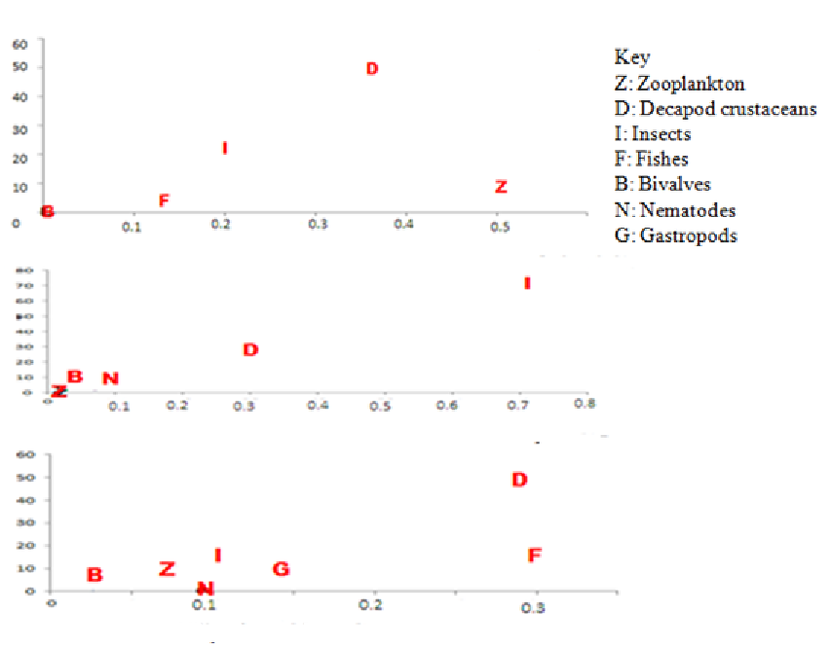
Frequency of occurrence
Prey specific abundance (%)

Figure 6: Feeding strategy of Papyrocranus afer from Lekki Lagoon

Discussion
Papyrocranus afer has been shown to be a moderate carnivorous predatory feeder as indicated by an overall estimated Vacuity Index of 47.96%. This notion was supported by the low feeding activities (the relatively high percentage of empty stomach; >30%) recorded for all size classes. High percentage of empty stomachs may reflect short period of feeding followed by rapid digestion. The occurrence of empty stomachs has been reported to be one of the characteristic features of predatory fishes associated with rapid rate of digestion and feeding regimes (Adámek et al., 2007). Another factor that also might explain the high percentage of empty stomachs in fishes, in general, is the type of prey (Keeley and Grant, 2001). This is apparent in the present study with P. afer foraging on the easily digestible animal food sources evidenced by zooplankton, invertebrates and fish in the stomach contents instead of plant food sources which could be difficult to digest due to their strong cell walls and high content of indigestible material (Hay et al., 1994). Furthermore, the assimilation efficiency of plant matter by fish is generally lower than that of animal prey (Cui et al., 1992).
There was a progression from preponderantly crustacean diet in P. afer juveniles, through an insectivorous diet in sub adults, to polyphagous diet in adults of this species in Lekki Lagoon. The dietary compositions observed in this study were similar to other studies on the species. Ugwumba and Kusemiju (1994) reported that P. afer fed on shrimps, insects (Notonecta sp., ephemenoptera nymphs, zygoteran nymphs) as well as ostracods and isopods in Lekki Lagoon. According to Egborge (1994), P. afer is an insectivorous predator in Warri Rivers in Niger Delta region of Nigeria. Idodo-Umeh (2003) reported that this species fed on aquatic insects, drowned terrestrial insects, small fish, shrimps, fruits, algae and detritus. Edema et al. (2007) also reported that P. afer in River Osse, Southern Nigeria fed on aquatic insects, fish, shrimps and worms.
Fish diet is highly linked to fish size as demonstrated by numerous studies and confirmed by the present study. Odedeyi and Fagbenro (2010) reported that juvenile stages of Mormyrus rume fed on crustaceans while the sub adults and adult stages were insectivorous feeders in River Ose, in Southern Nigeria. The juveniles of Chrisychthys nigrodigitatus had preference for plankton, the sub adults preferred fishes and crabs while adults had shrimps (Asuquo et al., 2012). It has also been reported that fish size could impact on prey diversity, feeding behavior or feeding rate (Mohanraj and Prabhu, 2012). Size could also strongly influence the dietary changes in fishes, with many species switching from smaller, easier to access prey, to larger prey, which are more difficult to catch or extract but of higher nutritive values (Nakumura et al., 2003). Magalhaes (1993) reported dietary shifts in an endemic cyprinid, Squalius pyrenaicus, of the Iberian Peninsula including shifts from soft bodied to hard-shelled prey with increasing body sizes of fishes. This is in agreement with observation in the present study with a preponderance of gastropods and bivalves in the diets of adults unlike the diets of sub adults and juveniles.
The dietary items for P. afer showed carnivorous and predatory habits for the species. The occurrence of fish fry in P. afer shows its piscivorous tendencies particularly in the adults. Fish scales encountered in the diets may possibly reflect scale-eating habits. Idodo-Umeh (2003) made a similar report on this phenomenon in some specialized predators in tropical aquatic communities. Dietary compositions in this study revealed that P. afer is likely a bottom dweller because it fed largely on bottom dwelling organisms (Olaosebikan et al., 2011).
Virtually all food items found in the adult were frequently benthic and of low motility. The periodic occurrence of planktonic animals in the stomach contents of this size-class could be attributed to the occasional near-bottom segregation of these organisms (Colombo et al., 2003; Costello and Mianzan, 2003). The occurrence of remains from crabs in the stomach indicates a less complete digestion of the food items which suggests that they persist longer in the digestive tract and consequently may be over-represented in the food as reported by Bowen (1997). Incidence of nematodes in the stomach contents was relatively frequent, and restricted to the sub adults and adults. These animals are common parasites of the digestive tract of many fish species (Arimoro and Utebor, 2013) and have been reported to be highly improbable food items (Fernández, and Oyarzun, 2001).
A pollution indicator, Chironomus larva, was also a food item indicating possible pollution in the lagoon. It was a primary food of the juveniles. Chironomids have been reported to dominate aquatic benthic invertebrate communities (Hynes, 1998) as they hardly show any habitat restriction (Victor and Ogbeibu, 1991) and are known to replace other invertebrate taxa in streams perturbed by human activity (Victor and Ogbeibu, 1991). High abundance of chironomids is a confirmed phenomenon in polluted water bodies in both temperate and tropical areas (Edokpayi and Nkwoji, 2007; Cardoso et al., 2010; Yakub and Ugwumba, 2009; Edward and Ugwumba, 2011).
Food habits of fishes are species specific (Ugwumba and Ugwumba, 2007). The biological significant overlaps in diets based on Schoener’s index between parallel size classes (juvenile: sub-adults; sub-adults: adults) of P. afer recorded in the present study may not indicate intra-specific competition since the size classes are exploiting available food resources. Different authors have reported that food preferences, feeding rhythms, and body sizes reduced direct food competition, hence allowing co-existence. Intra-specific competition is not necessarily evident in among size classes of the same species exploiting the same food resources (Maceina and Murphy, 1988; Zaret and Rand, 1971). However, values > 60% should be considered biologically significant and indicative of interspecific competition if the resources are limited (Zaret and Rand, 1971).
The switch from specialist feeders at early life stages (juvenile and sub-adults) of P. afer to generalist feeding strategy is an expected life history trait in most fish species. Vulnerable early life stages of freshwater fishes ingest tiny animal including micro-crustacean and diverse forms of zooplankton alluding to relatively narrow diet breadth (Adriaens et al. 2001). Such stages may also eat increasingly larger and various food items as they grow while maintaining or increasing feeding efficiency accompanied by corresponding morphological and The switch from specialist feeders at early life stages (juvenile and sub-adults) of P. afer to generalist feeding strategy is an expected life history trait in most fish species. Vulnerable early life stages of freshwater fishes ingest tiny animal including micro-crustacean and diverse forms of zooplankton alluding to relatively narrow diet breadth (Adriaens et al. 2001). Such stages may also eat increasingly larger and various food items as they grow while maintaining or increasing feeding efficiency accompanied by corresponding morphological and behavioural attributes involving efficient ingestion, digestion and assimilation (Adriaens et al. 2001, Steingrimsson and Gislason 2002).
Papyrocranus afer is carnivorous, opportunistic predator that feed on varied diet across the water column. This carnivorous habit implied that P. afer may require high protein diet during culture. Successful culture of any fish species in any enclosures relies to a great extent artificial formulation and commercialization of food to meet their requirement for optimum growth, besides productivity to maximize profit. Furthermore, fish generally exhibits ontogenic changes and stages during development. Each of these stages displays different feeding habits and preference for food.

References
- Adamek, Z., Andreej, J., and Gallardo, J. M. 2007. Food habits of four bottom-dwelling gobiid species at the confluence of the Danube and Hron Rivers (South Slovakia). International Review of Hydrobiology 92(4–5): 554 – 563.
- Adriaens, D., Aerts, P and Verraes, W. 2001. Ontogenetic shift in mouth opening mechanisms in a catfish (Clariidae, Siluriformes): A response to increasing functional demands. Journal of Morpholgy 247: 197–126.
- Adeitte, A., Winemillerb, K. O. and Fiogbea, E. D. 2005. Ontogenetic, seasonal, and spatial variation in the diet of Heterotis niloticus (Osteoglossiformes: Osteoglossidae) in the Soˆ River and Lake Hlan, Benin, West Africa Environmental Biology of Fishes 73: 367–378.
- Amundsen, P. A., Gabler, H-M., and Staldvik, F. J. 1996. A new approach to graphical analysis of feeding strategy from stomach contents data modification of Costello (1990) method. Journal of Fish Biology 48: 607 - 614.
- Arimoro, F. O and Utebor, K. E. 2013. Relevance of nematode parasitic burden in channid fishes of Orogodo River, southern Nigeria to organic pollution. Annual Review and Research in Biology 3(4): 584 - 595.
- Asuquo, P. E., Eni, U. I. and Job, B. E. 2012. Ontogenetic variations in the diets of Chrisychthys nigrodigitatus (Lacepede, 1803) in a tropical estuarine ecosystem in Nigeria. Journal of Fisheries and Aquatic Sciences 27(2): 15 - 20.
- Barbarino Duque, A. and Winemiller, K.O. 2003. Dietary segregation among large catfishes of the Apure and Arauca Rivers, Venezuela. Journal of Fish Biology 63: 410–427.
- Bowen, W. D. 1997. Role of marine mammals in aquatic ecosystems. Marine Ecology Progress Series 158: 267 – 264.
- Cardoso, I., Granadeiro, J. P. and Cabral, H. 2010. Benthic macroinvertebates vertical distribution in the Tagus estuary (Portugal): The influence of tidal cycle. Journal Estuarine Coastal Shelf Sciences 86: 580 – 586.
- Colombo, G. A., Mianzan H. and Madirolas, A. 2003. Acoustic characterization of gelatinous-plankton aggregations: four case of studies from the Argentine continental shelf, ICES Journal of Marine Science 60: 650-657.
- Costello, J. H. and Mianzan H. 2003. Sampling field distributions of Mnemiopsis leidyi (Ctenophora, Lobata): planktonic or benthic methods?, Journal of Plankton Research 25: 455-459.
- Cortés, E. 1997. A critical review of methods of studying fish feeding based on analysis of stomach contents: application to elasmobranches fishes. Canadian Journal of Fisheries and Aquatic Science 54: 726 -738.
- Costello, M. J. 1990. Predator feeding strategy and prey importance: a new graphical analysis. Journal of Fish Biology 36: 261–263.
- Cowx, I. G., Almeida, O., Bene, C., Brummet, R., Bush, S., Darwall, W., Pittock, J. and van Brakel, M. 2004. Value of river fisheries. Proceedings of the second international symposium on the management of large rivers for fisheries. Phnom Penh, Kingdom of Cambodia 11-14th February, 2003, Phnom Penh, Kingdom of Cambodia, 357p.
- Cui, Y., Liu, X., Wang, X. and Shen, S. 1992. Growth and energy budget in young grass carp, Ctenopharyngodon idella Val. fed plant and animal diets. Journal of Fish Biology 41: 231 - 238.
- Edema, C. U., Ogbeibu, A. E. and Utunye, M. 2007. Aspects of the biology of Papyrocranus afer and Xenomystus nigri (Family Notopteridae) in the River Osse, southern Nigeria. Tropical Freshwater Biology 16(2): 9 - 19.
- Edokpayi, C. A. and Nkwoji, J. A. 2007. Annual changes in the physicochemical and macrobenthic invertebrate characteristics of the Lagos Lagoon sewage dump site at Iddo, southern Nigeria. Ecology Environment Conservation 13(1): 13 – 17.
- Edward, J. B. and Ugwumba, A. A. A. 2011. Macroinvertebrate fauna of a tropical southern reservoir, Ekiti State, Nigeria. Continental Journal of Biological Sciences 4(1): 30 – 40.
- Egborge, A. B. M. 1994. Water Pollution in Nigeria: Biodiversity and Chemistry of Warri River. Ben Miller Books Nig. Ltd., Warri, 331p.
- Euzen, O., 1987. Food habits and diet composition of some fishes of Kuwait. Kuwait Bulletin Science, 9, 65-86.
- Fernández, C., and Oyarzun., C. 2001. Trophic variations of the Chilean croaker Cilus gilberti during the summer period 1997-1998 (Perciformes, Scienidae). Journal of Applied Ichthyology 17(5):227–233.
- George, E. L. and Hadely, W. H. 1979. Food and habitat partitioning between rock bass (Ambloplites rupestris) and small mouth bass (Micropierus dolomieui) young of year. Transactions of American Fish Society 108: 253 - 261.
- Gill, H.S. and Morgan. D.L.2003. Ontogenetic changes in the diet of Galaxiella nigrostriata (Shipway, 1953) (Galaxiidae) and Lepidogalaxias salamandroides Mees, 1961 (Lepidogalaxiidae). Ecology of Fresh. Fish 12: 151–158.
- Hay, M. E., Kappel, Q. E. and Fenical, W. 1994. Synergisms in plant defenses against herbivorous: interactions of chemistry, calcification and plant quality. Ecology 75: 1714 –1726.
- Hynes, K. E. 1998. Benthic macroinvertebrate diversity and biotic indices for monitoring of 5 urban and urbanizing lakes within the Halifax Regional Municipality (HRM), Nova Scotia, Canada. Soil and Water Conservation Society of Metro Halifax 14: 114 - 115.
- Hyslop, E. J. 1980. Stomach contents analysis: a review of methods and their application. Journal of Fish Biology 17:411-117.
- Idodo-Umeh, G. 2003. Freshwater fishes of Nigeria Taxonomy, Ecological Notes, Diet and Utilization. Idodo Umeh Publishers, Benin City, Nigeria, 232p.
- Inoue, J. G., Kumazawa, Y., Miya, M. and Nishida, M. 2009. The historical biogeography of the freshwater knifefishes using mitogenomic approaches: A Mesozoic origin of the Asian notopterids (Actinopterygii: Osteoglossomorpha). Molecular Phylogenetics and Evolution 51: 486 – 499.
- Keeley, E. R. and Grant, J. W. A. 2001. Prey size of salmonid fishes in streams, lakes and oceans. Canadian Journal of Fish and Aquatic Sciences 58: 1122 – 1132.
- King, R. P. 1994. Seasonal dynamics in the trophic status of Papyrocranus afer (Gunther, 1868) (Notopteridae) in a Nigerian rainforest stream. Revista de Biologia Tropical 27: 143 - 155.
- Maceina, M. J., Murphy, B. R., 1988. Florida, Northern, and hybrid largemouth bass feeding characteristics in Aquilla Lake, Texas. Proceedings of Annual Conference Southeast Association of Fisheries and Wildlife Ag., 42, 112-119.
- Magalhaes, M. F. 1993. Effects of seasons and body size on the distribution and diet of the Iberian chub Leuciscus pyrenaicus in a lowland catchment Journal of Fish Biology 42(6): 875 - 888.
- Mohanraj, T and Prabhu, K. 2012 Food habits and diet composition of demersal Marine Fishes from Gulf of Mannar, southeast coast of India. Advances in Biological Research 6(4): 159 - 164.
- Nakumura, Y., M. Horimonchi, Nakai, T and Sano, M. 2003. Food habits of fishes in a seagrass bed on a fringing reef at Iriomote Island, southern Japan. Ichthyology Research 50: 15-22.
- Odedeyi, D. O. and Fagbenro, O. A. 2010. Feeding habits and digestive enzymes in the gut of Mormyrus rume (Valenciennes 1846) (Osteichthyes Mormyridae). Tropical Zoology 23: 75 - 89.
- Olaosebikan, B. D., Bankole, N. O., Raji, A. and Ogundele, O. 2011. Fundamentals of Aquarium Sciences for Nigerian Students. Remi-Thomas Press, New Bussa, Niger State Pp. 79 - 83.
- Olson, M.H. 1996. Ontogenetic niche shifts in largemouth bass: Variability and consequences for first-year growth. Ecology 77: 179 – 190.
- Reed, H., Burchard, J., Hopson, A. J., Jenness, J., Var, B. 1967. Fish and Fisheries of Northern Nigeria. Ministry of Agriculture Northern Nigeria, 226p.
- Schoener, T. W. 1970. Non-synchronous spatial overlap of lizards in patchy habitats. Ecology 51, 408–418.
- Steingrimsson, S.O. and Gislason, G. M. 2002. Body size, diet and growth of landlocked brown trout, Salmon trutta, in the subarctic River Laxa, North-East Iceland. Environmental Biology of Fishes 63: 417–426.
- Teixeira, A. and R. M. V. Cortes, 2006. Diet of stocked and wild trout, Salmo trutta: is there competition for resources? Folia Zoologica 55: 61–73.
- Ugwumba, A. A. A and Kusemiju, K. 1994. The food and feeding habits of the non-cichlids fishes in the Lekki Lagoon, Nigeria. Nigeria Journal of Science 28: 351 - 368.
- Ugwumba, A. A. A. and Ugwumba, A. O. 2007. Food and Feeding Ecology of Fishes in Nigeria. Crystal Publishers, Ajah Lagos, Nigeria, 78p.
- Ukaonu, S. U., Mbawuike, B. C., Oluwajoba, E. O., Williams, A. B. Ajuonu, N. Omogoriola H. O., Olakolu, F. C. Adegbile, O. M. and Myade, E. F. 2011. Volume and value of ornamental fishes in the Nigerian export trade. Agriculture and Biology Journal of North America 2(4): 661 - 664.
- Victor, R. and Ogbeibu, A. E. 1991. Macroinvertebrate communicates in the erosional biotope of an urban stream in Nigeria. Nigeria Journal of Science 4: 1 – 2.
- Wallace, R. K. (1981). An assessment of diet-overlap indexes. Transactions of the American Fisheries Society 110, 72–76.
- WYakub, A. S. and Ugwumba, A. A. A. 2009. A study of the macroinvertebrate fauna of lower Ogun River at Ishasi, Ogun State, southwest Nigeria. The Zoologist 7: 65-74.
- Zaret, T. M. and RAND, A.S. 1971. Competition in tropical stream fishes: a support for the competitive exclusion principle. Ecology 52, 336-342.

.

3/9/2019

