**Producing a pervious green concrete pavement using waste materials**

M. Shaaban

Civil department, Giza Higher Institute for Engineering and Technology, Egypt

[mstafa**.**dagher@gmail.com](mailto:mstafa.dagher@gmail.com)

**Abstract:** Pervious rigid pavement is a kind of concrete pavement that allows water to percolate, so it used as storm water drainage system. This paper performed to study utilization of waste materials like; steel slag, crushed granite, and recycled aggregate to develop pervious concrete have appropriate properties to use as concrete pavement. The considered properties in this study were flexural strength, void content, and compressive strength. Three control mixes composed of dolomite with 300kg, 350kg, and 400 kg of cement were used to study the effect of; aggregate type, aggregate size, cement content, and binder to aggregate ratio on the considered properties. The results indicate that concrete mix S3 composed of steel slag aggregate with 400kg of ordinary Portland cement have compressive strength of 325 kg/cm2 and flexural strength of 56.35 kg/cm2, thus this mix appropriate to use as pavement subjected to heavy traffic loads. While pervious concrete produced using dolomite or crushed granite have strengths and void content with values suitable for concrete pavement subjected to medium traffic loads.

[M. Shaaban. **Producing a pervious green concrete pavement using waste materials.** *N Y Sci J* 2018;11(12):132-137]. ISSN 1554-0200 (print); ISSN 2375-723X (online). <http://www.sciencepub.net/newyork>. 14. doi:[10.7537/marsnys111218.14](http://www.dx.doi.org/10.7537/marsnys111218.14).

**Keywords**: Pervious Concrete, pavement, Waste Material, Steel Slag, Recycled Aggregate

**1. Introduction**

Pervious concrete also called as permeable concrete, No-fines concrete and porous concrete. Pervious concrete consider an eco-friendly material developed in 1980. Pervious concrete is a specific kind of cement concrete containing coarse aggregate and cement without fine aggregate or with 5% fine aggregate [1, 2]. Due to the diversified benefits as control storm water runoff, restoring ground water supplies and reducing water pollution, the porous concrete has been used in road pavements due to its performances of draining and retaining of water [3]. The water permeability coefficient of pervious concrete is about 2–6 mm/s and the void content lies between 15% and 25% [4]. One of the several reasons cause concrete strength tends to decrease is the voids content in hardened concrete itself [5]. Concrete used in pavement works should have strengths adequate to designed traffic loads as shown in Table 1 [6].

Table 1. Requirements of pavement concrete at age of 28 days

|  |  |  |  |
| --- | --- | --- | --- |
| Traffic load | Very Heavy | Heavy | Other |
| Compressive Strength kg/cm2 | 35-45 | 30-37 | 25-30 |
| Flexural Strength kg/cm2 | 5 | 4.5 | 4 |

Although pervious concrete has been studied for many years, there are many inapprehensible issues related to its structural performance [7].Using silica fume and super plasticizer with aggregate of lower nominal size can increase compressive and flexural strength of porous concrete up to 50 MPa and 6 MPa respectively [8].Evaluate the effect of sand and fiber on concrete permeability, compressive strength and tensile strength has been investigated [9].Study the performance of latex-modified porous concrete considering abrasion resistance, compressive strength,permeability,and tensile strength was performed [10].Effect of coarse aggregate type on mechanical and hydrological properties of pervious concrete has been studied [11].

**Research Objectives**

This study performed to develop pervious concrete mixes using recycled and waste materials as demolished concrete, crushed granite and steel slag, also evaluate these mixes with respect to that produced using natural dolomite.

**2.Experimental Study**

**2.1 Materials**

**Aggregate**:

Four types of aggregate were used here as coarse aggregate, naturaldolomite, steel slag, crushed granite, and recycled concrete aggregate, while fine steel slag was used as fine aggregate in some concrete mixes. Sieve analysis and physical properties of aggregates, are shown in Fig. 1 and Table 2 respectively.

**Cement**:

Ordinary Portland cement (OPC) CEMI-42.5N that meets the ASTM C150 requirements was used [11], physical properties and chemical composition of (OPC) presented in Table 3.

**Water:**

Potable tap water has been used in mixing and curing concrete.

**Super plasticizer**:

Sikament-163M high range water reducer (HRWR) complies with ASTM C494 type F was used as a super plasticizer additive with percentage of 1% of cement weight [13].

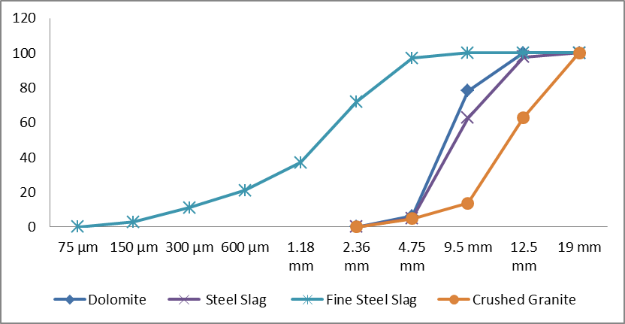

Figure 1. Grading of Aggregate

Table 2. Physical Properties of used aggregate

|  |  |  |  |  |
| --- | --- | --- | --- | --- |
| Physical Property | Dolomite | Granite | Steel Slag | Recycled Agg. |
| Specific Gravity of oven dry | 2.65 | 2.7 | 3.48 | 2.19 |
| Dry rodded weight ( kg / m3) | 1650 | 1560 | 1970 | 1385 |
| Nominal max. Size (mm) | 12.5 | 19 | 12.5 | 12.5 |
| Absorption % | 1.98 | 1 | 1 | 3.5 |

Table 3. Physical properties and composition of ordinary Portland cement

|  |  |
| --- | --- |
| Components | Percentage by Weight % |
| SiO2 | 21.36 |
| Al2O3 | 5.57 |
| Fe2O3 | 3.35 |
| CaO | 62.5 |
| Mgo | 1.18 |
| SO3 | 3.56 |
| Property | Value |
| Specific Gravity | 3.13 |
| Specific Surface area m2/kg | 312 |
| L.O.I | 0.97 |

**2.2Concrete Mix Design**

# The mix proportions were calculated according to Procedures outlined in ACI 522R‐10, Report on Pervious Concrete [14]. Employing the sequence outlined in that standard practice, the quantities of ingredients per cubic meter of concretegiven in Table 4.

**2.3 Specimens' preparation**

Mixing was performed in a revolving electric mixer of pan drum type. Then concrete casted in steel moulds immediately after mixing. Specimens were removed from moulds after 24 hours and cured in clean water for 28 days.

**2.4 Test Specimens and Instrumentations**

Cube specimens of 150 mm side length were used for compressive Strength test, while cylindrical specimens of 150x300 mm were used in void ratio calculations. Three prisms of 100 x 100 x 500 mm were prepared for flexural strength test.

**2.5 Results and Discussion**

**2.5.1Compressive Strength**

Figure 2 shows the test result of compressive strength of the developed concrete mixes with different types of aggregate after 28 day. These results indicate that use aggregate of steel slag with cement of 300 kg/m3, result in increase in strength (fcu =227kg/cm2) than that of control mix (i.e. dolomite concrete mix fcu=210kg/cm2). While concrete mix composed of crushed granite and concrete mix containing recycled aggregate have compressive strength of 123kg/cm2 and 63kg/cm2 respectively, these values are less than compressive strength of control mix which composed of dolomite (fcu=210kg/cm2). In other words, compressive strength of concrete mix made of recycled aggregate has the lower compressive strength (fcu=63kg/cm2). According conditions of concrete pavement [6], all concrete mixes containing cement of 300kg/m3 inadequate for pavement purposes.

Table 4. Concrete Mix Proportions (kg / 1 m3 Concrete)

|  |  |  |  |  |  |  |
| --- | --- | --- | --- | --- | --- | --- |
| Cement kg/m3 | Coarse Agg. Type | Mix designation | Coarse Agg. kg/m3 | Fine Agg. Type | Water kg | Super Plasticizer kg |
| 300 | Dolomite | CM1 | 1780 | No Fine Agg. | 105 | 3 |
| Steel Slag | S1 | 2045 | Steel Slag | 105 | 3 |
| Recycled Agg. | R1 | 1350 | No Fine Agg. | 105 | 3 |
| Granite | G1 | 1570 | No Fine Agg. | 105 | 3 |
|  |  |  |  |  |  |  |
| 350 | Dolomite | CM2 | 1780 | No Fine Agg. | 122.5 | 3.5 |
| Steel Slag | S2 | 2045 | Steel Slag | 122.5 | 3.5 |
| Recycled Agg. | R2 | 1350 | No Fine Agg. | 122.5 | 3.5 |
| Granite | G2 | 1570 | Fine Granite | 122.5 | 3.5 |
|  |  |  |  |  |  |  |
| 400 | Dolomite | CM3 | 1780 | No Fine Agg. | 140 | 4 |
| Steel Slag | S3 | 2045 | Steel Slag | 140 | 4 |
| Recycled Agg. | R3 | 1350 | No Fine Agg. | 140 | 4 |
| Granite | G3 | 1570 | Fine Granite | 140 | 4 |

Results in Fig.3show that compressive strength of concrete mixes with different aggregate types after 28 day. These results indicate that use aggregate of steel slag with cement of 350 kg/m3, result in increase in strength (fcu =271kg/cm2) than that of control mix (i.e. CM2-fcu=250kg/cm2). While concrete mix composed of crushed granite and concrete mix containing recycled aggregate have compressive strength of 173kg/cm2 and 87kg/cm2 respectively, these values are less than compressive strength of control mix which composed of dolomite (CM2-fcu=250kg/cm2). In other words, compressive strength of concrete mix made of recycled aggregate has the lower compressive strength (fcu=87kg/cm2). Also, Concrete mixes S2 and D2 have compressive strength adequate for medium traffic loads.

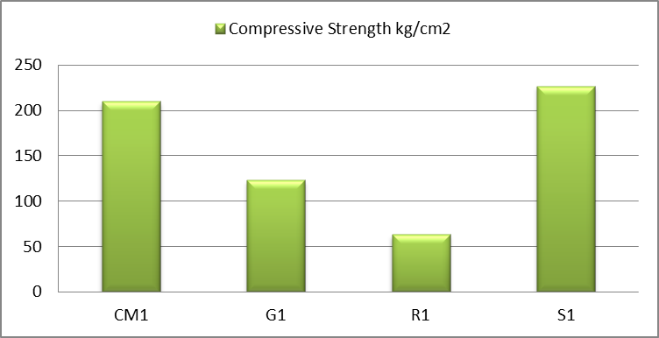

Figure 2. Compressive Strength of Concrete Mixes Containing 300kg of Cement

Figure 4 shows the test result of compressive strength of the developed concrete mixes after 28 day. These results indicate that use aggregate of steel slag with cement of 400 kg/m3, result in increase in strength (fcu =325kg/cm2) than that of control mix (i.e. CM2-fcu=289kg/cm2). While concrete mix composed of crushed granite and concrete mix containing recycled aggregate have compressive strength of 245kg/cm2 and 122kg/cm2 respectively, these values are less than compressive strength of control mix which composed of dolomite (CM2-fcu=289 kg/cm2). In other words, compressive strength of concrete mix made of recycled aggregate has the lower compressive strength (fcu=122kg/cm2). Based on requirements of concrete pavement mentioned before [**6**], concrete mixes D4 and S4 are adequate for pavement purposes subjected to heavy traffic loads.

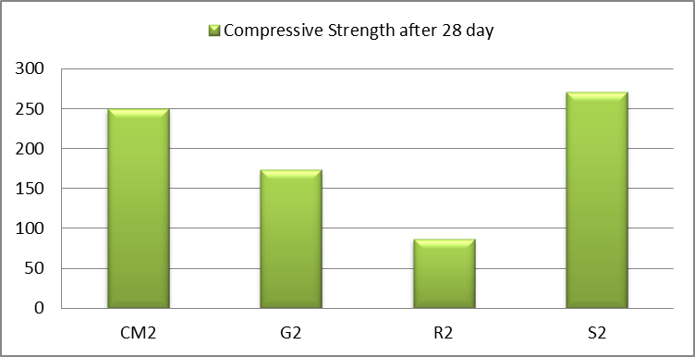

Figure 3. Compressive Strength of Concrete Mixes Containing 350 kg of Cement

In general, as indicated from Fig.5, increasing the binder to aggregate ratio increased the compressive strength for each aggregate type. In concrete mixes of dolomite (i.e. control mixes), increasing the binder to aggregate ratio from 0.168 to 0.224 increased the compressive strength with percentage of 37.6%. Also, results in Fig.5 show that the higher binder to aggregate ratio of 0.296 for recycled aggregate don’t lead to low compressive strength of 122 kg/cm2, while the lower binder to aggregate ratio of 0.146 in case of steel slag aggregate lead to compressive strength exceeds to 22kg/cm2, May be that's because of the voids percentage and aggregate size.

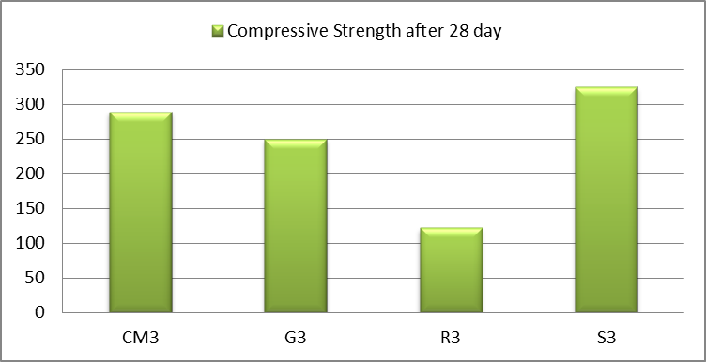

Figure 4. Compressive Strength of Concrete Mixes Containing 400 kg of Cement

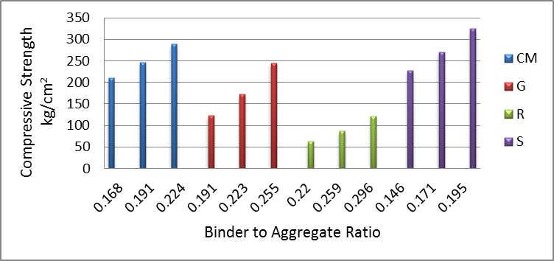

Figure 5. Effect of binder to aggregate ratio on compressive Strength

**2.5.2 Flexural Strength**

Figure 6shows the test result of flexural strength of the developed concrete mixes with different types of aggregate after 28 day. These results indicate that use aggregate of steel slag with cement of 300 kg/m3, result in increase in strength (fr =37.6kg/cm2) than that of control mix (i.e. dolomite concrete mix fr=49kg/cm2). While concrete mix composed of crushed granite and concrete mix containing recycled aggregate have flexural strength of 31kg/cm2 and 27.7kg/cm2 respectively, these values are less than compressive strength of control mix which composed of dolomite (fr=210kg/cm2). In other words, flexural strength of concrete mix made of recycled aggregate has the lower flexural strength (fr=63kg/cm2). These all concrete mixes containing cement of 300kg/m3 inadequate for pavement purposes [6].

Results in Fig.7show that flexural strength of concrete mixes with different aggregate types. These results indicate that use aggregate of dolomite with cement of 350 kg/m3, result in increase in strength (CM2-fr =52.7kg/cm2) than that of mix containing steel slag, (S2-fr=45.15kg/cm2). While concrete mix composed of crushed granite and concrete mix containing recycled aggregate have flexural strength of 35.32kg/cm2 and 29.45kg/cm2 respectively, these values are less than flexural strength of control mix which composed of dolomite (CM2-fr=52.7kg/cm2) with percentages of 32.97% and 44.11% respectively. In other words, flexural strength of concrete mix made of recycled aggregate has the lower flexural strength (fr=29.45kg/cm2). Also, Concrete mixes S2 and D2 have flexural strength adequate for medium traffic loads.

Figure 8shows the test result of flexural strength of concrete mixes containing 400kg of cement. These results indicate that use aggregate of steel slag with cement of 400 kg/m3, result in increase in strength (fr =56.35kg/cm2) than that of control mix (i.e. CM3-fr=55.46kg/cm2). While concrete mix composed of crushed granite and concrete mix containing recycled aggregate have flexural strength of 41.67kg/cm2 and 34.8kg/cm2respectively, these values are less than flexural strength of control mix which composed of dolomite (CM3-fr=55.46 kg/cm2) with percentages of 24.86% and 37.2% respectively. In other words, flexural strength of concrete mix made of recycled aggregate has the lower compressive strength (fr=34.8kg/cm2). Based on requirements of concrete pavement mentioned before [**6**], concrete mixes D4, and S4 are adequate for pavement purposes subjected to heavy traffic loads, while concrete mix G4 suitable for medium traffic loads.

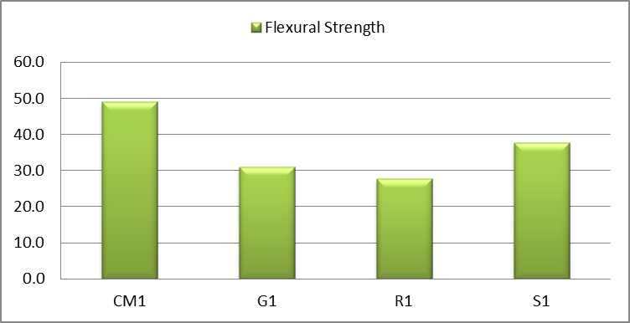

Figure 6. Flexural Strength of Concrete Mixes Containing 300 kg of Cement

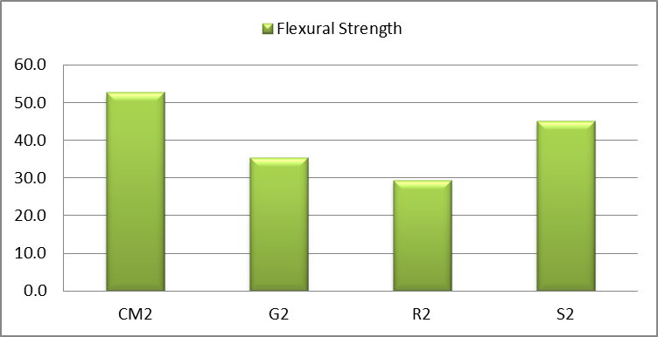

Figure 7. Flexural Strength of Concrete Mixes Containing 350 kg of Cement

**2.5.3 Void Ratio**

From Fig. 9, we can say that the void content ratio of concrete mixes depends on the aggregate size and cement content, where the void ratio of concrete increases with the increase in aggregate size while it decrease with increasing of cement content. Also, Fig.10 shows a relation between compressive strength and void ratio, Fig.10, states that compressive strength decreased with increasing of void ratio. The results indicate that the higher void ratio of concrete mix R1=25.3, leads to lower compressive strength of 63 kg/cm2, while the compressive strength of concrete mixes CM3and S3 are 289 kg/cm2 and 325kg/cm2 respectively, corresponding to void ratio 18.16 and 8.97 respectively.

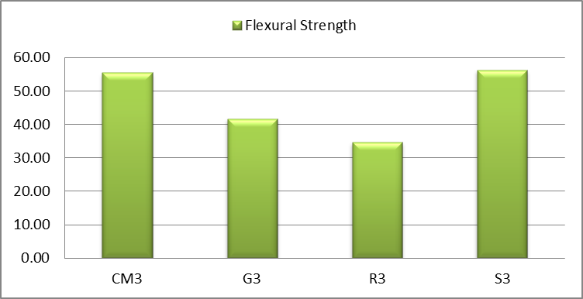

Figure 8. Flexural Strength of Concrete Mixes Containing 400 kg of Cement

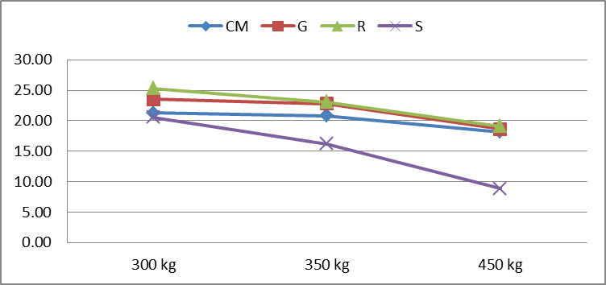

Figure 9. Relation between cement content and voids percentage

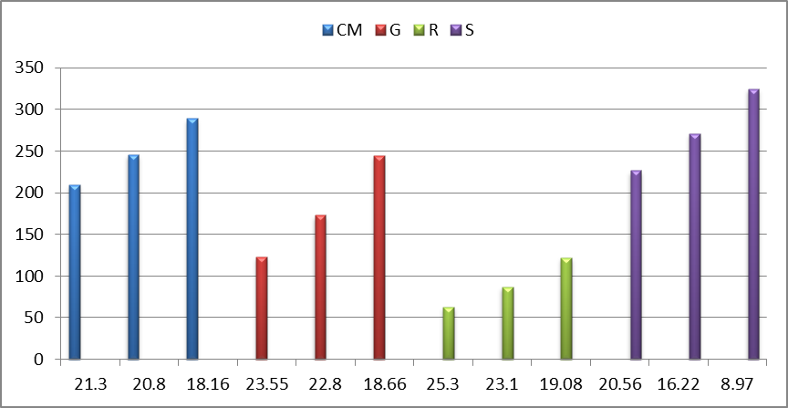

Figure 10.Relation between voids percentage and compressive strength

**3. Conclusions**

This study performed to evaluate properties of pervious concrete produced using waste and recycled aggregate. This study clarified effect of aggregate size, aggregate type, cement content, and binder to aggregate ratio on voids content percentage, compressive and flexural strength of pervious concrete. According to results, the following conclusions can be drawn:

1-Pervious concrete mixes containingwaste aggregate of steel slag with cement of 350 and 400 kg/m3haveappropriate strength and voids content for usage as pavement material in case of medium/heavy traffic loads.

2-Pervious concretes containing natural dolomite with cement of 350 or 400 kg/m3have appropriate strength for usage as pavement material in case of medium traffic loads.

3- Recycled aggregate inadequateto produce pervious concrete for pavement purposes where Fcu< 250kg/cm2 and Flexural strength < 40kg/cm2.

4-Crushed granite as waste material produce pervious concrete suitable for pavementsubjected to medium traffic loads; this is true if concrete mix contains cement of 400kg/m3.

**References**

1. Neithalath, N., Sumanasooriya, M.S., and Deo, O."Characterizing pore volume, sizes, and connectivity in pervious concretes for permeability prediction", Mater. Charact, Vol. 61, p.p.802–813, 2010.
2. Huang, B., Wu, H., Shu, X., Burdette, and E.G. "Laboratory evaluation of permeability and strength of polymer-modified pervious concrete", Construction and Building Materials, Vol. 24, p.p.818–823,2010.
3. M. Aamer Rafique Bhutta, K. Tsuruta, and J. Mirza, "Evaluation of high-performance porous concrete properties", Construction and Building Materials, Vol.31, p.p. 67-73,2012.
4. Schaefer, V.R., Wang, K., Suleiman, M.T., Kevern, and J.T.,"Mix Design Development for Pervious Concrete in Cold Weather Climates", Technical Report; National Concrete Pavement Technology Center: Ames, IA, USA, 2006.
5. H.K. Kim, and H.K. Lee, "Influence of cement flow and aggregate type on the mechanical and acoustic characteristics of porous concrete", Applied Acoustics, Vol. 71, No.7, p.p.607-615,2010.
6. IV Concrete works in "General technical conditions for roadworks", Zagreb, Croatin roads-Croatian motorways, p.p.132-147, 2001.
7. R. Gupta, "Monitoring in situ performance of pervious concrete in British "Columbia—A pilot study, Case Studies in Construction Materials, Vol.1, p.p.1-9,2014.
8. Jing Yang and Guoliang Jiang “Experimental study on properties of pervious concrete pavement materials”, Cement and Concrete Research, Vol. 33, p.p. 381–386,2002.
9. Baoshan Huang, Hao Wu, Xiang Shu and Edwin G, Burdette “Laboratory evaluation of permeability and strength of polymer-modified pervious concrete”, Construction and Building Materials, Vol.24, p.p. 818–823,2009.
10. Hao Wu, Baoshan Huang, Xiang Shu and Qiao Dong “Laboratory evaluation of abrasion resistance of Portland cement pervious concrete”, Journals of Materials in Civil Engg, p.p.697-702,2011.
11. Xiang Shu, Baoshan Huang, Hao Wu, Qiao Dong and Edwin G. Burdette “Performance comparison of laboratory and field produced pervious concrete mixtures”, Construction and Building Materials, Vol.25, p.p.3187–3192,2011.
12. ASTM C150, Standard Specification for Portland Cement, ASTM International, West Conshohocken, PA, 2015, www.astm.org.
13. ASTM C494 / C494M-15, Standard Specification for Chemical Admixtures for Concrete, ASTM International, West Conshohocken, PA, 2015, www.astm.org.
14. ACI 522R‐10, Report on Pervious Concrete, American Concrete Institute, Farmington Hills, MI, USA, 2010 (Reapproved 2011).

12/25/2018