Response of Arterial Stiffness with Interval Aerobic Training in Hypertensive Patients

Sara A. Abdel Tawab^{1*}, Azza A. Abd El-Hady², Mona M. Taha², Mohamed Shafiq Awad³

¹Physical Therapy Department in Hospital, Beni-Suef University, Egypt.
²Physical Therapy Department For Cardiovascular /Respiratory Disorder And Geriatrics, Faculty Of Physical Therapy, Cairo University, Egypt.
³Department of Cardiology, Faculty of Medicine, Cairo University, Egypt.
sassopt88244@yahoo.com

Abstract: Background: Arterial stiffness increments with aging and hypertension. Normal physical action has been suggested as an essential management component of hypertension. Purpose: To inspect the response of interval aerobic training program in diminishing arterial stiffness and blood pressure in hypertensive female patients. Methods: Forty female hypertensive patients referred medically, ages extended from 40:65 years of age, were relegated into two equivalent groups (Group A and B): group A were stage 1- mild grade essential hypertension (EH) while group B were stage 2-moderate essential hypertension (EH) and both groups got a similar high-intensity aerobic interval training program. The duration of treatment was twelve weeks, three times week after week, for a long time forty minutes for every session. Patients were evaluated their arterial stiffness utilizing Non-invasive blood pressure measurement system (Pulse Wave Velocity [PWV] analysis equipment) and peripheral arterial blood pressures utilizing an automated digital electronic BP monitor. Results: Within group comparison, a significant enhancement of estimated factors with more prominent enhancement in all factors for group B. Between group comparison, a significant difference in just estimations of PWV (pulse wave velocity), there was no significant in AIx @75 HR (augmentation index), SBP (systolic blood pressure) and DBP (diastolic blood pressure). Conclusion: The utilization of aerobic interval training can successfully enhance arterial stiffness and blood pressure in both stages (1 & 2) hypertensive female patients, with better enhancement change of arterial stiffness parameters and blood pressure considerably more in group B (stage 2) than group A (stage 1).
[Sara A. Abdel Tawab, Azza A. Abd El-Hady, Mona M. Taha, Mohamed Shafiq Awad. Response of Arterial Stiffness with Interval Aerobic Training in Hypertensive Patients. N Y Sci J 2018;11(12):41-47]. ISSN 1554-0200 (print); ISSN 2375-723X (online). http://www.sciencepub.net/newyork. 4. doi:10.7537/marsnys111218.04.

Keywords: Hypertension, Aerobic Interval Training, Arterial Stiffness, Blood pressure.

- Introduction:
Hypertension is defined as repeatedly raised clinic blood pressure (BP≥ 140/90mmg. Hypertension is ranked third as cause of disability and is a predictor of cardiovascular diseases, cerebrovascular accidents and death. Management of hypertension in earlier stages will forestall future risk. high blood pressure has been known jointly of the leading risk issue for mortality and has earned name as “the silent killer” (Alan, 2005).
Arterial stiffening could be a hallmark of ageing and is closely related to several pathological conditions including atherosclerosis, dyslipidemia, diabetes and chronic kidney diseases. Reduced blood vessel compliance (i.e. exaggerated stiffness) results in quicker reflection of the heartbeat wave from the peripheral tiny arteries to the heart, inflicting augmentation of the central aortal pressure. This augmentation in central pressure results in exaggerated ventricular after load and reduced coronary perfusion pressure that, eventually, could cause myocardial hypertrophy, ischemia and infarction. Thus, arterial stiffness and blood pressure (BP) each increase with advancing age and are independent predictors of cardiovascular (CV) events and mortality (Cavalcante et al., 2011).
Arterial stiffness is thought to play an important role in the pathophysiology of cardiovascular disease. Pulse wave velocity (PWV) is the speed with which the arterial pulse, generated by ventricular ejection, travels down the aorta and is an established surrogate marker of arterial stiffness. It has been shown to have a better predictive value than classic cardiovascular (CV) risk factors, such as blood pressure (BP), and is an independent prognosticator of CV mortality in the general population and people with hypertension. Augmentation Index (AIx), is a composite of PWV, arterial wave reflection and left ventricular ejection and reflects stiffness of the small and medium-sized muscular arteries and arterioles. AIx can indicate total CV risk, even in apparently healthy individuals (Laurent et al., 2006).
The decreasing elasticity from central to peripheral arteries ends up in a rise of PWV, systolic blood pressure (SBP) and of pulse pressure (PP) from central to peripheral arteries. However, the central systolic blood pressure (cSBP) and the central pulse pressure (cPP) are higher related to end-organ damage than the SBP and PP measured oscillometrically at the upper arm (Baulmann et al., 2013).
Central PWV has proved to be a good predictor for cardiovascular events and is measured by using a non-invasive, cuff-based, oscillometric measurement device applying a transfer function from the brachial pressure waves that were valid consistent with European Society of Hypertension recommendations. The cuff was centered to the left upper arm. Cuff size was chosen consistent with the circumference of the mid upper arm. The parameters were calculated by the Hypertension (Franssen and Imholz, 2010).
Although regular aerobic exercise appears to attenuate age-associated arterial stiffness and to reduce established arterial stiffness in normotensive subjects, Continuous moderate-intensity exercise training (CMT) interventions have failed to show any benefit in hypertensive patients. In the other hand, a study by Guimarães and Ciolac showed a reduction in arterial stiffness of hypertensive subjects after 16 weeks of high-intensity interval training (HIT), but not CMT. Higher levels of physical activity and cardiorespiratory fitness have shown to reduce the risk of hypertension in healthy normotensive persons. Moreover, exercise can reduce BP in hypertensive adults, and has shown to improve several factors involved in the pathophysiology of hypertension (Guimarães et al., 2010).
The aim of this study was to determine the response of arterial stiffness with interval aerobic training in hypertensive patients.

- Subjects, Material and Methods:
Subjects:
Forty sedentary women with essential hypertension, their ages ranged from 40-65 years. They were recruited from the out- patient hypertensive clinic unit of Beni-Suef University Hospital. The study was conducted in the out-patient clinic of Physical Therapy, Beni-Suef University Hospital in period of 10 April 2017 to 15 October 2017. All patients had signed a consent form before starting the program. The purpose, nature and potential risks of the study were explained to all subjects. The patients were randomly assigned to equal groups (in number).
Inclusion criteria:
Body mass index (BMI) of the patients ranged from 30-40 kg/m2. They were with mild to moderate essential hypertension [SBP/DBP: mild from 140-159/ 90-99 mmHg and moderate from 160-179/100-109 mmHg]. Their ages ranged from 40-65 years and were only females. All patients were hypertensive of 2-5 years duration. All patients were sedentary hypertensive subjects on anti-hypertensive medications. Patients were instructed to not make any dietary changes and maintain their original life style throughout the study.
Exclusion criteria:
Patients with the following conditions would be excluded from this study: Diagnosed coronary artery disease, an abnormal electrocardiogram during the exercise test and/or patients with non-cardiovascular functional limitations such as osteoarthritis, renal or respiratory disorders. Also patients with uncontrolled Hypertension or participating in regular physical activity (more than once a week) for the previous 6 months were excluded. The patients were randomly assigned to equal groups (in number).
Group (A): Twenty female patients with stage 1 essential hypertension (140-159 SBP and/or 90-99 mmHg DBP), each patient perform interval aerobic training (70-90% peak heart rate). The supervised training program consisted of 40-minutes sessions of pedaling exercise, 3 days /week, for a total of 3 months.
Group (B): Twenty female patients with stage 2 essential hypertension (160-179 SBP and/or 100-109 mmHg DBP), patients in this group performed the same interval training (70-90% peak heart rate) on a bicycle ergometer for 40 min as group (A) during the 12-week period. Subjects were encouraged to maintain their normal diet and other lifestyle habits throughout the study period.
Procedures:
Weight and Height scale:
Standard weight and height scale (floor type, RGT-200, made in China) was used to measure body weight and height of each patient to calculate body mass index for everyone [BMI= weight (kg) / height (m²)].
Automated office blood pressure measurement:
Prior to study enrollment, Subjects resting BP (SBP, DBP & HR) was monitored from the right arm using an automated digital electronic BP monitor (Omron digital BP monitor, Model 11 EM 403c; Tokyo Japan). Health professional should ensure correct cuff size and positioning. Health professionals should set the automated device to start the first measurement after 5 minutes of rest and to take a total or three blood pressure readings at 1-2 minute intervals. Patents should be seated in a quiet room alone for measurement. Health professionals should push the start button before leaving room.
Pulse wave analysis:
Pulse Wave Velocity [PWV], augmentation index (AIx @75HR) and resting heart rate were measured using analysis equipment which called Non-invasive blood pressure measurement system using "Mobil-O-Graph 24h PWA" with Hypertension Management Software Client Server (HMS-CS 4.3). PWA was performed using an oscillometric Mobil-O-Graph R 24 h PWA Monitor device (I.E.M GmbH, Germany) with integrated ARCSolver® software. Based on the oscillometric data, central hemodynamics as well as the 24-h PWV is calculated. Oscillometric pulse wave analysis are performed every 20min for 24 h. Subjects are instructed to hold their arm as steady as possible during the measurements but otherwise maintain their daily routine with no additional physical activity while wearing the device. After data readout, every individual measurement is reviewed for erroneous values. Values are deleted if the quality of data is graded 3 or 4 by the ARC Solver® software. The methods used for these analyses are the same as used by the SphygmoCor® software described previously (Wassertheurer et al., 2010).
Mobil-O-Graph (I.E.M., Stolberg, Germany). This device is a non-invasive, cuff-based, oscillometric measurement device applying a transfer function from the brachial pressure waves that were validated according to European Society of Hypertension recommendations. The cuff was centered to the left upper arm. Cuff size was chosen according to the circumference of the mid upper arm. The parameters were calculated by the Hypertension (Franssen and Imholz, 2010).
High intensity interval training:
Each exercise session consisted of a 10 minute warm-up, at 50% of HR peak followed by four bouts of 4 minutes (4×4) of pedaling on electronic bicycle ergometer, (Biodex LBC, Biodex Inc., New York) used in the exercise trainingat an intensity that elicited 90% of peak heart rate (ie, HR _{peak}) interspersed with 3- minute active recovery periods at 70% peak heart rate (the pedal cadence was 50rpm). The warming-up consisted of 10 min of zero pedaling. Exercise intensity was estimated by submaximal incremental exercise test. The Session was terminated with 10 minutes cool down. Total exercise time is 40 minutes. Exercise was given at laboratory 3 times per week for 12 weeks (Rodriguez et al., 2017).
Statistical analysis
Results are expressed as mean ± standard deviation. To get the actual effect of physical exercise training program, difference was calculated from the equation:- Pre-treatment value – post-treatment value. Test of normality, Kolmogorov-Smirnov test, was used to measure the distribution of data. Accordingly, comparison between mean values of normally distributed parameters in the two groups was performed using unpaired t test. Comparison between not normally distributed data in the two groups was performed Mann Whitney test. Comparison between pre- and post-treatment data in the same group was performed using Wicoxon Signed Rank test.

Results
This study was carried out on forty sedentary women with uncomplicated essential hypertension, their ages ranged from 40-65 years. their BMI ranged from 32.3 to 35.5 Kg/m² referred with mild or moderate (Systolic Blood Pressure [SBP] between 140-179 & Diastolic Blood Pressure [DBP] between 90-109 mmHg) essential hypertension.

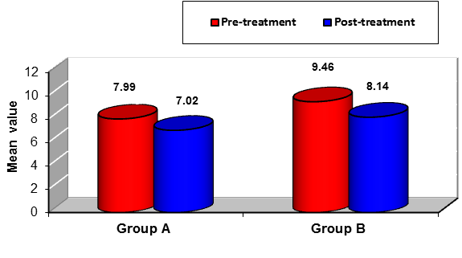
- Mean values of pulse wave analysis (PWV) measured pre- and post-treatment in each group
Between groups comparison:

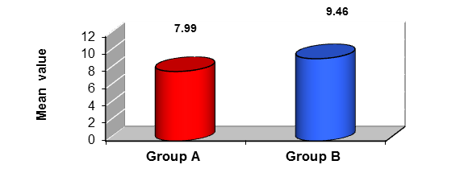
- Mean values of PWV in both groups measured pre-treatment

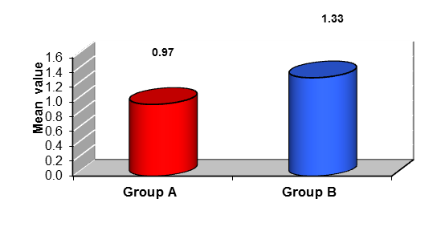
- Mean values of difference in PWV in both groups
AIX 75 HR

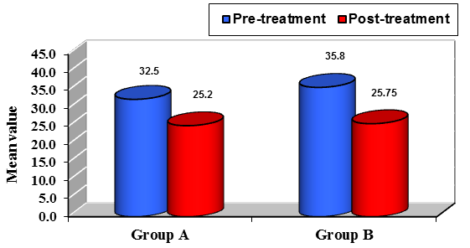
- Mean values of AIX 75 HR measured pre- and post-treatment in the each group
- Between groups comparison

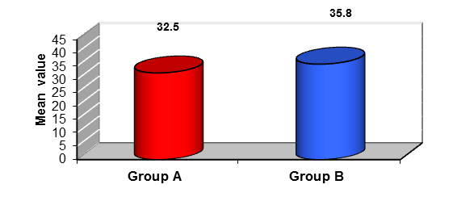
- Mean values of AIX 75 HR in both groups measured pre-treatment.

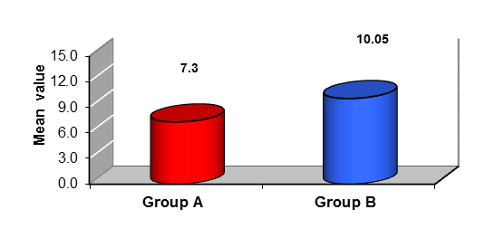
- Mean values of difference in AIX 75 HR in both groups.

Systolic blood pressure (SBP)
Within group comparison (pre- versus post-treatment comparison)

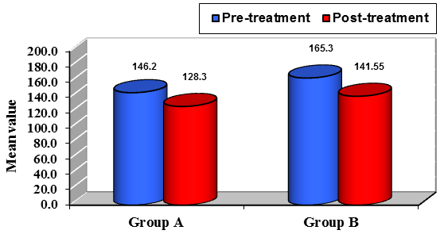
- Mean values of SBP measured pre- and post-treatment in the two studied groups.
- Between groups comparison

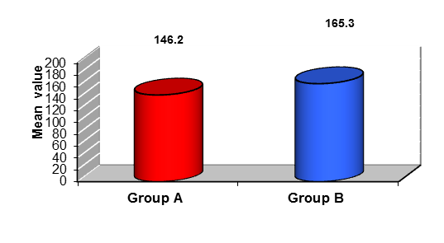
- Mean values of SBP in both groups measured pre-treatment.
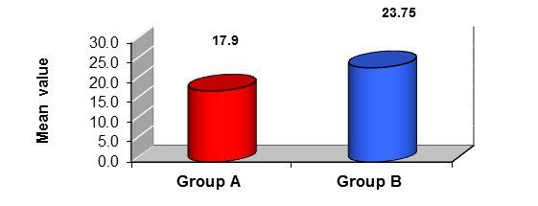
- Mean values of difference in SBP in both groups.
Diastolic blood pressure (DBP)
Within group comparison (pre- versus post-treatment comparison)

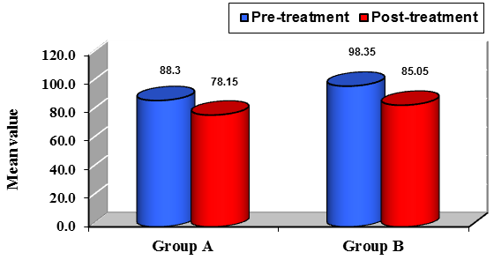
- Mean value of DBP in the two studied groups measured pre- and post-treatment
- Between groups comparison

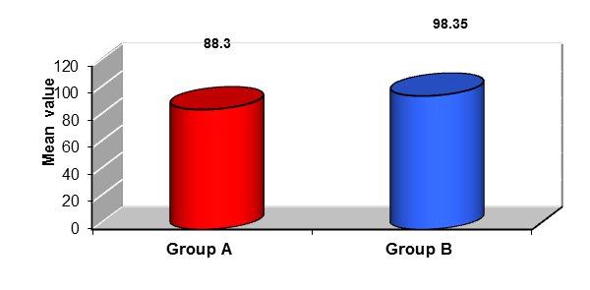
- Mean values DBP in both groups measured pre-treatment.

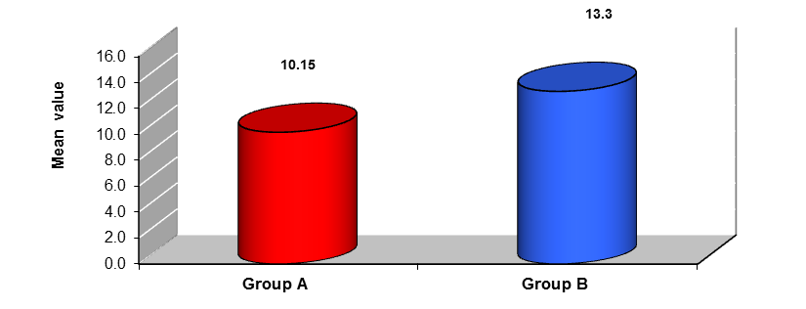
- Mean values of difference in DBP in both groups.

Correlation between difference in PWA and age in the two groups
In group A there was no statistical significant correlation between difference in PWA and age (r= -0.221; p= 0.350). Also in group B, there was no statistical significant correlation between difference in PWA and age (r= -0.374; p= 0.104) (Table).

4. Discussion
The fundamental point of this study was to assess the response of arterial stiffness to high-intensity aerobic interval training in hypertensive females patients stage 1 essential Hypertension (HTN) and stage 2 essential HTN patients and to demonstrate how the distinction will different between the impact of aerobic interval training program on hypertensive patients type I and the impact of the same program on type II after 12 weeks of training.
The present study demonstrated a statistical significant decrease in all measured variables in each group, with more prominent enhancement or decrease in all variables in favor of group B, there was a significant difference in the values of PWV (pulse wave velocity), however, there was no significant in AIx @75 HR (augmentation index), SBP (systolic blood pressure) and DBP (diastolic blood pressure) between both groups. Also there was no statistical significant correlation between difference in PWA and age in all groups.
Epidemiological studies reveal that from early to late adulthood (ie, 20–90 years), systolic BP increases approximately 14%, while AIx increases fivefold and PWV twofold. PWV has been appeared to be an Independent determinant of the longitudinal increment in systolic BP, and thus arterial pulse-wave contour measurements are respected more delicate than conventional brachial BP measures to detect the alterations in vascular structure and function that occur with aging or disease status (Najjar et al., 2008).
The results of the current study agreed with Mora-Rodriguez et al., (2017). Who observed similar central vasculature effects of exercise training with both measurements. To be specific, brachial systolic pressure and pulsatile PWV and AIx@75HR both were reduced by approximately 8% after 6 months of training.
The results of this study come in concurrence with Guimarães et al., (2010) who demonstrated a decrease in arterial stiffness of hypertensive subjects after 16 weeks of HIT, but not CMT. Authors concluded that HIIT and continuous exercise training were both beneficial for BP control in treated hypertensives but only HIIT reduced arterial stiffness. Interval exercise training significantly decreased the carotid to femoral pulse wave velocity values after 16 weeks, whereas no significant changes were observed in the continuous and control groups. Also, there was no correlation between age and PWV decline for all groups. Similar results were found in other study Ciolac et al, (2012) with normotensive women at familial risk for hypertension, where a significant arterial stiffness reduction was found after 16 weeks of HIT, but not CMT.
The results of the present study additionally concurred with Beck et al., (2013). Researchers reported that, both resistance and endurance exercise showed improvement and significant difference in resting SBP, DBP, augmentation index (AIx), AIx@75, left ventricular wasted pressure energy, an index of extra left ventricular myocardial oxygen requirement due to early systolic wave reflection, carotid–radial PWV and femoral–distal PWV.
Many results demonstrate that aerobic exercise training reduced arterial stiffness in healthy normotensive Ciolac et al., (2010); Yoshizawa et al., (2009) and hypertensive patients Beck et al., (2013); Guimarães et al., (2010); Madden et al., (2009). However, aerobic exercise failed to alter large arterial stiffness in older populations with isolated systolic hypertension Ferrier et al., (2001).
Also, there was a study attained by Gunjal et al., (2013) who studied the effect of aerobic interval training on blood pressure & myocardial function in hypertensive patients. AIT reduced systolic BP by 12mmhg and diastolic BP was reduced by 8mmhg after 12 weeks of aerobic interval training.
Additionally, the beneficial effects of regular aerobic exercise on vascular function are associated with a favorable influence on arterial blood pressure and arterial baroreflex sensitivity even in 4 weeks only as showed by Goldberg et al., (2012).
Aerobic training reduces multifactorial (Type 2 diabetes, aging, hypertension and hypercholesterolemia) arterial stiffness, but only in the short term. In older adults at high cardio-metabolic risk, aerobic exercise resulted in an initial 3-month improvement in arterial stiffness that became attenuated over the long term (6 months) which was concluded by Madden et al., (2013).
In agreement with the results of current study of Miura et al., (2015) who concluded that older hypertensive female subjects exhibited small changes in baPWV and SBP/DBP after 12-week circuit training and chair-based exercise for the lower extremities. Significant differences were observed in delta SBP, delta DBP and delta baPWV between the HT (hypertensive training) and HC (hypertensive control) groups, between the HT and NC groups, between the NT and HC groups and between the NT (normotensive training) and NC (control) groups. Furthermore, a significant difference was found in delta baPWV between the HT and NT groups.
The results of the current study disagree with Kim et al., (2016). That compared the effect of all-extremity high-intensity interval training (HIIT) and moderate-intensity continuous training (MICT) on aortic pulse wave velocity (PWV) and carotid artery compliance in older adults.
Also the results of the current study disagree with another study by Cortez-Cooper et al., (2008) Randomized, controlled intervention study in which 37 healthy, sedentary men and women (52± 2 years) performed 13 weeks of strength training (ST). No significant changes were observed in carotid artery compliance or carotid-femoral pulse wave velocity following ST (strength training) or ST + aero bic exercise.
The results of the current study also contradict or disagree with Aizawa and Petrella, (2008) who studied the acute impact of maximal dynamic exercise and the effect of 20 weeks of aerobic exercise on arterial stiffness of the carotid and brachial arteries in older hypertensives. Maximal exercise had no impact on arterial stiffness indices immediately and 24 h following exercise intervention.
Aerobic exercise likely influences functional components of arterial stiffness, such as increased NO production, although long-term aerobic exercise may also influence arterial wall structure, including advanced glycation end products cross-linking of proteins. Indeed, results from preclinical work in mice support the possibility that aerobic exercise may induce structural changes in the large elastic arteries of older animals, including reductions in collagen I and III, transforming growth factor-β1, and reduced smooth muscle α-actin (Santos-Parker et al., 2014).
The potent and time-efficient central and peripheral physiological effects of HIIT (high-intensity interval training) in various healthy/clinical populations as demonstrated by Shiraev and Barclay, 2012. In patients with cardiovascular disease, HIIT was shown to be superior to CME in reducing blood pressure, improving endothelial function, lipid profiles, VO2 max, left ventricular and overall myocardial function, as well as reversing left ventricular remodeling in heart failure patients. Patients with metabolic syndrome who carry out HIIT have been demonstrated to have improved endothelial function, insulin signaling, blood glucose and lipogenesis.

Conclusion
From previous obtained results, data revealed that there was significant improvement in both arterial stiffness parameters (PWV & AIx) and peripheral arterial blood pressure (SBP & DBP), with better improvement change of arterial stiffness parameters and blood pressure much more in group B than group A. There was a significant difference in the values of PWV (pulse wave velocity), however, there was no significant difference in AIx @75 HR (augmentation index), SBP (systolic blood pressure) and DBP (diastolic blood pressure) between both groups.

References
- Aizawa K and Petrella RJ, (2008): Acute and Chronic Impact of Dynamic Exercise on Arterial Stiffness in Older Hypertensives, The Open Cardiovascular Medicine Journal; 2:3-8.
- Alan Maryon-Davis (2005). Hypertension: the silent killer. Faculty of Public Health Briefing Statement. Faculty of Public Health of the Royal colleges of Physicians of the United Kingdom. London. May 2005.
- Beck DT, Martin JS, Casey DP and Braith RW, (2013): Exercise Training Reduces Peripheral Arterial Stiffness and Myocardial Oxygen Demand in Young Prehypertensive Subjects, American Journal of Hypertension; 26(9):1093-1102.
- Cavalcante JL, Lima JA, Redheuil A and Al-Mallah MH (2011): Aortic stiffness: current understanding and future directions. J Am Coll Cardiol 57: 1511–1522.
- Ciolac EG, (2012): High-intensity interval training and hypertension: maximising the benefits of exercise. Am J Cardiovasc Dis; 2(2): 102–110.
- Ciolac EG, (2012): High-intensity interval training and hypertension: maximising the benefits of exercise. Am J Cardiovasc Dis; 2(2): 102–110.
- Ciolac EG, Bocchi EA, Bortolotto LA, Carvalho VO, Greve JMD, Guimarães GV (2010): Effects of high-intensity aerobic interval training vs. moderate exercise on hemodynamic, metabolic and neuro-humoral abnormalities of young normotensive women at high familial risk for hypertension. Hypert Res;33:836–843.
- Collier SR, Kanaley JA, Carhart Jr R, Frechette V, Tobin MM, Hall AK, Luckenbaugh AN and Fernhall B, (2008): Effect of 4 weeks of aerobic or resistance exercise training on arterial stiffness, blood flow and blood pressure in pre- and stage-1 hypertensives, Exercise training mode in hypertensives, Journal of Human Hypertension; 22, 678–686.
- Cortez-Cooper MY, Anton MM, DeVan AE, Neidre DB, Cook JN and Tanaka H, (2008): The effects of strength training on central arterial compliance in middle-aged and older adults, European Journal of Cardiovascular Prevention and Rehabilitation; 2(15):149–155.
- Franssen PM and Imholz BP. (2010): Evaluation of the Mobil-O-Graph new generation ABPM device using the ESH criteria. Blood pressure monitoring; 15(4): 229–31.
- Goldberg MJ, Boutcher SH and Boutcher YN, (2012): The effect of 4 weeks of aerobic exercise on vascular and baroreflex function of young men with a family history of hypertension, Journal of Human Hypertension; 26, 644-649.
- Guimarães GV, Ciolac EG, Carvalho VO, D’Ávila VM, Bortolotto LA, Bocchi EA (2010): Effects of continuous vs. interval exercise training on blood pressure and arterial stiffness in treated hypertension. Hypert Res; 33: 627-632.
- Guimarães GV, Ciolac EG, Carvalho VO, D’Ávila VM, Bortolotto LA, Bocchi EA, (2010): Effects of continuous vs. interval exercise training on blood pressure and arterial stiffness in treated hypertension. Hypert Res; 33: 627-632.
- Gunjal S, Shinde N, Kazi A and Khatri S, (2013): Effect of Aerobic Interval Training on Blood Pressure and Myocardial function in Hypertensive Patients, International Journal of Pharmaceutical Science Invention; 6(2):27-31.
- Kim HK, Hwang CL, Yoo JK, Hwang MH, Handberg EM, Petersen JW, Nichols WW, Sofianos S, And Christou DD, (2016): All-Extremity Exercise Training Improves Arterial Stiffness in Older Adults, Medicine & Science In Sports & Exercise, the American College of Sports Medicine.
- Laurent S, Cockcroft J, Van Bortel L, Boutouyrie P, Giannattasio C and Hayoz D, (2006): Expert consensus document on arterial stiffness: methodological issues and clinical applications. Eur Heart J. 27(21):2588-605.
- Madden KM, Darcye Cuff CL, Potter TF and Meneilly GS, (2009): Short-Term Aerobic Exercise Reduces Arterial Stiffness in Older Adults with Type2 Diabetes, Hypertension, and Hypercholesterolemia, Cardiovascular and Metabolic Risk, Diabetes Care; 8(32):1531–1535.
- Madden KM, Lockhart C, Cuff D, Potter TF and Meneilly GS, (2013): Aerobic training-induced improvements in arterial stiffness are not sustained in older adults with multiple cardiovascular risk factors, Journal of Human Hypertension; 27:335–339.
- Miura H, Takahashi Y, Maki Y and Sugino M, (2015): Effects of exercise training on arterial stiffness in older hypertensive females, Eur J Appl Physiol; 115:1847–1854.
- Mora-Rodriguez R, Ramirez-Jimenez M, Fernandez-Elias VE, Guio de Prada MV, Morales-Palomo F, Pallares JG, Nelson RK and Ortega JF, (2017): Effects of aerobic interval training on arterial stiffness and microvascular function in patients with metabolic syndrome, J Clin Hypertens;1–8.
- Najjar SS, Scuteri A, Lakatta EG, (2005). Arterial aging: is it an immutable cardiovascular risk factor? Hypertension, 46(3):454-562.
- O’Donovan C, Lithander EF, Raftery T, Gormley J, Mahmud A, and Hussey J, (2014): Inverse Relationship Between Physical Activity and Arterial Stiffness in Adults With Hypertension, Physical Activity and Arterial Stiffness, Journal of Physical Activity and Health; 11:272-277.
- Santos-Parker JR, LaRocca TJ and Seals DR. (2014): Aerobic exercise and other healthy lifestyle factors that influence vascular aging. Advances in physiology education; 38(4):296-307.
- Shiraev T and Barclay G. (2012): Evidence based exercise-clinical benefits of high intensity interval training. Australian Family Physician; 41(12):960-2.
- Tjonna AE, Lee SJ and Rognmo O. (2008): Aerobic interval training versus continuous moderate exercise as a treatment for the metabolic syndrome: a pilot study. Circulation;118:346–54.
- Trapp EG, Chisholm DJ, Freund J and Boutcher SH. (2008): The effects of high-intensity intermittent exercise training on fat loss and fasting insulin levels of young women. Int J Obes (Lond); 32:684–91.
- Yoshizawa, M, Maeda S, Miyaki A, Misono M, Saito Y, Tanabe K and Ajisaka R, (2009): Effect of 12 weeks of moderate-intensity resistance training on arterial stiffness: A randomised controlled trial in women aged 32–59 years. British Journal of Sports Medicine; 43: 615–618.

12/6/2018

