**Life Cycle Assessment of the Enbuil-Tridipanel Building System in Egypt**

Abdelrahman A. Abd Elmonem1; Ayman Mosallam2; Mohamed El Mikawi3; Mona M. Abd Elwahab4

1 Teaching Assistant at Mansoura High Institute for Engineering and Technology, Egypt.

2 Professor, Civil & Environmental Engineering Department, University of California, Ir-vine (UCI)

3Associate Professor, Structural Engineering Department, Faculty of Engineering, Ain Shams University, Egypt

4 Associate Professor, Structural Engineering Department, Faculty of Engineering, Ain Shams University, Egypt

[Abdelrahman.ameen@hpd.com.eg](mailto:Abdelrahman.ameen@hpd.com.eg); [mosallam@uci.edu](mailto:mosallam@uci.edu); [m.elmikawi@eng.asu.edu.eg](mailto:m.elmikawi@eng.asu.edu.eg); [mo.mostafa@eng.asu.edu.eg](mailto:mo.mostafa@eng.asu.edu.eg)

**Abstract:** Life cycle assessment has become an important tool for determining the environmental impacts of materials and products. Egypt recently began showing great attention to this topic by the Ministry of Housing and the National Center for Housing and Building Research. This is maifisted in the establishment of the National Council for Housing Green Architecture for the purpose of thedevelopment of policies that lead to the dissemination and application of the idea sustaniblity and of green architecture. Recently, manufacturers have developed a new technique called 3D panel system (Enubil panel system) for low rise building up to three stories heigh. This techniqe replaces the use of conventional reinforced concrete low rise structures. However, this new structural technique is not used in Egypt as there isn’t a adefinite environmental assessment criteria. Therefore, this paper emphasizes the add value of using this new structural system. It compares its environmental impacts with that of the traditional reinforced concrete system (materials/methods). The software ATHENA Impact Estimatoris was used in this research to compute the environmental impacts for the two systems. The results related to the environmental impacts conclude that the EPS system is 30% lower than the traditional system. Also with using premevira software, the results conclude that the EPS system has lower cost and time impacts with 25% and 45% respectively than the traditional system.

[Abdelrahman A. Abd Elmonem; Ayman Mosallam; Mohamed El Mikawi; Mona M. Abd Elwahab. **Life Cycle Assessment of the Enbuil-Tridipanel Building System in Egypt.** *N Y Sci J* 2018;11(11):66-73]. ISSN 1554-0200 (print); ISSN 2375-723X (online). <http://www.sciencepub.net/newyork>. 11. doi:[10.7537/marsnys111118.11](http://www.dx.doi.org/10.7537/marsnys111118.11).

**Keywords**: Life cycle, Egyptian market, Environmental impacts, EPS system

# Introduction

The Construction sector represents more than 50% of investment which consumes more than half of the raw materials from gravel, sand, stones and about 40 - 50% of total energy around the world (Mirnateghi 2017). Reference to LCA results obtained in most recently researches related to construction sector nowadays showed that 46.6% of carbon emissions are emitted from substructure. Brick walls are responsible for 27.5% of emissions. Steel bars emit about 46.5% of total material carbon (Feifei fu 2014). This lack of efficiency in the use of earth's natural resources and the almost complete dependence on fossil fuels (coal, oil and natural gas and uranium) lead to improve understanding of LCA environmental impacts of construction materials.

The most commonly environmental impacts that are considered in life cycle assessment of construction sector are as follows; **Acidification Pollution (AP)** happens when the phenomena called acid dispositiontooks place where the process of reacting between water in the atmosphere and sulfur gases on the air (Kg SO2); **Aquatic Eutrophication Potential (EP)** also called by nitrification, the eutrophication potential caused due to nitrates and phosphates emissions in the water which reduce the oxygen quantity in the water and measured in (Kg N); **Global Warming Potential (GWP)** This phenomenon is defined as radiative forcing where nitrogen oxide (N2O), methane (CH4), hydro fluorocarbon (HFCs), Perflourocarbon (PFCs) and Sulfur hexafluoride (SF6) are considered the responsible gases which measured in (Kg CO2); **Ozone Depletion Potential (ODP)** Ozone depletion gases cause a high damage for the ozone layer where these gases release free radical particulates which breakdown O3 and measured in (Kg (CFC-11)); **Smog Potential** in the atmosphere where there are a largeamount of nitrogen oxides produced from VOCs sources and air pollutants could be produced in the presence of the sun and measured in (Kg O3); **Fossil fuel** Consumption is a subtotal of Total Primary Energy, by energy type, that includes all fossil fuel energies (Coal, Diesel, Feedstock, Gasoline, Heavy Fuel Oil, LPG (propane), and Natural Gas) (Jane Anderson 2012).

In response to the global warming awareness, energy consumption and the environment impacts, this paper will introduce the Enbuil panel system (EPS) showing its advantages as follow: shorter time and lower cost of erection, rapid installation and easy handling, the higher lightness of the building and maximum energy efficiency and reduces fossil fuel consumption. The paper highlights the main characteristics of the proposed construction system, and a full comparison to the traditional reinforced concrete\ bricks system in respect to environmental, cost and time impacts.

# Enbuil panel system

The main idea of this system is to locate the materials in the place where is demand. As shown in the below shape that shows concrete used on the tensile side only used to resist shear force. Despite the huge amount of concrete in this part, it has low shear strength that equal square root of compressive strength.

In CSP system the steel truss that connected the two wire mesh faces is responsible for resisting the shear instead of heavy concrete.

## **EPS Foam characteristics**

The raw material of the foam core is a virgin plastic bead with approximate 6% pentane. These plastic beads could be replaced by a recycled product. The main purpose of the core foam system is energy conservation and creates a comfortable living condition. This excellent insulation could be developed by using small cell size. These panels of EPS foam core have R-value 40% greater than other conventional systems which make the system considered the best solution for head insulation. Heat insulation is directly proportional to R-value. The maximum temperature for wall environment is between 167-180oF. In the standard EPS foam core, a 60 mm core with 40 mm concrete layer an R11 rating where a 100 mm core with 50 mm concrete layer is more efficient with an R-18 rating (Mirnateghi 2017).



Figure 1: Main components of sandwich panel system

## **Mortar Characteristics**

The main purpose of the concrete surface on both interior and exterior separated by the foam core is to absorb the heat or cool and keep the comfortable condition inside the home. To control the insulation temperature, its thickness varies from 1.5m to 5m depending on the demands of designers and structure element. The flexibility in the core thickness allows the flexibility of design for all elements (slabs-beams-walls). In EPS system, mortar should be applied by methods for Unique mortar sprayers. It’s important that mortar be pliable and applied generically to remove the air between the hidden and fresh mortar and to obtain uniform surface.

The last step for installing panels is applying cement. Sand layer on both sides with average thickness of (2.5-3) cm. The panel obtained with an expanded polystyrene care has compressive strength 250 kg/cm2. The plaster layer as shown in (**Error! Reference source not found.**) is dosed with a proportion of 1:3.5 between cement-sand and not exceeds 5cm. The mixture of plaster could be driven as follow: Cement: 380 Kg, Sand: 1510 Kg, Water: 240 Litters.



Figure 2: EPS system plastering works using shotcrete

## **Steel Wire Mesh**

When manufacturing EPS foam panels, the common wire mesh used is produced by a mesh 50mm X 50mm from center to the next for both longitudinal and transverse direction. The diameter of wire mesh could be determined according to the design and construction requirements to increase the flexibility and achieve design objectives.



Figure 3: components of steel wire mesh sandwich panel system (MIRNATEGHI, 2017).

Diagonal steel wire mesh: The diagonal truss wires, transverse wires and also shear connectors could be used as an expression for connectors between two wire mesh grid faces. The diameter of shear connectors could be varied according to the design requirements which in range 2.3-3.67 mm. Also, the number of shear connectors could be varied to provide the required shear strength which in between 50-200 per m2. The wall panel can get its rigidity from the welding between diagonal and grid wires on each side. These welded connections provide the system with a truss behavior that achieves the required rigidity and shear strength.

# Methodology

## **Case Study Methodology**



Figure 4: Methodology of life cycle assessment (LCA) study

The case study methodology will go through several steps as shown in the below chart to be prepared for assessment. First of all, the case study will be chosen according to a specific criterion in an attempt to select a case that represents low cost building in Cairo. Secondly, the case must have a quick brief of the structural specification of the building showing all spaces. Then to specify the assessment program needed for this procedure.

The case study procedure will de-pend on five phases to reach the last step embodied in the discussion and conclusion.

## **Choosing Criteria**

The criterion for the selection of the case study building is a very accurate process. In order to ensure that relevant and appropriate building case is selected, the case study will be selected based on several target characteristics. The following basic criteria are used in the selection process:

1. Climate Region: 6th October City region, Cairo.
2. Location: at least 300m west away from 6th October main road.
3. Age: has been established for three months.
4. Furnishing: fully furnished at a low level for Badwian.
5. Area: Gross area of building 140 m2 with a footprint of 100 m2.
6. Structural system: EPS wall system for the first model and traditional reinforced concrete system for the second model.
7. Occupation: at least is occupied by the small family.

## **Case Study Overview**

The first step in this study is a quick summary that shows basic information about Badwian house, area, cost, structure system… etc. and also discuss the architectural details consisting the building as shown in (**Error! Reference source not found.**).

Table 1: Project Basic Information

|  |  |  |
| --- | --- | --- |
| **Building Features** | **First model description** | **First model description** |
| **Location** | 6th october City – Main road, Cairo, Egypt | |
| **Orientation** | West Facing Front Elevation | |
| **Shape** | Rectangular residential low-cost home | |
| **Ceiling height** | 3.5 m | |
| **Floor area** | 140 m2 Total Gross area for the building, with 100 m2 net ground floor area | |
| **Window wall ratio** | 10% | |
| **Foundation** | Shallow foundation (Continuous Strip footing settled on plain concrete strip footings) | |
| **Floors** | Reinforced concrete for both 20 cm ground slab and columns with 10 cm reinforced concrete for slab on grade | Enubil panel system for both 15 cm Ground slab and columns with 10cm reinforced concrete for slab on grade |
| **Exterior walls** | 2.5 cm plaster + 25 cm concrete block + 2.5 cm plaster | 2.5 cm plaster + 7 cm Enubil panel + 2.5 cm plaster |
| **Internal walls** | 2.5 cm plaster + 12 cm concrete block + 2.5 cm plaster | 2.5 cm plaster + 7 cm Enubil panel + 2.5 cm plaster |
| **Roof** | 40 mm concrete tiles + 0.2 mm polystyrene + 4mm cold applied bitumen + 60 mm cement screed + | |
| **Windows & Doors** | Wooden Doors and Windows | |

## **Simulation Software**

The simulation process divided into three steps: first we use AutoCAD software to draw and calculate the bill of quantities for each structural system, and then we use Athena software for assessing the environmental impacts for each system. Finally primavera software was used to calculate cost and time impacts as we will discuss in the results later.



**Figure 5: The simulation process concerning the programs used**

The Athena Impact Estimator is a whole building, life cycle based environmental assessment tool that lets building de-signers, product specifies and policy analysts compare the relative environmental effects or trade-offs across alternative building design solutions at the conceptual design stage. Some of the Impact Estimator’s specific features include:

1. The ability to model the building’s complete structure and envelope (claddings, insulation, gypsum wall board, and roofing and window systems – over 1200 possible assembly combinations) over the expected life of a building;
2. A regionally sensitive calculator to convert operating energy to primary energy and emissions to allow users to compare embodied and operating energy environmental effects over the building’s life (requires a separate estimate of operating energy as an input);
3. An "end-of-life" module, which simulates demolition energy and final disposition of the materials incorporated in a building;
4. a context sensitive help facility in place of a users’ manual; and,
5. The capability to model both Canadian and US regional locations.

## **Modeling of spaces under study**

The Badwian house as shown in (**Error! Reference source not found.**) is a low-cost home which consists of three bedrooms, kitchen, main bath-room, guest bathroom, living room and outdoor open garden.

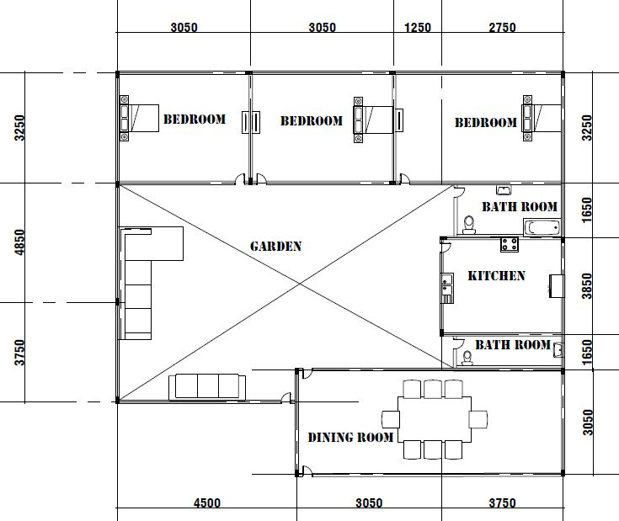

Figure 6: Low income BADWIAN house in 6th October city, EGYPT

## **Primavera software**

Using primavera software showing the advantages of using the EPS that reduce erection time than other traditional methods of construction by installing walls and roof by few men in a few minutes also eliminate the need of heavy equipment. Furthermore minimizing of storage area, quick and low cost transportation, easily installation and labor reduction all provide the significant reduction in the total cost investment.

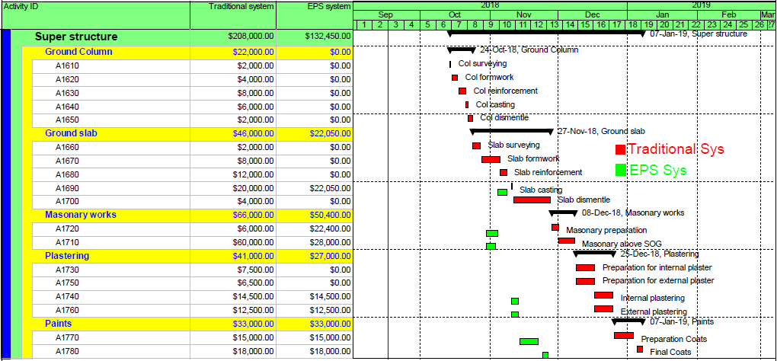

Figure 7: Gantt chart comparison between EPS sys and Traditional sys for super structure.

## **Case study procedure**

The building in this study has two structure systems that share in the foundation system (Strip Footings). The first system is Enubil panel system where external walls are made of panels type PSM180 for bearing and partition walls where the internal walls from PSM80 for bearing and partition walls. The ground slab is made from panels PSSG3 H16+4 which is reinforced with galvanized wire mesh 0.3*1.24 m. the process of quantifying construction materials for the EPS system wasn’t straight forward because of important design details were missed which have been acquired through interviews with Professor AYMAN MOSALLAM and professor MEDHAT KHORSHID. Details of the construction materials for our case study have been provided in the table below:

Table 2: Construction materials details for EPS system

|  |  |  |  |  |  |  |  |  |
| --- | --- | --- | --- | --- | --- | --- | --- | --- |
| **Material** | **Unit** | **Total Quantity** | **Floors** | **Foundations** | **Roofs** | **Walls** | **Mass Value** | **Mass Unit** |
| **Concrete Benchmark 2500 psi** | m3 | 9.4500 | 9.4500 | 0.0000 | 0.0000 | 0.0000 | 21.6398 | Tones |
| **Concrete Benchmark 3000 psi** | m3 | 11.1013 | 0.0000 | 11.1013 | 0.0000 | 0.0000 | 25.4595 | Tones |
| **Expanded Polystyrene** | m2 (25mm) | 214.2000 | 0.0000 | 0.0000 | 69.3000 | 144.9000 | 0.1542 | Tones |
| **Hot Rolled Sheet** | Tones | 1.4423 | 0.0000 | 0.0000 | 0.4666 | 0.9757 | 1.4423 | Tones |
| **Mortar** | m3 | 19.8720 | 0.0000 | 0.0000 | 6.0720 | 13.8000 | 25.4362 | Tones |

The second system is the traditional reinforced concrete system where external walls are made of concrete masonry units (CMU) 25cm while the internal walls from the same material but have 12cm thickness. The roof, columns, stair and beams are made of reinforced concrete:

Table 3: construction materials details for reinforced concrete system

|  |  |  |  |  |  |  |  |  |
| --- | --- | --- | --- | --- | --- | --- | --- | --- |
| Material | Unit | Total Quantity | Floors | Foundations | Roofs | Walls | Mass Value | Mass Unit |
| 12" Normal Weight Concrete Block | Blocks | 2,541.0000 | 0.0000 | 0.0000 | 0.0000 | 2,541.0000 | 62.6611 | Tons |
| Concrete Benchmark 2500 psi | m3 | 9.4500 | 9.4500 | 0.0000 | 0.0000 | 0.0000 | 21.6398 | Tons |
| Concrete Benchmark 3000 psi | m3 | 24.9613 | 0.0000 | 11.1013 | 13.8600 | 0.0000 | 57.2456 | Tons |
| Rebar, Rod, Light Sections | Tons | 0.2164 | 0.0000 | 0.2164 | 0.0000 | 0.0000 | 0.2164 | Tons |
| Vinyl Siding | m2 | 169.7143 | 169.7143 | 0.0000 | 0.0000 | 0.0000 | 0.3903 | Tons |
| Welded Wire Mesh / Ladder Wire | Tones | 2.3460 | 0.0000 | 0.0000 | 2.3460 | 0.0000 | 2.3460 | Tons |

**Results and Discussion:**

Thus, Sustainability is different and unique than other processes applied in the construction field, whereas the challenge of this system is the balance and equilibrium between the triple factors (time, cost and environment) as shown:

* **Time impact:** the usage of EPS system saves time compared to the usage of traditional system. The construction duration in case of using EPS system is about 6 weeks while the construction duration in case of using the traditional system is about 5 months. This reduction in time resulting from shorter time of erection and construction which save approximately 45% of total project duration:



Figure 8: Comparison between activities duration for EPS and Traditional system

* Cost impact: as mentioned previously the total cost of each system could be divided into two parameters: cost of materials and cost of energy.

We conclude that the premises of EPS system become socially of Reinforced concrete buildings in the case of low-cost buildings where, in our case study the total cost of EPS model is 25% less than the total cost of traditional system. This reduction ratio could be increased depending on the number of building stories.

The figure below shows the cost histogram and S-curve that clarify the cash flow for each model along project duration:

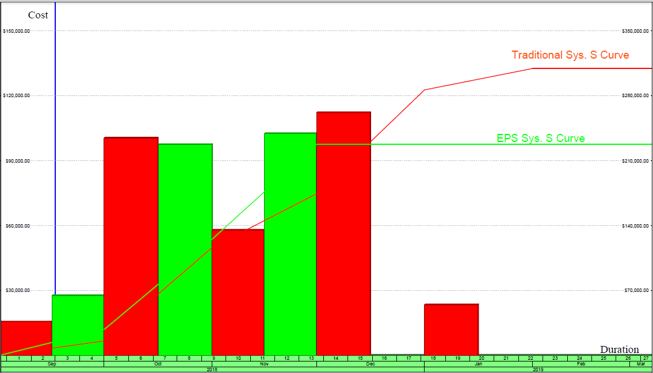

Figure 9: Cash flow comparison between EPS and traditional system

* **Environmental impact:** The purpose of this research is to evaluate the environmental impacts for the new and existing buildings construction systems and provide methodologies to improve the environmental performance. These impacts for both EPS and traditional system could be summarized in the histogram and table below assuming that traditional system is the base line of comparison:

Table 4: Environmental impacts comparison between traditional reinforced concrete system and EPS system

|  |  |  |  |  |
| --- | --- | --- | --- | --- |
| **Summary Measure** | **Unit** | **Reference Design**  **Total Effects**  **( Reinforced Model)** | **Proposed Design**  **Total Effects**  **(EPS model)** | **% Difference** |
| Global warming potential | kg CO2 | 2.19E+04 | 1.77E+04 | -19.31% |
| Stratospheric ozone depletion | kg CFC-11 | 3.97E-04 | 2.24E-04 | -43.65% |
| Acidification of land and water | kg SO2 | 1.16E+02 | 8.51E+01 | -26.58% |
| Eutrophication | kg N | 1.69E+01 | 9.60E+00 | -43.37% |
| Tropospheric ozone formation | kg O3 | 1.98E+03 | 1.50E+03 | -24.29% |
| Fossil Fuel Consumption | MJ | 1.98E+05 | 1.52E+05 | -23.58% |

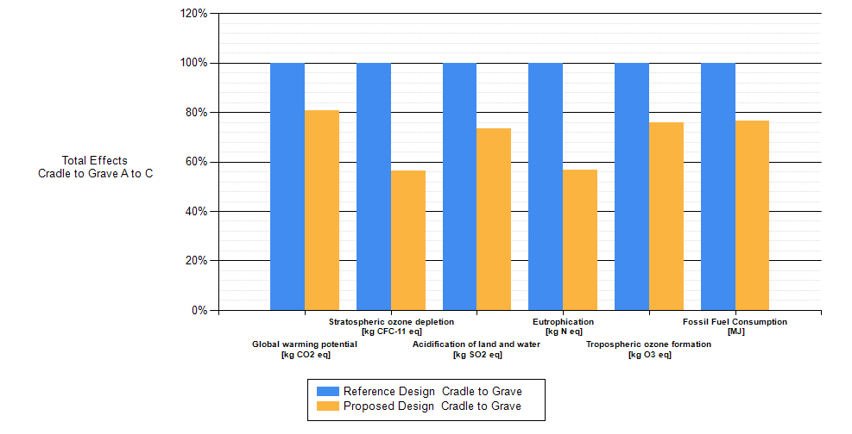

Figure 10: Environmental impacts comparison between traditional reinforced concrete system and EPS system

# Conclusion

# The following remarks conclude the principle points discussed in this paper:

* Careful selection of construction materials during construction phases is the first step to achieve sustainability aspects.
* Traditionally, the principle methodology of construction reinforced concrete/bricks houses in Egypt without consideration of the environmental impacts has not change over the last 50 years. The EPS construction system is sophisticated, effective and economical solution,
* The study results related to the environmental impacts highlight that the EPS system is 30% lower than the traditional systemwith a greet reduction in fossil fuel consumption by 24%.
* The study highlight that, significant reduction in the construction cost up to 25% could be achieved when using the EPS system as an alternative to the traditional reinforced concrete/bricks system.
* The study also indicated that, significant reduction in construction time 45% could be achieved when using the EPS system as an alternative to the traditional reinforced concrete/bricks system. This reduction ratio could be incraesed up to 60% depending on the number of building’s stories.
* The suggested EPS system produces the most economical and high quality product that could be suitable for low cost housing in Egypt in light of the increase in real estate costs in the current period.
* It’s also should be noted that EPS construction system requires a large construction volume to achieve an economical results.
* In general to achieve sustainability aspects means low environmental impacts, low construction cost and durable structures.

**References**

1. Feifei fu, Hanbin luo, Hua zhong and Andrew hill. "Development of carbon emission calculations system for optimizing building plan based on the LCA framwork." Hindawi public corporation mathematical problems in engineering 2014 (2014): 13.
2. Hassan, fatma. "LEED “ materials category a critical LEED “ materials category a critical LEED “ materials category a critical LEED “ materials category a critical Egyptanalysis of Applicability in Egyptanalysis of Applicability in Egyptanalysis of Applicability in Egypt." 2009.
3. Igopracio Zobal Zabribian, Antonio Valero Capilla, Alfonso Aranda Uson. "Life cycle assessment of building materials comprative analysis of energy and develpoment impacts and evaluation of the eco efficiensy improvemnt potential." university of zaragoza, mariano esquillor gomez- zaragoza, spain, 2010.
4. Jane Anderson, Jane Thornback. The embodied impacts of the construction products. London: Construction Products Association, 2012.
5. Lawrence, Mike. "Reducing the environmental impact of construction by using renewable materials." BRE center for innovative construction materials, department of architecture and civil engineering, unversity of bath, UK, 2015.
6. Manish komar, Dixit, Jose L.fernandez, Solis, Sarel lavy, Charles H.culp. "Identification of parameters for embodied energy measurments: a literature review." 2010.
7. Mirnateghi, Ehsan. "Design optimization of cementitious reinforced orthotropic sandwich composite system." (VDI-Berichte) 2017.
8. Mousa, Ahmad. "3D-panel system: A sustainable building solution for EGYPT." The International Conference for Industry Academia Collaboration. Civil Engineering, Architecture and Building Materials Track. Fairmont Heliopolis, Cairo, Egypt: https://www.researchgate.net, 2014.
9. Muhammed asif, Ammar Hamoud, Farhan Ashraf, Hassan saeed, Mian Mobeen shaukat, Muhammed Tahir Hassan. "Life cycle assessment of three bedroom house in saudi arabia." Environments 2017, 2017.
10. Peng Wu, Yongze song, Xin Hu and Xiangyu Wang. "A preliminary investigation of the transition from green building to green community: in sights from Leed ND." Australasian joint research centre for building information modelling, curtin university, perth, WA 6102, Australia, 2018.
11. Sarbring, Anna. "A carbon footprint assessment on construction and maintenance operations for the port of gothemburg." depart of energy and environment division of physical resource theory, charmles unvesity of technology, gotenburg, sweden, 2014.
12. Shinori Fujita, hiroshi matsumoto, hochin sing. "Assessment of CO2 emissions and resources sustainability for housing construction in malysia." international journal of low -carbon technologies 4, no. 1 (2009): 16-26.

11/22/2018