**Bacterial Quality of Ground Water of Petrol Filling Stations in Port Harcourt Area of Rivers State, Nigeria**

Uchenna Maryrose Obaji1 and Lucky Obukowho Odokuma2

1Department of Medical Biotechnology, Molecular Biotechnology Unit, National Biotechnological Development Agency, P. M. B. 5118, Wuse, FCT, Abuja, Nigeria

2Department of Microbiology, Faculty of Science, University of Port Harcourt,

P.M.B. 5323, Port Harcourt, Nigeria

[uchennaorji60@yahoo.com](mailto:uchennaorji60@yahoo.com)

# Abstract: Ground water quality of petrol filling stations in Port Harcourt area of Rivers State was investigated. The study covered highly populated area (HPA), industrial area (INA), low populated area (LPA), poorly populated area (PPA) and rural area (RUA). Total coliform count (TCC) ranged from 11 to 17 MPN/100 ml (wet) for HPA and 9 to 12 MPN/100ml (dry). In LPA, TCC ranged from 7 to12 MPN/100 ml and 2 to 4 MPN/100 ml (wet and dry). The RA had TCC of 7 to 9 MPN/100ml (wet) and 2 to 6 MPN/100ml (dry). TCC in INA ranged from 12 to 14 MPN/100 ml (wet) and 11 to 14 MPN/100ml (dry). For PPA TCC were 6 to 4 MPN/100 ml (wet) and 2 to 4 MPN/100 ml (dry). Control had TCC of 6 to 4 MPN/100ml (wet) and 2 to 4 MPN/100 ml (dry). Total heterotrophic bacteria (THB) in INA were 1.3x105 CFU/ml and 8.9 x 104 CFU/ml (wet and dry). Coliforms were above WHO limit of 1 to 10 MPN/100 ml. THB in HPA was 2.0x 105 CFU/ml (wet), 6.3x 104 CFU/ml (dry) while PPA gave THB of 8.3x 104 CFU/ml and 4.3x 104 CFU/ml (wet and dry). In PPA and LPA, the THB were 4.3x 104 CFU/ml and 4.9x 104 CFU/ml (wet) while 8.3x 104 CFU/ml and 8.1x 104 CFU/ml obtained in the dry. The RUA had THB of 8.3x 104 CFU/ml (wet), 4.4x 104 CFU/ml (dry), control had THB of 8.2x 104 CFU/ml (wet) and 3.7x 104 CFU/ml (dry). Physicochemical indices were significant (p<0.05) in dry than in wet season. *Klebsiella*, *Enterobacter, Citrobacter,* *Escherichia coli* and *Staphylococcus* were some of the bacterial genera isolated. It was concluded that industrialization and population density had negative impact on ground water quality of petrol filling stations in Port Harcourt Area of Rivers State.

[Obaji, U. M. and Odokuma, L. O. **Bacterial Quality of Ground Water of Petrol Filling Stations in Port Harcourt Area of Rivers State, Nigeria.** *N Y Sci J* 2018;11(11):31-37]. ISSN 1554-0200 (print); ISSN 2375-723X (online). <http://www.sciencepub.net/newyork>. 4. doi:[10.7537/marsnys111118.04](http://www.dx.doi.org/10.7537/marsnys111118.04).

**Keywords:** Ground water, filling stations, physichochemistry, Port Harcourt, hydrocarbons.

**Introduction**

There are organisms, such as anaerobes, which can survive without oxygen but no organism can survive for any length of time without water (Hammer and Hammer, 2004). Water is a universal solvent and as a solvent, it provides the ionic balance and nutrients, which support all forms of life.

In India the major source of water used to meet the domestic, agricultural and industrial needs is the ground water (Lee and Lee, 2005; Oforibika *et al.,* 2018). Groundwater is found underground in cracks and spaces in soil, sand and rocks. This source has two distinct functions; firstly, it is a significant source of both urban and rural population’s water supply and secondly it sustains many wetland ecosystems. Aquifers are a source of water for drinking, irrigation, stock supply, bottling and many other uses (Armon *et al.,* 1994).

Regular monitoring of groundwater is needed to prevent any adverse health outcomes. Contaminated groundwater contains a broad spectrum of microbial types similar to those found in surface soils and waters (WHO, 2008; APHA, 1995). These microorganisms encompass bacteria, fungi and protozoa, and are representative of most physiological types. On occasion pathogenic viruses, bacteria and protozoans of gastrointestinal origin from domestic, agricultural and other anthropogenic activities, may infiltrate through soils, sediments and rocks to the underlying groundwater. According to the WHO (2002), Coliforms includes all aerobic and facultatively anaerobic, Gram negative, non-spores forming and rod shaped bacteria that ferment lactose with acid and gas production at 35-37 °C within 48 hours. The coliform group also includes the *thermotolerant faecal coliforms* which are defined as being able to ferment lactose at 44ºC (APHA, 1992). In addition, microorganisms from the coliform group are capable of re-growth in aquatic environments. The World Health Organization (WHO, 2002) has bacteriological standards for potable water (Table 1).

The thermotolerant coliform groups (Entrobacteriaceae that are able to ferment lactose at 44°C) include several species of the genera *Klebsiella*, *Enterobacter* and *Citrobacter* as well as *Escherichia coli. E.coli* is considered the only true faecal coliform (grow at 44.5 0C), representing up to 95 % of the Enterobacteriaceae found in faeces (Waite, 1985; Gleeson and Gray, 1997).

**Table 1: Bacteriological Standards for Potable Water**

|  |  |  |  |  |
| --- | --- | --- | --- | --- |
| **S/No.** | **Microorganisms (Bacteria)** | **Limit (CFU/100 ml)** | **Groups** | **Score** |
| 1 | Fecal coliforms | <1─10 | Excellent | [A] |
| 2 | Total coliforms | 1─10 | Acceptable | [B] |
| 10─50 | Unacceptable | [C] |
| >50 | Grossly polluted | [D] |
| 3 | Total heterotrophic bacteria | <500 | Acceptable | [B] |
| 4 | Others | <1 | Excellent | [A] |

Measurement of microbiological quality of groundwater is difficult and costly. However, to allow quick and relatively inexpensive detection of faecal contamination in drinking water, faecal indicator bacteria are used as surrogates in a number of studies (SON, 2007).

The National Health and Medical Research Council (NHMRC) recommended the use of *Escherichia coli* as a primary indicator of faecal contamination of drinking water (NHMRC, 2003). There are many known waterborne pathogens capable of causing infections when digested even in very small numbers (Plazinska, 2000).

Most of them are present in large numbers in human and animal excreta (Back *et al.,* 1993; Bedient, 1994). It has been recognized that monitoring for presence of specific pathogens in drinking water supplies is laborious and impractical. Therefore, coliform bacteria are recommended for us as an indicator of fecal pollution in water. The study seeks to examine the bacterial quality of ground water of petrol filling stations in Port Harcourt Area of Rivers State, Nigeria.

## Materials and Methods

**Study area**

The study was carried out in Port Harcourt area of Rivers State in Nigeria.The study areas covers highly populated area (HPA), industrial area (INA), low populated area (LPA), poorly populated area (PPA) and rural area (RUA). Table 2 shows the experimental design/sampling stations in Port Harcourt area of Rivers State. These areas are however a flourishing commercial central district in Rivers State and houses several petrol filling stations.

The depths of hand dug wells in this region vary from 3.81 to 30.37 m above the mean sea level (A.S.L), and boreholes are generally between 21 and 58.86 m deep. Most of the hand dug wells (Fig. 1) are neither lined nor have properly constructed base or covers. Some are simply covered with planks and rusted metal sheets.

**Table 2: Experimental study areas (locations)**

|  |  |  |
| --- | --- | --- |
| **Sample Code** | **Study Area** | **Ranking** |
| INA | Trans Amadi | Industrial Area |
| HPA | Diobu | Highly Populated |
| PPA | Ndoki | Poorly Populated |
| LPA | GRA phase111 | Low populated area |
| RUA | Rumuekini | Rural Area |

**\***HPA (Highly populated area), INA (Industrial area), LPA (Low populated area), PPA (Poorly populated area), RUA (Rural area), and CON (Control).

The geology of the area is generally characterized by coastal plain sands which form the low lying, gently sloping uplands, and the coastal deposits forming extensive red earths, and loose poorly sorted sands that are mixed with an abundance of clays (World Bank, 2002).

The topography is generally low, ranging from 18 to 52 m above the mean sea level. The climate of Rivers area is characterized by two main seasons: wet (April - October) and dry (November - March) seasons. The peaks of rainfall occur in July and September/October, and they are often characterized by floods, which effects are usually aggravated by the poor surface drainage systems. Mean annual rainfall in Rivers area varies from 1567.2 mm at the North West to 1750 mm at the mainland (Oyeku, 2007).

**Sample collection**

Twenty (20) groundwater sources (10 each of boreholes and hand dug wells) were randomly selected for this study. Water samples were collected between May, and August, 2014 (wet season) and November and December, 2014 (dry season) in the selected groundwater points. The locations of the groundwater points were obtained with a hand held Global Positioning System (GPS, Germin 72 model) with position accuracy of less than 10 m. The choice of the sampling stations considered location, accessibility, proximity to residential areas and the topography of the study area. 12 sample stations were within the 2 residential areas (in the 2 km radius), 5 in the commercial area and 3 in the industrial section of the study area. In all, about 40% of the groundwater sources within 2 km radius of the landfill were sampled. Water samples, from tap were obtained using a sterile and well-capped container.

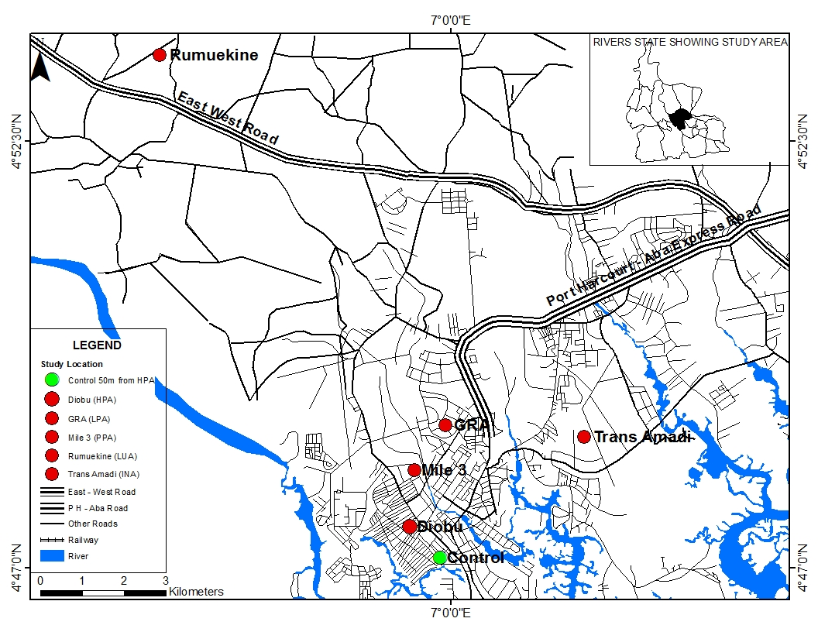

**Fig. 1: Map of Port Harcourt showing the study areas sampled**

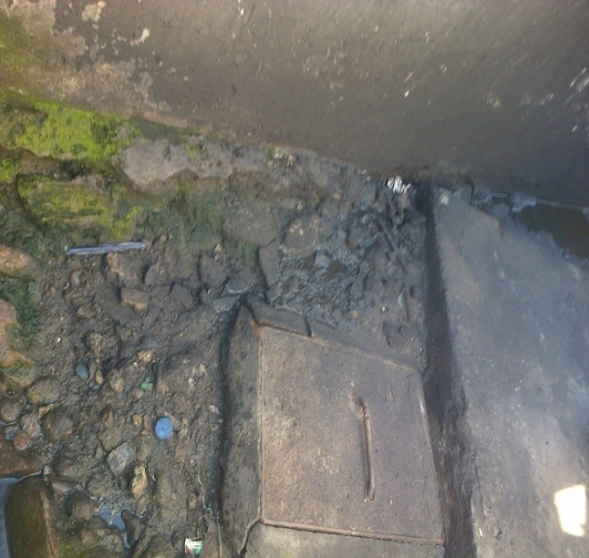

**Plate 1:** Hand dug well in a rural area in Port Harcourt.

This is usually a rubber container made from motorbike or car wheel tube, attached to a long chord. Using this, about 4 L bulk sample was collected in a large plastic bowl, after a thorough agitation of the water in the well; so as to derive a homogeneous and representative sample. Two litres was subsequently taken from the bulk sample and stored in well labeled, clean polyethylene bottles for laboratory analyses. Plate 1 show hand dug well in a rural area in Port Harcourt.

### Microbiological Analysis

The total coliform count, fecal coliform count and total heterotrophic bacterial counts were enumerated respectively during the wet (May and August) seasons using the method of Khan *et al*. (2005). The total heterotrophic bacteria count was performed on nutrient agar (oxoid). It comprised the following: meat extract 1g, yeast extract 2g; peptone 5l, NaCl2 5g, agar 15, distilled water 1litre and final pH 7.4±37 0C. The spread plate method was used (Kanika, 2011). Samples were prepared by adding 1ml of water to 9 ml sterile saline (0.85 % w/v) as diluents.

A serial ten-fold dilution was performed up to 10-5 and an amount of 0.1 ml of each dilution was spread-plated in duplicates on the nutrient agar plates. Culture plates were then incubated in an inverted position at room temperature (28±2 0C) for 24−48 hours. Total coliform counts (TCC) were determined using Multiple Tube Fermentation technique and expressed as Most Probable Number (MPN).

Statistical Analysis

The data generated in the study was subjected to statistical analysis to determine significance using the two way analysis of variance (ANOVA). If the mean difference was less than the critical ratio, the result was considered as not significant, *p*>0.05 but if the difference between means was greater than the critical ratio, the result was accepted as significant at *p*<0.05.

**Results and Discussion**

The total coliform count (TCC) and total heterotrophic bacteria (THB) counts were determined. The results showing seasonal variation of the various physiological groups of bacteria in ground water in highly populated area (HPA), industrial area (INA), low populated area (LPA), poorly populated area (PPA), rural area (RUA) and the control (CTL) are as presented in Figs. 2 and 3 respectively.

Coliform counts ranged from 11─17 MPN/100 ml in the wet season for HPA and 9─12 MPN/100 ml in the dry season. LPA area coliform counts ranged from 7─12 MPN/100 ml and 2─4 MPN/100 ml for wet and dry seasons, respectively. The RA had total coliform counts of 7─9 MPN/100 ml (wet) and 2─6 MPN/100 ml in the dry, which were within the acceptable limit (WHO, 2002; NHMRC, 2003). Coliform count in INA ranged from 12─14 MPN/100 ml in the wet and 11─14 MPN/100 ml in the dry season. Coliform counts for PPA ranged from 6─4 MPN/100 ml (wet) and 2─4 MPN/100 ml in the dry season which was also within acceptable limit of 1─10 MPN/100 ml set for portable water. The control (CT) had counts between 6─4 MPN/100 ml in the wet and 2─4 MPN/100 ml during the dry season for coliform bacteria (Fig. 2).

The mean seasonal variation in total heterotrophic bacterial (THB) counts during the study period is as shown in Fig.3. For total heterotrophic bacterial count, INA had average count of 1.3x105 CFU/ml and 8.9 x 104 CFU/ml for wet and dry season. HPA had 2.0x 105 CFU/ml (wet) and 6.3x 104 CFU/ml in the dry while the PPA results were 8.3x 104 CFU/ml and 4.3x 104 CFU/ml for wet and dry seasons, respectively.

PPA and LPA had 4.3x 104 CFU/ml and 4.9x 104 CFU/ml during the wet while 8.3x 104 CFU/ml and 8.1x 104 CFU/ml in the dry. The RUA had an average of 8.3x 104 CFU/ml (wet), 4.4x 104 CFU/ml (dry) while the CTL had 8.2x 104 CFU/ml for the wet and 3.7x 104 CFU/ml during the dry seasons, respectively. Members of the Entrobacteriaceae that is able to ferment lactose at 44°C including several species of the genera *Klebsiella* sp., *Enterobacter* sp.*, Serratis* sp.and *Citrobacter s*p. as well as *Escherichia coli w*here isolated. *E. coli* is considered the only true faecal coliform (grow at 44.50C), representing up to 95% of the Enterobacteriaceae found in faeces (Waite, 1985).

The presence of thermotolerant coliforms generally indicates that faecal contamination has occurred, but their presence in water does not always imply a health hazard. The World Health Organization (WHO, 2002) gave bacteriological standards for potable, as <1─10 (excellent) and 1─10 (acceptability) and results obtained deviated from the recommended standards set by the world health organization (WHO, 2002).

The result shows that a total of five Gram negative isolates (*Klebsiella* sp., *Serratia* sp., *Escherichia coli*, *Enterobacter* *sp.*, and *Citrobacter* *sp.*) all in the Enterobacteriaceae family. The presence of fecal coliform in a drinking water sample often indicates recent fecal contamination (possibly due to improperly working septic system, feces from pets and wild animals). That means there is a greater risk that pathogens are present. As per provincial guidelines, the drinking water should be boiled and corrective actions should be taken with fecal contamination (Edwards *et al.,* 1983).

Malachowsky *et al*. (1994) isolated coliform bacteria from oil contaminated ground water. If a laboratory detects only total coliform bacteria in drinking water, the source is probably environmental and fecal contamination is unlikely. However, if environmental contamination can enter the system, pathogens could get in too. It is important to find and resolve the source of the contamination.

As per provincial guidelines, suitable disinfection should be undertaken and water re-tested to ensure there is no fecal contamination (FMEnv, 1991; UNESCO, 2007; WHO, 1971; 1998). Wosu-Kinika and Odokuma (2016) had earlier demonstrated the seasonal influences on the physicochemistry and microbiology of soils in industrial areas in Port Harcourt Area. This study is in agreement with other studies (Solomon *et al.,* 2017; Dick *et al.,* 2018) which shown that the groundwater sources within 2 km radius of petrol filling stations in Port Harcourt area are contaminated by pathogenic microorganisms. In this study where the amount of colony-forming bacteria present was determined, the results show that total culturable heterotrophic bacterial counts were higher in the industrial area than the non-industrial area.

The spatial and seasonal variations in most of the investigated groups of bacteria suggest point source contamination in boreholes samples. The increase in the bacteria population could be attributed to the stimulatory effect of additional carbon and energy sources in the form of hydrocarbon which leads to an enrichment of the microbial population.

Statistically, there was significant difference (p<0.05) in seasonal variation of microbiological parameters (microbial diversity and abundance) for both dry and wet seasons in the industrial area and non industrial area, respectively during the study period. This corroborated the work of Wosu-Kinika and Odokuma (2016). The study has also provided some relevant baseline information for accessing the public health risks, which could arise from the intake of groundwater from selected area of Rivers State.

**Conclusion and Recommendations**

Groundwater around petrol filling stations were contaminated due to leakages from petrol tanks and seepages from septic tanks stored underground. There was a negative impact of industrialization and population density on groundwater quality. There was a significant (p<0.05) variation in the microbiological parameters of ground water in all study areas, with the wet season showing high level of contamination than in the dry season.

The study have showed that industrialization and population density have negative impacts on ground water quality. These impacts served as an early warning indicator to consumers and users of ground water around petrol filling stations. It was recommended that pipes, fittings and plumbing materials should be made of polyvinyl chloride.

Underground petrol storage tanks as well as septic tanks should not exceed twenty five years and should be replaced. Continuous monitoring and checks should be undertaken to ensure compliance with standards. It is therefore suggested that remediation process be carried out so as to render the polluted groundwater fit for use in agricultural and domestic purposes.

**Correspondence to:**

Uchenna Maryrose Orji,M.Sc. mNSM

Department of Medical Biotechnology,

Molecular Biotechnology Unit,

National Biotechnological Development Agency, Abuja, P. M. B. 5118, Wuse, Federal Capital Territory, Abuja, Nigeria.

Tel.: +2348036981101

Email: [uchennaorji60@yahoo.com](mailto:uchennaorji60@yahoo.com)

**References**

1. APHA (1995). Standard Methods for the Examination of Water and Wastewater. 19th Edition. American Public Health Association, Washington D.C.
2. APHA, AWWA, WEF (1992). Standard Methods for the Examination of Water and Wastewater. 18th Edn. Am. Pub. Health Ass., Washington, DC.
3. Armon, R. and Kitty (1994). The Health Dimension of Groundwater Contamination. In: Groundwater Contamination and Control, Holler (Ed.). Marcel Dekker, Inc., New York, USA.
4. Bedient, P.B. (1994). Groundwater contamination, transport and remediation, Prentice Hall PTR.
5. Back, W., M.J. Baedecker and W.W. Wood (1993). Scales in chemical hydrogeology: a historical perspective. In Regional Ground-Water Quality. Ed. W.M. Alley.111-129. Van Nostrand Reinhold, New York.
6. Dick, A. A., L. Solomon and S. Okparanta (2018). Assessment of selected physicochemical and microbial parameters of water sources along Oproama River in Oproama community in Rivers State, Nigeria. *World Rural Observation,* 10(1):69-74.
7. Edwards, K.A., Classen, G.A, Schroten, E.H.J. (1983). The water resource intropical Africa, and its exploitation, ILCA – Int. Livestock Centre for Africa, Res. Rep., Addis Ababa. 28.
8. Federal Ministry of Environment (FMEnv) (1991). Water Quality, Federal Water Standards, Guidelines and Standard for Environmental Pollution Control in Nigeria, National Environmental Standards – Part 2 and 3, Government Press, Lagos p. 238.
9. Gleeson, C. and N. Gray (1997). The Coliform Index and Waterborne Disease. E & FN Spon, London.
10. Hammer M.J. and Hammer, M. J. Jr. (2004). Water Quality. *In*: Water and Waste Water Technology.5th Edn. New Jersey: Prentice-Hall 2004; 139-159.
11. Kanika, S. (2011). Manual of Microbiology: Tools and Techniques. Ane Books Pvt. Ltd. New Delhi-110002, India, 2:175-200.
12. Khan, Z., J*.* Troquet and C. Vachelard (2005). Sample preparation and analytical techniques for determination of polyaromatic hydrocarbons in soils. *Int. J. Environ. Sci. Tech*. 2(3): 275-286.
13. Lee, G.F. and J.A. Lee (2005). Municipal solid waste landfills – water quality issues, Water Encyclopaedia: Water Quality and Resource Development, John Wiley. *NJ*. 163-169.
14. Malachowsky, K.J., T.J. Phelps, A.B. Teboli, D.E. Minnikin, D.C. White (1994). Aerobic mineralization of trichloroethylene, phynyl chloride and aromatic compounds by *Rhodococcus* species. *Appl. Environ. Microbiol.* 60:542-548.
15. NHMRC (2003). Review of Coliforms as Microbial Indicators of Water Quality. National Health and Medical Research Council. Commonwealth of Australia.
16. Oforibika, A. G., I. K. Alalibo and L. Solomon (2018). Environmental pollution and reportage in Nigeria. *World Rural Observation,* 10(1):75-77.
17. Oyeku, O. T., and A. O. Eludoyin (2010). Heavy metal contamination of groundwater resources in a Nigerian urban settlement. *African Journal of Environmental Science and Technology*, 4(4): 201-214.
18. Plazinska, A. 2000. Microbiological quality of drinking water in four communities in the Anangu Pitjantjatjara Lands, SA. Bureau of Rural Sciences, Canberra.
19. Solomon, L., O. George-West and I. K. Alalibo (2017). Environmental pollution in the Niger Delta and consequential challenges to sustainable development of the region: the role of an individual. *Researcher,* 9 (8):10-15.
20. Standards Organization of Nigeria (SON) (2007). Nigerian Standard for Drinking Water Quality. NIS 554.
21. UNESCO. UNESCO (2007). Water Portal newsletter. No. 161: Water-related Diseases. www.unesco.org/water/news/newsletter/161.sht ml>
22. WHO (2008). Guidelines for Drinking-water Quality, Third Edition Incorporating the First and Second Addenda, Volume 1: Recommendations. Geneva.
23. WHO (2002). International Standards for Drinking Water, World Health Organization, Geneva, 5-8.
24. WHO (1998). World Health Organisation’s Guidelines for Drinking water, Vol. 1, Geneva.
25. WHO (1971). International Standards for Drinking Water. 3rd Ed. Geneva.
26. Waite, W.M. 1985. A critical appraisal of the coliform test. *Journal of the Institute of Water Engineers and Scientists,* 39, 341-57.
27. World Bank (2002). *World Development Report 1982*, Volume 1. ISBN 0-19-503224-1. http://go.worldbank.org/16BEWURYE0.
28. Wosu-Kinika, R. and L.O. Odokuma (2016). Seasonal Influences on the Physicochemistry and Microbiology of Soils in Industrial Areas in Port Harcourt Area. *Nature and Science*, 14(1):30-3.

11/18/2018