Evaluation Of The Growth Performance Of Lands Snail Achatina Achatina Fed With Different Plant Materials In Sangere, Girei Local Government Of Adamawa State, Nigeria

¹Kwaga, B. T. ¹Martha, E.M., ¹Ali, A. and ²Khobe, D.

¹Department of Forestry, Modobbo Adama University of Technology, Yola
²Department of Animal Production, Adamawa State University, Mubi
²Correspondence: amanoyang@gmail.com; 08137459305 and 08051516924

Abstract: There is no adequate and reliable information on the plant materials that could contribute significantly to the growth of land snail in the study area. A total of sixty (60) snails were divided into three groups (A, B and C) and fed with three different plant material (paw-paw fruit, orange chaff and combination the two, i.e. paw-paw + orange chaff) for a period of eight weeks. Data obtained were subjected to one way analysis of variance (ANOVA) and descriptive statistics. The results obtained indicated that snail group fed with combination of paw-paw plus orange chaff recorded the highest weight (9.68kg) as against those fed with orange chaff (7.29kg) and paw-paw fruit (6.62kg) respectively. The result of cumulative length gained were 5.58cm, 4.67cm and 4.65cm for combination of paw-paw and orange chaff, orange chaff alone and paw-paw fruit alone respectively. There was significant difference (P<0.05) between the snails fed with combination of the feds (orange chaff and paw-paw fruit) and the single feeds. There was positive correlation between weight and length of snails fed with the three plant materials. Rearing of Achatina achatina fed with the combination of paw-paw fruit and orange chaff as better plant material is recommended.
[Kwaga, B. T. Martha, E.M., Ali, A. and Khobe, D. Evaluation Of The Growth Performance Of Lands Snail Achatina Achatina Fed With Different Plant Materials In Sangere, Girei Local Government Of Adamawa State, Nigeria. N Y Sci J 2018;11(10):81-86]. ISSN 1554-0200 (print); ISSN 2375-723X (online). http://www.sciencepub.net/newyork. 13. doi:10.7537/marsnys111018.13.

Key words: snail, length, weight, plant material, performance

Introduction
Snails belong to a large and highly diverse group of invertebrate animals, which means they lack a backbone. They belong to phylum mollusca (also called mollusks). The phylum mollusca among others includes slug, clams, oysters, mussels, squids, octopuses and nautiluses. They have soft bodies which are not segmented, slippery skin, no limbs and have hard shells. Snails are slow moving creatures and are nocturnal in habits. All farm snails are members of the class gastropoda and are capable of breathing free air. The three principal types of edible snails grown in Europe are Helix aspersa (petityris, small grey or brown snails, Western Europe and Mediterranean). Helix pomatia (Burgundy snail; central and South East Europe) and Achatna fulicia (edible tropical land snails that are abundant during the wet season). Snails can easily be gathered especially at night and before dawn, they can easily be domesticated and controlled (Ebenso and Okafor, 2002; Ebenso, 2003a). They can usually be seen after heavy rains, crawling on the ground or sometimes on the stems of trees, shrubs and on leaves (Augustine, 2008).
. The morphology of the snail consists of a head, foot and a visceral mass. Snails are usually found in calcareous wet soils and certainly rare in acid formation. During the day time when the weather is hot or during the dry season especially when the ground is dried, they become buried in the ground and remain there, a process referred to as aestivation. They resurfaced only when the environmental condition become favorable (Augustine, 2008). Snails are normally hermaphrodites and are protandrous but cross fertilization is necessary for them to reproduce. Reproduction is complex; the gonad is an ovotestis, producing both sperm and eggs. The ducts of the gonad are in most cases, divided with one channel for the transport of sperm and the other for eggs (Amubode, 1990). Although snails can function as both male and female, the sperm are formed earlier than the eggs. Eggs are laid in 14 – 21 days after mating. Temperature and relative humidity are the most important environment factors that influence land snail and their existence (Goodman, 2000). The lesser the temperature with high relative humidity, the better distributed they are in an area. It is for this reason that their natural distribution corresponds to humid regions. Water is important to the life activities of the snail not only as an essential element in their metabolism, but also in connection with their structural characteristics. The body is covered with a thin layer of epilium against dehydration (Cobbinah, 1994). Snails are somehow pest to human food or other resources. The consideration that they eat all which is consumable by humans and therefore possible competitors may be true. The snail’s physiognomy makes it important in the proper well being of the animal as well as in meeting set objectives of the interested farmer (Ayodele and Asimalowo, 1999).
Snail farming (heliculture) has become a very useful venture as a source of food for augmenting human animal protein requirement. It could also improve the economic status of the farmer (Odouniaye, 2001). Snails has high quality meat that is rich in protein, low in fat, a good source of iron and contain almost all the amino-acids needed by humans (Babalola and Akinsoyin, 2009). Snails are rich in vitamin A and vitamin B with sufficient concentration of amino acids. The amino acid profile of snail is 1¹/2 times more than that of a whole egg (Augustine, 2008).
The product from livestock which is the conventional source of animal protein is not adequate. Non conventional sources of animal protein such as snail need to be deeply investigated and harnessed to compliment the shortfall in the traditional meat supply. Most previous studies have failed to address the specific food requirement of Achatina achatina relying mostly on calcium needs of the snail (Ebenso, 2002). This study intends to investigate some food source that contributes significantly to the weight and length of Achatina achatina in the study area.

Methodology
Study Area
The study was conducted in Alhaji Umaru Abubakar Garden at Sangare of Girei Local Government Area. Girei is one of the twenty one (21) existing Local Government Areas of Adamawa state. The area lies between latitudes 12.00º′N and 12.48⁰N and longitudes 11⁰30′E and 11.45⁰E (Brown et al., 2005) (Figure 1). The area experiences distinct dry and wet seasons with temperatures and relative humidity varying with season. The rainy season falls between April and November, which is characterized by single maxima in August. Seventy percent of the total rainfall in the area happens to fall within the months August and September. The total amount of rainfall per annum recorded in the area is about 972mm. The dry season which is the harmattan period is between December and March. Temperature within the area varies with season. Although the temperatures are relatively high almost all the year round, it never exceeds 45ºC. December and January are the coldest months with average temperature of 34ºC (Adebayo and Nwaboso, 2005). Among the dominant woody plant species in the study area are: Danielia oliverii, Piliostigma thoningii, Terminalia albida, Balanites aegyptiaca, Guiera senegalensis, Annona senegalensis, Tamarindus indica and Ziziphus mauritania. Abundant grass species include: Croton lobadtus, Portuluca quadrifida, Sena obtusifolia, Sida acuta and Cenchrus species among others (Ikusemoran et al., 2013).
Study Design and Data collection
The snail samples were collected by hand picking from the nearest orchards and banana plantation at sangere. Pawpaw fruits and orange chaff were the food fed to the snails collected from the nearby markets. The study was carried out in 3 cages made of woods, nets, nails, and wire. The size of the cage was 45cm x30cm x 30cm. The 3 cages were grouped into A, B, and C and filled with loamy soil exposed to sunlight to get rid of harmful soil microorganism based on Augustine (2008) guide. Each of the group was stocked with 20 snails and fed ad-libitum as follows. Group A were fed with orange chaff, B with pawpaw fruits and C with combination of pawpaw fruits and orange chaff. Also calcium supplement in form of egg shell was added to the feed and fed to each group. Snail body weight and lengths of shell were recorded at regular intervals.

Statistical Analysis of Data
The data obtained was subjected descriptive statistics (charts, diagrams) and one way analysis of variance (ANOVA) as described by Okonkwo et al. (2002). Separation of significant means was done using Fisher’s Least Significant Difference.

Results
The result of the average body weight of the snails in the study area is shown in (Figure 2). The result revealed that the weight of snails fed with combination of pawpaw fruits and orange chaff had the highest mean value of (9.68g), this was followed by the snails fed with orange chaff (7.29g), while snails fed with pawpaw fruits produced the lowest mean value (6.62g). Also, analysis of variance conducted showed that there is significance difference (P< 0.05) in weight among the group of snails fed with the different food materials (Table 1). Result of mean shell length of the snails fed with combination of feeds (Figure 3) shows that those fed with combination of pawpaw fruits and orange chaff had the highest length value (5.58cm), this was followed by the length of snails fed with orange chaff (4.67cm) and the least was the snails fed with pawpaw fruits (4.61cm).
Also, analysis of variance conducted revealed that there is significance difference (P<0.05) among the length of the groups of snails fed with different food materials (Table 2).
A follow up analysis also using Fisher’s Least Significance Difference was used for the separation of mean (Table 3).

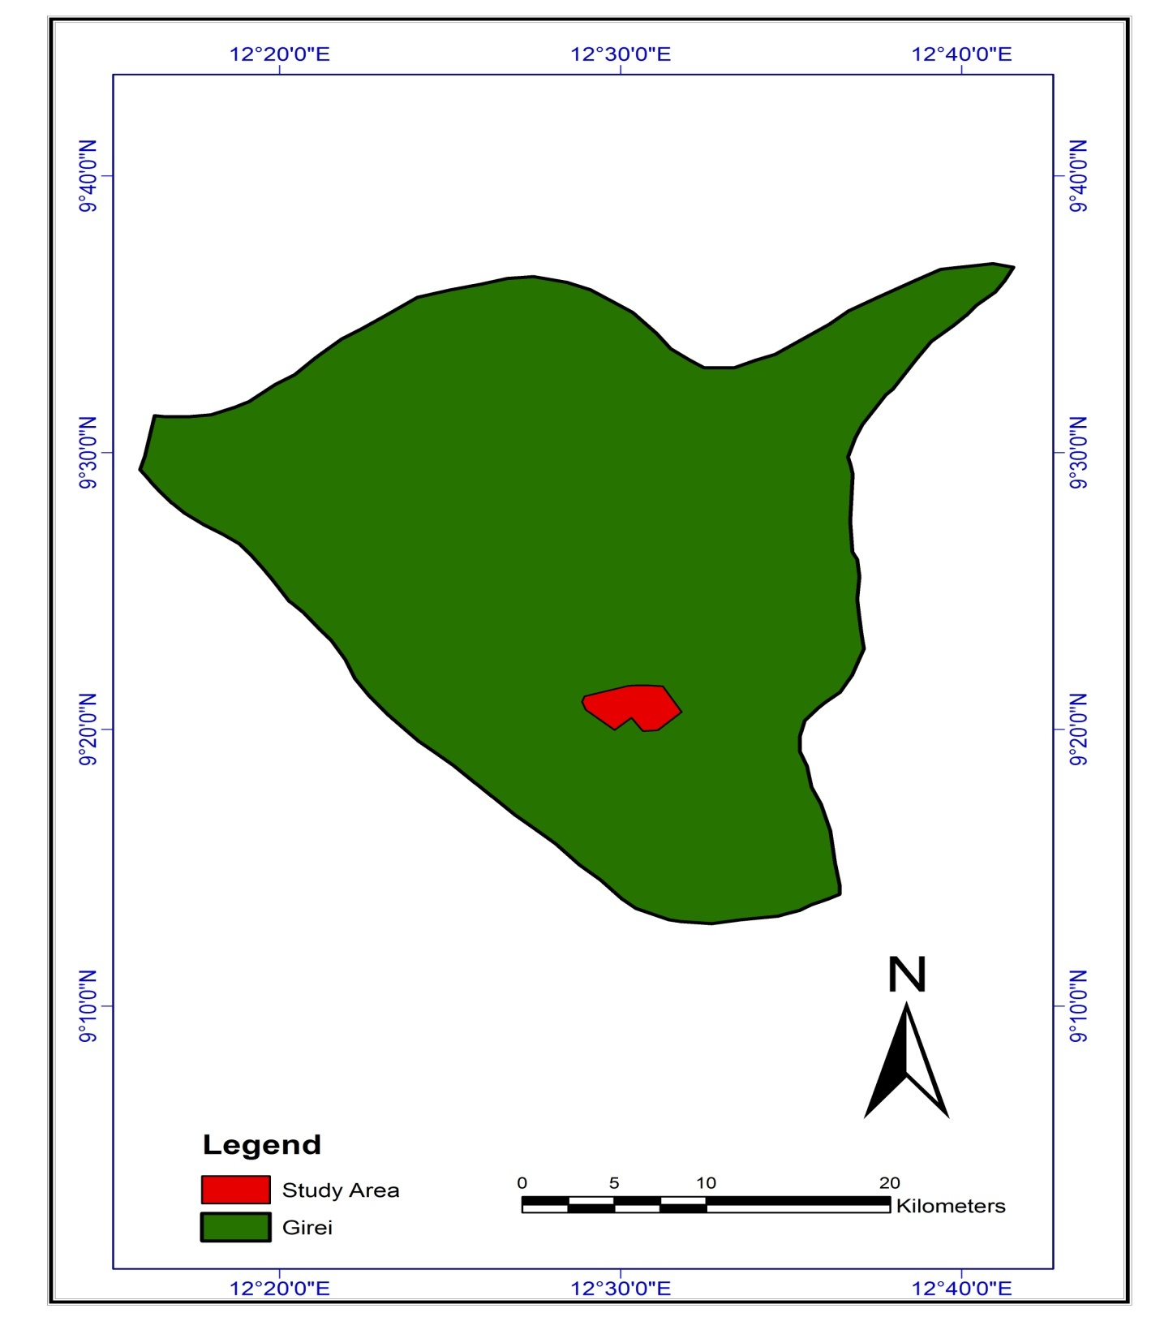
Fig:1 Map of Girei Local Govt. showing the study area. Source: Min. of Land & Survey, Adamawa state (2015).
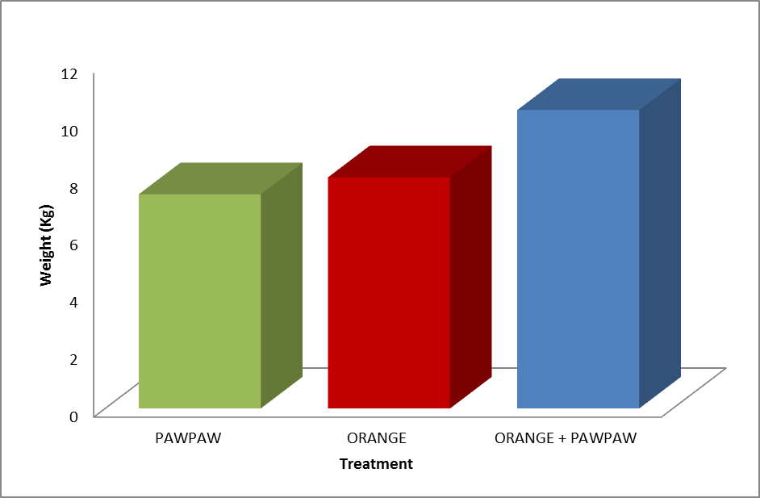
Figure 2: Bar chart showing mean weight of the snails in the study area

Table 1: Analysis of variance table for snail weight in the study area
 | Sum ofsquare | d.f | Mean square | F | Sig.
Treatment  Error  Total | 96.720  269.470  366.190 | 2  57  59 | 48.360  4.728 | 10.229 | .000

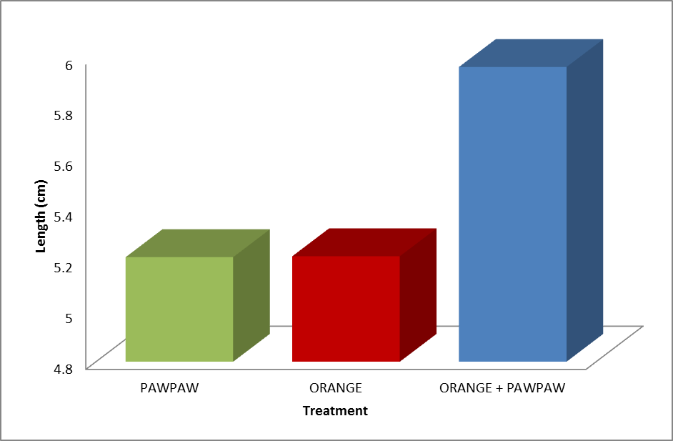
Figure 3: Bar chart showing mean length of the snails in the study area

Table 2: Analysis of variance for snail length in the study area
 | Sum ofsquare | d.f | Mean square | F | Sig.
Treatment  Error  Total | 7.453  33.725  41.178 | 2  57  59 | 3.726  .592 | 6.298 | .003

Table 3: Fishers least significant difference (LSD) of the treatment means Dependent Variable: LENGTH
(I)REP. (J)REP. | Mean Difference (I-J) | Std Error | Sig
A B  C  B A  C  C A  B | -.00377(n.s)  -.74952*  .00377(n.s)  -.74575*  .74952*  .74575* | .24324  .24324  .24324  .24324  .24324  .24324 | .988  .003  .998  .003  .003  .003
(* Significant at 0.05 level) (A = Pawpaw; B = Orange; C = Pawpaw + Orange)

Discussions
Indications from the findings of this study showed that an attempt to improve the quality of food supplement in rearing of snails was made. Similarly, in any helicultural business, assessing and determining the type of food that improve the growth of land snail have become increasingly important. This is in agreement with the report of Ebenso (2003a) who stated that snails can easily be raised/domesticated and controlled. However, most of the studies conducted paid too close attention to calcium dietary supplementation, while ignoring other food source that are needed for healthy growth by the snails (Daouda, 1993). Snails are herbivores, but little attention has been paid to investigate the plant materials they need for growth. The result from this investigation has indicated that Achatina achatina fed with a mixture or combination of pawpaw fruits and orange chaff grew better in terms of weight gain and shell length compared to either orange chaff or pawpaw fruits. Previous studies in other parts of the country investigated some plant materials consumed by captive snails with less attention given to pawpaw fruits, pawpaw leaves and water leaf as some of the materials that are wholly consumed by land snails. Also, weight gain in respect of pawpaw fruits and different source of calcium was observed in Achachatina marginata and Achatina achatina fed with powdered oyster shell separately from green forage (Daouda, 1993; Ebenso, 2003a)). Thus the current studies agrees with the previous findings that these plant materials are eaten by land the snails Achatina achatina and could be a source of food supplementation in rearing Achatina achatina in this part of the country. The study also shows that significant relationship between shell length and weight increase was observed in the three groups of snails fed with different plant materials.
There was a significant difference (p<0.05) in weight gain and increase in shell length based on the different type of food materials fed to the snails. Thus on the basis of weight gain as a growth indicator, the combination of pawpaw fruits and orange chaff could be accepted as the most preferred food type or plant materials for rearing Achatina achatina. However weight gain could be subject to environmental factors that could trigger desiccation, and reduce the weight of snails. There are many of such factors that affect snails, and even determine their distribution in their natural environment (Ikpa et al; 2006). Given such possibility, the whole weight gain of snails alone may therefore not be a better option for assessing growth in snail, since it could be drastically influenced by environmental factors.
The measure of shell length increase on the other hand could relatively be a better growth indicator between the two indices of growth investigated. This is because shell length increase would be permanent, unlike weight gain as observed by Lee et al; (1994) who said that snail when deprived of external source of calcium (soil or food) depend on their own shells for their calcium need and also that domesticated snails are three to five times higher in calcium content of their meat than snails from the wild.
Since snail meat is relatively a cheap source of protein, especially in rural areas, where land snails can be gathered from the wild, rearing of snails could be beneficial not only for dietary consumption but for commercial purposes as well in the study area ( Ebenso, 2003b). The potentials for snail farming therefore exists for willing farmers, who should take advantage of the findings provided in this investigation and should apply them on their snail farms.

Conclusion
It can be concluded from the results of this findings that Achatina achatina (land snails) could be fed with pawpaw fruits, orange chaff and a combination of both (pawpaw fruits and orange chaff). However, the mixture of pawpaw fruits and orange chaff is emphasized as they yielded better in terms of weight gain and shell length increase as growth indices. On the other hand, pawpaw fruits fed to the snails alone produced the least gain on each of these measured parameters. Also, there was a significant association in the weight and shell length of Achatina achatina fed with the combination of different plants materials.
A combination of vegetative food materials consumed by Achatina achatina should be used as preferred food materials for feeding the land snails on farms particularly pawpaw fruits and orange chaff.

References
- Adebayo, A.A. and Nwaboso, N. K. Climate; Agricultural Planning in Adamawa State. Agriculture in Adamawa State. Edited by Igwe, E.C.,. Mshelia, S.I. and Jada, M.Y. (2005). Paraclete Publishers, Yola-Nigeria 2005; 10-22 .
- Amubode, F.O and Oyoyo A.U. Performance of snails (Achachatina marginata) fed varying levels of calorie – protein supplementary diets. Nigeria journal of forestry 1995; 24 (1 and 2): 36 – 43.
- Augustine, U. O. (2008). Wildlife Management in Nigeria (Objectives, Principles and Procedures). Median Communications, 39 Hart Street, Calabar. Cross River State- Nigeria. 2008;146-167.
- Ayodele, I.A and Asimalowo, A.A. Essentials of snail farming. A technical guide to snail farming in the tropics. 1999.
- Babalola, O.O and A.O Akinsoyin. Proximate composition of mineral profile of snail meat from different breeds of land snail in Nigeria. Pakistan journal of nutrition 2009; 8: 1842 – 1844.
- Brown, J. Mitchelle, N.J and Beresford, M. The protected landscape approach/ linking Nature, culture and community LUCN. 2005; Pp45.
- Cobbinah, J.R. Snail farming in West Africa, a practical guide. Technical centre for Agricultural and Rural Co-operation (CTA), 1994; wageningenhe Netherlands.
- Daouda A.I.H.H. The calcium in the nutrition of giant African snail Achatina achatina 1993; B.E.D.M 1(2): 25 – 26.
- Ebenso I.E (2002) Consumption and sales of domesticated snails Achachatina marginata rural southern Nigeria. Tropical science (England) 42 (4): 185 – 187.
- Ebenso, I.E and Okafor, N.M. “Alternative diet for growing Achachatina marginata snails in south – eastern Nigeria”. Tropical science (England) 2002; 42(3): 144 – 145.
- Ebenso. I.E. Dietary calcium supplement for edible tropical land snail. Achachatina marginata in Niger Delta Nigeria, livestock Research for development 2003a; 15(5).
- Ebenso, I.E (2003b). Nutritive potentials of white snails Achachatina marginata in Nigeria. Discovery and innovation (kenya) 2003b; Article in press.
- Goodman, A.K. “Snail and snail farming”. Nigerian edible land snail “PI” 2000.
- Ikpa, T.F. Amonum, J.T and Orshi. T.H. The effect of soil calcium temperature and pH on the distribution of land snail in the wild. Journal of tropical forest Research 2006; 21(1).
- Ikusemoran, M., Anthony, D. and Maryah, U.M. Assessment of Flood Risk and Vulnerability of Communities in Benue Floodplains, Adamawa State, Nigeria. Journal of Geography and Geology 2013; 5 (4): 148-160 .
- Lee, M.K; Moon, J.H and Ryu, H.S. Nutritive composition and protein quality of giant snail product journal of Korean society of food and nutrition 1994; 23:453-458.
- Ministry of Land and survey, Headquaters, Yola, Adamawa state (2005).
- Odouniaye O. VoSnail rearing techniques and marketing strategies. Prepared for BOOM and PRAISE PROJECTS, Iworo – Ijebu, 2001.
- Okonkwo, A.G; Isaac; I. Nkanga and O.O Usoro. Effect of various feeding regines on the performance of snails (Achachtina marginata). Book of proc. 25th annual NSPA conference 19 – 23, March 2000. Umudik. 314 – 315.

10/25/2018

