**Comparative histopathological study of inferior turbinate hypertrophy in allergic rhinitis and in that in other causes**

Prof. Atef Adallah Elmaraghy1, Dr. Mohamed Kamel Ibrahim1, Dr. Osama Mostafa Mostafa2, Mohamed Elmowafy Mowafy Saad 3

1 Departments of ENT, faculty of medicine, Al-Azhar University, Egypt

2 Departments of pathology, faculty of medicine, Al-Azhar University, Egypt

3 Resident of Otolaryngology Kafr Elsheikh General Hospital, Egypt

[mohamedkamel292@yahoo.com](mailto:mohamedkamel292@yahoo.com)

**Abstract: Introduction:** Perceived nasal obstruction resulting from inferior turbinate hypertrophy (ITH) is a common complaint encountered in otorhinolaryngology practice. Several causes may induce significant hypertrophic changes of the inferior turbinate (IT) including allergic rhinitis and non allergic rhinitis also the clinical observation of compensatory contralateral inferior turbinate enlargement in patients with septal deviations is supposed common. **Aim of the Work:** Differentiate between compensatory hypertrophy of inferior turbinate and hypertrophy due to allergic rhinitis, provide histopathological information on various soft tissue and bony constituents of hypertrophied inferior turbinate, Study the results of its surgical management by partial inferior turbinectomy and Study the Complications of surgery. **Patients and Method:** A total of 25 patients who presented with nasal obstrusion due to HIT were evaluated before and after the surgery. **Results**: It was found that partial inferior turbinectomy for cases of ITH is effective in relieving symptoms of nasal obstruction In this study along with clinical outcome, histopathological features of the ITH with micrometric analysis showed that bony layer contributes significantly to the turbinate in cases of Anatomical malformation "i.e. DNS with compensatory ITH" and it should be a target of surgery with proper choice of surgical technique, i.e. a method like submucous diathermy won't be able to relief this patient from nasal obstruction. On the other hand mucosal layers contribute the main thickness of the turbinate in patient with Non anatomical malformation "i.e. Rhinitis" and bony layer contributes about less than 30% of the thickness of the turbinate. So surgical techniques-(which aim to remove the mucosa with leaving the bony part of the turbinate)-are suitable for such patients. In present study total thickness in Non anatomical malformation "i.e. Rhinitis" group and total thickness in Anatomical malformation "i.e. DNS with compensatory ITH" group show insignificant difference. The main difference in composition is the bony layer.

[Atef Adallah Elmaraghy, Mohamed Kamel Ibrahim, Osama Mostafa Mostafa, Mohamed Elmowafy Mowafy Saad. **Comperative histopathological study of inferior turbinate hypertrophy in allergic rhinitis and in that in other causes.** *N Y Sci J* 2018;11(10):57-62]. ISSN 1554-0200 (print); ISSN 2375-723X (online). <http://www.sciencepub.net/newyork>. 9. doi:[10.7537/marsnys111018.09](http://www.dx.doi.org/10.7537/marsnys111018.09).

**Keywords:** histopathology, inferior turbinate hypertrophy, chronic hypertrophic rhinitis.

**1. Introduction**

Perceived nasal obstruction resulting from inferior turbinate hypertrophy (ITH) is a common complaint encountered in otorhinolaryngology practice. Several causes may induce significant hypertrophic changes of the inferior turbinate (IT) including allergic rhinitis and non allergic rhinitis also the clinical observation of compensatory contralateral inferior turbinate enlargement in patients with septal deviations is supposed common.

Patients are usually offered conservative therapy with anti allergic drugs, systemic and topical decongestants, topical nasal and systemic steroid, and mast cell stabilizers. When these means do not provide adequate relief for the patient, surgery is suggested.

A wide variety of surgical procedures like partial resection, submucous resection, electrocautery, submucous diathermy, cryosurgery and laser ablation have been performed but results have been universally unsatisfactory***.***

The decision of inferiorturbinectomy should be based not only on the clinical presentation but also on the histopathological features of the organ. However, data on the latter are scarce and when available, investigated as a side topic.***.***

**2. Patients and methods**

**Source of data**

Data for this study was collected from patients attending department of Otolaryngology in Al-Hussein University Hospital, Al Azhar University. During period from July 2017 to January 2018.

This Study was approved by ethical committee of Ear, Nose and Throat department, Faculty of medicine, AlAzhar university.

**Type of study**

This is a cohort, prospective, nonrandomized, morphometric study that will be conducted on 20 persons.

**Inclusion criteria**

* Patient presenting with nasal obstruction due to ITH with or without deviated nasal septum.
* Not responding to medical therapy.

**Exclusion criteria**

* Patients below age of 16 years.
* Patients associated with fungal sinusitis, sinunasal polyposis, granuloma & neoplasm of nose and paranasal sinuses.
* Patients refuse or unfit for surgery.

**Method of data collection**

A total of 25 patients who presented with nasal obstrusion due to HIT was chosen for study. All cases were diagnosed after taking a detailed history regarding nasal obstruction and associated symptoms like nasal discharge, headache and sneezing.

Through clinical examination, severity of nasal obstruction will be assessed subjectively. Only patients who have diagnosed to have ITH secondary to deviated nasal septum, allergic rhinitis and non allergic rhinitis and not responding to medical therapy with antihistamines, nasal decongestant drops and intranasal steroids will be included in the study.

Patients were then subjected to various investigations like routine preoperative investigations, C.T scan of paranasal sinuses and ECG will be done for patients above 35 years old. Fitness for surgery was taken from physician whenever necessary, written informed consent was taken from the entire patient undergoing surgery.

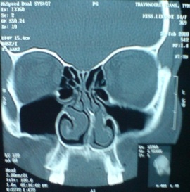 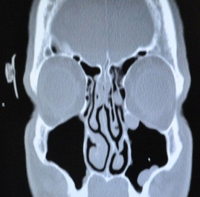

**Figure 1: C.T Scan Shows Deviated Nasal Septum with unilateral ITH**

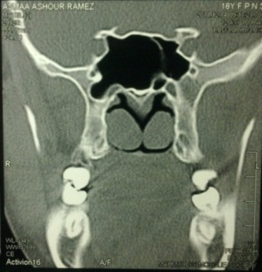 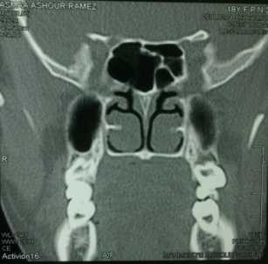

**Figure 2: CT Scan of Nose shows bilateral ITH**

All patient undergo Endoscopic partial inferior turbinectomy under general anesthesia with or without septoplasty. Turbinectomy included resection of posterior 2/3rd of turbinate and all layers will be excised during the procedure.

During the procedure turbinate architecture will be preserved by gentle handling and care will be taken not to damage the mucosal layer during turbinectomy, then specimen was preserved in 10% formalin solution and was sent for histopathological examination.

The turbinate specimens was processed in standard manner in the department of pathology and slides were prepared, taking care to include all three layers of the turbinate.

Then slides were examined microscopically with a micrometer attached to eye piece of the microscope. Each layer of the turbinate was measured along with study of architecture of venous sinuses and presence of inflammatory cells.

The patients who undergo turbinectomy were postoperatively assessed for complications like hemorrhage, crusting, synichae and infection. The patients answered a questionnaire consisting of the questions regarding subjective improvement of their symptom of nasal obstruction (free breathing, significant improvement, mild improvement and no improvement).

**3. Results**

Nasal obstruction caused by ITH has different etiologies for its onset e.g. allergic rhinitis, vasomotor rhinitis, deviated nasal septum, etc. Most of cases respond to medical therapy in form of anti allergic drugs, oral & local decongestant, topical & systemic steroid but some cases require surgery.

In present study the age of the study group ranged from 24 to 36 years. All the 25 patients (i.e. 100%) in our study presented with nasal obstruction not responding to medical therapy, 5 patients (i.e. 25%) showed rhinitis medicamentosa due to abuse of local xylometazoline drops. Nasal discharge was present in 12 patients (i.e. 48%).

Sneezing & itching were present in 12 patients in this study (i.e. 48%).

In this study, 17 patients (i.e. 68%) present with bilateral ITH, 8 patients (i.e. 32%) present with unilateral ITH.

The subjective score of nasal breathing was graded as 4 subgroups in our study.

Our study showed, 14 patients (i.e. 56%) had difficult nasal breathing at rest pre operatively, eight patients of them have DNS with unilateral or bilateral ITH and the remaining six patients complaining of bilateral ITH without DNS, 8 patients (i.e. 32%) with difficult nasal breathing on effort, 3 patients (i.e. 12%) present with mild nasal breathing on effort.

Septoplasty with unilateral inferior turbinectomy was done in 6 patients (i.e. 24%), 15 patients (i.e. 60%) underwent just bilateral inferior turbinectomy without septal correction and 4 patients (i.e. 16%) underwent septoplasty with bilateral turbinectomy.

Post operatively the nasal air flow subjectively assisted after 2 weeks. 19 patients (i.e. 76%) showed significant improvement, moderate improvement seen in 6 patients (i.e. 24%) mostly due to improper use of alkaline nasal wash and crust formation, no patients showed no improvement.

Post operative subjective assessment was done again after 2 months. 21 patiennts (i.e. 84 %) seen significant improvement, 4 patients (i.e. 16%) showed moderate improvement, two of them developed adhesion at raw surface of right turbinate bed and the other two showed much crusts than previous assessment.

Post operatively the complications were assessed. Crusting was seen in 2 patients (i.e. 8%). Patients were advised to use nasal alkaline douching. One patient (i.e. 4%) showed synichae at the site of turbinectomy. Synichae were released under local anesthesia.

In present study no reaction or secondary heamorrhage are detected in our patients, the previous two studies didn't specify the type of heamorrhage occurred.

Overall success rate of partial inferior turbinectomy in present study was 100%. All patients reported complete or partial relief from nasal obstruction after end of 6 months (90% showed complete relief and10% showed partial relief).

The patients who underwent turbinectomy were postoperatively assessed for complications like hemorrhage, crusting, synichae and infection. The patients answered a questionnaire consisting of the questions regarding subjective improvement of their symptom of nasal obstruction (free breathing, significant improvement, mild improvement and no improvement).

Chart 1 show groups of the study



Chart (2) showing patient complaint before the surgery





Chart (3) **show State of nasal breathing before the surgery**



Chart (4) show state **of nasal breathing** 2 weeks after the surgery

Chart (5) show state of nasal breathing 2 months after the surgery



Figure 3 show different layers of inferior turbinate indifferent groups

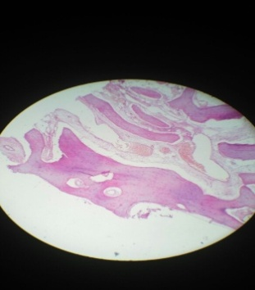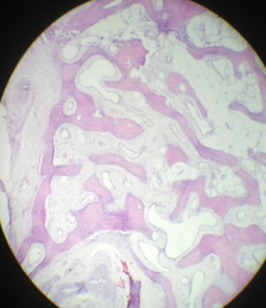

Compensatory case

**Figure 3:** Shows hypertrophy of bony layer (prominent bony trabeculae)

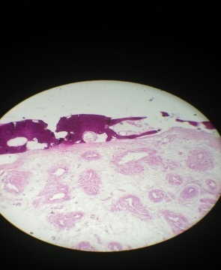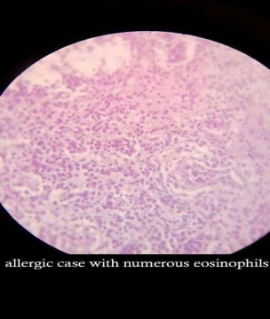

Allergy case

**Figure 4:** Gypertrohied turbinate specimen of allergic rhinitis showing thickining of mucosal layer (prominent mucous glands and numouerous eosinophils and little bony trabeculae)

**4. Discussion**

Nasal obstruction caused by ITH has different etiologies for its onset e.g. allergic rhinitis, vasomotor rhinitis, deviated nasal septum, etc. Most of cases respond to medical therapy in form of anti allergic drugs, oral & local decongestant, topical & systemic steroid but some cases require surgery.

In present study the age of the study group ranged from 24 to 36 years.

All the 25 patients (i.e. 100%) in our study presented with nasal obstruction not responding to medical therapy, 5 patients (i.e. 25%) showed rhinitis medicamentosa due to abuse of local xylometazoline drops. Nasal discharge was present in 12 patients (i.e. 48%).

The patients presented with nasal obstruction (i.e. 100%) but incidence of nasal discharge in the above study was 48 %. this higher incidence of patients presenting with nasal discharge might be due to abuse of local xylometazoline drops.

Sneezing & itching were present in 12 patients in this study (i.e. 48%).

In this study, 17 patients (i.e. 68%) present with bilateral ITH, 8 patients (i.e. 32%) present with unilateral ITH..

The subjective score of nasal breathing was graded as 4 subgroups in our study.

Our study showed, 14 patients (i.e. 56%) had difficult nasal breathing at rest pre operatively, eight patients of them have DNS with unilateral or bilateral ITH and the remaining six patients complaining of bilateral ITH without DNS, 8 patients (i.e. 32%) with difficult nasal breathing on effort, 3 patients (i.e. 12%) present with mild nasal breathing on effort.

Septoplasty with unilateral inferior turbinectomy was done in 6 patients (i.e. 24%), 15 patients (i.e. 60%) underwent just bilateral inferior turbinectomy without septal correction and 4 patients (i.e. 16%) underwent septoplasty with bilateral turbinectomy.

Post operatively the nasal air flow subjectively assisted after 2 weeks. 19 patients (i.e. 76%) showed significant improvement, moderate improvement seen in 6 patients (i.e. 24%) mostly due to improper use of alkaline nasal wash and crust formation, no patients showed no improvement.

Post operative subjective assessment was done again after 2 months. 21 patients (i.e. 84 %) seen significant improvement, 4 patients (i.e. 16%) showed moderate improvement, two of them developed adhesion at raw surface of right turbinate bed and the other two showed much crusts than previous assessment.

Patients were again followed up 6 months after surgery and subjectively assessed regarding state of nasal obstruction. And it gives the same results of the post operative assessment by 2 months.

Post operatively the complications were assessed. Crusting was seen in 2 patients (i.e. 8%). Patients were advised to use nasal alkaline douching. One patient (i.e. 4%) showed synichae at the site of turbinectomy. Synichae were released under local anesthesia.

In present study no reaction or secondary heamorrhage are detected in our patients, the previous two studies didn't specify the type of heamorrhage occurred.

Overall success rate of partial inferior turbinectomy in present study was 100%. All patients reported complete or partial relief from nasal obstruction after end of 6 months (90% showed complete relief and 10% showed partial relief).

**Histopathology**

In present study mean total thickness of inferior turbinate 25.8±8.039mm in Non anatomical malformation "i.e. Allergic Rhinitis" group and 27.30±9.592mm in patients with Anatomical malformation "i.e. DNS with compensatory ITH" and 27±7.211 in vasomotor rhinitis group. Difference in total thickness in the three conditions was insignificant.

In present study mean thickness of medial mucosal layer in group of Anatomical malformation "i.e. DNS with compensatory ITH’ 4.5±1.080mm where as its thickness in Non anatomical malformation "i.e. Allergic Rhinitis" group was 5.1±2.011mm and 5.2±0.57 in vasomotor rhinitis group. Thickness of bony layer was 5.25±0.54 in allergic rhinitis group and 6.4±0.966 group of Anatomical malformation "i.e. DNS with compensatory ITH’ and 2.6±0.418 in vasomotor rhinitis group. Mean thickness of lateral mucosal layer was 2.50±0.624 mm in Anatomical malformation "i.e. DNS with compensatory ITH". and 2.6±0.810 mm in Non anatomical malformation "i.e. Rhinitis" group. and 2.8±0.274 mm in vasomotor rhinitis group.

Present study showed that bony layer contributes significantly to the turbinate in cases of Anatomical malformation "i.e. DNS with compensatory ITH" and it should be a target of surgery with proper choice of surgical technique, i.e. a method like submucous diathermy won't be able to relief this patient from nasal obstruction.

On the other hand mucosal layers contribute the main thickness of the turbinate in patient with Non anatomical malformation "i.e. Rhinitis" and bony layer contributes about less than 30% of the thickness of the turbinate. So surgical techniques-(which aim to remove the mucosa with leaving the bony part of the turbinate)-are suitable for such patients.

In present study thickness of mucosal layers in Non anatomical malformation "i.e. Rhinitis" group and thickness mucosal layers in Anatomical malformation "i.e. DNS with compensatory ITH" group show insignificant difference. The main difference in composition is the bony layer.

Condition of venous sinusoids in each condition was also studied. In both conditions (100% of patients) there were congested venous sinusoids. In patients with allergic rhinitis with abuse of local xylometazoline drops (i.e. 25%) showed more increase in number with associated rupture and haemorrhage of venous sinusoids with concomitant some degree of submucosal fibrosis.

Lymphocytes & plasma cells and eosinophils were prominent inflammatory cells in allergic rhinitis group, where as in deviated nasal septum with ITH group lymphocytes and plasma cells were prominent inflammatory cells and mast cells were uncommonly encountered.

None of the specimens examined in this study showed granulomas, dysplasia, or malignant changes.

**Conclusion**

In this study indications, outcome and complication of partial inferior turbinectomy were studied. It was found that partial inferior turbinectomy for cases of ITH is effective in relieving symptoms of nasal obstruction.

In this study along with clinical outcome, histopathological features of the ITH with micrometric analysis showed that bony layer contributes significantly to the turbinate in cases of Anatomical malformation "i.e. DNS with compensatory ITH" and it should be a target of surgery with proper choice of surgical technique, i.e. a method like submucous diathermy won't be able to relief this patient from nasal obstruction.

On the other hand mucosal layers contribute the main thickness of the turbinate in patient with Non anatomical malformation "i.e. Rhinitis" and bony layer contributes about less than 30% of the thickness of the turbinate. So surgical techniques-(which aim to remove the mucosa with leaving the bony part of the turbinate)-are suitable for such patients.

In present study total thickness in Non anatomical malformation "i.e. Rhinitis" group and total thickness in Anatomical malformation "i.e. DNS with compensatory ITH" group show insignificant difference. The main difference in composition is the bony layer.

**References**

1. Baig M, Akhtar FP (2004); Management of the hypertrophied inferior turbinate. J Rawal Med Coll. 2004; 8(2): 75-77.
2. Bandos RD, DeMello VR, Ferreira MDS, Rossato M, Lima WTA (2006); Clinical and ultrastructural study after partial inferior turbinectomy. Rev. Bras Otorrinolaringol 2006; 72(5):609-16.
3. Barbosa Ade A, Caldas N, Morais AX, Campos AJ, Caldas, Lessa F (2005); Assessment of pre and post operative symptomatology in patients undergoing inferior turbinectomy. Rev Bras Otorhinological (Engl. Ed). 2005; 71(4): 468-71.
4. Bauchau V, Durham SR (2005); Epidemiological characterization of the intermittent and persistent types of allergic rhinitis. Allergy 2005; 60(3):350-3.
5. Berger G, Hammel I, Berger R, Avraham S, Ophir D (2000); Histopathology of inferior turbinate with compensatory hypertrophy in patients with deviated nasal septum. The Laryngoscope. 2000; 110:2100-2105.
6. Berger G, Azim MB, Ophir D (2003); The normal inferior turbinate: Histomorphometric analysis and clinical implications. Laryngoscope. 2003; 113: 1992-1998.
7. Berger G, Gass S, Ophir D (2006); The histopathology of the hypertrophic inferior turbinate. Arch otolaryngol head neck surg 2006; 132:588-594.

10/25/2018